Table of Contents

List of Figures

List of Tables

Abstract
Discord gives community administrators fine-grained control over channels, roles, members, and permissions, but substantial configuration changes require many interdependent actions and can expose a live community to permission mistakes or partial failure. This project designed and implemented an AI-assisted Discord management platform in which an administrator describes a desired outcome in natural language while deterministic software retains authority over execution.
The platform uses a declarative, plan-first workflow. A large language model can modify only an isolated desired-state representation through registered tools. The system then derives an ordered difference from the observed guild state, applies structural and server-rule validation, presents a Discord-like preview, and requires explicit approval before a bot can mutate Discord. Per-guild locking, stale-state hashes, bounded retry and execution, persisted snapshots, best-effort structural rollback, drift detection, and Server-Sent Events support the safety and operational lifecycle. The implementation uses a TypeScript monorepo with React, Hono, Discord.js, PostgreSQL, Drizzle ORM, and an OpenAI-compatible model interface. It was developed iteratively, with the highest-risk boundaries addressed before broader interface features.
Evaluation combined automated component tests, Playwright system tests, code inspection, and recorded live Discord observations. All 208 collected Vitest cases across 27 files passed. The browser runner reported 45 passing and eight skipped assertions; when assessed against the 20 complete acceptance-case specifications, however, the results were two pass, fourteen partial, one fail, and three skipped. Live observations demonstrated stale-plan execution rejection, guild-scoped drift notification, and authenticated stream readiness. The measured p95 read latency was 2072 ms and therefore failed the declared one-second target. Controlled multi-step execution, failure-injected rollback, active cancellation, restart recovery, provider compatibility, deployment, and user-comprehension evaluation remain incomplete.
The project demonstrates that natural-language convenience can be separated from privileged Discord mutation through a reviewable declarative control plane. Its strongest evidence concerns the deterministic planning and safety core; broader black-box and live evaluation is required before claiming full satisfaction of the complete requirement set.

List of Abbreviations
Abbreviation | Meaning
AI | Artificial Intelligence
API | Application Programming Interface
AT | Automated Test case identifier
BCS | British Computer Society (The Chartered Institute for IT)
BR | Business Rule identifier
C4 | Context, Containers, Components, and Code architecture model
CORS | Cross-Origin Resource Sharing
CRUD | Create, Read, Update, and Delete
DAG | Directed Acyclic Graph
DB | Database
E2E | End-to-End
ER | Entity–Relationship
FK | Foreign Key
FR | Functional Requirement identifier
GDPR | General Data Protection Regulation
HTTP | Hypertext Transfer Protocol
JSON | JavaScript Object Notation
JSONB | Binary JSON storage type in PostgreSQL
LLM | Large Language Model
NFR | Non-Functional Requirement identifier
OAuth 2.0 | Open Authorization 2.0
ORM | Object–Relational Mapping
PF | Performance evaluation case identifier
PK | Primary Key
RBAC | Role-Based Access Control
REST | Representational State Transfer
SHA-256 | Secure Hash Algorithm with a 256-bit output
SPA | Single-Page Application
SQL | Structured Query Language
SSE | Server-Sent Events
ST | System Test case identifier
TTL | Time to Live
UC | Use Case identifier
UI | User Interface
UML | Unified Modeling Language
URL | Uniform Resource Locator
UUID | Universally Unique Identifier

Chapter 1: Introduction
This chapter introduces the project. It sets out the context in which the system was built, the motivation for building it, the specific problem it addresses, the objectives it pursues, the scope it accepts, and the structure of the remainder of this report.

1.1 Background and Context
Discord is a widely used communication platform organized around servers, known as guilds in Discord's own API. Each server contains channels, categories, roles, and members. What distinguishes Discord from most other mainstream chat platforms is the depth and configurability of this structure. A role grants guild-level capabilities to a group of members; a channel can then override those capabilities for a specific role or member through a permission overwrite; categories group channels and can propagate their own permissions to the channels beneath them. Discord evaluates the result through a hierarchy of guild permissions, role positions, and channel-specific overwrites (Discord, n.d.-a; Discord, n.d.-b).
This configurability is a strength for communities that need fine-grained control, but it also means that a server's configuration is not a flat list of independent settings. The pieces are interdependent: a private staff area requires a staff role to exist, the category and its channels to be created in the right order, the default role to be denied access, the staff role to be allowed, and the acting identity to sit high enough in the role hierarchy to make those changes at all. Chapter 2 (Section 2.1.1) examines this dependency structure in more detail. The practical consequence for this project is that Discord administration is a configuration-management problem, not a sequence of unrelated commands.

1.2 Motivation
The motivation for this project comes from three observations about managing a non-trivial Discord server, followed by a fourth about what has recently become possible.
Configuration complexity is coupled, and it grows with the server. Because roles, categories, channels, and overwrites depend on one another, the effort of managing a server does not scale linearly with its size. A large community server can hold dozens of channels and many roles, and each change has to be reasoned about in relation to the others. It is not that an administrator has "a lot to learn"; it is that a single intended outcome (a new members-only section, say) decomposes into several dependent edits that must be made consistently. An administrator may be comfortable with roles but unsure about per-channel overwrites, or the reverse, and the coupling means a gap in either area can produce a subtly wrong result.
The native client offers no preview and no undo for structural change. Discord's built-in administration is imperative and immediate. Deleting a channel removes it and its message history at once, with no dry-run, no summary of what a change will affect, and no rollback. For a single edit this is acceptable; for a coordinated change across several roles and channels it means the administrator is working without a safety net, and any mistake is discovered only after it has taken effect.
Configuration drifts as servers and their admin teams evolve. Real servers are edited over time, often by more than one administrator, and permissions accumulate ad hoc. Discord provides no view of what has become inconsistent or what changed since some earlier point, so even an experienced administrator can gradually lose a clear picture of their own server. This is the concrete form of the familiar experience that a long-running server becomes hard to keep clean.
Large language models make a natural-language control layer newly practical. Recent tool-using language models can translate an informal instruction into a structured, typed set of operations. This makes it feasible to let an administrator describe an outcome in plain English and have software turn that into an inspectable plan. This workflow was not practical before models could reliably emit constrained, schema-valid output (Yao et al., 2023; Schick et al., 2023). The opportunity is therefore to use an LLM as an intent interpreter while keeping authority over the live server in deterministic software and an explicit human approval step.

Why Discord specifically
These observations apply with most force to Discord rather than to other mainstream chat platforms. Discord has the deepest and most tightly coupled configuration model among widely used chat platforms: roles and a role hierarchy, per-channel and per-member permission overwrites, and categories that propagate permissions, all evaluated together. Platforms such as Slack or Microsoft Teams expose a comparatively flat and shallow configuration surface, where the payoff of a plan-and-diff control layer would be small. On Discord the payoff is large, precisely because the complexity is of the coupled, interdependent kind that a declarative plan-first system is well suited to relieve. Discord is also a serious target rather than a toy: it hosts large communities with real stakes around access control and moderation, and it exposes a capable bot and REST API through which such a system can actually be built (Discord, n.d.-a; Discord, n.d.-c; Discord, n.d.-d). For these reasons Discord is the platform where this approach is both most needed and most feasible.

1.3 Problem Statement
The problem this project addresses can be stated as follows. An administrator needs to make structural changes to a live Discord server whose configuration is complex and interdependent. Expressing those changes directly through Discord's native interface is laborious and error-prone for coordinated edits, and it offers no way to preview a change or recover from a mistake. Delegating the changes to an AI that acts directly on the server would remove the manual effort but introduce a different risk: a language model can misread intent or fabricate output, and it would be doing so against a live server that a real community depends on, with the same lack of preview and recovery.
The problem is therefore not merely to generate Discord configuration from natural language (existing products already do that; BuildMyDiscord, n.d.; Discord, n.d.-e), but to place a declarative, reviewable, and recoverable control plane between the model's probabilistic interpretation and the privileged actions that reshape a live guild, so that natural-language convenience does not come at the cost of safety.

1.4 Objectives
The objective of this project is to design and build a platform that lets an administrator manage an existing Discord server through natural language, while keeping every change inspectable, validated, and human-approved before it reaches the live server. Concretely, the system aims to:
- authenticate the administrator through Discord and confine them to servers they are authorized to manage;
- translate a natural-language request into a structured plan of changes without touching the live server during planning;
- present the planned result as a Discord-like preview together with the difference from the server's current state;
- allow the plan to be revised, manually edited, and reverted across iterations before approval;
- validate the plan for structural safety, Discord permission constraints, and the server's own written rules, and require explicit human approval before execution;
- execute the approved plan against Discord with live progress reporting; and
- attempt best-effort structural recovery after a failure or on request, and detect when the live server has drifted from the planned state.
These objectives are made precise as the functional and non-functional requirements in Chapter 3.

1.5 Scope
The project covers the lifecycle from a natural-language request to a controlled structural change on an existing Discord guild: conversational planning and clarification, desired-state preview and current-versus-desired differences, revision and manual editing and iteration history, deterministic structural validation and an LLM-assisted guild-rule check, explicit approval with stale-state rejection and per-guild execution locking, ordered execution with progress events, best-effort structural rollback, and detection of external drift.
The following are deliberately outside the project's scope:
- message, attachment, ban, and nickname archival comparable to a dedicated backup service;
- general community-bot features such as moderation, ticketing, leveling, welcome flows, music, or engagement;
- subscription, billing, and organization management;
- a public marketplace for globally shared templates;
- replacement of Discord's native client or permission model;
- a continuously autonomous controller that changes a guild without renewed human approval;
- an Astro-based landing or documentation site for the platform;
- detailed audit logs of administrative actions; and
- full administrator and user account management.
Section 2.5 positions this scope against comparable systems in more detail.

1.6 Report Structure
The remainder of this report is organized as follows.
- Chapter 2 (Literature Review) reviews the concepts, technologies, and existing systems that frame the project: Discord administration, tool-using language models, declarative configuration management, and safety patterns for long-running external operations. It also compares software-development methodologies and explains the selected development, technology, and control approaches.
- Chapter 3 (Requirement Analysis) describes the system's external behavior: what it does as observed by its users and the external systems it depends on, through functional and non-functional requirements, a use case diagram, and use case specifications.
- Chapter 4 (System Design) turns inward and describes how the system is built to meet those requirements, covering the overall architecture, component and data design, the key algorithms, the API surface, the user interface, and the security design.
- Chapter 5 (Implementation) describes how the system was actually built: the development environment, the implementation of the main modules, the technical problems encountered and the solutions adopted, and evidence of the completed system.
- Chapter 6 (Testing and Evaluation) describes the testing activities used to verify the system's correctness and quality, presents the test cases and their results, and evaluates the system against its requirements, including its strengths and limitations.
- Chapter 7 (Conclusion and Future Work) evaluates the project objectives, identifies its principal contribution and lessons, prioritises the work needed to close the remaining evidence and implementation gaps, and gives the final conclusion.
The appendices provide detailed requirements traceability and the supporting test registers referred to by the main chapters.

Chapter 2: Literature Review
This chapter reviews the concepts, methods, technologies, and existing products that frame the Discord Platform. The project is not simply a chatbot connected to a Discord bot. It is a configuration-management system in which natural language captures an administrator's intent, while a declarative state model, deterministic checks, human approval, and a controlled execution engine decide what may happen to the live server. The literature is therefore drawn from five areas: Discord administration, tool-using language models, declarative configuration management, safety patterns for long-running external operations, and software-development methodologies.

2.1 Background Knowledge

2.1.1 Discord servers as configurable systems
Discord calls each server a guild. A guild contains channels, categories, roles, members, and permission settings. Roles grant guild-level capabilities to groups of members, while channel permission overwrites can allow or deny specific capabilities for a role or member in one channel. Discord represents permissions as a bitfield and evaluates them through a hierarchy of guild permissions, role positions, and channel-specific overwrites (Discord, n.d.-a; Discord, n.d.-b). Consequently, apparently simple requests such as "make a private staff section" involve several dependent decisions:
- a staff role must exist;
- the category and its child channels must exist in the intended order;
- the default role must be denied access;
- the staff role must be allowed access; and
- the bot's own role must be high enough to create or modify the target resources.
This dependency structure is important because a server configuration cannot be treated as a list of unrelated API calls. Creating a channel before its new parent category, or assigning a role before that role exists, would fail. Permission changes can also have a wider effect than their small representation suggests. A system that automates Discord administration must therefore understand resource relationships, ordering, and the bot's authorization boundary.
Discord applications normally use two complementary interfaces. The Gateway is a persistent WebSocket connection through which Discord sends events such as channel, role, and member changes (Discord, n.d.-c). The REST API is used for explicit reads and mutations. Both surfaces are authenticated and subject to Discord's permission and rate-limit rules (Discord, n.d.-a; Discord, n.d.-d). This creates a common systems trade-off: cached Gateway state is efficient for interactive planning, but a fresh REST read is more appropriate when correctness at an execution boundary matters.
The human and bot identities are also distinct. OAuth2 authenticates the administrator and exposes the guilds that the user can access, whereas a bot token identifies the application account that performs Discord operations (Discord, n.d.-a). A safe management platform must check both sides: the human must be authorized to manage the selected guild, and the bot must have sufficient Discord permissions and role position to carry out the approved change.

2.1.2 Natural-language intent and structured action
A natural-language interface lowers the knowledge required to describe a server configuration. The administrator can express an outcome such as "create a support area for verified members" without naming REST endpoints, permission bits, or role IDs. However, free-form text is not a safe execution format. It can be ambiguous, incomplete, or internally inconsistent, and a generative model may produce different outputs for similar prompts.
Research on language-model agents provides a useful separation between reasoning about a task and acting through a constrained interface. ReAct interleaves reasoning with task-specific actions so that a model can update a plan using observations from its environment (Yao et al., 2023). Toolformer similarly studies models that decide which external API to call, when to call it, and which arguments to provide (Schick et al., 2023). These works motivate tool use, but tool use alone does not guarantee safe administration. A model-selected function call remains probabilistic output. The receiving system must still validate its name and arguments, control its effects, and decide whether it is permitted to run.
For this project, the LLM is best understood as an intent interpreter and plan author, not as the final authority. Its output is restricted to a fixed registry of typed operations. During planning, those operations modify an imagined server state rather than Discord itself. This preserves the accessibility of natural language while moving authority into deterministic software and an explicit human approval step.

2.1.3 Declarative configuration and desired state
Declarative systems describe what state should exist, rather than prescribing every command needed to reach it. Kubernetes controllers, for example, observe current state and repeatedly move managed resources toward desired state (Kubernetes Authors, n.d.). Terraform applies a related plan-first workflow: it compares configuration with current infrastructure, presents an execution plan, and applies the reviewed changes later (HashiCorp, n.d.). Both examples show why current state, desired state, and the difference between them should be separate concepts.
The same model is valuable for Discord administration:
- read the current guild state;
- fork it into an editable desired state;
- change the desired state without mutating Discord;
- compute the required create, update, move, and delete operations;
- show those operations to the administrator; and
- apply only the approved plan.
Unlike Kubernetes, the project is not a continuously authoritative controller that silently reconciles every difference. Discord administrators may intentionally change a server outside the platform. The selected approach is therefore human-triggered convergence: drift is detected and reported, but a new or repaired plan must still be reviewed and approved. This retains the benefits of desired-state modelling without taking control away from the guild's administrators.

2.2 Related Technologies and Methodologies

2.2.1 Schema-constrained tool calling
Tool calling provides a bridge between language and application logic. Each tool has a name, description, and parameter schema. The model selects a tool and supplies arguments; application code validates and handles the call. The important security property is that the model does not receive a general-purpose Discord client. It can express only the operations exposed by the tool registry.
The methodology has three boundaries:
- syntactic boundary: tool arguments must satisfy a schema;
- semantic boundary: the requested mutation must be valid for the current desired state; and
- authority boundary: planning a tool must not execute it against Discord.
This project goes beyond the typical reason-act loop described by ReAct (Yao et al., 2023). Most structural tools are deferred: their planning function updates desired state, while their execution function remains unreachable until the plan has been generated, validated, and approved. The special interaction tool can pause planning to ask the administrator a question, but it has no Discord side effect. This distinction prevents conversational uncertainty from becoming an immediate live mutation.

2.2.2 Plan, preview, approve, and apply
Terraform's saved-plan workflow illustrates an important control: the reviewed plan can become the specific artifact later applied, rather than merely an informal preview (HashiCorp, n.d.). The Discord Platform adopts the same principle as a methodology, although its state model and operations are specific to Discord.
The separation provides several benefits:
- the administrator can inspect additions, edits, moves, and deletions before execution;
- the same desired state can be revised manually or through another LLM turn;
- deterministic validation can examine the complete plan rather than isolated commands;
- dependencies can be ordered before any mutation begins; and
- the system can record exactly which contract the administrator approved.
Preview is therefore more than a user-interface convenience. It is part of the safety boundary. The Discord-like visual representation helps the administrator interpret the proposed outcome, while the explicit step list preserves technical detail for validation and execution.

2.2.3 Human-in-the-loop AI and layered assurance
The NIST Generative AI Profile recommends documenting how model output is used and overseen, combining human oversight with automated evaluation, and maintaining governance throughout the AI system lifecycle (NIST, 2024). These recommendations are particularly relevant when model output may cause external side effects.
No single control is sufficient for this project. Human approval can catch intent errors but may miss a dangling symbol or Discord constraint. Deterministic validation can prove structural invariants but cannot reliably interpret every natural-language server policy. An LLM policy check can interpret flexible rules but should not be trusted as the only guard. The selected assurance model therefore layers:
- schema validation at the API and tool boundaries;
- state-store invariants during planning;
- a deterministic diff and dependency graph;
- structural and permission validation before execution;
- an LLM-assisted check against guild-specific written rules;
- a human review and approval gate; and
- stale-state and authorization checks at execution time.
The ordering of the policy check is an implementation limitation discussed in Chapter 4. The current system performs the guild-rule LLM check at execution rather than making rules part of the initial planning prompt. The literature supports layered assurance, but it does not imply that two probabilistic model calls constitute deterministic proof. The hard-coded checks and approval gate remain necessary.

2.2.4 Compensating recovery for external side effects
A Discord execution is a long-running sequence of remote operations, not one database transaction. Once Discord has accepted a channel deletion or role change, a PostgreSQL rollback cannot undo it. The Saga pattern addresses a similar problem by decomposing a long-lived transaction into smaller transactions with compensating actions when later work fails (Garcia-Molina and Salem, 1987).
This project uses the same broad recovery idea but avoids claiming full transactional rollback. It captures the guild's structural state before execution and, after a failure or rollback request, computes another diff that attempts to converge the live guild toward that snapshot. This can recreate channels, roles, overwrites, and member-role assignments, but it cannot restore data that Discord no longer retains, such as messages in a deleted channel or the original IDs of recreated resources. A request already dispatched through Discord.js may also settle after the engine stops waiting. Best-effort structural convergence is therefore a more accurate term than atomic rollback.

2.2.5 Server-Sent Events for progress reporting
Planning and execution both produce ordered, server-to-browser progress updates. The browser sends commands through ordinary HTTP requests, while the server sends turn, step, completion, failure, and rollback events in one direction. Server-Sent Events (SSE) fit this communication shape: the HTML standard defines the EventSource interface for a server to push events to a web page over an HTTP event stream (WHATWG, n.d.).
WebSockets would support full-duplex communication, but the project does not require arbitrary messages in both directions over the same connection. Keeping commands as authenticated REST requests and progress as SSE reduces protocol and state-management complexity. The trade-off is that reconnect behavior and missed terminal events must be handled deliberately by the client and server.

2.2.6 Software-development methodologies
The project's control methodology describes how the finished platform handles a Discord change; it is separate from the development methodology used to build and evaluate the software. Four approaches were considered for the latter.
Sequential development divides work into ordered requirement, design, implementation, testing, and delivery stages. Its strengths are a visible document trail, stable review points, and a clear relationship between an agreed requirement and its designed solution. These qualities suit an academic project with prescribed chapters and deliverables. Its weakness is the assumption that important uncertainty can be removed before implementation. Royce's early description of staged large-system development also included feedback to earlier stages rather than presenting a purely one-pass process (Royce, 1970). For this project, Discord behavior, LLM output, and asynchronous browser flows could not all be validated from documents alone; important defects emerged only when the working system was exercised.
Scrum organises development around a Product Backlog, a cross-functional Scrum Team, fixed- length Sprints, and defined planning, review, and retrospective events (Schwaber and Sutherland, 2020). It supports frequent inspection and adaptation, and its increments can expose integration problems earlier than a final test phase. However, claiming Scrum requires evidence of its roles, artifacts, commitments, and events. This project did not maintain a Product Owner, Scrum Master, formal Sprint Reviews, or the complete Scrum artifact set. Calling an informal series of short development periods "Scrum" would therefore overstate the process actually followed.
Spiral development is explicitly risk-driven. Each cycle considers objectives, alternatives, constraints, risks, development, and evaluation before the next commitment (Boehm, 1988). This is attractive for a system whose main uncertainties concern privileged Discord mutations, probabilistic model output, stale external state, and recovery after partial failure. A formal Spiral process, nevertheless, requires repeated risk-analysis and commitment artifacts that would add substantial overhead to a single-project implementation. Risk influenced the work strongly, but the complete formal model was not used.
Iterative and incremental development delivers the system in successive working slices and revisits earlier decisions as evidence emerges. Larman and Basili describe the long history of this approach and its common rejection of a single-pass, document-driven lifecycle (Larman and Basili, 2003). It also aligns with the Agile principles of frequent working-software delivery, responsiveness to changed requirements, technical excellence, and reflection on how to improve (Beck et al., 2001). Its trade-off is that requirements, design, implementation, tests, and documentation can drift unless every increment updates the complete evidence chain.
Methodology | Principal benefit for this project | Principal mismatch or cost
Sequential development | Clear academic stages and documentation checkpoints | External and AI behavior revealed late changes that crossed stages
Scrum | Frequent inspection of working increments | Formal roles, events, and artifacts were not maintained
Spiral | Direct focus on Discord, AI, concurrency, and recovery risks | Full risk-analysis cycles would impose disproportionate overhead
Iterative and incremental | Working slices can be tested and corrected as evidence emerges | Requires disciplined synchronization of requirements, code, and tests

2.3 Related Work and Existing Systems

2.3.1 Native Discord administration and Server Templates
Discord's native interface is the baseline solution. Administrators can create and edit channels, roles, categories, and permission overwrites directly. It offers maximum control and immediate feedback, but a complex setup requires many separate screens and a detailed understanding of Discord's permission model.
Discord Server Templates reduce repeated setup. A template can clone categories, channels, roles, and permissions, and Discord provides a preview before creating a server (Discord, 2025). However, the native workflow creates a new guild from the template. It is not a general plan-and-diff mechanism for modifying an existing guild. Templates also require manual synchronization when the source changes, and Discord documents that some community channel types are not transferred (Discord, 2025). Native templates therefore solve repeatable initial structure more directly than iterative management of a live server.

2.3.2 Xenon
Xenon is a mature Discord backup, cloning, and template product. Its public documentation describes loading a template or backup onto an existing guild, including channels, categories, roles, and permissions (Xenon Bot, 2025). Its backup system can store channels, roles, and server settings by default, with additional message and member data available in paid tiers (Xenon Bot, n.d.).
Xenon's strength is recoverability and replication. It can copy structure across guilds and offers scheduled backups. Its documentation also warns administrators to back up first and review permissions after loading a template because a load may overwrite settings (Xenon Bot, 2025). The default backup load replaces channels and roles, although options can narrow that behavior (Xenon Bot, n.d.). This workflow is template- or snapshot-driven rather than a conversational translation of a new intent into a minimal desired-state diff. Xenon does not document a desired-state model, an iterative planning conversation, stale-state detection, or a step-level validation pipeline. An administrator who wants to restructure an existing guild with an ongoing conversation history and rollback guarantees cannot obtain that from the documented Xenon workflow.

2.3.3 AI-assisted Discord builders
AI-assisted server builders now overlap directly with this project's natural-language goal. BuildMyDiscord publicly describes a "describe, review, deploy" flow in which generated channels, roles, and permissions are editable before initial deployment (BuildMyDiscord, n.d.). It also provides a tool-using AI editor for live servers and requires confirmation for destructive operations. Its broader scope includes an integrated management bot with moderation, onboarding, tickets, and other community features (BuildMyDiscord, n.d.).
BuildMyDiscord does not document a persistent desired-state model, iteration history, stale-state detection, deterministic whole-plan validation, or a convergent rollback mechanism. An administrator who wants to inspect the full diff before committing, verify that assumptions still hold after approval, or recover from a mid-execution failure toward a documented before-snapshot cannot obtain those guarantees from the reviewed BuildMyDiscord materials.
AiGuild provides another in-Discord approach. Its Discord App Directory listing describes a prompt-based /setup command that generates a server, together with commands for onboarding and voice statistics (Discord, n.d.-e). The public listing focuses on generation through slash commands and does not document a desired-state history, deterministic whole-plan validation, stale-state rejection, failure compensation, or drift workflow.
The existence of these systems changes the project's novelty claim. Natural-language Discord generation is not unique. The meaningful distinction is the control model: this project applies the plan-first workflow to both initial and ongoing structural changes, keeps planning side-effect free, exposes the evolving desired state, validates the complete diff, rejects stale assumptions, and treats recovery and external drift as first-class concerns.

2.3.4 Comparative analysis
The following comparison is limited to capabilities documented by each product's cited public materials as accessed on July 29, 2026. "Not documented" does not prove that a private or newer version lacks the capability; it means the capability cannot be credited from the reviewed source.
System | Primary interaction | Existing-guild changes | Review before mutation | Documented recovery model | Relationship to this project
Discord native settings | Manual graphical settings | Yes, one setting at a time | The edited form is visible, but there is no whole-change plan | Manual correction | Baseline control and familiarity; high effort for coordinated changes
Discord Server Templates | Template link and preview | No; creates a new guild | Yes, template preview | No rollback workflow documented | Strong for repeatable initial structures, not live-guild reconciliation (Discord, 2025)
Xenon | Slash commands, backups, and templates | Yes | Documentation recommends post-load review rather than a full minimal-diff contract | Snapshot/backup loading | Stronger backup and content-preservation scope; less focused on conversational intent (Xenon Bot, 2025; Xenon Bot, n.d.)
BuildMyDiscord | Natural-language builder and live AI editor | Yes | Initial generated structure is reviewable; destructive live edits require confirmation | Comparable automatic failure rollback is not documented on the reviewed page | Closest functional competitor; broader management-bot scope, different execution controls (BuildMyDiscord, n.d.)
AiGuild | Prompt through Discord slash commands | Generates/configures a guild | Not documented in the public listing | Not documented in the public listing | Lightweight in-Discord generation; less publicly documented planning and recovery detail (Discord, n.d.-e)
Discord Platform (this project) | Natural-language Studio plus manual desired-state editing | Yes | Full desired-state and diff review before every structural execution | Before-snapshot, automatic best-effort compensation, and requested rollback, with the outcome (success or failure) reported rather than assumed | Narrower than all-in-one management bots; deeper emphasis on plan integrity, validation, stale state, and drift
The comparison shows that the project should not be evaluated as a replacement for every Discord administration product. It does not attempt Xenon's message-level archival, BuildMyDiscord's general management-bot feature set, or the simplicity of a one-click native template. It explores how AI-authored structural changes can be made inspectable and controllable on an existing guild.

2.4 Selected Technologies and Methodologies

2.4.1 Selection criteria
Technology selection followed the project's main constraints rather than choosing the largest framework in each category. The system needed:
- one strongly typed language across browser, API, planning, and shared domain logic;
- direct access to Discord's Gateway and REST behavior;
- relational persistence for users, guild ownership, conversations, plans, and snapshots;
- flexible storage for versioned desired-state and plan documents;
- streaming support for long-running work;
- runtime validation for untrusted API and model output; and
- a deployment model that can run on one commodity host during development and evaluation.

2.4.2 Application technology stack
Layer | Selected technology | Rationale and trade-off
Language and workspace | TypeScript and pnpm workspaces | TypeScript provides static checking before execution (Microsoft, n.d.), which is valuable when the same domain contracts cross the web, server, database, and tool layers. pnpm workspaces link local packages into one repository (pnpm Contributors, n.d.). The trade-off is a compile-time type system that still requires runtime validation at external boundaries.
Web interface | React, React Router, Vite, Tailwind CSS, and Zustand | React's component model suits the Studio's independent chat, preview, tab, modal, and sidebar states (React Team, n.d.). Vite provides a fast development server and optimized production build (Vite Team, n.d.). Tailwind keeps styling colocated through utility classes (Tailwind Labs, n.d.), while Zustand provides a small hook-based store with selector subscriptions (pmndrs, n.d.). This stack is productive for a SPA but places accessibility, loading-state, and client-state discipline on the application.
HTTP API | Hono on Node.js | Hono uses standard Request and Response primitives and supports Node through an adapter (Hono Authors, n.d.). Its small routing and middleware surface matches a monolithic API without requiring a larger service framework. The trade-off is that architectural boundaries must be maintained by project structure rather than framework modules.
Discord integration | Discord.js v14 | Discord.js provides object-oriented access to the Discord API (discord.js Authors, n.d.), including Gateway caches and REST-backed guild operations. It avoids reimplementing authentication, event handling, resource managers, and permission constants. The application still must handle Discord-specific hierarchy, propagation delay, and non-cancellable in-flight calls.
Persistence | PostgreSQL and Drizzle ORM | PostgreSQL supports relational constraints and transactions together with jsonb, whose binary representation is efficient to process and can be indexed (PostgreSQL Global Development Group, n.d.). This fits normalized ownership/status data plus versioned plan documents. Drizzle keeps schemas and SQL-like queries in TypeScript (Drizzle Team, n.d.). JSONB flexibility is useful, but plan content is less directly queryable than a fully normalized step schema.
Authentication | Better Auth with Discord OAuth2 | Better Auth is a framework-agnostic TypeScript authentication system with social sign-on and session management (Better Auth, n.d.). Discord OAuth2 avoids a separate password store and provides the identity needed for guild authorization. Authentication alone is insufficient; every guild route must still check the user's current Manage Server permission.
LLM access | Raw fetch to an OpenAI-compatible endpoint | OpenRouter exposes an OpenAI-compatible chat-completions API and a broad model catalogue (OpenRouter, n.d.). Using raw HTTP rather than a provider SDK keeps the endpoint, key, and model configurable and reduces coupling. The trade-off is that streaming parsing, errors, aborts, and tool-call accumulation are application responsibilities.
Runtime schemas | Zod | Zod combines runtime validation with inferred TypeScript types (McDonnell, n.d.). The same tool schema can validate model arguments and be converted for the LLM's tool definition. It adds a schema layer, but prevents compile-time types from being mistaken for runtime checks.
Live progress | Server-Sent Events | SSE is a web standard for one-way server push (WHATWG, n.d.), which matches planning and execution logs. It is simpler than a bidirectional socket for this flow, but reconnect and event-lifecycle handling remain explicit concerns.
Testing | Vitest | Vitest uses Vite's transform and configuration pipeline (Vitest Team, n.d.), giving the TypeScript monorepo a consistent unit-test environment. Discord and database boundaries still require mocks or integration infrastructure; framework convenience does not remove that cost.
This stack also supports a simple monorepo boundary: packages/shared owns the declarative model, tool contracts, and validation utilities; packages/db owns persistence; apps/server owns the API, planner, execution engine, and Discord bot; and apps/web owns the Studio. A microservice split was not selected because the current scale does not justify distributed transactions, service discovery, or multiple deployment units. The modular monolith preserves process-local coordination for planning sessions, guild locks, event buses, and the bot cache.

2.4.3 Selected control methodology
The selected methodology can be summarized as conversational intent, declarative state, and controlled execution:
- Natural language captures intent. It is the primary authoring interface, not the executable artifact.
- Typed tools constrain model output. Unknown operations and malformed arguments are rejected.
- Planning modifies desired state only. The LLM has no Discord execution context.
- A deterministic diff generates the plan. Ordered steps, dependencies, and symbolic IDs are derived from current and desired state.
- Preview and iteration precede approval. The administrator can revise, manually edit, or revert without touching Discord.
- Validation is layered. Structural checks, Discord permission rules, a guild-policy check, authorization, and stale-state checks cover different failure classes.
- Approval binds execution to a reviewed artifact. Execution does not reinterpret the original prompt.
- Recovery is compensating, not atomic. Snapshots support best-effort convergence after failure or a later rollback request.
- Drift is reported, not silently overwritten. External changes cause the administrator to refresh or explicitly repair the plan.
This methodology is intentionally more conservative than a live AI editor that executes ordinary changes as soon as they are requested. It adds review latency and implementation complexity, but it also creates a traceable boundary between probabilistic interpretation and privileged action. That boundary directly supports the safety, reliability, and maintainability requirements defined in Chapter 3 and the architecture detailed in Chapter 4.

2.4.4 Selected development methodology
The selected development methodology was iterative and incremental development with risk-driven prioritisation. This description matches the recorded work without claiming the formal roles and events of Scrum or the complete risk-analysis process of Spiral. Requirements and design provided a baseline, but they remained revisable when implementation and evaluation produced contrary evidence.
The system developed through a sequence of connected increments:
- establish the plan-first boundary and shared server-state contracts;
- implement desired-state mutation and the registered planning tools;
- generate deterministic diffs and add structural and permission validation;
- integrate the Discord adapter, locking, deadlines, snapshots, and rollback;
- expose planning and execution through the API, persistence layer, and SSE event streams;
- build the Studio preview, iteration, template, rule, drift, and recovery workflows; and
- add automated, browser-level, and live Discord evaluation, then correct defects found at those boundaries.
Risk determined the order within and between these increments. The project tested pure state and diff behavior before relying on Discord; isolated the LLM from the execution context before adding live mutations; added stale-state checks and per-guild locking before treating execution as safe; and treated failures discovered during live Discord and SSE use as inputs to another implementation and regression-test cycle. Chapter 5 records examples including strict role hierarchy, terminal event replay, durable planning completion, and truthful rollback-failure reporting.
This approach retained the documentation discipline useful to an academic project while allowing the design to respond to observed behavior. Its main cost was synchronization: a corrected feature could leave an earlier requirement, design paragraph, test classification, or screenshot obsolete. The report therefore uses requirement identifiers, implementation inventories, recorded test results, and the traceability appendix to reconnect the final evidence after the last increment.

2.5 Project Scope Compared with Similar Systems
The project covers the lifecycle from a natural-language request to a controlled structural change on an existing Discord guild:
- conversational planning and clarification;
- desired-state preview and current-versus-desired differences;
- revision, manual editing, templates, and iteration history;
- deterministic structural validation and LLM-assisted guild-rule checking;
- explicit approval, stale-state rejection, and per-guild execution locking;
- ordered Discord execution with progress events and transient retries;
- automatic and requested best-effort structural rollback, with the outcome, success or failure, reported rather than assumed; and
- detection of external drift.
The following areas are deliberately outside the project scope:
- message, attachment, ban, and nickname archival comparable to a dedicated backup service;
- general moderation, ticketing, leveling, welcome, music, or engagement-bot features;
- subscription, billing, and enterprise organization management;
- a public marketplace for globally shared templates;
- replacement of Discord's native client or permission model;
- a continuously autonomous controller that changes a guild without renewed human approval;
- an Astro-based landing or documentation site for the platform;
- detailed audit logs of administrative actions; and
- full administrator and user account management.
This boundary positions the project between native manual administration and direct AI automation. Compared with native settings, it reduces the effort of coordinating many related changes. Compared with native templates, it works with evolving existing guilds rather than only creating a new one. Compared with Xenon, it gives up deep archival scope in favor of intent-based minimal changes. Compared with current AI builders, it treats the desired state, complete diff, validation result, approval, stale-state check, and recovery attempt as explicit parts of every structural change.
The project's contribution is therefore not a claim that AI can generate Discord channels and roles; existing products already demonstrate that capability. Its contribution is an applied architecture for placing a declarative, reviewable, and recoverable control plane between an LLM's interpretation and a privileged Discord bot.

Chapter 3: Requirement Analysis
Requirement analysis describes the external behavior of the system, what the system does as observed from the outside, by its users and by the external systems it depends on. It does not describe how the system is built internally; that is the subject of Chapter 4 (System Design).
The primary user of the system is the Administrator: a person who is signed in through Discord and holds the Manage Server permission on the Discord server (called a guild) they want to configure. The system also interacts with two external systems: the Discord API (through a bot) and an LLM provider (an OpenAI-compatible chat-completions endpoint used for planning and policy checks).

3.1 Functional Requirements
Functional requirements state what the system shall let its users do, phrased as behavior observable from outside the system. Each requirement is given an identifier (FR-x) so that later chapters, in particular the use case specifications (Section 3.4) and the test cases (Chapter 6), can refer to it directly.

3.1.1 Authentication and Access Control
ID | Requirement | Description
FR-1 | Sign in with Discord | The system shall let a user sign in using their Discord account (OAuth2). No separate account or password is created.
FR-2 | List manageable servers | After signing in, the system shall show the user only the Discord servers on which they hold the Manage Server permission.
FR-3 | Require an operable bot | The system shall allow configuration only when the platform's bot is a member of the server and holds Administrator. For a plan that edits, moves, or deletes an existing role, or assigns or removes a member role, the bot's highest role shall also be above every role targeted by that plan; otherwise execution shall be blocked with guidance to reposition the bot. Channel- and category-only plans do not require the bot to occupy the server's highest role.
FR-4 | Reject unauthorized actions | The system shall reject any planning or execution request for a server the user is not authorized to manage, before any AI or Discord action runs.

3.1.2 Planning from Natural Language
ID | Requirement | Description
FR-5 | Submit a request in natural language | The administrator shall be able to describe a desired server change in plain English (for example, "make a Support section with three text channels and a Helper role").
FR-6 | Generate a structured plan | The system shall turn the request into a structured, previewable plan of changes (channels, categories, roles, permissions, member roles) without touching the live server.
FR-7 | Ask clarifying questions | When the request is ambiguous, the system shall be able to pause and ask the administrator a clarifying question, then continue once answered.
FR-8 | Stream planning progress live | The system shall show the planning progress in real time as the plan is being built, including the actions being added to the plan.
FR-27 | Cancel planning in progress | The administrator shall be able to cancel a plan that is still being generated, stopping the LLM before it completes.

3.1.3 Preview and Iteration
ID | Requirement | Description
FR-9 | Preview the desired state | The system shall present the planned result in a Discord-like preview (channels, categories, roles, members) so the administrator can see the outcome before anything is applied.
FR-10 | Show the difference from the current server | The preview shall indicate what is added, changed, or removed relative to the server's current state.
FR-11 | Revise the plan | The administrator shall be able to send a follow-up instruction to refine the current plan.
FR-12 | Revert to an earlier version of the plan | The system shall keep the history of plan iterations and let the administrator restore any earlier iteration.
FR-13 | Manually edit the desired state | The administrator shall be able to make manual edits to the planned result in addition to natural-language instructions.
FR-14 | Use templates as ideas | The administrator shall be able to attach a saved template to the conversation so the planner can incorporate it into the plan.

3.1.4 Validation and Approval
ID | Requirement | Description
FR-15 | Validate structural safety | Before execution, the system shall check the plan for structural problems (for example, referencing a role the bot cannot manage, or two channels with the same name) and block execution if any are found.
FR-16 | Validate against server rules | The system shall check the plan against the server's own written rules (a policy check) and surface any violations as blockers or warnings.
FR-17 | Approve a plan | The administrator shall be able to approve a reviewed plan, which locks it as the contract to be executed.

3.1.5 Execution
ID | Requirement | Description
FR-18 | Execute an approved plan | The administrator shall be able to execute an approved plan, applying the changes to the live Discord server through the bot.
FR-19 | Stream execution progress live | During execution, the system shall show a live log of each step as it starts, completes, or fails.
FR-20 | Roll back automatically on failure | If a step fails during execution, the system shall automatically attempt to converge the server's structure, channels, categories, roles, permission overwrites, and member-role assignments, toward its pre-execution snapshot. The system shall report the rollback outcome and any residual divergence. Data Discord does not preserve across deletion (message history in removed channels, original resource IDs) cannot be restored, and an in-flight Discord request cannot be cancelled after dispatch.
FR-21 | Reject stale-state approval and execution | The system shall refuse to approve or execute a plan if the server has changed since the plan was created, to avoid acting on an out-of-date view.
FR-28 | Abort execution in progress | The administrator shall be able to abort an execution while it is running. The system shall stop scheduling new steps, stop waiting for the current step, and attempt structural rollback. Because an already-dispatched Discord request cannot be cancelled, that request may still settle later; the system shall report the rollback outcome rather than claim unconditional restoration.

3.1.6 Post-Execution and Monitoring
ID | Requirement | Description
FR-22 | Roll back a completed plan | The administrator shall be able to request reversal of a previously completed plan. The system shall diff current state against the retained before-snapshot, attempt structural convergence, and report whether the rollback completed or left residual differences.
FR-23 | View plan history | The system shall show a history of past plans and their outcomes for the server.
FR-24 | Detect and notify of drift | The system shall detect when the server is changed outside the platform (for example, edited directly in Discord) and notify the administrator, offering to refresh the plan's view of the server.

3.1.7 Rules and Template Management
ID | Requirement | Description
FR-25 | Manage server rules | The administrator shall be able to create, edit, and delete the server's written rules that the policy check (FR-16) enforces.
FR-26 | Manage templates | The administrator shall be able to create, edit, and delete reusable configuration templates for a server.

3.2 Non-Functional Requirements
Safety is the defining quality of this system: it makes changes to live Discord servers on the user's behalf, so it must never act carelessly.
Each requirement below has an acceptance criterion. A criterion marked assessment target is a proposed evaluation threshold rather than a claim that the current implementation has already passed that evaluation.

3.2.1 Safety and Reliability
ID | Requirement | Description | Acceptance criterion
NFR-1 | Approval-gated execution | The system shall never apply any change to a live server without explicit human approval of the specific plan. Planning and preview shall have no side effects on Discord. | Planning, preview, revision, manual-edit, and revert tests record zero Discord mutation calls; an execution request without an approved plan is rejected.
NFR-2 | Structural rollback on failure | If any execution step fails, the system shall initiate structural rollback by diffing current state against the before-snapshot. It shall verify and report the resulting state. Rollback is best-effort convergence of channels, categories, roles, overwrites, and member roles; it cannot recover discarded data or cancel an already-dispatched Discord request. | Injecting a failure after at least one mutation causes a rollback attempt, a post-rollback state comparison, and a user-visible result identifying success or residual divergence.
NFR-3 | Single execution per server | The system shall ensure that at most one plan executes against a given server at any time, preventing concurrent conflicting changes. | Two simultaneous execution requests for one guild result in at most one executing plan; the other is rejected as busy. Locks older than 30 minutes or without a heartbeat for 5 minutes are eligible for recovery.
NFR-4 | Stale-state protection | The system shall detect when its view of a server is out of date and refuse to approve or execute a plan built on that stale view. | Change the guild after a plan fork and before approval or execution; the request is rejected with a stale-state response and no Discord mutation occurs.
NFR-5 | Recoverability | The system shall retain before/after snapshots of executed plans so that structural reversal can be attempted after the fact, subject to the limits in NFR-2 and the snapshot-retention period. | A completed execution creates before/after snapshots usable by rollback; snapshots remain available for 30 days and are removed by the daily cleanup job after expiry.
NFR-6 | Fault tolerance on transient errors | The system shall retry transient failures (rate limits, temporary network or server errors) with backoff before treating a step as failed. | A transient failure receives the initial attempt plus at most three retries with increasing backoff; a non-transient failure is not retried as transient.

3.2.2 Performance and Responsiveness
ID | Requirement | Description | Acceptance criterion
NFR-7 | Real-time feedback | Planning and execution progress shall be streamed to the user as it happens, rather than appearing only after the operation completes. | A representative planning run emits progress before its terminal event, and an execution emits start and completion/failure events for each attempted step before the final result.
NFR-8 | Low-latency reads during planning | The system shall read a server's current state from an in-memory cache during planning, avoiding per-request calls to Discord and staying within Discord's rate limits. | A planning request uses the cached projection without a Discord state-fetch call. Assessment target: cached state and preview reads complete at p95 ≤ 1 second under 20 concurrent local requests.
NFR-9 | Bounded long-running operations | Long operations (LLM planning, execution) shall be bounded by two deadlines: a per-step deadline after which the engine stops waiting for a hung action, and an overall execution deadline after which it stops scheduling work, attempts rollback, and releases its lock. These deadlines bound the engine's wait; they cannot cancel a Discord request already in flight. | A hung step stops blocking the engine after 30 seconds; an execution reaches its overall 5-minute deadline, stops scheduling new work, attempts rollback, and releases the lock. The dispatched Discord request may still settle later.

3.2.3 Security and Privacy
ID | Requirement | Description | Acceptance criterion
NFR-10 | Delegated authentication | The system shall authenticate users through Discord OAuth2 and shall not store user passwords. | The sign-in flow redirects to Discord OAuth2, and the application exposes no local-password form or password-authentication API.
NFR-11 | Multi-tenant isolation | The system shall isolate each server's data and shall restrict every operation to users authorized for that specific server. | A signed-in user without Manage Server for a guild receives an authorization error before the request reads guild data, calls the LLM, or calls Discord; cross-guild records are not returned.
NFR-12 | Least-privilege secret handling | Sensitive credentials (the bot token, OAuth secrets, session keys) shall be provided through environment configuration and never exposed to the client or logged in cleartext. | A scan of server responses, the built client, and representative logs finds no configured credential values; credentials are read only by server-side configuration.
NFR-13 | Auditability | The system shall keep a persistent record of conversations, approved plans, and executed changes for later review. | After planning and execution, the database contains the conversation, plan owner, plan data, status, results, and execution timestamps. The current design does not claim a separate executor identity.

3.2.4 Usability
ID | Requirement | Description | Acceptance criterion
NFR-14 | Familiar preview | The preview shall resemble the Discord interface so that administrators can interpret the planned outcome without learning a new visual language. | Assessment target: at least 80% of five representative Discord administrators correctly identify planned additions, changes, and removals in a representative preview without assistance.
NFR-15 | Natural-language interaction | The primary means of describing changes shall be plain English, requiring no knowledge of the underlying tools or data model. | Assessment target: at least 80% of five representative Discord administrators complete three representative configuration tasks using plain-English requests without naming tools or internal fields.
NFR-16 | Reversible exploration | The user shall be able to explore, revise, and revert plans freely, because none of these actions affect the live server until execution. | Revision, manual-edit, template-attach, and iteration-revert tests update desired-state history while recording zero live Discord mutations before execution.
NFR-17 | Actionable failure reporting | When an execution step fails, the system shall present a human-readable diagnosis and suggested remedy (for example, a missing-permission or deleted-resource explanation) rather than a raw error code. | For representative permission, stale-state, conflict, timeout, and Discord API failures, the UI/API result includes a plain-language cause and next action, not only a numeric or provider error code.

3.2.5 Maintainability and Architecture
ID | Requirement | Description | Acceptance criterion
NFR-18 | Declarative, plan-first design | The system shall represent every intended change as declarative state that is diffed against reality, rather than executing imperative commands directly. | Every live mutation in an execution trace is attributable to an ordered stored plan step produced from a desired-state diff; a request cannot dispatch an unplanned mutation.
NFR-19 | Constrained AI surface | The AI planner shall be able to affect the system only through a fixed, validated set of tools, and shall never reach Discord directly. | An unregistered or malformed model tool call is rejected before dispatch, and the LLM integration has no direct Discord client or execution-context access.
NFR-20 | Type safety and validation | Inputs crossing system boundaries (tool parameters, API requests) shall be schema-validated. | Representative malformed API bodies and tool arguments receive validation errors before planning or execution side effects; valid boundary values are accepted.

3.2.6 Compatibility and Portability
ID | Requirement | Description | Acceptance criterion
NFR-21 | Discord API compliance | The system shall interact with Discord only through supported bot APIs and shall respect Discord's rate limits and permission model. | Integration or contract tests show mutations use the bot API, reject operations disallowed by Discord permissions or hierarchy, and classify rate-limit/transient responses for bounded retry.
NFR-22 | Provider-agnostic LLM integration | The system shall integrate with the LLM through a standard OpenAI-compatible interface, so the underlying model or provider can be changed via configuration. | The same planning flow succeeds against two OpenAI-compatible endpoint configurations without code changes; endpoint, API key, and model are supplied through server configuration.
NFR-23 | Self-hostable deployment | The system shall be deployable on commodity hardware (a single host with a local database), without dependence on managed or serverless-only services. | A clean deployment using one application host and local PostgreSQL starts, migrates, and serves the web/API without a managed or serverless platform; Discord and the configured LLM remain documented external dependencies.

3.3 Use Case Diagrams
The system has one primary actor and depends on two external services. The Administrator is the only actor who initiates system workflows; the Discord API and LLM Provider are external services that the system calls in response to administrator actions, but do not themselves initiate use cases. The Scheduler represents time-triggered internal behavior. The use cases are divided into three diagrams so that each workflow remains readable.
Actor | Type | Role in the system
Administrator | Primary (human actor) | A signed-in Discord user holding Manage Server on the target guild. Initiates every user-facing workflow.
Discord API | External service | Provides OAuth login, guild and permission data, and applies live changes through the bot. It is also the source of external drift. The system calls Discord API; Discord API does not initiate use cases.
LLM Provider | External service | Produces and revises plans, checks plans against server rules at execution, and assists with template merge and stale-plan repair. The system calls the LLM provider in response to administrator requests; the LLM provider does not initiate use cases.
Scheduler | Internal time-triggered component | Periodically initiates drift detection from inside the platform's own backend. It represents the passage of time rather than a human user or an external system.
An «include» relationship denotes behavior that always runs as part of a use case. An «extend» relationship denotes conditional or optional behavior. The diagrams intentionally omit detailed exception paths; those are specified in Section 3.4.

3.3.1 Access and planning
This diagram covers entry to the platform and all actions that change only the planned desired state. None of these actions mutates the live Discord server. The Administrator (a human with the Manage Server permission on a Discord guild) is the primary actor. The platform communicates with Discord API to fetch current server state and offer authentication, and with an LLM Provider to generate plans from natural language. Internal use cases (shown inside the system boundary) are triggered by the administrator or extended by other use cases; those without arrows to external systems are pure local operations.
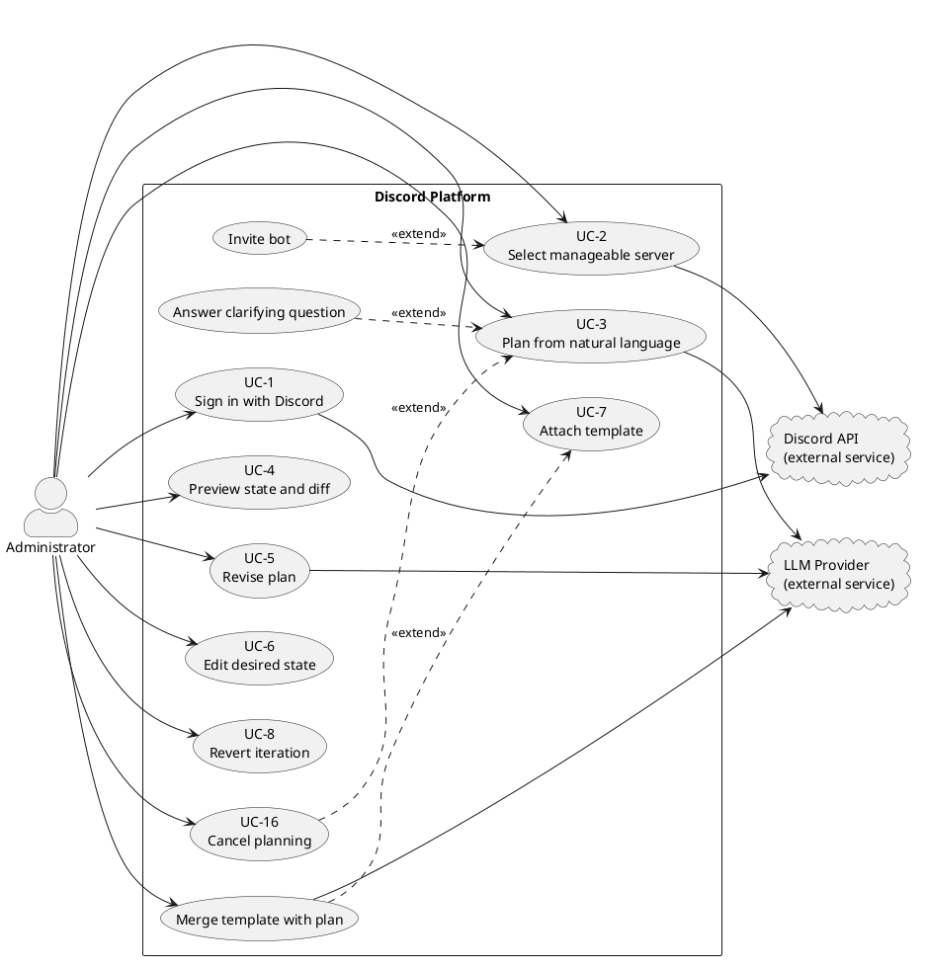
Figure 3.1: Use case diagram, access and planning

3.3.2 Approval and execution
Approval records the reviewed desired state as the contract to execute; it does not run validation or contact the LLM. At execution start, the system performs a fresh conflict check, a structural validation pass, and an LLM-based policy check against the stored server rules. The ordinary planning prompt does not currently receive those rules. When rules exist, the policy check fails closed if they cannot be loaded or evaluated; guilds without rules skip the policy call. This diagram shows the additional actors and flows introduced by execution: all execution and rollback operations contact Discord. The Check pre-execution conflicts and Validate plan use cases are included automatically in UC-10, ensuring revalidation happens before any live changes. Attempt structural rollback can be triggered by explicit user request (UC-11) or by execution failure (UC-17).
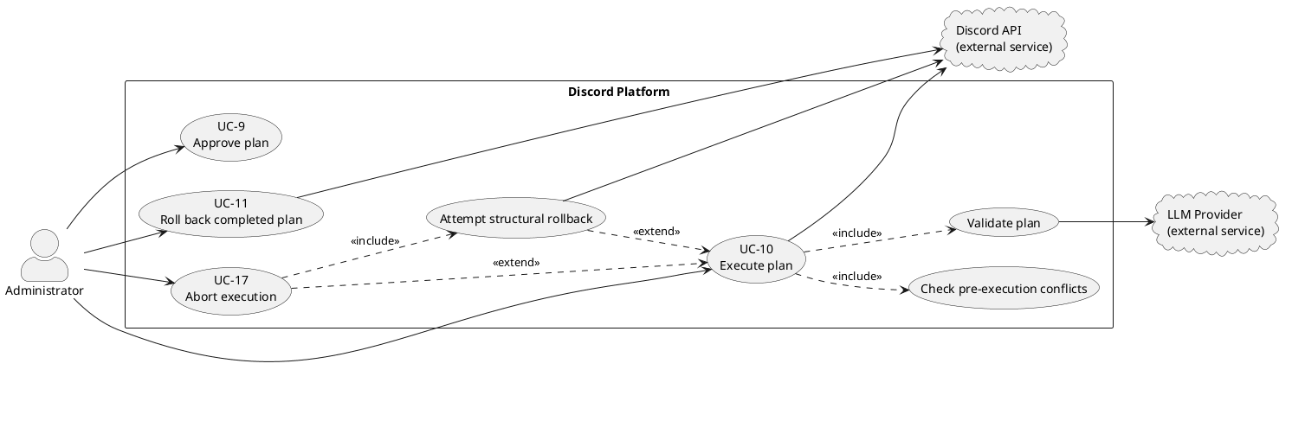
Figure 3.2: Use case diagram, approval and execution

3.3.3 Monitoring and management
The Scheduler detects external changes in the background. This is not an external system actor, it is an internal background job running as part of the platform's backend infrastructure, triggered periodically to check for drift. Detection and review are separated because the system records and reports drift, then waits for the administrator rather than refreshing or repairing a plan automatically. The Detect drift use case is internal and runs on a timer; the Re-plan stale plan with AI use case brings the LLM into the drift workflow. The platform records these events but does not act on them without explicit approval.
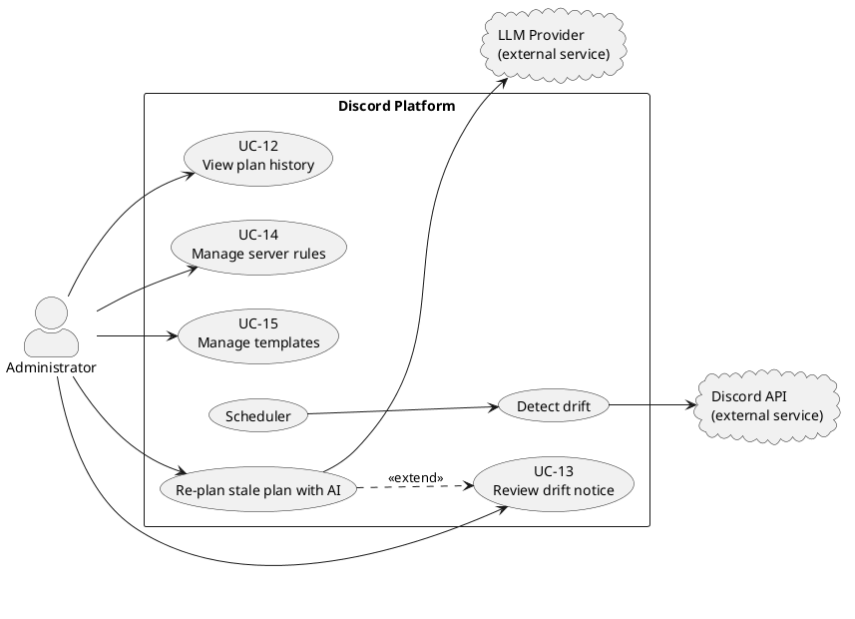
Figure 3.3: Use case diagram, monitoring and management
If drift affects an approved plan, Re-plan stale plan with AI can fork from current state while retaining the previous conversation and desired state as repair context. If no approved plan exists, the safe alternative is a new conversation from current state. Dismissing the visible notice does not remove the server-side hash check or make a stale plan executable.

3.4 Use Case Specifications
The diagram in Section 3.3 shows which use cases exist; this section specifies how all seventeen behave. Every use case records its actors, linked requirements, precondition, trigger, main success flow, alternative and exception flows, and postcondition. The grouping below reflects workflow only; it does not imply that one group is less important or less fully specified. These are normative requirements. Chapter 6 evaluates whether the final implementation fully, partially, or does not yet realise each one.
The administrator is the only actor in these specifications. Discord and the LLM provider are listed as supporting external services, not actors, because they do not initiate a goal against the platform. Where periodic drift checking is mentioned, the scheduler is an internal trigger rather than an actor.

3.4.1 Core use cases
UC-3: Plan from natural language
Field | Detail
Realises | FR-5, FR-6, FR-7, FR-8, FR-27
Primary actor | Administrator
Supporting services | LLM Provider
Precondition | Administrator is signed in, has selected a server they can manage, and the bot is operable on that server (FR-3).
Trigger | Administrator submits a natural-language request describing a change.
Main flow | 1. System records the current server state as the plan's comparison baseline. 2. System opens a planning conversation. 3. The planner turns the request into a structured desired state without touching Discord. 4. System streams each planning action to the administrator as it is added. 5. On completion, System stores the result as a new plan iteration and makes it available for preview.
Alternate flows | A1: Clarification (FR-7): if the request is ambiguous, the planner emits a clarifying question, the conversation enters waiting_for_user, and planning resumes once the administrator answers (see UC "Answer clarifying question"). A2: Cancel (FR-27): the administrator cancels an in-progress plan; System stops the planner and marks the conversation cancelled.
Exception flows | E1: Cache not ready: if the bot has not finished building its cache, the fork hash cannot be computed and System returns a retry-later error without creating a conversation. E2: Clarification timeout: if the administrator does not answer within the ask-user window, the session is cancelled and the conversation marked expired.
Postcondition | A previewable desired state exists as a plan iteration; the live server is unchanged (NFR-1).
UC-9: Approve plan
Field | Detail
Realises | FR-17, FR-21 (approval half)
Primary actor | Administrator
Supporting services | None
Precondition | A conversation exists with a completed planning session and at least one plan iteration; the administrator has reviewed the preview and diff (UC-4).
Trigger | Administrator approves the reviewed plan.
Main flow | 1. System re-checks that the administrator may manage the server. 2. System confirms that the plan's comparison baseline still matches the live server and that no other plan is executing against it. 3. System records the latest reviewed desired state as the approved plan of record. 4. System closes the planning session.
Alternate flows | None
Exception flows | E1: Stale view (FR-21): if the server changed since planning, System refuses approval and directs the administrator to start a new conversation. E2: Server busy: if another plan holds the guild lock, System refuses approval. E3: Session not completed: if planning is still running, System refuses approval.
Postcondition | A plan exists as the contract to execute; approval performs no validation and no live change. Validation is deferred to execution start (UC-10).
UC-10: Execute plan
Field | Detail
Realises | FR-15, FR-16, FR-18, FR-19, FR-20, FR-21 (execution half), FR-28
Primary actor | Administrator
Supporting services | Discord API, LLM Provider (policy validation against server rules)
Precondition | An approved plan exists; the bot is operable on the server; the administrator may manage the server.
Trigger | Administrator executes the approved plan.
Main flow | 1. System verifies that the plan may execute and its comparison baseline still matches the server. 2. System compares the approved desired state with current state to produce ordered changes. 3. System checks those changes for current-state conflicts, «include» Check pre-execution conflicts. 4. System runs structural validation and policy validation against stored server rules, «include» Validate plan, and reports any warnings. 5. System reserves the guild so no second execution can run concurrently. 6. System records a before-snapshot, applies each change through the bot, and streams start/completion/failure progress, with bounded retries for transient failures. 7. On success, System records an after-snapshot and reports completion.
Alternate flows | A1: Abort (FR-28): the administrator aborts mid-execution; System stops scheduling new steps and stops waiting for the current request, attempts rollback, and reports the outcome. The underlying Discord request may still settle because it cannot be cancelled after dispatch.
Exception flows | E1: Stale view (FR-21): server changed since planning → refuse as a conflict. E2: Conflict check fails: a current-state assumption fails → refuse with the list of conflicts; plan stays draft. E3: Validation fails (FR-15, FR-16): blockers found, or configured server rules cannot be loaded or evaluated → refuse with blockers and warnings; plan stays draft. A guild with no configured rules skips the policy check. E4: Server busy: lock held by another plan → refuse. E5: Step failure (FR-20): a step fails after retries → System attempts convergence to the before-snapshot and records the execution and rollback outcome. E6: Overall timeout (NFR-9): execution exceeds the overall deadline → stop waiting, attempt rollback, and release the lock.
Postcondition | On success, the live server matches the approved desired state and before/after snapshots are retained (NFR-5). On failure or abort, structural rollback is attempted and its outcome is reported; exact restoration is not guaranteed when Discord has discarded data, a rollback operation fails, or an already-dispatched request settles late.
UC-11: Roll back a completed plan
Field | Detail
Realises | FR-22, NFR-5
Primary actor | Administrator
Supporting services | Discord API
Precondition | A plan is in the completed state and its before-snapshot is retained; the bot is operable; the administrator may manage the server.
Trigger | Administrator requests an undo of a completed plan.
Main flow | 1. System loads the plan's before-snapshot. 2. System compares current server state with that snapshot to compute reversing changes. 3. If nothing differs, System reports that rollback is already satisfied. 4. Otherwise System reserves the guild for exclusive execution and applies the reversing changes through the bot. 5. System records and reports the outcome.
Alternate flows | None
Exception flows | E1: Not completed: the plan is not in the completed state → refuse. E2: Snapshot missing: the before-snapshot cannot be found → refuse. E3: Server busy: lock held by another plan → refuse.
Postcondition | If rollback succeeds, the server structure matches the plan's pre-execution snapshot within the limits of FR-20. If it fails, the plan remains failed and the error identifies that recovery was incomplete.
Note on rollback (E5 in UC-10 and UC-11): rollback is not a naive replay of the applied steps in reverse. In both cases System diffs the current live state against the target (pre-execution) state and executes that diff, so the server attempts to converge to the target structure even if some steps only partly applied. The Discord integration cannot cancel an operation already sent to Discord, so a timed-out or aborted request may finish after the engine has stopped waiting. Rollback is therefore a best-effort structural recovery mechanism, not a transactional guarantee, and it cannot restore data Discord discards on deletion.

3.4.2 Plan iteration and management use cases
UC-5: Revise plan
Field | Detail
Realises | FR-11
Primary actor | Administrator
Supporting services | LLM Provider
Precondition | An active, non-stale conversation has a completed turn and is not currently planning.
Trigger | Administrator submits a follow-up instruction about the current plan.
Main flow | 1. System verifies the administrator and conversation. 2. System sends the follow-up instruction with the existing conversation and desired state to the planner. 3. The planner updates the structured desired state. 4. System streams progress. 5. System stores the result as a new plan iteration.
Alternate flows | A1: Clarification: the planner pauses for an answer before completing the revision. A2: Cancel: the administrator invokes UC-16 and System restores the pre-turn desired state.
Exception flows | E1: Turn already in progress: refuse the overlapping revision. E2: Stale conversation: refuse and require drift recovery. E3: Provider failure: report the failure and preserve the last completed iteration.
Postcondition | A new revision exists or the previous completed iteration remains current; the live server is unchanged.
UC-6: Edit desired state
Field | Detail
Realises | FR-13
Primary actor | Administrator
Supporting services | None
Precondition | An active, non-stale conversation has a desired state and is not in a planning turn.
Trigger | Administrator saves a structured manual change in the desired-state editor.
Main flow | 1. System verifies access and checks that the conversation is editable. 2. Administrator adds, edits, moves, or removes a supported planned resource. 3. System validates the submitted structure. 4. System applies the change to desired state. 5. System records a new manual-edit iteration and refreshes the preview and diff.
Alternate flows | A1: Cancel edit: discard the unsaved UI change and retain the current iteration. A2: Multiple edits: repeat steps 2–5 for additional resources.
Exception flows | E1: Planning in progress: refuse the edit. E2: Stale conversation: refuse the edit. E3: Invalid structure: show validation details and leave the stored iteration unchanged.
Postcondition | The validated manual edit is the latest plan iteration, or no stored state changes after cancellation/failure; Discord remains unchanged.
UC-13: Review drift notice
Field | Detail
Realises | FR-24, FR-21
Primary actor | Administrator
Supporting services | Discord API and LLM Provider (only when AI repair is selected); an internal scheduler triggers periodic comparison
Precondition | Scheduled drift detection has found a difference between the live guild and the recorded view and has notified the administrator.
Trigger | Administrator opens or acts on the drift notification.
Main flow | 1. System shows that the guild changed externally and keeps stale approval/execution blocked. 2. Administrator reviews the notice. 3. Administrator chooses a recovery action. 4. System either starts repair from current state, starts a fresh conversation, or dismisses only the visible notice. 5. Any repaired result returns to preview and review.
Alternate flows | A1: Approved stale plan: invoke Re-plan stale plan with AI, preserving previous intent as repair context. A2: Unapproved conversation: start a new conversation from current state. A3: Dismiss: hide the notice while server-side stale-state protection remains.
Exception flows | E1: Fresh state unavailable: report that recovery cannot start and keep the plan blocked. E2: AI repair fails: preserve the old plan as stale and offer retry or a fresh conversation.
Postcondition | A repaired plan is ready for review, a fresh conversation exists, or the stale plan remains blocked; no automatic live-server change occurs.
UC-14: Manage server rules
Field | Detail
Realises | FR-25
Primary actor | Administrator
Supporting services | None
Precondition | Administrator is signed in and may manage the selected server.
Trigger | Administrator opens server rules and chooses to create, edit, or delete a rule.
Main flow | 1. System lists the server's rules. 2. Administrator enters or changes rule text. 3. System validates and saves the change. 4. System displays the updated rule set. 5. At a later execution, the policy check loads the stored rules; ordinary planning does not automatically receive them.
Alternate flows | A1: Delete: request removal, confirm it, and remove the rule. A2: Cancel: discard unsaved text.
Exception flows | E1: Unauthorized guild: refuse the request. E2: Invalid or missing rule: show validation/not-found feedback and preserve existing rules.
Postcondition | The persisted rule set reflects the successful change and applies to subsequent execution-stage policy checks.
UC-15: Manage templates
Field | Detail
Realises | FR-26
Primary actor | Administrator
Supporting services | LLM Provider (only when merge is selected)
Precondition | Administrator is signed in and may manage the selected server.
Trigger | Administrator opens template management and chooses to create, edit, delete, or merge a template.
Main flow | 1. System lists templates scoped to the server. 2. Administrator creates or selects a template. 3. Administrator edits its metadata and structure. 4. System validates and saves it. 5. System displays the updated template. 6. The template can later be attached through UC-7.
Alternate flows | A1: Delete: confirm and remove the selected template. A2: Merge: choose a template, start an AI-assisted planning turn, and return the merged desired state for review. A3: Cancel: discard unsaved edits.
Exception flows | E1: Unauthorized guild: refuse the request. E2: Invalid structure or missing template: show feedback and preserve stored templates. E3: Merge provider failure: report the failure without changing the live server.
Postcondition | The template set reflects successful CRUD changes, or a merged plan iteration is ready for review; the live server remains unchanged.

3.4.3 Access, review, history, and interruption use cases
UC-1: Sign in with Discord
Field | Detail
Realises | FR-1
Primary actor | Administrator
Supporting services | Discord API
Precondition | Administrator has a Discord account and can reach the platform.
Trigger | Administrator selects Sign in with Discord.
Main flow | 1. System redirects the browser to Discord OAuth2. 2. Administrator authenticates with Discord and authorizes the requested scopes. 3. Discord returns the browser to the platform. 4. System establishes a session and opens the server-selection view.
Alternate flows | A1: Existing session: System recognizes the valid session and skips re-authentication. A2: Cancel consent: Administrator returns unauthenticated.
Exception flows | E1: OAuth denial or callback failure: show a sign-in error and do not create a session. E2: Discord unavailable: report that authentication is temporarily unavailable.
Postcondition | Administrator has an authenticated platform session, or remains signed out; the platform never collects a local password.
UC-2: Select manageable server
Field | Detail
Realises | FR-2, FR-3, FR-4
Primary actor | Administrator
Supporting services | Discord API
Precondition | Administrator is signed in.
Trigger | Administrator opens the server picker or selects a server.
Main flow | 1. System obtains the administrator's Discord guild permissions. 2. System lists only guilds where the administrator holds Manage Server. 3. Administrator selects a guild. 4. System verifies that the bot is present and holds Administrator. 5. System opens the guild workspace.
Alternate flows | A1: Bot absent: offer the Discord bot invitation flow, then re-check membership. A2: Bot lacks _Administrator: explain the required permission. A3: Role operation planned later: execution additionally checks the bot above each targeted role.
Exception flows | E1: Permission changed: if Manage Server was removed, reject access and refresh the list. E2: Guild cache not ready: show retry-later feedback without starting planning.
Postcondition | A manageable, operable guild is selected, or the administrator receives the action required before configuration can continue.
UC-4: Preview state and diff
Field | Detail
Realises | FR-9, FR-10
Primary actor | Administrator
Supporting services | None
Precondition | A plan iteration and a current guild-state projection are available.
Trigger | Administrator opens the desired-state preview or a planning turn completes.
Main flow | 1. System loads the current desired state and current guild projection. 2. System presents categories, channels, roles, permissions, and member roles in a Discord-like view. 3. System marks additions, changes, and removals. 4. Administrator inspects the affected resources before deciding to revise, approve, or leave the plan.
Alternate flows | A1: Inspect detail: open a channel, role, member, or permission detail view. A2: No differences: state that the desired state already matches the current projection.
Exception flows | E1: Current projection unavailable: report that comparison cannot be completed and disable approval until current state is available. E2: Stale plan: show drift status and keep approval blocked.
Postcondition | Administrator can identify the planned outcome and its differences; viewing the preview does not modify Discord.
UC-7: Attach template
Field | Detail
Realises | FR-14
Primary actor | Administrator
Supporting services | LLM Provider (only for merge)
Precondition | An active, non-stale conversation and at least one accessible template exist.
Trigger | Administrator selects a template for the conversation.
Main flow | 1. System lists templates scoped to the selected guild. 2. Administrator chooses a template. 3. System attaches it to the conversation and makes its metadata/structure available as planning context. 4. The attached template is shown in the conversation. 5. A subsequent planning or merge turn can incorporate it into desired state.
Alternate flows | A1: Merge now: begin an AI-assisted merge and return the merged iteration for review. A2: Detach: remove the template from future planning context without changing completed iterations.
Exception flows | E1: Template missing or belongs to another guild: refuse the attachment. E2: Planning turn in progress: defer/refuse a context change until the turn is safe. E3: Merge failure: keep the prior desired state and report the provider error.
Postcondition | The template is attached for future planning, a merged iteration exists, or prior state is preserved; Discord remains unchanged.
UC-8: Revert iteration
Field | Detail
Realises | FR-12
Primary actor | Administrator
Supporting services | None
Precondition | An active, non-stale conversation has at least two iterations and is not in a planning turn.
Trigger | Administrator selects an earlier iteration and requests reversion.
Main flow | 1. System displays the iteration timeline. 2. Administrator selects an earlier version. 3. System loads its desired-state snapshot. 4. System restores that state as the current desired state. 5. System records the reversion as a new iteration and refreshes the preview.
Alternate flows | A1: Inspect only: view an iteration without reverting. A2: Cancel: close history and keep the current iteration.
Exception flows | E1: Planning in progress: refuse reversion until the turn finishes or is cancelled. E2: Stale conversation: require drift recovery. E3: Iteration missing: report that it can no longer be loaded.
Postcondition | The selected snapshot becomes the latest desired state through a new iteration, or current state remains unchanged; Discord is untouched.
UC-12: View plan history
Field | Detail
Realises | FR-23
Primary actor | Administrator
Supporting services | None
Precondition | Administrator is signed in and has selected a guild they may manage.
Trigger | Administrator opens plan history.
Main flow | 1. System verifies guild access. 2. System retrieves plans belonging to the selected guild. 3. System lists each plan with status, owner, creation/execution time, and outcome. 4. Administrator selects a plan. 5. System displays its approved changes and recorded result.
Alternate flows | A1: No history: display an empty state and a route to start planning. A2: Filter: narrow the list by status or date when supported.
Exception flows | E1: Unauthorized guild: refuse the request and return no records. E2: History unavailable: show a retryable loading error.
Postcondition | Administrator has reviewed stored plan history without altering a plan or the live guild.
UC-16: Cancel planning
Field | Detail
Realises | FR-27
Primary actor | Administrator
Supporting services | LLM Provider
Precondition | A planning or revision turn is in progress.
Trigger | Administrator selects Cancel planning.
Main flow | 1. System verifies access and finds the active planning session. 2. System aborts the outstanding LLM request. 3. System stops processing further model tool calls. 4. System restores the pre-turn desired-state snapshot when available. 5. System marks the conversation cancelled and reports cancellation.
Alternate flows | A1: Turn already completed: keep the completed iteration and report that no active turn remains to cancel.
Exception flows | E1: Session not found: return a not-running response without changing stored desired state. E2: Cancellation request interrupted: the user may retry; no Discord mutation can have occurred because planning is side-effect free.
Postcondition | The active planning turn no longer produces plan changes; the live server remains unchanged.
UC-17: Abort execution
Field | Detail
Realises | FR-28, FR-20
Primary actor | Administrator
Supporting services | Discord API
Precondition | An approved plan is currently executing.
Trigger | Administrator selects Abort execution.
Main flow | 1. System verifies the administrator and plan. 2. System signals the active execution to abort. 3. System stops scheduling new steps and stops waiting for the in-flight step. 4. System attempts to converge guild structure toward the before-snapshot. 5. System records and reports the execution and rollback outcome.
Alternate flows | A1: Abort between steps: no further step is dispatched before rollback begins. A2: In-flight request settles later: drift detection or subsequent review exposes any resulting divergence.
Exception flows | E1: Plan no longer executing: report that it cannot be aborted. E2: Rollback operation fails: record and report residual divergence. E3: Already-dispatched Discord request: it cannot be cancelled and may complete after the engine stops waiting.
Postcondition | Execution is no longer actively scheduling work and a rollback outcome is recorded; exact pre-execution restoration is not guaranteed.

3.5 Business Rules and Constraints
The functional and non-functional requirements say what the system does and how well. This section states the rules the system must uphold regardless of implementation, the constraints imposed on it from outside, and the concrete numeric limits it is currently configured with.

3.5.1 Business rules
Business rules are domain invariants: they would remain true even if the system were rewritten in a different language or framework. They state the required behavior; the Testing and Evaluation chapter assesses whether each rule is fully, partially, or not yet enforced by the final implementation.
ID | Rule | Rationale | Enforced via / traces to
BR-1 | No change is applied to a live server without explicit human approval of the specific plan. | The platform mutates real servers on the user's behalf; unattended change is unacceptable. | NFR-1, FR-17
BR-2 | At most one plan may execute against a given server at any time. | Concurrent executions would race on the same channels, roles, and overwrites. | NFR-3; per-server execution lock
BR-3 | A plan built on a stale view of the server must not be approved or executed. | Acting on an out-of-date view could destroy or duplicate resources the user never saw. | FR-21, NFR-4; conversation fork hash compared to live state
BR-4 | A server may be configured only when the bot is present and holds Administrator. For role edits, moves, deletions, or member-role assignment, the bot must also be above every role targeted by the plan. | Discord role hierarchy limits role operations, but does not require a globally highest bot role for channel- or category-only work. | FR-3; targeted pre-execution hierarchy validation
BR-5 | The AI planner may affect the system only through the fixed, validated tool set; it never reaches Discord directly. | Constrains the AI's blast radius and makes every AI action previewable and validatable. | NFR-19; tool registry
BR-6 | Every intended change is expressed as declarative desired state diffed against reality, never as blind imperative commands. | Enables preview, validation, and convergent rollback. | NFR-18; diff engine
BR-7 | Planning and preview have no side effects on the live server. | Users must be free to explore and revise without consequence. | NFR-1, NFR-16
BR-8 | Only users holding Manage Server on a target server may plan or execute against it, and each server's data is isolated. | Multi-tenant safety and least privilege. | FR-2, FR-4, NFR-11
BR-9 | Failed or aborted executions trigger an automatic best-effort attempt to converge the server's structure toward its pre-execution snapshot, and the outcome is reported. | Partial changes should be recovered where Discord permits, without presenting rollback as an infallible transaction. | FR-20, FR-28, NFR-2

3.5.2 Constraints
Constraints are limits the system does not get to choose; they come from the platforms and protocols it depends on.
ID | Constraint | Consequence for the system
C-1 | Discord enforces API rate limits. | State is read from an in-memory cache during planning; transient rate-limit errors are retried with backoff (NFR-8, NFR-6).
C-2 | Discord's role hierarchy governs what the bot may modify. | The bot must sit above every role it manages (BR-4); a plan cannot manage roles above the bot.
C-3 | Discord permanently discards some data on deletion, message history in removed channels, and the original numeric IDs of deleted resources, and the bot integration exposes no cancellation hook for an already-dispatched operation. | Rollback can only attempt structural convergence; it cannot recover discarded data or guarantee that a late in-flight operation will not create new drift (FR-20, FR-28, NFR-2, NFR-5).
C-4 | Authentication is delegated to Discord OAuth2. | The system stores no passwords and cannot authenticate users Discord does not (NFR-10).
C-5 | AI planning requires an external, OpenAI-compatible LLM endpoint. | The planner depends on a configured provider; the interface is provider-agnostic so the model can be swapped (NFR-22).
C-6 | The system targets self-hosted deployment on a single host with a local database. | No dependence on managed or serverless-only services (NFR-23).

3.5.3 Configured limits
The following numeric values are current configuration, not domain rules: they are tuned for a responsive single-host deployment and can be changed without altering the system's behaviour in principle. They are listed here so the requirements above are not misread as mandating specific durations.
Limit | Value | Purpose
Clarification response window | 2 minutes | If the administrator does not answer a clarifying question in time, the planning session expires (UC-3, E2).
Per-step execution deadline | 30 seconds | The engine stops waiting for a step and retries it rather than stalling the whole execution; the underlying Discord request cannot be cancelled (NFR-9).
Overall execution deadline | 5 minutes | A stuck execution stops scheduling work, attempts rollback, and releases its lock (NFR-9).
Retries per step | 3 (4 total attempts) | A transient failure can be retried three times after the initial attempt, with backoff between attempts (NFR-6).
Drift detection interval | 60 seconds | How often the Scheduler polls for external changes (UC "Detect drift", FR-24).
Execution lock TTL / heartbeat-stale threshold | 30 minutes / 5 minutes | A crashed executor's lock is eventually reclaimed so a server is not locked forever (NFR-3).
Execution snapshot retention | 30 days | Before/after execution snapshots remain available for rollback until their expiry time (NFR-5).
Snapshot cleanup interval | Daily | Old before/after snapshots are pruned on a daily sweep.

3.6 Legal, Social, Ethical and Professional Issues
A system that authenticates real people and reshapes live community spaces on their behalf raises concerns beyond its functional behaviour. This section examines those concerns under four headings, and for each it distinguishes what the current design already addresses from the risks that remain open. The professional analysis is framed against the British Computer Society (BCS) Code of Conduct (BCS, 2022), the relevant professional standard for this work.

3.6.1 Legal issues
Data protection (UK GDPR / GDPR). The system processes personal data about two groups. For signed-in administrators it stores a name, email address, avatar, Discord identity, session IP address and user-agent. It also reads the usernames, Discord IDs, and role assignments of ordinary guild members so the planner can reason about member-role changes. Some of that guild structure is sent to the configured LLM provider in the system prompt and can be persisted inside conversation messages and desired-state iterations. The second group may never use this platform directly and should not be treated as if accepting the administrator-facing service automatically covers their data.
The relevant principles (European Union, 2016) include lawfulness, fairness and transparency, data minimisation, purpose limitation, storage limitation, integrity and confidentiality, and accountability. Contractual necessity may support the processing needed to provide the service to the signed-in administrator, but a controller would need to identify and document an appropriate lawful basis for processing other members' data rather than assume the same basis applies.
Addressed: authentication is delegated to Discord OAuth2, so no passwords are stored (NFR-10); operations and persisted resources are scoped to an authorised guild (NFR-11); and conversations, plans, plan ownership, status transitions, and execution timestamps provide a partial technical audit trail (NFR-13).
Open risks: there is no automated data-retention or erasure mechanism. Conversation content and plan history accumulate without a purge policy (only execution snapshots are pruned, on a daily sweep), which sits awkwardly with the storage-limitation principle and a data subject's right to erasure. A production deployment would need a documented retention schedule, deletion and export paths, and a privacy notice that explains administrator and guild-member data flows.
The external LLM provider is a further processing recipient. A production operator would need to establish the controller/processor relationship, review the provider's retention and model-training terms, execute an appropriate data processing agreement, and assess any international transfer mechanism. The current application makes the endpoint configurable but does not itself prove that a selected provider satisfies those obligations. Data minimisation should also be revisited: member identifiers and usernames should be omitted or pseudonymised when the requested plan does not require member-level reasoning.
Credential handling. The system holds OAuth access and refresh tokens and the bot token, credentials that, if leaked, grant real control over user accounts and servers.
Addressed: secrets are supplied through environment configuration and are never exposed to the client or logged in cleartext (NFR-12).
Open risks: OAuth access and refresh tokens are persisted in the database as plaintext columns (a Better Auth default), rather than encrypted at rest. On a self-hosted single-host deployment (C-6) a database compromise would expose them. Encryption at rest, or delegating token custody entirely, would reduce this exposure.
Third-party terms. As a Discord bot and API consumer, the system is bound by Discord's Developer Terms of Service and API terms, including rate limits and acceptable-use rules; violations can result in the bot being banned. The design respects the API's rate limits and permission model (NFR-21, C-1, C-2), but ongoing compliance is an operational responsibility, not a one-off guarantee.

3.6.2 Social issues
Power asymmetry over a shared space. A Discord server is a shared social environment, but only administrators use this platform. A single administrator can restructure channels, roles, and members that many other people inhabit, and those members have no visibility into, or say over, the AI-generated plan. The tool amplifies an administrator's reach, a sentence of natural language can become dozens of structural changes, which concentrates power and raises the cost of a careless or ill-intentioned instruction.
Addressed: the system limits who can act to holders of Manage Server (BR-8), so it does not widen the circle of people who can reshape a server beyond those Discord already trusts. It also makes changes deliberate rather than accidental: nothing is applied without an explicit, reviewed approval (BR-1).
Open risks: the platform does nothing to inform or involve the wider membership of a server whose structure is about to change; that remains a matter of the administrator's own judgement and the server's social norms. The tool could also encourage over-frequent restructuring simply because it is cheap.
Deskilling and over-reliance. Because the system turns intent into action without the user needing to understand Discord's underlying model (NFR-15), administrators may lean on it in place of learning the platform, and may approve plans they do not fully understand. The Discord-like preview and explicit diff (FR-9, FR-10, NFR-14) are the main mitigation. They aim to make the outcome legible before approval, but they do not remove the risk that a user rubber-stamps a plan.
Accessibility. As a web application the Studio interface should meet accessibility expectations so administrators with disabilities can review plans on equal terms. The requirements touch this only indirectly through the familiar-preview goal (NFR-14); full conformance would require dedicated evaluation and is not yet claimed.

3.6.3 Ethical issues
AI acting on real infrastructure. The central ethical tension is that a language model, which can misread intent or hallucinate, proposes changes to a live server that real communities depend on. The system's whole architecture is a response to this: the AI can act only through a fixed, validated tool set and never touches Discord directly (BR-5); every intended change is expressed as declarative state and shown as a preview and diff before anything happens (BR-6, FR-9, FR-10); and no change is applied without an explicit human approval (BR-1). The human-in-the-loop approval gate is the core ethical safeguard: a person, not the model, authorises every live change.
Informed consent and transparency. The preview and diff turn approval into informed consent: the administrator approves the shown outcome, not merely their original sentence. When the system detects that the server has drifted, it notifies and waits rather than silently reconciling (UC-13), keeping the human in control.
Open risks: informed consent is only as strong as the reviewer's attention. A plausible but subtly wrong plan can still be approved; structural validation (FR-15) and the policy check against server rules (FR-16) catch certain classes of error, but neither can stop a technically valid plan that is simply not what the user meant.
Accountability when things go wrong. If an execution causes harm, responsibility is genuinely distributed across the administrator who approved it, the platform that generated it, and the model provider. The design supports investigation by retaining the plan owner/approver, conversation, plan content, statuses, results, and execution timestamps (NFR-13). It does not currently record a separate executedBy identity when another authorised administrator starts execution, so it cannot always attribute approval and execution to two distinct people. Failed executions trigger automatic structural rollback (BR-9, FR-20), but that recovery is best effort.
Open risks: rollback can attempt to restore structure, not data Discord discards on deletion (C-3). A plan that successfully but wrongly deletes a channel full of history causes irreversible loss even though the system did exactly what it was told. An aborted or timed-out Discord request may also finish after the engine stops waiting because the Discord integration provides no cancellation hook for the in-flight operation. These residual risks mean the design can narrow harm through preview, approval, validation, and recovery, but cannot promise transaction-like reversal.

3.6.4 Professional issues
The work is assessed here against the four principles of the BCS Code of Conduct (BCS, 2022): the public interest, professional competence and integrity, duty to relevant authority, and duty to the profession.
Public interest. The principle requires having due regard for the privacy, security, and wellbeing of others. The design serves this through multi-tenant isolation and least-privilege secret handling (NFR-11, NFR-12) and through the safety-first stance that protects the servers of people who never touch the tool. Open gap: the outstanding data-protection issues in Section 3.6.1 (no retention or erasure policy and OAuth tokens stored in plaintext) would need to be resolved before a deployment could claim to fully discharge this duty, and are recorded honestly here rather than presented as solved.
Professional competence and integrity. The plan-first, declarative architecture (BR-6, NFR-18), the constrained AI surface (BR-5), schema validation at system boundaries (NFR-20), and the layered safety mechanisms (approval, validation, rollback, locking) reflect deliberate engineering for a high-risk domain rather than expedient shortcuts. Integrity is also served by stating the system's limits plainly: the irreversible-deletion risk, the pragmatically chosen (not empirically derived) timeout values, and the reliance on reviewer attention, instead of overstating the guarantees.
Duty to relevant authority. The system respects the authority of the platform it operates on: it works only through Discord's supported bot APIs and honours its rate limits and permission hierarchy (NFR-21, C-1, C-2) rather than circumventing them, and it authenticates through Discord's own OAuth rather than creating a parallel credential store (NFR-10).
Duty to the profession. Deploying AI that acts on live systems is an area where careless work reflects on the field. Building in preview, explicit approval, reversible exploration, and automatic rollback, and documenting the residual risks, models a responsible way to put an LLM in control of real infrastructure, in contrast to systems that let a model act unchecked.
In summary, the design already addresses the core professional obligations around competence, platform authority, and safe AI deployment, while the main open gaps are the data-protection concerns of Section 3.6.1. Recording those gaps rather than concealing them is itself part of acting professionally.

Chapter 4: System Design
Chapter 3 described the system from the outside: what an administrator can do and the qualities the system must have. This chapter turns inward and describes how the system is built and behaves to meet those requirements. It proceeds from the high-level architecture, the overall shape and the major components, down to the detailed design of individual parts: the data model, the key algorithms, the API surface, the user interface, and the security design.
Unless explicitly identified as a target or open gap, statements in this chapter describe the current implementation. Chapter 3 remains the normative statement of required external behavior; Chapter 6 will assess which requirements the final build fully or partially satisfies.

4.1 System Architecture

4.1.1 The driving idea
Every significant structural choice in this system follows from one problem: a large language model, which can misread intent or fabricate output, must be allowed to reshape a live Discord server that real communities depend on. The architecture's job is to make that safe. Its answer is indirection: a series of deliberate gaps between the model's intent and irreversible reality, so that nothing the AI produces reaches Discord without first being made declarative, previewable, validatable, and recoverable where Discord permits.
Four architectural commitments realise this, and each traces directly to a requirement from Chapter 3:
- Plan-first and declarative (BR-6, NFR-18). The system never issues blind imperative commands. It represents the intended outcome as desired state, diffs that against the server's actual state, and applies only the computed difference. The diff is the unit of change, which is what makes preview and convergent rollback possible.
- The AI is boxed in (BR-5, NFR-19). The planner can only emit calls to a fixed registry of validated tools; it has no path to Discord.js. This bounds what the AI can express and guarantees every AI action is inspectable.
- An abstraction seam decouples execution logic from Discord (NFR-18). The execution engine and executable tool functions depend on an ExecuteContext interface rather than Discord.js. The bot supplies the concrete Discord.js implementation. Planning and diffing remain separately testable through domain types and desired state; validation is not entirely behind this seam because it reads stored rules and bot role-position information.
- Human approval gates every live change (BR-1, NFR-1). Planning and preview have no side effects; only an explicit, reviewed approval moves a plan toward execution, and failures trigger an automatic structural recovery attempt.
The remainder of this section presents the architecture at three levels of zoom: system context, containers, and the plan-first data flow. It then records the three architectural decisions that most shape the system.

4.1.2 System context
At the widest zoom, the platform is a single system used by one external human actor and depends on two external services. The administrator drives every workflow from the browser. The scheduler is an internal background task within the platform's own backend infrastructure. It periodically triggers drift detection; it is not an external actor. Discord is both the system of record the platform reads from and the system it applies changes to, and the LLM provider turns natural language into structured plans.
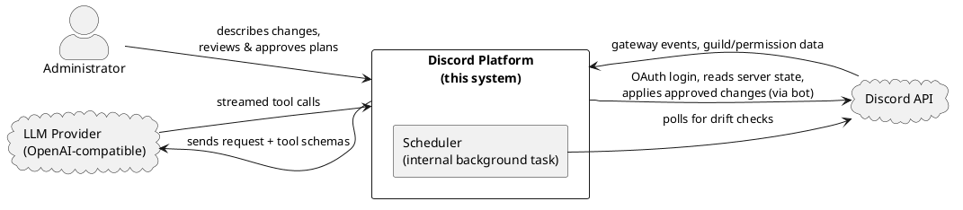
Figure 4.1: System context diagram
The system boundary is meaningful: the administrator never talks to Discord or the LLM directly, and the AI never talks to Discord. All external relationships pass through the platform, which is where every safety control lives. The Scheduler sits inside the boundary because it is application code the project built: a periodic timer in the backend that detects drift, not a third-party service.

4.1.3 Container diagram
Zooming in, the system is organised as a pnpm monorepo with two runnable applications and two shared packages. The term "Container" here refers to the C4 model vocabulary: a Container is a separately runnable or deployable unit, such as an application or data store, rather than a Docker container (Brown, n.d.). In this architecture, each Container represents either a process (web app, server) or a persistence layer (database).
- Web app (apps/web): a Vite + React single-page application. It hosts the Studio, where the administrator describes changes, watches the Discord-like preview update live, and approves plans. State is held in Zustand; styling is Tailwind. It talks to the server over a REST API and receives live updates over Server-Sent Events (SSE).
- Server (apps/server): a single Node.js process that runs both the Hono HTTP API and the Discord.js bot. This co-location is deliberate (Section 4.1.5): the API reads the server's current structure from the bot's in-memory cache with no extra Discord calls. The server also owns the planning engine, diff engine, execution engine, validation, locking, and drift detection.
- Shared package (packages/shared): the pure domain core: the tool registry, the desired-state model and store, the diff-relevant types, permission constants, and the ExecuteContext interface. It depends on neither Discord.js nor the database, so it is portable and directly testable.
- Database package (packages/db): the Drizzle ORM schema, migrations, and client. PostgreSQL persists conversations, plan iterations, plans, snapshots, rules, templates, and drift events.
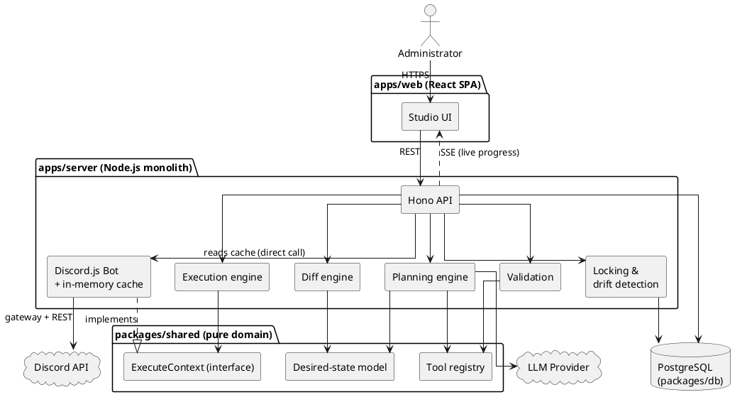
Figure 4.2: Container architecture diagram
Two edges in this diagram carry the architecture's central ideas. First, Exec --> ECtx and Bot ..|> ECtx: the execution engine depends only on the ExecuteContext interface, and the bot is the concrete implementation that fulfils it against Discord.js. This isolates step dispatch and makes the execution engine testable with a plain mock context, although validation still reads Discord-derived role positions through the bot permission helpers. Second, API --> Bot : reads cache: the API reads live server structure by a direct in-process call into the bot's cache, not over the network, the reason the two run as one process.

4.1.4 The plan-first data flow
The defining behaviour of the system is the pipeline a request travels along, from natural language to applied change. It has a strict property: side effects on Discord occur only in the final stage, and only after a human approval. Every earlier stage operates on in-memory or persisted state, never on the live server.
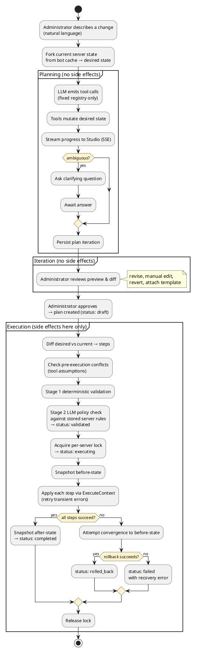
Figure 4.3: Activity diagram, plan-first data flow
Three aspects of this flow are worth drawing out, because they are where the architecture earns its safety properties:
- The desired state is checked again against current cached reality. A fork hash of the bot-maintained server-state projection is taken when planning begins; at approval and execution the system rebuilds that projection from the current custom cache and compares its hash. Execution also re-diffs the desired state against that projection. This is not a synchronous Discord REST fetch, but it is refreshed through gateway lifecycle events and protected by the separate drift detector. If the hash changed, approval or execution is refused and an unexecuted plan can enter the confirmed AI re-plan flow (FR-21).
- Validation runs at execution start, not at approval. Approval only records the reviewed desired state as the contract to execute; the pre-execution conflict check, Stage 1 deterministic checks, and Stage 2 LLM policy check run at the start of execution. Stage 2 loads the stored server rules and a summary of the computed steps; those rules are not currently injected into the ordinary planning prompt. This ordering matters because a check at approval could pass and then execute minutes later against changed state. A current limitation is that a rule-conflicting proposal may reach review before Stage 2 identifies it. At execution, however, configured rules fail closed: rule-load failure, missing LLM configuration, provider failure or timeout, and empty or malformed responses all become block-level issues before any Discord mutation.
- Rollback is convergent, not a reverse replay. On failure the system does not undo steps one by one. It diffs the current live state against the before-snapshot and executes that diff, attempting to converge the server back to its starting structure even if steps only partly applied. This is best-effort recovery rather than a transaction. Discord discards message history and original IDs on deletion, rollback steps can themselves fail, and Discord.js cannot cancel a request already dispatched; a timed-out or aborted request may therefore settle after the engine has begun recovery (C-3, FR-20, FR-28).

4.1.5 Key architectural decisions
Three decisions shape the system more than any other and are recorded here with their rationale and trade-offs.
Monolithic backend (API and bot in one process). The Hono API and the Discord.js bot run in a single Node.js process and communicate by direct function calls rather than a message broker. The driving reason is the cache: the bot maintains an in-memory view of every guild's structure via the Discord gateway, and planning needs to read that structure constantly. Co-location lets the API read it as a plain in-process call, avoiding per-request Discord calls (and their rate-limit cost, C-1) and keeping planning reads low-latency (NFR-8). A second reason is that the bot needs a persistent gateway WebSocket, which rules out serverless hosting, and LLM planning can take tens of seconds, which rules out short serverless timeouts. The trade-off is horizontal scalability: the two cannot be scaled independently. This is acceptable for the target self-hosted, single-host deployment (C-6, NFR-23); a future split into separate processes with a shared cache over Redis or PostgreSQL notification remains possible without changing the domain logic.
Server-Sent Events over polling or WebSockets. Planning and execution progress are pushed to the Studio over SSE (for example, GET /api/plan/:id/stream). The communication is one-way (server → client) and append-only, a live log of steps, which is exactly SSE's shape, so the bidirectional complexity of WebSockets is unnecessary. Browser EventSource attempts reconnection automatically. The planning stream replays its latest terminal event to a late subscriber, preventing a fast completion or clarification request from leaving the Studio stuck. Intermediate planning events and execution progress are not replayed, so reconnection does not necessarily restore the complete log. SSE also carries only server-to-client traffic; client actions (approve, revise, abort) use ordinary REST calls, which fits since those are discrete commands rather than a stream.
The constrained AI surface as a design element. Although described above as a safety commitment, the tool registry is also a concrete architectural component worth naming here: it is a fixed list of tool definitions in packages/shared, each pairing a JSON-schema parameter definition (for the LLM) with a pure plan function that mutates desired state and an optional getAssumptions function used by the pre-execution conflict check. The planner can do nothing the registry does not define, and because the tools live in the pure domain package, they can be validated and tested without the LLM or a live Discord connection. Current automated coverage is partial rather than complete; the final coverage and requirement evidence belong in Chapter 6.

4.2 Component and Service Design
Section 4.1 described the containers and the pipeline that runs through them. This section zooms one level further in, to the individual components inside the server that do the work, and specifies each one's responsibility, its inputs and outputs, and the design choices that shape it. The components are grouped by the stage of the pipeline they serve: the domain core they all build on, then planning, then diff, then validation, then execution, and finally the cross-cutting infrastructure (locking, drift detection, event buses) that the others rely on.
The unifying design rule across all of them is the one established in Section 4.1.1: side effects on Discord are confined to the execution stage, and everything before it manipulates in-memory or persisted state. That rule is why most of these components can be pure functions or depend only on an interface, and why the codebase can test roughly two thirds of the server logic with a plain mock object rather than a live Discord connection.

4.2.1 The domain core (packages/shared)
Every other component builds on a small, dependency-free domain package. It imports neither Discord.js nor the database, which is what makes it portable and directly unit-testable, and it is the single place where the shape of a plan is defined.
- Domain types (types.ts). The vocabulary the whole system speaks: ServerState (the current structure of a guild), DesiredState (the planned structure), PlanStep (one ordered, executable change), and the supporting Role, ChannelBase, PermissionOverwrite, MemberRole, and Tombstone types. Because these types are shared, the planner, diff engine, validation, and execution engine all agree on what a plan is without importing each other.
- The desired-state model and store (state/). DesiredState is the central data structure of the system: the declarative description of what the server should look like after execution. It is not a plain snapshot, it carries active items (things that should exist), tombstones (things explicitly deleted during planning), and a symbol counter for naming not-yet-created resources. Every mutation flows through DesiredStateStore, which is the single choke point that validates a change before it is applied (no duplicate names, referenced roles exist, and so on) and generates symbols for new resources. No planning tool touches DesiredState directly; they all call the store. fork.ts builds a store from a captured ServerState, which is how planning begins from the server's real structure.
- The tool registry (tools/). The fixed catalogue of seventeen tools the planner may call, described as an architectural element in Section 4.1.5. Each tool pairs a Zod parameter schema (converted to a JSON schema for the LLM) with a pure plan() function that mutates desired state through the store, an optional execute() function that applies the change through the ExecuteContext interface, and an optional getAssumptions() function that declares the pre-execution conditions the change relies on (for example, "parent category still exists", "no name conflict"). Two tools are marked planning_only and are never dispatched during execution. ask_user is handled specially by the planning loop, which pauses until the administrator answers. batch_set_overwrite applies several overwrite changes to desired state in one call; the diff later emits individual set_overwrite steps.
- The ExecuteContext interface (execute-context.ts). The seam between execution logic and Discord. Tool execute() functions and the execution engine depend on this interface, never on Discord.js. The concrete implementation lives in the bot (Section 4.2.6). This is the single decision that makes the execution engine testable with a mock context.
- Server-state hashing (hash-server-state.ts). A stable stringify plus SHA-256 that reduces a ServerState to a forkStateHash. This hash is the mechanism behind stale-state protection (NFR-4): planning records the hash of the state it forked from, and approval and execution recompute it to detect whether the server changed underneath the plan.
- Constants (constants.ts). Discord permission metadata and permission-name/bitfield conversion helpers, the channel-type mapping, and the plan-status, step-status, and snapshot-type enumerations.

4.2.2 The planning engine
The planning engine turns natural language into a DesiredState. Its job is to drive a constrained conversation with the LLM, dispatch the tool calls the LLM emits, and stream progress, all without touching Discord.
- Planning session (planning-session.ts). The core state machine. It is not a simple loop: it can pause on an ask_user call, hold its state in server memory, and resume when the administrator answers. On each turn it builds the system prompt (which encodes the four-phase planning model, roles, then layout, then access control, then members, and restricts which tools are legal in each phase), sends the conversation plus the tool schemas to the LLM, and dispatches each returned tool call through the registry into the store. Validation happens at dispatch: Zod checks the parameter shape, then the store checks state-level constraints, and only then is desired state mutated. A turn cap (maxTurns = 20) prevents a runaway loop; on exhaustion the session force-completes with an explanatory summary. The pause-and-resume design is necessary because a single LLM exchange can last several seconds and an ask_user pause is indefinite, blocking a thread for that duration is impractical. Decoupling the session object from the HTTP request lets the route return immediately and the administrator's reply resume the same session later.
- Session manager (session-manager.ts). An in-memory registry of active PlanningSession objects keyed by conversation, plus the timeouts that expire an ask_user pause that is never answered. Sessions live in memory deliberately (Section 4.4): a server restart loses an in-flight LLM turn, so startup marks planning and waiting rows as interrupted. Completed iterations remain durable and can still be reviewed and approved without the old session.
- LLM transport (llm-request.ts, stream-parser.ts). A thin layer over a raw streaming fetch to an OpenAI-compatible chat-completions endpoint, configured entirely by LLM_BASE_URL / LLM_API_KEY / LLM_MODEL. The stream parser accumulates tool-call deltas across SSE chunks and separates the model's thinking text from its answer text. Keeping the transport this thin is what satisfies provider-agnostic integration (NFR-22): swapping models is a configuration change, not a code change.
The engine emits its progress at tool-call granularity, not token by token: a tool call is dispatched the moment it is fully accumulated, and a tool_called / tool_result pair is streamed to the Studio so the preview re-renders live. The administrator sees the level that matters, which tools ran and what they did, rather than a stream of raw tokens. Emitting at this granularity is also what makes the planning side-effect free: every tool call mutates only DesiredStateStore and nothing on Discord, so the entire planning output can be inspected, revised, or discarded without any cleanup cost.

4.2.3 The diff engine
The diff engine (diff-engine.ts) is the component that makes the system declarative. It is a pure function, (ServerState, DesiredState) → PlanStep[], and it makes no decisions of its own: no heuristics, no rename detection, no scoring. It reads explicit state, active items, tombstones, symbols, and emits the corresponding Discord steps. This "dumb and deterministic" stance is a deliberate design choice, argued at length in the design docs: any cleverness here (for instance, guessing that a delete-plus-create was "really" a rename) would be brittle and would take a judgement call away from the human reviewer, who is far better placed to make it.
It runs in three phases:
- Generate raw steps. For each active item: if it carries a real Discord ID it is existing (emit an edit_* step if it differs, skip if identical, flag a conflict if it has vanished from the server); if it carries a symbol it is new (emit a create_* step). Overwrites and member roles are diffed symmetrically, anything present in the server but absent from desired state becomes a removal, because, unlike channels and roles, they gain nothing from a tombstone audit trail. Each tombstone becomes a delete_* step.
- Topological sort. Steps are ordered by TOOL_ORDER (categories before the channels that live in them, roles before the members assigned to them, creation before the overwrites that reference the created items, deletions last) and by an explicit dependency graph over symbols. A post-sort pass resolves any symbol-like reference that actually points at a pre-existing resource back to its real Discord ID.
- Optimise. Merge multiple edits to the same Discord ID into one step, then drop no-op steps (an edit whose field set turned out empty).
The output is an ordered PlanStep[] plus a symbol table recording which step defines each symbol, the input the execution engine resolves against.

4.2.4 The validation subsystem
Validation (validation.ts) runs at the start of execution, not at approval (Section 4.1.4). It is the one part of the pre-execution path that is not fully behind the ExecuteContext seam, because it reads stored server rules and the bot's role position. It is organised as two stages.
Stage 1: deterministic checks (no LLM). Five groups run in order and are pure functions over the plan steps and desired state, so they are fast and fully unit-testable:
- A. Permissions and hierarchy: permission names are valid; the bot holds ADMINISTRATOR (hard block); and no step edits, moves, deletes, or assigns a role positioned above the bot's highest role (the hierarchy invariant behind FR-3).
- B. Dependencies: every symbolic reference resolves to a defined symbol of the right type, and the dependency graph is a sortable DAG with no cycles or dangling indices.
- C. Resource constraints: no duplicate names among created items, no duplicate member-role operations, category child counts within Discord's limit of 50, and channel-type constraints (a topic only on text/announcement, a bitrate only on voice/stage).
- D. Safety guards: block granting ADMINISTRATOR to a plan-created role unless explicitly requested; warn when the plan may exceed the execution time budget; warn when two unsynced channels in a category carry identical overwrites that could be consolidated up to the category.
- E. Plan integrity: the plan has at least one step and a legal status.
The design docs record several checks that were deliberately left out, per-action permission checks (redundant under ADMINISTRATOR), "won't delete important channels" guards (they contradict the present-don't-judge philosophy), and a planData schema check (the data is produced internally by the diff engine, never parsed from untrusted input). These omissions are design decisions, not gaps, and Chapter 6 treats them as such.
Stage 2: server-rule policy check (validateWithLLM). Per-guild natural-language rules are checked by a second LLM pass that reads the rules plus a summary of the computed steps and returns block/warning issues. It no-ops when no rules exist. When rules do exist, the check has a 30-second request bound and fails closed if the rules cannot be loaded, no LLM key is configured, the provider fails, or its response is empty or malformed.
This second pass is a semantic defence-in-depth layer, not independent verification or a security guarantee. It is useful because deterministic validators cannot generally infer the meaning of a rule such as "do not delete the announcements channel unless approved." However, an LLM can still misinterpret a rule or plan, and using the same provider or model family for planning and validation creates shared reliability limitations. The additional call also adds latency, cost, and provider availability dependence. Hard, recurring constraints are therefore candidates for later representation as structured policy fields that deterministic validators can enforce.
The selected design combines early prompt guidance with the fail-closed execution backstop. An authorised guild's current rule text is loaded when a PlanningSession is created and retained with that session. The shared prompt builder places the rules in a clearly labelled policy section and tells the planner to explain a conflict or request clarification instead of deliberately producing a violating state. Because clarification, revision, template-context changes, template merges, and confirmed stale-plan repair all use the same session prompt builder, rebuilt prompts retain both the original server context and the loaded rules.
Prompt inclusion improves proposal quality but is not enforcement. A session retains the rule set it began with, so rules changed during a long review may not appear in that session's prompt. Stage 2 therefore reloads the current rules at execution and remains authoritative: changed, unavailable, or violated rules block execution and require the administrator to revise or re-plan. This avoids treating an LLM's compliance with prompt text as a security boundary.
A related pre-execution step, the conflict check, runs each step's getAssumptions() against fresh state before Stage 1. When it fails, execution is blocked outright, there is no force-apply, and the administrator can invoke the confirmed AI re-plan flow (POST /plans/:planId/replan), which re-forks from current state and asks the planner to adapt the plan, preserving the conversation and prior intent.

4.2.5 The execution engine
The execution engine (execution-engine.ts) is the only server component that causes side effects on Discord, and it is the component where the recoverability requirements (NFR-2, NFR-6, NFR-9) are realised. It receives an ordered PlanStep[], a symbol table, and an ExecuteContext, and applies the steps. Confining all Discord mutations here, behind the ExecuteContext interface, is a deliberate seam: the planning engine, diff engine, and validation subsystem never touch Discord directly, which keeps them fully unit-testable and makes the execution context the single target for integration hardening.
- Symbol resolution. Before each step, symbols in its parameters are replaced with the real Discord IDs recorded as earlier steps completed ($cat_0 → the ID Discord returned when the category was created). Tools only ever receive resolved IDs; resolution is an engine-level concern, not a tool concern.
- Retry with backoff (NFR-6). Each step is attempted up to MAX_RETRIES = 3 additional times on a transient error (network/5xx/timeout), with exponential backoff (1 s → 2 s → 4 s) and ±25% jitter. Discord.js handles 429 rate-limit backoff itself. Known permanent errors (403/404/400) are diagnosed through a hardcoded fix map and fail the step; unknown errors fail the step too, the engine never asks the LLM to diagnose an execution error.
- Two deadlines (NFR-9). A per-step deadline (DEFAULT_STEP_TIMEOUT_MS = 30 s) stops the loop from blocking forever on one hung Discord call, and an overall execution deadline (EXECUTION_TIMEOUT_MS = 5 min, enforced in the plans route via an AbortController) stops the engine scheduling new work. Both bound the engine's wait; neither can cancel a Discord request already in flight, so a timed-out request may still settle later, a limit stated plainly in Chapter 3 and honoured in the reporting.
- Convergent rollback (NFR-2). On any permanent step failure, abort, or overall timeout, rollbackFull() does not replay steps in reverse. It reads fresh Discord state, forks the before-snapshot into a DesiredState, runs the diff engine to compute the reverse delta, and executes that as an ordinary plan. This converges the server toward its starting structure even if steps only partly applied, and handles external changes since execution uniformly. It is best-effort structural recovery, not a transaction: Discord discards message history and original IDs on deletion, and a rollback step can itself fail. The engine reports the outcome, success or residual divergence, rather than claiming unconditional restoration.

4.2.6 The bot and its cache
The Discord.js bot (bot/) is the system's window onto Discord, and it plays two distinct roles.
- Live state cache (bot/cache.ts, bot/index.ts). The bot maintains an in-memory projection of every guild's structure, kept current by gateway lifecycle events (ChannelCreate/Update/Delete, GuildRoleCreate/…, GuildMemberAdd/…, GuildCreate/Delete). Because the API runs in the same process (Section 4.1.5), planning reads this projection as a direct in-process call, with no Discord round-trip and no rate-limit cost, the mechanism behind low-latency planning reads (NFR-8).
- ExecuteContext implementation (bot/execute-context.ts). The concrete fulfilment of the domain interface: every Discord.js call the execution engine needs, and nothing more. It is stateless and throws on failure, leaving retry, rollback, and tracking to the engine above it.
- Permissions and formatting (bot/permissions.ts, bot/formatter.ts). Reads the bot's own ADMINISTRATOR status and role position (used by validation), and renders the cached ServerState into the compact structured text the planner receives upfront.

4.2.7 Cross-cutting infrastructure
Three smaller services support the pipeline without belonging to any single stage.
- Locking (locking.ts). Enforces single execution per server (NFR-3) through a lock held in the guilds row (currentPlanId plus acquire / heartbeat / release timestamps). acquireGuildLock is a conditional update that succeeds only when no lock is held, so two concurrent executions cannot both win. Stale locks are recoverable: a background job (startPeriodicLockCleanup, every 5 minutes, also run at boot) clears any lock older than a 30-minute TTL or without a heartbeat for 5 minutes, which is how a crashed execution frees its guild.
- Drift detection (drift-detector.ts, bot/index.ts). Relevant channel, role, and member-role changes observed through the Discord gateway immediately emit and persist a guild-scoped drift event. Events observed while an execution lock is held are suppressed as expected plan effects. A scheduled poll (every 60 s) remains as a consistency check between the Discord.js and application caches; detected mismatches are also persisted and streamed over SSE. Detection and remedy are deliberately separated: the system reports drift and then waits for the administrator (FR-24), rather than refreshing a plan automatically. The server-side stale hash check remains in force regardless of whether the visible notice is dismissed.
- Event buses (event-bus.ts, planning-event-bus.ts) and snapshot cleanup (snapshot-cleanup.ts). Two small pub/sub buses decouple the engines from the SSE endpoints, one per plan for execution events, one per conversation for planning events, so a component emits progress without knowing who is listening. A daily cleanup job deletes snapshots past their 30-day retention (NFR-5) and orphaned plan iterations.

4.3 Database Design
The system persists to a single PostgreSQL database, defined as a Drizzle ORM schema in packages/db/src/schema.ts. The schema serves two purposes that shape its design: it is the durable audit record required by NFR-13 (conversations, plans, and executed outcomes survive restarts and are available for review), and it is the recovery store required by NFR-5 (before/after snapshots retained so a completed plan can be reversed). Ephemeral planning state, the in-flight LLM loop, the live DesiredState being mutated within a turn, is held in server memory, not the database (Section 4.4); what reaches the database is the committed record of a plan iteration, not the working state.
A convention runs through the schema. Every table carries id, createdAt, and updatedAt; column names are snake_case in SQL and camelCase in TypeScript; resource-scoped tables carry a guildId that both links to the owning guild and serves as the isolation boundary enforced above the database (NFR-11); and larger structured payloads, desired state, plan steps, snapshot contents, are stored as jsonb rather than being decomposed into relational columns, because they are read and written as whole documents by the domain code and are never queried field-by-field in SQL.

4.3.1 Entity–relationship overview
The tables fall into three groups: the authentication tables managed by Better Auth (users, sessions, accounts, verifications), the guild-scoped configuration and audit tables (guilds, conversations, plan_iterations, plans, snapshots, rules, templates, drift_events), and no others. The diagram below shows the guild-scoped core and its links to the user and guild anchors; the Better Auth session/account/verification tables are omitted for readability, as they hang off users in the conventional way.
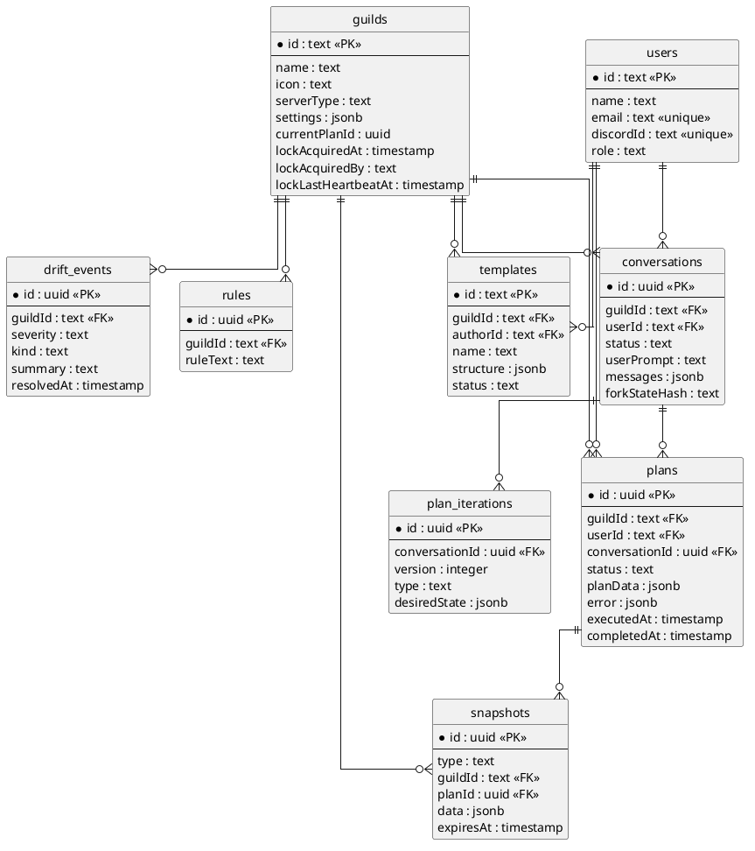
Figure 4.4: Entity–relationship diagram, database schema
Two relationships in this diagram carry the plan-first model. A conversation owns an ordered series of plan iterations (version unique per conversation), each holding one DesiredState document and tagged by how it was produced, llm_generated, manual_edit, or revert. This is the iteration history that powers preview, revert (FR-12), and manual editing (FR-13). A plan is the contract created at approval; it links back to the conversation that produced it and forward to the snapshots taken around its execution, so the executed outcome is always traceable to the reviewed intent (NFR-13).

4.3.2 Key tables
The tables below carry the system's core behaviour; the Better Auth tables are standard and are not detailed here.
- guilds. The anchor for a Discord server and, notably, the home of the execution lock (Section 4.2.7). Rather than a separate lock table, the lock is four columns on the guild row, currentPlanId, lockAcquiredAt, lockAcquiredBy, lockLastHeartbeatAt, so that "acquire the lock" is a single conditional UPDATE … WHERE current_plan_id IS NULL that PostgreSQL serialises for us (NFR-3). settings and serverType are per-guild configuration; subscriptionTier exists but is currently unused. icon stores the Discord CDN icon URL captured from the bot's Guild object when the row is first created (GuildCreate, Section 4.2.6) and is not refreshed if the server's icon changes afterward. The guild-list and guild-detail routes include it in their JSON response, but the currently routed Studio guild picker (Section 4.5.1) renders only the guild name and member count, the icon-as-avatar rendering exists only in the retired, unrouted Dashboard and Setup pages, so the column is populated and exposed by the API without a live consumer today.
- conversations. The top-level planning unit and the LLM audit log. It stores the originating userPrompt, the full messages array as jsonb, a status (active, waiting_for_user, cancelled, expired, …), and the forkStateHash, the SHA-256 of the server state the conversation forked from, which is the value stale-state protection (NFR-4) compares against.
- plan_iterations. One row per saved desired-state version within a conversation. desiredState is the full jsonb document; version is unique per conversation (a uniqueIndex enforces it); type records provenance. These rows survive server restarts, which is what lets a user reopen a conversation and revert to an earlier iteration even after the in-memory session is gone.
- plans. The approved contract and its execution record. planData holds the ordered steps as jsonb; status moves through the lifecycle (draft → validated → executing → completed / rolled_back / failed); executedAt and completedAt timestamp the run; and error captures a structured failure for actionable reporting (NFR-17). Indexed by guildId and userId for history queries (FR-23).
- snapshots. Server-state captures for rollback (NFR-5). type distinguishes the before- and after-execution snapshots; data is the full ServerState as jsonb; planId links the snapshot to its plan; and expiresAt drives the 30-day retention cleanup. Indexed by (guildId, type), by planId, and by expiresAt so the cleanup job can scan efficiently.
- rules. Per-guild natural-language policy strings (ruleText) consumed by the Stage 2 policy check (FR-16, FR-25). Deliberately unstructured free text, which is why enforcing them requires an LLM rather than a deterministic check.
- templates. Reusable configuration templates scoped to a guild (structure as jsonb, plus name, description, category, tags, status). Attachable to a conversation and mergeable into a plan (FR-14, FR-26).
- drift_events. The persisted output of the drift detector: severity, kind, summary, and details, indexed by (guildId, createdAt) for history. The table also defines a resolvedAt column and a (guildId, resolvedAt) index intended for an open/resolved distinction, but no code path currently writes or reads resolvedAt, the live Studio drift toast (Section 4.5.4) is driven entirely by the in-memory SSE event the drift detector emits, not by a database query. The column is schema-defined groundwork for future drift-resolution tracking, not a wired-up feature (FR-24).

4.3.3 Design choices worth noting
Two choices are worth calling out because they trade query flexibility for a simpler, document-oriented model that matches how the domain code uses the data.
First, planData, desiredState, and snapshot data are opaque jsonb documents. The domain code reads and writes them whole (plan.planData as unknown as PlanData), so decomposing them into relational tables would buy nothing and cost a great deal of mapping. The accepted trade-off is analytical rather than operational: because the individual steps inside a plan are not broken out into columns, a future reporting feature, for example, "how many plans deleted a voice channel last month?", could not be answered with an ordinary indexed WHERE clause. It would require either a GIN index over the jsonb document, which is heavier to maintain and more awkward to query than a B-tree index on a normalized column, or a separate extraction step that materializes the fields of interest. This is a deliberate limitation logged as a Phase-2 item (making planData queryable), not a defect: the product has no analytics surface today, and where a table genuinely does need to be filtered by its contents, drift_events, indexed by guild and creation time, the schema already uses normalized, indexed columns rather than burying those fields in jsonb. drift_events also carries a resolvedAt column and index for a resolution-status filter, but that filter is not yet queried by any route; see Section 4.3.2. The document-oriented choice is therefore applied only where the value is consumed as a whole.
Second, the four Better Auth tables are owned by the auth library, not by application code. They follow Better Auth's expected shape (a password column exists on accounts, for instance, even though the system uses Discord OAuth exclusively and never populates it). The application reads them but does not manage their schema, and the rare raw-SQL access the codebase needs targets these tables specifically. This is why the security design (Section 4.6) can state that no local password is ever stored despite the column existing.

4.4 API and Data Flow Design
Section 4.1.4 described the plan-first pipeline at the level of stages and safety properties. This section makes that pipeline concrete: the shape of the HTTP API the Studio calls, the conventions every endpoint shares, and the request/response sequences of the two flows that carry the most weight, starting a planning conversation and executing an approved plan. Where 4.1.4 answered what happens and why it is safe, this section answers how a client drives it.

4.4.1 API design and shared conventions
The backend exposes a single HTTP API mounted under /api, composed in hono/app.ts from seven route modules plus a small set of top-level endpoints. The API is resource-oriented and mostly nested under a guild (/api/guilds/:guildId/...), because almost every operation is scoped to one Discord server. It is not a strict REST/CRUD API: several endpoints are commands (/plans/:planId/execute, /conversations/:convId/approve) rather than resource mutations, which matches a domain where the interesting operations are verbs, plan, approve, execute, roll back, not row edits.
Every request passes through a fixed middleware chain before reaching a handler, and the order matters:
- CORS, credentialed CORS is scoped to the configured web origin (WEB_APP_URL, default http://localhost:5173), because the browser sends the session cookie cross-origin.
- Rate limit, a sliding-window limiter caps traffic at 100 requests per minute (hono/middleware/rate-limit.ts), applied to all of /api/* (NFR-9).
- Bot-ready gate, every /api/* handler awaits the botReady promise before running. This is a deliberate correctness guard, not just startup hygiene: a request served before the guild cache is populated would fork a plan from an empty state and silently corrupt the planning contract. Blocking until the cache is warm makes that class of bug impossible.
- Authentication, authMiddleware resolves the Better Auth session from the cookie and attaches the user to the Hono context; requireUser throws a 401 if absent. The SSE stream endpoints remain inside this bot-ready and authentication chain, then run an additional resource lookup and guild authorization before subscribing. Only the Better Auth handler itself sits outside the protected api composition so that a session can be created.
On top of that chain, individual handlers apply two more checks that recur across the whole API and are worth naming once here rather than repeating per endpoint:
- Guild authorization. Guild-scoped handlers call userHasManageGuild(userId, guildId) and return 403 if the caller lacks the Discord Manage Server permission on that guild. Authentication proves who you are; this proves you may act on this server (FR-2). It is detailed in Section 4.6.
- Guild operability. Command handlers that touch a guild call checkGuildOperable / checkGuildAccess, which confirm the bot is actually in the guild and its cache entry exists. A missing guild returns 404, while a bot that is present but lacks ADMINISTRATOR returns 403; transient failures while resolving a user's Discord membership are converted to 503 by the global error handler. This separates "you are not allowed" from "the system cannot act right now", so the Studio can retry an availability failure without treating it as a permission failure.
Request bodies and query strings are validated at the boundary with Zod via Hono's zValidator, so a malformed request is rejected with a 400 before any handler logic runs and every handler can treat its input as well-typed. Response conventions are uniform: JSON throughout, resource creation returns 201, and errors return a JSON object with an error string (plus, for the execution pipeline, structured conflicts / blockers / warnings arrays so the Studio can render actionable messages rather than a bare string). A single app.onError handler centralises the failure contract, it maps HTTPException to its status, converts an internal DiscordApiError into a 503 ("Discord API is temporarily unavailable"), and collapses everything else to a 500 so an unexpected throw never leaks an internal error shape to the client.
The client side mirrors these conventions in one place. The web app routes every call through an apiFetch wrapper (apps/web/src/lib/api.ts) that attaches credentials, sets the JSON content type, and treats a 401 as a global signal to clear auth state and redirect to /login. Because that behaviour lives in the wrapper, no individual component has to handle session expiry.
The table below summarises the surface. HTTP verbs are grouped per resource; the three stream endpoints are Server-Sent Event streams rather than ordinary responses. The plan and conversation streams are covered in 4.4.4; the drift stream is covered in Section 4.2.7.
Resource / endpoint | Methods | Purpose
/api/health | GET | Liveness, DB reachable, bot connected (unauthenticated)
/api/auth/* | GET, POST | Better Auth handler (Discord OAuth2 sign-in/callback/session)
/api/me | GET | Current authenticated user
/api/bot | GET /status, GET /invite | Bot connection status; OAuth invite URL
/api/guilds | GET (list), GET /:id, PATCH /:id | Guilds the user manages; server type & settings
/api/guilds/:g/rules | GET, POST, PUT /:id, DELETE /:id | Server policy rules (Stage 2 input)
/api/guilds/:g/state etc. | GET /state, /channels, /roles | Read the cached current server state
/api/guilds/:g/drift/stream | GET (SSE) | Live external-change (drift) notifications for the guild
/api/guilds/:g/plans | GET, GET /:id, POST | List / read / create a plan
/api/guilds/:g/plans/:id/* | POST execute, abort, rollback, replan | Execution lifecycle commands
/api/guilds/:g/conversations | GET, GET /:id, POST | List / read / start a planning conversation
/api/guilds/:g/conversations/:id/* | POST approve, revise, cancel, ask-user, revert/:v, edit-state, template attach/detach | Planning-loop commands
/api/guilds/:g/templates | GET, GET /:id, POST, PUT, DELETE, POST /:id/merge | Template CRUD + LLM merge
/api/plan/:id/stream | GET (SSE) | Live execution progress
/api/conversations/:id/stream | GET (SSE) | Live planning progress

4.4.2 Flow: starting a planning conversation
The most characteristic request in the system is POST /api/guilds/:guildId/conversations, the client sends a natural-language prompt and the server begins an LLM planning session. What makes it architecturally interesting is that the HTTP response does not carry the plan. The request returns almost immediately with a conversation record, and the actual planning work streams over a separate SSE channel. The POST is a kick-off; the /conversations/:id/stream endpoint is where the result arrives.
The handler (conversations.ts) runs the following sequence:
- Validate the body (userPrompt) with Zod, then authorise the caller against the guild.
- Fork the current state. It builds a ServerState from the bot cache and computes a forkStateHash (SHA-256) over it. This hash is persisted on the conversation row and is the anchor for every later stale-state check, it records exactly which version of reality the plan was formed against. If the cache is not yet populated, hashing fails and the handler returns 503 with a retry message rather than forking from nothing.
- Persist the conversation (status: "planning", empty message log, the fork hash) and return it to the client.
- Start the planning session as an in-process background task. A PlanningSession is created with an emit callback wired to the conversation event bus; the session runs the LLM tool-calling loop independently of the HTTP request that started it.
From that point the client opens GET /api/conversations/:id/stream and receives the planning progress live: streamed reasoning, each tool call and its effect on the desired state, and finally either a completed event or an ask_user event. The emit callback also drives the conversation's persisted status as a side effect, waiting_for_user when the LLM asks a clarifying question, completed when it finishes, expired on error or timeout, so the database always reflects the live session even though the work is detached from any single request.
Two details in this flow are load-bearing. First, ask_user is not a dead end: when the LLM needs clarification it emits the question over SSE and arms a two-minute timeout; the client answers with POST /conversations/:id/ask-user, which resumes the same in-memory session. If the timeout fires first, the session is cancelled and the conversation is marked expired. Second, the forkStateHash captured here is what later lets execution detect that the world moved: the same hash is recomputed at execution time and compared, which is the mechanism behind the 409 described next.

4.4.3 Flow: executing an approved plan
POST /api/guilds/:guildId/plans/:planId/execute is the only endpoint that mutates Discord, and it is where the safety machinery of Section 4.1.4 becomes a concrete, ordered gauntlet of checks. Each check maps to a specific HTTP status so the Studio can distinguish "the plan is stale" from "the plan is invalid" from "someone else is executing." The handler runs them in this order, returning at the first failure:
- Operability + authorization, checkGuildOperable (404/403) and userHasManageGuild (403), as for every command.
- Load and state-check the plan, the plan must exist for this guild (404) and be in draft or approved status (400); a plan mid-execution or already completed cannot be re-run.
- Stale-state detection (409). If the plan is tied to a conversation, the server rebuilds ServerState from the current cache, recomputes its hash, and compares it to the conversation's forkStateHash. A mismatch means the server changed since planning began, so execution is refused with 409 and canAIRepair: true, the signal the Studio uses to offer the confirmed AI re-plan flow (FR-21) rather than a dead error.
- Re-diff (409). The desired state is diffed against current reality. If the diff reports conflicts, for example the plan edits a channel that no longer exists, it returns 409 with the conflict messages.
- Pre-execution assumption checks (409). Each step's tool assumptions (parent exists, no name collision, bot hierarchy) are evaluated against the current state; any failure returns 409 with the specific messages.
- Stage 1 deterministic validation (400). validatePlan runs the hard-coded check groups; blockers return 400 with structured blockers/warnings arrays. On success the plan advances to status: "validated".
- Lock acquisition (423). acquireGuildLock takes the per-guild execution lock via a conditional UPDATE. If another plan holds it, the endpoint returns 423 Locked, the status that names exactly this condition, and the guild serialises rather than executing two plans concurrently.
Only after all seven gates pass does the handler snapshot the before-state, apply each step through a DiscordExecuteContext, and stream progress over the plan event bus. Two timers bound the work: a per-step deadline inside the execution engine and a five-minute overall AbortSignal.timeout that aborts the run mid-step. A heartbeat interval refreshes the lock so a long-but-healthy execution is not reclaimed by the stale-lock sweeper.
The terminal outcomes are deliberately explicit. On success the plan is marked completed, an after-snapshot is stored, and the JSON response reports { success, steps, error }. On failure the handler updates the plan to failed and, if a before-snapshot was captured and the bot is still connected, attempts the convergent rollback described in 4.1.4, streaming rollback_started and per -step rollback events. If the bot disconnected mid-execution it skips rollback because it cannot safely compute the reverse diff without a live cache. The current catch path records the plan as failed and returns 500; the log makes the skipped rollback explicit so the partial mutation can be investigated rather than pretending that recovery succeeded. A finally block always clears the abort controller, stops the heartbeat, and releases the lock, so no failure path can strand the guild in a locked state. As a final consistency step, sibling conversations whose forkStateHash no longer matches the new reality are marked stale and their in-memory sessions cancelled, the same drift the drift detector would otherwise catch, applied immediately at the moment the server changed.

4.4.4 Server-Sent Events for live progress
Both long-running flows report progress over SSE rather than in the HTTP response, because both are one-way, append-only logs, precisely SSE's shape, as argued in 4.1.5. The two stream endpoints (/api/plan/:id/stream, /api/conversations/:id/stream) share a structure: they authorise the caller against the resource's guild, emit an initial streaming_ready status, then subscribe to the relevant in-process event bus (event-bus for execution, planning-event-bus for planning) and forward each event to the client as a typed SSE message. A 30-second heartbeat keeps the connection alive through proxies, and an onAbort handler unsubscribes when the client disconnects so the bus does not leak subscribers.
This is the read side of an asymmetric design: the server pushes progress over SSE, but every client action, approve, revise, execute, abort, is an ordinary authenticated REST call. Those are discrete commands, not a stream, so forcing them through a bidirectional socket would add complexity for no benefit. The Studio therefore holds one EventSource open per active resource and issues normal POSTs alongside it.
The event buses are in-process rather than durable logs. The planning bus retains the latest terminal event (ask_user, completed, error, or expired) so a subscriber that attaches after a fast turn still reaches the correct phase. Intermediate planning events and execution events emitted during a disconnect are not replayed. The design mitigates this at the point where it matters most rather than by making the complete stream durable: the authoritative record is the persisted resource (the conversation's iteration history, the plan's status and step results), not the event log. Accordingly the client treats SSE as a live accelerator and REST as the source of truth, on a terminal event such as completed it re-fetches the conversation over REST to load the full iteration history and latest desired state, so a reconnect that misses intermediate events still converges on correct final state. The remaining limitation is mid-execution granularity: if the connection drops during a long execution, the per-step progress that elapsed during the gap is not recoverable in the timeline, only the final persisted outcome. A general fix would be a REST endpoint that returns the full ordered event log for a resource on reconnect (or SSE Last-Event-ID replay from a durable buffer); this is noted as future work rather than built, because the persisted-resource re-fetch already restores correctness of state, and only live progress detail is affected.

4.4.5 Asynchronous commands as a cross-cutting pattern
The two flows above share one shape worth stating as a design principle, because it recurs across the API: a command that triggers long work returns quickly with a handle, and the work reports separately over SSE. Starting a conversation returns the conversation row while the LLM keeps planning; approving returns a plan handle, and the subsequent execution reports its progress over the plan stream. This keeps request handlers short and within normal HTTP timeouts even though the underlying operations, LLM loops of tens of seconds, executions of up to five minutes, run far longer than any single response should. It is the API-level expression of the same separation the whole architecture rests on: the request records intent, and the actual effects unfold, observably, behind it.

4.5 User Interface Design
The user interface is designed around the platform's central safety rule: an administrator should be able to describe, inspect, revise, and understand a server change before authorising it. The primary workspace is therefore not a conventional settings dashboard. It is a chat-native Studio that places the natural-language conversation beside a persistent, Discord-like representation of both the current and desired server states. This arrangement keeps the request, the planner's progress, the proposed result, and the approval controls within one visual context (FR-5–FR-13, FR-17, NFR-14–NFR-16).
The diagrams in this section are deliberately low-fidelity. The sitemap records navigation and route ownership, while the wireframes record information hierarchy, major controls, and the relationship between panes. They are design artifacts rather than evidence of the rendered application. Screenshots of the implemented interface are consequently reserved for Chapter 5, where they can be presented alongside the implementation they evidence.

4.5.1 Information architecture and sitemap
The application has a shallow information architecture. Discord OAuth sign-in is the only public workflow; after authentication, the Studio is the hub from which an administrator chooses a guild, opens a conversation, previews a plan, manages rules, or enters the template library. Keeping these tasks under one authenticated shell avoids the split mental model of a separate "AI chat" and "server dashboard." The template library and editor remain separate routes because their wider forms and editable structure benefit from the full content width, but both return directly to the selected guild's Studio.
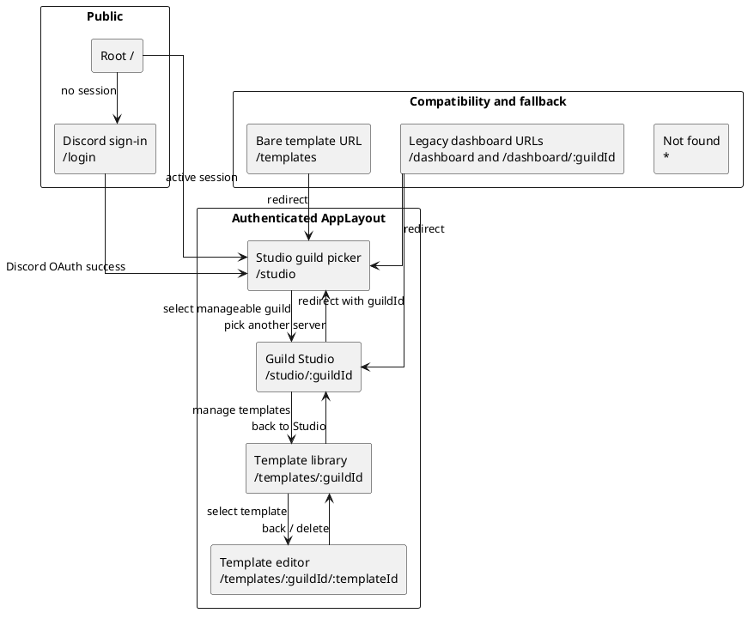
Figure 4.5: Sitemap and routing diagram
The route guard in App.tsx encloses every Studio and template route in AppLayout. If no authenticated session exists, navigation to any protected route is replaced with /login; an authenticated user who visits /login is sent to /studio. The layout contributes the global header, product identity, the Studio navigation item, signed-in user identity, and sign-out, while the selected route supplies the workspace beneath it.
The main routes have the following interface responsibilities:
Route | Primary interface responsibility
/login | Begin Discord OAuth2 sign-in; no local-password form is presented.
/studio | List guilds available to the signed-in administrator and provide the bot-invite empty state when no guild is ready.
/studio/:guildId | Host conversation history, natural-language planning, desired-state review, execution progress, drift feedback, templates, and rules for one guild.
/templates/:guildId | Search and browse the selected guild's saved template library.
/templates/:guildId/:templateId | Edit template metadata and structure, fork a copy, or delete the template.
The old Dashboard is intentionally absent from the active sitemap. Existing /dashboard links are compatibility redirects to the Studio, and the retained Dashboard.tsx and Setup.tsx source files are not routed. This consolidation matches the product's dominant workflow: choose a server, describe a target, and review the resulting state in one place.
The first wireframe shows the authenticated entry state. At this point the conversation and preview columns are not yet meaningful, so StudioShell collapses their optional slots and gives the guild chooser the working area.
┌──────────────────────────────────────────────────────────────────────────────┐
│ Discord Platform Studio [User] Sign out │
├──────────────────────────────────────────────────────────────────────────────┤
│ Studio │
├──────────────────────────────────────────────────────────────────────────────┤
│ │
│ Select a guild to plan against │
│ │
│ ┌──────────────────────────┐ ┌──────────────────────────┐ │
│ │ Community Server │ │ Support Server │ │
│ │ 428 members│ │ 91 members │ │
│ └──────────────────────────┘ └──────────────────────────┘ │
│ │
│ Empty alternative: │
│ "No guilds ready yet" + explanation + [Invite the bot] │
│ │
└──────────────────────────────────────────────────────────────────────────────┘
Only guilds returned by the authorised guild-list endpoint are offered. If the list is empty, the page explains that the bot must be invited with Administrator permission and provides the generated Discord OAuth invite link. This makes the missing precondition actionable instead of presenting an empty selector (FR-2, FR-3).

4.5.2 Studio shell and visual hierarchy
After a guild is selected, the Studio becomes a three-column desktop workspace under two headers. The global AppHeader preserves application identity and session controls. Directly below it, StudioHeader identifies the active guild and provides a "Pick a server" route back to the guild chooser. The working surface then divides into a 256-pixel conversation sidebar, a flexible central conversation, and a 480-pixel preview panel. The fixed side columns make the history and structural preview stable while the centre absorbs changes in viewport width.
Each column has one primary responsibility:
- Conversation history (left). ConversationSidebar starts with New Chat, then groups persisted conversations into Today, Yesterday, and Earlier. Each row uses the initiating prompt as its recognisable label, includes its current status, and loads the selected conversation into the centre pane. The sidebar can collapse its contents to icon-only controls, reducing visual distraction while retaining the column's allocated width.
- Intent and decisions (centre). ChatArea is the workflow surface. It begins with curated request suggestions and a free-form prompt, then renders the user's request, planning events, clarification controls, the completed desired state, and execution results as a chronological conversation. The controls that change lifecycle state, revise, edit, approve, save as a template, rollback, and start over, appear next to the result they affect.
- Current and desired structure (right). RightPanel behaves like an editor tab strip. Server and Desired are persistent tabs; the latter displays an empty instruction until a conversation produces desired state. The + menu opens closable Roles, Members, Templates, and Settings tabs. Selecting a channel in the Server tab opens a closable channel-detail tab with its type-specific settings and permission overwrites.
The following wireframe captures the full Studio in its plan-review state. It shows the most information-dense state because it contains all three objects the administrator must compare before approval: the original intent, the generated proposal, and the current/desired server representation.
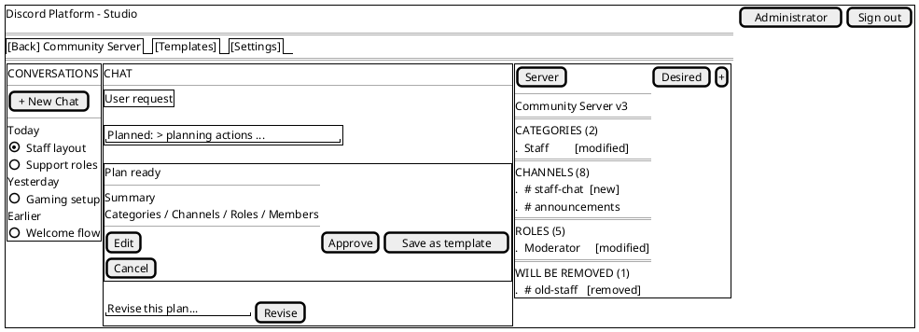
Figure 4.6: Wireframe - Studio shell in plan-review state
The layout deliberately duplicates the desired-state representation in two places. The completed assistant bubble keeps the proposal and its decision buttons together in the conversational record, while the Desired tab gives the same structure a persistent inspection surface independent of chat scrolling. Both use DesiredStateView, so categories, channels, roles, members, removal sections, and diff badges have identical semantics in either location.
The visual language is Discord-inspired rather than a pixel-for-pixel Discord copy. Categories and channels follow Discord's familiar hierarchy; roles and member assignments are shown as structured lists; dark shell surfaces, subdued borders, and the Discord-like accent support recognition without implying that the preview is the live Discord client. The right panel remains explicitly labelled Server or Desired, which is essential: visual similarity must not blur the distinction between reality and a proposal (NFR-14, NFR-18).

4.5.3 Conversation lifecycle and interaction states
The central pane is governed by a small, explicit UI state model. The useConversation hook owns the active identifiers, phase, planning and execution event logs, desired and current states, iteration list, errors, and in-flight guard. ChatArea renders one set of controls for each phase, so the administrator is led through the workflow rather than being presented with all possible commands at once.
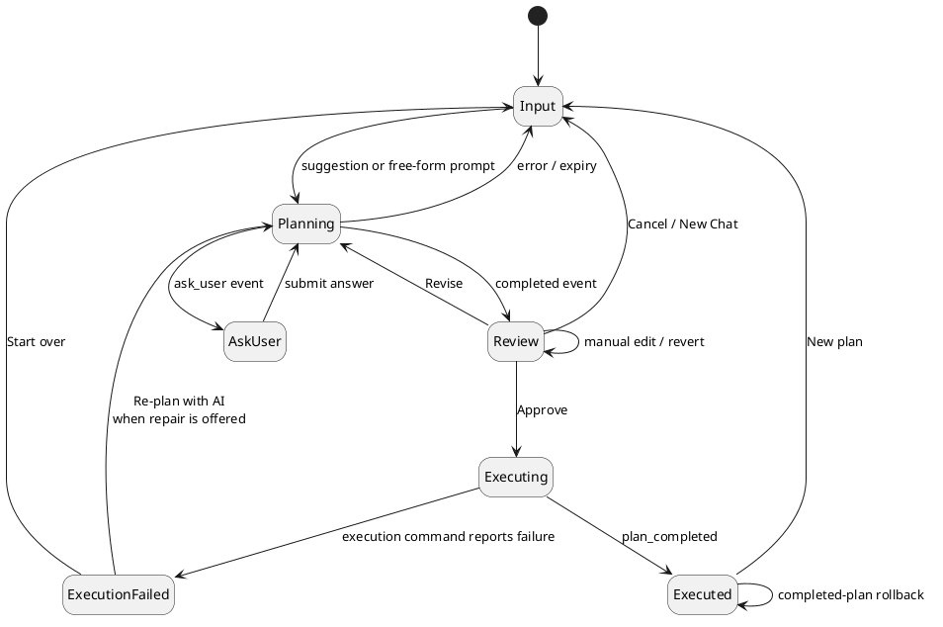
Figure 4.7: State machine, conversation UI lifecycle
The visible treatment of each phase is as follows:
UI phase | Visible design and available action
input | WelcomeScreen offers five representative configuration prompts and a free-form textarea. Either path creates a conversation.
planning | The user prompt remains visible and an assistant bubble is labelled Planning…. A collapsed log grows as turn_started, tool_called, and tool_result events arrive, exposing progress without overwhelming the primary conversation.
ask_user | A Waiting for you planning state is followed by the planner's question. The control supports single- or multi-select options and a custom answer when allowed; submission returns to planning.
completed / review | A Plan ready bubble presents the summary, desired-state preview, iteration-history entry point, and Edit, Approve, Save as template, and Cancel actions. A separate Revise input remains docked below the conversation.
executing | An Executing… bubble appends step-start, completion, retry, failure, and rollback events as they stream from the plan endpoint. Actions that could submit a duplicate lifecycle command are guarded while a request is in flight.
executed | The bubble becomes Execution complete and offers Rollback or New plan.
execute_failed | A human-readable error is presented with Start over. When the API marks a stale/conflicted plan as AI-repairable, Re-plan with AI starts the confirmed repair flow and returns the conversation to planning.
This state-specific design supports progressive disclosure. A new user only needs to understand the prompt box; planning exposes the tool log only on demand; review reveals decision controls after a concrete state exists; and rollback appears only after execution. The workflow therefore preserves the power required by experienced administrators without making the underlying tool registry or plan-step schema part of the normal interaction (NFR-15).
The interface also treats long work as observable rather than blocking. The initial conversation POST returns before the plan exists, and the planning bubble is populated from /api/conversations/:id/stream. Approval opens /api/plan/:id/stream before issuing execution, so step events can appear while the execution request remains in progress. The user receives one continuous narrative even though commands and progress use the asymmetric REST/SSE design described in Section 4.4.

4.5.4 Desired-state preview, revision, and history
The desired-state preview is the principal safety surface because approval is a decision about the proposed end state, not about the wording of the original prompt. DesiredStateView decomposes the DesiredState document into five readable groups: categories, channels, roles, member-role assignments, and tombstones. When the current server state is available, a pure client-side diff labels resources as new, modified, or removed. Resources present in Discord but absent from the target are collected under Will be removed, while prior planning deletions retained as tombstones appear under Already removed. This makes destructive consequences visible instead of forcing the user to infer them from an instruction log (FR-9, FR-10).
Review supports three complementary forms of iteration:
- Natural-language revision. The docked Revise field sends a follow-up instruction to the same conversation. The centre pane returns to planning, streams the new work, and eventually displays a new desired-state iteration (FR-11).
- Manual editing. Edit changes DesiredStateView from read-only rows to a working copy. The user can add, modify, or remove categories, channels, and roles through inline controls. Save sends the edited state to the conversation's edit-state command and appends a manual_edit iteration; Cancel discards the working copy (FR-13).
- Version restore. The History control opens IterationHistoryModal, which sorts versions newest-first and identifies each as LLM-generated, manual edit, or revert. Selecting a version opens a read-only preview; Revert makes that state current by appending a new revert iteration rather than deleting later history (FR-12, NFR-16).
This append-only presentation is significant. A revision does not silently replace the reviewed result, and a revert does not erase the route taken to the current state. The UI reflects the persistence model from Section 4.3: each version remains independently inspectable, while one latest iteration supplies the active desired state.
The Approve button is intentionally located after the preview rather than in a global toolbar. It is disabled when a planning or command request is already in flight and when the client has received a drift event for the selected guild. A drift toast explains that Discord changed externally and offers Re-fork, which resets the conversation so a new plan can begin from current reality. The server repeats the stale-state comparison on approval and execution, so this UI gate is immediate guidance rather than the only protection (FR-21, FR-24, NFR-4).

4.5.5 Templates, rules, and contextual inspection
Secondary workflows are kept close to the Studio without competing with the conversation. The right panel's + menu is the local navigation mechanism: each selected tool opens as a closable tab while Server and Desired remain pinned. This creates a workbench model in which an administrator can inspect a role list, a member's role assignments, a template, or a channel's permission overwrites and then return to the plan without losing conversation state.
Templates have three deliberately different entry points:
- Templates tab. A compact per-guild browser supports text search, displays channel and role counts, and starts a server-side LLM merge into a fresh planning conversation. Its Manage → link opens the full library.
- Conversation template panel. Once a conversation exists, a toolbar button opens TemplatePanel above the chat. Templates can be attached to or detached from the conversation context, allowing the planner to treat them as design ideas rather than commands that immediately mutate the desired state (FR-14).
- Standalone library and editor. The library route supports broader browsing. Selecting an item opens the editor, where metadata and structure can be changed, the template can be forked, or it can be deleted (FR-26).
The third wireframe shows the standalone template-management path. It is a conventional document editor rather than a three-column Studio because the user is editing one reusable artifact, not comparing a live server, a conversation, and a proposal.
┌──────────────────────────────────────────────────────────────────────────────┐
│ Discord Platform Studio [User] Sign out │
├──────────────────────────────────────────────────────────────────────────────┤
│ ← Back Edit template [Fork] [Delete] [Save] │
│ v3 · id: staff-layout │
│ │
│ Name [ Staff layout__________________________________________ ] │
│ Description [ Private staff area with moderator roles______________ ] │
│ Category [ community____________________________________________ ] │
│ Tags [ staff, moderation____________________________________ ] │
│ │
│ STRUCTURE [Edit structure] │
│ ┌──────────────────────────────────────────────────────────────────────────┐ │
│ │ Categories (1) Staff │ │
│ │ Channels (2) #staff-chat #staff-voice │ │
│ │ Roles (1) Moderator │ │
│ │ Members (0) │ │
│ └──────────────────────────────────────────────────────────────────────────┘ │
└──────────────────────────────────────────────────────────────────────────────┘
The editor reuses the same DesiredStateView and useDesiredStateEdit logic as conversation editing. This is a deliberate consistency choice: a channel or role has the same presentation and edit behavior whether it belongs to an active plan or a reusable template. Metadata is saved separately from the structure, and Fork creates a new per-guild copy before navigating to the new editor.
Server rules are managed in SettingsTab, not on a separate Dashboard. The tab lists the guild's free-text rules and supports add, inline edit, and delete. These rules become input to the Stage 2 policy validation described in Section 4.2.4 (FR-25). Keeping rule management beside the Desired preview makes the relationship visible: rules describe the local policy against which proposed states are checked, while the plan remains the object being reviewed.
The remaining contextual tabs are read-oriented. Roles and Members provide server-wide summaries, while clicking a channel in the Server view opens a detail tab showing its category, type-dependent settings, tags where relevant, and permission-overwrite table. These views reduce the need to leave the Studio for Discord merely to verify the context of a proposed change.

4.5.6 Client state, feedback, and error presentation
The component design separates durable server data from transient presentation state. useConversation owns the active workflow and all API/SSE coordination; useDesiredStateEdit owns an isolated working copy during manual edits; and the Zustand useStudioStore owns workspace concerns that need to cross components, principally the right-panel tabs and the per-guild stale flag. Authentication is held separately in useAuthStore. This prevents an open tab or partially typed edit from being mistaken for persisted plan state.
Feedback is placed at the scope of the action that produced it:
- planning and execution progress appears chronologically inside the chat;
- loading and empty states appear within the panel or page waiting for data;
- template, rule, and conversation errors appear beside their corresponding controls;
- drift is guild-wide and therefore appears as a top-right alert toast;
- potentially destructive template and rule deletion requires confirmation;
- in-flight guards and disabled buttons prevent duplicate submissions.
The interface uses familiar text labels alongside icons for consequential actions such as Approve, Delete, Rollback, and Save. The tab strip exposes tablist, tab, selection, and close labels; modal history identifies itself as a dialog; the drift notification uses alert semantics; and icon-only close controls carry accessible labels. These measures do not constitute a full accessibility evaluation, that belongs in Chapter 6, but they make the intended interaction semantics explicit in the component design.
Errors are translated into workflow choices where the server provides enough information. A stale or conflicted execution can expose Re-plan with AI; other execution failures expose Start over; a missing channel opened in a detail tab explains that it may have been removed; and an unavailable guild list presents the bot-invite route. Raw streamed events are retained for diagnostic visibility, but the primary bubble label and error message remain human-readable (NFR-17).

4.5.7 Scope and current interface constraints
The implemented interface is intentionally desktop-first. The global header, guild cards, and standalone template pages include responsive Tailwind variants, but the full Studio keeps fixed 256-pixel and 480-pixel side columns and does not yet replace them with mobile drawers. The conversation sidebar can reduce its contents to icon-only controls, but it does not currently release its allocated width; the right tab strip scrolls when many tabs are open. A complete small-screen Studio remains future refinement rather than an implemented claim.
The active navigation is also intentionally narrow. Full administration, subscription and billing, detailed audit-log browsing, and user management are outside the locked project scope. The retired Dashboard and Setup pages remain on disk only as stashed code. Plan and conversation evidence is surfaced through the conversation list, iteration history, and execution bubbles rather than a separate analytics dashboard. This is not yet a dedicated persisted plan-and-outcome history view of the kind required by FR-23; the API can list plans, but the active web routes do not expose that list.
Lifecycle commands are presented at the phase where they are meaningful. Cancel appears while the planner is generating or waiting for clarification, Abort appears during execution, and the contextual Settings shortcut opens the Studio SettingsTab directly. Server-side status, authorization, and lock checks remain authoritative if a client submits one of these commands at an invalid time.
Finally, the design keeps browser controls advisory and the API authoritative. The interface disables actions when it knows a request is unsafe or stale, but it never assumes that disabled buttons are a security boundary. Guild authorization, plan status, validation, stale-state comparison, and execution locking are repeated on the server as detailed in Section 4.6. This preserves the key relationship between the UI and the plan-first architecture: the Studio helps the administrator make an informed decision, while the backend determines whether that decision can be applied safely.

4.6 Security and Safety Design
Security in this platform is a chain of independent gates rather than a single login check. The browser is an untrusted client; the Hono API is the policy boundary; PostgreSQL stores the user's plans and conversations; Discord is the external system of record; and the LLM provider is an untrusted transformation service. A request must first identify a user, then prove that the user may act on the selected guild, then prove that the bot can operate that guild, and, for a live change, pass the plan-integrity and concurrency checks described in Sections 4.1 and 4.4. This layering is important because a valid web session does not by itself grant authority over any Discord server.

4.6.1 Identity, sessions, and the authentication boundary
Identity is delegated to Discord OAuth2 through Better Auth. The server does not implement a password flow: the accounts table has a library-compatible password column, but the application never populates or reads it for login. Better Auth persists users, sessions, accounts, and verification records in the four library-owned tables described in Section 4.3.2. The application configures an HTTP-only session cookie and enables Better Auth's short-lived cookie cache; the browser-side apiFetch wrapper sends that cookie with every request and turns a 401 response into a single logout-and-redirect action.
The protected API is composed under /api and applies authMiddleware before dispatching route modules. The middleware asks Better Auth for the session from the request headers, stores the authenticated user and session in Hono's context, and returns a uniform JSON 401 when no session is present. Handlers call requireUser at their boundary as a second, typed assertion. The health endpoint and Better Auth's own /api/auth/* handler are intentionally outside the protected route composition: health is a liveness probe, while the auth handler must be reachable before a session exists. The bot status and invite endpoints are mounted under the protected API and therefore still require a session.
Environment validation is part of the boot boundary. The server refuses to start without DATABASE_URL, a 32-character BETTER_AUTH_SECRET, valid auth and web URLs, and (in production) the Discord bot and OAuth credentials. This prevents a partially configured process from accepting requests with an unknown session or Discord identity configuration. The Better Auth user record also contains role and subscriptionTier fields, but neither participates in authorization; they are currently informational and the platform has no local RBAC or subscription gates.
This boot-time validation is also where least-privilege secret handling (NFR-12) is enforced. BETTER_AUTH_SECRET, DISCORD_BOT_TOKEN, and DISCORD_CLIENT_SECRET are parsed once by env.ts into the validatedEnv singleton (env-validated.ts), and the modules that need them, Better Auth's config, the bot login call, import that singleton rather than re-reading process.env. The LLM_API_KEY is the one exception to that single-path pattern: planning-session.ts reads process.env.LLM_API_KEY directly rather than through validatedEnv, because it is optional and gates the mock-planner fallback in development; this is a minor inconsistency in an otherwise centralised scheme, not a leak, since the value still never leaves the server process. None of these credentials ever crosses the client/server boundary: the web app's own VITE_API_URL is the only environment value bundled into the browser build (Vite only exposes VITE_-prefixed variables), and no server route echoes a credential value back in a JSON response, the DISCORD_CLIENT_ID returned by the bot-invite endpoint is a public OAuth application identifier, not a secret. Logging follows the same discipline, the reviewed logger.* call sites around configuration (for example, the missing-bot-token warning in index.ts and the missing-LLM-key error in validation.ts) log that a credential is absent, never its value. .env and its variants are excluded from version control (.gitignore), so secrets are not committed alongside the code that consumes them. The one credential the design does not encrypt at rest is the Discord OAuth access/refresh token pair Better Auth persists in the accounts table in plaintext; that residual risk is scoped in Section 4.6.6 rather than claimed as covered here.

4.6.2 Guild authorization and tenant isolation
Authorization is derived from Discord, not from an application-admin table. For a requested (userId, guildId) pair, userHasManageGuild first resolves the user's linked Discord account, confirms that the bot is ready and has the guild in its cache, and fetches the member from Discord. The request is allowed when that member is the guild owner or has the Discord MANAGE_GUILD permission. A positive or negative result is cached for 60 seconds to avoid a Discord member fetch on every API call; the cache can be invalidated per user when membership changes. If Discord cannot answer the membership request, the helper throws DiscordApiError, which the global Hono handler exposes as a 503 instead of incorrectly converting an outage into a 403 denial.
Every state, rules, plan, conversation, and drift route repeats this check. Template mutations and template merges do as well, while the current template browsing handlers allow any authenticated session to request the selected guild's templates and global templates. Resource-oriented routes that enforce guild access add an ownership check after loading the row: the plan or conversation must belong to the guildId in the URL, otherwise the handler returns 404. The two top-level execution and planning SSE routes do the same lookup before subscribing to an event bus. Consequently, possession of an ID from another guild does not expose its plan data or live events.
That template-browsing exception is narrower than the execution boundary but is still a tenant-isolation consideration: the current GET list/detail handlers do not call userHasManageGuild, so a caller with a valid application session who knows another guild's identifier can request that guild's stored templates. Template writes remain protected by guild access and, for updates and deletes, by the template author's user ID. If templates become private tenant data, their read handlers need the same guild authorization check as the other guild-scoped resources.
The second recurring authorization layer is bot operability. botReady blocks API composition until the first Discord gateway cache rebuild completes. checkGuildOperable then requires both a cache entry (the bot is in the guild) and the bot's ADMINISTRATOR permission. A missing cache entry is 404; missing ADMINISTRATOR is 403 with a remediation message. The same gate is used before planning, state reads, rule changes, plan execution, and rollback, so an authenticated manager cannot turn a disconnected or unsafe bot into a partial mutation tool.

4.6.3 Bot privileges and the Discord trust boundary
The bot is deliberately installed with Discord's ADMINISTRATOR permission (the invite route generates permission bitfield 8). This is a broad gateway privilege, but it establishes a safety invariant: channel overwrites cannot lock the bot out, including an @everyone VIEW_CHANNEL denial. The cache rebuild and guild-join handlers log guilds where the invariant is absent, and the operability gate blocks their API operations. Execution re-checks operability and validation immediately before mutation using the bot's current Discord.js cache; fresh direct Discord reads are reserved for the after-snapshot and rollback paths.
Role hierarchy is checked at execution validation time. Group A reads the bot's highest role position and blocks edits, moves, or deletions of roles above it; member-role additions and removals receive the same block. Group D separately blocks a newly created role that grants ADMINISTRATOR. Permission names are parsed against the shared Discord permission registry, so an unknown permission cannot enter a set_overwrite step. These are deterministic checks and do not depend on an LLM's interpretation.
The implementation currently enforces hierarchy when a plan is validated, rather than maintaining a separate startup "bot is highest role" flag. That is strong enough to stop the execution path, but it is a narrower implementation than the aspirational startup requirement in docs/design/security.md; the distinction is recorded here rather than presenting the design target as an already deployed gate.

4.6.4 Plan isolation, validation, and human approval
The LLM has no Discord client or database mutation capability. It can only produce calls described by the fixed tool registry, and planning tools mutate a DesiredState fork in memory. The only execution-capable tool calls are turned into diff steps and dispatched later by an explicit execute command. This keeps prompt injection or malformed model output inside a typed, inspectable data structure until a human has reviewed the preview and approved the plan.
At the execution boundary, Zod validates request bodies before route logic. The diff engine rejects missing resources and emits an ordered step list; assumption checks then re-check parent existence, name collisions, and other tool-specific preconditions against the current cache. Stage 1 deterministic validation checks permissions, symbol dependencies and cycles, resource limits and type constraints, safety guards, overwrite-consolidation warnings, and plan integrity. Block-level issues fail closed with 400 and structured blocker and warning arrays. Stage 2 sends a compact plan summary and the guild's rule text to the configured OpenRouter-compatible provider only when that guild has rules. A no-rule guild skips the call. For a guild with rules, rule-load failure, missing provider configuration, a non-success response, a 30-second timeout, or empty/malformed output produces a block-level availability issue. Provider failure is therefore not interpreted as policy compliance.
The current implementation also keeps guild rules out of the planning system prompt. They influence the execution-time Stage 2 check only, so an administrator may see a plan that has not been policy-screened until approval time. This is the remaining documented design divergence rather than a bypass of the execution-time enforcement gate.

4.6.5 Stale state, concurrency, and recovery
The main time-of-check/time-of-use risk is addressed by anchoring a conversation to the SHA-256 forkStateHash of the cache state it planned from. Execution recomputes the hash and returns 409 when the guild changed. It then rebuilds the diff and evaluates every step's assumptions again, so a plan cannot rely solely on an old preview. After an execution, sibling conversations whose hash no longer matches are marked stale and their in-memory planning sessions are cancelled.
Execution is serialised per guild by an atomic conditional update on the guild row (UPDATE guilds SET … WHERE id = ? AND current_plan_id IS NULL). The lock records plan, owner, acquisition time, and heartbeat time; a 60-second heartbeat keeps healthy five-minute executions alive. A 30-minute TTL and five-minute periodic cleanup recover locks from crashes or dead processes, while the finally block releases the lock on every normal or error path. Co-locating the lock on the guilds row keeps the design simple, no separate lock table, and acquisition is a single indexed write, at the cost of one tradeoff worth naming: because the lock columns share the row with the guild's configuration, every lock check, heartbeat, and release writes that same row. Under a workload with very high concurrent reads and writes of one guild's configuration this could cause mild row-lock contention on the hot row. It is acceptable here because the platform's unit of work is a single administrator planning and executing against one guild at a time, so per-guild write concurrency is low by design; a deployment expecting many concurrent writers per guild would move the lock to its own table. The plan-level AbortController stops work after five minutes, and each step has its own deadline and bounded retry policy. Permanent failure, timeout, or user abort triggers a diff-based rollback against the before-snapshot when the bot is still connected. Rollback is structural and best effort: Discord message history and some member-side effects cannot be reconstructed from a server snapshot. If the bot disconnects, rollback is skipped and the route reports a failure for manual review rather than issuing unauditable compensating calls.

4.6.6 Transport controls, persistence, and remaining limits
Credentialed CORS is restricted to WEB_APP_URL; the rate limiter applies a sliding 100-request-per-minute window to /api/*. It keys the window by the connection's source IP and only trusts x-forwarded-for when TRUST_PROXY=1, which prevents an arbitrary client header from selecting a different bucket. The limiter is process-local, so deployments with multiple server instances would need a shared store to obtain a global limit.
The application route layer does not add a separate CSRF-token middleware for cookie-authenticated commands. Its browser-facing protection is the origin-restricted credentialed CORS policy and Better Auth's cookie/session behavior; production deployment should keep those origins and cookie settings aligned rather than treating CORS as a substitute for an independent CSRF control.
SSE connections authenticate and authorize before subscribing, emit a ready event, and unregister on client abort. Heartbeats keep intermediaries from closing idle streams. Planning terminal events have a bounded in-memory replay, while intermediate planning and execution progress missed during reconnect is not replayed; the client recovers authoritative state by re-fetching the persisted resource over REST, as detailed in 4.4.4.
Conversations, prompts, LLM messages, desired states, plans, rules, and snapshots are persisted as PostgreSQL rows, several as jsonb documents. The application does not add field-level encryption or a detailed audit-log table; database, cookie, secret, and LLM-provider protection remain deployment responsibilities. Detailed audit logging, application-level RBAC, and subscription/tier enforcement are explicitly outside the current scope. One gap in the least-privilege secret handling discussed in 4.6.1 is that Better Auth stores the Discord OAuth access and refresh tokens it manages as plaintext columns in the accounts table rather than encrypted at rest, so a database compromise on the self-hosted, single-host deployment (C-6) would expose them; this is an open risk rather than a covered control. These limits do not remove the plan-first safety gates, but they bound what can be claimed about forensic traceability and multi-instance security in the current build.

Chapter 5: Implementation
This chapter describes how the Discord server management platform was actually implemented. It follows the system from the browser interface to the Hono API, the planning engine, the declarative state model, validation, and finally Discord execution. Chapter 4 presented the intended internal design; this chapter focuses on concrete modules, functions, runtime call chains, and implementation trade-offs found in the source code.
The implementation preserves one boundary throughout the system: an LLM may propose changes to an in-memory desired state, but it cannot call Discord directly. A deterministic diff and validation pipeline must turn that state into executable steps, and a human administrator must approve the result before the Discord adapter receives any mutation command.

5.1 Development Environment

5.1.1 Workspace and language configuration
The project is implemented as a TypeScript monorepo managed through pnpm workspaces. The workspace contains two applications and two reusable packages:
Workspace | Responsibility
apps/web | Vite and React single-page application containing the Studio interface
apps/server | Hono API, planning engine, background jobs, and Discord.js bot
packages/shared | Shared types, schemas, desired-state store, tool registry, and tool behavior
packages/db | PostgreSQL connection, Drizzle schema, relations, and migrations
The root TypeScript configuration targets ES2022, uses ES modules and bundler-style module resolution, and enables strict type checking. Each workspace has its own typecheck command, while the root command runs all workspace checks recursively. Vitest is installed at the workspace root so tests can import TypeScript source directly across workspace boundaries.
The principal implementation dependencies are shown below. Versions are the ranges recorded in the current package manifests rather than claims about the latest available releases.
Area | Implemented technology
Browser application | React 18, React Router 7, Zustand 5, Vite 6, Tailwind CSS 3
HTTP server | Hono 4 on the Node adapter
Discord integration | Discord.js 14
Authentication | Better Auth with Discord OAuth2
Validation | Zod 3 and Hono's Zod validator
Persistence | PostgreSQL 16, Drizzle ORM, and the postgres driver
Logging | Pino with pino-pretty during development
Verification tooling | TypeScript, ESLint, Prettier, and Vitest

5.1.2 Local services and configuration
PostgreSQL is the only locally hosted infrastructure dependency. The supplied Docker Compose file runs PostgreSQL 16 Alpine, exposes port 5432, persists data in a named volume, and includes a pg_isready health check. Discord and the configured LLM endpoint remain external services.
The normal local workflow is:
cp .env.example .env
docker compose up -d
pnpm install
pnpm db:migrate
pnpm dev
The root development command starts the web and server workspaces concurrently. Vite serves the web application on port 5173, while the Hono server defaults to port 3001. The server validates database, authentication, web-origin, Discord, and LLM configuration through validateEnv() before normal operation. Development may omit the LLM key and use a mock planner response; production requires the Discord bot and OAuth credentials in addition to the database and authentication configuration. If a development guild has server rules, execution also requires an LLM key because the execution-time policy check fails closed.
No secret is embedded in the browser bundle. The browser receives only the API URL and communicates with the server using the Better Auth session cookie. Discord tokens, OAuth secrets, the database URL, and LLM credentials are read in the server process.

5.1.3 Process startup and background work
apps/server/src/index.ts composes the runtime through one awaited startup sequence. It runs database migrations, clears stale guild locks, marks process-local planning work interrupted by a prior restart, and only then starts cleanup jobs, the drift detector, the HTTP listener, and the Discord client. The bot exposes a botReady promise. Protected API routes await that promise before handling requests so planning cannot fork from a partially built guild cache.
The server remains a monolith: API routes, active planning sessions, SSE event buses, the Discord client, and background jobs share one Node process. This simplifies event delivery and access to the bot cache, but it also means active sessions and event history are not inherently shared across multiple instances. Section 5.8 records the operational consequences of that choice.

5.2 Module Implementation

5.2.1 Declarative domain core
packages/shared is the implementation boundary between probabilistic planning and deterministic execution. Its ServerState type represents the observed Discord guild, while DesiredState represents the target configuration being edited during planning. Existing resources retain their Discord identifiers; new resources receive symbols such as $cat_0, $ch_1, and $role_2. Explicit channel, category, and role deletions are recorded as tombstones.
An earlier design treated this desired state as a JSON document that the LLM would edit directly, similar to the way an agentic coding assistant modifies files in a repository. That model provided a simple declarative representation, but unrestricted document replacement made domain invariants and the meaning of individual changes implicit. The implemented design retains the declarative state while moving mutation behind typed tools and DesiredStateStore, so creation, editing, deletion, symbol assignment, and validation each have an explicit application-controlled boundary.
All planning mutations pass through DesiredStateStore. Tool implementations do not edit the state object directly. The store checks resource existence and name uniqueness before mutation, generates symbols, supports snapshots and reversion, and maintains member-role and permission-overwrite state. This produces an important failure property: if a store method rejects a tool call, the previous desired state remains intact.
The tool registry binds four concerns under one tool name, following the tool-selection-and-argument pattern studied for language-model tool use (Schick et al., 2023):
- the JSON-compatible parameter description sent to the LLM;
- Zod parsing of the received arguments;
- the planning function that mutates DesiredStateStore; and
- optional assumptions that must still hold before execution.
The registry currently covers categories, channels, roles, permission overwrites, member-role assignments, batch permission planning, and the ask_user interaction. The executionMode field prevents planning-only tools from reaching the Discord dispatcher.

5.2.2 Discord state cache and adapter
The Discord.js client is implemented under apps/server/src/bot. On ClientReady, the bot rebuilds the channel, role, and permission-overwrite portions of an internal guildCache. Guild availability and member events populate and maintain its member-role entries. Channel, role, member, guild-join, and guild-removal events continue updating the cache as Discord changes. The cache is the fast source for previews, hashes, and pre-execution checks.
Live mutation is isolated behind the shared ExecuteContext interface. DiscordExecuteContext implements that interface with Discord.js guild operations such as guild.channels.create(), channel.edit(), guild.roles.create(), and member-role updates. Shared tool execution helpers depend on the interface rather than on Discord.js classes. Consequently, most planning and execution logic can be tested with a plain mock context.
The implementation also distinguishes the event-fed cache from a fresh Discord read. Planning and validation use the cache for low latency. Post-execution snapshots and rollback call buildCurrentStateFromDiscord(), which fetches current channels and roles before constructing a new ServerState.

5.2.3 HTTP, authentication, and persistence
apps/server/src/hono/app.ts applies credentialed CORS and a sliding-window rate limiter to the API, then mounts authentication middleware and the route modules. Better Auth handles Discord OAuth2 and session persistence. Guild-scoped mutation routes call userHasManageGuild() before planning or execution and return an error if the user cannot administer the selected guild.
PostgreSQL stores users, sessions, linked accounts, guild metadata, conversations, plan iterations, approved plans, execution snapshots, rules, templates, and drift events. Large structured values such as DesiredState, LLM messages, plan data, and snapshots are stored in JSONB columns. Indexed foreign keys support the common guild, user, conversation, and plan lookups.
Two in-process event buses bridge long-running server work to browser Server-Sent Events (SSE) streams (WHATWG, n.d.):
- planning-event-bus.ts publishes events by conversation identifier; and
- event-bus.ts publishes execution and rollback events by plan identifier.
The corresponding SSE handlers authorize the caller before subscribing, send a ready event, emit a heartbeat every 30 seconds, and unsubscribe when the browser disconnects.

5.2.4 Studio user interface
Studio.tsx composes the implemented application workspace. Its component tree is:
App
└─ AppLayout
└─ Studio
└─ StudioShell
├─ StudioHeader
├─ ConversationSidebar
├─ ChatArea
│ ├─ planning and execution bubbles
│ ├─ DesiredStateView
│ ├─ IterationHistoryModal
│ └─ SaveTemplateModal
└─ RightPanel
└─ TabPanel
├─ ServerTab / ChannelDetail
├─ DesiredTab
├─ RolesTab / MembersTab
├─ TemplatesTab
└─ SettingsTab
useConversation() is the main browser-side controller. It owns the conversation phase, opens and closes planning and execution streams, performs approve, revise, re-plan, rollback, and revert requests, and exposes state and commands to ChatArea. useDesiredStateEdit() separately owns the working copy used for manual desired-state edits. Zustand stores cross-component tab selection and per-guild stale state, while local hook state holds the active conversation and streamed events.
This split keeps route composition thin: Studio.tsx supplies hooks and callbacks, ChatArea renders lifecycle states, and RightPanel renders structural context. The same DesiredStateView and desired-state primitives are reused by the conversation preview and template editor.

5.3 Natural-Language Planning Implementation

5.3.1 Exact planning call chain
The following is the implemented function and component chain for a new natural-language request:
ChatArea / WelcomeScreen
→ useConversation.createConversation(prompt)
→ POST /api/guilds/:guildId/conversations
→ conversations route handler
→ checkGuildAccess()
→ buildServerState()
→ hashServerState()
→ db.insert(conversations)
→ new PlanningSession(...)
→ setSession()
→ PlanningSession.start()
→ runLoop()
→ callLLM()
→ buildLLMRequest()
→ fetch(OpenRouter-compatible endpoint)
→ parseOpenRouterStream()
→ handleStreamedToolCall()
→ dispatchTool()
→ getTool(toolName)
→ tool.plan(params, DesiredStateStore)
→ DesiredStateStore.add/edit/remove/set...
→ onTurnComplete()
→ db.insert(planIterations)
→ db.update(conversations.messages)
The feedback branch runs alongside the state-mutation branch:
PlanningSession.emit(event)
→ emitConversationEvent(conversationId, event)
→ GET /api/conversations/:id/stream
→ useConversation.connectPlanningSSE()
→ React phase and event state
→ ChatArea planning log / ask-user bubble / completed preview
This chain is useful in the implementation chapter because it identifies the exact transition from natural language to structured state. The LLM response does not become an execution request. It is parsed into registered tool calls, each tool call is validated, and each successful planning call updates only the in-memory store.

5.3.2 Streaming tool dispatch
PlanningSession.callLLM() sends the system prompt, bounded message history, and generated tool definitions to an OpenRouter-compatible endpoint. The stream parser accumulates fragmented tool arguments and invokes the callback only after one complete tool call is available. The session then dispatches that call immediately so the browser sees progress at tool-call granularity.
The core dispatch is intentionally small. The following abridged excerpt shows the boundary:
const tool = getTool(toolName);
const result = tool.plan(params, this.store);
await this.emit({ type: "tool_result", toolName, result });
if (toolName === "ask_user") {
return {
type: "ask_user",
question: params.question,
options: params.options,
};
}
return { type: "success", result };
getTool() rejects names outside the registry, the registered wrapper parses parameters with Zod, and tool.plan() delegates mutation to the store. Errors are returned to the LLM as tool results so the model may correct a malformed or inconsistent proposal without leaving a partial state change.

5.3.3 Clarification, revision, and iteration persistence
The ask_user tool is planning-only. When it is called, PlanningSession changes to waiting_for_user, records the tool-call identifier, emits an ask_user event, and returns from the planning loop. The route starts a two-minute timeout and changes the persisted conversation status. The browser posts the selected or custom answer to the ask-user route, which adds the answer as a tool result and resumes the same LLM message sequence.
At the end of each turn, the route callback snapshots the desired state into plan_iterations, increments the store version, and persists the updated LLM message history. Revision adds another user message and runs the same session again. Manual editing and iteration reversion create their own iteration types, allowing the UI to show where each desired state came from.
The planner limits its retained request history to the system prompt and the most recent 49 conversation messages. This bounds request size while preserving recent tool context. The system prompt contains the current guild representation, the four planning phases, permission strategy, and the registered tool usage rules.
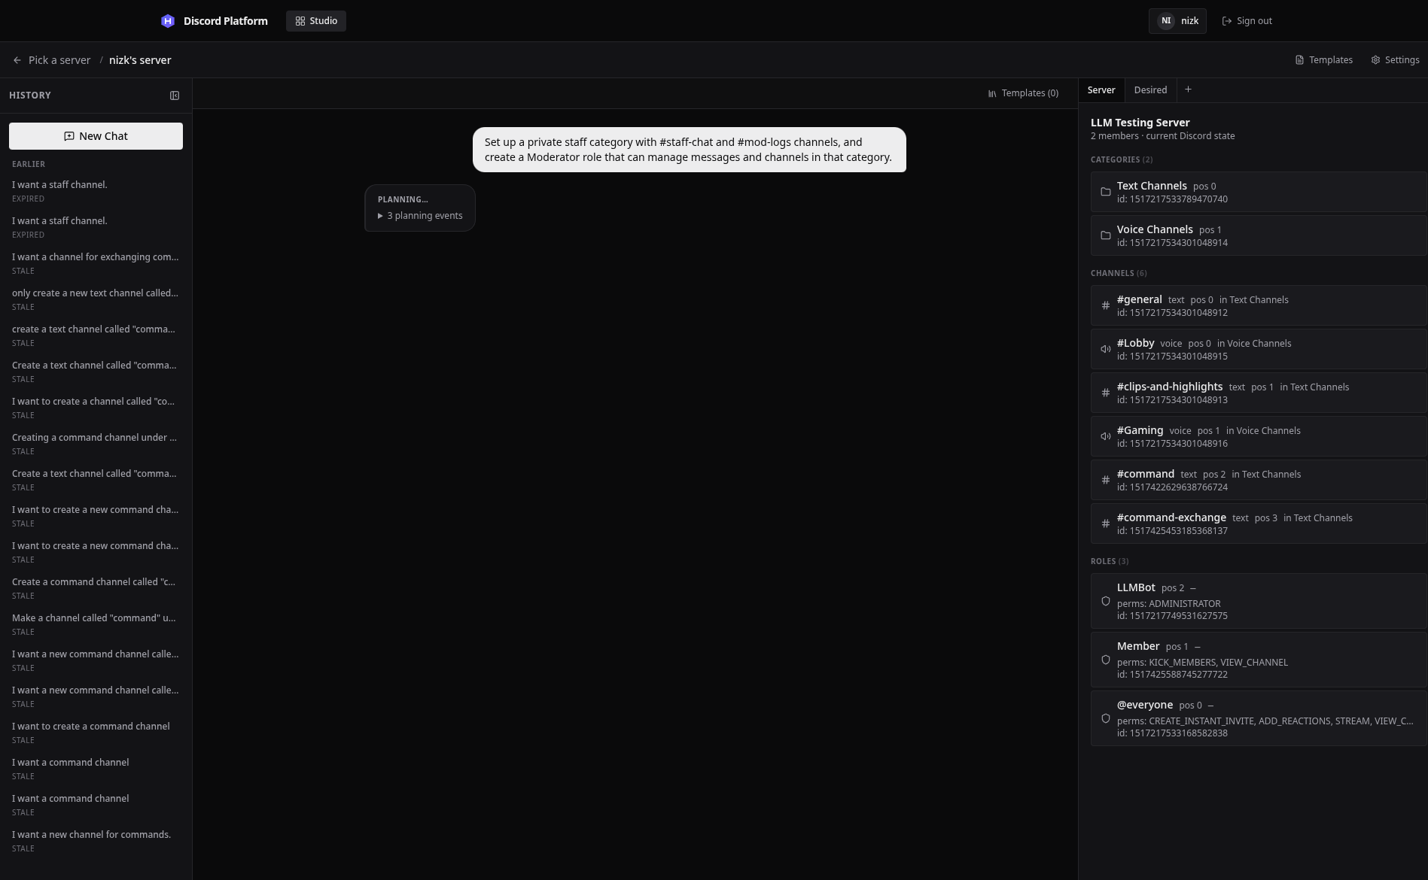
The planning log makes the plan-first boundary visible: tool calls and results are shown while the live Discord server remains unchanged, and approval controls do not appear until planning completes.

5.4 Approval, Validation, and Execution Implementation

5.4.1 Exact approval and execution call chain
The browser's Approve action performs two API commands: it first freezes the latest desired state as a plan and then executes that plan, mirroring the plan-then-apply workflow used by Terraform (HashiCorp, n.d.). The implemented call chain is:
ChatArea Approve button
→ useConversation.approve()
→ POST /api/guilds/:guildId/conversations/:convId/approve
→ checkGuildAccess()
→ checkConversationNotStale()
→ checkGuildNotLocked()
→ load latest plan_iteration
→ db.insert(plans with desiredState snapshot)
→ useConversation.executePlan(planId)
→ connectExecSSE(planId)
→ POST /api/guilds/:guildId/plans/:planId/execute
→ checkGuildOperable()
→ userHasManageGuild()
→ compare forkStateHash with current state
→ buildServerState()
→ diffEngine(realState, desiredState)
→ evaluateAssumptions()
→ validatePlan()
→ acquireGuildLock()
→ db.insert(execution_before snapshot)
→ new DiscordExecuteContext(guild)
→ execution-engine.executePlan()
→ resolveSymbols()
→ dispatchWithDeadline()
→ dispatchStep()
→ shared execute...() helper
→ DiscordExecuteContext method
→ Discord.js Guild API
→ buildCurrentStateFromDiscord()
→ db.insert(execution_after snapshot)
→ db.update(plan status and results)
→ releaseGuildLock()
Execution events travel through the plan event bus and /api/plan/:id/stream to useConversation.connectExecSSE(), which updates the execution bubble with started, completed, retry, failed, and rollback events.

5.4.2 Deterministic diff generation
diffEngine(realState, desiredState) is a pure implementation boundary. It generates raw category, channel, role, member-role, overwrite, and tombstone steps; topologically sorts symbol dependencies; merges compatible edits; removes no-ops; and rebuilds the final symbol table. References to existing resources that disappeared after planning become structured conflicts instead of guessed matches.
The route refuses execution when the diff contains conflicts. It then obtains each step's registered assumptions and evaluates them against the current server state. This catches invalidated preconditions such as a missing parent, duplicate name, or inaccessible role before a Discord call is made.

5.4.3 Validation layers
validatePlan() combines deterministic and LLM-assisted checks. The deterministic groups validate permission names, bot role hierarchy, symbol existence and type compatibility, dependency cycles, resource constraints, duplicate names, channel-type properties, member-role duplication, overwrite structure, administrator grants, and plan status. Any block-level issue prevents execution.
The second stage loads the selected guild's natural-language rules and asks the configured LLM to classify the plan. A guild without rules skips this stage. When rules exist, the stage fails closed: rule-load failure, missing LLM configuration, a non-success provider response, a request exceeding 30 seconds, and empty or malformed output all produce a block-level availability issue. Valid responses preserve the provider's block and warning severities.

5.4.4 Ordered execution, deadlines, and retry
The execution engine processes the ordered steps sequentially. Before a step runs, symbolic references are replaced with Discord identifiers created by earlier steps. A creation result updates the symbol table so later channel-parent, overwrite, and member-role operations use the real ID.
Each Discord operation is raced against a 30-second step deadline and the plan abort signal. A step timeout is classified as transient and may be retried up to three times with exponential backoff and jitter. A user abort or five-minute plan deadline is represented by StepAbortedError and is never retried.
The implementation uses a promise race because the Discord.js methods in this adapter do not accept an abort signal. The caller can stop waiting, although the underlying Discord request may still settle later:
const timer = setTimeout(() => settle(() => reject(new StepTimeoutError(timeoutMs))), timeoutMs);
const onAbort = () =>
settle(() => reject(new StepAbortedError(String(abortSignal?.reason ?? "Execution aborted"))));
dispatchStep(step, ctx).then(
(result) => settle(() => resolve(result)),
(err) => settle(() => reject(err))
);
The subtle consequence is that deadline expiry bounds the execution loop's wait, not the external side effect itself. A late successful Discord request can therefore be observed by the subsequent fresh-state read or drift detector. This is a limitation of adding caller-side cancellation around an API without a native cancellation hook.

5.4.5 Locking, snapshots, and rollback
An atomic conditional update on the guild row acquires the per-guild execution lock. The lock stores the plan, process owner, acquisition time, and heartbeat. A heartbeat protects a legitimate long-running plan, while startup and periodic cleanup clear abandoned locks after configured stale periods. The route releases the lock in a finally block.
Before mutation, the route persists an execution_before snapshot. If a step fails, rollbackFull() fetches current Discord state, forks the before-snapshot into a desired state, and calls the same diff and execution machinery to converge back toward the earlier structure:
const currentState = await buildCurrentStateFromDiscord(ctx.guildId);
const desiredBefore = fork(beforeSnapshot);
const diffResult = diffEngine(currentState, desiredBefore);
const result = await executePlan({
planId,
steps: diffResult.steps,
symbolTable: diffResult.symbolTable,
ctx,
emit,
});
This avoids maintaining a separate handwritten inverse for every Discord operation, following the same compensating-action principle used to recover long-lived transactions decomposed into smaller steps (Garcia-Molina and Salem, 1987). Rollback remains best effort: the structural snapshot cannot recreate message history or every external side effect, and Discord may reject a reverse operation. The implemented event path reports that case as rollback_failed instead of presenting incomplete recovery as success.

5.5 Implementation of Important Features

5.5.1 Preview and manual iteration
The latest persisted DesiredState is rendered in DesiredStateView. Existing current state is passed alongside it so the desired-state primitives can mark additions, edits, and deletions. The same representation includes tombstones, member-role assignments, and permission-related channel state. The administrator may revise through natural language, revert to a prior iteration, or enter manual edit mode. Manual edits are posted back to the conversation and stored as a new manual_edit iteration; they do not edit Discord directly.
When the administrator requests rollback of a completed execution (FR-22), the system retrieves the before-snapshot that was persisted at execution start from the snapshots table. The rollback operation diffs the current Discord state against this retrieved before-snapshot and generates a reverse convergence plan using the same diff engine that produced the forward plan. This approach ensures that rollback coverage remains synchronized with forward execution capabilities as the system evolves.
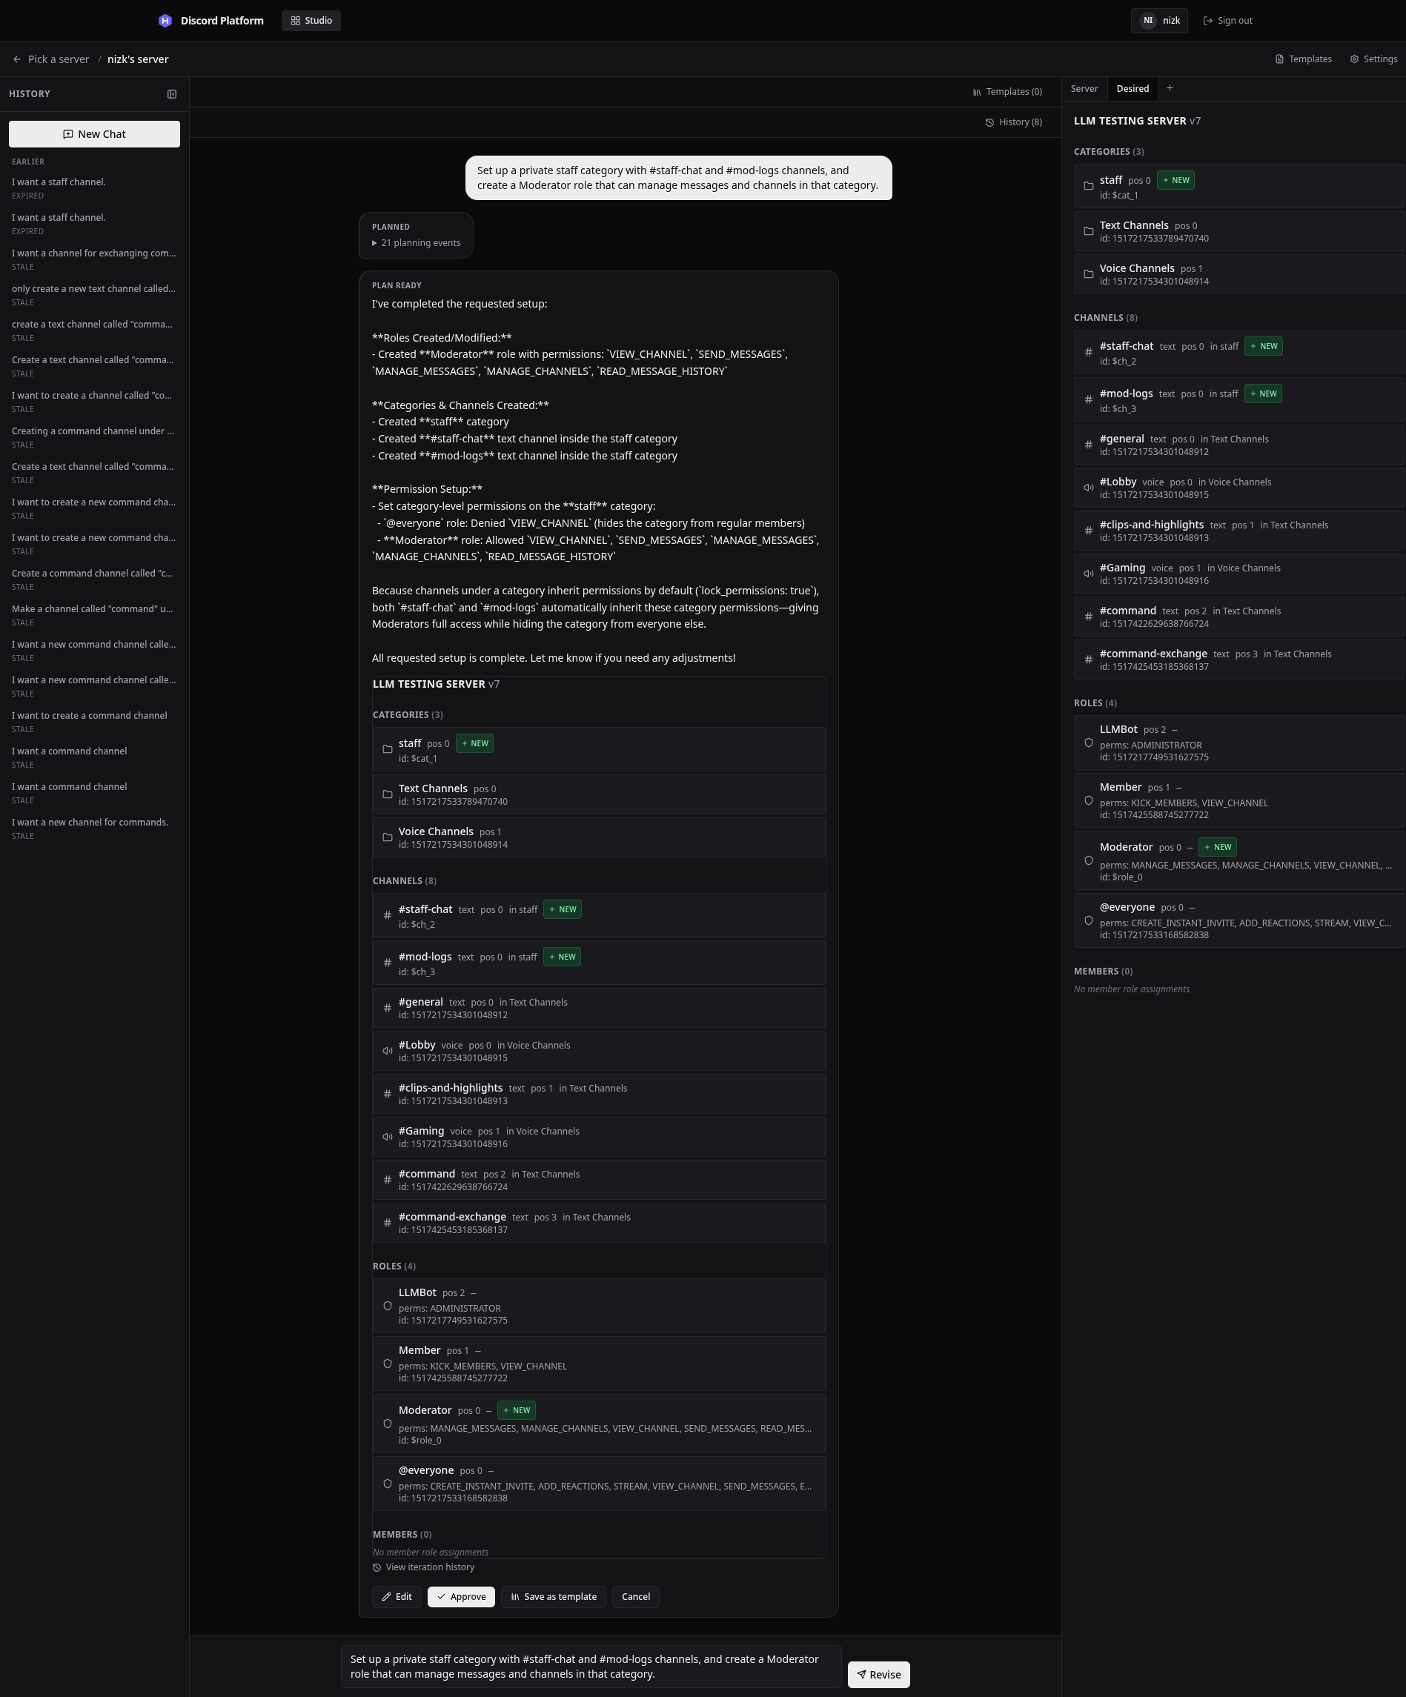
The preview renders the desired state as a Discord-like interface with visual indicators for additions (green), modifications (yellow), and deletions (red strikethrough). The administrator can inspect channel permissions, role assignments, and structural organization before approval.
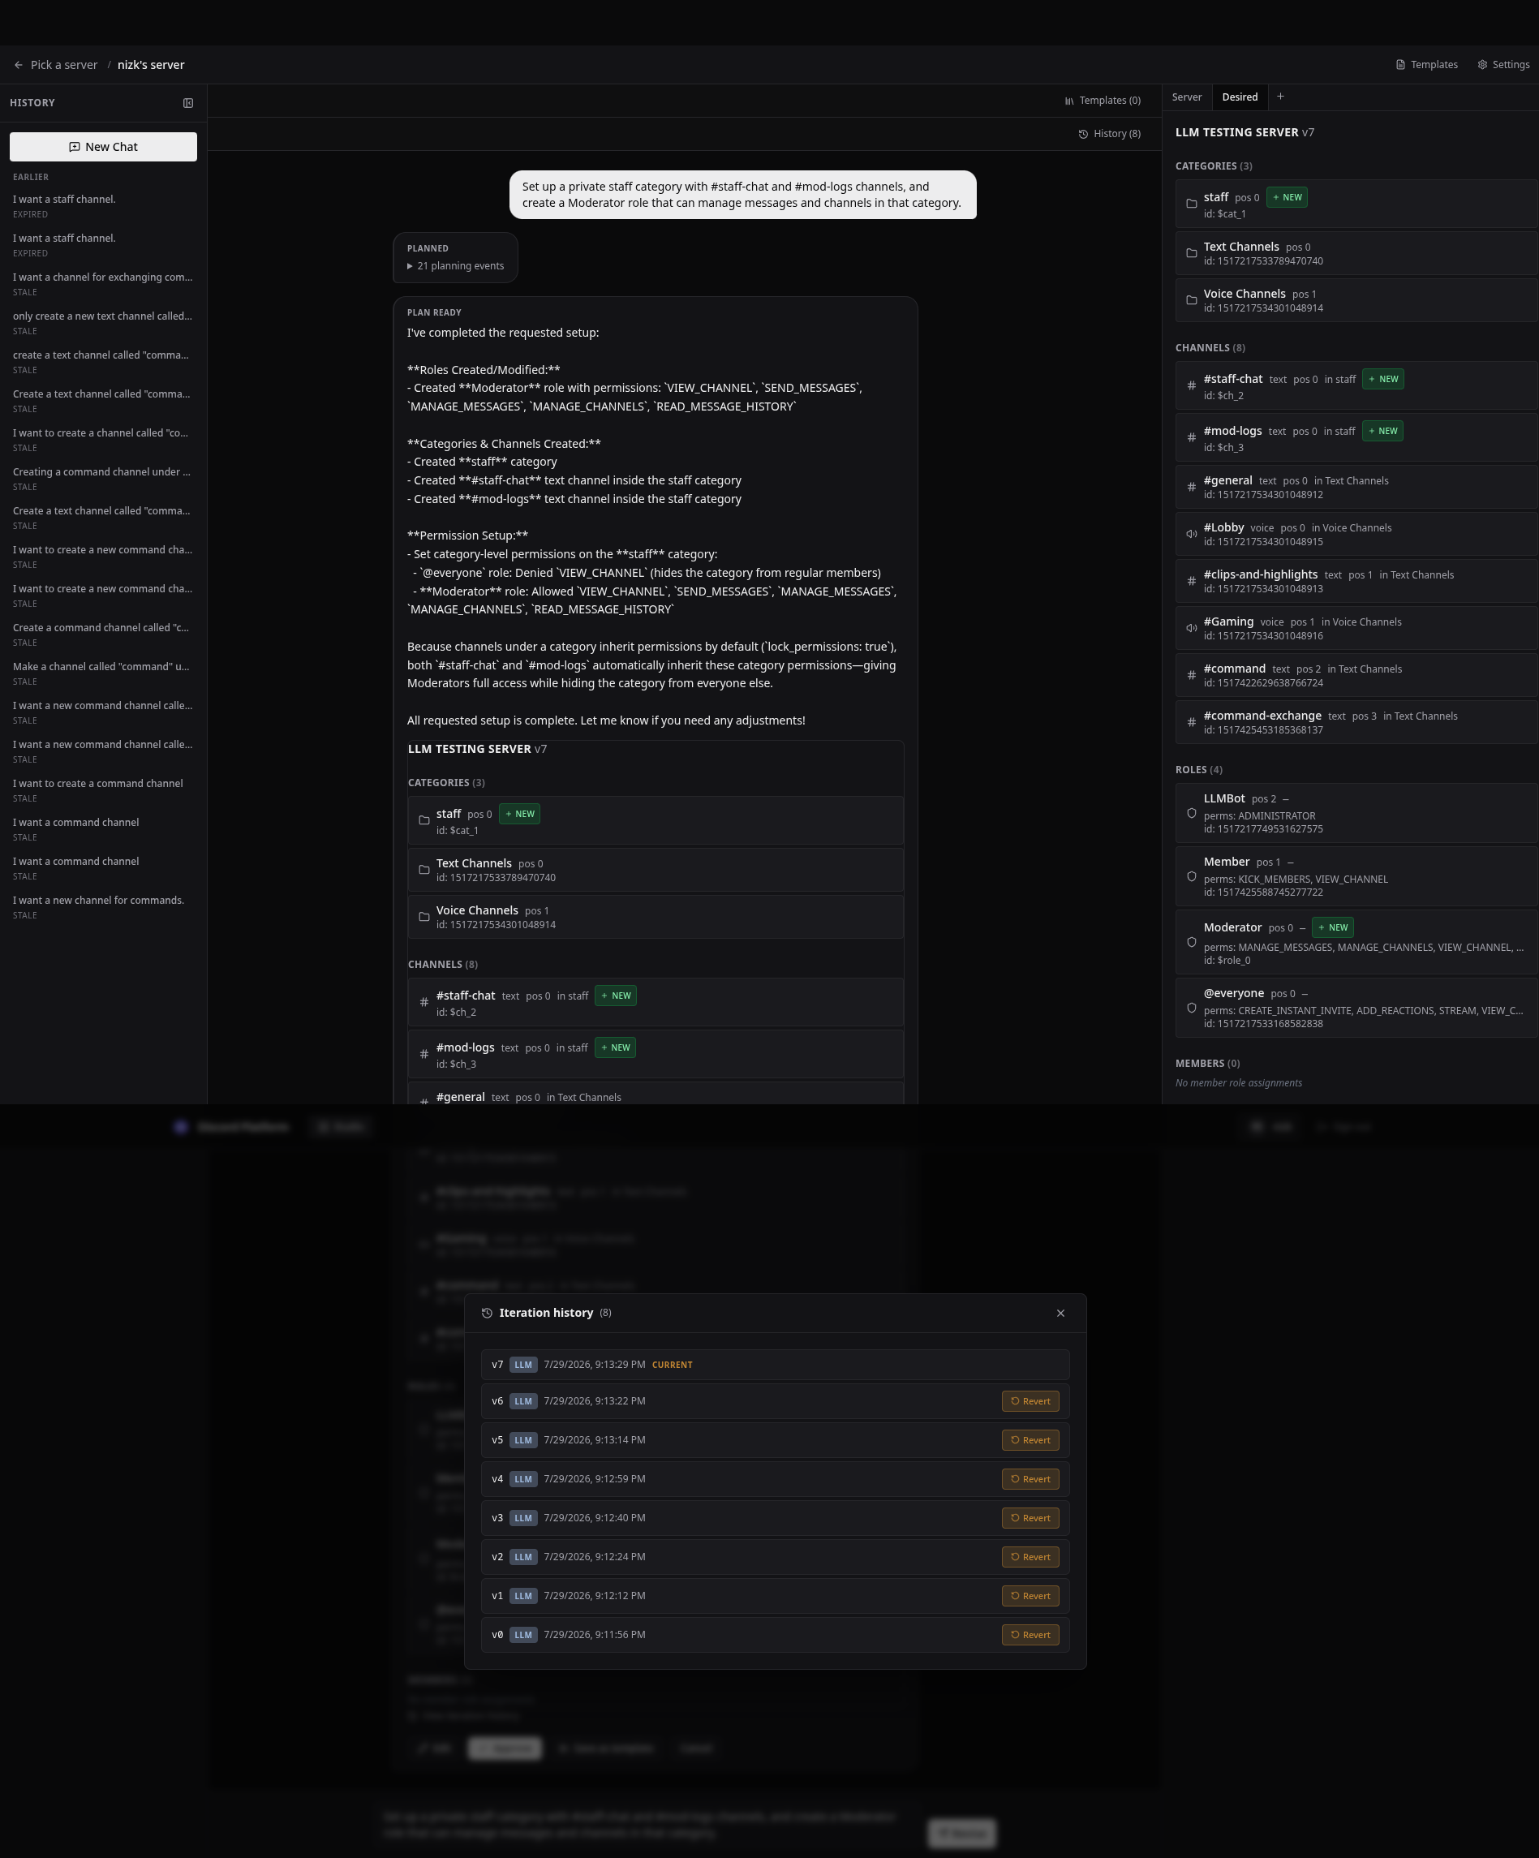
The iteration history preserves every version of the desired state throughout the planning session, allowing the administrator to revert to any prior iteration if a revision introduces unwanted changes.

5.5.2 Confirmed re-planning after stale-state rejection
Every conversation stores a hash of the Discord state from which it was forked. Execution recomputes that hash and returns a conflict when the server changed. The failed execution bubble offers Re-plan with AI only when the response states that repair is possible.
The re-plan route loads the old desired state and persisted message history, builds a structured repair prompt from current state and failed assumptions, replaces the old system message with one built from fresh state, and starts PlanningSession again. The repaired desired state is persisted as a new iteration and returns to review. The repair route does not execute Discord changes.
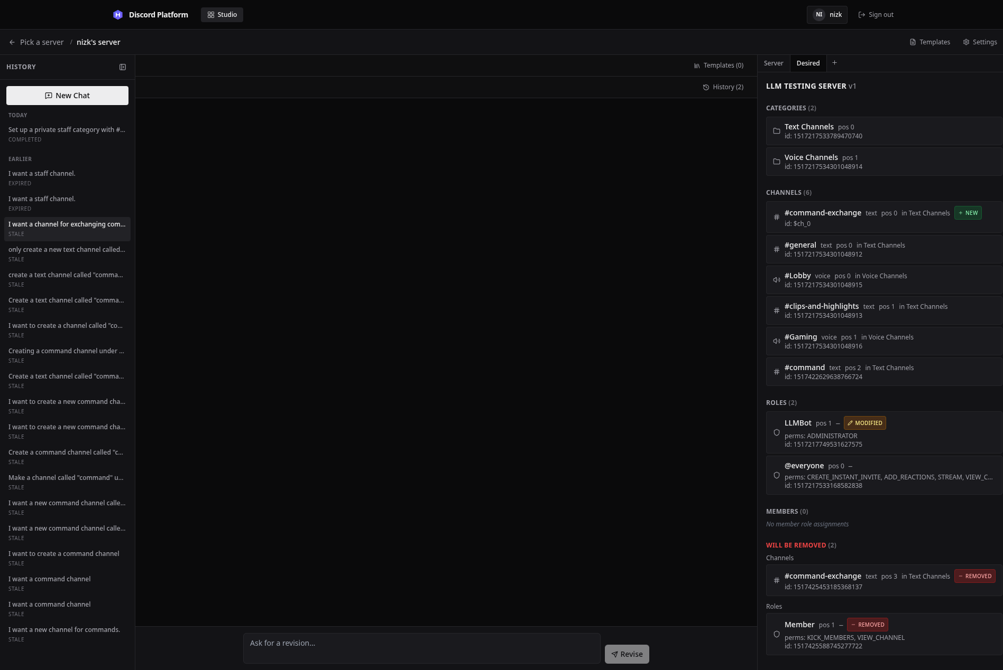
The stale-state presentation prevents approval against an obsolete comparison baseline and directs the administrator toward a fresh fork or the confirmed AI repair flow.

5.5.3 Templates and guild rules
Templates store reusable desired-state structures in PostgreSQL. The Studio can save a completed desired state, browse guild templates, edit template structure, attach template context, and start an LLM-driven merge. A merge creates a normal planning conversation and therefore should produce a new reviewable desired state rather than applying the template directly.
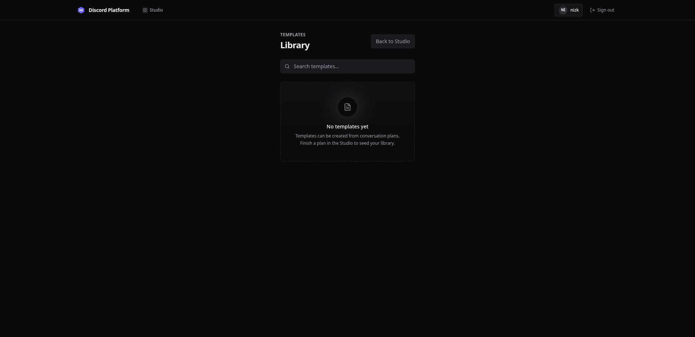
The template library displays saved templates with their names, descriptions, and structural summaries. Templates can be attached to planning conversations to guide the LLM toward known working patterns.
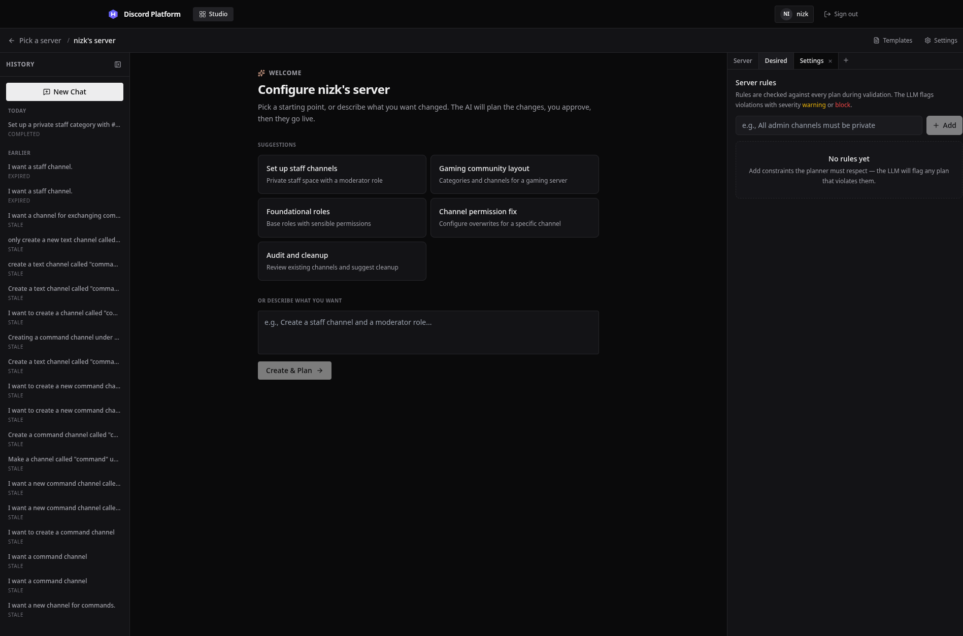
Guild rules are edited in SettingsTab and stored in the rules table. The validation pipeline loads them into the retained planning prompt and reloads the current set for mandatory Stage 2 policy checking before execution. If configured rules cannot be evaluated, execution is blocked and the existing error flow displays the availability reason.

5.5.4 Drift reporting
Gateway handlers publish and persist relevant channel, role, and member-role changes as soon as Discord reports them. Events observed while a guild execution lock is held are treated as expected plan convergence rather than external drift. A periodic comparison between Discord.js's cache and the platform cache remains as a missed-event consistency check. useGuildDrift() marks the selected guild stale and supplies the latest event to DriftIndicator. The Studio disables approval for a stale guild and offers a re-fork action rather than silently applying an old plan. Unlike a Kubernetes controller that reconciles divergence automatically (Kubernetes Authors, n.d.), detected drift here only marks the guild stale and requires a human-reviewed re-fork or repair.

5.5.5 Authentication and guild isolation
Discord OAuth2 supplies user identity, and the API derives guild authority from Discord's MANAGE_GUILD permission or guild ownership. Plan, conversation, state, rule, execution-stream, and planning-stream routes load the resource's guild before authorizing access. Bot operability is a separate check: the bot must be connected to the guild and hold ADMINISTRATOR, while role-mutating plans must also pass hierarchy validation.
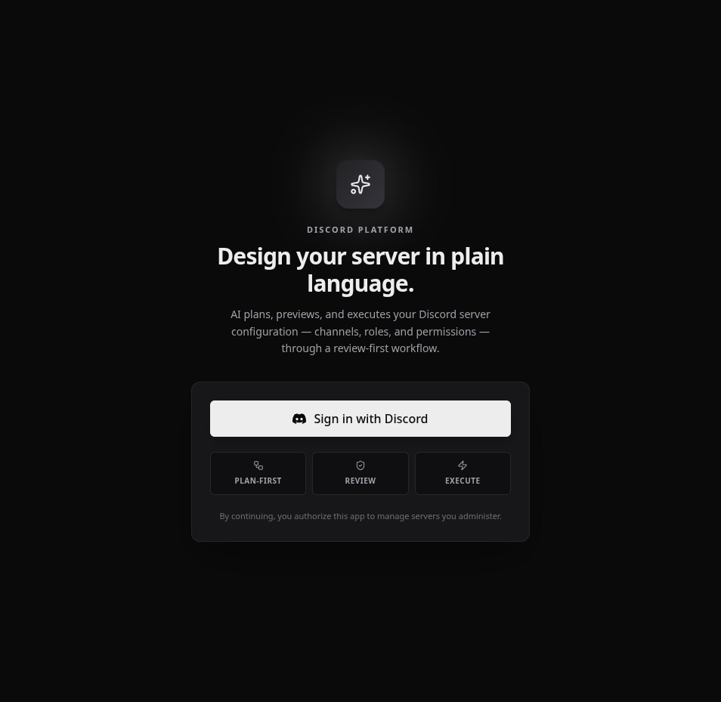
The platform uses Discord OAuth2 for authentication. No separate username or password is created; the user's Discord identity and guild permissions directly determine access.

After authentication, the guild picker displays only servers where the user holds the Manage Server permission and the bot is present with Administrator permission. Servers that do not meet these requirements are filtered out at the API level.

5.5.6 Execution progress and recovery
When an approved plan is executed, the system streams live progress over Server-Sent Events. Each step is reported as it starts, completes, or fails. If a step fails, the system automatically initiates structural rollback by diffing current Discord state against the before-snapshot and generating a reverse convergence plan.
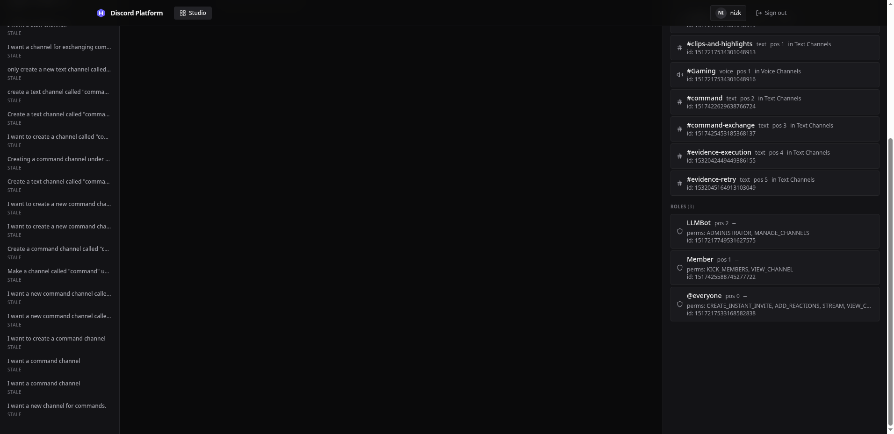
The execution timeline displays each step with its status, elapsed time, and any errors. The administrator can monitor the operation as it progresses or abort the execution mid-flight.
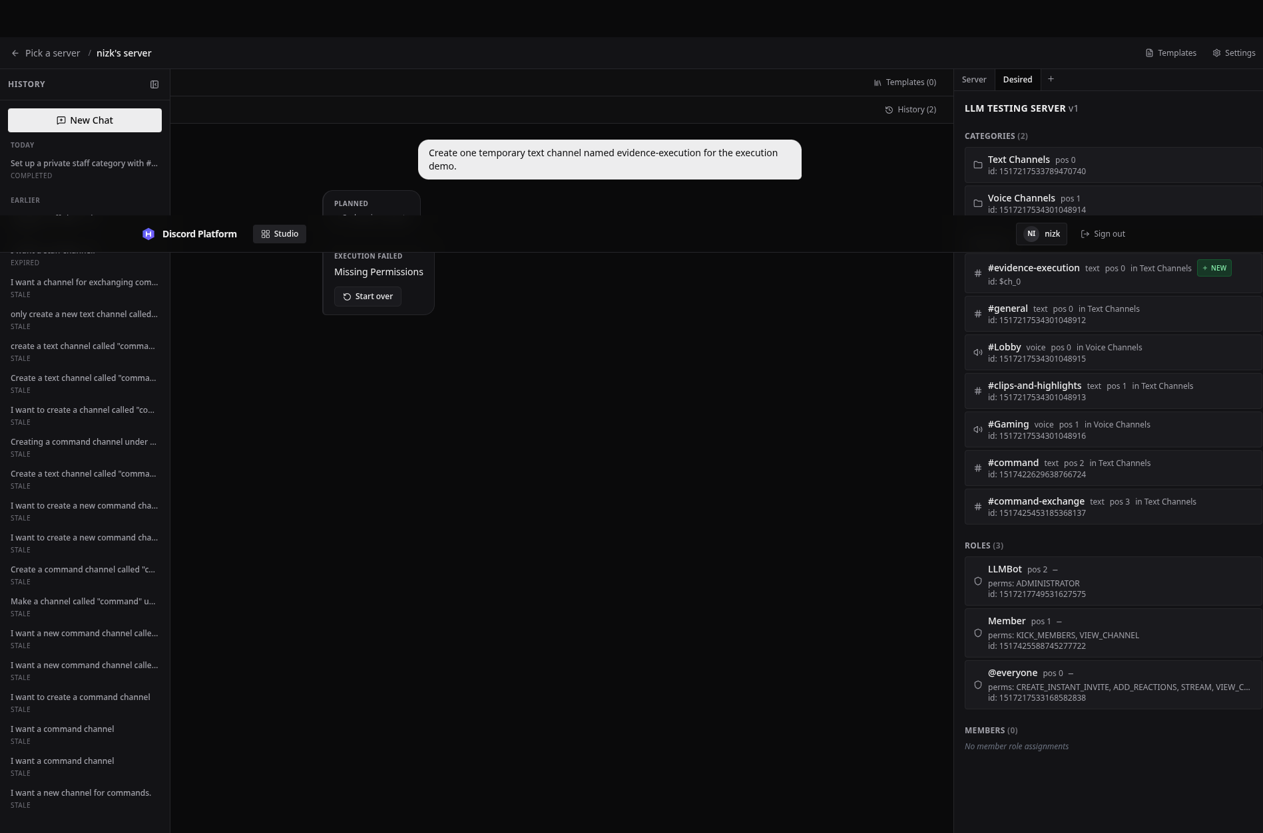
Failures remain part of the evidence rather than being hidden. The Studio reports the failed step, the actionable permission diagnosis, and the result of the automatic structural recovery attempt.
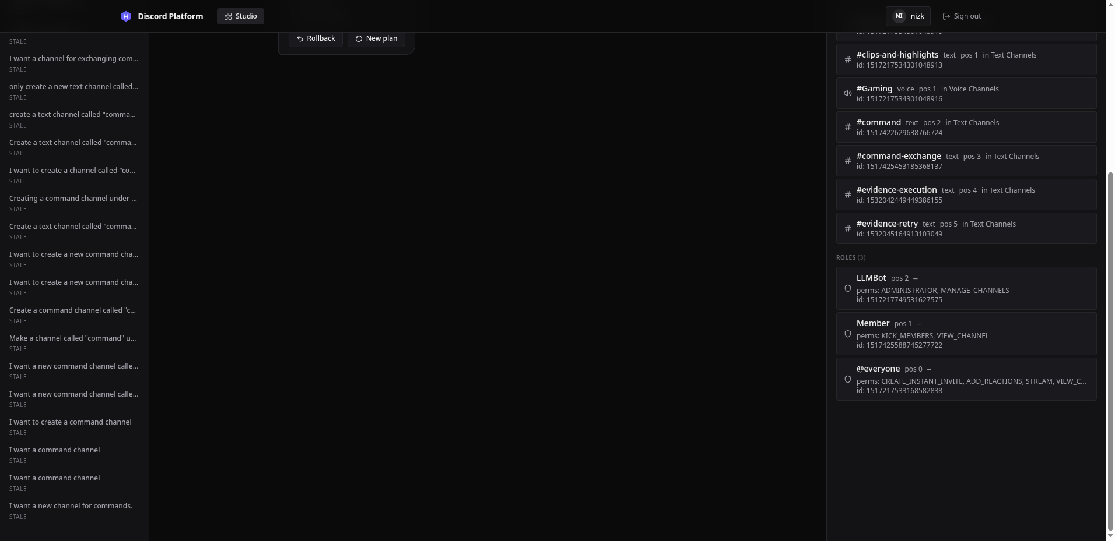
After successful execution, the Studio presents Rollback as an explicit administrator action. A failed execution follows a separate error path that reports the automatic recovery attempt and any residual divergence.
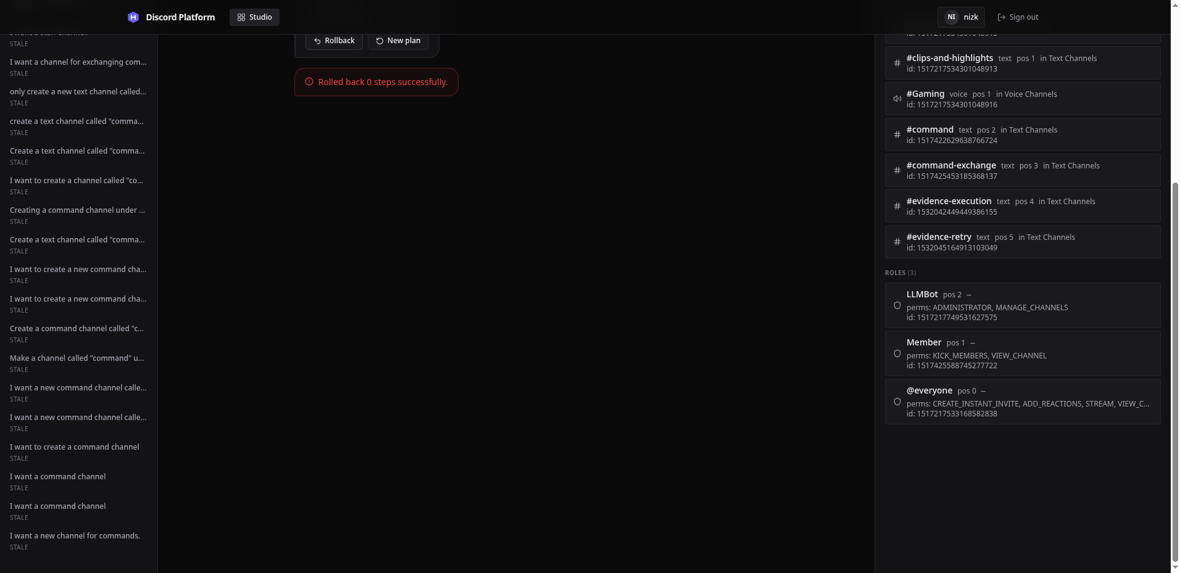
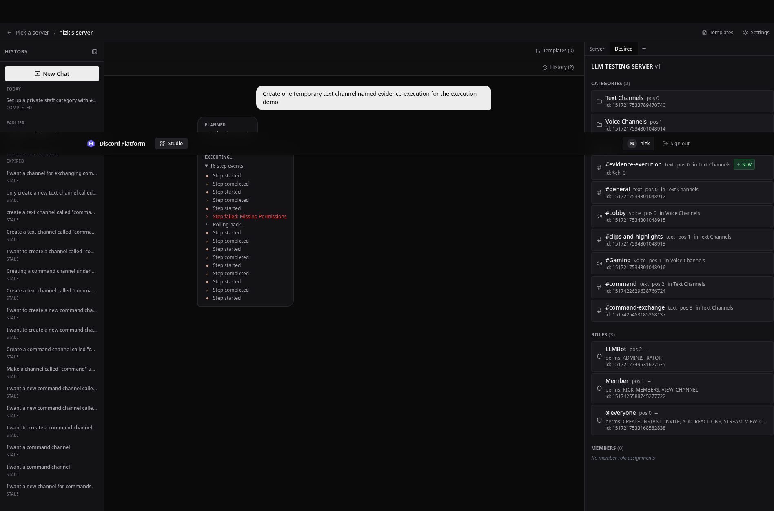
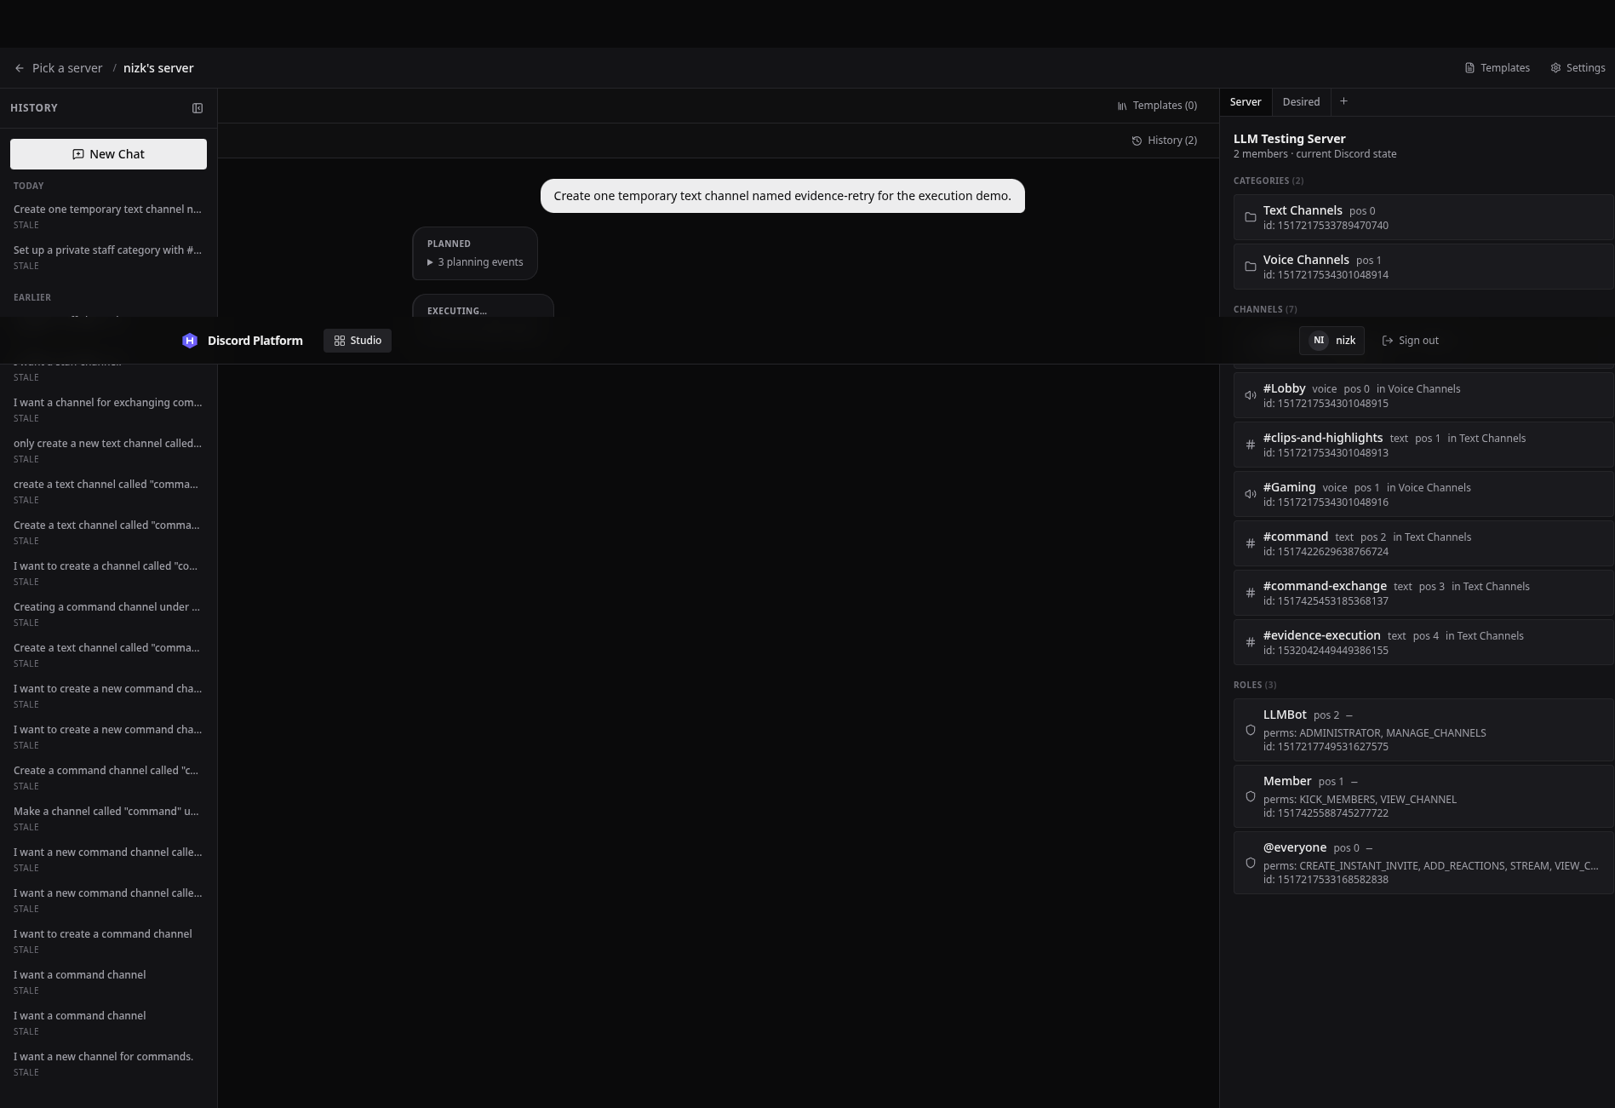
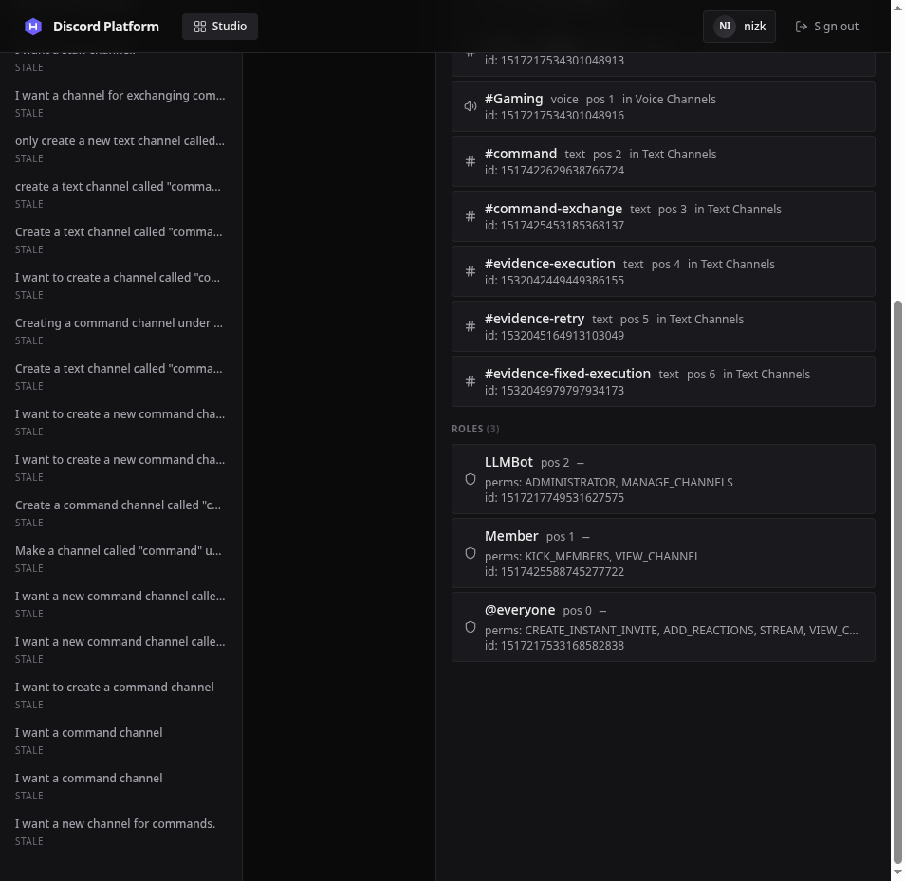
The administrator can trigger manual rollback of a successfully completed execution. The system retrieves the before-snapshot, diffs current state against it, and attempts to converge Discord back to its pre-execution structure.

5.6 Technical Problems and Adopted Solutions
This section records problems for which a solution is already implemented. It does not include the remaining operational limitations in Section 5.8.
Technical problem | Failure mode | Implemented solution
Probabilistic LLM output cannot be trusted as an execution command | A malformed or over-broad response could reach a privileged bot | Restrict the LLM to a fixed tool registry and allow planning tools to mutate only DesiredStateStore
Newly created Discord resources have no ID during planning | Later channels, overwrites, and member assignments cannot refer to a resource that does not exist yet | Assign symbols during planning, topologically sort dependencies, and replace symbols with returned Discord IDs during execution
External Discord changes can invalidate a reviewed plan | The approved preview may no longer match the live guild | Store a fork-state hash, reject stale execution, evaluate assumptions again, and provide confirmed AI re-planning from fresh state
A single Discord request can hang inside a plan | A timeout checked only between steps cannot interrupt the active call | Race each step against a per-step deadline and plan abort signal through dispatchWithDeadline()
Transient and terminal errors need different behavior | Retrying an explicit abort violates user intent, while never retrying timeouts harms reliability | Use structural error classes for hard abort behavior and the existing transient classifier for retryable timeouts
Handwritten inverse operations become incomplete as tools are added | Rollback coverage drifts from forward execution coverage | Fetch current state and use the same diff engine to generate a reverse convergence plan toward the before-snapshot
Planning-only does not necessarily mean interactive | Batch permission planning was incorrectly treated as a clarification pause | Use the specific ask_user tool name to control interaction and retain executionMode only for execution eligibility
Browser requests outlive a normal HTTP interaction | The user cannot see planning, retries, or rollback progress | Publish typed events through per-conversation and per-plan buses and consume them through authenticated SSE streams

5.7 Code Evidence Summary
The implementation evidence used in this chapter is concentrated in the following modules:
Concern | Principal implementation files
Browser lifecycle and call chains | Studio.tsx, ChatArea.tsx, RightPanel.tsx, useConversation.ts
Planning session | planning-session.ts, llm-request.ts, stream-parser.ts, session-manager.ts
Declarative state and tools | desired-state-store.ts, tools/registry.ts, category/channel/role/permission/member tools
Diff and validation | diff-engine.ts, validation.ts, evaluate-assumptions.ts
Execution and recovery | execution-engine.ts, locking.ts, bot/execute-context.ts
API orchestration | hono/app.ts, routes/conversations.ts, routes/plans.ts, routes/templates.ts
Persistence | packages/db/src/schema.ts and Drizzle migrations
Discord observation | bot/index.ts, bot/cache.ts, drift-detector.ts
Chapter 6 evaluates these modules through their existing tests and records specific test inputs, expected outputs, actual outputs, and remaining coverage gaps. This chapter does not convert the existence of a test file into a claim that every path has been verified.

5.8 Implementation Review Outcomes and Remaining Limitations

5.8.1 Corrected call-chain defects and continuity limits
A call-chain review found the issues in Table 5.3. They were corrected before the final report was completed; the table records the adopted behavior rather than presenting already-resolved defects as current limitations.
Table 5.3. Implementation-review findings and adopted fixes
Finding | Adopted fix
A fast planning turn could finish before the browser subscribed to SSE. | The planning event bus retains the latest terminal event (ask_user, completed, error, or expired) and replays it to a late subscriber. Intermediate progress remains transient.
Template merge removed its completed session before approval. | Merge now retains the completed session, and approval can also construct the contract from the persisted latest iteration after a restart.
Rebuilding a prompt for template attachment discarded the original planning context. | PlanningSession retains its forked ServerState and rebuilds the prompt from that base plus active templates.
Completion could be emitted before iteration persistence succeeded. | Turn persistence is part of the state transition. Failure produces an error; completed is emitted only after the snapshot and messages are stored.
Failed reverse execution could be reported as completed rollback. | A distinct rollback_failed event is propagated to the Studio; completion is emitted only for successful reverse convergence.
Failed after-snapshot capture fabricated an empty guild and hashed it as real state. | No after-snapshot is stored when the fresh read fails. The response identifies that absence and all guild conversations are conservatively marked stale because no verified comparison hash exists.
Guild-scoped template reads lacked guild authorization. | List and detail routes check userHasManageGuild; authenticated global templates remain readable and cross-guild resources remain hidden.
Cancel, Abort, and Settings commands were not exposed at the appropriate Studio phase. | Planning and clarification views expose Cancel, execution exposes Abort, and the Settings header opens SettingsTab directly.
Process restarts left in-memory planning statuses appearing active. | Startup marks interrupted planning/waiting rows as errors. Persisted completed conversations remain reviewable and approvable without an in-memory session.
Ordinary gateway changes could disappear when both Discord.js and application caches converged. | Channel, role, and member-role gateway events are published and persisted at observation time; events under an execution lock are suppressed as expected plan effects.
Traffic and cleanup could start while migrations were still running. | One awaited main() performs migrations and recovery before binding the HTTP listener or starting background jobs.
Saved guild rules were checked only at execution, allowing avoidable rule-conflicting proposals. | Initial, template-merge, and stale-repair sessions load authorised guild rules into the retained system-prompt context. Execution still reloads and validates current rules as the fail-closed backstop.
Two operational limits remain. Only terminal planning events are replayed; intermediate planning and execution progress missed during a disconnect is not reconstructed as a full timeline. In addition, an in-flight LLM turn cannot resume after a process restart: it is marked interrupted, while already completed iterations remain durable. These limits affect continuity and progress detail, not the authoritative desired state or the approval and execution safety gates.

5.8.2 Planning-stage policy guidance
The policy design is now prompt guidance plus a fail-closed execution backstop. Conversation creation, server-side template merge, and confirmed stale-plan repair load the authorised guild's current rule text before constructing PlanningSession. The session retains that rule set and the shared system-prompt builder includes it after the platform's fixed planning instructions. Template attachment and detachment rebuild the prompt from the retained server state, rules, and active template context, so they no longer discard policy guidance. The planner is instructed to explain an unsatisfiable conflict and request clarification rather than knowingly plan a violating state.
The prompt is advisory, not a security boundary. At execution, Stage 2 reloads current rules and checks the computed plan with a bounded LLM request. Guilds without rules remain deterministic; guilds with rules fail closed when loading or evaluation is unavailable, and blockers prevent live mutation. Consequently, a rule changed after planning may require revision at execution, but it cannot be bypassed by the session's older prompt context. A regression test verifies that rule text survives system-prompt rebuilding.

5.9 Screenshot Evidence
The repository contains captured evidence from one demonstration guild under docs/report/screenshots/. The captures are listed below. The initial execution attempts exposed an internal diff and hierarchy-validation defect: unchanged permission arrays caused spurious edits to the bot's own role, and equal-position role targets were not blocked before execution. Those defects were fixed and covered by regression tests. A post-fix live Studio execution and rollback capture is included below.
- Authentication. The OAuth login form and authenticated guild picker are captured in 01-discord-oauth-login.png and 02-authenticated-guild-picker.png.
- Planning progress. 03-studio-planning-tool-progress.png shows the Studio while streamed planning events are being received.
- Desired-state preview. 04-completed-desired-state-preview.png shows the completed plan, including newly proposed categories, channels, roles, and permission changes.
- Iteration history. 05-iteration-history.png shows the persisted planning iterations.
- Template and rule management. 06-template-library.png shows template browsing and 07-guild-rules-settings.png shows the guild-rule settings view.
- Execution feedback. 09-studio-execution-progress.png and 11-studio-execution-progress-after-permission.png show the earlier Studio execution attempts; 10-studio-execution-permission-failure.png records the honest failure state returned by Discord. 12-studio-execution-progress-fixed.png shows the post-fix execution flow and 13-studio-execution-complete-rollback-fixed.png shows successful completion with the Rollback control. 14-studio-rollback-fixed.png records the rollback result; it reports zero reverse steps because the live state had already converged to the before snapshot after the temporary channel operation.
- Stale desired state. 08-stale-desired-state.png shows a stale conversation and its desired state, including resources marked for removal.
- Confirmed re-plan. No capture is included. The confirmed re-plan feature is implemented as POST /plans/:planId/replan (Section 5.5.2), but the specific execution path, a stale-hash failure followed by administrator confirmation, was not triggered during the demonstration session. The inspected stale conversation did not expose the confirmed re-plan action in the reachable UI, and the failed execution did not qualify for the AI-repair path. The absence of a capture is a gap in evidence, not a gap in implementation.
- Rollback verification state. 15-studio-rollback-verification-planning.png shows the Studio after the completed rollback, with the session returned to the planning interface and the pre-execution desired state available for review.
The captures contain no tokens or secret configuration, but visible display names and numeric test resource identifiers should be redacted before submission if the final-report privacy policy treats them as personal or identifying data. Each caption should identify the requirement being demonstrated and should not claim a successful execution unless the corresponding run and result are recorded in Chapter 6.

5.10 Chapter Summary
The platform is implemented as a plan-first TypeScript monolith with a React Studio, Hono API, PostgreSQL persistence, and a Discord.js execution adapter. Its central call chains enforce a clear separation: natural language becomes registered planning tool calls; those calls mutate a desired state; approval freezes a snapshot; deterministic diffing and validation produce ordered steps; and only the execution context can mutate Discord. Symbols, stale-state hashes, per-guild locks, per-step deadlines, SSE progress, snapshots, and diff-based rollback address the main technical risks of coordinating an LLM with an external administrative API.
The implementation review corrected event-delivery, template lifecycle, prompt rebuilding, durable completion, rollback reporting, snapshot accuracy, template authorization, command exposure, restart-state, drift-reporting, and startup-order defects. The principal remaining product limitation is continuity detail rather than authoritative-state safety: only terminal planning events are replayed after a disconnect, and an in-flight LLM turn cannot resume after process restart. Chapter 6 evaluates the resulting implementation without treating unexecuted system tests as evidence.

Chapter 6: Testing and Evaluation

6.1 Evaluation Objectives
Testing was used to determine whether the implemented platform behaves as specified in Chapter 3 and whether its safety mechanisms remain effective when inputs, external state, or dependencies do not behave as expected. This distinction is important for an AI-assisted administration system. A generated plan can be syntactically valid while still being inappropriate for the current guild, and an execution can complete at the API level while leaving Discord in a state different from the reviewed preview. The evaluation therefore considers both internal correctness and externally observable outcomes.
The evaluation has five objectives:
- verify deterministic planning logic such as desired-state mutation, diff generation, dependency ordering, and validation;
- verify that execution control handles deadlines, retries, aborts, locks, and rollback without bypassing the reviewed plan;
- verify the complete user-visible flow from authentication and planning through approval, execution, and recovery;
- assess security, performance, and usability against the acceptance criteria in Section 3.2; and
- identify limitations that prevent a requirement from being claimed as fully demonstrated.
Passing implementation-authored tests is not treated as proof of the complete system. A test can repeat the same mistaken assumption as the code under test, while a mock can behave more simply than Discord, PostgreSQL, a browser, or an LLM provider. For that reason, this chapter separates automated regression evidence from live demonstration evidence and from independent evaluation that has not yet been performed.

6.2 Testing Strategy

6.2.1 Levels of testing
The testing strategy follows the architecture described in Chapter 4.
- Unit testing exercises pure functions and isolated state transitions. This is the strongest existing evidence for permission-name conversion, desired-state operations, tool schemas, diff generation, validation rules, stream parsing, and client-side diff utilities.
- Component testing connects a small number of real modules while replacing external dependencies. Examples include the ServerState → diff → validation pipeline and the planning session with a simulated OpenAI-compatible stream.
- Integration testing should cross an actual system boundary, such as a Hono route with PostgreSQL, the Discord adapter with a test guild, or the browser with the API. The existing file named integration.test.ts integrates only the diff engine and validator over in-memory objects; it is therefore classified as a component test in this chapter.
- System and acceptance testing operates the deployed application through its public UI or API and observes the dedicated Discord guild and database. This level is required for claims about OAuth, tenant isolation, live Discord mutation, persistence, rollback, and end-user behavior.
- Regression testing reruns previously failing scenarios after a correction. The current suite contains regression cases for unchanged permission arrays, strict Discord role hierarchy, planning-only permission batches, and per-step deadlines.

6.2.2 Requirement-derived test design
Test cases should be derived from the requirements and acceptance criteria before their expected results are compared with the implementation. Each case records a requirement identifier, explicit preconditions and input, expected output, actual output, status, and evidence location. This creates the traceability chain:
FR / NFR / business rule
↓
independent test case and expected result
↓
observed UI, API, database, and Discord result
↓
pass, fail, partial, or not evaluated
For deterministic functions, the expected value can be stated directly. For a system test, the expected Discord state must be specified independently rather than calculated by the platform's own diff engine. Reusing the same production algorithm as the test oracle would allow the implementation and the test to agree on the same defect.

6.2.3 Result classification
The following statuses are used:
Status | Meaning
Pass | The recorded actual output satisfies the independently stated expected output.
Fail | The observed output contradicts the expected output.
Partial | Some behavior is supported, but an important boundary or acceptance criterion is absent.
Blocked | The case was attempted but could not complete because a prerequisite was unavailable.
Not yet evaluated | No controlled execution and result have been recorded; code existence is not substituted.

6.2.4 Test record format
The result data accompanying this chapter is stored under docs/report/testing/. CSV was selected because it can be inspected directly, imported into a spreadsheet, and processed without a project-specific tool. The files serve different purposes:
- automated-test-results.csv records the number of cases and result for every automated test file;
- representative-automated-test-cases.csv records the specific inputs, expected outputs, actual outputs, evidence boundary, and result for the cases summarised in Table 6.2; and
- independent-system-test-cases.csv is the execution register for the system, security, performance, and usability work. It preserves the original expected output alongside the actual output, status, environment, date, and evidence recorded during the August 2026 run.
A Not yet evaluated row is a test specification, not a test result. When a pending case is executed, the tester must record the environment, date, actual output, status, and an evidence path without replacing the original expected output.

6.3 Automated Regression Testing
The test cases in this section are executed automatically by Vitest. "Automated" means the tests are defined as executable code, run by a test framework without manual interaction, and verified by programmatic assertions rather than human observation. The author writes test specifications and runs the test command; the tool executes the test logic, compares actual output to expected assertions, and reports pass or fail without further human intervention during the test run itself.

6.3.1 Environment and execution
A fresh automated run was performed on 1 August 2026 against the working tree after the Section 5.8 implementation-review fixes, with the following environment:
Item | Value
Operating OS | Linux 7.1.5-zen1-2-zen, x86-64
Node.js | 24.16.0
pnpm | 11.9.0
Vitest | 4.1.7
Test runtime | Node environment configured by Vitest
Test database | Local PostgreSQL URL supplied to configuration validation; database access was mocked by the existing database-dependent tests
External APIs | Discord and LLM calls were mocked or replaced by local streams
The suite was run with NODE_ENV=test, synthetic local authentication configuration, and pnpm test:run. Configuration values are not included because credentials are not test evidence and must not be written into the report. Without the mandatory database, authentication-secret, and application-URL variables, three server suites fail during module import before their assertions are collected. Supplying valid non-secret test values produced the result in Table 6.1.
Table 6.1. Automated test result by repository layer
Layer | Test files | Test cases | Passed | Failed
Shared domain package | 8 | 63 | 63 | 0
Server and planning code | 16 | 110 | 110 | 0
Web stores and utilities | 3 | 35 | 35 | 0
Total | 27 | 208 | 208 | 0
The executable inventory and fresh result are used here. The full result summary is stored in testing/automated-test-results.csv, with the selected detailed records in testing/representative-automated-test-cases.csv.

6.3.2 Representative automated cases
Table 6.2 records representative inputs and outputs from the suite. These cases were selected for their connection to the system's principal risks rather than to make the table appear exhaustive.
Table 6.2. Representative automated test cases
ID | Area and input | Expected output | Actual output | Result
AT-01 | Convert permission names VIEW_CHANNEL, SEND_MESSAGES, and ADMINISTRATOR to Discord.js-style names | ViewChannel, SendMessages, and Administrator | All values matched | Pass
AT-02 | Apply a two-item permission batch where the second item references a non-existent channel symbol missing-channel | Throw an error and retain no overwrite from the first item | An error was thrown; the overwrite map remained empty | Pass
AT-03 | Compare a real role and desired role whose permission arrays contain identical values | Generate no edit_role step | No role-edit step was generated | Pass
AT-04 | Plan that creates role "Moderator" and assigns it to member "alice" in the same desired state | Place role creation before member assignment and resolve the dependency | Two steps were generated in topological order | Pass
AT-05 | Target an existing role "Helper" at the same hierarchy position as the bot | Validation fails because Discord requires the bot to be strictly above the target | Validation returned a blocker | Pass
AT-06 | Pass a channel symbol #new-channel where a role identifier is expected | Validation rejects the symbol-type mismatch | Validation returned a blocker | Pass
AT-07 | Execute a member-role assignment step whose adapter promise never settles, with a 100 ms test deadline | Four total attempts, three retry events, then a terminal plan failure | Four calls, three step_retry events, and plan_failed were recorded | Pass
AT-08 | Abort execution while an adapter promise is still pending | Stop waiting for the step and return a failed result | The result was unsuccessful and a plan_failed event was recorded | Pass
AT-09 | Acquire a guild lock twice using two distinct plan/owner pairs | First acquisition succeeds; second acquisition fails and does not replace the owner | Returned true then false; the first plan and owner remained | Pass
AT-10 | Parse stream fragments {"name": and "staff-chat"} for a create_channel tool call | Reconstruct one call with arguments {"name":"staff-chat"} | One completed tool call with the expected name and arguments was returned | Pass
AT-11 | Receive a planning-only batch_set_overwrite call with permission configuration for three channels, followed by final response | Continue the planning loop without entering ask_user; store the overwrite | Session reached completed, emitted no ask_user, and stored the expected permission | Pass
AT-12 | Compare two identical guild projections and then projections containing channel, role, or field differences | No drift for identical projections; specific drift events for each difference | The detector produced the expected empty or specific event sets | Pass
AT-13 | Compare current and desired state where channel topic, permissions-lock, role permissions, and member roles differ | Mark each changed entity as modified | Client diff utilities classified the expected entities as modified | Pass
AT-14 | Inspect the manual rollback handler source | Handler text calls buildCurrentStateFromDiscord() rather than the custom-cache projection | The expected source string was present and the cache-builder assignment was absent | Pass
AT-15 | Evaluate policy with rules unavailable (missing key), provider failure/timeout, empty output, or malformed JSON | Every unavailable or invalid policy result becomes a block; a no-rule guild skips the call | Thirteen cases passed, including valid empty, blocker, warning, and availability paths | Pass
AT-16 | Emit planning completion before any SSE subscriber attaches, then subscribe; separately make turn persistence throw | Late subscriber receives the terminal event; persistence failure emits error and never emits completed | Terminal replay matched; failed persistence rejected the turn with no false completion | Pass
AT-17 | Create a planning session with a saved guild rule, then attach a template and rebuild its system prompt | The initial and rebuilt prompts both retain the numbered guild rule | The rule remained present before and after prompt rebuilding | Pass
AT-14 is deliberately described as a source-structure assertion. It proves that one textual call is present in the handler, but it does not execute the route or prove that Discord state is fetched successfully at runtime.

6.3.3 Strength of the automated evidence
The automated suite provides useful evidence within the boundaries it actually exercises:
- desired-state operations reject invalid references and preserve atomicity for permission batches;
- selected channel, permission, and member-role tools plan and dispatch the expected values;
- the diff engine handles selected member-role, overwrite, hierarchy, and external-deletion cases;
- validation rejects selected unsafe hierarchy, duplicate, channel-type, and symbol-type cases;
- the execution loop implements the tested abort, deadline, and retry behavior;
- event buses, stream parsing, drift comparison, UI state, and UI diff classification behave consistently for the supplied in-memory inputs; and
- the complete suite can be rerun offline without contacting Discord or an LLM provider.
However, the suite cannot by itself support a claim that the platform has passed system acceptance:
- Discord.js behavior is represented by mock contexts or in-memory maps.
- The locking tests use a handwritten fake database rather than PostgreSQL.
- The planning tests use constructed SSE responses rather than a real provider.
- The file named integration.test.ts does not cross a process, database, HTTP, browser, or Discord boundary.
- The plan-route test inspects source text instead of issuing an HTTP request.
- The Vitest web tests cover stores and pure utilities; there are no rendered .test.tsx component tests or jsdom interaction tests. Playwright system tests are assessed separately in Section 6.5.
- No statement or branch coverage measurement is configured.
- The suite was created alongside the implementation and no mutation score or independent fault-seeding result has yet been recorded.
Accordingly, “208 passed” is reported as an automated regression result, not as 100% requirement coverage or proof that all production flows are correct.

6.4 Recorded Live Demonstration
Chapter 5 records one demonstration on a dedicated Discord guild. The available captures support the following observations:
- Discord OAuth and the authenticated guild picker were displayed.
- Planning progress was streamed into the Studio.
- A completed desired-state preview showed proposed categories, channels, roles, and permissions.
- Iteration history, template browsing, and guild-rule settings were visible.
- Discord returned a real permission failure during an early execution attempt, and the Studio displayed that failure rather than reporting success.
- After the discovered permission-array and equal-role-position defects were corrected, a later execution reached the completed state.
- A rollback request completed with zero reverse steps because the observed live structure had already converged to the before-snapshot after the temporary channel operation.
- A stale desired state was displayed, although the full confirmed re-plan path was not captured.
This evidence is valuable because it crosses the browser, server, and Discord boundaries that the automated suite mocks. It also shows that live testing exposed defects that passing isolated tests had not initially prevented. Nevertheless, it was a development demonstration rather than a controlled acceptance run: the exact initial guild fixture, input prompt, API transcript, database rows, and independently specified expected state were not preserved as one repeatable test record. The captures therefore support implementation evidence but are not counted as a complete pass for the affected functional and non-functional requirements.

6.5 Independent System Test Design

6.5.1 Test data and oracle
Independent system testing should use a dedicated guild containing a small, recorded fixture:
- one category with two text channels;
- one voice channel;
- an @everyone overwrite plus one role-specific overwrite;
- a bot role placed above one manageable role and at or below one unmanageable role;
- two test members with known role assignments; and
- a second Discord account that does not hold Manage Server.
Before each case, the guild fixture should be restored and captured through Discord's supported API. Expected outcomes should be written into the test case before execution. Names, positions, permissions, and member-role assignments can then be compared after planning, execution, or rollback. Volatile identifiers and timestamps should be normalised, but meaningful resource IDs must remain available when a case concerns identity or deletion.
The core procedure is shown in Algorithm 6.1.
Algorithm 6.1. Independent plan, execution, and rollback evaluation
INPUT:
recorded guild fixture F
natural-language request R
independently specified expected state E
restore the Discord test guild to F
BEFORE ← fetch and normalise state through the Discord API
submit R through the public Studio or HTTP API
wait for the completed preview
PRE_APPROVAL ← fetch and normalise state through the Discord API
assert PRE_APPROVAL = BEFORE
review the displayed desired state
assert the displayed result matches E
approve and execute the plan
AFTER ← fetch and normalise state through the Discord API
compare AFTER with E and record every difference
request rollback
ROLLED_BACK ← fetch and normalise state through the Discord API
compare ROLLED_BACK with BEFORE and record every residual difference
record UI events, API responses, database records, and Discord states
The expected state E must not be generated by the production diff engine. It is an independently written oracle derived from the fixture and requirement.

6.5.2 Priority system cases
The cases in Table 6.3 are required before the corresponding requirements can be presented as fully evaluated. Partial status records a controlled result for only part of the stated acceptance criterion; it is not treated as a full pass.
Table 6.3. Independent system and acceptance cases
ID | Requirements | Procedure and input | Expected result | Current status
ST-01 | FR-1, NFR-10 | Sign in from a clean browser profile using a dedicated Discord account | Discord OAuth completes; no local password form or password API is exposed | Pass, Discord-only login surface and disabled email/password endpoint verified
ST-02 | FR-2, FR-4, NFR-11, BR-8 | Request guild data, templates, rules, planning, and execution for a guild the account cannot manage | Every request is rejected before guild data, LLM calls, or Discord mutation | Partial, requests were non-successful, but accepted 503 responses and no downstream-call instrumentation limit the claim
ST-03 | FR-5–FR-10, NFR-1, NFR-16, BR-1, BR-7 | Request a category, channels, role, and overwrite; inspect Discord before approval | A matching preview and diff are shown while the normalised live Discord structure remains unchanged | Partial, unchanged Discord structure verified; the mock stopped at waiting_for_user, so the independently specified preview was not compared
ST-04 | FR-17, FR-18, NFR-1 | Call execution for a draft or otherwise unapproved plan | Request is rejected and no Discord mutation occurs | Partial, authentication, wrong-guild, and missing-plan gates passed; execution of a real draft plan was not exercised
ST-05 | FR-18, FR-19, NFR-7, NFR-18 | Approve and execute a multi-step independently specified desired state | Ordered events are visible; final Discord structure matches the reviewed state; every mutation corresponds to a stored plan step | Skipped, requires controlled live Discord mutation
ST-06 | FR-3, FR-15, NFR-21, BR-4 | Attempt to edit a role below, equal to, and above the bot's highest role | Only the strictly lower target is permitted; blocked cases make no mutation and explain the hierarchy requirement | Skipped, requires controlled live roles around the bot's hierarchy position
ST-07 | FR-20, NFR-2, BR-9 | Inject a terminal failure after at least one successful mutation | Reverse convergence is attempted; the API and UI report success or exact residual divergence; Discord is compared with the before-state | Skipped, requires a controllable failure during live Discord execution
ST-08 | FR-21, FR-24, NFR-4, BR-3 | Change Discord after planning and before approval, then try approval and execution | Both operations reject the stale plan and make no further mutation; the user can start confirmed re-planning from fresh state | Partial, live edit caused execution to return 409 with canAIRepair; approval and repair were not exercised
ST-09 | FR-27 | Cancel while the LLM is still generating a plan | Generation stops, the conversation reaches a terminal cancelled state, and no plan can execute | Partial, completed-session rejection was verified; the mock completed before active cancellation could be observed
ST-10 | FR-28, NFR-2, NFR-9 | Abort a multi-step execution while one step is pending | No later steps are scheduled; the engine stops waiting, attempts rollback, and reports possible late in-flight effects | Partial, missing-plan response passed; abort during an in-flight Discord step was skipped
ST-11 | FR-22, NFR-5 | Restart the server after completed execution, then request rollback using retained snapshots | The completed plan and snapshots survive restart and rollback can still be attempted | Partial, persisted plan access was observed; a controlled restart followed by rollback was skipped
ST-12 | FR-16, FR-25 | Create a blocking guild rule; submit a violating plan with the policy provider available, unavailable, and malformed | Valid violations retain their severity; unavailable or malformed evaluation blocks execution; a guild without rules skips the call | Partial, rule CRUD and access controls passed; provider-backed public policy enforcement was skipped
ST-13 | FR-14, FR-26, NFR-11 | Read, edit, attach, and merge a template; repeat read using an unauthorized account | Authorized operations persist correctly; unauthorized reads and writes disclose no guild template data | Partial, list, read, create, and unauthenticated rejection passed; edit, attach, merge, and a second authenticated tenant were not exercised
ST-14 | FR-24 | Edit a channel directly in Discord and wait for the configured detection interval | A fresh Discord read detects the change, persists one drift event, and notifies only the affected guild | Partial, live edit emitted a guild-scoped drift SSE event; database persistence was not asserted
ST-15 | NFR-13 | Complete planning and execution, restart the server, and query the stored history | Conversation, owner, plan data, status, results, and timestamps remain available | Partial, conversation, iteration, and plan records were queryable; completed execution and a controlled process restart were not part of the case
ST-16 | NFR-17 | Trigger permission, stale-state, conflict, timeout, and provider failures | Each response explains the cause and a useful next action rather than exposing only a raw provider code | Partial, selected missing-resource, cross-guild, and session-state errors were descriptive; permission, timeout, and provider failures were not all triggered
Several cases target specific risks found during the implementation review. In particular, ST-02 can expose missing authorization on template reads; ST-07 can detect false rollback_completed reporting; ST-12 verifies the implemented fail-closed rule boundary through a public flow; and a fast form of ST-03 can reveal planning events emitted before the browser subscribes. Their expected outcomes come from Chapter 3, not from the current behavior.

6.5.3 Playwright E2E test execution
On 1 August 2026, the independent system test register (ST-01 through ST-16 and PF-01 through PF-04) was implemented using Playwright 1.60.0 and attempted against the local development environment. The runner reported 45 passing assertions and eight skipped assertions. Table 6.3a instead counts the 20 complete case specifications: a case is partial when its runnable assertions pass but do not cover the complete preconditions and expected output. The results are recorded in independent-system-test-cases.csv.
Table 6.3a. E2E test execution summary
Status | Count | Description
Pass | 2 | Complete stated result observed for ST-01 and the supplementary PF-04 case
Partial | 14 | Runnable assertions passed, but part of the stated expected output was absent
Fail | 1 | PF-02 exceeded the requirement's declared one-second p95 target
Skipped | 3 | ST-05, ST-06, and ST-07 had no runnable assertion for their principal behavior
Total | 20 | Twenty cases specified; seventeen attempted at least in part and three skipped
The test execution revealed:
- Mock LLM behavior: The mock planner (used when LLM_API_KEY is unset) completes in 3–8 seconds and always calls the ask_user tool, leaving conversations in waiting_for_user status. This is side-effect free as intended but prevents testing full plan completion without a real LLM.
- Authentication and authorization: All OAuth-only assertions pass (ST-01: 2/2 tests). The tested cross-guild requests returned non-success responses (ST-02: 7/7 assertions), and the exercised template requests respected the tested authorization boundaries (ST-13: 4/4 assertions). Unauthenticated requests returned 401. These results do not prove the unobserved downstream non-invocation or complete template lifecycle in the original cases.
- Planning side-effects: ST-03 verified Discord state remains unchanged after planning completes. Channel count, role count, and all names identical before and after.
- Execution safety: ST-04 verified authentication, wrong-guild, and missing-plan rejection, but did not execute a real draft plan. ST-09 verified the response after the mock session had already completed, not cancellation while generation remained active.
- Persistence: ST-15 found conversations, plans, and iterations queryable in PostgreSQL during the running environment. It did not perform the process restart or completed-execution audit sequence in its stated procedure. ST-11 exercised persisted plan access when prior data was available; rollback after a controlled restart remained skipped.
- Policy enforcement: ST-12 verified rule CRUD operations and authorization (4/5 tests). Policy enforcement with LLM provider skipped (.fixme).
- Error messages: ST-16 found descriptive error fields for selected missing-guild, cross-guild, missing-plan, and inactive-session responses. It did not trigger every permission, conflict, timeout, and provider failure named by the case.
- Performance: PF-02 measured p95 = 2072 ms for 20 concurrent state reads. Although the Playwright assertion used a five-second local guard and passed, the recorded result failed the one-second NFR-8 acceptance target. The supplementary PF-04 case observed rate limiting (62 OK, 48 rate-limited out of 110 requests).
- Live manual results: ST-08 observed a direct Discord edit and verified that execution was rejected with HTTP 409 and canAIRepair: true. ST-14 subscribed before a second channel edit and received a channel_updated event for the affected guild. PF-01 verified that an authenticated conversation stream emits streaming_ready immediately after connection.
- Remaining skipped tests: Eight individual tests remain marked .fixme(): ST-05, ST-06, ST-07, ST-10, ST-11, ST-12, the multi-step execution half of PF-01, and PF-03. They require a controlled live execution, injected failure, restart boundary, provider result, or hung adapter.
Full test artifacts (screenshots, video recordings, traces) are stored in test-results/. Detailed findings in e2e/TEST_RESULTS.md.

6.6 Non-Functional Evaluation

6.6.1 Performance and responsiveness
The automated suite confirms event ordering and deadline behavior only with constructed streams and fake timers. Playwright E2E tests executed on 1 August 2026 provide the following measurements:
ID | Requirement | Workload | Target from Chapter 3 | Status
PF-01 | NFR-7 | One representative planning run and one multi-step execution, recording event timestamps | Progress event appears before the terminal event | Partial, authenticated stream emitted streaming_ready; multi-step progress ordering remains skipped
PF-02 | NFR-8 | Cached state and preview reads under 20 concurrent local clients | p95 response time no greater than one second | Fail, measured p95 = 2072 ms, exceeding the declared target
PF-03 | NFR-9 | Hung adapter request and an execution exceeding the overall deadline | 30-second step bound and five-minute plan bound, followed by cleanup | Partial, config verified (5min/30s), live timeout test skipped
PF-04 | Supplementary control | More than 100 API requests in one minute from one client | Requests beyond the configured window are rate-limited | Pass, 62 OK, 48 rate-limited out of 110 requests
PF-02 latency: The local environment ran PostgreSQL, the Hono server, and 20 Playwright request contexts on one machine, which is relevant context but does not change the criterion after the measurement. The Playwright test's five-second assertion acted as a coarse local regression guard; it was not the NFR-8 acceptance threshold. The measured p95 of 2072 ms therefore fails the declared one-second target. A later deployment benchmark may explain the bottleneck or justify a prospective revision to the requirement, but no faster production result is inferred here.
PF-04 rate limiting: The 100 requests/minute window is correctly enforced. Test sends 110 requests in rapid succession; 62 complete successfully (200), 48 are rate-limited (429 with descriptive error message). The test runs last alphabetically (filename zzz-pf-04-rate-limit.spec.ts) to avoid exhausting the rate limit before other tests run.

6.6.2 Security and privacy
Code inspection shows Discord OAuth, server-side environment configuration, guild authorization helpers, plan validation, and rate limiting. These controls are design and implementation evidence. Playwright E2E tests executed on 1 August 2026 provide the following controlled results:
Authentication (NFR-10):
- ST-01 verified no password form exposed in UI (2/2 tests)
- Email/password endpoint returns 400 with EMAIL_PASSWORD_DISABLED error code
- Discord OAuth button is the only authentication method visible
Authorization (NFR-11):
- ST-02 verified cross-guild isolation across all endpoints (7/7 tests)
- Unauthorized guild access: all state/plans/conversations/rules requests return 403/404/503
- Unauthenticated requests return 401 across protected endpoints
- ST-13 verified template authorization (4/4 tests): authorized users can list/read/create templates; unauthorized users get 401 on all template operations
Observed security controls:
- OAuth-only authentication (no local password storage)
- Guild authorization enforced before data access
- Template read/write authorization enforced
- Rate limiting active (PF-04)
- Cross-guild identifier substitution blocked
- Unauthenticated route access blocked
Not yet verified:
- Inspection of HTTP responses and browser bundles for credential leakage using synthetic sentinel secrets
- Malformed request bodies and tool arguments at API boundaries
- Verification that LLM and Discord calls are not made after authorization rejection (requires instrumentation or network capture)
NFR-10 is demonstrated for the tested authentication surface. NFR-11 remains partial because the cross-guild tests accepted availability responses and did not instrument whether rejected requests avoided every downstream database, LLM, and Discord call. Full security compliance also requires penetration testing and credential-leakage inspection.

6.6.3 Usability
The screenshots show a Discord-like preview and a natural-language workflow, but they do not measure whether representative users can understand or complete tasks. NFR-14 and NFR-15 define assessment targets rather than implemented guarantees. The proposed evaluation recruits five Discord administrators and asks each participant to:
- identify additions, modifications, and removals in one preview;
- create a support category with three channels through plain English;
- revise the result and restore an earlier iteration; and
- explain whether Discord has changed before approval.
Completion, correctness, assistance required, elapsed time, and participant comments should be recorded. The target is at least four of five participants, or 80%, completing the preview and natural-language tasks successfully. No participant result has yet been collected, so the target is not presented as achieved.

6.6.4 Fault detection and mutation testing
Because the regression tests were developed with the implementation, their ability to reject faulty implementations should also be measured. On an isolated temporary branch, one small fault can be introduced at a time:
- allow execution without approved status;
- change strict role hierarchy from botPosition > targetPosition to an equality-permitting rule;
- remove stale-state rejection;
- omit the reverse-diff call after a step failure;
- classify a terminal abort as retryable; or
- emit rollback completion after a failed reverse plan.
The relevant tests are then run and the mutation is restored. A mutation is killed when at least one test fails for the intended reason; it survives when the suite still passes. The mutation score is:
mutation score = killed non-equivalent mutations / all non-equivalent mutations × 100%
The live runs changed only existing channel metadata and did not execute a generated plan. The chapter therefore does not infer multi-step execution or rollback strength from these results.

6.7 Requirements Evaluation
Table 6.4 summarises what the current evidence supports. “Partial” means that code and one or more isolated tests or captures exist, but the requirement's complete acceptance criterion has not been demonstrated.
Table 6.4. Current evidence against requirement groups
Requirement group | Existing evidence | Assessment
Authentication and guild access (FR-1–FR-4) | OAuth and guild-picker captures; authorization code inspection; ST-01 and ST-02 E2E assertions | Partial, OAuth surface verified; cross-guild responses rejected, but downstream non-invocation and exact manage-guild filtering need stronger observation
Planning and cancellation (FR-5–FR-8, FR-27) | Mocked planning-session and stream-parser tests; live planning capture; ST-03 and ST-09 E2E assertions | Partial, side-effect-free planning verified; active cancellation and a complete independent preview oracle remain
Preview and iteration (FR-9–FR-14) | Desired-state, client-diff, and store tests; preview, iteration, and template captures; ST-13 assertions | Partial, interfaces and isolated behavior evidenced; full browser workflows and user comprehension were not evaluated
Validation and approval (FR-15–FR-17) | Structural-validator and fail-closed policy tests; ST-04 and ST-12 assertions | Partial, isolated validation is strong; draft-plan rejection and provider-backed public policy flow remain incomplete
Execution and interruption (FR-18–FR-21, FR-28) | Execution-loop tests for two member operations, timeout, and abort; one recorded live execution; ST-08 and ST-10 partial | Partial, stale execution rejection verified live; approval repair, live abort, and complete execution remain
Post-execution and monitoring (FR-22–FR-24) | Drift-comparison tests; live drift SSE capture; ST-11, ST-14, and ST-15 assertions | Partial, live notification and selected persistence observed; drift-row persistence and rollback after controlled restart remain
Rule and template management (FR-25–FR-26) | Fail-closed policy tests, UI captures, implementation inspection, ST-12 and ST-13 assertions | Partial, rule CRUD and basic template authorization observed; provider flow and complete template lifecycle remain
Safety and reliability (NFR-1–NFR-6) | Strong isolated evidence for validation, locks, retries, and deadlines; partial ST-03, ST-04, and ST-08 cases | Partial, deterministic safeguards are well tested; their complete public live composition is not
Performance (NFR-7–NFR-9) | Live SSE readiness, constructed event/deadline tests; PF-02 failure; PF-03 partial | Partial with a failed target, event readiness observed, p95 target missed, and live execution deadlines remain unmeasured
Security and privacy (NFR-10–NFR-13) | Architectural controls, code inspection, and ST-01, ST-02, ST-13, ST-15, and ST-16 assertions | Partial, delegated authentication is strong; tenant-call isolation, secret scanning, and restart-based audit evidence remain incomplete
Usability (NFR-14–NFR-17) | UI captures and utility tests; ST-16 actionable error messages (5/5) | Partial, error messages verified; user study not performed
Architecture and validation (NFR-18–NFR-20) | Declarative state, registered-tool, schema, diff, and validation tests | Partial, public API boundaries and unregistered-model-call rejection need broader tests
Compatibility and deployment (NFR-21–NFR-23) | Discord.js and configurable LLM adapter implementation | Not demonstrated against two providers or a clean deployment record
The strongest current result is deterministic component behavior: all 208 collected automated unit/component cases pass. Playwright also reports 45 passing assertions and eight skipped, but those runner totals must not be read as 45 complete requirement passes. The 1 August 2026 run added the following controlled observations:
Newly verified through E2E tests:
- OAuth-only authentication with no password form (ST-01)
- Non-success responses for tested unauthorised and wrong-guild requests (ST-02)
- Side-effect free planning (ST-03)
- Authentication, wrong-guild, and missing-plan execution gates (ST-04)
- Basic template list/read/create authorization boundaries (ST-13)
- Queryability of selected conversation, iteration, and plan records (ST-15)
- Descriptive errors for selected public failure responses (ST-16)
- Rate limiting enforcement (PF-04)
- Completed-session cancellation rejection (ST-09)
- Stale-plan execution rejection after a live Discord edit (ST-08)
- Guild-scoped drift SSE notification after a live channel edit (ST-14)
- Authenticated conversation-stream readiness (PF-01)
Partially verified:
- Stale plan handling (live execution rejection verified; approval rejection and repair remain)
- Abort behavior (endpoint verified; live abort requires Discord bot)
- Rollback persistence (DB records verified; rollback-after-restart requires live test)
- Drift detection (live SSE notification verified; persisted drift row not asserted)
- Policy enforcement (CRUD verified; LLM-based policy check requires real API key)
- Performance latency (p95 = 2072 ms, which fails the one-second NFR-8 target)
The weakest areas are the boundaries carrying the greatest real-world risk that remain incompletely verified: full multi-step Discord convergence, failure injection and rollback, active cancellation, provider-backed policy behavior, downstream-call isolation after authorization rejection, restart recovery, the missed read-latency target, deployment reproducibility, and user comprehension.

6.8 Strengths, Limitations, and Overall Assessment
The platform has several testability strengths. Its declarative DesiredState, pure diff engine, schema-validated tools, and ExecuteContext boundary make substantial planning logic testable without Discord. Regression cases cover subtle failures such as permission arrays with different ordering, equal-position role targets, atomic batch permissions, symbol dependencies, and hung execution steps. The live demonstration also showed an important professional behavior: a Discord permission failure was displayed honestly and used to drive a correction rather than being hidden.
The current evidence also has material limitations:
- the automated suite is predominantly white-box and implementation-authored;
- mocks replace the database, Discord adapter, LLM provider, and browser in unit tests;
- route coverage remains narrow: template authorization uses mocked route tests, while the plan rollback case is a source-text assertion rather than an HTTP execution;
- eight E2E tests require controlled live dependencies and cannot run in CI;
- the recorded demonstration is not a fully reproducible test dataset;
- saved guild rules now guide initial, template-merge, and stale-repair planning, but prompt adherence remains probabilistic and current rules must still be revalidated at execution;
- no controlled usability, deployment, or multi-step execution mutation evaluation has been completed;
- terminal planning events are replayed, but intermediate planning and execution events missed during a disconnect are not reconstructed, and an in-flight LLM turn cannot resume after restart;
- E2E tests use mock LLM which completes instantly and always calls ask_user, preventing full plan completion testing without a real LLM API key.

6.8.1 Evaluation of planning-stage rule guidance
The planning-stage rule integration implemented in Sections 4.2.4 and 5.8.2 should be evaluated against an execution-only baseline rather than being accepted merely because the rules appear in a prompt. Repeated scenarios should include a compatible request, a directly conflicting request, ambiguous and mutually conflicting rules, a rule change after review, and planning-context rebuilding during revision, template merge, and stale-plan repair. The expected safety result remains the same: an unchecked or violating plan must not execute.
The comparison should measure the proportion of first proposals that satisfy the configured rules, the number of late policy blockers, clarification and re-planning turns, time to an approvable proposal, token usage, and planning latency. It should also repeat selected cases across supported models or providers because a planner and validator from the same model family may share failure modes. These measurements would determine whether earlier guidance provides enough usability and efficiency benefit to justify its additional prompt and session-state complexity; they would not replace the fail-closed execution test.
The defensible conclusion is therefore not that the whole system has passed testing. The available results show that the deterministic core has a functioning regression baseline and that selected public and live boundaries have been observed. Full compliance with Chapter 3 remains unproven until the partial and skipped cases in Sections 6.5 and 6.6 are completed against their original expected outputs. The failed latency case and incomplete cases remain part of the final evidence rather than being removed or reclassified through post-result thresholds.

6.9 Chapter Summary
This chapter evaluated the project using requirement-derived criteria and a deliberately cautious evidence model. A reproducible Vitest run (Vitest Team, n.d.) collected 208 passing cases across 27 files. These cases provide credible regression evidence for desired-state manipulation, registered planning tools, selected diff and validation rules, locks, stream parsing, deadline and abort handling, drift comparison, and client-side state logic. They do not exercise most production boundaries.
The recorded Discord demonstrations add browser-to-Discord observations: a real permission failure and corrected execution, stale-plan rejection after an external edit, guild-scoped drift SSE, and authenticated stream readiness. The controlled Playwright results are reported only for the assertions actually observed; broader acceptance steps remain partial or skipped, and the p95 read target was missed. The current overall assessment is therefore partial: the deterministic core and selected live boundaries are supported by evidence, while the complete deployed workflow still requires broader measured black-box evaluation.

Chapter 7: Conclusion and Future Work

7.1 Achievement of the Project Objectives
This project set out to make substantial Discord configuration easier without allowing a probabilistic model to act directly on a live community. The resulting platform implements the complete intended control path from natural-language request to desired-state planning, preview, validation, approval, execution, rollback, and drift monitoring. Completion of an implementation path is not, however, the same as complete verification. Table 7.1 therefore assesses each objective using the evidence and limitations established in Chapter 6.
Table 7.1. Achievement of the project objectives
Objective | Outcome and evidence | Assessment
Authenticate through Discord and restrict access to manageable guilds | Discord OAuth is the only exposed sign-in method. Guild access helpers and protected routes are implemented, and ST-01 and ST-02 exercised the principal public rejection paths. The tests did not instrument every downstream call after rejection. | Substantially achieved; isolation evidence remains partial
Translate natural language into a structured plan without changing Discord | Planning sessions use registered tools against a forked desired-state store. Component tests and ST-03 support the side-effect-free boundary, although ST-03 did not independently validate the complete generated preview. | Achieved in implementation; partially demonstrated end to end
Present a Discord-like preview and current-to-desired difference | The Studio renders desired channels, categories, roles, members, tombstones, and diff badges. Figures 5.2–5.4 and client utility tests show the interface and supporting logic; no controlled comprehension study was performed. | Implemented; usability target not evaluated
Support revision, manual editing, iteration history, and reversion before approval | Conversation revision, desired-state editing, persisted iterations, and revert routes and controls are implemented. Store and state tests cover isolated behavior, while the complete browser workflow has not been independently executed as one acceptance case. | Implemented; verification remains partial
Validate structural safety and server rules, then require explicit approval | Deterministic validation, strict role-hierarchy checks, current guild-rule loading, fail-closed provider handling, and approval gates are implemented and strongly covered by component tests. The complete provider-backed public policy flow and a real draft-plan execution rejection remain incomplete. | Substantially achieved; public-flow evidence remains partial
Execute an approved plan with live progress | The execution engine applies ordered diff steps through a Discord adapter and emits progress over SSE. Recorded captures show execution behavior, but the controlled multi-step ST-05 case was skipped. | Implemented; not fully demonstrated under controlled live conditions
Recover structurally after failure or request, and detect external drift | Before/after snapshots, diff-based rollback, abort handling, stale checks, and drift polling are implemented. Live stale rejection and drift notification were observed; injected partial failure, residual-divergence reporting, and rollback after restart remain unverified. | Partially demonstrated
The central project objective has therefore been met at the level of a functioning integrated system: the model proposes state, deterministic software decides what the proposal means operationally, and a human controls the authority boundary. The evaluation does not support the stronger claim that every functional and non-functional acceptance criterion has passed. The detailed position for each requirement is preserved in Appendix A.

7.2 Principal Contribution
The principal contribution is not natural-language generation by itself. Existing tools can already generate server structures or automate individual Discord commands. The contribution is the placement of a declarative, reviewable, and recoverable control plane between language-model interpretation and privileged Discord operations.
Three design choices make that contribution concrete. First, the planner operates on a forked desired state through a fixed tool registry and has no Discord execution context. The model can express intent only within the platform's typed configuration vocabulary. Second, a deterministic diff and validation pipeline turns that state into an inspectable execution contract. Approval applies to the specific reviewed plan, and a hash prevents that contract from being used against a server state that has since changed. Third, execution is treated as a long-running external operation rather than a database transaction. Locking, deadlines, retries, snapshots, abort signals, state re-observation, and best-effort convergence address the fact that Discord mutations can succeed partially and cannot be atomically reversed.
Together these choices provide a reusable architectural lesson for AI-assisted administration: probabilistic interpretation can improve the input experience without being trusted as the final safety or authority mechanism. The same separation could apply to other configuration domains where users need to review consequences before an external system changes.

7.3 Lessons Learned

7.3.1 Keep interpretation separate from authority
The most important boundary was the one between planning and execution. Reusing the Discord adapter during planning would have made tool calls convenient, but it would also have made side effects dependent on model behavior. A desired-state store allowed the same planning vocabulary to remain expressive while keeping the live system unreachable until deterministic validation and approval had completed.

7.3.2 External state makes reviewed plans temporary
A valid plan is valid only relative to the server state from which it was derived. Discord can change through its native client, another bot, or another administrator while a preview is open. Fork hashes, fresh observations before privileged actions, and confirmed re-planning were therefore not secondary features; they were necessary to preserve the meaning of approval.
Drift detection also showed that comparing two caches is not always equivalent to observing an external change. A Discord gateway event updated both the Discord.js cache and the application's projection before the periodic comparator ran, leaving equal states and no notification. Emitting drift at the gateway observation boundary preserved the fact that a change had occurred, while the periodic comparison remained useful for missed or inconsistent updates. The general lesson is to capture externally meaningful transitions before normal cache convergence erases them.

7.3.3 Recovery needs truthful semantics
Rollback could not be described honestly as an atomic undo. Deleted Discord resources may lose data or identifiers, and a request already sent to Discord may settle after the application stops waiting. The safer design is to re-observe the guild, calculate a reverse difference toward the retained snapshot, attempt that convergence, and report any residual divergence. This distinction also changed how abort and failure messages were implemented and evaluated.
The same precision was required for deadlines. An abort check between execution steps did not bound a Discord request that never returned, because control could not reach the next check. The deadline had to wrap each awaited operation. Even then, racing the operation against a timer or abort signal stops the engine's wait; it cannot cancel a Discord request that exposes no cancellation hook. A timeout can be retried as a transient failure, whereas a user or plan abort is a hard terminal condition. Representing the latter with a distinct error type kept that invariant independent of mutable error-message wording.

7.3.4 Ordering matters in asynchronous workflows
Planning and execution cross the browser, SSE streams, application memory, PostgreSQL, an LLM provider, and Discord. Small ordering decisions therefore affected correctness. Terminal planning state had to be persisted before a completion event was published, and late subscribers required bounded terminal event replay. Startup recovery also had to finish before accepting requests. These problems were not visible from the static architecture alone and justified the iterative, risk-driven development approach selected in Chapter 2.

7.3.5 Model distinct states and responsibilities explicitly
Several defects came from using one convenient label or representation for two different concepts. A planning_only tool classification describes whether a tool may reach execution; it does not say whether the planning loop should pause for human input. Inferring interaction from that classification caused a batch permission tool to behave like ask_user. The correction made user interaction an explicit tool behavior rather than a side effect of execution eligibility.
Discord role handling exposed a similar problem. Two separately allocated permission arrays can represent the same permission set, so reference or ordered comparison produced unnecessary role edits. Discord hierarchy is also a strict boundary: possessing Administrator does not allow a bot to edit a role at its own highest position. Structural set comparison removed no-op edits, while a greater-than-or-equal hierarchy check blocked impossible mutations before dispatch.
Finally, optional policy must distinguish absence from unavailability. A guild with no configured rules has no policy step to perform. A guild with rules but an unavailable or malformed external evaluator has a policy that could not be checked; treating those states alike would silently bypass an administrator's constraint. The implemented fail-closed behavior reflects a broader lesson: fallback logic must preserve the security meaning of each state, not merely keep the workflow moving.

7.3.6 Passing components do not prove the deployed workflow
The 208 passing automated cases give useful confidence in state manipulation, diffing, validation, policy failure behavior, retries, locking, and selected UI logic. They do not reproduce a real provider, browser timing, PostgreSQL restart, or a Discord guild undergoing a multi-step mutation. Similarly, a passing Playwright assertion may exercise only part of a broader acceptance case. Separating runner results from acceptance assessments made the final evaluation less impressive numerically but more useful and defensible.

7.3.7 From direct document editing to constrained state mutation
The earliest design treated the desired server configuration as a JSON document that the LLM could edit directly, in a similar way to an agentic coding assistant modifying files in a software repository. This was an attractive starting point: the document was easy to inspect, version, and compare, and it naturally expressed the target configuration rather than a sequence of Discord commands. However, it also placed too much responsibility on the correctness of each model-generated document replacement. Resource identity, deletion intent, symbol assignment, and the validity of intermediate mutations were not explicit at the boundary where the model changed the state.
The design therefore evolved toward a typed tool registry and DesiredStateStore. The LLM still edits a declarative representation in the conceptual sense, but every mutation is expressed as a domain operation and validated by application code. This retains the useful properties of the original idea while adding controlled mutation, snapshots, tombstones, stable identifiers, and an auditable record of planning actions. It also allows the model's planning interface to remain separate from the Discord execution interface.
The broader lesson is that unrestricted file-like editing can be a useful mental model for an AI agent, but it is not always the best application boundary. When a state model carries safety-critical invariants, a domain-specific mutation layer can preserve declarative planning while ensuring that the application, rather than the probabilistic model, owns those invariants.

7.4 Limitations and Prioritised Future Work
Future work should close the highest-risk evidence gaps before adding unrelated features.
- Complete controlled live execution and recovery tests. The first priority is a disposable Discord guild and recorded fixture for ST-05–ST-07 and ST-10. Tests should execute a representative multi-step plan, inject a failure only after a confirmed mutation, exercise active abort, compare normalised before/after states, and preserve rollback events and residual differences. This would test the platform's main safety claim at the boundary where unit mocks are least representative.
- Diagnose and repeat the latency measurement. PF-02 recorded a p95 of 2072 ms against a one-second target. Profiling should separate application, authentication, database, and Playwright-client time before optimisation. The original workload should then be repeated on the local reference setup and a documented deployment. The target should be revised only prospectively and with a usability or operational justification, not to convert the existing failure into a pass.
- Strengthen public-boundary and interface tests. Route tests should verify guild filtering, approval and execution gates, malformed request bodies, cross-guild record access, and the absence of LLM or Discord calls after an authorization failure. Rendered React tests should cover approval gating, stale warnings, iteration reversion, template and rule actions, execution progress, and failure/rollback presentation. These additions are relatively small compared with live Discord tests and would close several partial assessments without changing production behavior.
- Improve restart and event recovery. A controlled restart test should prove retained plan and snapshot availability and manual rollback after restart. The current bounded replay protects late subscribers from missing the latest terminal planning event, but intermediate events are not reconstructed and an in-flight model turn cannot resume after process loss. Durable event offsets or persisted workflow checkpoints would be needed for stronger multi-instance and restart guarantees. The currently stashed dashboard also leaves historical plans without a dedicated user-interface home; a focused plan-history view should expose the retained audit data.
- Evaluate provider and policy behavior. The same planning scenarios should be run against at least two OpenAI-compatible providers, including tool-call fragmentation, timeout, malformed response, and rule-conflict cases. Planning with rule guidance should be compared with an execution-only policy baseline using first-proposal compliance, clarification turns, late blockers, and time to approval. Deterministic and fail-closed execution checks must remain the authority boundary regardless of the model result.
- Evaluate deployment and human comprehension. A clean, scripted deployment on one commodity host with local PostgreSQL should record migration, startup, health, logging, backup, and secret-handling checks. Separately, the small studies specified by NFR-14 and NFR-15 should measure whether representative Discord administrators correctly understand diff markers and can complete configuration tasks using natural language. Their errors and recovery paths are more informative than visual preference ratings alone.
These priorities intentionally defer subscriptions, a public template marketplace, general moderation features, autonomous configuration, and the other items excluded in Section 1.5. They improve confidence in the defined project rather than expanding its scope.

7.5 Final Conclusion
This project produced an integrated AI-assisted Discord management platform whose architecture is plan-first rather than command-first. Administrators can express intent conversationally, inspect and revise a desired configuration, validate it, approve a fixed plan, and observe controlled execution and recovery behavior. The model is useful at the interpretation boundary but is deliberately denied direct authority over Discord.
The evaluation supports strong confidence in the deterministic core and provides selected evidence at real browser and Discord boundaries. It also identifies a failed latency target and material incomplete acceptance cases. The appropriate conclusion is therefore neither that the approach failed nor that the platform is fully production-proven. The work demonstrates the feasibility and value of a declarative safety boundary for natural-language administration, while defining the live execution, recovery, performance, security, compatibility, deployment, and usability evidence still required for a stronger operational claim.

Appendix A: Requirements Traceability Matrix
This appendix connects every requirement in Chapter 3 to its principal design, implementation, and evaluation evidence. It is a navigation aid rather than a substitute for the cited sections. Pass, Partial, Fail, and Not evaluated use the evidence rules in Section 6.2.3. The existence of code or a screenshot does not by itself upgrade a requirement to Pass; the complete acceptance criterion must have been observed.

A.1 Functional Requirements
ID | Requirement | Principal design evidence | Principal implementation evidence | Verification evidence | Current assessment
FR-1 | Sign in with Discord | Sections 4.1.3 and 4.6.1 | Section 5.5.5; auth/config.ts; Login.tsx | ST-01; Figures 5.7–5.8 | Pass
FR-2 | List manageable servers | Sections 4.5.1 and 4.6.2 | Section 5.5.5; auth/helpers.ts; routes/guilds.ts | ST-02; Figure 5.8 | Partial, rejection paths were observed, but exact guild-list filtering was not independently asserted
FR-3 | Require an operable bot | Sections 4.2.4 and 4.6.4 | Sections 5.4.3 and 5.5.5; guild-check.ts; validation.ts | AT-05 and validator tests; ST-06 skipped | Partial
FR-4 | Reject unauthorized actions | Sections 4.1.3 and 4.6.2 | Section 5.5.5; authorization helpers and protected routes | ST-02 | Partial, responses were rejected, but downstream non-invocation was not instrumented
FR-5 | Submit a request in natural language | Sections 4.2.2 and 4.5.2 | Sections 5.2.4 and 5.3.2; WelcomeScreen; ChatArea | Planning-session tests; Figure 5.1; ST-03 | Partial
FR-6 | Generate a structured plan | Sections 4.2.2–4.2.3 and 4.4.2 | Sections 5.3.1–5.3.3; desired-state store and tool registry | AT-02, AT-10, AT-11; ST-03 | Partial, structured planning is tested, but the independent full-preview oracle was not applied
FR-7 | Ask clarifying questions | Sections 4.2.2 and 4.5.2 | Section 5.3.3; ask_user; planning session and chat UI | Planning-session tests; ST-03 uses the mock pause behavior | Partial
FR-8 | Stream planning progress live | Sections 4.2.2 and 4.4.4 | Sections 5.2.4 and 5.3.2; planning event bus and SSE route | Figure 5.1; PF-01 stream readiness | Partial, complete event ordering was not measured
FR-9 | Preview the desired state | Sections 4.2.3 and 4.5.2 | Sections 5.3.1 and 5.5.1; DesiredStateView | Figure 5.2; state/store tests; ST-03 | Partial
FR-10 | Show the difference from the current server | Sections 4.2.3 and 4.5.3 | Sections 5.3.3 and 5.5.1; diff utilities and Desired tab | AT-13; Figure 5.2 | Partial
FR-11 | Revise the plan | Sections 4.2.2 and 4.5.2 | Sections 5.3.3 and 5.5.1; conversation revision route and useConversation | Planning-session and store tests | Partial, no complete browser acceptance case
FR-12 | Revert to an earlier version | Sections 4.3.2 and 4.5.2 | Sections 5.3.3 and 5.5.1; iteration persistence and modal | Figure 5.3; state/store tests | Partial
FR-13 | Manually edit the desired state | Sections 4.2.3 and 4.5.2 | Section 5.5.1; useDesiredStateEdit and editable desired-state components | State/store and diff-utility tests | Partial, rendered workflow not independently tested
FR-14 | Use templates as ideas | Sections 4.2.2 and 4.5.5 | Section 5.5.3; template attach, detach, and merge routes/UI | Figure 5.5; ST-13 covers only part of the template lifecycle | Partial
FR-15 | Validate structural safety | Sections 4.2.4 and 4.6.4 | Section 5.4.3; validation.ts; assumption evaluator | AT-05, AT-06 and validation suites | Partial, strong component evidence, incomplete public live composition
FR-16 | Validate against server rules | Sections 4.2.4 and 4.6.4 | Sections 5.4.3 and 5.5.3; fail-closed policy validation | AT-15; policy-validation tests; ST-12 partial | Partial
FR-17 | Approve a plan | Sections 4.2.4–4.2.5 and 4.5.2 | Section 5.4.1; approval route and Studio control | ST-04 partial; stale-state tests | Partial, a real draft plan was not used in the rejection case
FR-18 | Execute an approved plan | Sections 4.2.5 and 4.4.3 | Sections 5.4.1 and 5.4.4; execution engine and Discord execute context | Execution-engine tests; Figures 5.9–5.11; ST-05 skipped | Partial
FR-19 | Stream execution progress live | Sections 4.2.5 and 4.4.4 | Sections 5.4.4 and 5.5.6; event bus, plan SSE, and execution UI | AT-07; Figures 5.9–5.11; PF-01 partial | Partial
FR-20 | Roll back automatically on failure | Sections 4.2.5 and 4.6.5 | Sections 5.4.5 and 5.5.6; rollbackFull and rollback reporting | Rollback-reporting tests; Figure 5.10; ST-07 skipped | Partial, controlled injected live failure was not executed
FR-21 | Reject stale-state approval and execution | Sections 4.2.5 and 4.6.5 | Sections 5.4.1 and 5.5.2; fork hash checks and re-plan route | Figure 5.4; ST-08 | Partial, live execution rejection observed; approval rejection and confirmed repair remain
FR-22 | Roll back a completed plan | Sections 4.2.5 and 4.6.5 | Sections 5.4.5 and 5.5.6; manual rollback route and snapshots | AT-14; Figures 5.11–5.12; ST-11 partial | Partial
FR-23 | View plan history | Sections 4.3.2 and 4.5.2 | Plans are persisted and listable, but the current UI has no dedicated plan-history home | ST-15 shows selected records are queryable | Fail, the required user-facing history is not currently exposed
FR-24 | Detect and notify of drift | Sections 4.2.6 and 4.6.5 | Section 5.5.4; drift detector, stream, and indicator | AT-12; Figure 5.4; ST-14 | Partial, live notification observed, but persisted event was not asserted
FR-25 | Manage server rules | Sections 4.3.2 and 4.5.5 | Section 5.5.3; rules routes and Studio Settings tab | Figure 5.6; ST-12 CRUD assertions | Partial, principal CRUD observed; full policy flow remains incomplete
FR-26 | Manage templates | Sections 4.3.2 and 4.5.5 | Section 5.5.3; template routes, editor, and Studio panel | Figure 5.5; ST-13 partial | Partial, update, attach, merge, and full tenant lifecycle were not all exercised
FR-27 | Cancel planning in progress | Sections 4.2.2 and 4.5.2 | Section 5.3.3; session cancel route and UI | ST-09 | Partial, only rejection after the mock had completed was observed
FR-28 | Abort execution in progress | Sections 4.2.5 and 4.6.5 | Sections 5.4.4–5.4.5; abort-aware execution engine and route | AT-08; ST-10 partial | Partial, isolated pending-step abort works; controlled live abort was skipped

A.2 Non-Functional Requirements
ID | Requirement | Principal design evidence | Principal implementation evidence | Verification evidence | Current assessment
NFR-1 | Approval-gated execution | Sections 4.2.2–4.2.5 and 4.6.4 | Isolated desired-state planning and approval-state gates | ST-03 and ST-04 | Partial, side-effect-free planning observed; real draft execution rejection incomplete
NFR-2 | Structural rollback on failure | Sections 4.2.5 and 4.6.5 | Diff-based rollback, fresh state observation, and residual reporting | Rollback-reporting tests; ST-07 skipped | Partial
NFR-3 | Single execution per server | Sections 4.2.5 and 4.6.5 | Database-backed per-guild locks, heartbeat, and stale recovery | AT-09 and locking tests | Partial, simultaneous public execution was not independently tested
NFR-4 | Stale-state protection | Sections 4.2.5 and 4.6.5 | Stable state hash checks before approval and execution | ST-08 | Partial, live execution path observed, not the complete acceptance criterion
NFR-5 | Recoverability | Sections 4.3.2 and 4.6.5 | Before/after snapshots and daily retention cleanup | Snapshot and persistence tests; ST-11 partial | Partial
NFR-6 | Fault tolerance on transient errors | Sections 4.2.5 and 4.6.5 | Classified retry with bounded exponential backoff and jitter | AT-07 and execution-engine tests | Pass at component boundary
NFR-7 | Real-time feedback | Sections 4.4.4 and 4.5.2 | Planning and execution SSE buses and browser consumers | Figures 5.1 and 5.9; PF-01 | Partial
NFR-8 | Low-latency reads during planning | Sections 4.1.2 and 4.4.1 | In-memory guild projection for planning reads | PF-02: p95 2072 ms | Fail, exceeds the one-second target
NFR-9 | Bounded long-running operations | Sections 4.2.5 and 4.6.5 | 30-second step and five-minute plan deadlines with cleanup paths | AT-07, AT-08; PF-03 partial | Partial, configured behavior tested in isolation; live deadline case skipped
NFR-10 | Delegated authentication | Sections 4.1.3 and 4.6.1 | Discord OAuth through Better Auth; no password form/API | ST-01 | Pass
NFR-11 | Multi-tenant isolation | Sections 4.1.3 and 4.6.2 | Guild authorization helpers and scoped routes | ST-02 and ST-13 | Partial, downstream non-invocation and a second authenticated tenant remain unobserved
NFR-12 | Least-privilege secret handling | Section 4.6.1 | Server environment validation and client/server separation | Code inspection only; sentinel response, bundle, and log scan not run | Not evaluated against its acceptance criterion
NFR-13 | Auditability | Sections 4.3.2 and 4.6.6 | Persistent conversations, iterations, plans, results, and timestamps | ST-15 | Partial, selected rows queryable; completed execution and controlled restart absent
NFR-14 | Familiar preview | Sections 4.5.2–4.5.4 | Discord-like Studio preview and diff badges | Figures 5.2–5.4; no five-user study | Not evaluated against its assessment target
NFR-15 | Natural-language interaction | Sections 4.2.2 and 4.5.2 | Conversational planning UI and registered planning tools | Recorded planning flow; no five-user task study | Not evaluated against its assessment target
NFR-16 | Reversible exploration | Sections 4.2.2–4.2.3 and 4.5.2 | Forked desired state, revision, manual edit, template attach, and iteration revert | State/store tests and Figures 5.2–5.5 | Partial, complete zero-mutation workflow not independently exercised
NFR-17 | Actionable failure reporting | Sections 4.5.2 and 4.6.5 | Error diagnosis and user-facing failure/rollback states | Figure 5.10; ST-16 | Partial, selected errors were descriptive, but all named classes were not triggered
NFR-18 | Declarative, plan-first design | Sections 4.1.4, 4.2.3, and 4.4.3 | Desired state, deterministic diff, stored steps, and execution adapter boundary | State, diff, and execution tests; ST-03 | Partial, no complete live trace mapped every mutation to its stored step
NFR-19 | Constrained AI surface | Sections 4.1.4 and 4.6.4 | Fixed tool registry, Zod parameters, and no Discord context in planning | Tool and validation tests; registry invariant test remains absent | Partial
NFR-20 | Type safety and validation | Sections 4.4.1 and 4.6.4 | Strict TypeScript, Zod schemas, and route/tool validation | Selected schema and tool tests; public malformed-body coverage incomplete | Partial
NFR-21 | Discord API compliance | Sections 4.1.2 and 4.6.4 | Discord.js adapter, permission/hierarchy checks, and rate-limit retry classification | Validator and execution tests; ST-06 skipped | Partial
NFR-22 | Provider-agnostic LLM integration | Sections 4.1.2 and 4.4.2 | Configurable OpenAI-compatible endpoint, key, and model | No recorded two-provider execution | Not evaluated against its acceptance criterion
NFR-23 | Self-hostable deployment | Sections 4.1.2–4.1.3 | Monorepo application, PostgreSQL migrations, and documented local setup | No recorded clean deployment test | Not evaluated against its acceptance criterion

A.3 Traceability Summary
The matrix exposes three different forms of incompleteness. First, some behavior is implemented and covered strongly in isolation but has not been composed through the public live workflow, such as automatic rollback and execution deadlines. Second, some assessment targets require new evidence rather than code changes, particularly user comprehension, two-provider compatibility, secret-leakage inspection, and clean deployment. Third, FR-23 has a direct implementation gap: plans are retained but the current interface has no dedicated plan-history view. These distinctions determine the priority order in Section 7.4.

Appendix B: Database Data Dictionary
This appendix documents the implemented PostgreSQL schema from packages/db/src/schema.ts. It supplements the entity--relationship diagram in Section 4.3; it is a reference for the as-built database, not a separate proposed design. jsonb fields retain complete domain documents because the application reads and writes them as whole values.

B.1 Authentication Tables
Table | Purpose | Primary key | Foreign keys | Main stored data
users | Better Auth user record, extended for Discord identity and application role. | id (text) | None | Name, email, verified flag, image, Discord ID, subscription tier, role, created/updated timestamps.
sessions | Authenticated browser sessions. | id (text) | user_id → users.id | Unique token, expiry, IP address, user agent, created/updated timestamps.
accounts | OAuth account and token record managed by Better Auth. | id (text) | user_id → users.id | Provider/account IDs, access and refresh tokens, expiries, scope, ID token, and timestamps.
verifications | Time-limited Better Auth verification records. | id (text) | None | Identifier, value, expiry, created/updated timestamps.

B.2 Guild Configuration and Audit Tables
Table | Purpose | Primary key | Foreign keys | Main stored data and indexes
guilds | Discord guild anchor and execution-lock state. | id (text, Discord guild ID) | None | Name, icon, type, settings JSON, subscription tier, current plan ID, lock owner/acquisition/heartbeat, created/updated timestamps.
conversations | A user's planning conversation for one guild. | id (UUID) | guild_id → guilds.id; user_id → users.id | Status, original prompt, messages JSON, fork-state hash, timestamps. Indexed by guild_id.
plan_iterations | Immutable desired-state version within a conversation. | id (UUID) | conversation_id → conversations.id | Version, iteration type, desired-state JSON, creation timestamp. Indexed by conversation; (conversation_id, version) is unique.
plans | Reviewed execution contract generated from a conversation. | id (UUID) | guild_id → guilds.id; user_id → users.id; optional conversation_id → conversations.id | Status, prompt, server type, plan-data JSON, execution/completion timestamps, error JSON. Indexed by guild and user.
snapshots | Before/after guild-state records used for recovery and rollback. | id (UUID) | guild_id → guilds.id; optional plan_id → plans.id | Snapshot type, state JSON, expiry, metadata JSON, creation timestamp. Indexed by (guild_id, type), expiry, and plan ID.
rules | Administrator-defined natural-language constraints for a guild. | id (UUID) | guild_id → guilds.id | Rule text and timestamps. Indexed by guild.
templates | Reusable configuration templates, either global or guild-scoped. | id (text) | optional guild_id → guilds.id; optional author_id → users.id | Version, name, description, structure JSON, validation-rules JSON, category, tags, official flag, status, timestamps. Indexed by guild.
drift_events | Persisted notifications of Discord changes outside an active plan. | id (UUID) | guild_id → guilds.id | Severity, event kind, summary, details JSON, creation and resolution timestamps. Indexed by (guild_id, created_at) and (guild_id, resolved_at).

B.3 Data-Handling Notes
- Guild-scoped records use guild_id as the tenant boundary. Route and helper authorization checks enforce that boundary before database records are exposed.
- plans.plan_data, plan_iterations.desired_state, and snapshots.data hold declarative state or execution documents. Their contents are validated by the application rather than queried as independent relational entities.
- snapshots.expires_at supports retention cleanup. Authentication-table columns are managed through Better Auth; the platform code uses raw SQL only where that library's table shape is required.

Appendix C: Detailed Test-Case Register
This appendix preserves the detailed test records summarised in Chapter 6. The authoritative machine-readable registers remain in testing/; this appendix provides a report-readable version of their test cases, inputs, expected outputs, observed results, and evidence boundaries. A passing mocked or structural test does not establish an untested live Discord, browser, PostgreSQL, or provider boundary.

C.1 Representative Automated Test Cases
The automated suite recorded 208 passing cases on 1 August 2026. The following 17 cases are the detailed representative records from testing/representative-automated-test-cases.csv.
ID | Test case and specific input | Expected / actual output | Status and boundary
AT-01 | Convert VIEW_CHANNEL; SEND_MESSAGES; ADMINISTRATOR. | Expected ViewChannel; SendMessages; Administrator; all values matched. | Pass: pure conversion function.
AT-02 | Apply two overwrites; second references a missing channel. | Expected error with no first overwrite retained; error thrown and map remained empty. | Pass: in-memory desired state.
AT-03 | Compare the same role permissions in reverse order. | Expected no edit_role; no edit step generated. | Pass: in-memory states.
AT-04 | Create a role then assign its symbol to a member. | Expected creation before assignment; two topologically ordered steps generated. | Pass: in-memory states.
AT-05 | Target role equals the bot's highest position (5). | Expected hierarchy blocker; blocker returned. | Pass: mocked bot/cache.
AT-06 | Supply a channel symbol where a role identifier is required. | Expected symbol-type blocker; blocker returned. | Pass: in-memory plan and mocked bot data.
AT-07 | Adapter promise never settles; 100 ms step deadline. | Expected four attempts, three retries, terminal failure; all recorded. | Pass: mocked execution context and fake timers.
AT-08 | Pending adapter promise; abort signal after 5 ms. | Expected engine stops waiting and fails plan; unsuccessful result and failure event recorded. | Pass: mocked execution context.
AT-09 | Acquire guild g1 for plan 1, then plan 2. | Expected true then false with first owner retained; observed. | Pass: handwritten fake database.
AT-10 | Split streamed create_channel JSON arguments across chunks. | Expected one completed call with staff-chat; observed. | Pass: constructed SSE stream.
AT-11 | Batch permission tool followed by final LLM response. | Expected no clarification pause and completed session; observed. | Pass: mocked fetch and SSE.
AT-12 | Compare identical guild projections, then channel and role changes. | Expected no event then specific events; observed. | Pass: in-memory projections/event bus.
AT-13 | Change channel topic/lock, role permissions, and member roles. | Expected all entities classified modified; observed. | Pass: pure web utility.
AT-14 | Inspect manual-rollback handler source. | Expected Discord state builder, not cache-state assignment; observed. | Pass: source-text inspection only.
AT-15 | Evaluate configured rules with missing key, load/provider failures, malformed output, blockers, warnings, and no rules. | Expected all unavailable/invalid policy states block; thirteen cases passed. | Pass: mocked database/provider boundaries.
AT-16 | Emit completion before late subscription; separately fail persistence. | Expected terminal replay only after durability; completion replayed and failure emitted no false completion. | Pass: in-memory event bus and mocked persistence.
AT-17 | Rebuild planning prompt after attaching a template with a guild rule. | Expected rule present before and after rebuild; observed. | Pass: in-memory planning session.

C.2 Independent System, Security, and Performance Cases
The full execution register is testing/independent-system-test-cases.csv. Table C.2 preserves every case recorded there on 1 August 2026.
ID | Case | Expected output | Recorded actual output | Status
ST-01 | Complete Discord OAuth from a clean profile. | OAuth completes; no password form or API. | Discord button only; password endpoint returned 400 EMAIL_PASSWORD_DISABLED. | Pass
ST-02 | Reject cross-guild access using guild B identifiers. | Requests reject before data, LLM, or Discord access. | Tested requests returned 403/404/503; unauthenticated requests returned 401. | Partial
ST-03 | Keep planning side-effect free for a category, channels, role, and overwrite. | Preview matches independent state; Discord state stays unchanged. | Before/after Discord snapshots identical; preview content was not independently compared. | Partial
ST-04 | Execute an unapproved draft plan. | Request rejected; Discord unchanged. | Non-existent plan returned 404; wrong guild 403/404/503; unauthenticated 401. | Partial
ST-05 | Execute a reviewed multi-step plan exactly. | Ordered progress; final state matches review; mutations map to stored steps. | Marked .fixme(); requires live Discord mutations. | Skipped
ST-06 | Enforce strict Discord role hierarchy. | Only lower role editable; blocked cases do not mutate and explain why. | Marked .fixme(); requires live Discord mutations. | Skipped
ST-07 | Roll back after injected failure. | Reverse convergence and exact residual reporting; final state compared to before state. | Marked .fixme(); requires live Discord mutations. | Skipped
ST-08 | Reject stale plan and offer confirmed re-planning. | Approval/execution reject without mutation; repair starts fresh. | Live edit changed hash; execution returned 409 with canAIRepair: true. | Partial
ST-09 | Cancel active planning. | Generation stops; conversation cancelled; no plan produced. | Mock had completed; cancellation returned 409 for no active session. | Partial
ST-10 | Abort during pending execution step. | No later step; stop waiting; rollback and report late effects. | Missing-plan abort 404; live abort .fixme(). | Partial
ST-11 | Roll back after server restart. | Plan/snapshots survive; rollback remains available. | Plan and before-snapshot queryable; live rollback .fixme(). | Partial
ST-12 | Apply server rules with provider success/failure. | Violations and unavailable/malformed policy results block; no-rule guild skips call. | Rule CRUD and authorization worked; enforcement .fixme() without API key. | Partial
ST-13 | Protect guild templates. | Authorized operations persist; unauthorized users see no guild data. | Listed/read/created templates and unauthenticated 401 observed; other operations/tenant incomplete. | Partial
ST-14 | Detect direct Discord edit. | Fresh observation persists one event and notifies affected guild only. | Drift stream emitted channel_updated for affected guild; persistence not asserted. | Partial
ST-15 | Retain audit record over planning/execution and restart. | Conversation, plan, results, and timestamps survive. | Conversation, iteration, and plan rows queryable; completed execution/restart not tested. | Partial
ST-16 | Present actionable errors. | Each public failure explains cause and next action. | Selected missing-guild, inactive-session, access, missing-plan, and approval errors were descriptive. | Partial
PF-01 | Measure event ordering. | Progress appears before terminal event. | Conversation SSE emitted streaming_ready; multi-step ordering skipped. | Partial
PF-02 | Measure cached-read latency with 20 concurrent clients. | p95 ≤ 1 second. | p95 = 2072 ms; exceeds requirement target. | Fail
PF-03 | Measure 30-second step and five-minute execution deadlines. | Engine stops waiting, then rolls back and cleans lock. | Configuration verified; live timeout .fixme(). | Partial
PF-04 | Send 110 requests inside the rate-limit window. | Requests beyond 100 receive explanatory 429. | 62 OK; 48 rate-limited; response contained rate-limit error. | Pass

C.3 Detailed Automated Results by Test File
The complete per-file automated result register is testing/automated-test-results.csv. It records 27 test files and 208 passing cases, with each file's evidence boundary and revision. It is retained as CSV because it is more suitable for auditing and spreadsheet import than a repeated report table.

References
BCS, The Chartered Institute for IT (2022). Code of Conduct for BCS Members. Version 8, 8 June. [online] Available at: https://www.bcs.org/media/2211/bcs-code-of-conduct.pdf. [Accessed 29 July 2026].
Beck, K. et al. (2001). Principles behind the Agile Manifesto. [online] Available at: https://agilemanifesto.org/principles. [Accessed 1 August 2026].
Better Auth (n.d.). "Introduction." Better Auth Documentation. [online] Available at: https://better-auth.com/docs/introduction. [Accessed 29 July 2026].
Boehm, B. W. (1988). "A Spiral Model of Software Development and Enhancement." Computer, 21(5), pp. 61–72. doi: 10.1109/2.59.
Brown, S. (n.d.). "Container." C4 model. [online] Available at: https://c4model.com/abstractions/container. [Accessed 1 August 2026].
BuildMyDiscord (n.d.). "AI Discord Server Builder." [online] Available at: https://buildmydiscord.com/en. [Accessed 29 July 2026].
discord.js Authors (n.d.). "discord.js (14)." discord.js Documentation. [online] Available at: https://discord.js.org/docs/packages/discord.js/14. [Accessed 29 July 2026].
Discord (2025). "Server Templates." Discord Help Center, 3 July. [online] Available at: https://support.discord.com/hc/en-us/articles/360041033511-Server-Templates. [Accessed 29 July 2026].
Discord (n.d.-a). "OAuth2 and Permissions." Discord Developer Documentation. [online] Available at: https://docs.discord.com/developers/platform/oauth2-and-permissions. [Accessed 29 July 2026].
Discord (n.d.-b). "Permissions." Discord Developer Documentation. [online] Available at: https://docs.discord.com/developers/topics/permissions. [Accessed 29 July 2026].
Discord (n.d.-c). "Gateway." Discord Developer Documentation. [online] Available at: https://docs.discord.com/developers/events/gateway. [Accessed 29 July 2026].
Discord (n.d.-d). "Rate Limits." Discord Developer Documentation. [online] Available at: https://docs.discord.com/developers/topics/rate-limits. [Accessed 29 July 2026].
Discord (n.d.-e). "AiGuild." Discord App Directory. [online] Available at: https://discord.com/discovery/applications/1412051464796241971. [Accessed 29 July 2026].
Drizzle Team (n.d.). "Why Drizzle?" Drizzle ORM Documentation. [online] Available at: https://orm.drizzle.team/docs/overview. [Accessed 29 July 2026].
European Union (2016). Regulation (EU) 2016/679 of the European Parliament and of the Council of 27 April 2016 on the Protection of Natural Persons with Regard to the Processing of Personal Data and on the Free Movement of Such Data (General Data Protection Regulation). Official Journal of the European Union, L 119, 4 May. [online] Available at: https://eur-lex.europa.eu/eli/reg/2016/679/oj/eng. [Accessed 29 July 2026].
Garcia-Molina, H. and Salem, K. (1987). "Sagas." In Proceedings of the 1987 ACM SIGMOD International Conference on Management of Data, pp. 249–259. doi: 10.1145/38713.38742.
HashiCorp (n.d.). "Create a Terraform Plan." Terraform Documentation. [online] Available at: https://developer.hashicorp.com/terraform/tutorials/cli/plan. [Accessed 29 July 2026].
Hono Authors (n.d.). "Web Standards." Hono Documentation. [online] Available at: https://hono.dev/docs/concepts/web-standard. [Accessed 29 July 2026].
Kubernetes Authors (n.d.). "Controllers." Kubernetes Documentation. [online] Available at: https://kubernetes.io/docs/concepts/architecture/controller/. [Accessed 29 July 2026].
Larman, C. and Basili, V. R. (2003). "Iterative and Incremental Development: A Brief History." Computer, 36(6), pp. 47–56. doi: 10.1109/MC.2003.1204375.
McDonnell, C. (n.d.). "Zod." Zod v3 Documentation. [online] Available at: https://v3.zod.dev/. [Accessed 29 July 2026].
Microsoft (n.d.). "The TypeScript Handbook." TypeScript Documentation. [online] Available at: https://www.typescriptlang.org/docs/handbook/intro.html. [Accessed 29 July 2026].
NIST (2024). Artificial Intelligence Risk Management Framework: Generative Artificial Intelligence Profile. NIST AI 600-1, July. doi: 10.6028/NIST.AI.600-1. [online] Available at: https://nvlpubs.nist.gov/nistpubs/ai/NIST.AI.600-1.pdf.
OpenRouter (n.d.). "Quickstart." OpenRouter Documentation. [online] Available at: https://openrouter.ai/docs/quickstart. [Accessed 29 July 2026].
pmndrs (n.d.). "Introduction." Zustand Documentation. [online] Available at: https://zustand.docs.pmnd.rs/. [Accessed 29 July 2026].
pnpm Contributors (n.d.). "Workspace." pnpm Documentation. [online] Available at: https://pnpm.io/workspaces. [Accessed 29 July 2026].
PostgreSQL Global Development Group (n.d.). "JSON Types." PostgreSQL 16 Documentation. [online] Available at: https://www.postgresql.org/docs/16/datatype-json.html. [Accessed 29 July 2026].
React Team (n.d.). "Describing the UI." React Documentation. [online] Available at: https://react.dev/learn/describing-the-ui. [Accessed 29 July 2026].
Royce, W. W. (1970). "Managing the Development of Large Software Systems." In Proceedings of IEEE WESCON, pp. 1–9.
Schick, T., Dwivedi-Yu, R., Dessi, R., Raileanu, R., Lomeli, M., Hambro, E., Zettlemoyer, L., Cancedda, N. and Scialom, T. (2023). "Toolformer: Language Models Can Teach Themselves to Use Tools." In Advances in Neural Information Processing Systems 36. [online] Available at: https://proceedings.neurips.cc/paper_files/paper/2023/hash/d842425e4bf79ba039352da0f658a906-Abstract-Conference.html.
Schwaber, K. and Sutherland, J. (2020). The Scrum Guide: The Definitive Guide to Scrum: The Rules of the Game. November. [online] Available at: https://scrumguides.org/scrum-guide.html. [Accessed 1 August 2026].
Tailwind Labs (n.d.). "Styling with Utility Classes." Tailwind CSS Documentation. [online] Available at: https://tailwindcss.com/docs/styling-with-utility-classes. [Accessed 29 July 2026].
Vite Team (n.d.). "Getting Started." Vite Documentation. [online] Available at: https://vite.dev/guide/. [Accessed 29 July 2026].
Vitest Team (n.d.). "Getting Started." Vitest Documentation. [online] Available at: https://vitest.dev/guide/. [Accessed 29 July 2026].
WHATWG (n.d.). "Server-Sent Events." HTML Standard. [online] Available at: https://html.spec.whatwg.org/dev/server-sent-events.html. [Accessed 29 July 2026].
Xenon Bot (2025). "How to Load a Template or Backup on an Existing Discord Server." 11 April. [online] Available at: https://xenon.bot/blog/discord-templates-existing-server. [Accessed 29 July 2026].
Xenon Bot (n.d.). "Backups." Xenon Wiki. [online] Available at: https://wiki.xenon.bot/backups. [Accessed 29 July 2026].
Yao, S., Zhao, J., Yu, D., Du, N., Shafran, I., Narasimhan, K. and Cao, Y. (2023). "ReAct: Synergizing Reasoning and Acting in Language Models." In Proceedings of the 11th International Conference on Learning Representations (ICLR). [online] Available at: https://openreview.net/forum?id=WE_vluYUL-X.

