## 



Database Systems Project Proposal

Patient Medical Treatment Tracking System

22.10.2018

Project Group No: 6

Burak Erkılıç - 21501035

Çağatay Sel - 21502938

Kaan Kıranbay - 21501103

Mert Saraç - 21401480

Course Teacher: [Shervin R. Arashloo](http://www.cs.bilkent.edu.tr/~s.rahimzadeh/) - Course TA: Arif Usta

**Table of Contents**

**Overview** **3**

**Requirements** **4**

Functional Requirements 4

Non-functional Requirements 6

Limitations 6

**Entity Relationship Diagram**7

**References**8

# 

# 

# Overview

In this report, our database project which is Patient Tracking System will be expanded under several heading such as functional requirements, non-functional requirements, limitations, entity relationship diagrams.

Aim of this project is designing optimal database system with all requirements of the system so, both patients and doctors can make their tasks easily. In designing process of the system, we looked for same systems in terms of its requirements. We tried to add the most optimal number of the attributes in each entity. Also, we omit some entities such as nurse, due to not taking a crucial role in the system. In this kind of systems, as we observed, only doctors’ information is stored and if a problem arises, nurses are not responsible for this unlike doctors.

Our patient tracking system allows adoctor or a patient or a pharmacist to log and monitor the medical related information and request various medical activities. This system is part of an overall [information system](https://en.wikipedia.org/wiki/Hospital_information_system) and it interacts with the person's [electronic health record](https://en.wikipedia.org/wiki/Electronic_health_record), where information specific to the person is stored.

Our project’s website: <https://segocago.github.io/CS353_Database_Project/>

**Why Database System is Required**

The system we have designed for patient tracking system requires database management due to the need for persistent data storage [1]. In order to provide the functionality of viewing previously registered information, our system must store these information. Moreover, our system must be able to fetch the stored information from our server and deliver these information to users. These information include but not limited to following attributes: patients’ allergy, disease, examination, test and drug history; pharmacy and hospital addresses, phones etc. To store and serve these information to patients in an acceptable amount of time, we use relational database systems as part of our overall system.

Requirements

This section explains the functional, nonfunctional requirements and limitations of our system.

## **Functional Requirements**

* **Registering & Viewing Vaccine History**
* Doctors have the ability to register their patients vaccinations to system so that their patients will be able to view their vaccination history. This history will include the name of vaccines and when the patient got vaccinated.
* **Registering & Viewing Examination History**
* Doctors can register examinations to systems so that patients will able to see the details and dates of their examinations.
* **Registering & Viewing Diagnoses History**
* Doctors will be able to register their diagnoses as part of patients’ examination. Patients will be able to see their history of diagnoses.
* **Registering & Viewing Prescription History**
* After examinations, doctors will register the prescription of the patient if they have prescribed. Patients will be able to see the contents of their prescriptions and the dates when they were prescribed.
* **Registering & Viewing Treatment History**
* System will enable doctors to register any treatment that they have applied. These treatments will be stored and patients will be able to view their treatment history.
* **Registering & Viewing Used Drugs**
* System will register patient’s drug history by using their prescriptions. Doctors will be able to see this history and determine if the drugs they will prescribe carries a risk of reaction to their previous drugs.
* **Registering & Viewing Test Results**
* Doctors will register the test results of their patients to systems. This will provide the opportunity of viewing patient’s previous tests to doctors. Patients will also be able to see their results if they want to get council from doctors or relatives.
* **Registering & Viewing Allergies**
* Doctors and patients will be able to register any known allergy of the patient to system. This allergy history could be viewed by doctors in order to inform them about the patients.
* **Registering & Viewing Chronic Diseases**
* Doctors can add chronic diseases to patient information. It will help other doctors to have better understanding about a patient.
* **Booking Examinations**
* Patients will be able to make examination reservations from the doctors. These reservations will be approved by doctors.
* **Register & Login**
* There is five type of accounts, users can connect with the app, which are hospital authority, admin, doctor, pharmacist and patient accounts.
* For registering as doctor account, first user register as doctor and they have to wait for related hospital approval.
* Pharmacist and Hospital accounts can only be given by admins.
* Users can register with state ID number by themselves.
* **Checking Drug Availability in Pharmacies**
* App is going to check if drug available in pharmacist if it is not app is going to suggest similar drug.
* **Viewing Pharmacy & Pharmacist Information**
* Patients can see some of Pharmacist Information such as location, name and communication information.
* **Viewing Hospital Information**
* Patients and doctors can see hospital information such as their address and communication information.

## Nonfunctional Requirements

* System will respond to user requests in less than 5 seconds.
* System will be able to serve at least 100 at the same time.
* System should allow to 1000 of users to enroll the system and handle their requests as much as fast.
* System will ensure coherence during database manipulations.
* System will ensure that there will not be any data lost during system failures.

## Limitations

* Drugs can be prescribed by only doctors.
* Pharmacist can’t reach patient information.
* Test results, Diagnoses can be added by only doctors.
* Chronic Diseases and Allergies can be added by only patients.
* Only patients can demand booking examination.
* Emergency contacts can be reached by doctors.
* Hospitals can approve doctor accounts.
* Hospitals and Pharmacist accounts will be approved by admins.

# Entity Relationship Diagram

Figure in the next page shows the initial conceptual design of our project. We have drew the diagram by using an online tool [2].

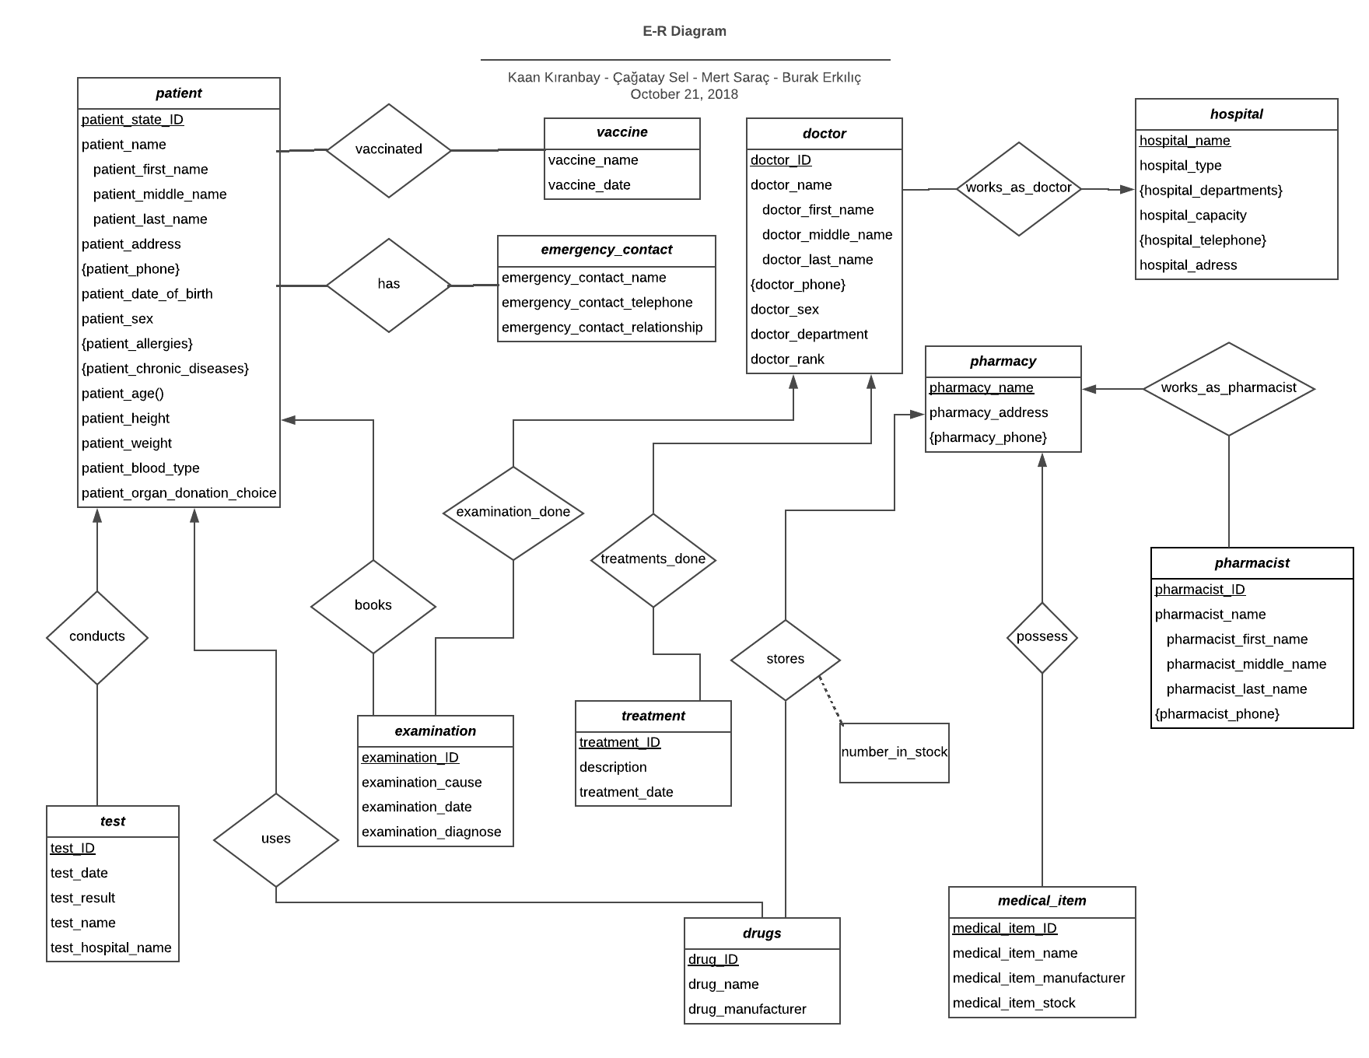

References

[1]A. SILBERSCHATZ., H. Korth and S. Sudarshan, *DATABASE SYSTEM CONCEPTS*, 6th ed. [S.l.]:

MCGRAW-HILL EDUCATION.

[2]"Online Diagram Software & Visual Solution | Lucidchart", *Lucidchart*, 2018. [Online]. Available: https://www.lucidchart.com. [Accessed: 21- Oct- 2018].