**Job Wizard Application Use Cases**

*Last Update: 2025-06-18*

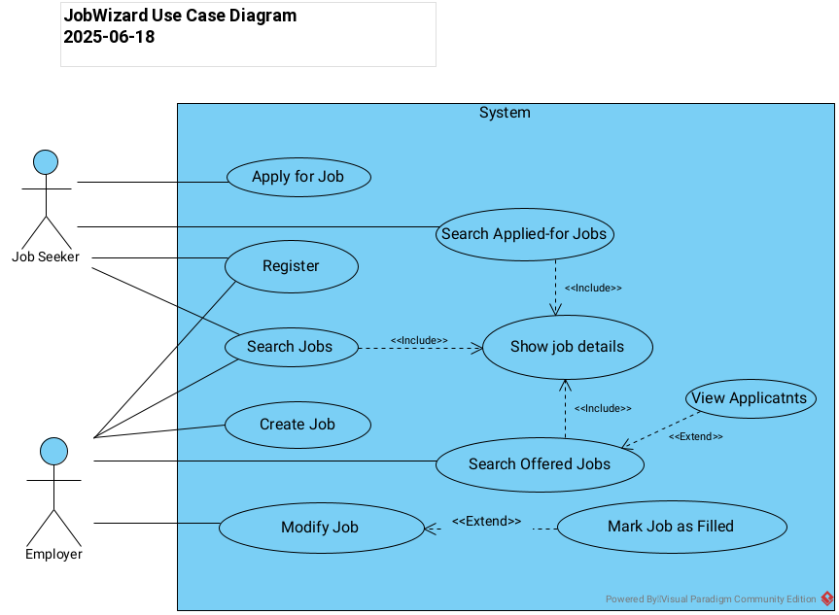

|  |  |
| --- | --- |
| **Use case name** | **Register** |
| **Actors** | Job Seeker or Employer - Note that one user can function in both roles, at different times |
| **Goal** | Create a known user who can be associated with job information |
| **Preconditions** | None |
| **Main success scenario** | 1. User enters email address, which will be their user identification. 2. User enters first and last name. 3. User enters phone number. 4. User enters maximum education level. 5. System validates the input information. 6. System confirms creation of the user. |
| **Postconditions** | User can perform other tasks in Job Wizard |
| **Extension A** | 1. Email, phone number or education level is found to be invalid or missing, or name is missing. 2. System displays an error message and prompts again |
| **Extension B** | 1. System discovers that a user with the specified email already exists. 2. System displays an error message and does not create the user. |
| **Comments** | For simplicity we do not require any password. We also do not provide any way for a user to update the information in their profile, such as phone number or education level. A real application would need this functionality. |

|  |  |
| --- | --- |
| **Use case name** | **Search Jobs** |
| **Actors** | Job Seeker or Employer |
| **Goal** | See a list of posted jobs with associated information. This is a general search based on the job content. There are also specialized search use cases for Job Seekers versus Employers. |
| **Preconditions** | User has registered. |
| **Main success scenario** | 1. User enters email address to identify themselves. 2. Optional search criterion: user enters date posted. 3. Optional search criterion: user enters minimum education level. 4. Optional search criterion: user enters minimum salary. 5. Optional search criterion: user enters a keyword to be found in the job title. 6. System validates the input information. 7. System retrieves jobs that match the criteria specified. 8. System displays a list of jobs sorted by date posted. Display includes job ID, job title, date posted and status (open or filled) |
| **Postconditions** | User can select a specific job to examine in detail. |
| **Extension A** | 1. Some search criterion has an invalid format. 2. System displays an error message and prompts again |
| **Extension B** | 1. User with the specified email does not exist. 2. System displays an error message and prompts again. |
| **Extension C** | 1. System does not find any jobs that match the specified criteria. 2. System displays an informative message and prompts again. |
| **Comments** | Note that if the user does not specify any search criteria, the system will display all jobs in the database. |

|  |  |
| --- | --- |
| **Use case name** | **Show Job Details** |
| **Actors** | Job Seeker or Employer |
| **Goal** | See more information about a specific job |
| **Preconditions** | User has already done a job search via one of the three “search” use cases. |
| **Main success scenario** | 1. User enters the job ID for the job to be displayed. 2. System displays job ID, job title, job description (maximum 1024 characters), job creator (email address of user), minimum education level required, minimum years experience required, salary, status and posted date. |
| **Postconditions** | User can go back to initial list and choose a new job ID. |
| **Extension A** | 1. System finds that the job ID is invalid 2. System displays an error message and prompts again |
| **Comments** | Note that we do not ask the user to enter their email again, but the system will require this information to be sent to the back end. |

|  |  |
| --- | --- |
| **Use case name** | **Search Applied-For Jobs** |
| **Actors** | Job Seeker |
| **Goal** | See a list of jobs for which the current user has applied. |
| **Preconditions** | User has registered. |
| **Main success scenario** | 1. User enters email address to identify themselves. 2. System validates the email. 3. System retrieves jobs for which the user has applied. 4. System displays a list of jobs sorted by date posted. Display includes job ID, job title, date posted and status (open or filled) |
| **Postconditions** | User can select a specific job to examine in detail. |
| **Extension A** | 1. The system discovers that the user has not applied for any jobs yet. 2. System displays an informational message. 3. User should be able to return to top level of the user interface. |
| **Extension B** | 1. System discovers that user with the specified email does not exist. 2. System displays an error message and prompts again. |
| **Comments** | There is no point in asking for information again in Extension A. |

|  |  |
| --- | --- |
| **Use case name** | **Apply for Job** |
| **Actors** | Job Seeker |
| **Goal** | Apply for a specific job |
| **Preconditions** | User has registered. |
| **Main success scenario** | 1. User enters email address to identify themselves. 2. System validates the email. 3. User enters the job ID in which they are interested. 4. System associates a job application with this user and job 5. System confirms success. |
| **Postconditions** | User is associated with the job as an applicant. The job will show up in the “applied-for jobs” list. |
| **Extension A** | 1. System discovers that the specified job does not exist. 2. System displays an error message and prompts for a new job ID. |
| **Extension B** | 1. System discovers that user with the specified email does not exist. 2. System displays an error message and prompts again. |
| **Extension C** | 1. System discovers that the job status is “filled” so no more applications are being accepted. 2. System displays an error message and prompts again for a new job ID. |
| **Extension D** | 1. System discovers that the education level of the job seeker is lower than the minimum education level specified in the job description. 2. System displays a warning message and asks if the user wants to continue. 3. User either confirms or cancels. |

|  |  |
| --- | --- |
| **Use case name** | **Create Job** |
| **Actors** | Employer |
| **Goal** | Create a new job in the system, which job seekers can see and apply for |
| **Preconditions** | User has registered. |
| **Main success scenario** | 1. User enters email address to identify themselves. 2. System validates the email. 3. User enters the job title (up to 64 chars) 4. User enters the job description (up to 1024 chars) 5. User enters the minimum education level: not specified, high school diploma, bachelors degree, masters degree, doctoral degree. 6. User enters minimum years experience required (0 = none or not specified) 7. User enters monthly salary in baht. 8. System validates the input information. 9. System creates a new job with the entered information, assigns it an ID and associates it with this user as the creator. 10. System displays the new job ID and confirms success. |
| **Postconditions** | User is associated with the job as the creator. The job will show up in the available jobs list and in the offered jobs list for this user. |
| **Extension A** | 1. System discovers that some of the input data is not valid. 2. System displays a detailed error message and prompts for new information. |
| **Extension B** | 1. System discovers that user with the specified email does not exist. 2. System displays an error message and prompts again. |

|  |  |
| --- | --- |
| **Use case name** | **Modify Job** |
| **Actors** | Employer |
| **Goal** | Modify the information associated with a job posting |
| **Preconditions** | User has registered. |
| **Main success scenario** | 1. User enters email address to identify themselves. 2. System validates the email. 3. User enters the job ID of the job they want to change. 4. System allows the user to specify a new job title (up to 64 chars), job description (up to 1024 chars), minimum education level, minimum years experience required, monthly salary. There must be some way for the user to indicate what attributes to change. 5. System validates the input information. 6. System modifies the specified job with the entered information. 7. System confirms success. |
| **Postconditions** | Data associated with the selected job will be updated. |
| **Extension A** | 1. System discovers that some of the input data is not valid. 2. System displays a detailed error message and prompts for new information. |
| **Extension B** | 1. System discovers that user with the specified email does not exist. 2. System displays an error message and prompts again. |
| **Extension C** | 1. System discovers that the job ID is not valid. 2. System displays an error message and prompts again. |
| **Extension D** | 1. System discovers that the specified job has a status of “filled”. This means it cannot be modified. 2. System displays an error message and prompts again. |

|  |  |
| --- | --- |
| **Use case name** | **Mark Job as Filled** |
| **Actors** | Employer |
| **Goal** | Modify a job posting to indicate that the job is no longer active |
| **Preconditions** | User has registered. |
| **Main success scenario** | 1. User enters email address to identify themselves. 2. System validates the email. 3. User enters the job ID of the job they want to mark as filled. 4. User enters the email address/user name of the person who has been hired. 5. The system updates the job information to indicate that the job has been filled, by the specified person. 6. The system confirms success. |
| **Postconditions** | Selected job has status “filled”. It can no longer be modified. |
| **Extension A** | 1. System discovers that user with the specified email does not exist. 2. System displays an error message and prompts again. |
| **Extension B** | 1. System discovers that the job ID is not valid. 2. System displays an error message and prompts again. |
| **Extension C** | 1. System discovers that the specified job already has a status of “filled”. 2. System displays an error message and prompts again. |
| **Extension D** | 1. System discovers that the user ID of the hired person does not exist. 2. System displays an error message and prompts again. |

|  |  |
| --- | --- |
| **Use case name** | **Search Offered Jobs** |
| **Actors** | Employer |
| **Goal** | See a list of jobs that the current user has created. |
| **Preconditions** | User has registered. |
| **Main success scenario** | 1. User enters email address to identify themselves. 2. System validates the email. 3. System retrieves jobs the user has created. 4. System displays a list of jobs sorted by date posted. Display includes job ID, job title, date posted and status (open or filled) |
| **Postconditions** | User can select a specific job to examine in detail. |
| **Extension A** | 1. The system discovers that the user has not created any jobs yet. 2. System displays an informational message. 3. User should be able to return to top level of the user interface. |
| **Extension B** | 1. System discovers that user with the specified email does not exist. 2. System displays an error message and prompts again. |
| **Comments** | There is no point in asking for information again in Extension A. |

|  |  |
| --- | --- |
| **Use case name** | **View Applicants** |
| **Actors** | Employer |
| **Goal** | See information about people who have applied to one of the employer’s jobs |
| **Preconditions** | User has searched offered jobs |
| **Main success scenario** | 1. User enters job ID for job of interest 2. System validates job ID. 3. System displays a list of users who have applied for the job: email address/user name, name, phone and minimum education, sorted by application date. |
| **Postconditions** | None |
| **Extension A** | 1. System determines that the job ID is invalid or not a job offered by this user. 2. System displays an error message and prompts again. |
| **Extension B** | 1. System determines that no one has applied for the selected job. 2. System displays an informational message and prompts again. |