Capstone Three Final Report
Toxic vs. Non-Toxic Plant Classification from Images

Problem Statement
Accidental exposure to toxic plants is a recurring, preventable safety risk for hikers, pet owners, gardeners, and parents who may encounter unfamiliar plants in remote or unmonitored environments. Most people cannot reliably tell a poison ivy leaf from a harmless look-alike in the moment it matters. This project set out to build an image-based classifier that tells the two apart automatically, so that anyone with a phone camera can get a fast, reliable answer about whether a plant in front of them is dangerous to touch.
Because the cost of a missed detection (telling someone a toxic plant is safe) is far higher than the cost of a false alarm (flagging a harmless plant as toxic out of caution), the project was scoped around recall on the toxic class rather than overall accuracy. The target set at the outset of the project was at least 90% recall on toxic plants in binary toxic/non-toxic classification, with species-level identification (85% accuracy) noted as a stretch goal for future work.

The Data
The project used the Toxic Plant Classification dataset, comprising 9,952 images across ten plant species: five toxic (Eastern Poison Ivy, Western Poison Ivy, Eastern Poison Oak, Western Poison Oak, and Poison Sumac) and five non-toxic (Virginia Creeper, Boxelder, Jack-in-the-pulpit, Bear Oak, and Fragrant Sumac).
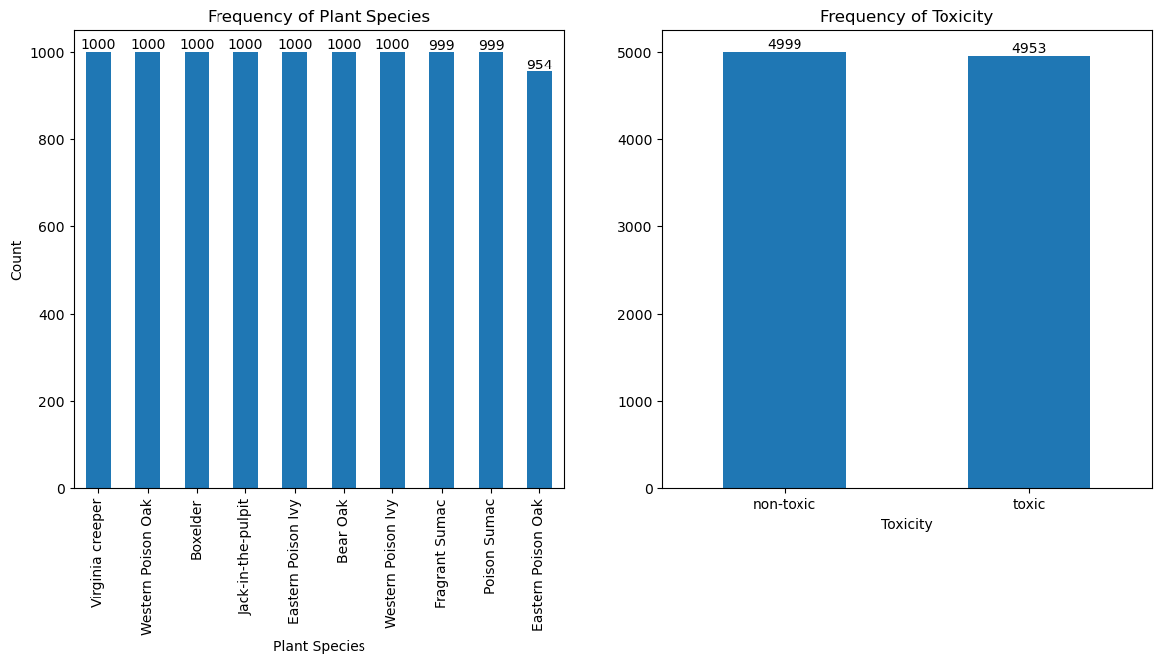
Figure 1. Species and toxicity class counts. The dataset is well balanced, with 9 of 10 species at 999–1,000 images and an overall 4,999 / 4,953 non-toxic/toxic split.
The classes are well balanced both within species (nine of ten species have 999 or 1,000 images, with Eastern Poison Oak slightly lower at 954) and between toxic and non-toxic groups (4,999 non-toxic vs. 4,953 toxic). This meant no resampling was strictly required to correct for skew, though class weighting was still used during training as an extra safeguard given the asymmetric cost of errors.

Data Wrangling
Initial viewing of the metadata dataset showed no missing values, however there were some unnecessary features, such as class id and species label that were removed. Additional feature columns were created for image orientation and color based properties to allow for more analysis of the data.

Exploratory Data Analysis
Exploratory analysis showed an important risk before any modeling began. Images varied in orientation, and a chi-square test of independence between orientation and toxicity returned a statistically significant association (χ² = 58.6, p < 0.001). In plain terms, toxic and non-toxic images in this dataset were not randomly distributed across orientations: landscape images were disproportionately toxic, and portrait images disproportionately non-toxic.
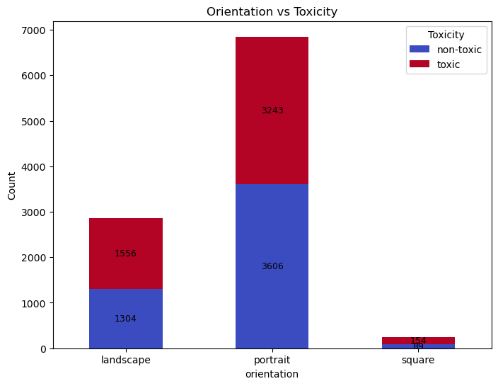
Figure 2. Image orientation by toxicity class. Landscape-oriented photos are disproportionately toxic plants, creating a risk the model learns orientation as a shortcut rather than learning actual plant features.
Left unaddressed, a convolutional network could learn to classify by orientation rather than by genuine visual features of the plant — a shortcut that would inflate validation metrics while failing badly on real-world photos taken at arbitrary angles. This finding directly shaped the preprocessing strategy: random rotation, random horizontal and vertical flipping, and random resized cropping were all built into the training pipeline specifically to prevent the model from relying on orientation as a signal.

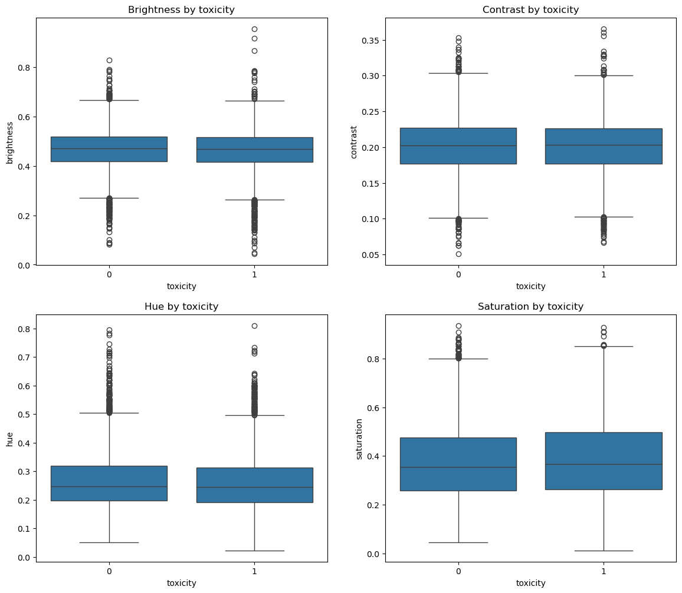
Figure 3. Color based properties by toxicity class. Brightness, contrast, and hue are similar, with saturation having a slightly higher saturation range in toxic plants.

Color-based features of brightness, contrast, hue, and saturation were also examined across both toxicity and species groupings. These features were largely similar across classes and across species, with one minor exception (Poison Sumac trended more saturated, while Virginia Creeper and Eastern Poison Ivy trended less saturated than other species). This was treated as a minor consideration for augmentation rather than a leakage risk, since the differences were not strongly tied to the toxic/non-toxic boundary itself.

Modeling Approach

Preprocessing
All images were resized and normalized for a standard 224×224 input pipeline, with heavy data augmentation on the training set: random resized cropping, horizontal and vertical flips, rotation, color jitter, light affine and perspective distortion, and random erasing. The dataset was split 80/20 into training and validation sets. Three CNN models stages were run, each building on lessons from the last.

Model 1: ResNet18 Baseline
A ResNet18 model pretrained on ImageNet was used as a first baseline, with its convolutional backbone frozen and only a new two-class classification head trained. After 15 epochs, this reached 72.1% validation accuracy with 71.6% recall on the toxic class — a reasonable starting point, but well short of the 90% recall target.

Model 2: EfficientNet-B0 Baseline
Swapping the backbone to EfficientNet-B0 (also frozen, ImageNet-pretrained, same simple training setup) modestly outperformed the ResNet18 baseline, reaching 75.4% validation accuracy and 74.2% recall after 15 epochs. The improvement confirmed EfficientNet-B0 as a stronger architecture for this problem, but a frozen backbone with only a linear head was not enough to hit the recall target.
Also worth noting, in both baselines, the model began plateaued around the 6th epoch, leading to this being the number chosen as the first phase in the training schedule below.

Model 3: Tuned EfficientNet-B0
The final model kept the EfficientNet-B0 backbone but trained it far more deliberately, combining several techniques aimed squarely at the recall objective:
- Class weighting (1.3× weight on the toxic class) and label smoothing in the loss function, to bias the model toward catching toxic cases.
- Mixup and CutMix augmentation, randomly blending or patching together training images to improve generalization and reduce overfitting to any single visual shortcut (including orientation).
- A three-phase training schedule: first training only the classifier head (6 epochs), then unfreezing the top 30% of the backbone (4 epochs), then fully fine-tuning the entire network (10 epochs) with cosine-annealed learning rates at each stage.
This staged approach paid off. By the end of full fine-tuning, validation accuracy reached 83.7% with 86.4% recall, 82.4% precision, and F2 score of 0.85; values that are already a substantial improvement over both baselines, though still short of the 90% recall goal at the model’s default decision threshold.

Calibration and Threshold Tuning
The default classification threshold of 0.5 treats a missed toxic plant and a false alarm as equally costly, which does not reflect the real priorities of this project. To close the gap to the recall target without retraining, the model’s confidence scores were first calibrated using temperature scaling (learned temperature ≈ 0.83). Then the classification threshold was tuned by sweeping values and selecting the one optimized the balance between the F2 score, recall, precision, and false negatives, focusing primarily on the F2 score, a metric that weights recall more heavily than precision, matching the project’s safety-first priority.
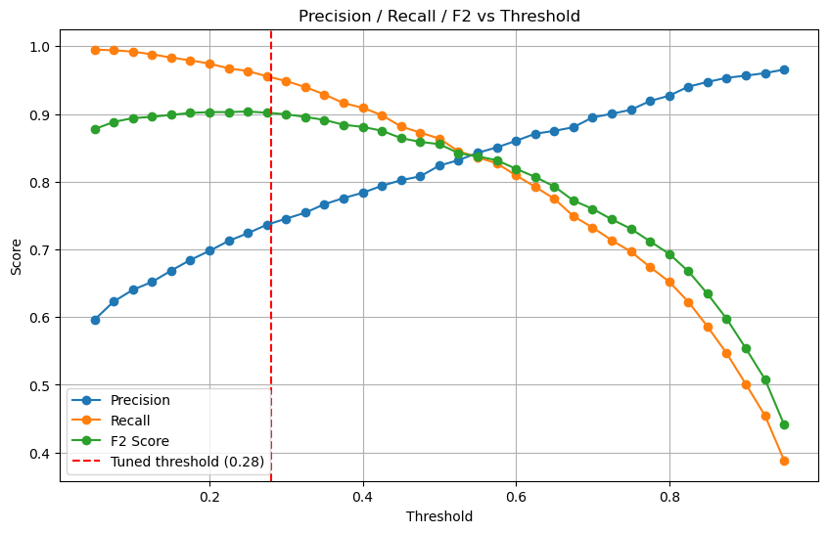
Figure 4. Precision, recall, and F2 score across decision thresholds. Lowering the threshold below the default 0.5 trades some precision for a substantial recall gain; 0.28 was selected as the operating threshold.
The tuned threshold of 0.28 was chosen, as the model reached 95.4% recall, 73.6%, precision, 90% F2 score, and had fewer than 50 false negatives. on the held-out validation set (F2 = 0.900), clearing the 90% recall target with room to spare. This threshold was deliberately chosen on the steep part of the precision/recall trade-off curve: pushing the threshold even lower continues to buy small amounts of recall but starts costing meaningfully more in false alarms, while raising it back toward 0.5 drops recall below the project’s safety bar.

Findings: How the Model Performs in Practice
To understand how the model functions on real images, not just on the held-out validation split, the calibrated model was run against every image in the full dataset at the 0.28 threshold and the predictions were compared species-by-species against ground truth.
The results tell a clear and consistent story. Every toxic species was identified correctly 98–99% of the This is exactly the behavior the project was optimized for: the model essentially never lets a toxic plant slip through as “safe.”
Non-toxic species tell a very different story. Accuracy ranged from a high of 83% (Jack-in-the-pulpit) down to just 50% (Fragrant Sumac) and 57% (Boxelder). In other words, roughly half of all Fragrant Sumac photos and over 40% of Boxelder photos were incorrectly flagged as toxic. This is the direct trade-off of tuning the decision threshold for high recall: the model has been deliberately made cautious, and that caution falls disproportionately on a handful of non-toxic species that share enough visual features with their toxic look-alikes to regularly cross the lowered threshold.
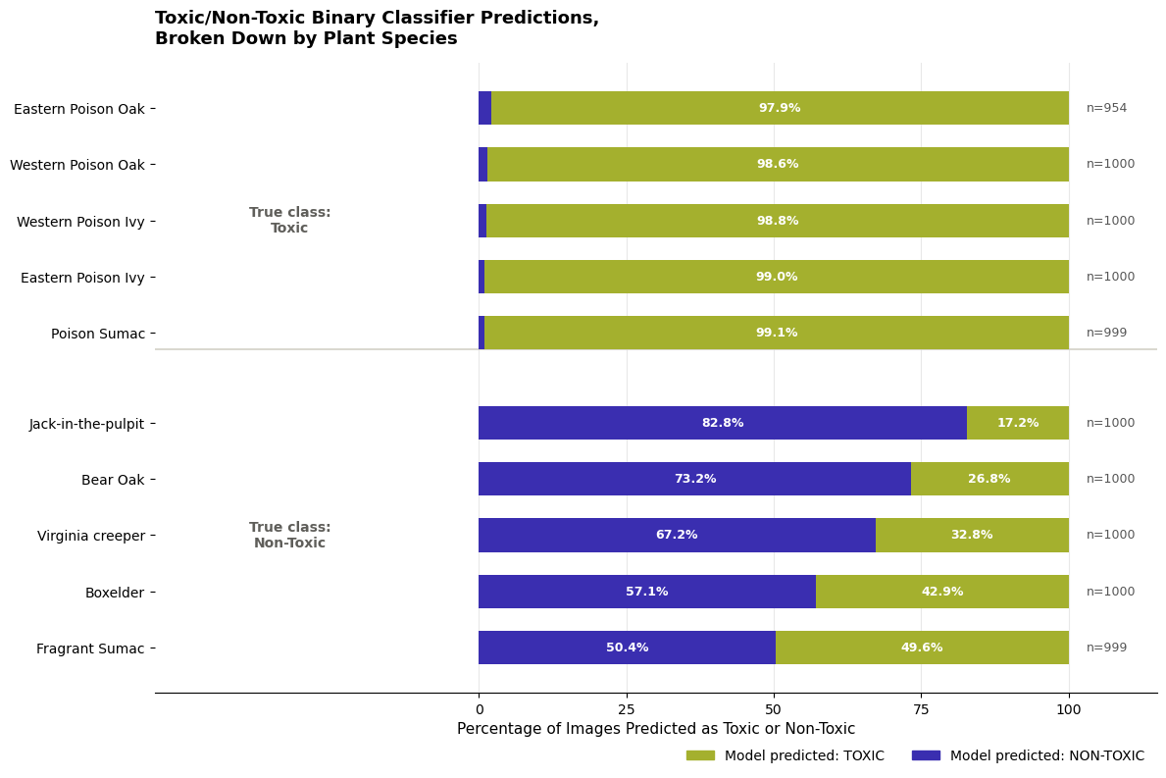
Figure 5. Correct vs. incorrect predictions by species, grouped by true toxicity. The model is highly reliable on every toxic species, but accuracy on non-toxic species varies widely.
This pattern is the single most important finding of the project. A 95% recall headline number is accurate but incomplete on its own. The practical experience of a user photographing a Fragrant Sumac or Boxelder plant would be a false toxic warning roughly half the time. That is an acceptable, even sensible, trade-off for a tool whose entire purpose is to err on the side of caution around safety, but it is a trade-off that should be communicated honestly to anyone using the tool, rather than discovered by surprise.

Ideas for Further Research
- Targeted data collection or augmentation for the weakest non-toxic species (Fragrant Sumac, Boxelder, Virginia Creeper) to give the model more examples of the specific features that distinguish them from their toxic look-alikes, rather than relying on a single global threshold to compensate.
- Collecting or sourcing field photos (rather than the curated dataset images used here) to validate that performance holds up on the messier, more varied images real users would actually submit — different lighting, backgrounds, partial views, and camera quality.
- Integration of geolocation and seasonal metadata to give the model more features to train on.
- Species-level classification as a second-stage model: once an image is flagged toxic, a follow-up model identifying which of the five toxic (or five non-toxic) species it most resembles could let users sanity-check a toxic flag, directly addressing the false-positive concern surfaced above. This was the stretch goal noted in the original proposal and remains a natural next step.
- Expanding beyond the current ten species to cover additional regionally common toxic and non-toxic plants, which would increase the tool’s real-world usefulness without requiring a full model redesign given the architecture already in place.

Recommendations for the Client
- Deploy the tuned model (threshold 0.28) for its intended safety use case but pair every “toxic” prediction with a brief, honest caveat about false-positive rates for visually similar non-toxic species. Because the model is intentionally tuned to over-flag rather than under-flag, users should understand that a “toxic” result means “please treat this with caution,” not “this is definitely toxic,” particularly for plants resembling Fragrant Sumac or Boxelder.
- Prioritize the species-level follow-up model described above before any broader rollout. Because toxic-species recall is already excellent (98–99%), the highest-value next investment is reducing false alarms on non-toxic look-alikes, not further tuning the binary toxic/non-toxic threshold.
- Treat this model as a first-pass safety filter, not a standalone identification authority. The client should position the tool as a quick screening aid that flags “plants worth being careful around,” while still directing users toward professional identification resources (extension offices, poison control, local experts) for any plant that will be handled, ingested, or used medicinally.

Conclusion
This project successfully delivered an image classifier that meets its primary safety objective: 95.4% recall on toxic plants, comfortably above the 90% target, achieved through a deliberate combination of architecture selection, advanced augmentation, staged fine-tuning, and threshold tuning informed directly by the project’s risk priorities. The exploratory analysis early in the project — particularly the discovery of an orientation-based leakage risk — directly shaped a more robust training pipeline. The clearest opportunity ahead is narrowing the gap on a handful of non-toxic species that the model currently over-flags out of caution, which the recommendations above translate into concrete next steps for the client.

