**Hello Team!** **Consider the below two tables**:

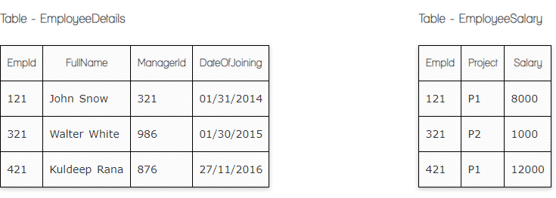

**Ques.1. Write a SQL query to fetch the count of employees working in project 'P1'.**

**Your Answer:**

**Select Count (**Project) **from** EmployeeSalary **where** Project = 'P1'

**Ques.2. Write a SQL query to fetch employee names having salary greater than or equal to 5000 and less than or equal 10000.**

**Your Answer:**

**Select** FullName **from** EmployeeDetails **where** Price **between** 5000 **and** 10000

**Ques.3. Write a SQL query to fetch count of employees sorted by project's count in descending order.**

**Your Answer:**

**Select Count (**EmpID), Project **from** EmployeeSalary **Group by** Project, **Order by count** **(**EmpID) **DESC**

**Ques.4. Write a query to fetch employee names and salary records. Return employee details even if the salary record is not present for the employee.**

**Your Answer:**

**Select** EmployeeDetails.EmpId, EmployeeSalary. Salary

**from** EmployeeDetails

**LEFT JOIN** EmployeeSalary **ON** EmployeeDetails.EmpId = EmployeeSalary.EmpId

**Ques.5. Write a SQL query to fetch all the Employees details from EmployeeDetails table who joined in Year 2016.**

**Your Answer:**

**Select * from** EmployeeDetails **where** DateOfJoining like “%2016”

**Ques.7. Write a SQL query to insert new record to the EmployeeDetails table with any data.**

**Your Answer:**

**Insert into** EmployeeDetails **(**EmpId**,** Fullname, ManagerId, DateJoining) **values (**'521', 'John Andrews', '926', '08/07/2022'**)**

**Ques.8. Write a SQL query to update EmployeeSalery table with setting Salary to 2000 for Project P2.**

**Your Answer:**

**update** EmployeeSalery **set** Salary = 2000 **where** project = ‘P2’

**Ques.9. Write a SQL query to right join both tables and draw the results.**

**Your Answer:**

**Select** EmployeeDetails *, EmployeeSalary *

**from** EmployeeSalary **Right JOIN** EmployeeDetails **ON** EmployeeDetails.EmpId = EmployeeSalary.EmpId

|  |  |  |  |  |  |
| --- | --- | --- | --- | --- | --- |
| EmpId | ManagerId | DateofJoining | Project | Salary | FullName |
| 121 | 321 | 01/31/2014 | P1 | 8000 | John Snow |
| 321 | 986 | 01/30/2015 | P2 | 1000 | Walter White |
| 421 | 876 | 27/11/2016 | P1 | 12000 | Kuldeep Rana |

**Now take these two tables:**

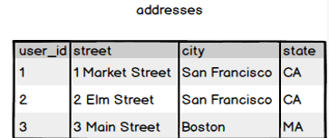

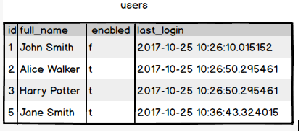

**Ques.10. Write a SQL query to fetch all users full_name from San Francisco.**

**Your Answer:**

**SELECT** users.full_name, addresses.city

**FROM** users **INNER JOIN** addresses **ON** users.id = addresses.user_id **where** city = “San Francisco”

**Ques.11. Write a SQL query to fetch all users full_name who are not from Main street**

**Your Answer:**

**SELECT** users.full_name, addresses.street

**FROM** users **LEFT JOIN** addresses **ON** users.id = addresses.user_id

**where not** street='3 Main street'

**Ques.12. Write a SQL query to fetch all users full_name who are from Main street or San Francisco**

**Your Answer:**

**SELECT** users.full_name, addresses.street

**FROM** users **LEFT JOIN** addresses **ON** users.id = addresses.user_id

**where** street='3 Main street' Or City = “San Francisco”

**Ques.13. Write a SQL query to fetch user full_name who is equal to user_id from Boston (find user_id value in sub_query)**

**Your Answer:**

**SELECT** users.full_name

**FROM** users

**where** id =

(**SELECT** user_id

**FROM** addresses

**where** city = Boston)