**1. Introduction**

Overview of the Dataset: Briefly describe the California Housing Dataset, including its source and the type of information it contains.

Project Objective: Clarify the goal of predicting median house values in California districts, highlighting the importance of this task.

Outline of the Report: Summarize the main sections of the report, providing the reader with a roadmap of what to expect.

The California Housing Dataset, accessible through popular data science libraries like Scikit-Learn and Kaggle, provides a rich tapestry of data points, including geographical locations, age, room counts, population metrics, and proximity to the ocean, among others. This dataset serves as the foundation for developing models aimed at estimating median house values across various districts in California. The task at hand involves not just predicting these values but doing so with a level of accuracy and insight that surpasses traditional methods, specifically a baseline model established through Linear Regression, which yielded a Root Mean Squared Error (RMSE) of 58.000 and an R-squared score of 0.5758.

The objective of this project, as outlined in the assignment brief is to explore this dataset, engaging in thorough data preprocessing, feature engineering, and the selection and implementation of advanced predictive models. By comparing these models against the baseline, the project seeks to illuminate the efficacy of different algorithms and their suitability to the dataset's characteristics. This technical report documents each step of the process, from initial data exploration to the final model evaluation, detailing the rationale behind algorithm selection and the insights garnered from a comparative analysis. Through this comprehensive examination, the report not only showcases the project's outcomes but also contributes to a deeper understanding of the predictive modeling landscape within the real estate valuation domain.

**2. Data Exploration and Preprocessing**

Initial Data Exploration: Discuss your initial findings about the dataset's features, target variable, and any interesting patterns or anomalies observed.

Data Cleaning: Describe the steps taken to clean the dataset, including handling missing values and outliers. Justify your choices.

Feature Engineering: Explain any new features you created and their expected impact on the model's performance.

Data Visualization: Include key visualizations that helped you understand the data better and informed your preprocessing decisions.

In the initial phase of data exploration, we embarked on a thorough examination of the California Housing Dataset. This dataset comprises a diverse range of attributes, including geographical coordinates (longitude and latitude), housing median age, total rooms, bedrooms, population figures, household counts, median income, and proximity to the ocean. A distinctive characteristic of this dataset is the 'ocean_proximity' attribute, a categorical variable indicating the property's relative location to the ocean, with values such as 'NEAR BAY' and '<1H OCEAN'. Our preliminary analysis, facilitated by pandas' functionality, revealed that while most columns were populated with numerical data, the 'total_bedrooms' column contained 207 missing values, necessitating immediate data cleaning interventions.

The preprocessing phase was enriched through data visualization techniques and strategic feature engineering, aimed at distilling insights and enhancing the predictive capability of our models. Utilizing seaborn and matplotlib, we visualized the distribution of median house values, revealing a notable skewness in the data.

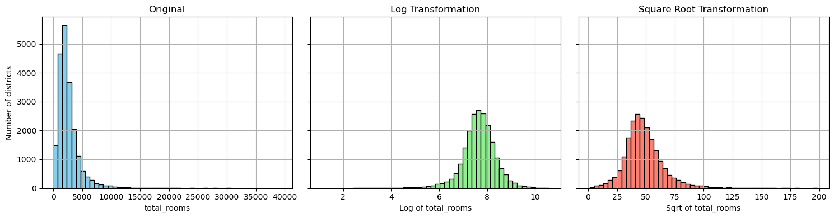

For instance, the histogram of 'median_house_value' showcased a significant concentration of houses in the higher value range, indicative of the dataset's skewed distribution. To address these skewness issues and unearth latent patterns, we employed logarithmic and square root transformations on heavily skewed features such as 'total_bedrooms', 'population', and 'median_income'. This approach significantly normalized their distributions, as visually evidenced by the transformation plots in our notebook. For example, the log transformation of 'population' yielded a more symmetric distribution, enhancing its suitability for linear models.

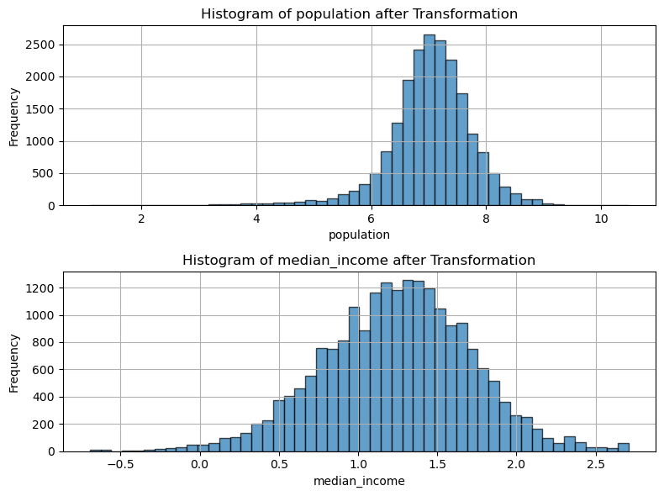  
In the process of refining our predictive models, a significant improvement was observed upon the removal of outliers, particularly those capped at the maximum values for both median_house_value and housing_median_age. This adjustment primarily aimed to address the skewed nature of our dataset, where a noticeable concentration of records existed at these maximum thresholds.

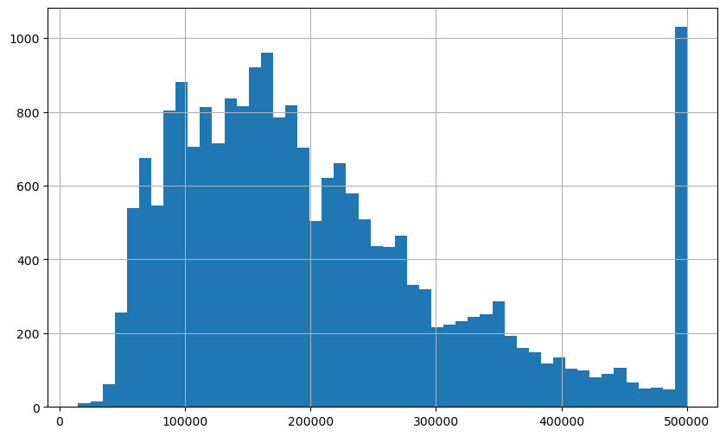

By eliminating these right outliers, we ensured a more balanced distribution of data, which in turn, enhanced the model's ability to generalize from the training data to unseen data. The impact of this intervention was clearly reflected in the performance metrics across all models, with the most notable enhancement observed in the XGBoost model.

The Root Mean Square Error (RMSE), a critical measure of prediction accuracy, showed a substantial reduction from 46k to 41k for the XGBoost model post-adjustment. This improvement underscores the importance of data preprocessing and the strategic handling of outliers in optimizing model performance. While the decision to remove these records was optional, it exemplified a pragmatic approach to mitigating the influence of data capping on predictive accuracy, thereby contributing to more reliable and effective predictions.

Moreover, our feature engineering efforts led to the creation of insightful attributes such as 'rooms_per_household', 'bedrooms_per_room', and 'population_per_household'. Correlation analysis post these additions revealed newfound associations with the target variable, 'median_house_value', illustrating the efficacy of these engineered features.

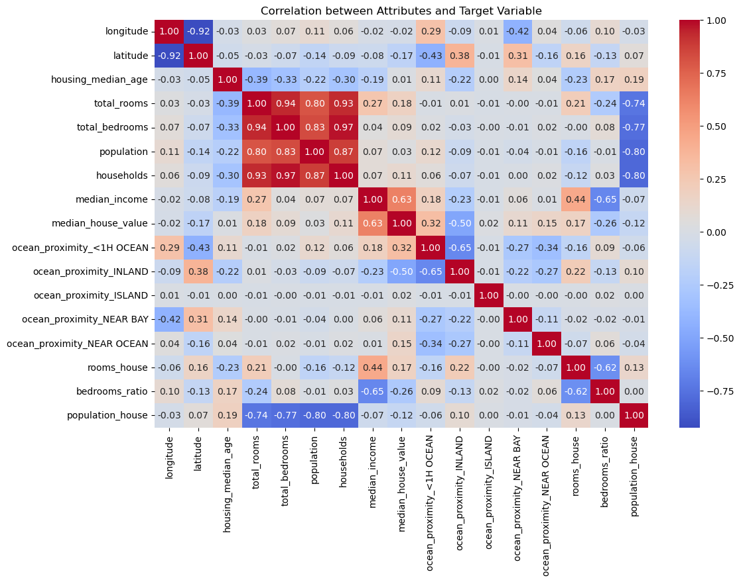

The 'rooms_per_household' feature, in particular, emerged with a correlation coefficient of 0.15, underscoring its potential utility in predicting house values.

**3. Model Selection**

Choice of Models: Justify the selection of Random Forest and XGBoost models over Linear Regression, based on the dataset's characteristics and preliminary analysis.

Theoretical Background: Provide a brief overview of how Random Forest and XGBoost work, emphasizing their suitability for this task.

Upon completion of an extensive preliminary analysis, which included a detailed examination of the dataset's attributes, rectification of missing values, and the application of essential data transformations, the next phase involves the critical selection of predictive models. Given the dataset's inherent complexity, characterized by a diverse range of numerical variables, along with observable non-linear relationships among features, it became imperative to explore beyond the confines of Linear Regression. This decision was influenced by the dataset's demand for models capable of navigating its intricacies efficiently.

For the model selection aspect of this project, the predictive task categorizes it as a regression problem, as we aim to forecast a specific numerical value. This task is further refined into a multiple regression problem, considering the model's reliance on a multitude of input features to generate its predictions. Additionally, this is characterized as a univariate regression endeavor, given our objective to predict a singular outcome for each district.

In light of these considerations, two models were identified as particularly fit for the task: Random Forest and XGBoost.

**Random Forest**

Random Forest is a potent machine learning technique that constructs a multitude of decision trees at training time, outputting the mode of the classes (classification) or mean prediction (regression) of the individual trees. Random forests correct for decision trees' habit of overfitting to their training set. This model utilizes two key concepts: bagging and feature randomness, to create an ensemble of trees with controlled variance. The method involves training each tree on a different data subset and using a random subset of features for splitting each node, which increases diversity among the trees and results in a more robust overall model. The ensemble nature of random forest allows it to achieve high accuracy without the need for extensive parameter tuning, making it nearly "parameter-free" and remarkably efficient across a wide range of datasets (Breiman, 2001).

**XGBoost**

XGBoost (eXtreme Gradient Boosting) stands out as an advanced implementation of gradient boosting that is both highly efficient and scalable. It is particularly known for its speed and performance, which comes from its optimization of traditional gradient boosting methods. XGBoost introduces a novel tree learning algorithm that efficiently handles sparse data and a regularization component that controls the model's complexity to prevent overfitting. This makes it adaptable and effective across various data types and tasks. XGBoost's unique features include the ability to handle missing values intrinsically, employ column block for parallel learning, and apply shrinkage and column sampling, contributing to its superior performance in predictive accuracy and speed compared to many other models (Chen and Guestrin, 2016).

**4. Model Implementation and Evaluation**

**Model Training**

The focus of this project was on employing and evaluating the Random Forest and XGBoost models for predicting median house values in California districts. The dataset underwent a split, allocating 80% for training purposes and the remaining 20% for testing. Prior to model training, feature scaling was implemented through the StandardScaler to normalize the feature set, ensuring that the magnitude of the features did not bias the model performance.

The Linear Regression model was then trained on the scaled training data, establishing a benchmark for evaluating the more complex Random Forest and XGBoost models. This straightforward approach allowed for a clear comparison of the effectiveness of ensemble methods against traditional regression techniques. The Linear Regression model's performance was assessed using the same metrics (MSE, RMSE, MAE, and R²), providing a foundational understanding of the predictive capabilities of basic regression analysis in the context of housing value prediction.

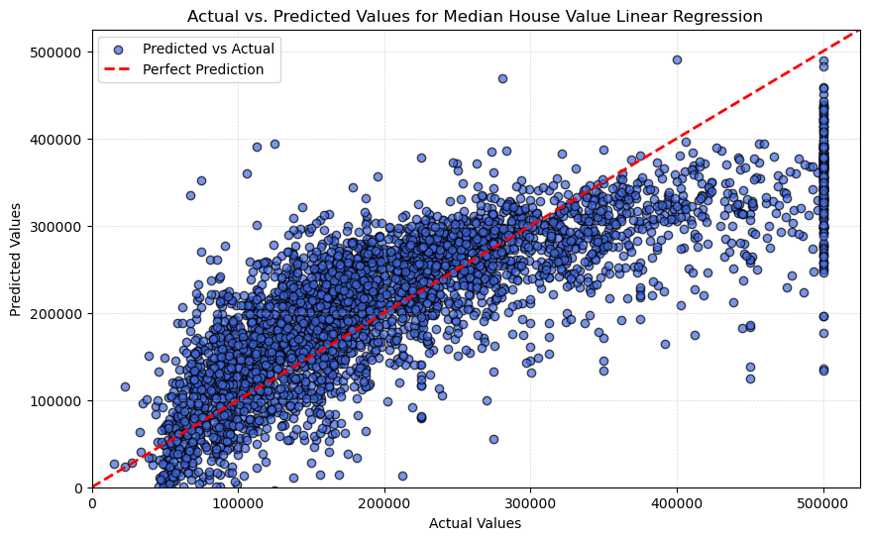

For the Random Forest model, a comprehensive approach was adopted to optimize its hyperparameters. The process involved exploring various configurations of the model's parameters to identify the combination that yielded the best performance.

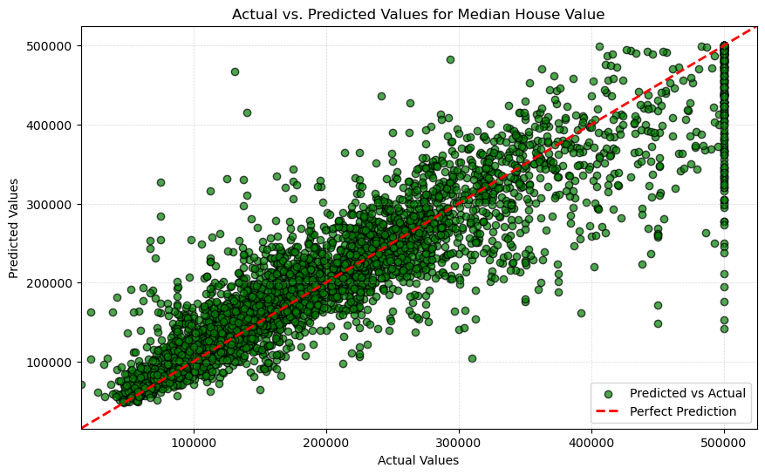

Similarly, the XGBoost model was subject to meticulous hyperparameter tuning. Special attention was given to parameters such as the learning rate, max depth, and subsample size, with an objective to fine-tune the model for optimal accuracy. The training process incorporated validation strategies to guard against overfitting, thereby enhancing the models' generalizability to new data.

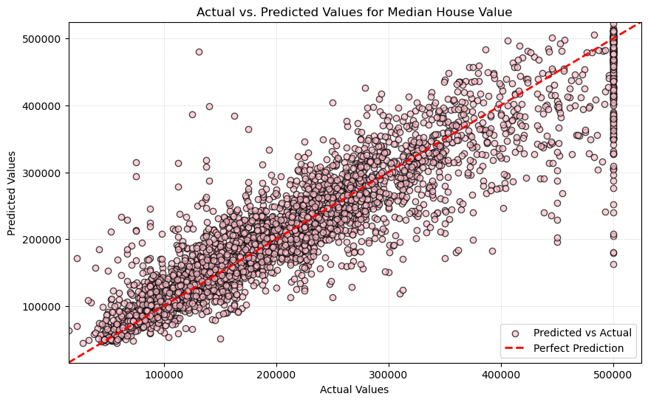

**Performance Evaluation**

The evaluation of the models' performance was anchored on several key metrics: Mean Squared Error (MSE), Root Mean Squared Error (RMSE), Mean Absolute Error (MAE), and the R-squared (R²) score. These metrics provided a holistic view of the models' accuracy and their ability to predict the median house values effectively.

* R² Score: Also known as the coefficient of determination, this metric quantifies the proportion of the variance in the dependent variable that is predictable from the independent variables. It ranges from 0 to 1, where 1 indicates perfect prediction accuracy. A higher R² score suggests a model that captures a greater proportion of the variance in the data.

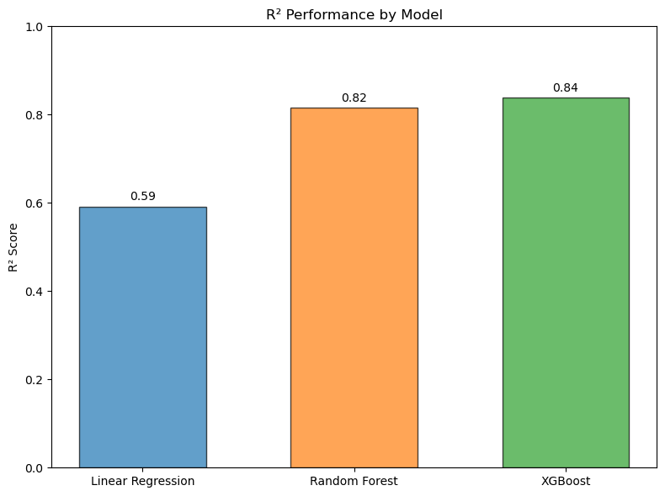

* Mean Squared Error (MSE): MSE measures the average of the squares of the errors, which are the differences between the predicted and actual values. It provides a way to quantify the model's overall prediction error. A lower MSE indicates a model with better precision, as it suggests smaller average errors in the predictions.

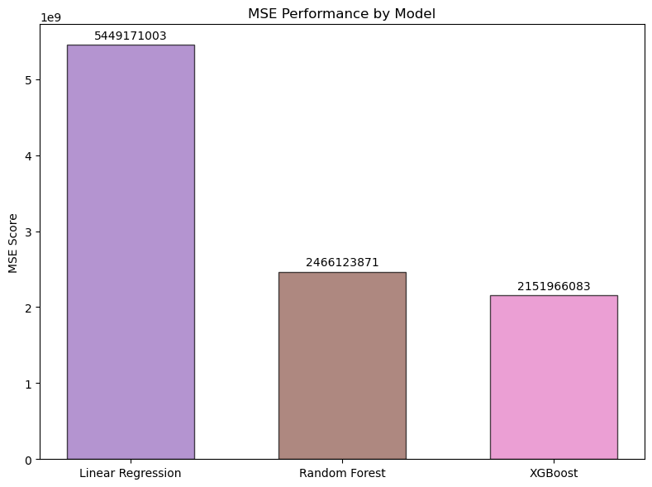

* Root Mean Squared Error (RMSE): RMSE is the square root of the MSE and serves a similar purpose by quantifying the model's prediction error. However, RMSE is in the same units as the predicted and actual values, making it more interpretable. Like MSE, a lower RMSE value signifies a more accurate model.

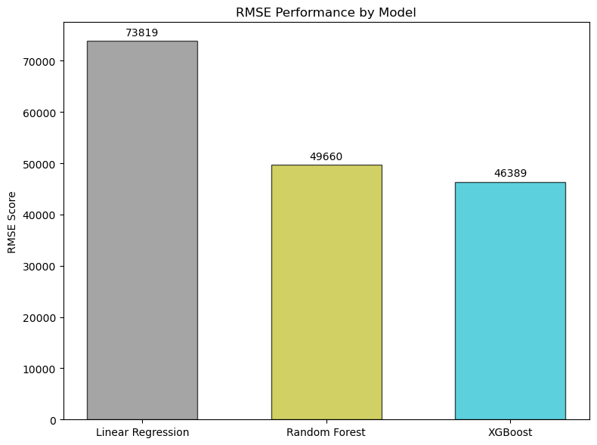

* Mean Absolute Error (MAE): MAE measures the average absolute difference between predicted and actual values, disregarding the direction of the errors. It provides a straightforward indication of the average prediction error magnitude. A model with a lower MAE is considered to have better accuracy as it indicates smaller average errors in its predictions.

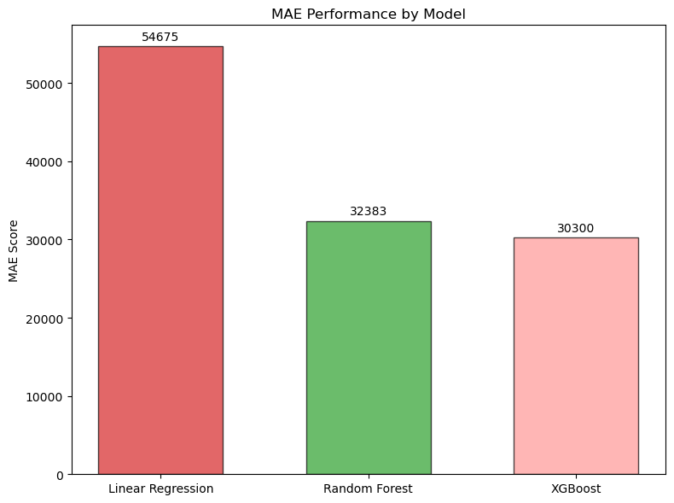

The Linear Regression model established a benchmark for assessing the improvements offered by the more complex Random Forest and XGBoost models, facilitating a clear understanding of the advancements in predictive accuracy achieved through ensemble learning approaches.

* R2 for Linear Regression: 0.5918248324894824
* MSE for Linear Regression: 5449171003.299519
* RMSE for Linear Regression: 73818.50041351096
* MAE for Linear Regression: 54674.98861805524

The Random Forest model demonstrated commendable predictive ability, marking a significant improvement over the baseline Linear Regression model. It achieved a higher R-squared score, indicating a stronger correlation between the predicted and actual values. It also outperforms the baseline model from the assignment requirement of 58,000 RMSE (which shows the variance of the prediction expressed in US Dollars).

* R2 for Random Forest: 0.8152727224763123
* MSE for Random Forest: 2466123871.130901
* RMSE for Random Forest: 49660.08327752684
* MAE for Random Forest: 32383.03500242248

XGBoost model further elevated the performance, outshining the Random Forest model across all evaluation metrics. The fine-tuning of the XGBoost model's hyperparameters resulted in a slight enhancement in its predictive accuracy, as evidenced by the evaluation metrics.

* XGB MSE score: 2151966083.4682903
* XGB RMSE score: 46389.288456154296
* XGB MAE score: 30299.889339003454
* XGB R squared score: 0.8388050006019712

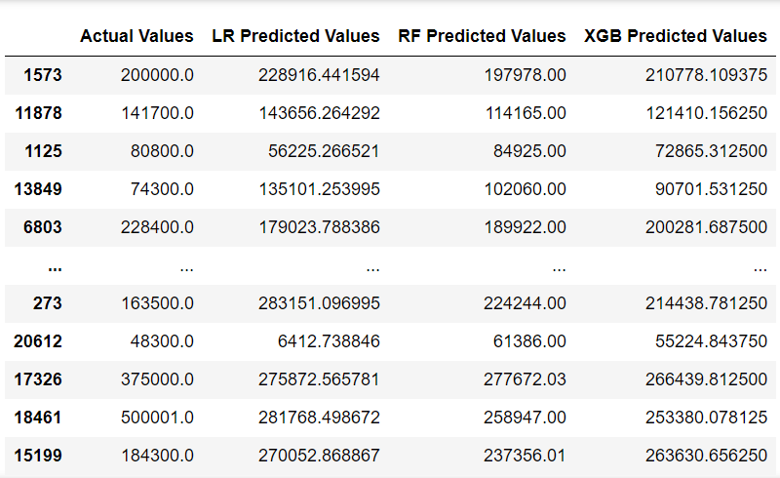

Visualizations played a pivotal role in comparing the models' performance. Scatter plots of the predicted versus actual values offered intuitive insights into the models' predictive accuracy. The linear alignment of points around the perfect prediction line in these plots served as a visual indicator of the models' effectiveness.

**Discussion**

The models' performance underscored the efficacy of ensemble learning methods in tackling complex regression tasks. However, the journey to achieving optimal model performance was not devoid of challenges. Hyperparameter tuning, in particular, proved to be both resource-intensive and time-consuming. Identifying the ideal combination of parameters required extensive experimentation and validation, which could be streamlined through automated hyperparameter optimization techniques in future work.

Improvements to the models could be explored through more advanced feature engineering and the incorporation of additional data that may influence house values, such as economic indicators or geographical features. Moreover, alternative ensemble methods and deep learning architectures could be assessed for their potential to offer further improvements in predictive accuracy.

The implications of the results are significant for stakeholders in the real estate and housing markets. The ability to accurately predict house values supports informed decision-making, investment strategies, and policy development. It highlights the potential of machine learning in contributing valuable insights into housing market dynamics.

5. Conclusion and Future Work

Summary of Findings: Recap the key outcomes of your project, highlighting the model that performed best and why.

Limitations: Acknowledge any limitations of your approach and how they might affect the results.

Recommendations for Future Research: Suggest areas for further investigation or alternative approaches that could enhance model performance.

6. References

Citations: List all datasets, libraries, and external resources referenced or used in your project.

Breiman, L. Random Forests. Machine Learning 45, 5–32 (2001). <https://doi.org/10.1023/A:1010933404324>

Chen, T., & Guestrin, C. (2016). XGBoost: A Scalable Tree Boosting System. Proceedings of the 22nd ACM SIGKDD International Conference on Knowledge Discovery and Data Mining.

<https://doi.org/10.1145/2939672.2939785>

Finalizing the Report

Clarity and Conciseness: Ensure your report is easy to read and avoids unnecessary jargon. Where technical terms are required, provide clear definitions.

Supporting Visuals: Include relevant charts, graphs, and tables that support your analysis and findings. Ensure they are clearly labeled and accompanied by captions explaining their significance.

Code Snippets: While the main focus is on the narrative, you may include key code snippets that played a crucial role in your analysis or model development. Ensure they are well-commented to aid understanding.