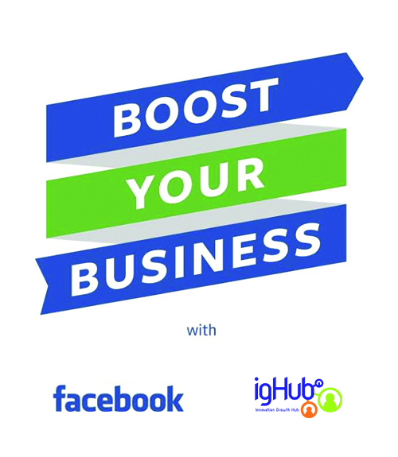

### 29th October, 2018

### The President,

### Association of Microfinance Banks of Nigeria,

### FCT,

### Abuja,

### Nigeria.

**Facebook Boost Your Business Training for SME’s (Nigeria)**

***#BoostYourBusinessNG***

*“Of the 91M Nigerians online, 22M of them are on Facebook every month”.*

Aside capital and skilled personnel, access to market and lack of sales remain tops amongst the many challenges facing most startup entrepreneurs and business owners in Nigeria today, that is why IGHub has collaborated with Facebook to offer the Boost Your Business with IGHub + Facebook training initiative.

Designed for micro, small and medium sized business owners, this training program teaches the fundamentals of digital marketing for business growth. Our goal is to help business owners better understand their brand, their audience, and how to best reach and service their customers online.

The nationwide BYB training program is part of Facebook’s ongoing commitment to helping to grow a community of digitally empowered entrepreneurs and business leaders in Nigeria.

More than 70 million businesses around the world have a presence on Facebook, allowing them to reach the 2 billion people who visit Facebook monthly to share and connect with the people, places and local businesses that matter to them.

This training is collaboration between IGHub and Facebook and **FREE** for requesting organizations that want to seize the opportunity to train and empower its members. Participants will receive an e-certificate of attendance and refreshments.

**SUMMARY OF PROGRAM DETAILS:**

**Program Title:** Boost Your Business with Facebook and IGHub **(#BoostYourBusinessNG)**

**Duration:** 1-day **(4- 6 hours)** *(inclusive of break & Light Refreshments)*

**Fee:** **FREE**

**Venue:** Requesting organization to provide

**Date:** Requesting organization to decide *(subject to trainers’ availability)*.

**Coverage:** Nationwide

**Target Audience:** Entrepreneurs, business owners and trade organizations.

Coverage Area: **Module** **I**: Customer Insight & Branding Essentials

**Module II:** Boost Your Business with Facebook

**Module III:** Grow Your Business with Instagram

**Module IV:** Whatsapp for Business

**Benefits:** -Gain huge brand/product visibility leveraging Facebook and Instagram.

-Generate leads and Connect with new customers,

-Gain insights to help grow + drive sales. See your business flourish.

-Refreshment

-Certificate of attendance

**Small businesses are growing with Facebook in Nigeria (Don’t Miss Out)**

* 3 out 4 of small and medium-sized businesses on Facebook say they have increased sales because of the platform.
* 82% of small and medium-sized businesses on Facebook believe the platform allows them to sell products or services in other cities, states, or countries.
* 90% of small and medium-sized businesses on Facebook state that the platform helps them attract customers.

**Come give your business the boost it needs to grow in 2018.**

This training will provide businesses with the most up-to-date tools, insights, and best practices for achieving success on online leveraging the internet and social media. Learn directly from young digital enthusiasts and social media experts, network with other entrepreneurs, be refreshed, earn a certificate and join our prestigious community of thriving business owners in Nigeria. You will sure walk away with the knowledge, skill and resources; you need to grow your business!

To request for this training, please email: [fbtraining@ighub.com.ng](mailto:fbtraining@ighub.com.ng) or call; +234(0)8162723729.

**We look forward to discussing this further with you and/or your team.**

Thanks,

**Daniel Chinagozi Elizabeth Laiza Kalu**

Project Coordinator Project Manager

+23408030907949 +234 8162723728

[**daniel@ighub.com.ng**](mailto:daniel@ighub.com.ng) [**elizabeth@ighub.com.ng**](mailto:elizabeth@ighub.com.ng)

