The CIFAR-10 dataset

The CIFAR-10 dataset consists of 60000 32x32 colour images in 10 classes, with 6000 images per class. There are 50000 training images and 10000 test images.
The dataset is divided into five training batches and one test batch, each with 10000 images. The test batch contains exactly 1000 randomly-selected images from each class. The training batches contain the remaining images in random order, but some training batches may contain more images from one class than another. Between them, the training batches contain exactly 5000 images from each class.
Here are the classes in the dataset, as well as 10 random images from each:
airplane |  |  |  |  |  | 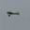 |  |  |  | 
automobile |  |  |  |  |  |  |  |  |  | 
bird |  |  |  |  | 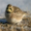 |  |  |  |  | 
cat |  |  | 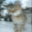 | 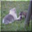 |  |  |  |  |  | 
deer | 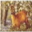 |  |  |  |  |  |  |  |  | 
dog | 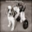 |  |  |  |  |  | 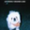 |  |  | 
frog |  |  | 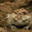 | 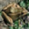 |  | 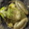 |  |  |  | 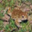
horse |  |  |  |  |  |  | 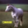 |  |  | 
ship |  |  |  |  |  |  |  |  |  | 
truck |  |  |  |  |  |  |  |  |  | 
URL: http://www.cs.toronto.edu/~kriz/cifar-10-python.tar.gz

Fashion-MNIST
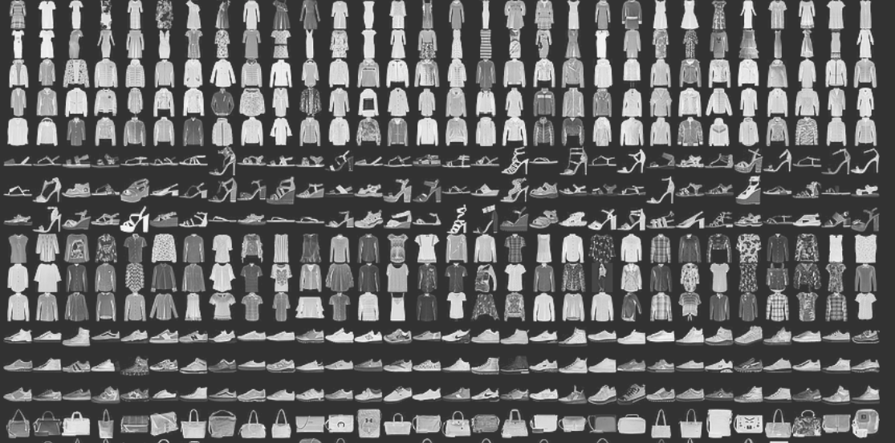
Fashion-MNIST consists of 60,000 training images and 10,000 test images. It is a MNIST-like fashion product database. The developers believe MNIST has been overused so they created this as a direct replacement for that dataset. Each image is in greyscale and associated with a label from 10 classes.
Number of Records: 70,000 images in 10 classes
URL: https://www.kaggle.com/zalando-research/fashionmnist?select=fashion-mnist_train.csv

Emotion Detection From Facial Expressions
Identify the emotion associated with the facial expression in a set of images
URL: https://www.kaggle.com/c/emotion-detection-from-facial-expressions/data

Multi-Domain Sentiment Dataset
About: The Multi-Domain Sentiment Dataset contains product reviews taken from Amazon.com from 4 product types (domains) — kitchen, books, DVDs, and electronics. Here each domain has several thousand reviews, but the exact number varies by the domain. The reviews contain star ratings (1 to 5 stars) which can also be converted into binary labels.
URL: http://www.cs.jhu.edu/~mdredze/datasets/sentiment/index2.html

