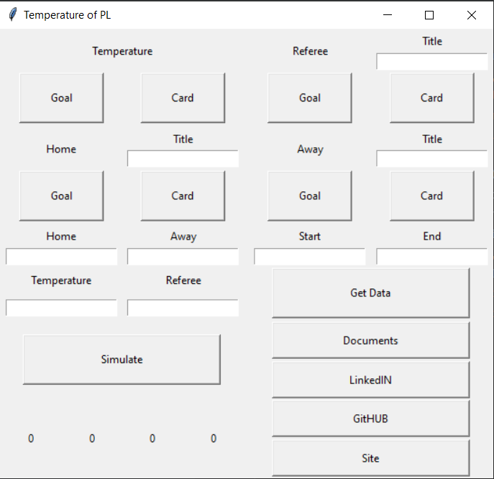

Above you see the main menu of the program.

# Temperature

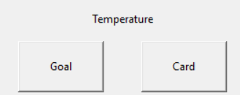

This section shows you all the results you get from the program. If you press the "Goal" button, you will see the goals as a bar diagram, and if you press the "Card" button, you will see the cards as a line diagram.

# Referee

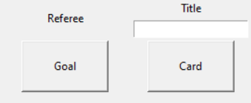

This section shows you results of a specific referee. You have to enter exactly same string to entry. If you press the "Goal" button, you will see the goals as a bar diagram, and if you press the "Card" button, you will see the cards as a line diagram.

# Home

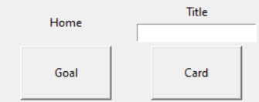

This section shows you results of a specific home team. You have to enter exactly same string to entry. If you press the "Goal" button, you will see the goals as a bar diagram, and if you press the "Card" button, you will see the cards as a line diagram.

# Away

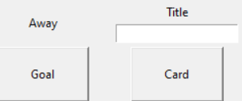

This section shows you results of a specific away team. You have to enter exactly same string to entry. If you press the "Goal" button, you will see the goals as a bar diagram, and if you press the "Card" button, you will see the cards as a line diagram.

# Simulation

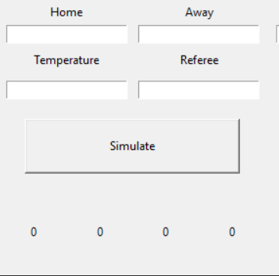

In this section, you perform a simulation based on the results obtained. You must enter the home team, away team, temperature and referee entry respectively. You must enter exactly the same string for input. As a result, you will get the home team goal, the away team goal, the number of yellow cards and the number of red cards.

* These results are obtained by collecting the required data at the entered temperature value and dividing it by 3.

# Get Data

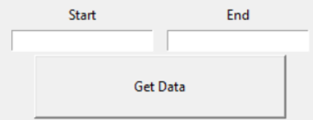

In this section, you select the range of information you want to evaluate. The program can only take between the "2000-2001" and "2018-2019" seasons.

* When specifying the season you want, you should write only the last two digits. For example, when you want to get the information between the "2003-2004" season and the "2011-2012" season, you should write 3 in the "Start" section and 11 in the "End" section.
* Min. Start = 0, Max End = 18.

# Credits

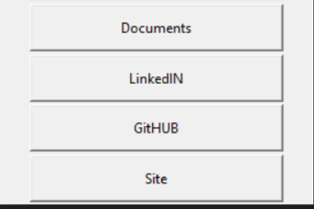

* This opens the file. (Documents)
* Opens my LinkedIN page. (LinkedIN)
* Opens the project's GitHub Repository. (GitHUB)
* Opens my blog page where I evaluate the results. (Site)