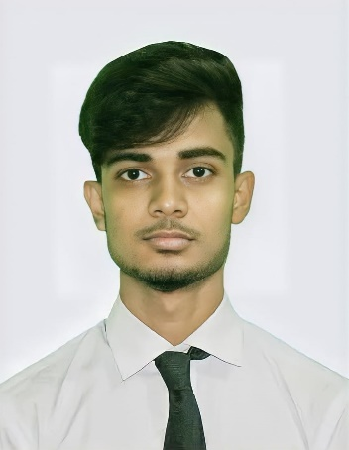

# MD SAROWAR JAHAN

* **Phone:**

+880 01796 522505

* **WhatsApp:**

+880 01774 897701

* **Present Address:**

Uttar Mollikpur, Mollikpur-6321, Nachole, Chapainawabganj.

* **Email:**

[ensarowar@gmail.com](mailto:ensarowar@gmail.com)

# Skills

**Hard Skills:**

* MS Office
* Adobe

**Soft Skills:**

* Communication
* Creativity
* Problem Solving
* Leadership

# Co-Curricular Activities

* Reading
* Swimming
* Athletics
* Traveling

# Career Objective

To work in a dynamic and fast paced organization where I will get chance to mobilize my education and experimental knowledge to achieve organizational goa through the mutual benefits.

# Educational Qualification

# Diploma in Engineering

Chapainawabganj Polytechnic Institute

Computer

2023

CGPA 02.98 of 04.00

**Secondary School Certificate**

Gomastapur Pilot High School

Science

2019

GPA 04.82 of 05.00

**Junior School Certificate**

Kholsi Bilateral High School

General Science

2017

GPA 05.00 of 05.00

# Personal Information

|  |  |
| --- | --- |
| * **Father’s Name** | : Md Johorul Islam |
| * **Mother’s Name** | : Mst Sharifa Begum |
| * **Birth Date** | : April 15, 2002 |
| * **NID** | : 151203225 |
| * **Gender** | : Male |
| * **Marital Status** | : Un-Married |
| * **Religion** | : Islam |
| * **Nationality** | : Bangladeshi |
| * **Height** | : 5’ 7” |
| * **Blood Group** | : AB+ |

# Language Proficiency

|  |  |
| --- | --- |
| * **English** | : Conversational |
| * **Bangla** | : Native |