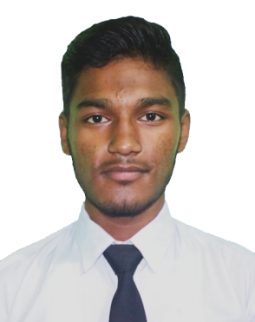

# MD ZEHAD ALI

# Web Developer

* **Phone:**

+880 1744 646344

* **WhatsApp:**

+880 1744 646344

* **Present Address:**

Kazipara, Mirpur-10, Dhaka-1216

* **Email:**

[sehabkhanzehad@gmail.com](mailto:sehabkhanzehad@gmail.com)

* **Github:**

github.com/[sehabkhanzehad](https://github.com/sehabkhanzehad)

* **Linked-In:**

[Linkedin.com/in/sehabkhanzehad](https://www.linkedin.com/in/sehabkhanzehad)

# Skills

**Hard Skills:**

* HTML
* CSS, SASS
* BootStrap
* JavaScript
* PHP & Laravel
* SQL
* Git & Github
* MS Office

**Soft Skills:**

* Communication
* Creativity
* Problem Solving
* Leadership

# Co-Curricular Activities

* Reading
* Swimming
* Athletics
* Traveling

# Career Objective

"I am a Web Developer with expertise in JavaScript, PHP, and Laravel, committed to delivering high-quality, scalable web applications. Seeking to contribute my full-stack skills to a dynamic team, driving innovative digital solutions that exceed client expectations and support organizational success."

# Experience

# M/S RAJ TRAVELS

2021–2023

**It Officer**

**Job Responsibilities:**

* Provide technical support
* Solves technical issues
* Managing information technology & computer system

**Achievements**

* Receiving high accolades from the management

# Educational Qualification

* Diploma in Engineering in **Computer** from “**Chapainawabganj Polytechnic Institute**” in 2023 with a CGPA of 03.41 out of 04.00.
* SSC in **Science** from “**Nayagola** **High School, Chapainawabganj**” in 2019 with a GPA of 04.78 out of 05.00.

# Training /Certification

* **Name:** Web Development with PHP & Laravel

# Ostad Ltd.

**Topics Covered:** Javascript, Advanced PHP, Laravel, Database Design & Structure (RDBMS), Application Architecture.

**Country**: Bangladesh.

**Training/Course Status**: Running

* **Name:** Professional Web Development with PHP & Laravel.

# Creative IT Institute

**Topics Covered:** HTML, CSS, Bootstrap (Framework),JavaScript, PHP & Laravel (Framework), DBMS Management etc.

**Country**: Bangladesh.

**Training/Course Status**: Complete

**Got Certificate**

# Language Proficiency

* **Bangle:** Native
* **English:** Conversational

# Reference

* **Md Din Islam Tahsan**

**Sr. Software Developer**

Creative IT Institiute

[tahsan.cit.bd@gmail.com](mailto:tahsan.cit.bd@gmail.com) +880 1777 308777

* **Muhammad Shohidullah Kaisar**

**Sr. Software Engineer**

Appnap Technology Limited

[ravenkaisar@gmail.com](mailto:tahsan.cit.bd@gmail.com)

+880 1750 191515

# Personal Information

|  |  |
| --- | --- |
| * **Father’s Name** | : Md Asrafil |
| * **Mother’s Name** | : Mst Shokatara |
| * **Birth Date** | : December 11, 2003 |
| * **NID** | : 9163365340 |
| * **Gender** | : Male |
| * **Religion** | : Islam |
| * **Nationality** | : Bangladeshi |
| * **Height** | : 5’ 7” |