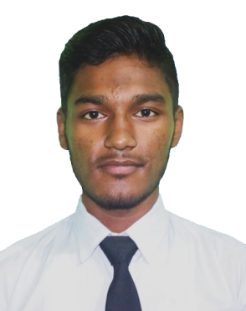

# MD ZEHAD ALI

# Web Developer

* **Phone & WhatsApp:**

+880 1744-646344

* **Address:**

Kazipara, Mirpur-10, Dhaka-116.

* **E-mail:**

[sehabkhanzehad@gmail.com](mailto:sehabkhanzehad@gmail.com)

* **GitHub:**

github.com/[sehabkhanzehad](https://github.com/sehabkhanzehad)

* **Linkedin:**

[linkedin.com/in/sehabkhanzehad](https://www.linkedin.com/in/sehabkhanzehad)

# Skills

* **Hard Skills:**
* HTML
* CSS, SASS & Bootstrap
* JavaScript & jQuery
* PHP & Laravel
* SQL & RDBMS
* Git & Github
* MS Office
* **Soft Skills:**
* Creativity
* Leadership
* Management
* Communication
* Problem Solving

# Co-Curricular Activities

* Coding
* Reading
* Writing
* Researching
* Traveling

# Career Objective

"I am a Web Developer with expertise in JavaScript, PHP, and Laravel committed to delivering high-quality, scalable web applications. Seeking to contribute my full-stack skills to a dynamic team, driving innovative digital solutions that exceed client expectations and support organizational success."

# Experience

* **Laravel Developer (Remote)**

**Research & Development Global Nest**

2024–Present | Dhaka, Bangladesh.

**Job Responsibilities:**

* Develop and maintain web applications using Laravel.
* Manage and optimize database schemas.
* Troubleshoot and resolve application issues.
* **It Officer**

**M/S Raj Travels**

2021–2023 | Chapainawabganj, Bangladesh.

**Job Responsibilities:**

* Solves technical issues.
* Provide technical support.
* Managing information technology & computer system.

**Achievements:**

* Receiving high accolades from the management.

# Educational Qualification

* **BSc in Computer Science & Engineering (Evening),**

**Bangladesh University of Business & Technology – (BUBT),**

2024 - Present | Dhaka, Bangladesh.

* **Diploma Engineering in Computer,**

**Chapainawabganj Polytechnic Institute – (CNPI),**

2019 - 2023 | Chapainawabganj, Bangladesh.

* **SSC in Science,**

**Nayagola** **High School – (NHS),**

2019 | Chapainawabganj, Bangladesh.

# Training/Certification

* **Web Development with PHP & Laravel,**

**Ostad Ltd,**

March, 2024 - Present | Dhaka, Bangladesh.

**Topics Covered:**

* Javascript, jQuery, AJAX
* Advanced PHP & Laravel
* Database Design & Structure (RDBMS)
* Application Architecture.

# References

* **Din Islam Tahsan**

**Sr. Software Developer**

Creative IT Institiute

[tahsan.cit.bd@gmail.com](mailto:tahsan.cit.bd@gmail.com) +880 1777-308777.

* **Muhammad Shohidullah Kaisar**

**Sr. Software Engineer**

Appnap Technology Limited

[ravenkaisar@gmail.com](mailto:tahsan.cit.bd@gmail.com)

+880 1750-191515.

# Proffesional Web Development with PHP & Laravel,

**Creative IT Institute,**

2023 | Dhaka, Bangladesh.

**Topics Covered:**

* HTML, CSS, SASS, Bootstrap
* Git & GitHub
* JavaScript, PHP & Laravel
* DBMS Management etc.

**Got Certificate**

# Language Proficiency

# Bangle: Native

# English: Conversational