**Nama = Setya Hadi Nugroho**

**Kelas = 2KS1**

**NIM = 222112358**

**Praktikum PBW ke-7**

**Jsforms.html**

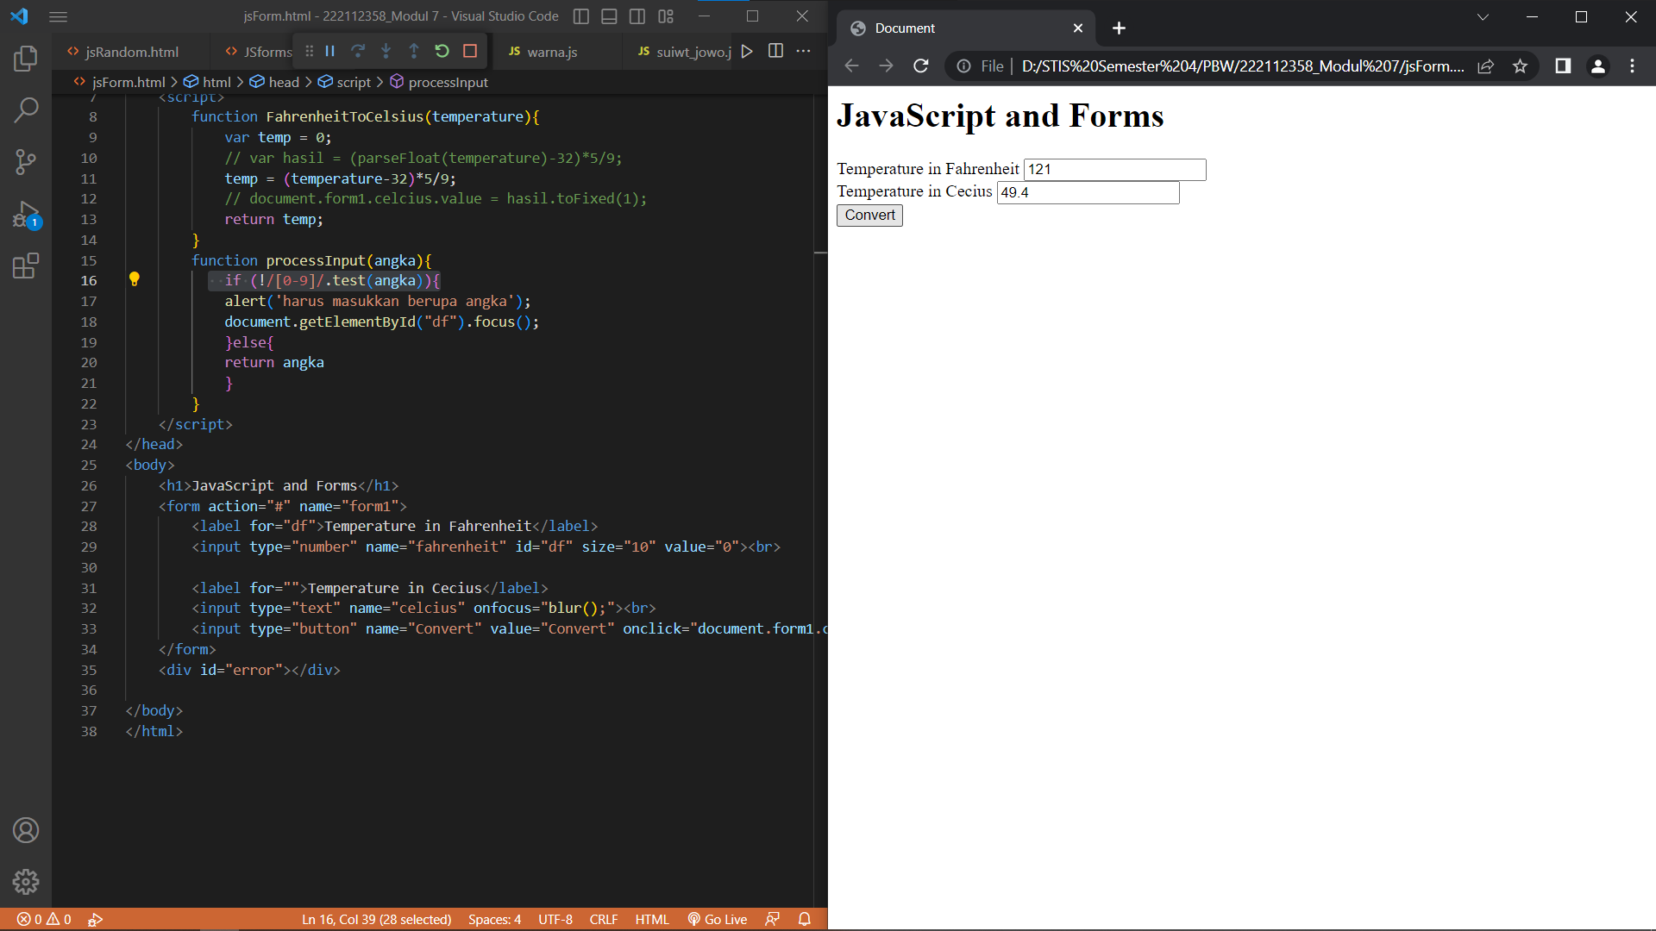

**Js.random.html**

