***Documentation***

Class Result:

This is the base class of all the functions representing different kind of grading systems.

Methods inside class Result:

* CSVParser input():
  + Opens a prompt for selecting the CSV File that shows marks of students.
  + The Format of CSV File should contain – SID, Name, Marks – as the coloumn headers.
  + Returns a parsed version of the uploaded CSV File.
* Void PECgrades(CSVParser):
  + Takes the parsed file retuned by the input() as its input parameter.
  + Loops over each row in the CSV File to calculate mean,variance and standard deviation of the data as a whole.
  + Loops again over the CSVRecord’s object to check the conditions of assigning grades to the students according to the prospectus of PEC as attached (X represents mean of the data and σ represents standard deviation of the data).
  + Displays the grades achieved by each student on the standard output.
  + 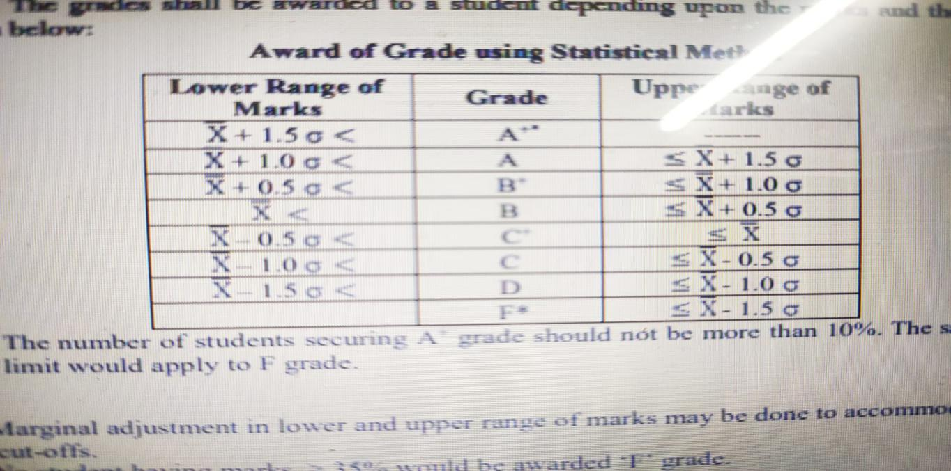Returns nothing.