1.Apply the concept of conditional statements in python to find given odd or ev en

Script: 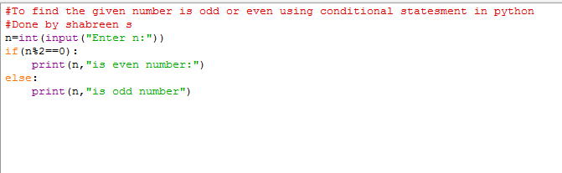

0utput: 