Saher Hassan

Mcsf19a022

Mobile computing

Lecture 05

First we will go to file then on new project then this window will pop up

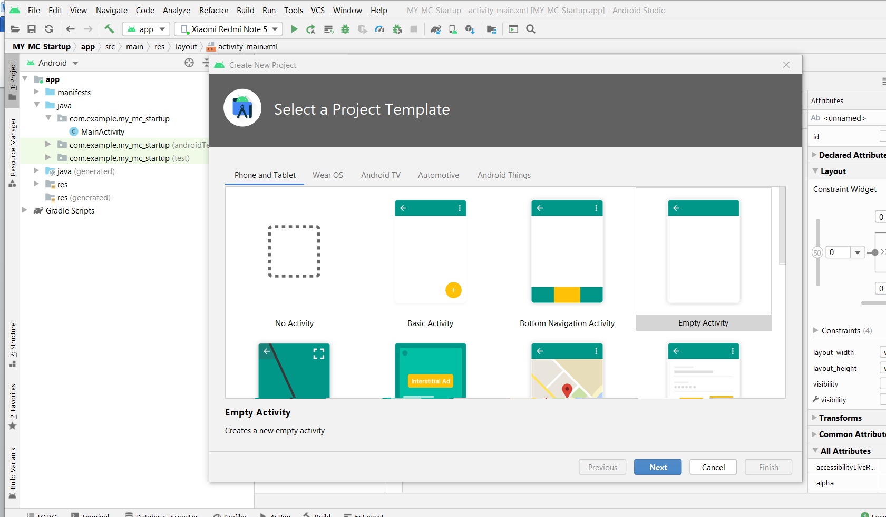

Chose empty activity

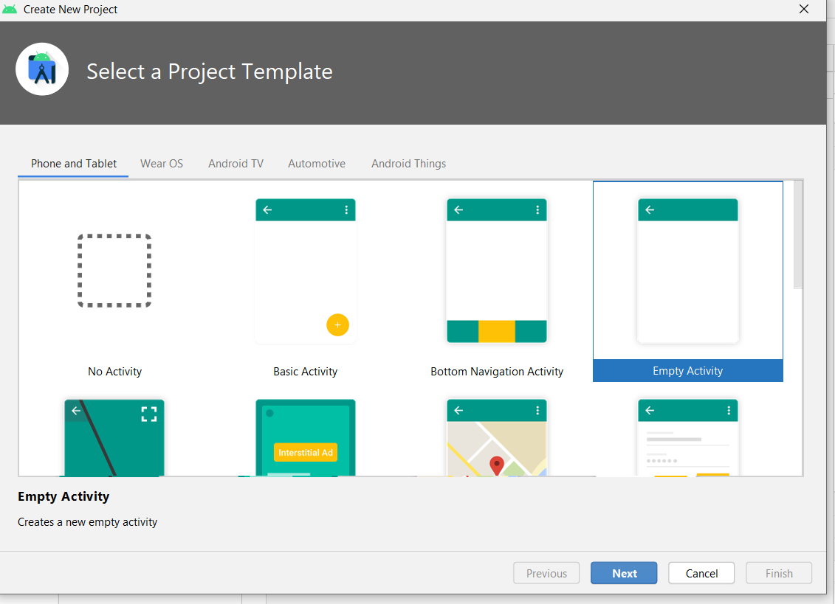

Then click on next and this window will pop up

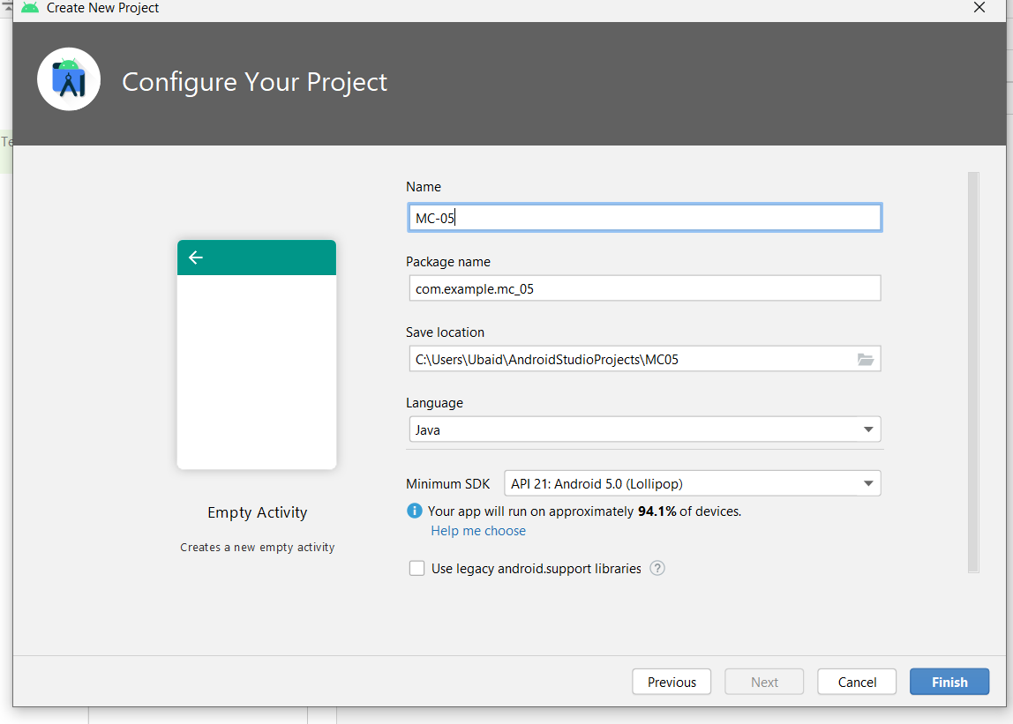

Here you can write your project any name.

Theres this package name that will uniquely identify it from others.

Then click on finish

When you click on finish this will pop up

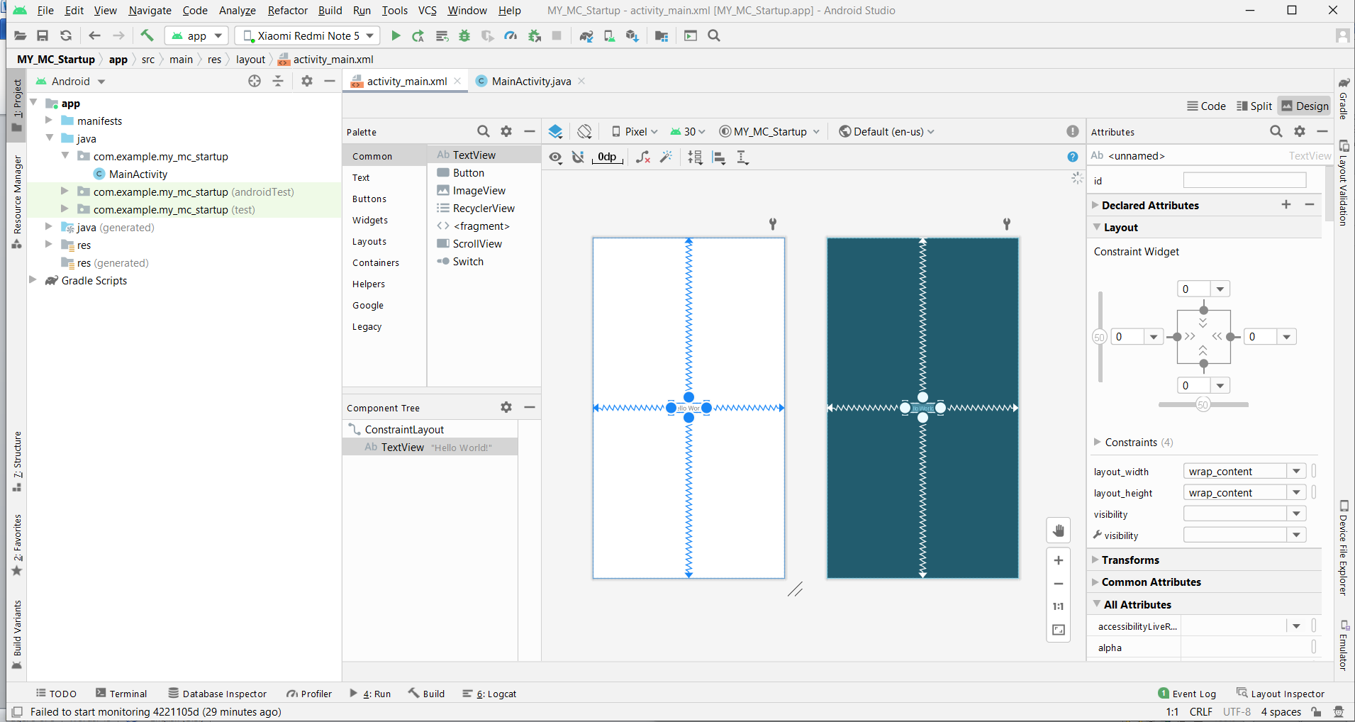

Here we have activity main-xaml

In which we will see the design of our code

And this section is where we write our code

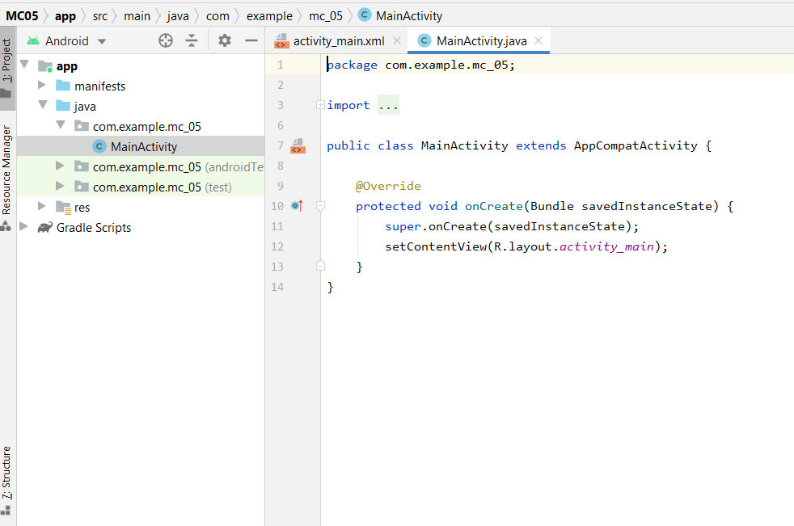

And if we click on this it will run our app.



And heres the results.

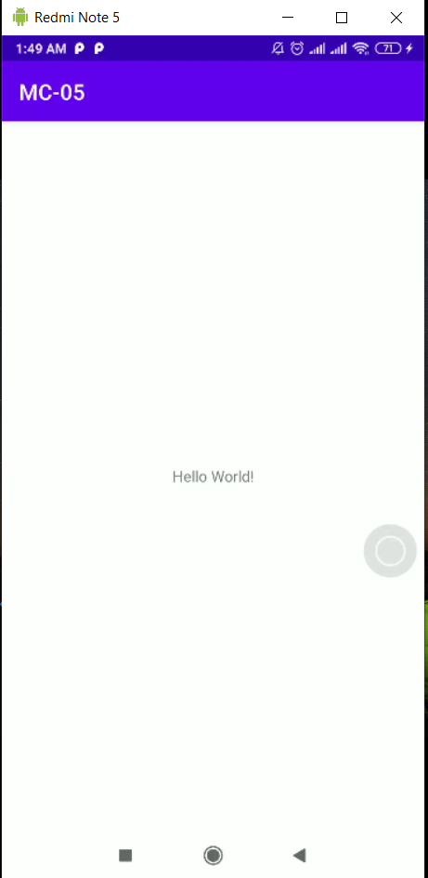

TODO tasks :

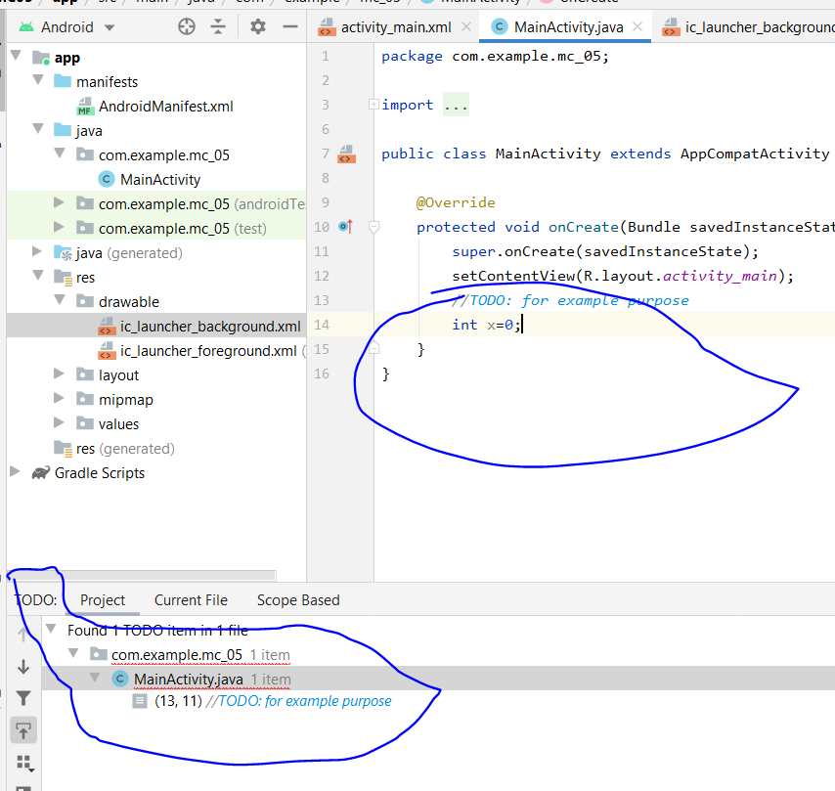

Here will be our project dependencies

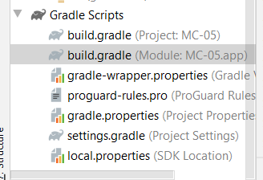

Here is our default text that is showing on our screen

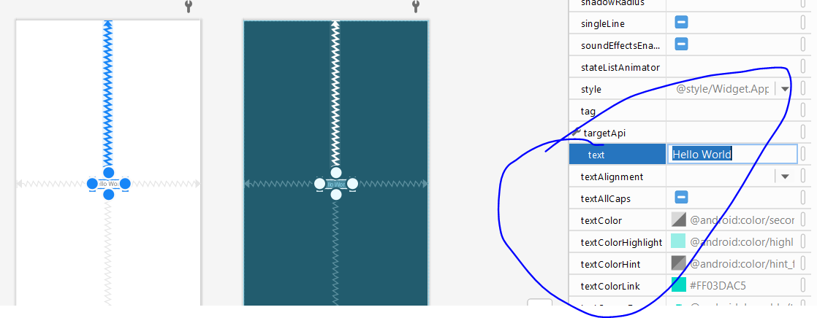

And we will change it

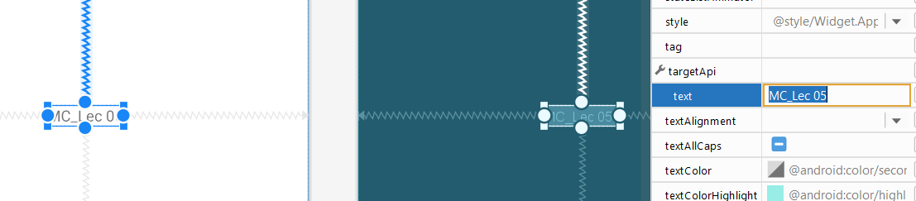

And heres the results

