Saher Hassan

Mcsf19a022

Mobile Computing

Git

Creating repository ,conflicts,newbranch etc.

First we create a repository on github in online mode and named it.

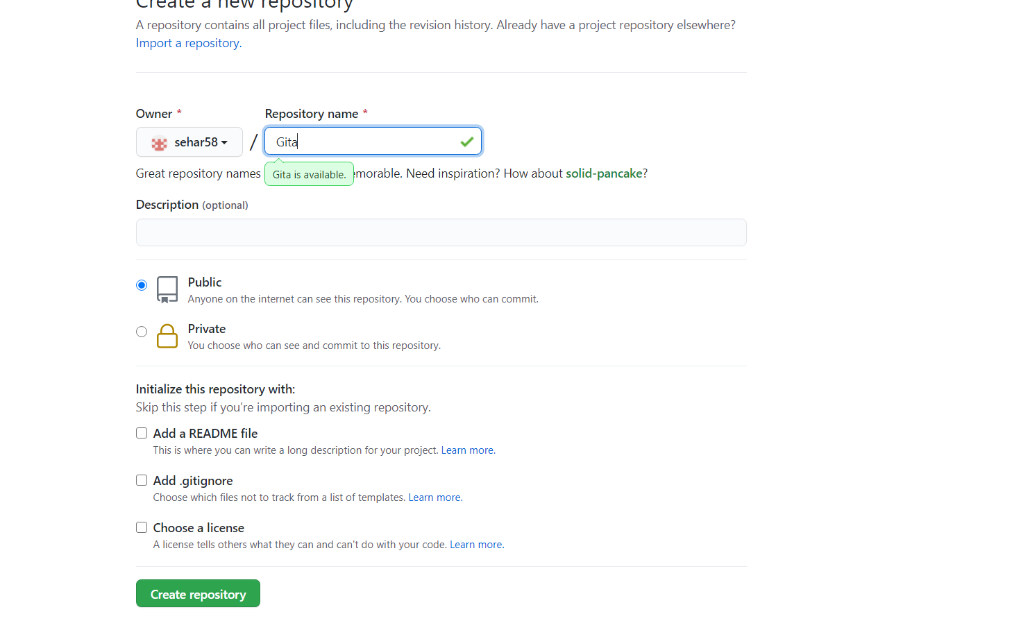Then it will create a link of our repository .we will copy it from here and then use it further.

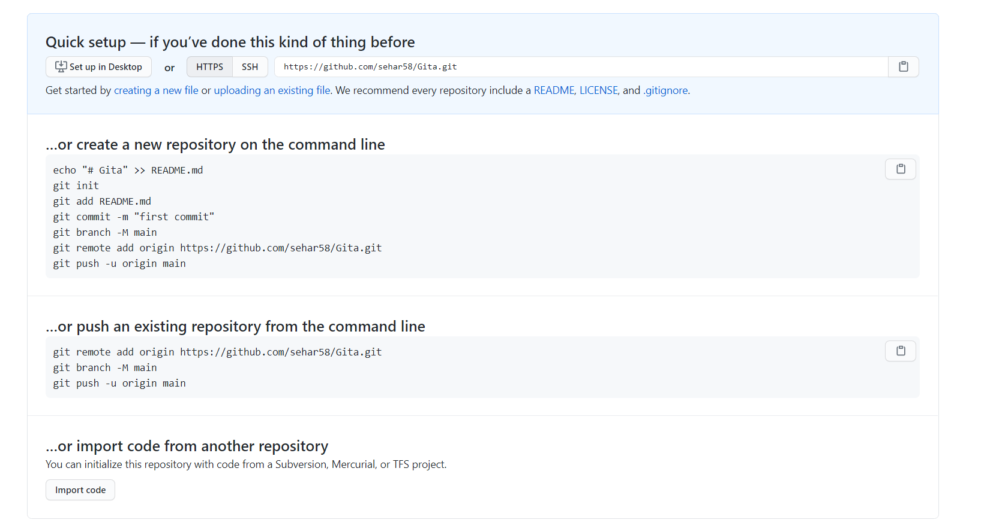Then we will open our document that we want to clone in our computer then oen git bash from there a prompt will open then we will clone it by writing the command of “git clone[url that we copy it]”

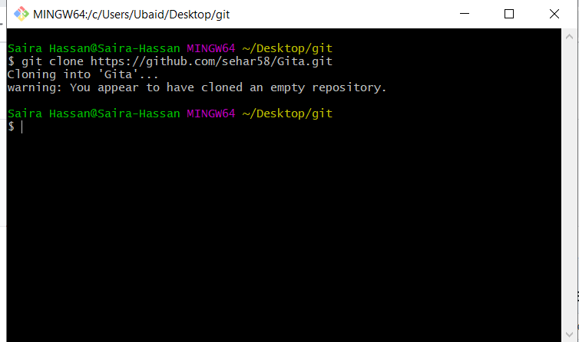

Then we will write the command of adding our file in which we write “git add (filename)”

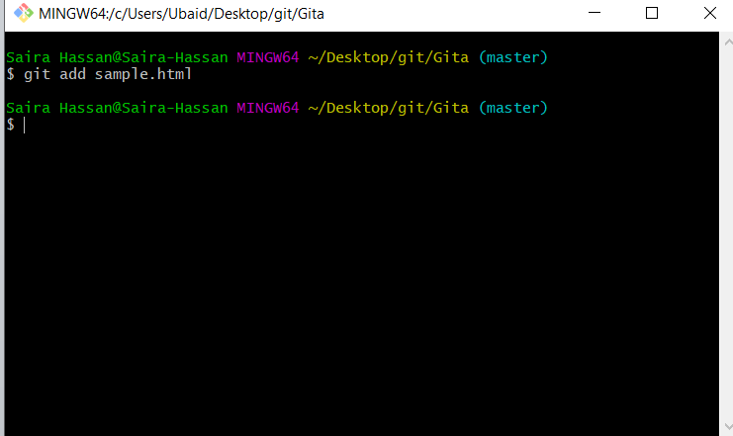

No we have to give that thing a name by committing it by command “git commit -m [“any name”].

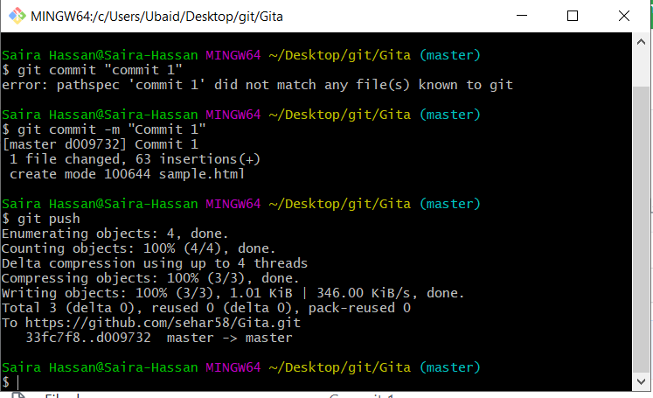

Then push it to online git hub repository by “git push”

It’s a three step process that every time you made a change you have to do it

Git add file name

Git commit –m “commit1”

//git commit -am “commit”

Git push

Now you see in the below ss that it will upload a file on our account.

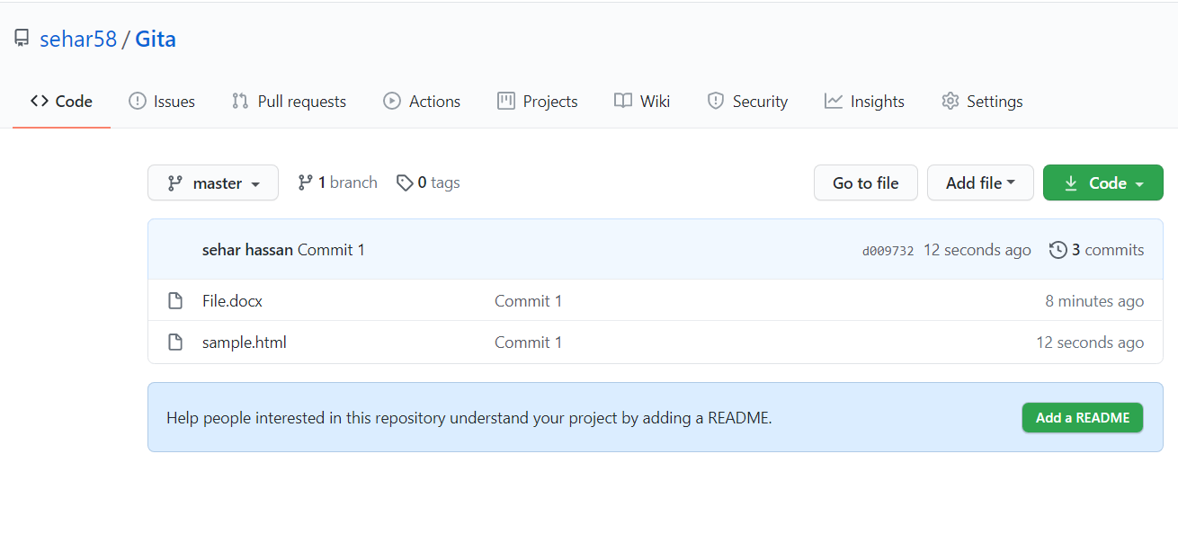

To check the status write “git status”

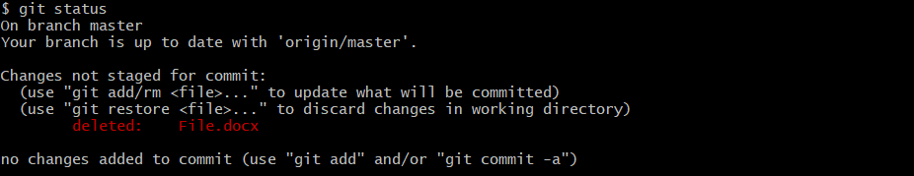

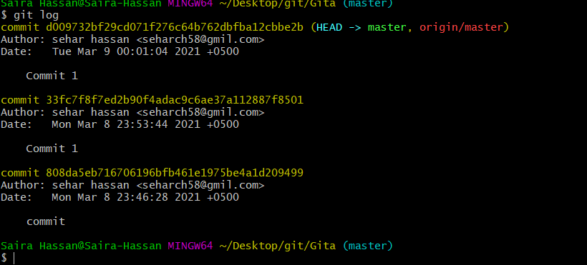

**Conflict:**

We can edit it online also.

Suppose some people are working on a project as team and some person have written one line of code in online mode, then he will commit it by clicking the button, he don’t have to add commit and push because he is already changing in online mode.

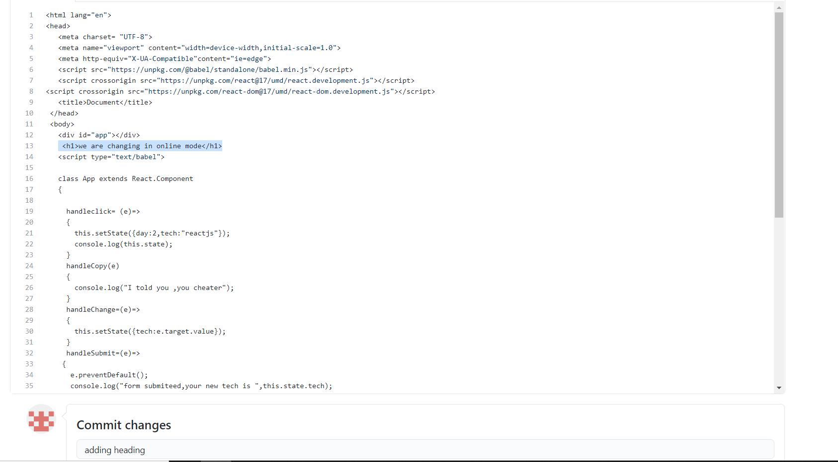

And some person have write some online r do some changes in offline mode in the file.

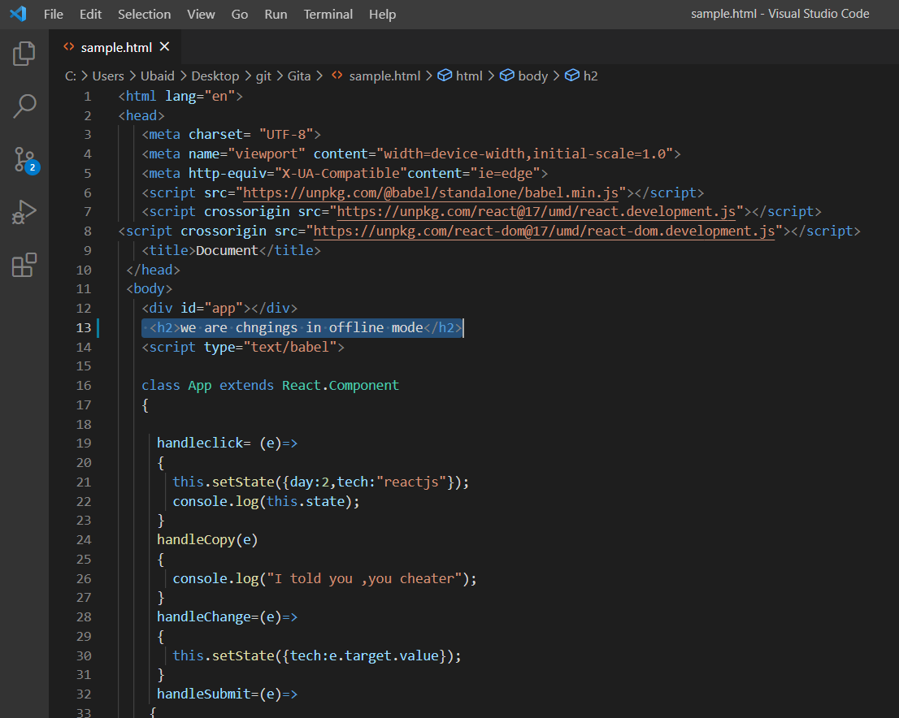

And he will also add commit and push it

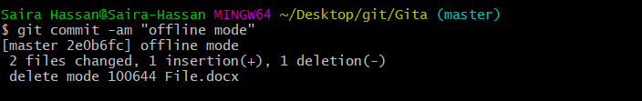

But when he push it an error will occur because it will become a conflict that what change to accept and changes made in online mode are not present in offline file.

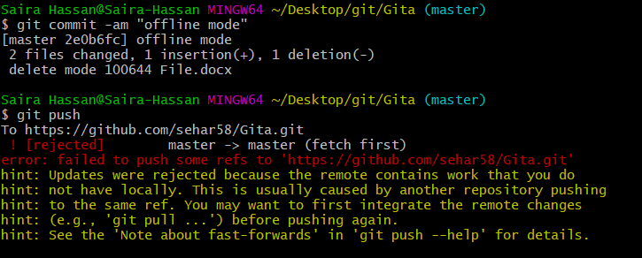

So to get all the data from online mode he will pull all the data from online mode to the offline mode in original file by “git pull”command but here the conflict arises that what thing to accept.

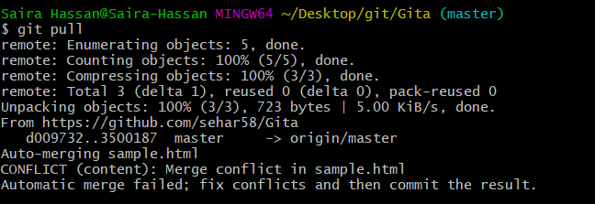

Then in original file both changes will appear then you will select which mode to accept.

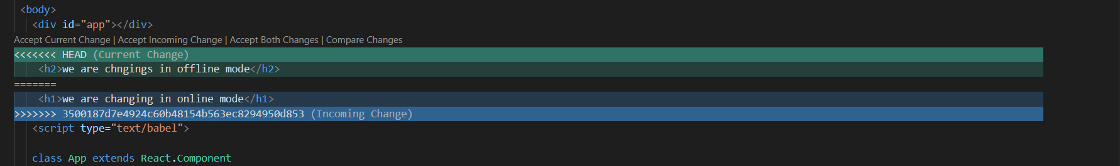

We have accepted both changes so it will show both lines of code and merge them in offline mode but still e have to merge them also in online mode.

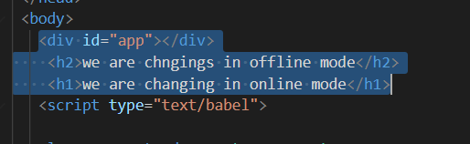

So we will add comit and push them.

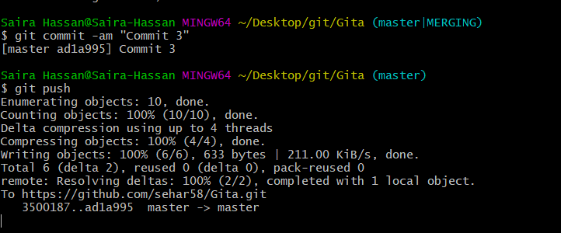

And we will both changes in online mode also.

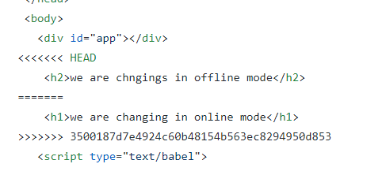

“git log” command will tell us that what changes are made at what time and what is going on on online and offline mode.

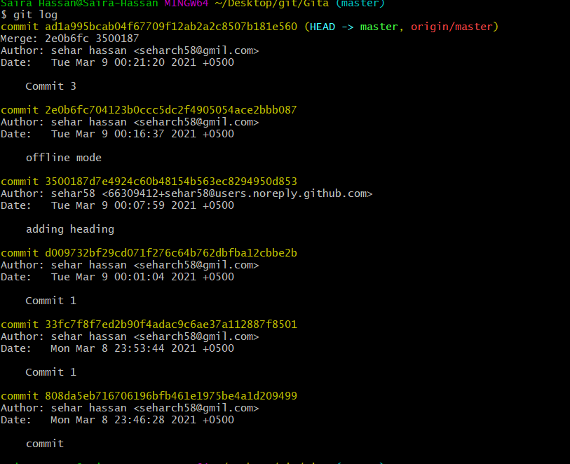

Sometimes we have to add some code to check for experiment with the older code so it allows us to make a new branch and do experiments there and then later on add with the parent branch called master branch.

To do this first make a new branch by typing “git checkout –b newbranch”

And you will be shifted to a new branch and whatever changes you will do ,it will not be present in original file.

And if you want to check you are on which branch simply type “git branch”.

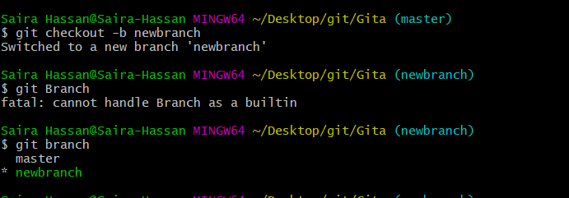

Then suppose you did some changes in new branch.

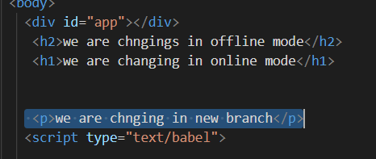

Then you have to add and commit that change.

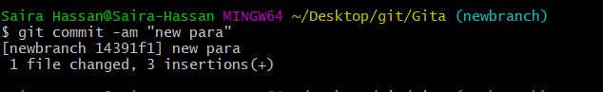

If you want to go to the master branch simply tye”git checkout master”

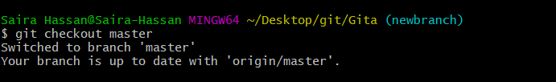

See in the previous ss that no change will happen in master branch.

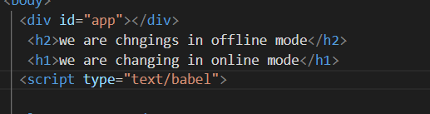

If you are sure that the changes you did in newbranch is okay then merge that piece of code to the master branch by “git merge [name of experimental branch]”.

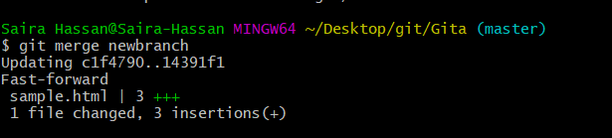

And then push it to the online mode.

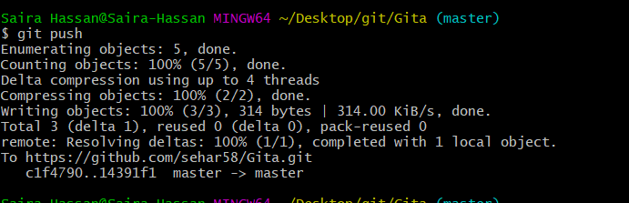

And you will see the changes there.

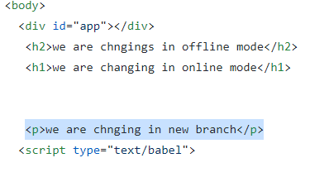

The end.