***Saher Hassan***

***Mcsf19a022***

***Mobile computing***

***Lecture IDE Introduction***

**Lec 06YT**

Here we have this right now

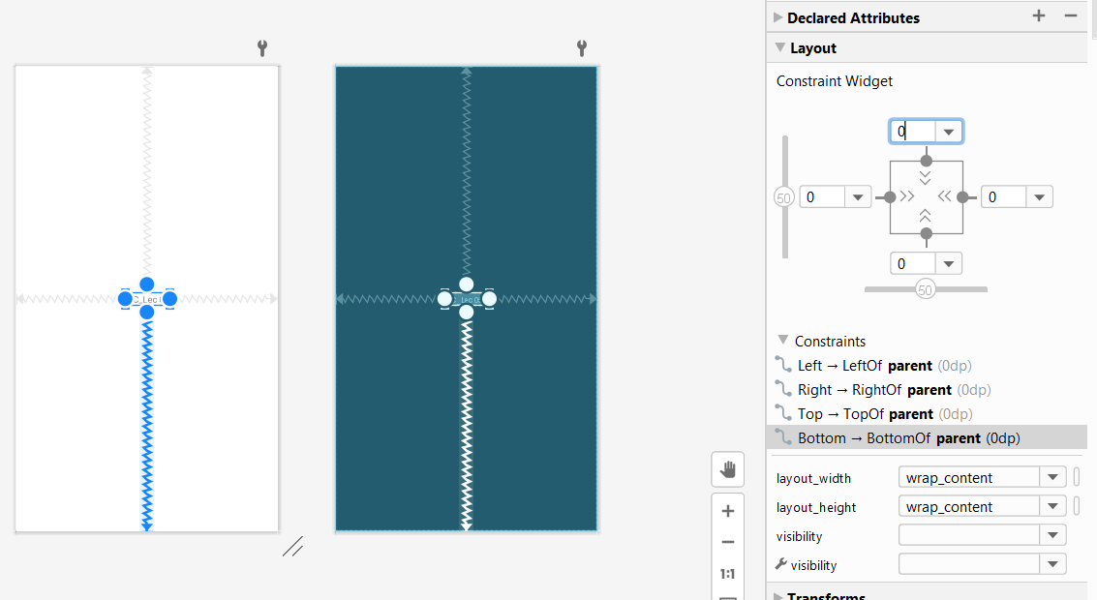

Now if we del the upper constraint it will move to the downward direction]

Like this

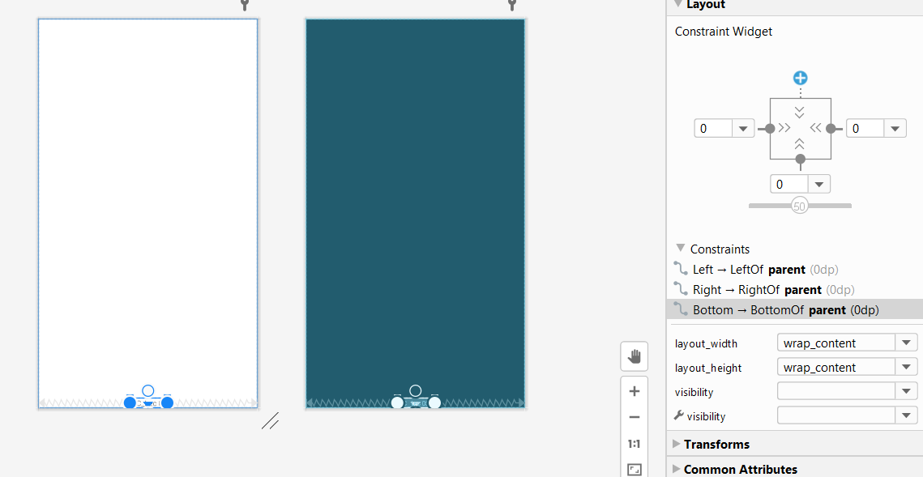

And output is like this

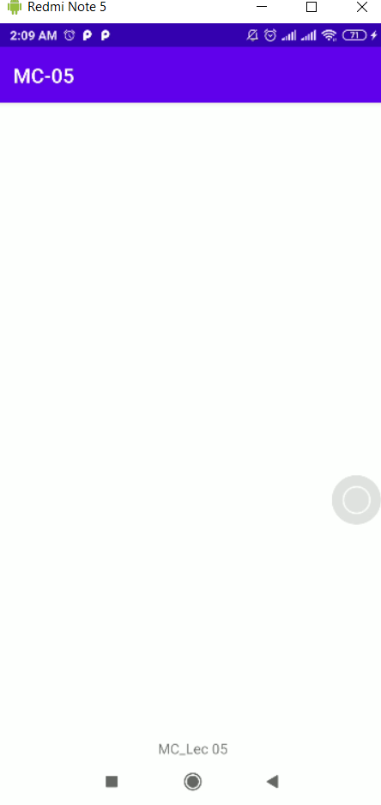

Same if we delte the lower one

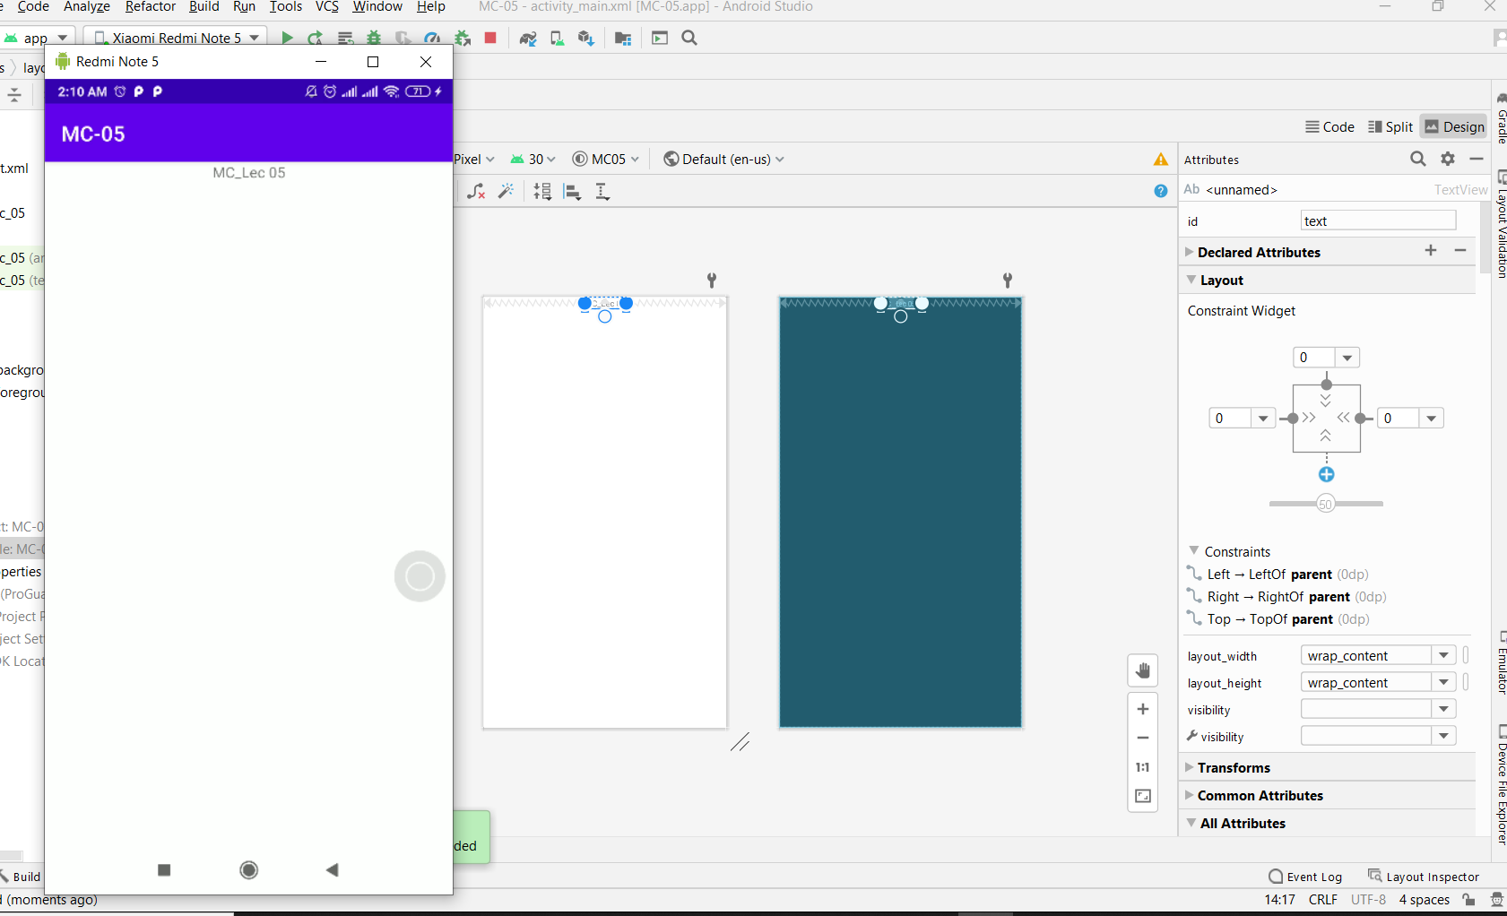

Same if we del the right one it will go left

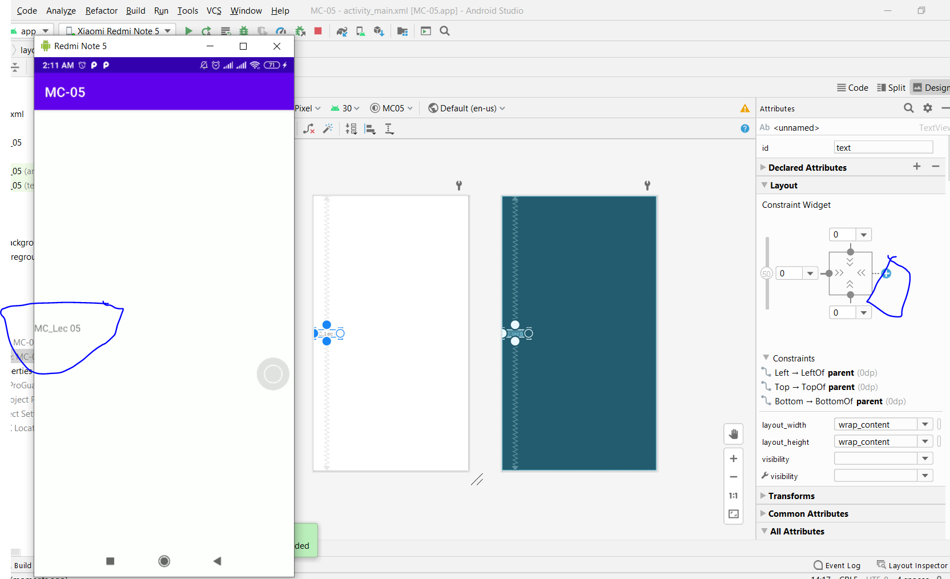

We can have diff views

It will show both design and blue print

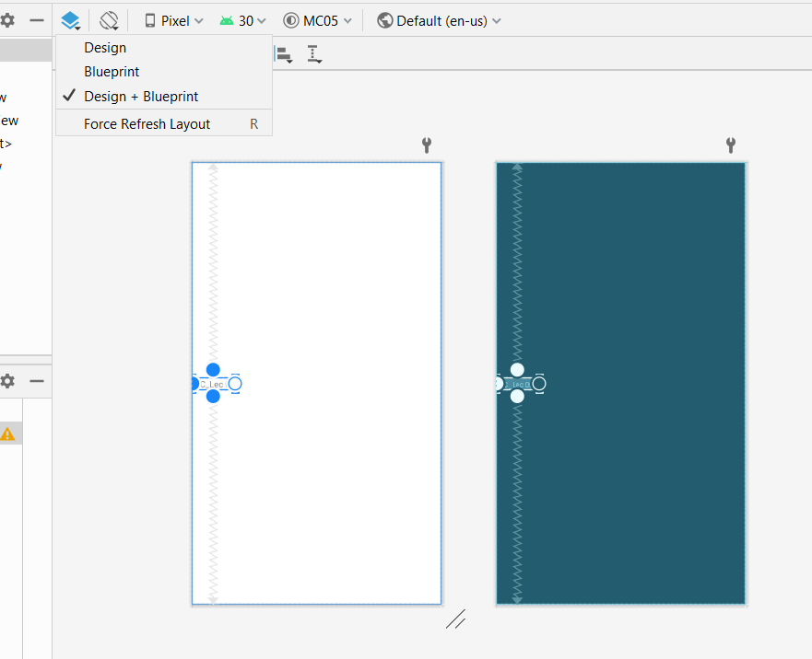

Now It will only show blue print

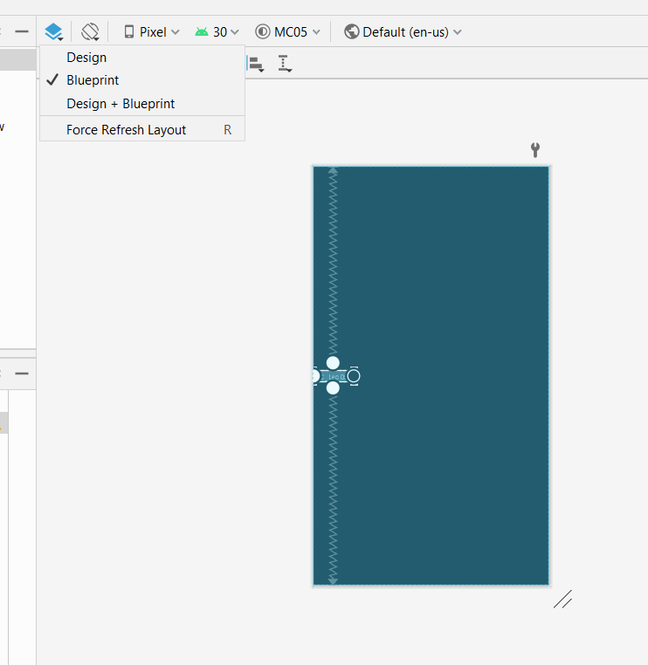

Now if we go to Pixels it show diff devise on which we can view

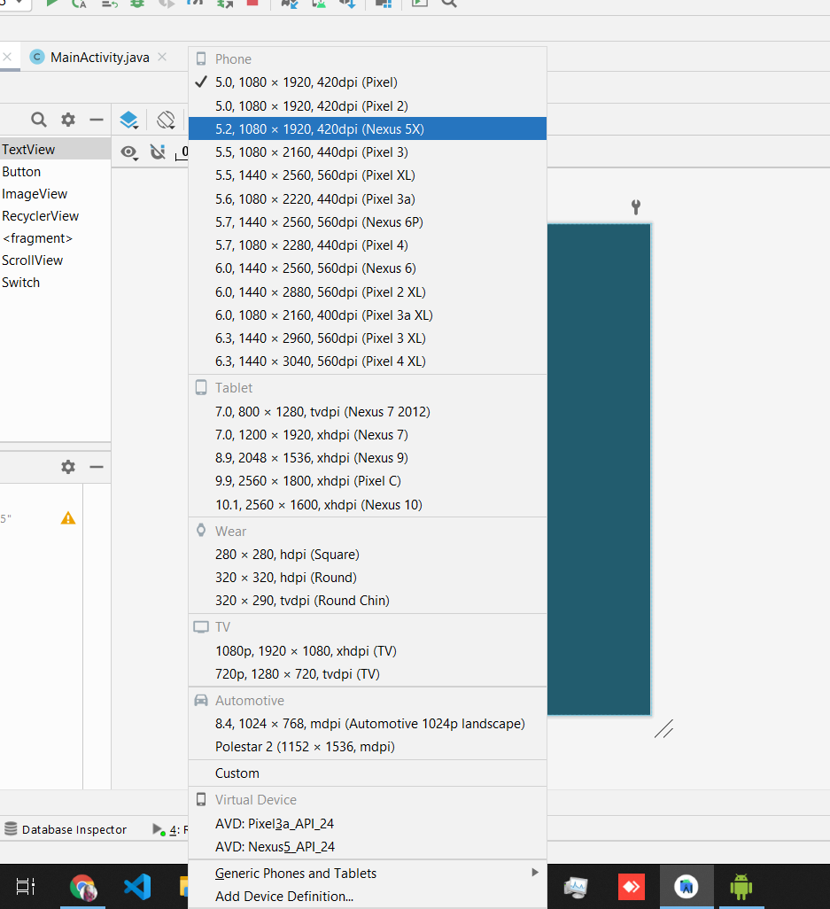

It will show diff modes of view like portrait landscape etc.

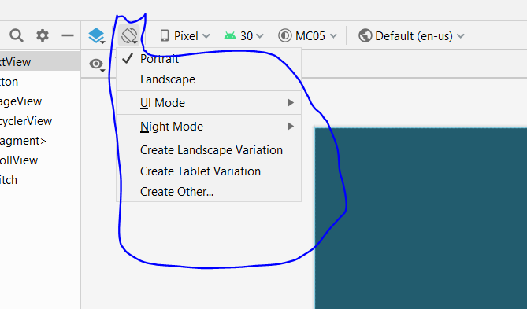

Ok now if we add a button.By dragging button to our xmal file

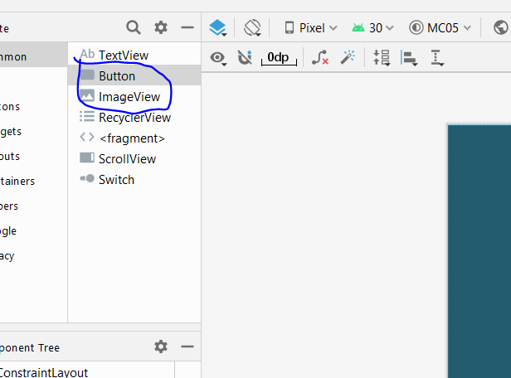

We have added a button without its contraints and it will go to the top left corner

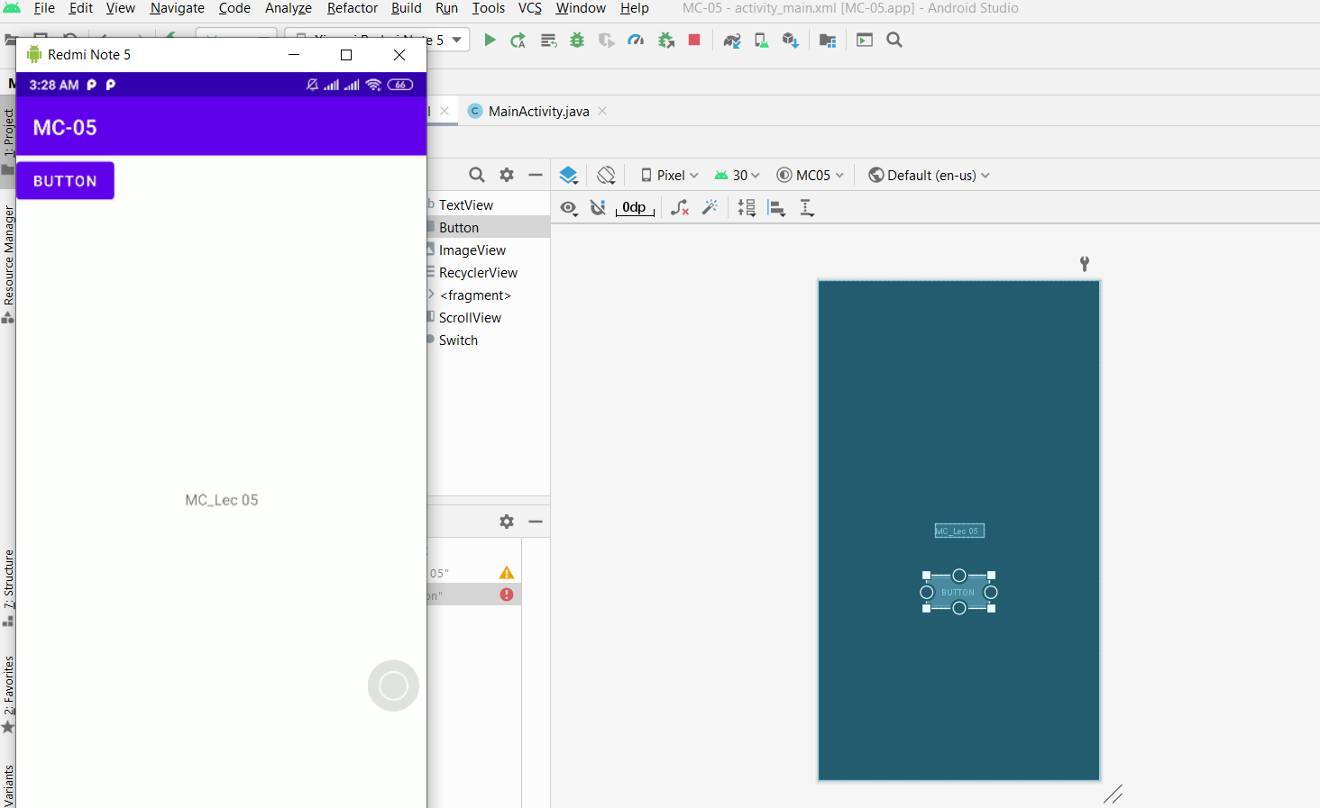

Now we will apply constraints to our buttons and I added a little marging to our heading

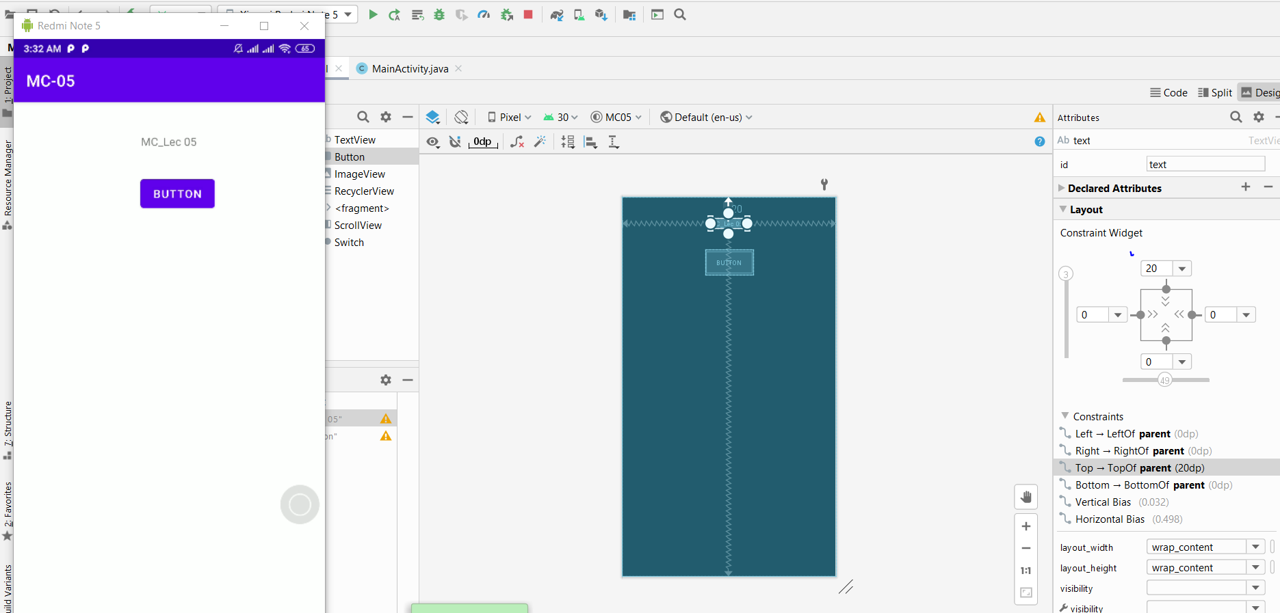

Adding constraints to button

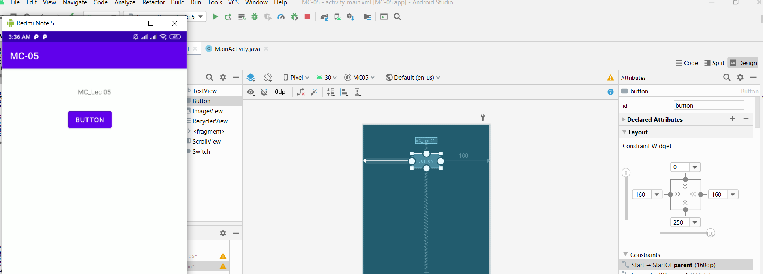

Its our component tree that will show what thing is first then what next like first we have added some text and then button so it is showing just like that

