***Saher Hassan***

***Mcsf19a022***

***Mobile computing***

***Lecture Layouts***

**Lec 07YT**

Lec 07

In lec 07 we have talk about view and view groups.

One view group contatins diff views and can also contain diff view groups.

Each layout file must contain exactly one view group.

We have made a new project

Linear layout:

Adding resources

Now we are going to add resources.

We will go to res->layout

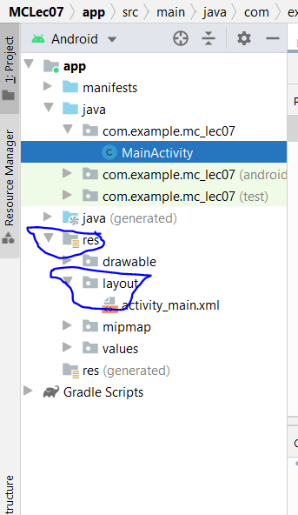

After right clicking on layout this will pop up

Then click on New->layout resource file

Choose this

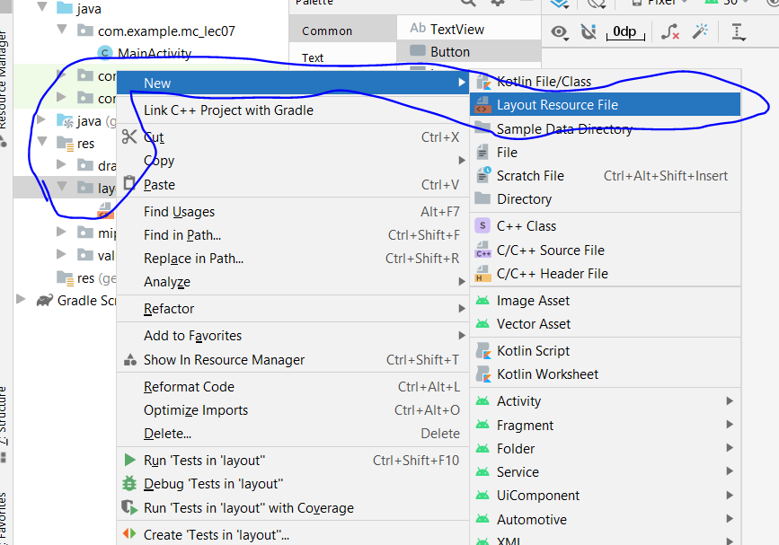

This window will pop up

Give it a file name whatever you want. Then click okay.

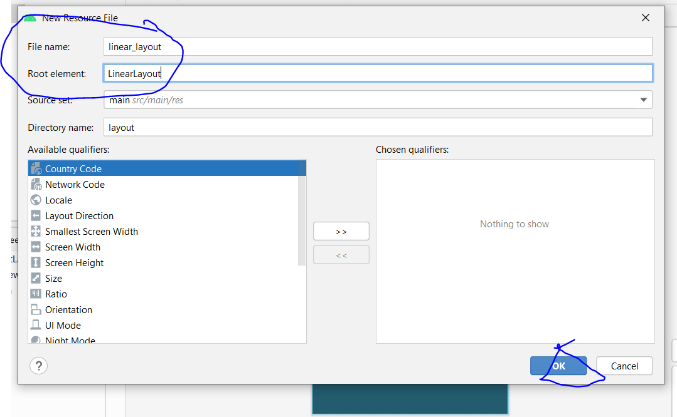

After okay this file linear layout.xml will be formed with this code and there is also a design section

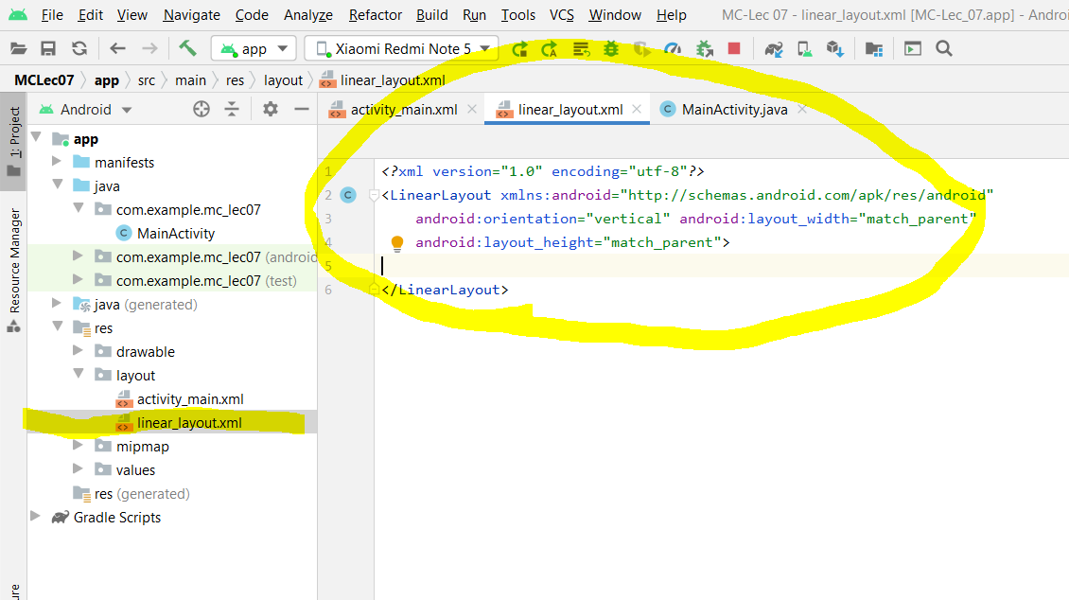

In its design section we will do some work.

In the design section of linearlayout.xml I have added some textviews and from the text section I have chosen some password, email and in the end there’s a button sign in

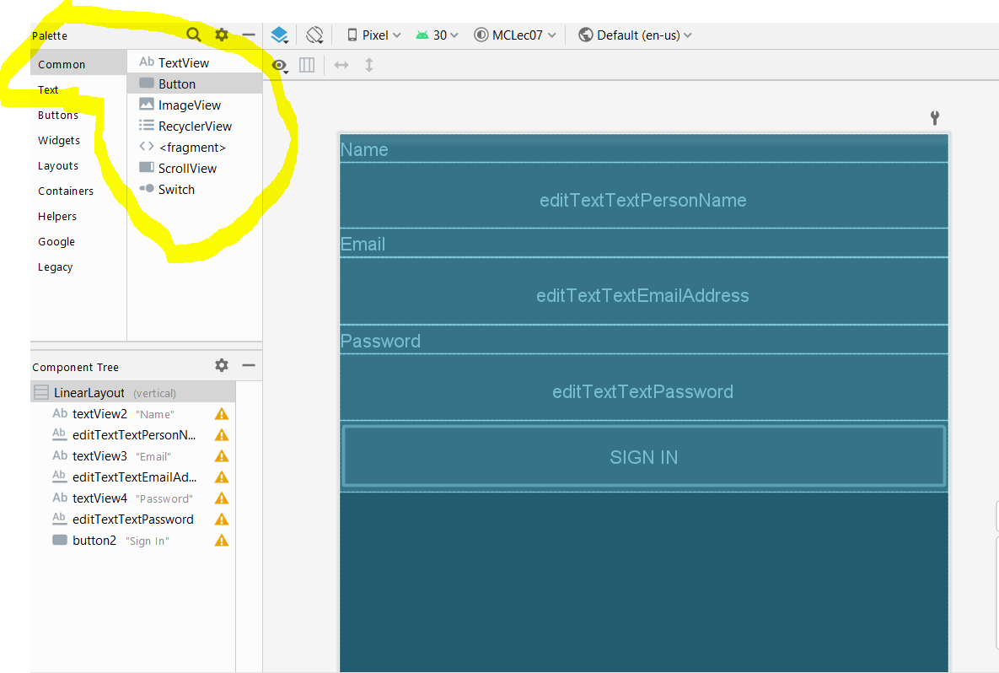

So to show output go to main activity.java here’s the default value of setcontentview is acitivity main

We will set it to linear_layout (the file which we have made now and did some design work)

Then it will show output of that code in our screen

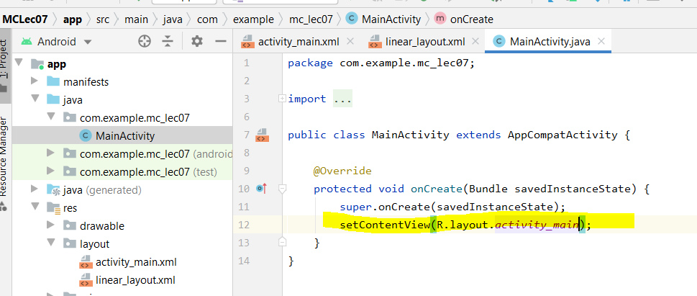

Here’s its output

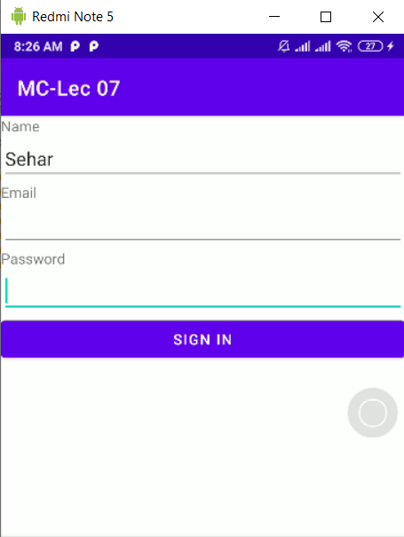

This dependency will be created in gradle

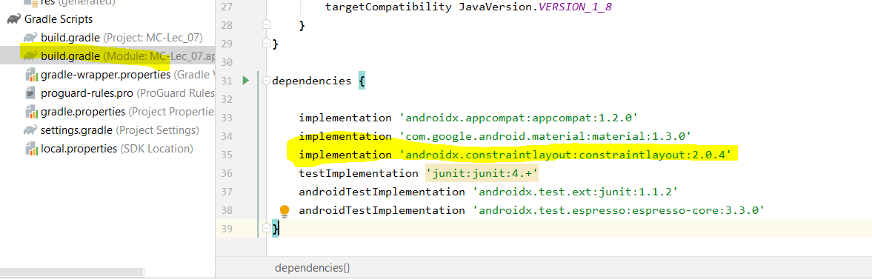

Clear Constraints

We can clear them all by clicking this symbol

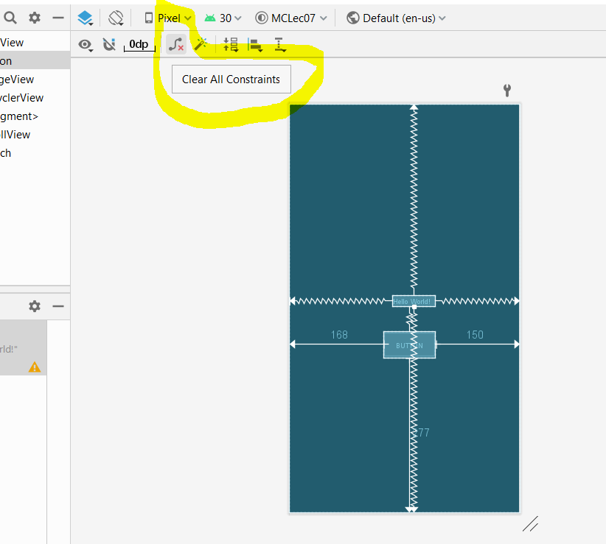

After deleting

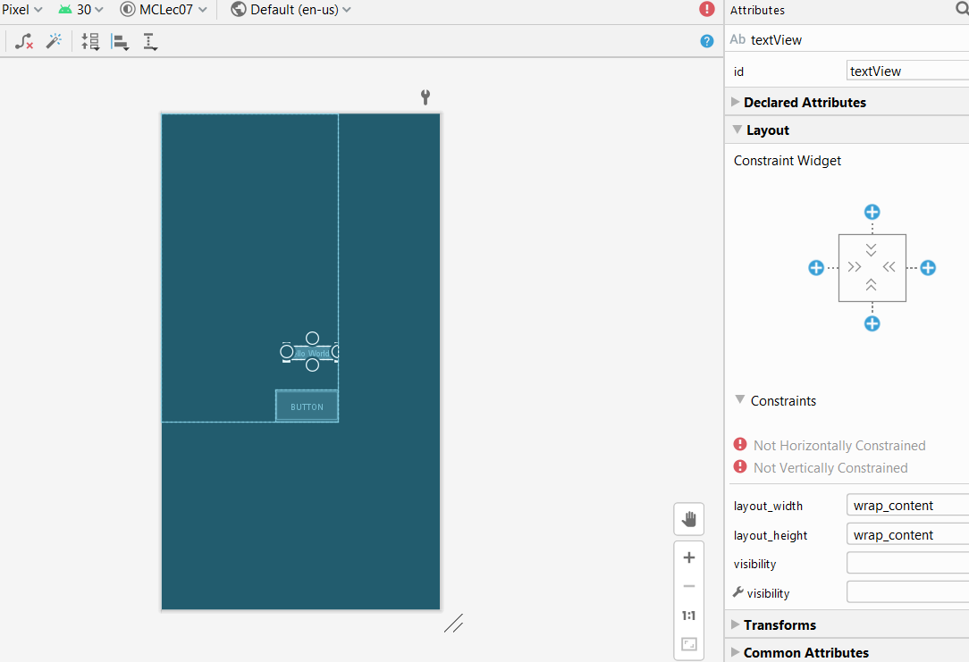

We can create constraints by clicking those plus buttons

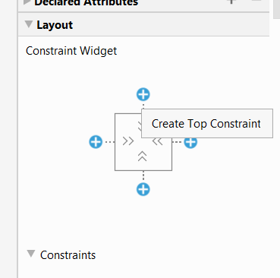

Just like this.It takes existing dimensions and accordingly it create right left distance and we can aslo give distance manually

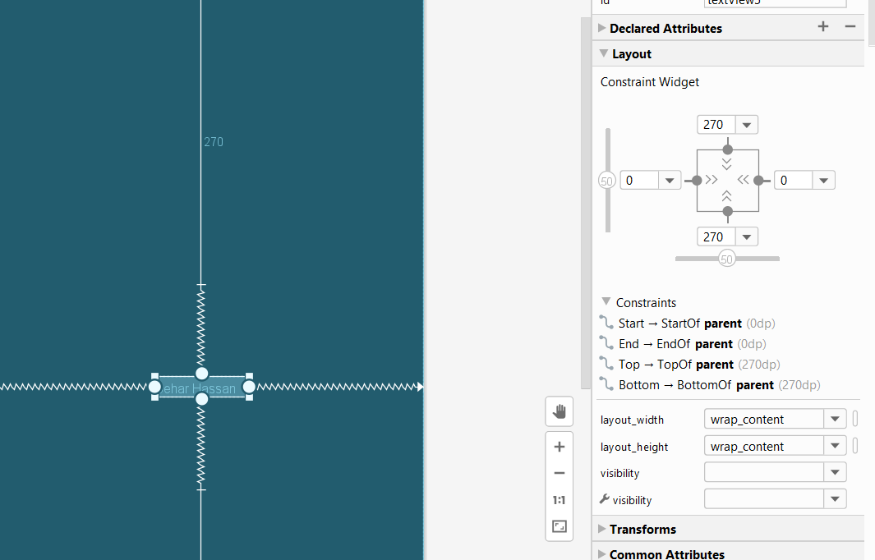

We can also set its bise setting from here.it will move and downward from here

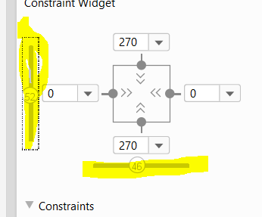

To Add image:

Go to res->drawables then paste some copy images then press okay.

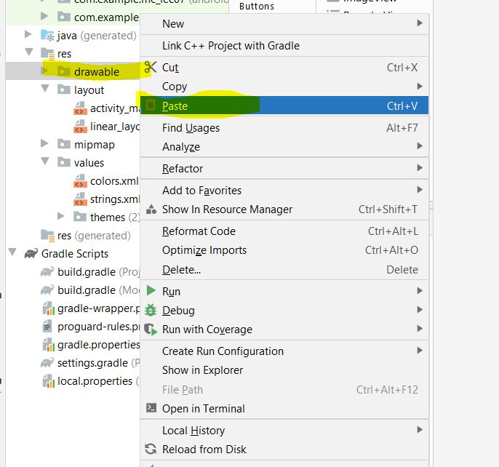

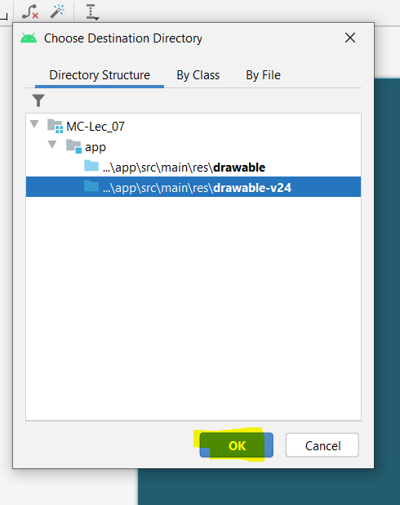

Go to image view then in activitymain.xml

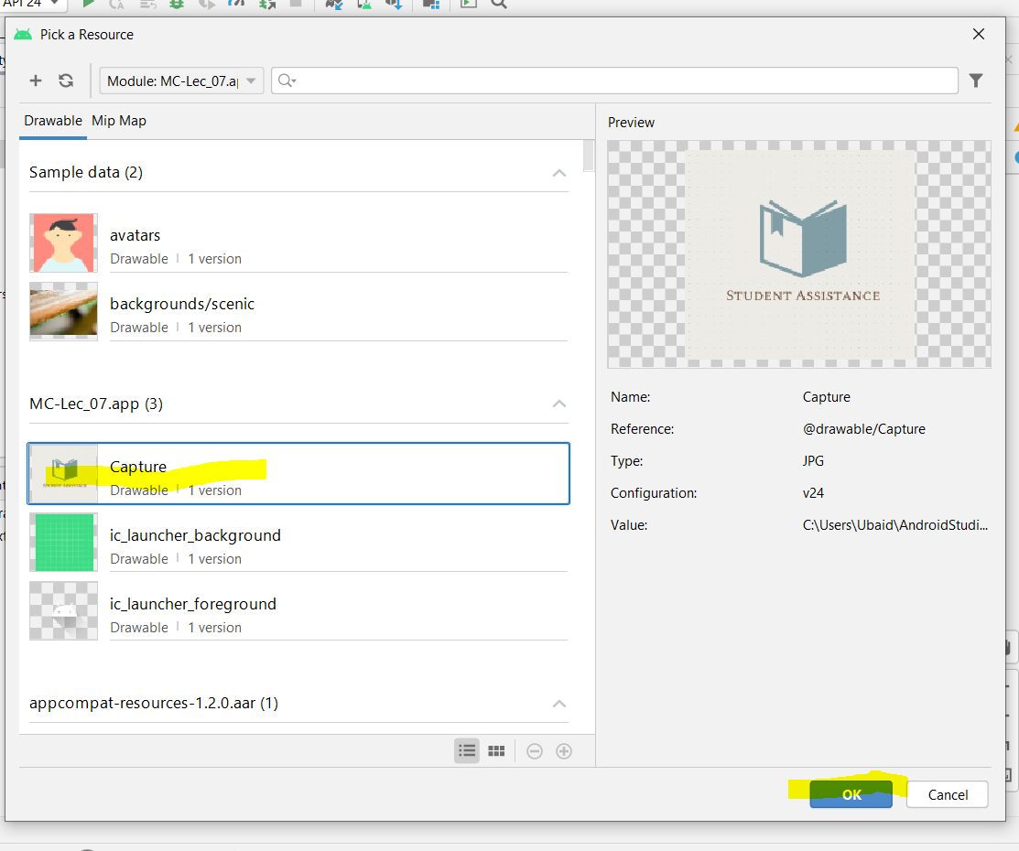

Constraint Base line:

When we are using edit text and text view and want them to be symmetrical then we will drop their base lines so that their dimensions become symmetrical.

I have taken a text view and phone number and drop their base lines .

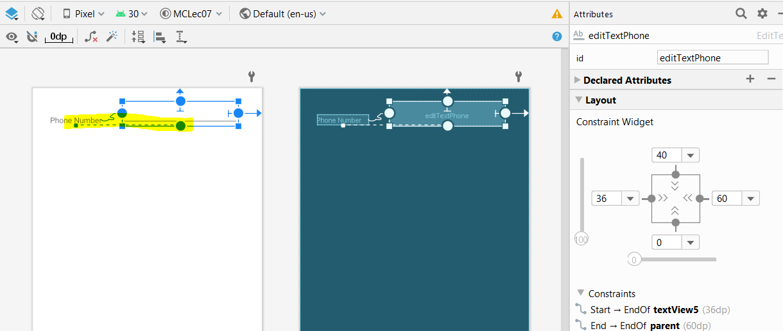

And that’s their output symmetrical

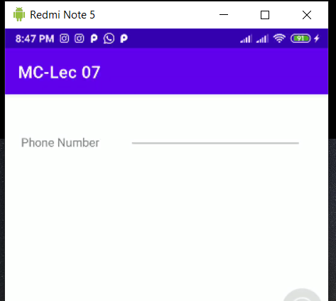

Show all constraints:

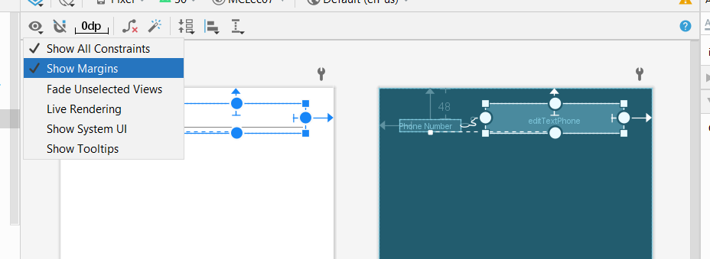

Multiple Buttons Arrangements:

We have taken three buttons

Select them all and then align them to left eedges

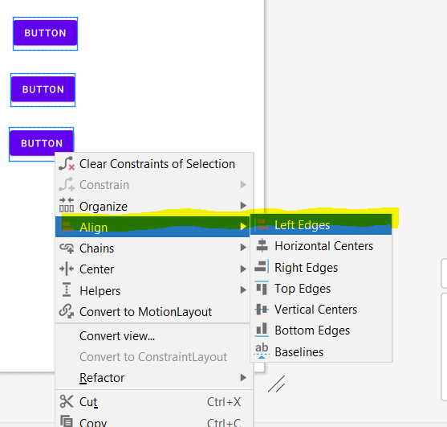

Now they will move together

I have also given them some constraints now they will move together

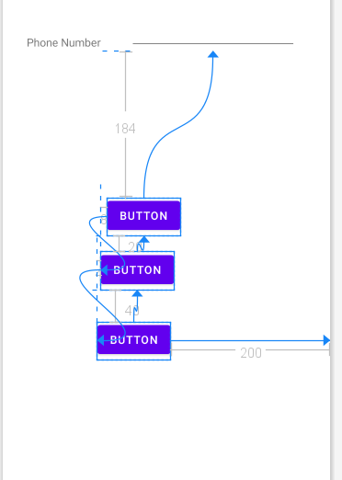

Output

