Saher Hassan

Mcsf19a022

Lec-10

List View

First we have drag the list view

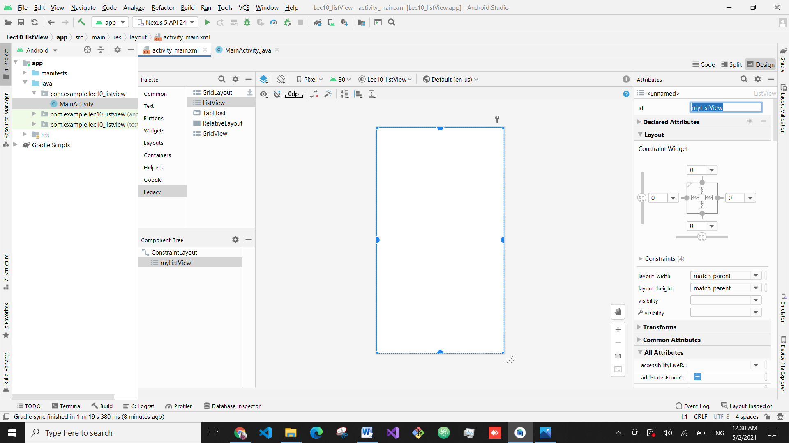

Then in main activity we write some code

In the below pic we can also use friendArraylist

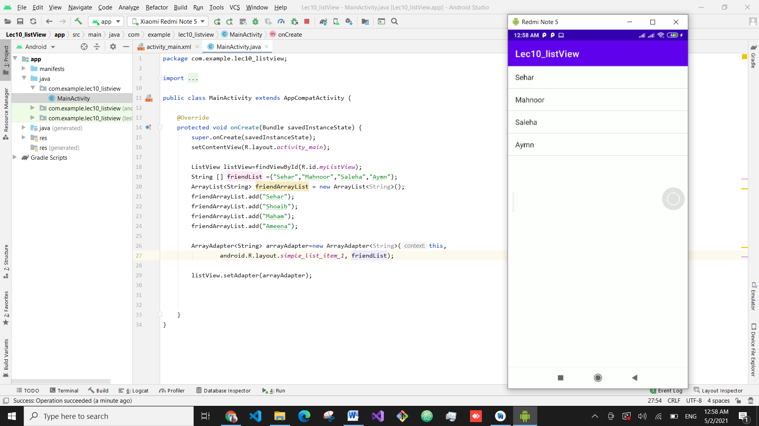

Then we have added a button and plain text and assign them ids above list view and make list view match constraint

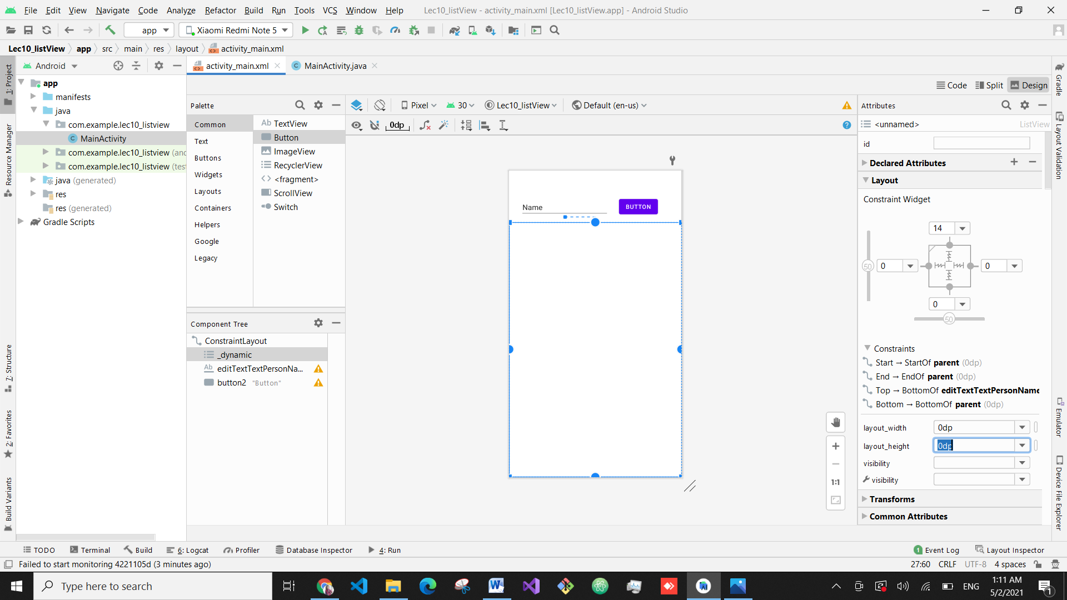

Then we have made their instances of button andtext.

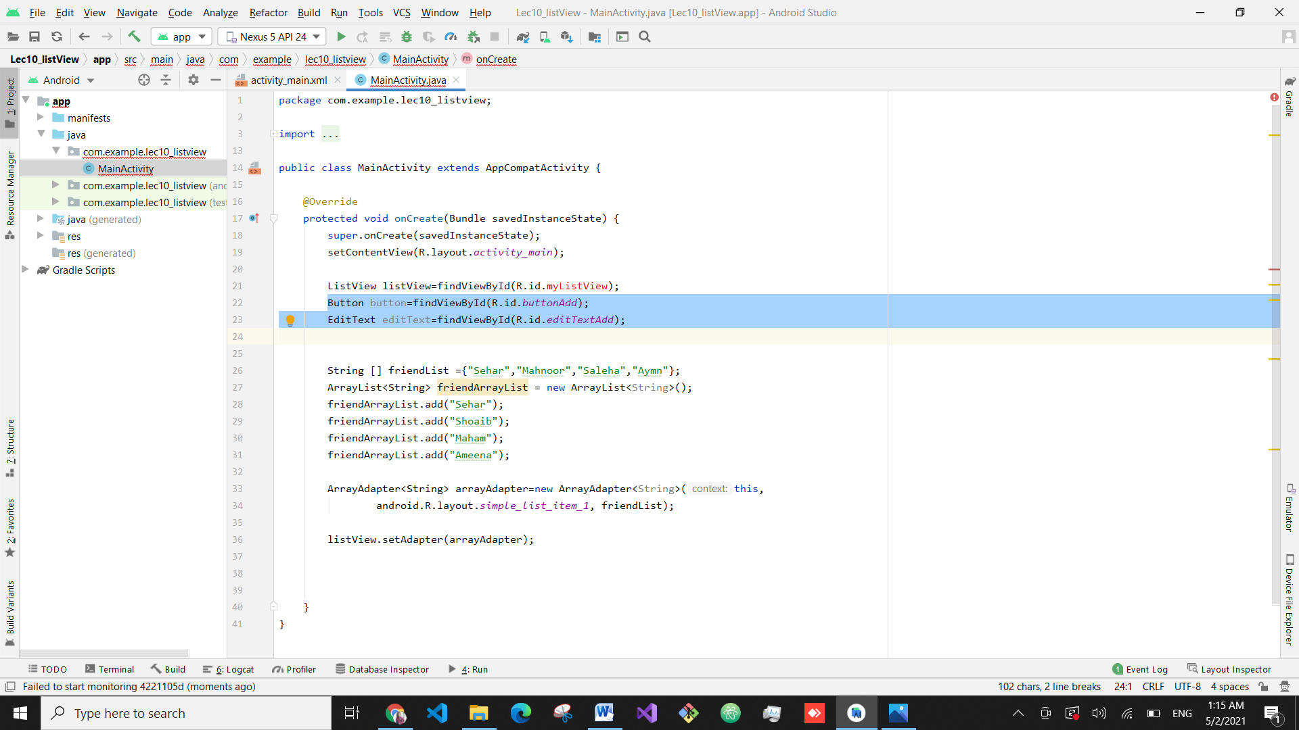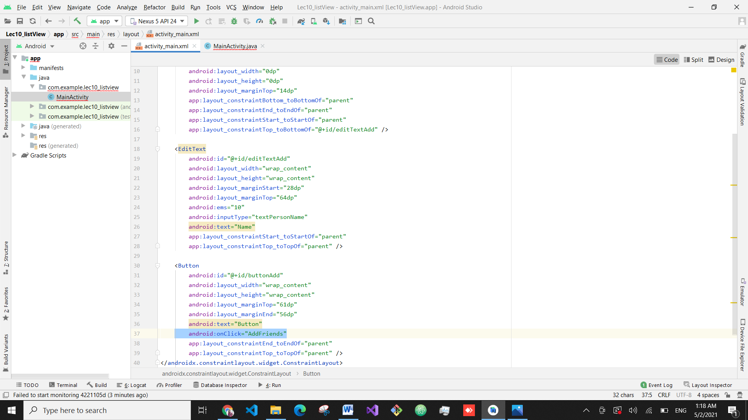

Now in activity main.java we can access friendarraylist and edit text so we make that array before override and make that add friend function

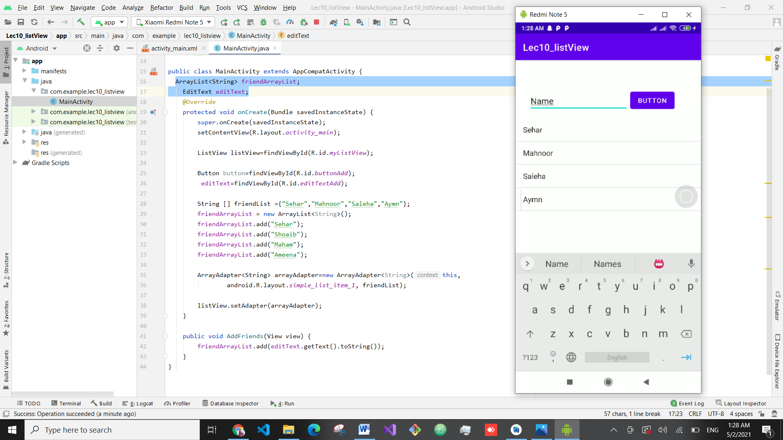

Its not working because that adapter part should be in function

So we copy it into function and make the instances of listview and adapter above override

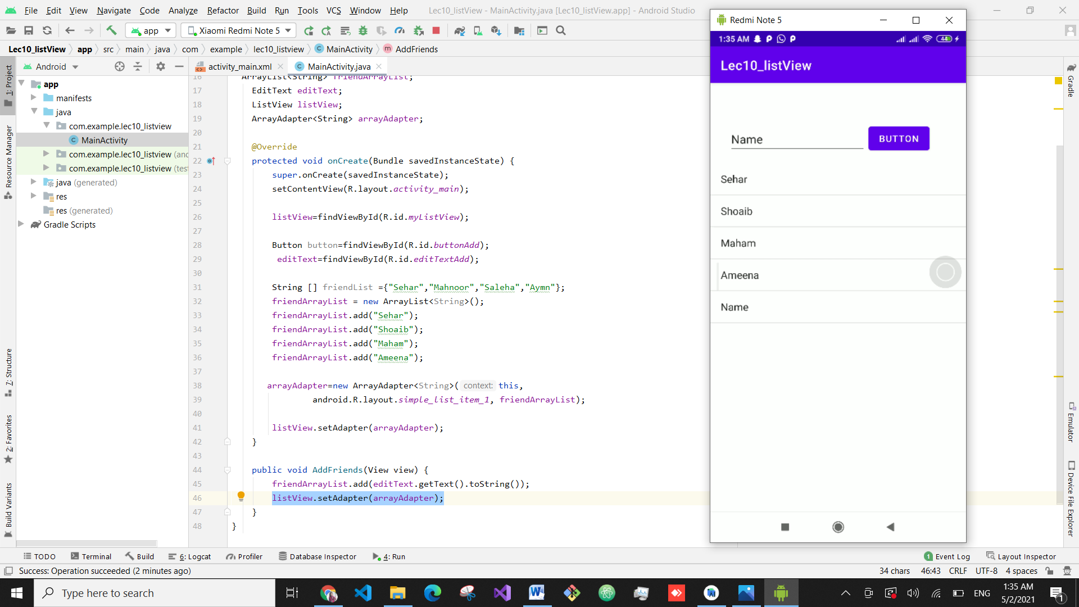  
where you click on name it show us on logcat that you clicked this

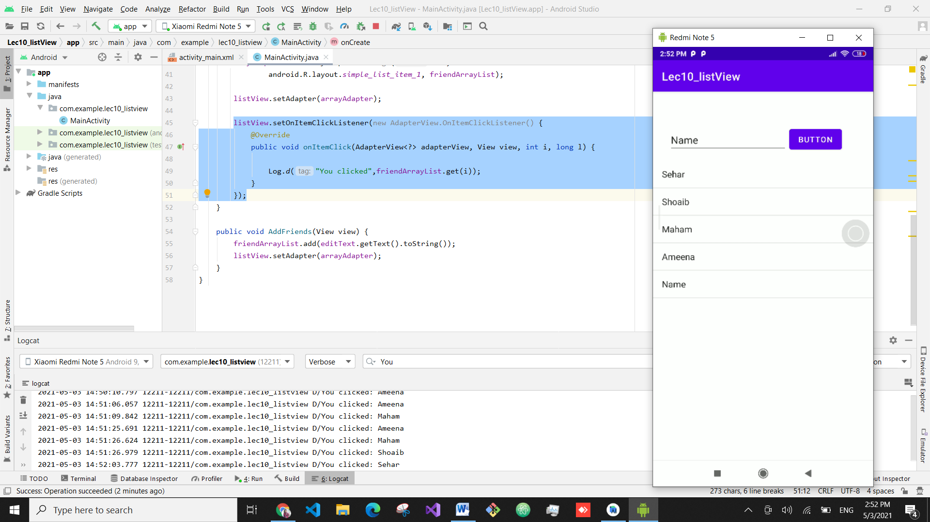

For sorting data:

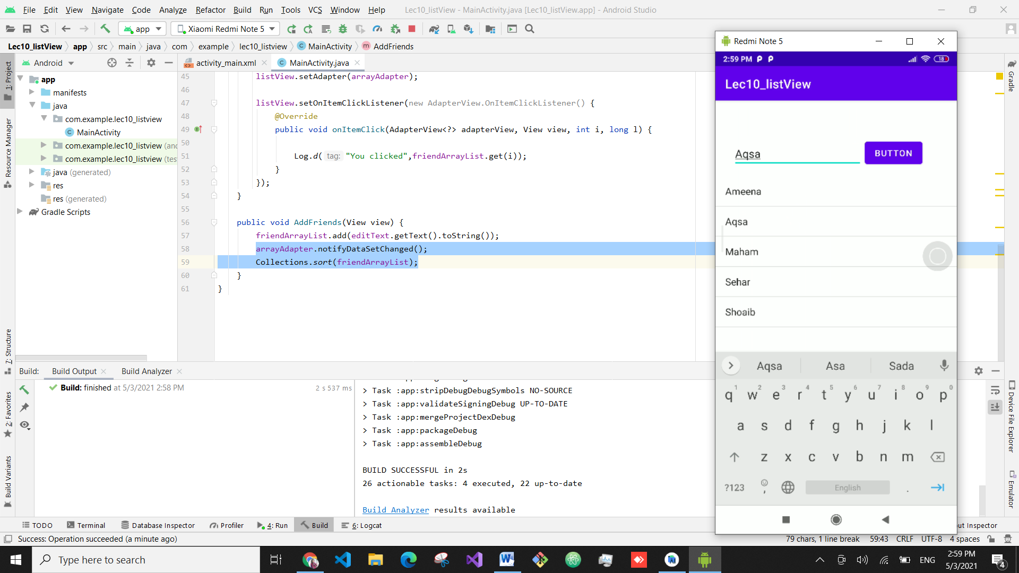

To move data from one activity to other

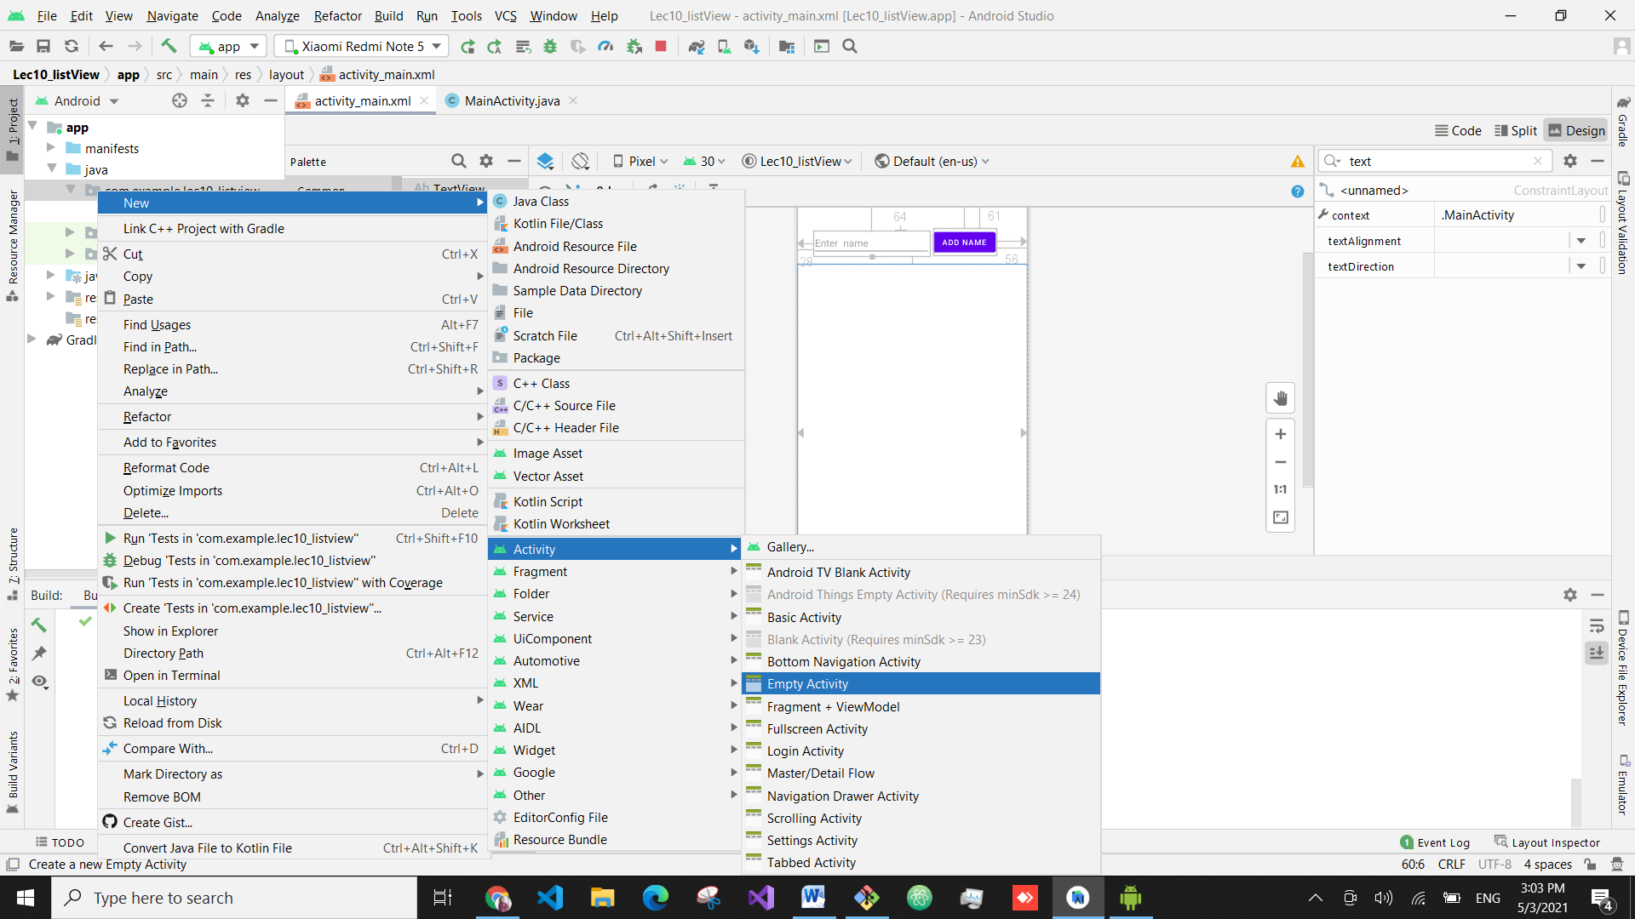

Then we have added a textview in this.

And when we enter on name it will move us to detailed activity

