**Lec: Animation 1**

**Name: Saher Hassan**

**Roll No: Mcsf19a022**

1. Adding video and media controls using code.

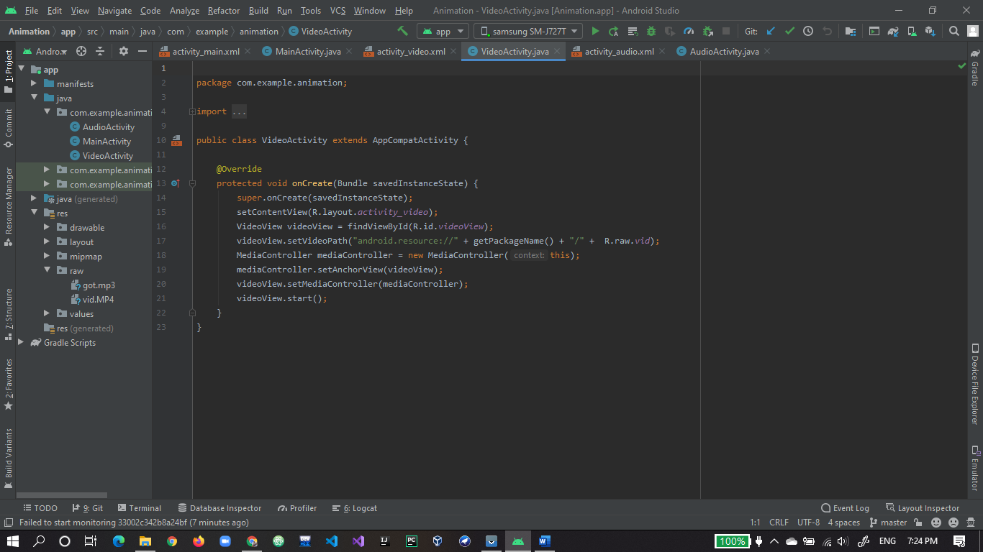

1. Video widget on xml.

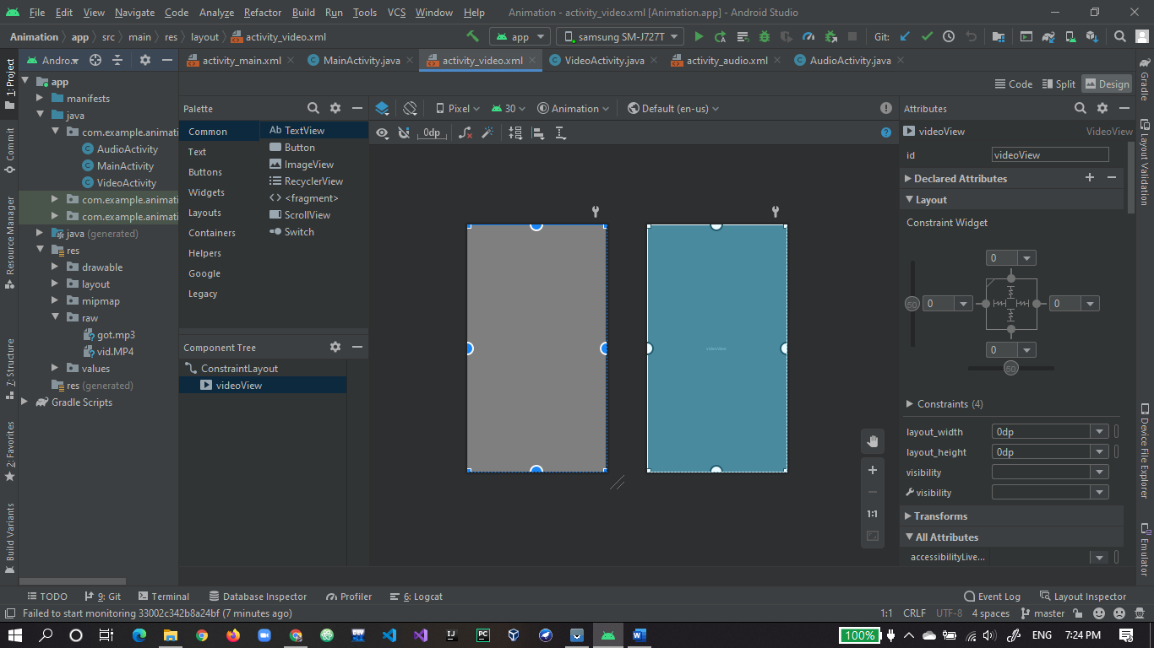

1. Video is working fine.

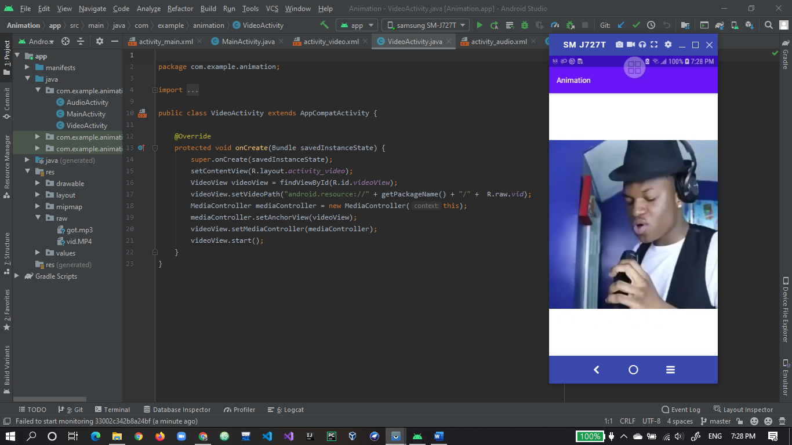

1. Media controller also working fine.

