**Lec: Animation 2**

**Name: Sehar Hassan**

**Roll No: Mcsf19a022**

1. Code to add audio and to start and pause the audio.

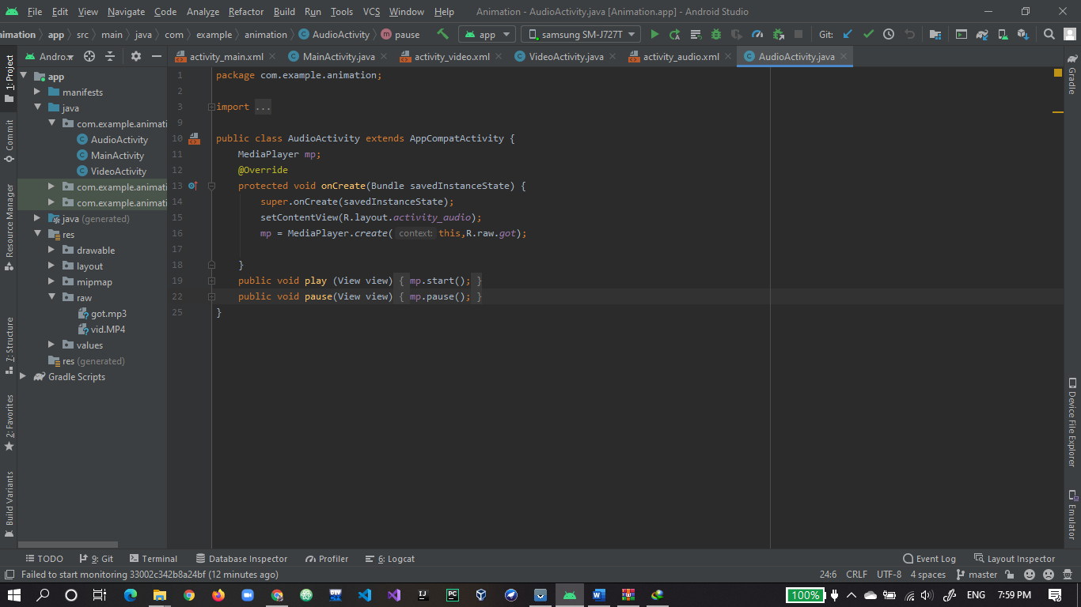

1. two buttons on xml to run and stop the audio.

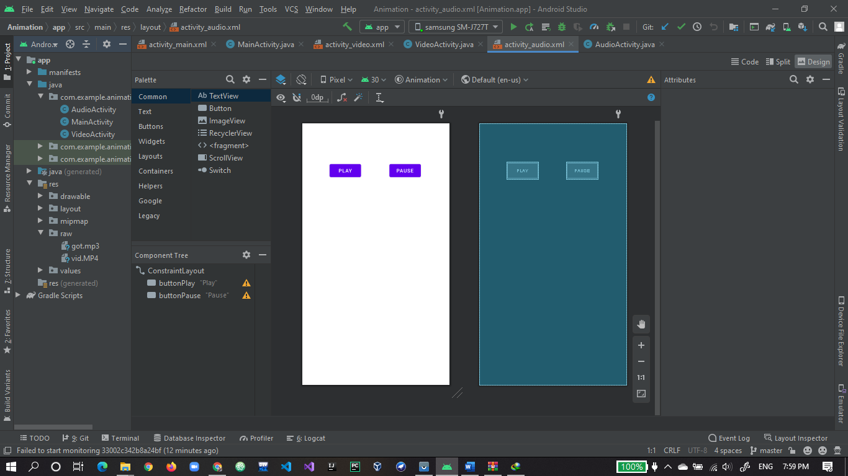

1. app is running and audio play on click of play button and pause on click of pause button.

