**Lec: Animation 1**

**Name: Saher Hassan**

**Roll No: Mcsf19a022**

1. Code to manipulate the picture.

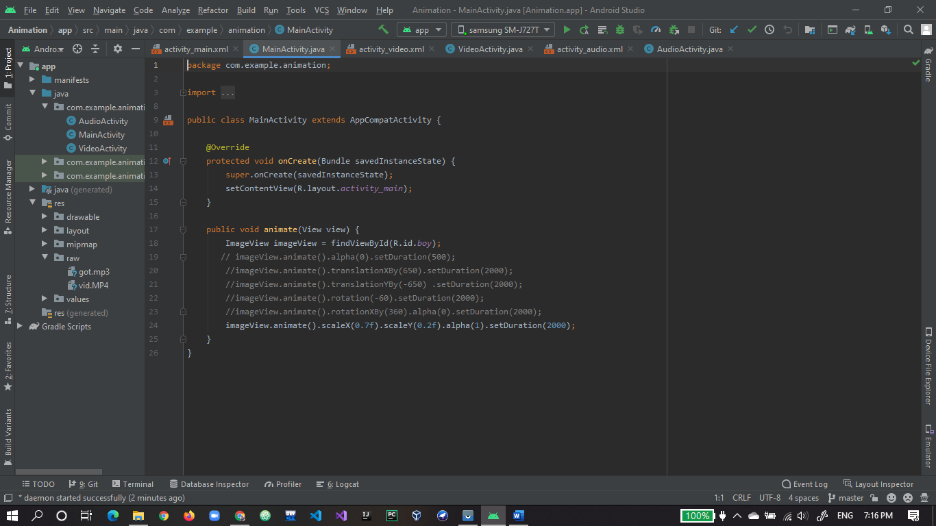

1. Xml of animation project.

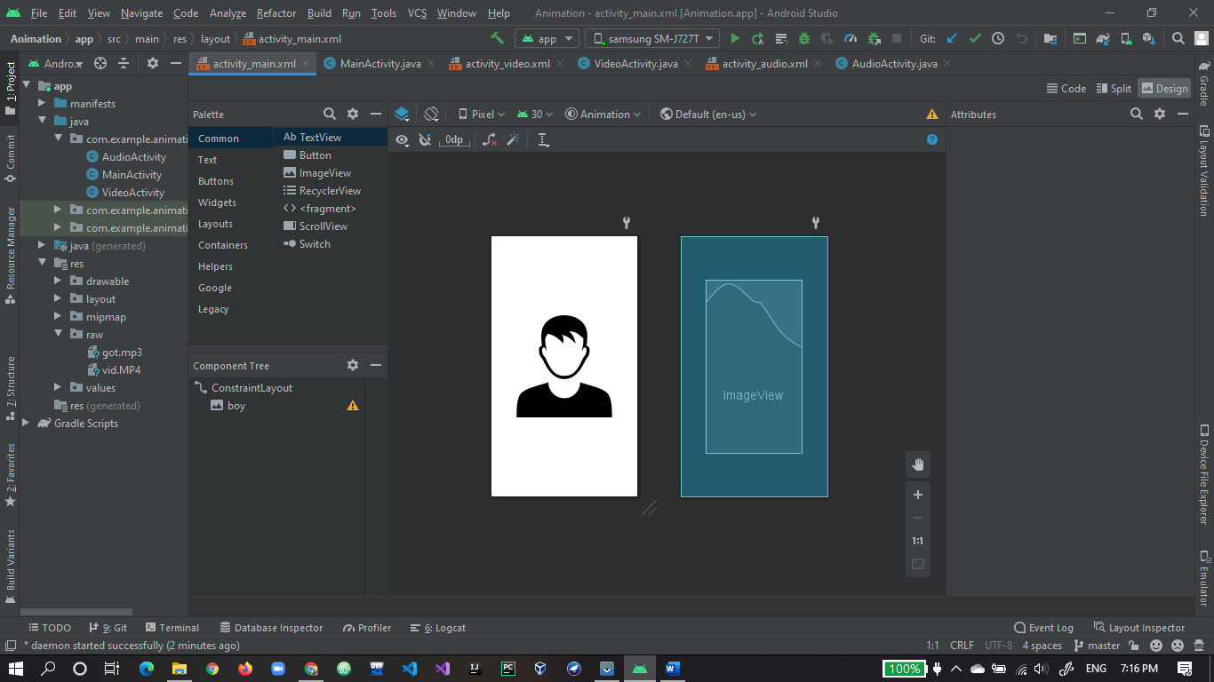

1. App run first time output.

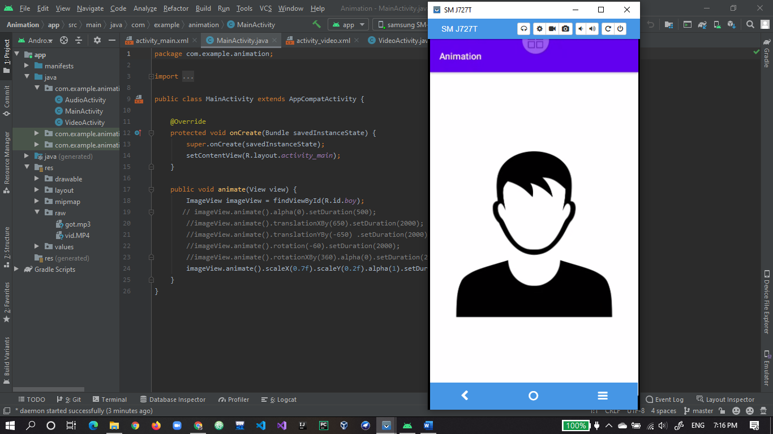

1. After clicking on picture animation code works fine.

