**Lec:** ArrayList 3

**Name:** Saher Hassan

**Roll No:** Mcsf19a022

1. Seekbar code to show table of seekbar index.

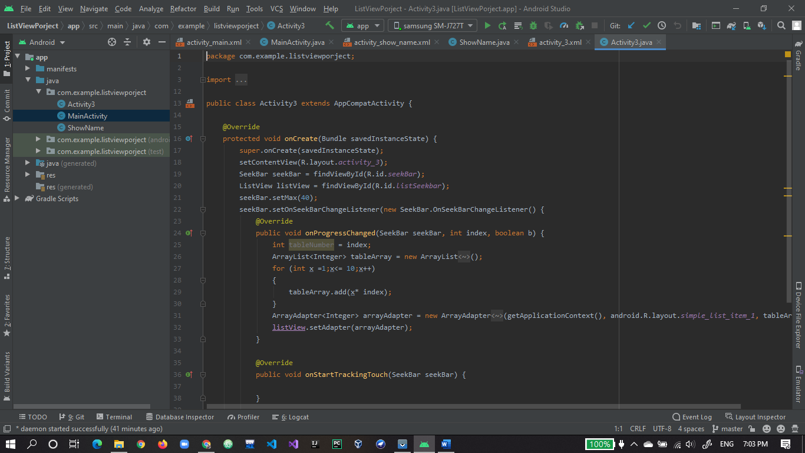

1. Seekbar xml design.

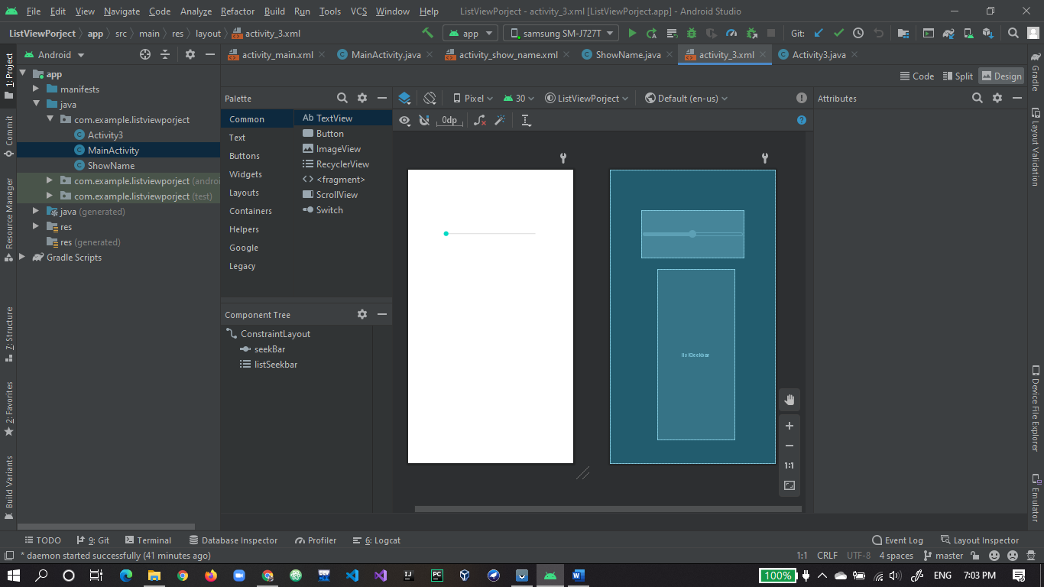

1. First run of app seekbar is shown on screen.

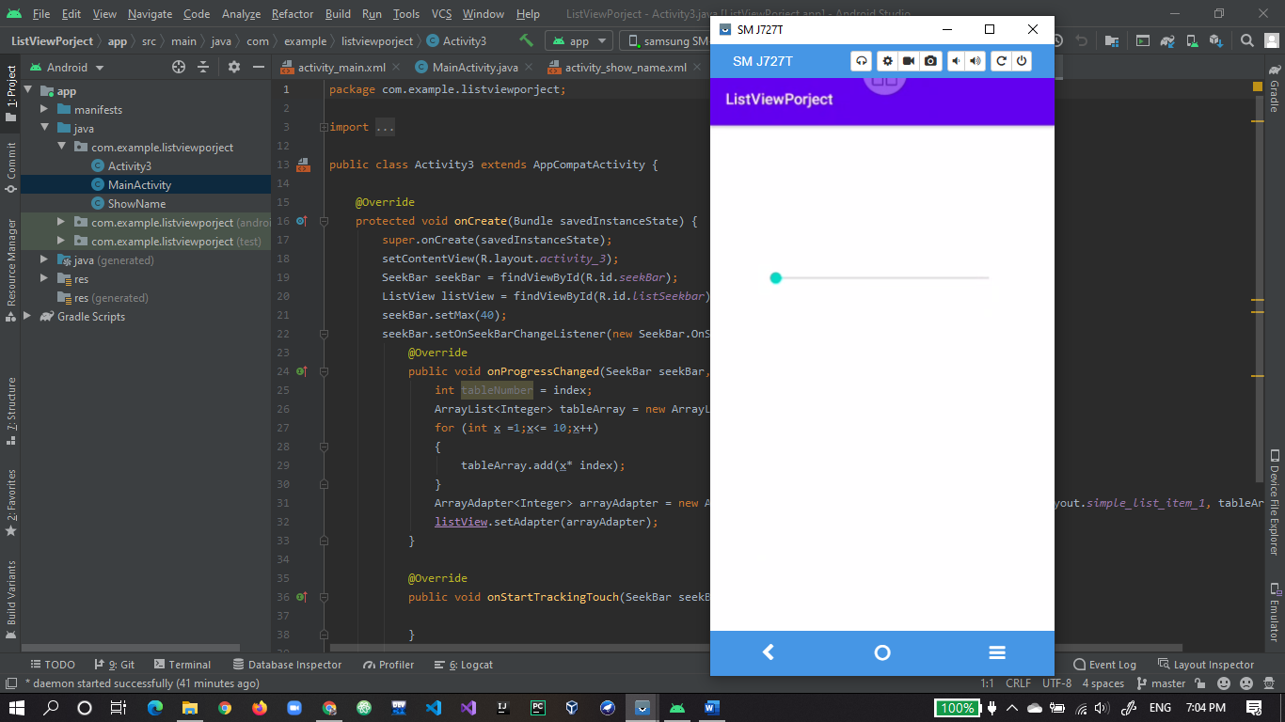

1. Seekbar increasing and making table below in listview.

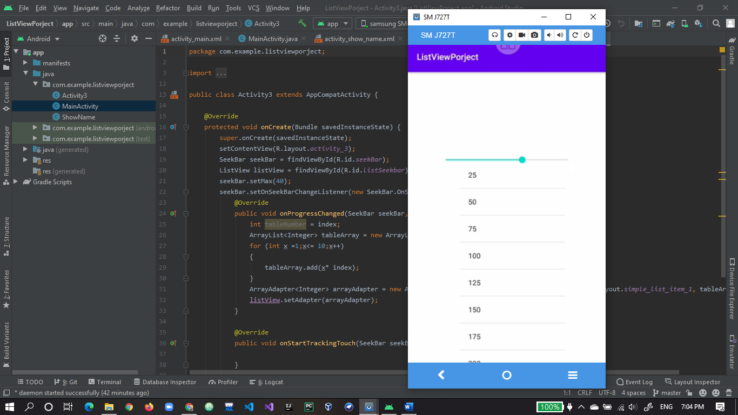

1. Seekbar decreasing and making table below.

