**To-do task 2**

**Name:** Sahar Hassan

**Roll No:** Mcsf19a022

1. **Create empty project.** 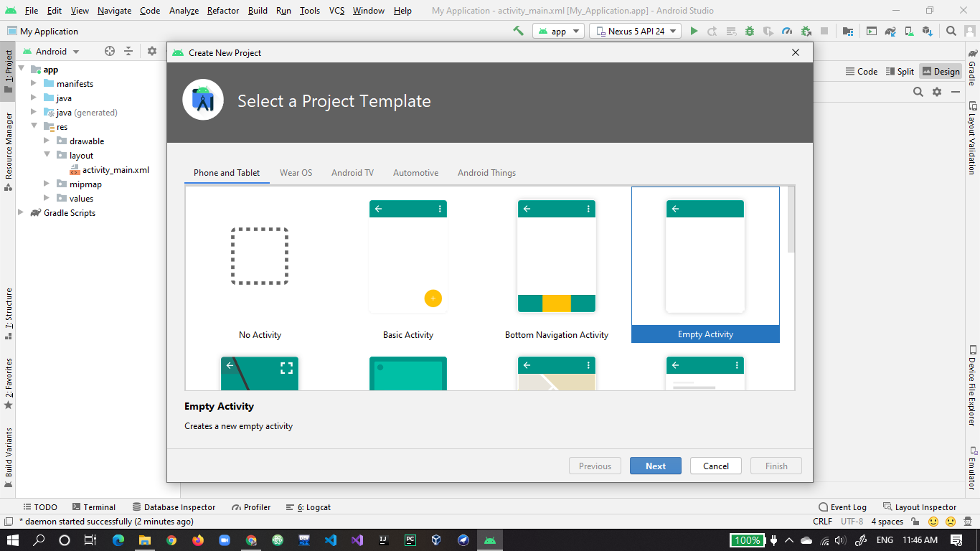
2. **Name the project.** 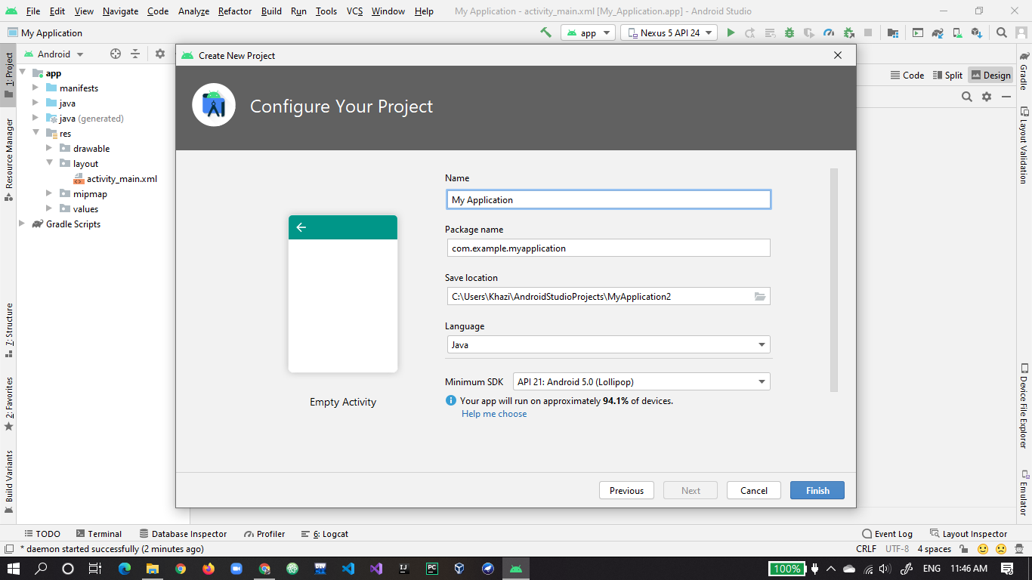
3. **Project is started.** 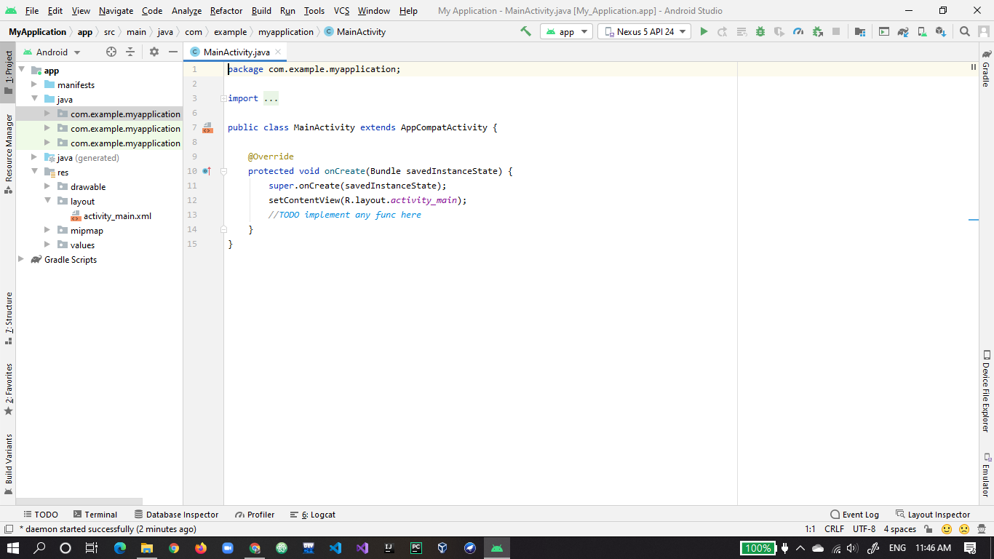
4. **First screen with only one textbox.** 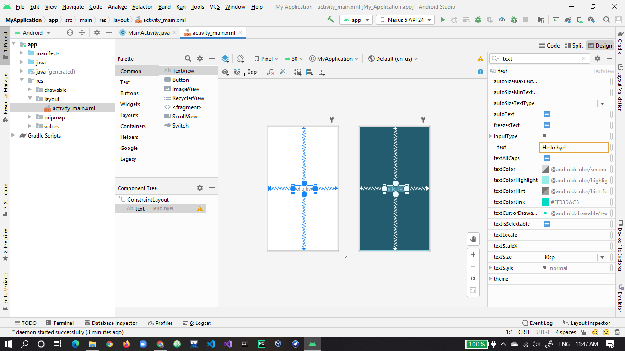
5. **Second screen with two textbox.** 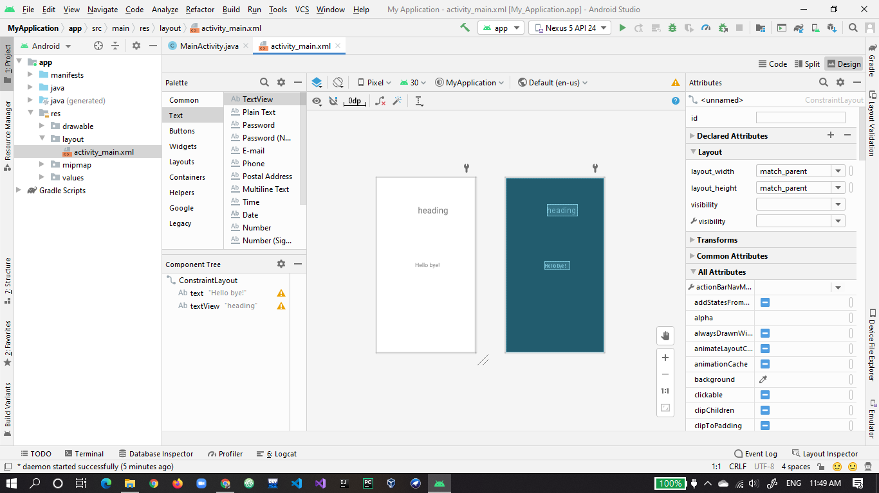
6. **Third screen with three textbox.**

