DEVIXO SOLUTIONS
Web Development Internship Program
Professional Personal Portfolio Website
Project Report
Student Name | Sehar Fatima
Internship Domain | Web Development
Task Number | Task 01
Technologies | HTML5, CSS3
GitHub Repository | https://github.com/seharfatima433/portfolio-website
Submission Date | 11 October 2026

1. Objective
The objective of this task is to design and develop a modern, professional and fully responsive personal portfolio website using only HTML5 and CSS3. The website presents my profile, technical skills, education, projects and contact information through a clean and attractive interface, and demonstrates my understanding of layouts, responsive design, navigation, animations and UI design.

2. Problem Statement
A resume is a flat document and cannot show how a developer designs and builds for the web. Employers and clients need one place where they can quickly see who the developer is, what skills they have, what they have built, and how to contact them. This website had to solve that problem under three conditions: it must work on every screen size, it must be easy to navigate, and it must be written entirely by hand with no CSS framework or downloaded template, so that it truly shows my own HTML and CSS skills.

3. Technologies Used
Technology | How it was used
HTML5 | Page structure using semantic tags: header, nav, main, section, article, figure, dl and footer.
CSS3 | All styling: CSS variables, Flexbox, Grid, media queries, transitions, keyframe animation, blend modes.
Google Fonts | Instrument Serif for headings and Manrope for body text, with fallback fonts.
VS Code + Live Server | Writing the code and previewing changes instantly.
Chrome DevTools | Testing desktop, tablet and mobile layouts.
Git and GitHub | Version control and hosting the repository.
No Bootstrap, Tailwind CSS, UI framework, website template or JavaScript was used.

4. Website Structure
The project is kept in one clean folder:
portfolio-website/
index.html website structure
style.css all styling
README.md project documentation
images/ profile photo, about image, project thumbnails
screenshots/ desktop, mobile and code screenshots
report/ this PDF report

The website is a single page with a sticky navigation bar and six sections, followed by a footer:
- Home: name, tagline, short introduction, call-to-action buttons and profile photo.
- About: personal introduction, academic background, career interests and statistics.
- Skills: skill cards grouped by area.
- Education: degree, university, completion date, achievements and certification.
- Projects: three project cards with thumbnail, description, technologies and live link.
- Contact: email, phone, location, social links and a contact form.
- Footer: name, quick links, social links and copyright.

5. Design Approach
I wanted the website to feel warm, personal and professional rather than a typical template. I took the visual style of my existing personal portfolio and rebuilt it from scratch in plain HTML and CSS.
- Colour theme: cream background (#F9F4EC), deep maroon (#44141E) for text and buttons, rose (#E4748A) for highlights and tan (#E6D0B2) for soft shapes. All colours are CSS variables, so the theme stays consistent and is easy to change.
- Typography: a tall serif (Instrument Serif) for large headings with italic rose words for emphasis, and a clean sans-serif (Manrope) for readable body text.
- Components: thick maroon outlines with a hard offset shadow on buttons, navigation and cards. On hover they move slightly toward the shadow, which gives a pressed effect.
- Layout: CSS Grid for page sections and card grids, Flexbox for the header, footer and small components, and generous, consistent spacing.
- Visual hierarchy: large display headings, small uppercase labels above them, and short paragraphs.
- Accessibility: strong text contrast, visible keyboard focus outlines, alt/aria labels on images and icons, and animations switched off for users who prefer reduced motion.

6. Website Features
- Sticky navigation bar with links to all sections and smooth scrolling.
- Mobile menu built with a CSS-only checkbox toggle (no JavaScript).
- Hero section with name, tagline, introduction, buttons and photo card with floating technology tiles.
- Skill cards, education cards and professional project cards with consistent styling.
- Contact form UI with name, email, subject, message and submit button (no backend needed).
- Hover animations on buttons, navigation links, cards and social icons.
- Fully responsive layout for desktop, laptop, tablet and mobile without horizontal scrolling.
- Semantic HTML, meaningful class names and a commented, cleanly formatted code base.

7. Implementation Steps
- Installed VS Code and the Live Server extension and created the project folder with index.html, style.css and an images folder.
- Collected the real content: personal details, skills, education, project descriptions, live links, photo and project screenshots.
- Wrote the HTML structure using semantic tags: header with navigation, a main element with six sections, and a footer.
- Defined the colour theme, fonts and shadow as CSS variables and added a basic reset in style.css.
- Styled the header and navigation bar, then the hero section using CSS Grid.
- Built the About, Skills, Education, Projects and Contact sections with a shared card style.
- Added smooth scrolling and hover animations using transition and transform.
- Made the site responsive with media queries for laptop, tablet and mobile, including a CSS-only mobile menu.
- Tested every navigation link and every screen size in Chrome DevTools and fixed layout problems.
- Added comments to the code, wrote the README, took screenshots and uploaded everything to GitHub.

8. Code Screenshots
Figure 1: HTML structure (semantic tags)
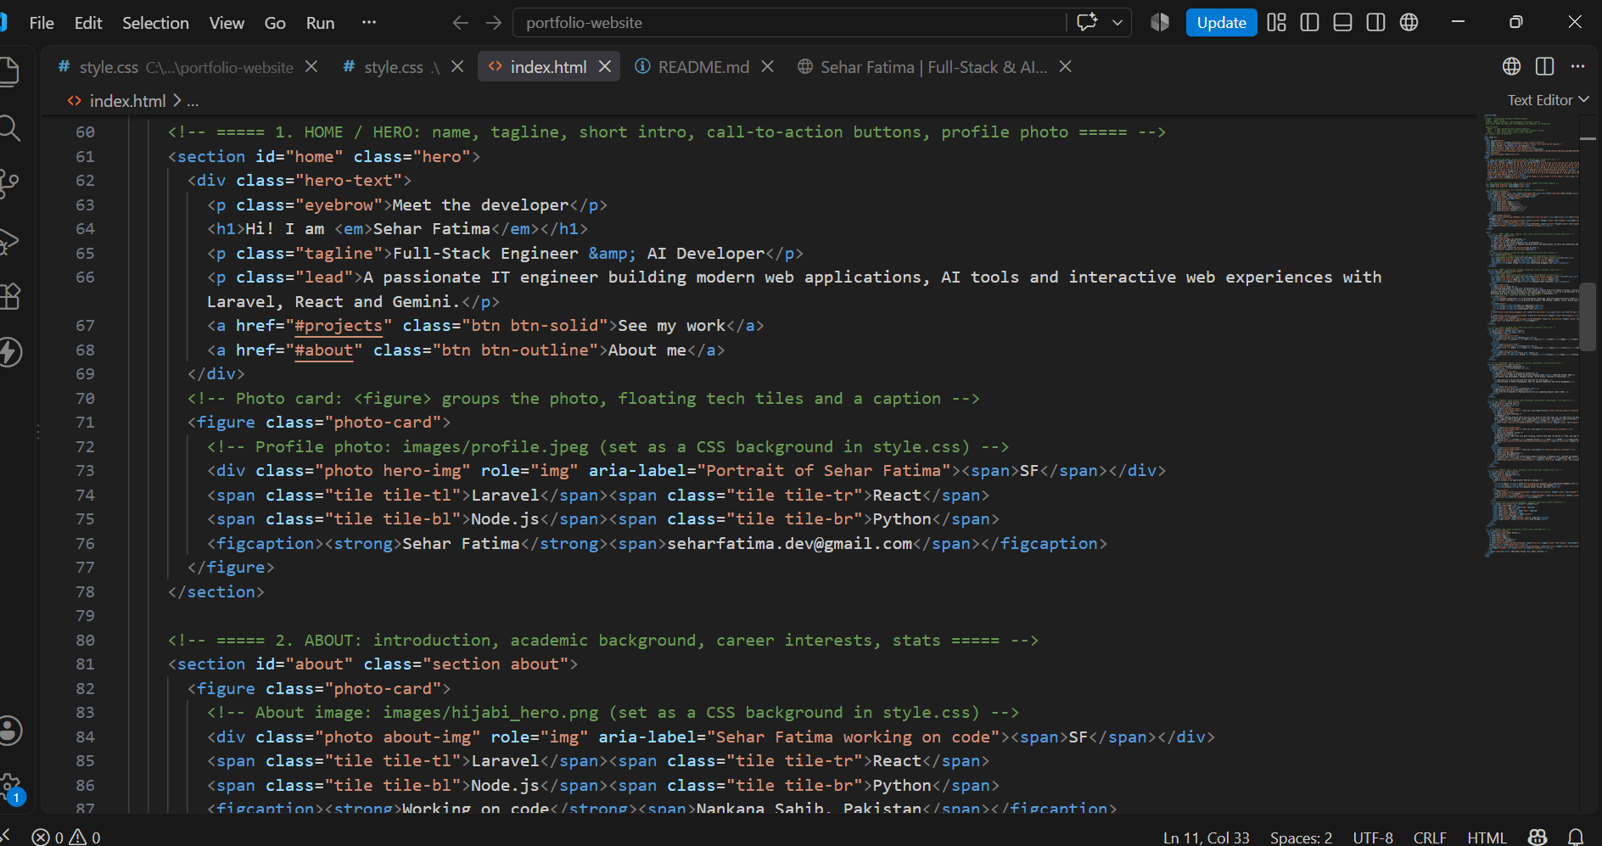The HTML is built with semantic tags. The header holds the logo and navigation, main holds one section per topic (each with an id so the navigation links can jump to it), and footer closes the page. Using these tags makes the structure clear to browsers and screen readers.
Figure 2: CSS variables and reset
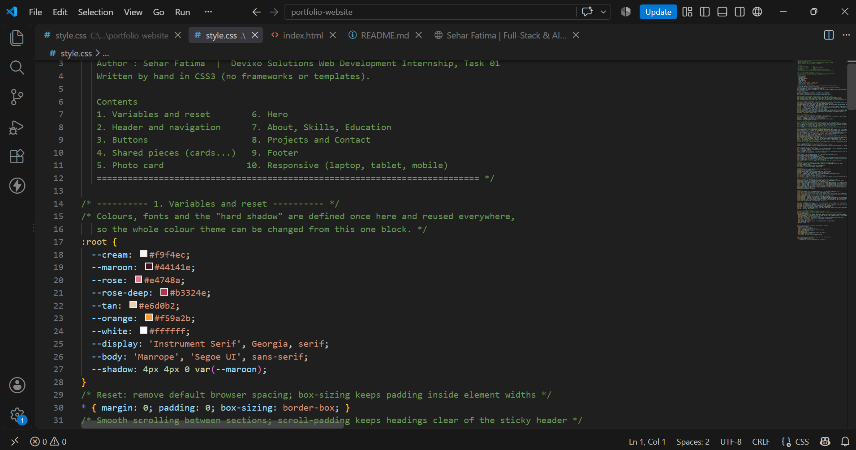The colour theme, fonts and shadow are stored as CSS variables in :root. Every component uses these variables, so the design stays consistent and a colour can be changed in one place. The reset removes default browser spacing and sets box-sizing so widths are predictable.
Figure 3: Card grid layout
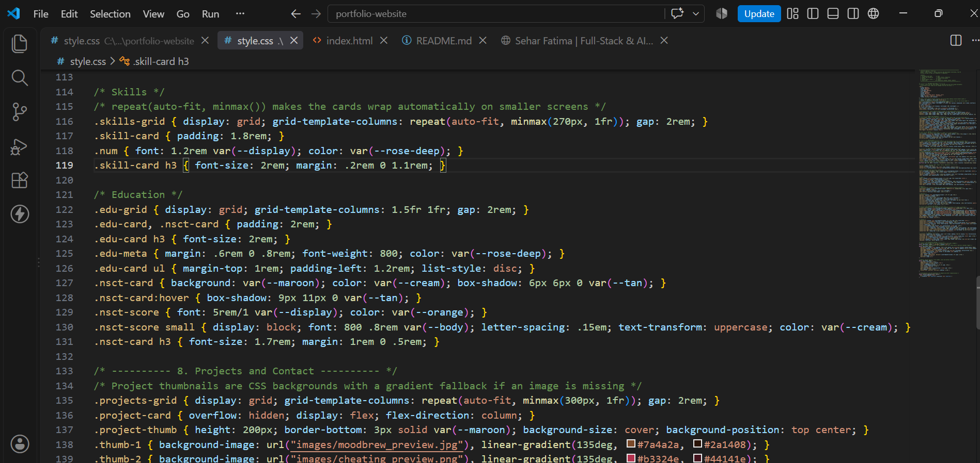 The skills and project cards use CSS Grid with repeat(auto-fit, minmax()). The columns wrap automatically as the screen gets narrower, so the cards stay responsive without extra code. Both grids follow the same pattern, which keeps the layout consistent across sections.
Figure 4: Media queries for responsive design
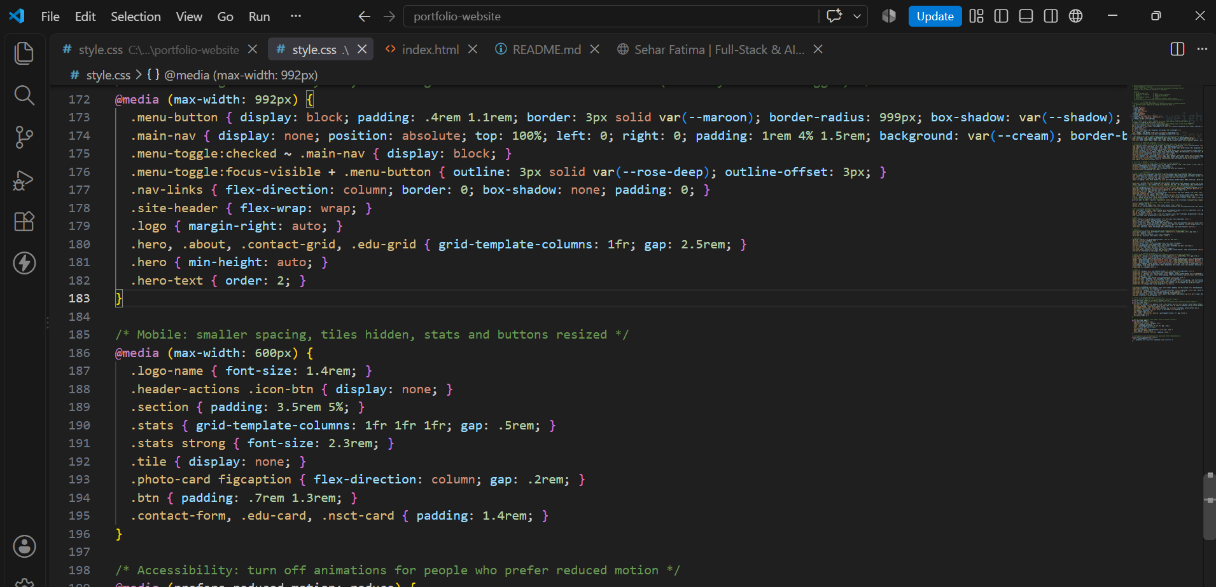 Media queries at 992px and 600px adapt the layout for tablet and mobile. On tablet the grids become single columns and the navigation turns into a Menu button that opens with a CSS-only checkbox. On mobile the spacing is reduced, the floating tiles are hidden and the buttons are resized. An extra rule at 1280px hides the email button on laptops so the navigation bar does not get cramped.

9. Output / Result Screenshots

9.1 Desktop View
Figure 5: Home / Hero section
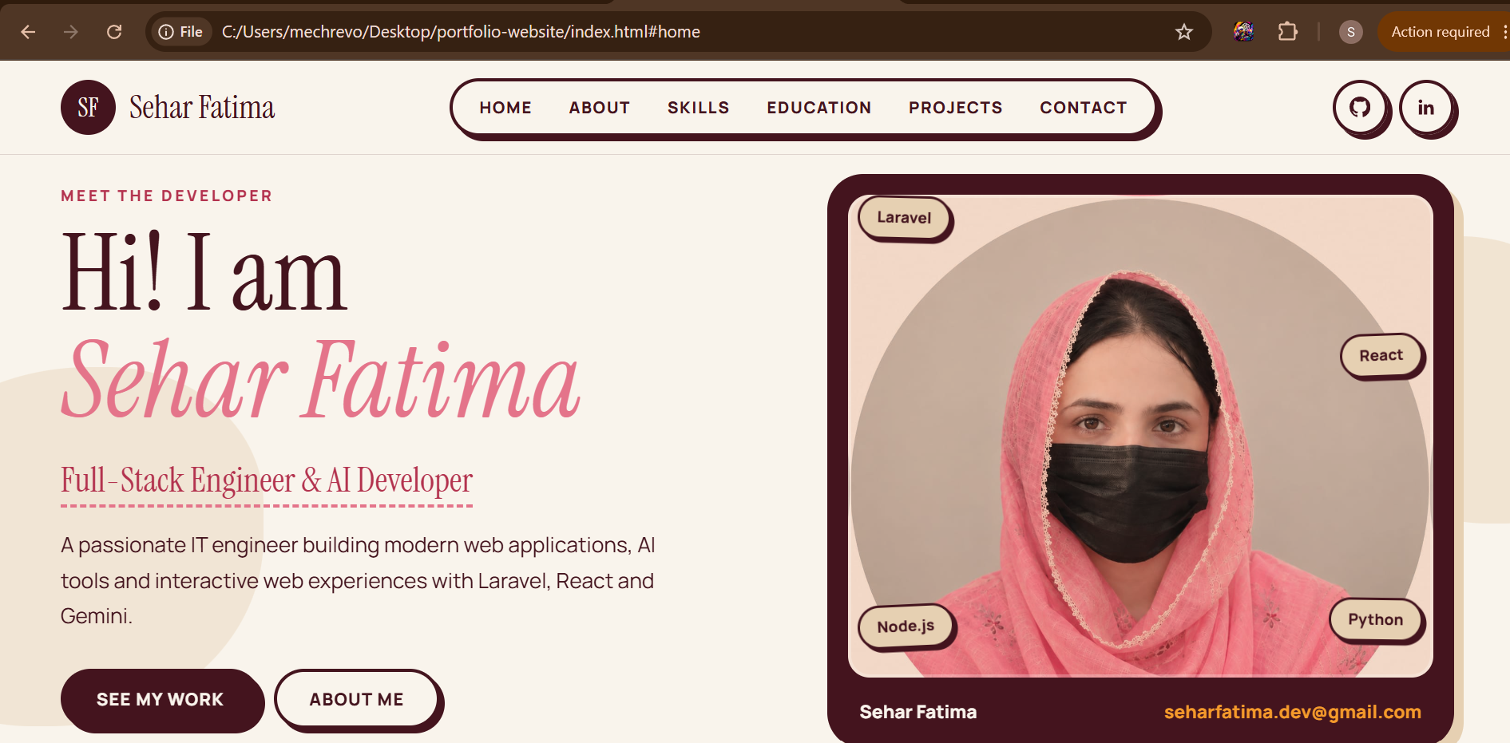
The hero section shows my name, tagline, a short introduction, two call-to-action buttons and my photo card. The navigation bar stays fixed at the top.
Figure 6: About section
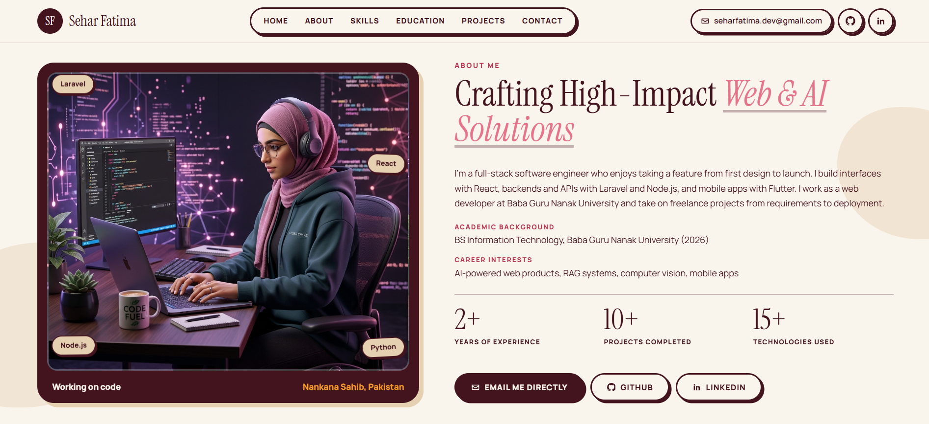The About section contains my introduction, academic background, career interests, three statistics, and buttons for email, GitHub and LinkedIn.
Figure 7: Skills section
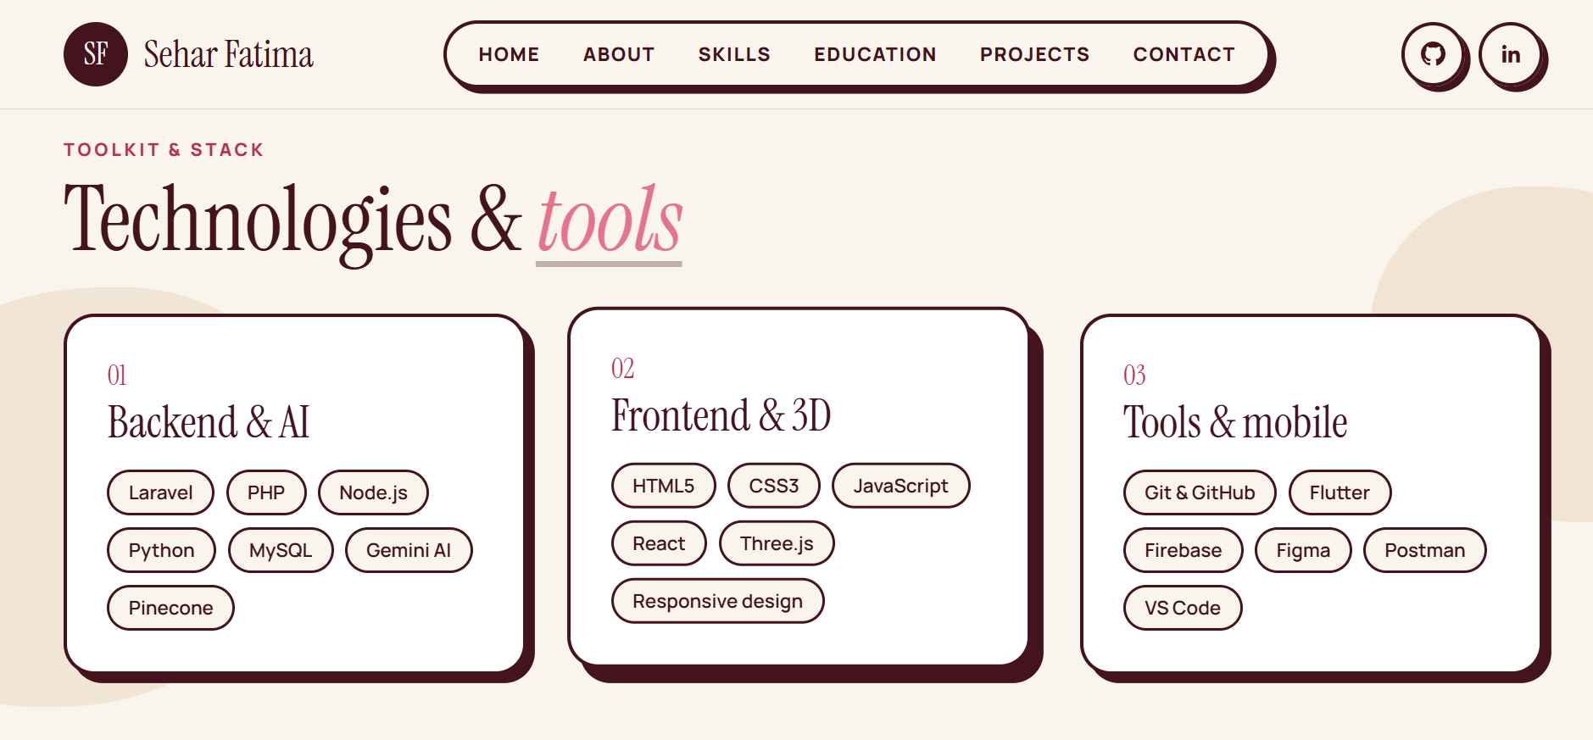Skills are grouped into three cards (Backend & AI, Frontend & 3D, Tools & mobile). Each skill is shown as a rounded tag.
Figure 8: Education section
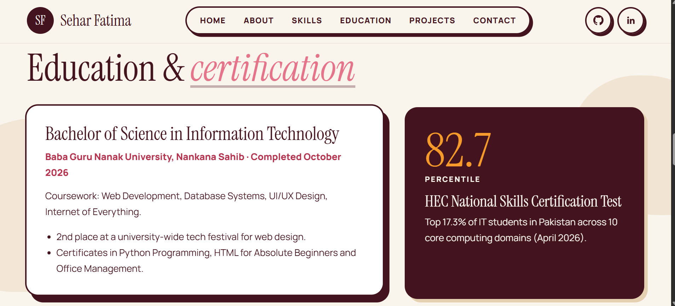The Education section shows my BS Information Technology degree, university, completion date and achievements, next to a card for the HEC National Skills Certification Test result.
Figure 9: Projects section
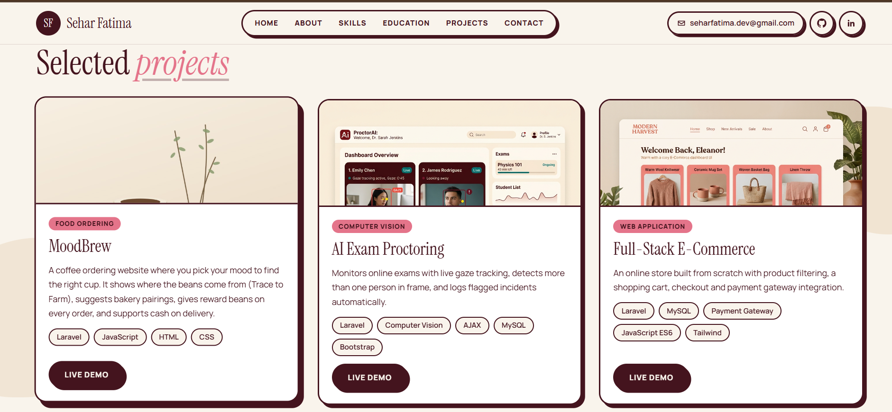Three project cards (MoodBrew, AI Exam Proctoring and Full-Stack E-Commerce) each show a thumbnail, short description, technologies used and a Live demo button.
Figure 10: Contact section
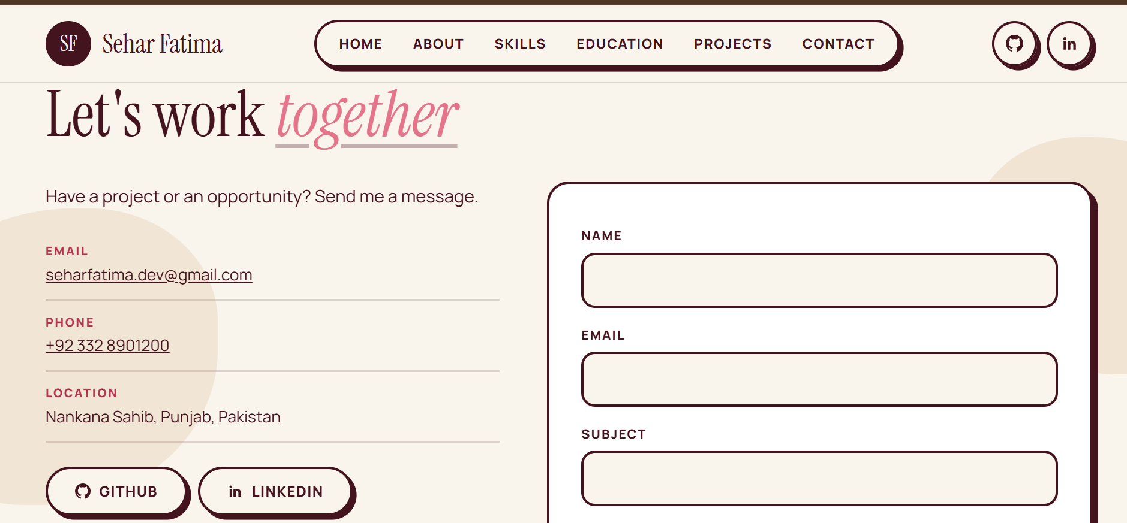
The Contact section lists my email, phone, location and social links, and includes a contact form with name, email, subject and message fields.
Figure 11: Footer

The footer contains my name, quick navigation links, social icons and the copyright notice.

9.2 Tablet View

Figure 12: Tablet layout
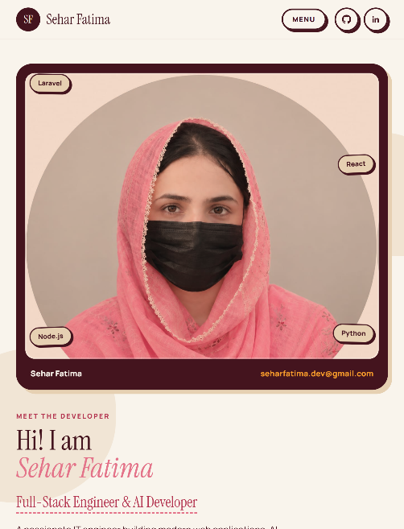
On tablet widths the layout switches to a single column and the navigation collapses into a Menu button.

9.3 Mobile View
Figure 13: Mobile home section
On mobile the hero stacks vertically with the photo first. Text sizes and button sizes adjust, and there is no horizontal scrolling.
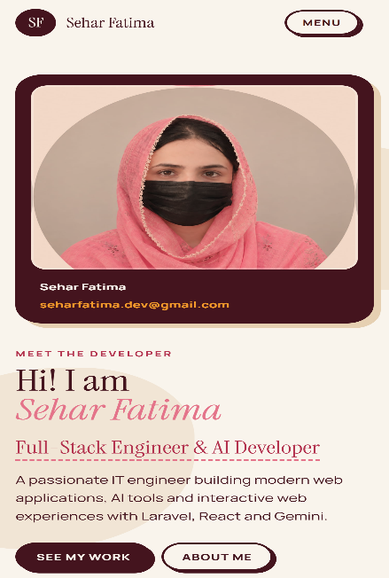
Figure 14: Mobile menu open
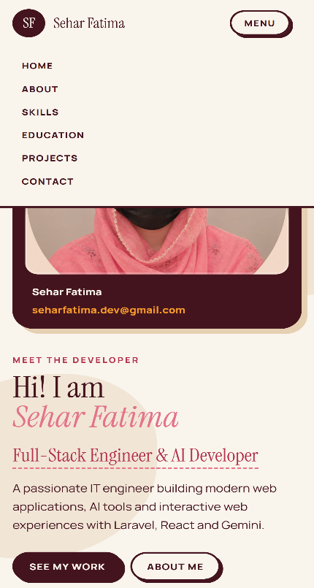
Tapping Menu opens the navigation links in a vertical list. This works with a CSS-only checkbox, without JavaScript.
Figure 15: Mobile projects section
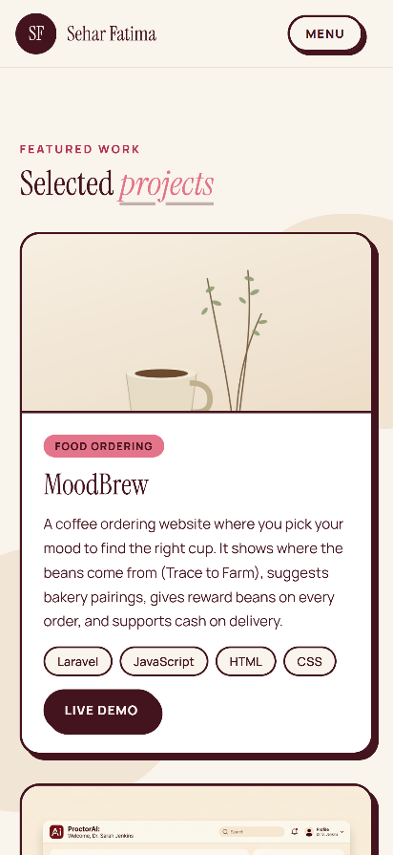
Project cards stack in a single column and keep the same style as on desktop.
Figure 16: Mobile contact section
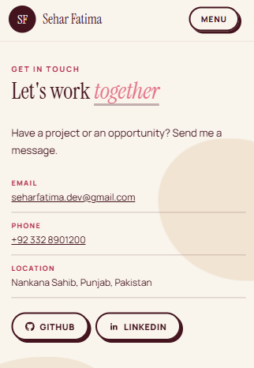
The contact details and the form fit the small screen, with full-width input fields.

9.4 Project Screenshots
The three projects featured in the portfolio, each with a live demo:
- MoodBrew (coffee ordering website): https://devlura.site/MoodBrew/public/
- AI Exam Proctoring: https://devlura.site/web-cheating-detection-main/public/
- Full-Stack E-Commerce: https://devlura.site/E-Commerce/public/

10. Challenges Faced
- Making the navigation fit: with six links, the logo and contact shortcuts in one row, the logo name broke onto two lines on some widths. I fixed it by keeping the name on one line, reducing the link padding and hiding the email button on narrower screens.
- A mobile menu without JavaScript: the task allows only HTML and CSS, so I built the Menu button with a hidden checkbox, a label and the :checked selector.
- Photo background: my profile photo has a white background that looked like a white box inside the dark frame. I solved it with background-blend-mode: multiply and a warm background colour.
- Hero heading wrapping: the long name split awkwardly across lines. Putting the name on its own line with display: block made the heading look balanced.
- Image file paths: images did not appear until the file names in the CSS matched the real file names and extensions exactly (for example .jpg versus .png).
- Responsive testing: I checked each section in DevTools at several widths and adjusted the grid columns and spacing until there was no horizontal scrolling.

11. Conclusion
This task helped me build a complete, professional portfolio website using only HTML5 and CSS3. I practised semantic HTML, CSS variables, Flexbox, Grid, media queries, transitions and a CSS-only mobile menu, and I learned how to organise a project, test it on different screen sizes and publish it with Git and GitHub. The finished website presents my profile, skills, education, projects and contact details clearly and works well on desktop, tablet and mobile. In the future I would like to add a dark mode and connect the contact form to a backend.

12. GitHub Repository Link
https://github.com/seharfatima433/portfolio-website
The repository contains the HTML and CSS source code, images, screenshots, this PDF report and the README.md file.

