GeoMinerAI
AI-Augmented Geological Exploration Workspace

Technical Documentation & Architecture Guide

Version 2.0 | February 2026

1. Executive Summary
GeoMinerAI is a unified, AI-augmented geological exploration workspace built on Streamlit. It replaces a fragmented four-tab interface with a single, integrated workspace containing four persistent panels: a Layer List, a Map Layout output panel, an interactive Live Map, and a natural-language Prompt Box. All analytical capabilities — RAG question-answering, hotspot spatial analysis, Sn-REE prospectivity assessment, machine-learning baselines, depth profiling, geoprocessing (buffer, clip), and geological cross-section construction — are accessible through plain-English commands. No tab switching, no manual mode selection, no algorithm knowledge required from the user.
The flagship capability is the geological cross-section engine: a professional-grade structural geology pipeline that combines an LLM-powered interpretation prompt (covering orientation, true/apparent dip, topographic profile, depth projection, fold and fault interpretation, uncertainty handling, and mineral exploration relevance) with an automated matplotlib schematic figure.

2. What is GeoMinerAI? Agent, Tool, or Both?

2.1 Classification
GeoMinerAI does not fit neatly into either the 'agent' or 'tool' category. It occupies a third position best described as an NLP-driven domain-specific AI co-pilot or an agentic analytical workspace.
As a Tool:
- It is a Streamlit web application with a graphical interface.
- It accepts discrete inputs (files, text commands) and returns discrete outputs (figures, tables, maps, text).
- Users interact with it directly; it does not act autonomously without prompting.
As an Agent (partially):
- It interprets natural language commands and autonomously selects the appropriate analysis pipeline.
- It orchestrates multiple sub-tasks (file ingestion, embedding, retrieval, computation, visualisation) in sequence without step-by-step user guidance.
- It maintains conversational and spatial state across interactions (session memory, drawn features, layer registry).
- It routes to specialised tools — hotspot, cross-section, buffer, clip, RAG QA — based on intent, analogous to tool-use in LLM agents.
However, GeoMinerAI does NOT exhibit full agentic behaviour: it does not plan multi-step tasks autonomously (no ReAct loop, no chain-of-thought planning, no self-correction). Its intent routing is deterministic keyword/regex-based, not LLM-planned. The LLM is called only for generation (cross-section text, QA answers, narrative), not for reasoning about which tools to invoke.
Formal Classification:
- Primary: NLP-routed analytical tool with agentic UI behaviour
- Secondary: Domain-specific AI co-pilot for mineral exploration geology
- Pattern: Tool orchestrator with natural-language command interface

2.2 Domain Context
GeoMinerAI is designed for mineral exploration geologists, specifically those working with granite-related Sn-Nb-Ta-REE systems (with the Jos Plateau Younger Granites, Nigeria as the primary reference dataset). Its analytical capabilities reflect the real exploration workflow: from raw XRF geochemical data through spatial analysis, prospectivity screening, drill-hole profiling, and structural interpretation.

3. System Architecture
GeoMinerAI is organised as a five-layer architecture. Each layer has a single responsibility and communicates with adjacent layers only. Figure 1 illustrates the full stack.
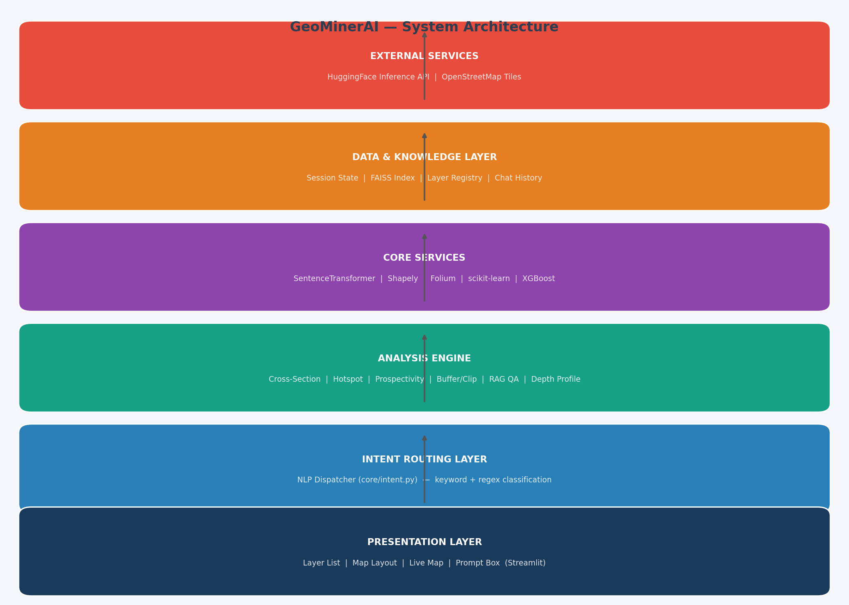
Figure 1: GeoMinerAI System Architecture

Layer | Name | Key Components | File(s)
5 (top) | Presentation | 4 Streamlit panels: Layer List, Map Layout, Live Map, Prompt Box | app.py
4 | Intent Routing | NLP dispatcher: keyword + regex classification | core/intent.py
3 | Analysis Engine | 7 handlers: cross_section, hotspot, prospectivity, buffer, clip, depth_profile, qa | app.py (handlers)
2 | Core Services | RAG, FAISS, SentenceTransformer, Shapely, Folium, scikit-learn, matplotlib | core/*.py
1 | Data/Knowledge | Session state, layer registry, FAISS index, chat history, drawn features | app.py (session state)
0 (ext) | External | HuggingFace Inference API, OpenStreetMap tile servers | core/llm_hf.py

4. Core Modules
GeoMinerAI is composed of ten core Python modules, four of which were created in this version:
Module | File | Purpose | New?
Multi-format Ingester | core/geo_ingest.py | Ingests PDF, Word, CSV, GeoJSON, KML, images, rasters, plain text into a unified layer dict | YES
Intent Classifier | core/intent.py | Keyword/regex NLP dispatcher; returns (intent, metadata) tuple | YES
Cross-Section Engine | core/cross_section.py | LLM prompt builder + matplotlib geological cross-section figure generator | YES
Geoprocessor | core/geoprocessing.py | Buffer (Shapely or degree fallback), clip points to polygon, centroid, haversine distance | YES
RAG System | core/rag.py | PDF chunking, FAISS index build, semantic retrieval (all-MiniLM-L6-v2)
LLM Interface | core/llm_hf.py | HuggingFace InferenceClient wrapper: text_generation + chat_completion with fallback
Hotspot Analyzer | core/snree_hotspots.py | Getis-Ord Gi*, Local Moran's I, grid-binning; KNN spatial weight matrix
ML Engine | core/snree_ml.py | Logistic Regression + Random Forest baselines; within-hole depth trend
Chemistry Engine | core/chemistry.py | Element-to-oxide conversion; column standardisation
Lab Orchestrator | core/snree_lab.py | Sn-REE prospectivity pipeline: XRF summary, FracProxy, quick screening

5. Data Flow
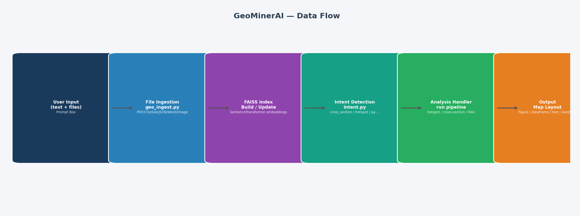
Figure 2: End-to-end data flow through GeoMinerAI
The six-stage data flow is as follows:
User Input: The user types a natural-language command and/or uploads files via the Prompt Box.
File Ingestion: geo_ingest.ingest_file() routes each file by extension to the appropriate parser (PDF: pypdf; Word: python-docx; CSV: pandas; GeoJSON: json; Image: Pillow; Raster: rasterio). Each file becomes a layer dict containing: name, type, chunks (text), dataframe, geodata, image, metadata, raw_bytes.
Index Build: build_index_from_layers() encodes all text chunks using SentenceTransformer (all-MiniLM-L6-v2) and inserts embeddings into a FAISS IndexFlatIP. This index is rebuilt incrementally as new layers are added.
Intent Detection: detect_intent(text) scans the command string for keywords and regex patterns, returning a (intent_name, metadata_dict) tuple. No LLM is called at this stage.
Handler Execution: The dispatcher calls the appropriate handler function. Each handler runs its pipeline (spatial stats, ML, LLM generation, geometry operations) and calls _push_output() to store results in session state.
Output Rendering: On the next Streamlit rerun, the Map Layout panel renders all output cards (text, matplotlib figure, dataframe, GeoJSON) in reverse chronological order with download buttons.

6. UI Layout and Panel Design
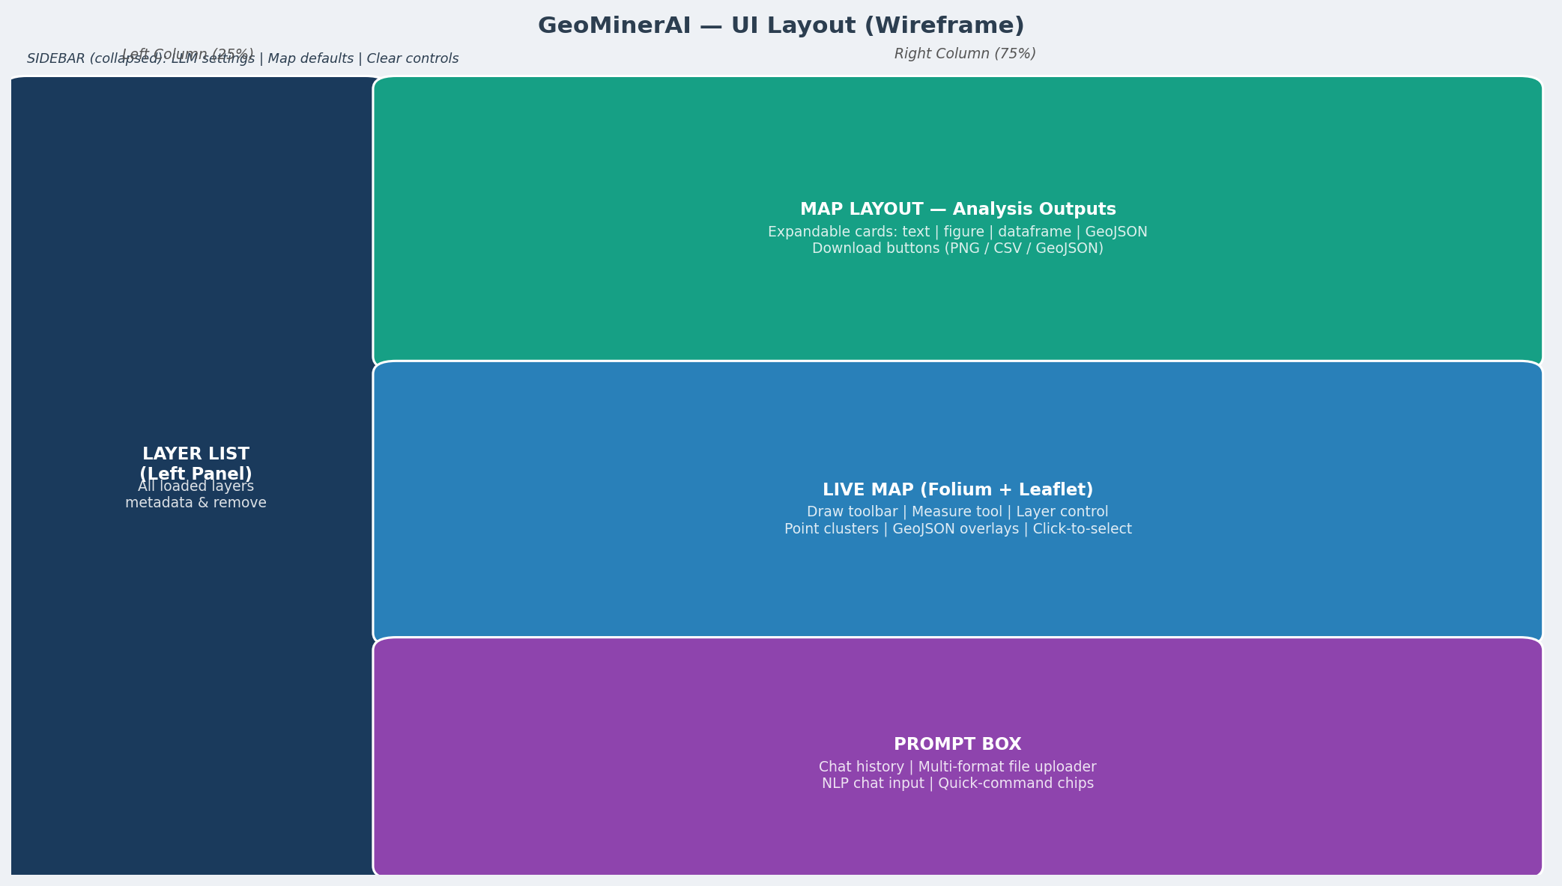
Figure 3: GeoMinerAI single-workspace UI layout

6.1 Layer List (Left Panel, 25%)
Displays every layer currently in memory. For each layer, the panel shows: file type icon, name, type, size (KB), column names (CSV), row count, spatial flag (lat/lon present), GeoJSON feature count, CRS (rasters), and any metadata notes. A Remove button purges the layer from memory and rebuilds the FAISS index. A live chunk count shows the current state of the knowledge base.

6.2 Map Layout (Upper Right, 75% wide)
The primary output surface. Every analysis result is pushed here as an expandable card sorted newest-first. Each card shows its timestamp and title, and contains one of: rendered Markdown text, a matplotlib figure (with PNG download), a scrollable dataframe (with CSV download), or a GeoJSON viewer (with .geojson download). The first card is always expanded automatically.

6.3 Live Map (Centre Right)
An interactive Folium/Leaflet map rendered via streamlit-folium. Features:
- Draw toolbar (top-left): polyline, polygon, rectangle, marker
- Measure tool: distances in metres/kilometres
- Mouse position display (bottom-left)
- CSV point layers rendered as CircleMarkers, coloured by hotspot cluster (red=hot, blue=cold, orange=medium, grey=neutral)
- GeoJSON layers overlaid with purple fill
- Layer control for toggling visibility
- Save drawings to Layer List button (persists drawn geometry as a GeoJSON layer)
- Click-to-select nearest data point with toast notification

6.4 Prompt Box (Lower Right)
The primary interaction surface. Contains: a scrolling chat history (last 8 messages), a multi-format file uploader accepting 18 file extensions, four quick-command chips (Hotspot, Cross-Section, Prospectivity, Buffer 500m), and a persistent chat input field. File uploads are processed immediately on submit; text commands are routed through the intent classifier.

7. NLP Intent Routing
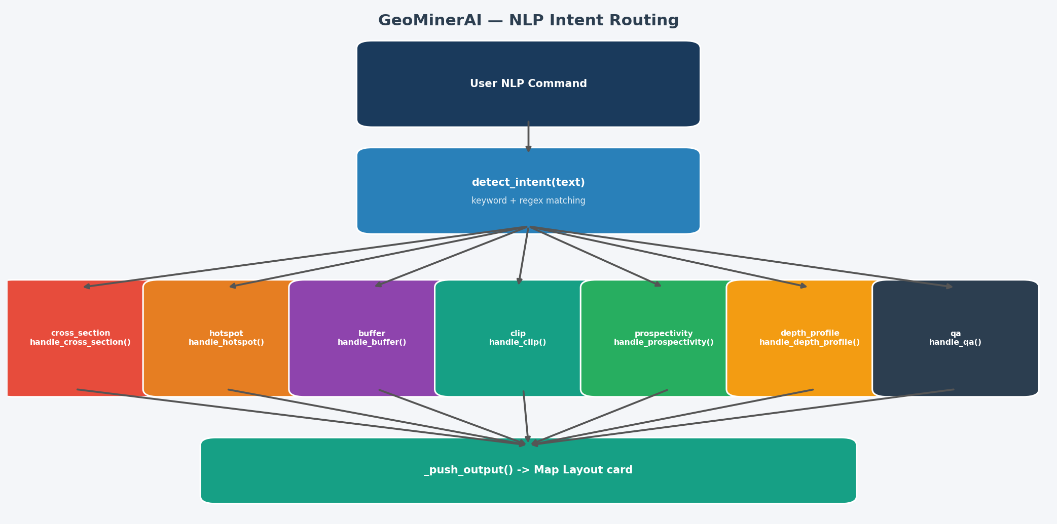
Figure 4: Intent detection and handler dispatch
The intent router (core/intent.py) is a lightweight, deterministic classifier that avoids LLM calls for routing decisions, keeping latency low. It operates on a priority-ordered keyword list:
Intent | Trigger Keywords (examples) | Handler | Extra metadata extracted
cross_section | cross section, section line, draw section, A to A | handle_cross_section() | section_label, section_length_m
hotspot | hotspot, Gi*, Moran, anomaly, clustering | handle_hotspot() | method (Gi*/Moran/Grid), variable
buffer | buffer, zone around, distance from, expand polygon | handle_buffer() | distance_m
clip | clip, extract within, intersect, mask by | handle_clip() | —
prospectivity | prospectivity, Sn-REE, XRF, FracProxy, greisen | handle_prospectivity() | —
depth_profile | depth profile, downhole, strip log, interval | handle_depth_profile() | variable
map_display | show on map, add to map, visualize layer | (info message) | —
qa | (fallback — no keyword matched) | handle_qa() | —

8. Geological Cross-Section Engine
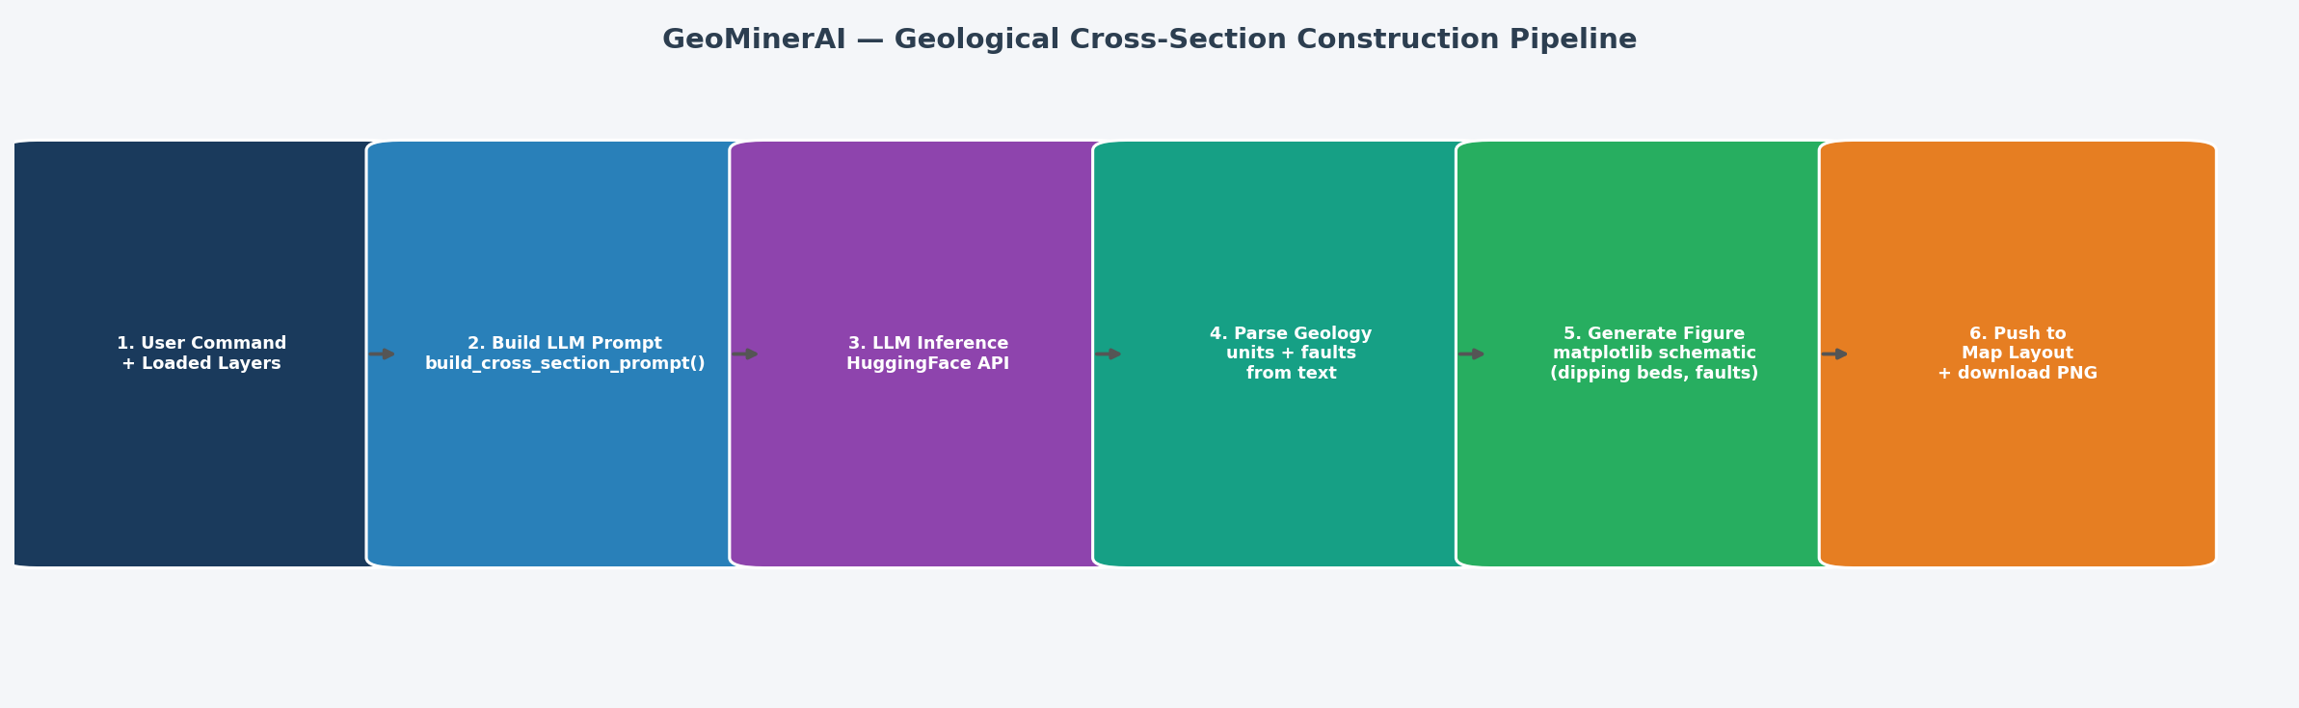
Figure 5: Cross-section construction pipeline
The cross-section engine is GeoMinerAI's flagship capability and the most technically demanding feature. It combines a professional structural-geology LLM prompt with an automated matplotlib schematic figure.

8.1 LLM Prompt Specification
The system prompt instructs the LLM to:
- Establish section orientation: determine true vs apparent dip; apply the apparent-dip correction formula if needed.
- Construct topographic profile: extract or estimate elevations along the section line; state vertical exaggeration.
- Project surface contacts: identify where the section line intersects each lithological contact; preserve stratigraphic order.
- Project units to depth: use dip angle and direction to project each unit downward; maintain consistent thickness unless deformation justifies change; distinguish data-constrained from inferred geometry.
- Interpret structures: identify folds (anticline, syncline, monocline) and fault types (normal, reverse, thrust, strike-slip); apply correct displacement direction.
- Handle uncertainty: propose the most geologically plausible model; state all assumptions; offer at least two alternative interpretations.
- Validate internal consistency: check for impossible unit stacking, inconsistent bed thickness, fault displacement errors.
- Assess mineral exploration relevance: identify structural traps, zones of structural intersection, optimal drill targets.
Critical constraints embedded in the prompt: do not fabricate data; do not assume vertical beds without support; do not change stratigraphic order without tectonic explanation; prioritise geological plausibility over visual symmetry.

8.2 Schematic Figure Generation
generate_cross_section_figure() builds a matplotlib figure with the following elements:
- Topographic profile: either from loaded DEM data or a synthetic sinusoidal approximation
- Dipping geological units: colour-filled polygons with a linear dip-ramp calculated from dip angle and direction; bedding tick marks at 20%, 50%, 80% along section
- Fault lines: red solid (normal/strike-slip) or dashed (thrust/reverse) vertical offsets with type annotations
- Section end labels (A / A prime)
- Uncertainty ribbon: hatched zone at the base of the section indicating depth of reliable constraint
- Scale bar, grid, legend, and disclaimer note

9. Advantages and Use Cases

9.1 Key Advantages
Unified workspace: All analytical workflows live in one page. No tab switching, no context loss between analyses.
Natural-language interface: Geologists work in domain language. Commands like 'run hotspot analysis on SnO2' or 'draw cross section A to A prime' are immediately understood and executed.
Multi-format knowledge base: Upload any combination of PDFs, Word reports, CSV assay data, GeoJSON geology maps, KML files, satellite images, and rasters. All are chunked, embedded, and indexed automatically.
Geological cross-section: No equivalent open-source tool provides LLM-driven structural interpretation combined with an automated schematic. This closes a critical gap in AI-assisted exploration geology.
Everything under the hood: Users see final outputs (maps, figures, tables, narratives) without needing to understand Gi* statistics, FAISS retrieval, or logistic regression. The complexity is abstracted.
Interactive spatial editing: Draw polygons directly on the live map and immediately use them in geoprocessing commands (buffer, clip). The spatial and analytical workflows are tightly coupled.
Transparent outputs: Every result card includes a download button. Figures export as high-resolution PNG. Data exports as CSV. Geometries export as GeoJSON. Nothing is locked in.
Modular architecture: Each core module is independently testable. New analysis types can be added by writing a handler function and registering a keyword in intent.py.

9.2 Primary Use Cases
- Greenfield exploration: upload geological reports and regional geochemical surveys; ask questions; identify target zones
- Drill-hole analysis: load XRF interval data; run prospectivity screening; generate depth profiles; draw cross-sections
- Structural mapping: upload geological maps as GeoJSON; draw section lines on the live map; generate cross-sections with LLM interpretation
- Literature synthesis: build a RAG knowledge base from PDFs; ask comparative questions across multiple papers
- Field preparation: define AOI polygons on the map; buffer known anomalies; clip datasets to study area; export for field use

10. Limitations and Challenges

10.1 Streamlit Performance
Streamlit's execution model is the single largest architectural constraint. Every user interaction — a button click, a file upload, a chat message — triggers a complete top-to-bottom rerun of app.py. There is no partial component update, no virtual DOM, and no server-sent event streaming.
- Full page rerun penalty: on a moderately loaded server, each rerun takes 0.5-3 seconds even before any computation. With a live Folium map, SentenceTransformer model in memory, and multiple session state objects, this rises to 2-8 seconds.
- Blocking execution: analysis handlers (LLM inference, FAISS search, ML training) block the entire UI thread. The user sees a spinner but cannot interact with any other panel.
- Session state memory growth: the layer registry, FAISS index, and output list are stored in Streamlit session state. For a long session with many layers and outputs, this can exhaust memory on resource-constrained deployments.
- No multi-user isolation by default: session state is per-browser-tab but the SentenceTransformer model and any shared caches are global. Concurrent users on the same server share model memory.

10.2 Map Rendering Issues
The Folium/streamlit-folium map is rendered as an HTML iframe inside the Streamlit page. This creates several performance and UX issues:
- Full map rebuild on every rerun: the entire Folium map object (including all layers, markers, controls) is reconstructed in Python and re-sent to the browser as a new HTML blob on every Streamlit rerun. There is no diff or incremental update.
- Drawing state partially lost: shapes drawn by the user in the browser exist only in the browser's Leaflet state. They are captured via the st_folium return value and stored in session state, then re-added as static GeoJSON overlays on the next render — meaning users cannot edit or delete individual drawn shapes after a rerun.
- Large dataset slowdown: rendering 1,000+ CircleMarker objects in Folium generates a large HTML blob. At 5,000+ points the browser tab can become unresponsive. Each point is a separate DOM element with event listeners.
- iframe communication latency: every map interaction (click, draw complete) requires a round-trip between the Leaflet iframe and the Streamlit Python server via the streamlit-folium bridge component. This adds ~200-500ms per interaction on top of the rerun cost.
- No server-side tile caching: OpenStreetMap tiles are fetched fresh by the browser on each map load, adding network latency on first render.

10.3 LLM Constraints
- HuggingFace API rate limits: free-tier inference is rate-limited and can return 503 errors under load. The fallback chain (text_generation -> chat_completion) mitigates but does not eliminate this.
- Model quality variability: open-weight models (Zephyr-7B, Mistral-7B, Phi-2) produce highly variable output quality for geological tasks. Smaller models may refuse to generate cross-section text of appropriate depth and accuracy.
- No streaming output: the UI shows a spinner for the entire LLM generation time (typically 5-30 seconds for 700-900 tokens). There is no token-by-token streaming display.
- Context window limitations: for large knowledge bases, the RAG retrieval returns only the top-k chunks. Important context may be missed if k is too small or the embedding similarity is imperfect.

10.4 Data Scale Limitations
- FAISS is rebuilt in-memory on every new layer addition — fine for <100,000 chunks but slow for larger knowledge bases.
- The cross-section parser relies on regex to extract geological units and dip values from free text; complex or poorly formatted input may yield incorrect or default geometry.
- No persistent storage: all layers, outputs, and session state are lost on page refresh or server restart. There is no database backend.
- No native support for .shp (shapefile) or GeoPackage without geopandas, which requires GDAL — a complex binary dependency not included by default.

11. Proposed Fixes and Mitigations

11.1 Immediate Fixes (within Streamlit)
@st.cache_resource for model loading: Wrap the SentenceTransformer and any other heavy model loads with @st.cache_resource. This ensures models are loaded once per server process, not once per rerun. Expected improvement: 2-5 seconds off every rerun.
@st.cache_data for expensive computations: Cache hotspot analysis, ML training, and FAISS index builds with @st.cache_data using a hash of the input data. Repeated identical analyses return instantly.
st.fragment for map isolation: Streamlit >= 1.37 supports @st.fragment, which allows a sub-component to rerun independently without triggering a full page rerun. Wrapping render_live_map() in a fragment means map interactions do not reload the entire page.
Point clustering / aggregation: Replace individual CircleMarker objects with Folium's MarkerCluster plugin for datasets >500 points. The browser renders a single cluster circle instead of hundreds of DOM elements. Add a server-side pre-aggregation step (grid binning to ~200 representative points) before rendering.
Pydeck instead of Folium: pydeck (already in requirements) uses WebGL via deck.gl and can render 100,000+ points at interactive framerates. Replace the Folium map with a pydeck ScatterplotLayer for data point rendering, while keeping Folium for drawing tools or using a complementary HTML component.
Paginated output panel: Cap the Map Layout panel at 10 visible output cards. Add a 'Load older results' expander. This prevents the DOM from growing unbounded during long sessions.
Async handler execution: Use Python's asyncio or a background thread (st.runtime.scriptrunner) to run LLM inference without blocking the UI. Show a live progress indicator that updates without a full rerun.

11.2 Architectural Fixes (Beyond Streamlit)
For production-grade performance, a migration away from Streamlit's execution model is recommended:
- FastAPI backend + React/Next.js frontend: decouple computation from rendering. The backend exposes REST endpoints for each analysis handler. The frontend updates only the affected component.
- WebSocket LLM streaming: stream tokens from the LLM directly to the browser using Server-Sent Events or WebSockets, eliminating the spinner wait.
- PostgreSQL + Redis: replace in-memory session state with a proper database. Layers and outputs persist across sessions and server restarts. Redis handles ephemeral state (drawn features, chat history).
- Celery task queue: offload long-running tasks (LLM inference, ML training, FAISS rebuild) to background workers. The UI polls for results asynchronously.
- Vector tile server: serve point data as Mapbox Vector Tiles (MVT) from PostGIS for smooth rendering of millions of points in the browser.

12. Future Directions and Roadmap

12.1 Near-term (3-6 months)
- st.fragment map isolation to reduce rerun cost (Streamlit 1.37+)
- pydeck migration for point rendering (WebGL, handles 100k+ points)
- Persistent session storage (SQLite or PostgreSQL) so layers survive page refresh
- Streaming LLM output using st.write_stream
- Shapefile and GeoPackage support via geopandas (with pre-built GDAL wheel)
- Export to DXF format for CAD compatibility with section lines and geology polygons
- Drillhole 3D viewer using pydeck ColumnLayer or PyVista embedded via streamlit-pyvista

12.2 Medium-term (6-18 months)
- Migration to FastAPI + React frontend for production performance
- Multi-user collaboration: shared layer registry, real-time map sync via WebSockets
- True 3D geological modelling: CesiumJS or Three.js for 3D cross-section and block model visualisation
- Direct integration with industry geological databases (GSWA, NGSA, MinEx CRC datasets)
- Full ReAct-style LLM agent: the model plans multi-step geological workflows autonomously, calling geoprocessing and analysis tools as needed
- Domain-fine-tuned LLM: fine-tune a base model on geological reports, cross-section descriptions, and structural interpretations for higher output quality

12.3 Long-term Vision
- Mobile-first field companion app: GPS-integrated, offline-capable, syncs with the main workspace
- LiDAR and drone survey ingestion: direct processing of point clouds (.las/.laz) and orthomosaics
- Automated resource estimation: geostatistical interpolation (kriging) within drawn polygons with JORC-compliant uncertainty reporting
- Export to industry formats: Leapfrog, Seequent, Micromine, and Datamine project files
- Natural-language geological report generation: one-click production of an exploration summary report from all outputs in the session

13. Technology Stack
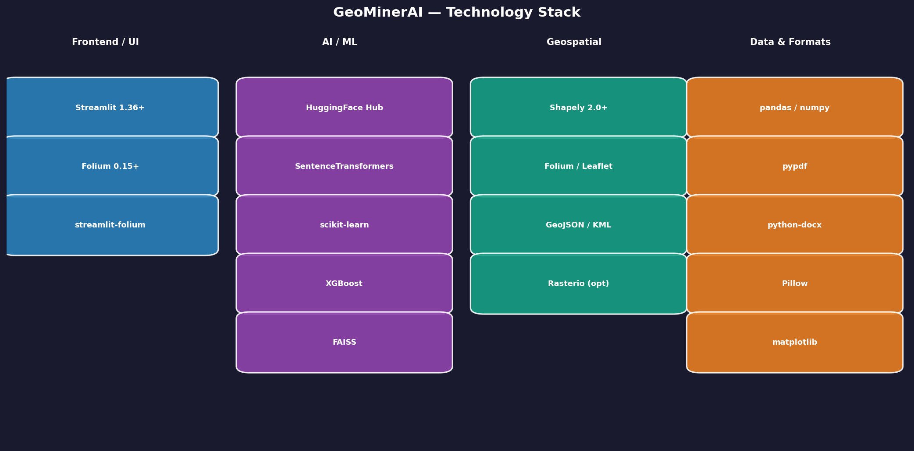
Figure 6: GeoMinerAI technology stack
Category | Package | Version | Role
Frontend/UI | Streamlit | >=1.36 | Web application framework
Frontend/UI | Folium | >=0.15 | Interactive Leaflet.js map wrapper
Frontend/UI | streamlit-folium | >=0.18 | Folium-Streamlit bridge component
AI/ML | sentence-transformers | >=3.0 | Text embedding (all-MiniLM-L6-v2)
AI/ML | faiss-cpu | >=1.8 | Approximate nearest-neighbour index
AI/ML | scikit-learn | >=1.4 | Logistic regression, Random Forest
AI/ML | xgboost | >=2.0 | Gradient-boosted prospectivity model
AI/ML | huggingface-hub | >=0.34 | HuggingFace inference API client
Geospatial | Shapely | >=2.0 | Geometry: buffer, clip, containment
Geospatial | pydeck | >=0.9 | WebGL map rendering (future)
Data | pandas | >=2.1 | Tabular data manipulation
Data | numpy | >=1.26 | Numerical arrays
Data | matplotlib | >=3.8 | Cross-section and profile figures
Formats | pypdf | >=4.2 | PDF text extraction
Formats | python-docx | >=1.1 | Word document parsing and generation
Formats | Pillow | >=10.0 | Image loading (PNG, JPG, TIFF)
Formats | rapidfuzz | >=3.6 | Fuzzy string matching for metrics

14. Project File Structure
The repository is organised as follows:
geominerAI_GeoGPT/
├── app.py # Main Streamlit application (single workspace)
├── requirements.txt # Python dependencies
├── core/
│ ├── __init__.py
│ ├── geo_ingest.py # NEW: Multi-format file ingestion
│ ├── intent.py # NEW: NLP intent detection
│ ├── cross_section.py # NEW: Geological cross-section engine
│ ├── geoprocessing.py # NEW: Buffer, clip, spatial ops
│ ├── rag.py # PDF chunking + FAISS retrieval
│ ├── llm_hf.py # HuggingFace LLM interface
│ ├── snree_hotspots.py # Gi*, Moran, grid spatial stats
│ ├── snree_ml.py # ML baselines + depth profiles
│ ├── snree_lab.py # Sn-REE prospectivity pipeline
│ ├── chemistry.py # Element/oxide conversion
│ ├── geogpt.py # GeoGPT dataset loader
│ ├── benchmark.py # Benchmark utilities
│ └── metrics.py # Exact match + fuzzy similarity
├── data/
│ └── readings/ # Pre-loaded geological PDF library
│ └── *.pdf # 25 reference papers
├── scripts/
│ ├── generate_docs.py # Documentation generator (this script)
│ ├── download_geogpt.py # Dataset downloader
│ ├── eval_geogpt.py # Evaluation runner
│ └── run_geogpt_benchmark.py # Benchmark runner
└── docs/
├── GeoMinerAI_Technical_Documentation.docx
├── GeoMinerAI_Technical_Documentation.pdf
└── diagrams/ # Generated diagram PNGs

15. Quick-Start Guide

15.1 Installation
Requirements: Python 3.10+ and pip.
git clone https://github.com/sehmilo/geominerAI_GeoGPT.git
cd geominerAI_GeoGPT
pip install -r requirements.txt
echo 'HF_TOKEN = "hf_your_token_here"' > .streamlit/secrets.toml
streamlit run app.py

15.2 First Workflow: Hotspot Analysis
- Open the Prompt Box (bottom right)
- Upload a CSV file containing columns: hole_id, lat, lon, SnO2 (or similar)
- Click the 'Hotspot' quick-command chip or type: run hotspot analysis on SnO2
- Results appear in Map Layout; coloured points appear on the Live Map
- Download the cluster table as CSV from the output card

15.3 First Workflow: Geological Cross-Section
- Upload any geological map, report PDF, or CSV with strike/dip data
- On the Live Map, draw a polyline representing the section trace
- Click 'Save drawings to Layer List'
- Type: draw cross section A to A prime with granite dipping 25 NE over schist
- The LLM interpretation and matplotlib schematic appear in Map Layout
- Download the PNG for use in reports

