**Homework 05: Decision Tree Regression**

I wrote Decision Tree using R programming language by following the steps below.

1. I read file “hw05_data_set.csv” using the data_set variable.

2. I split the data into two as training and test data.

3. Calculator node mean square errors for impurity measure.

4. Formula in the book. (Formula: 9.10 books)

5. Total error of the split in the book.(Formula: 9.14 books)

6. Plot drawing in the below.

7. Drawing a lines in the below.

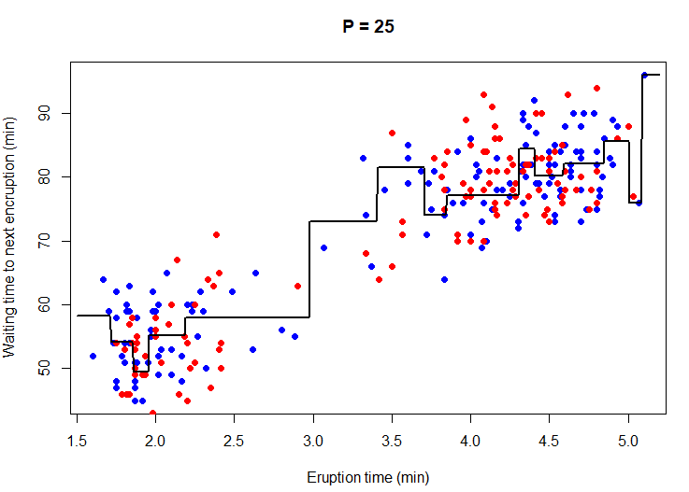

8. Calculator RMSE in formula. (For example= “RMSE is 6.4541 when P is 25”).

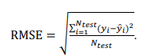

9. “pre-prunning-values” set data list (5-10-15-20-25-30-35-40-45-50).

10. Plot drawing in the below.

11. Drawing a lines in the below .

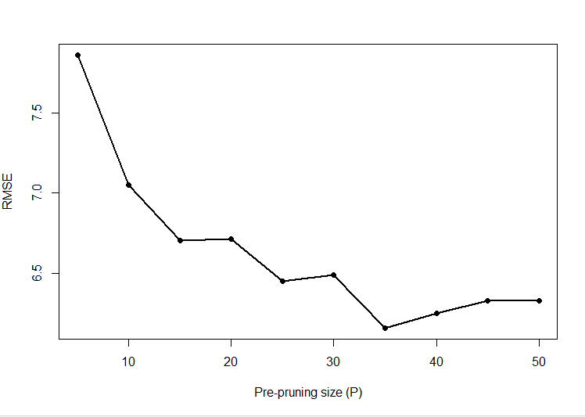

**Şeyhmus Aydoğdu**