**Homework 06: Modeling Cash Withdrawals from ATMs**

I wrote Modeling Cash Withdrawals from ATMs using R programming language by following the steps below.

1. Install required package, first install the neuralnet library.
2. I read file “training_data.csv”, using the training dataset.
3. I read file “test_data.csv”, using the test dataset.
4. Define normalize function and denormalize function.
5. X_train dataset to be normalize
6. X_test dataset to be normalize.
7. Import the neuralnet library and create NN classifier model by passing argument set of label and features, dataset, number of neurons in hidden layers, and error calculation.
8. Calculator fit neural network
9. Neural network in parameter below:

* (TRX_COUNT) is label and (REGION, DAY, MONTH, YEAR, TRX_TYPE) are features.
* data=X_train_normalize
* threshold = 0.5,
* hidden=3 ##represents single layer with 3 neurons respectively.
* act.fct = "logistic"
* linear.output = FALSE

1. Plot neural network in below.

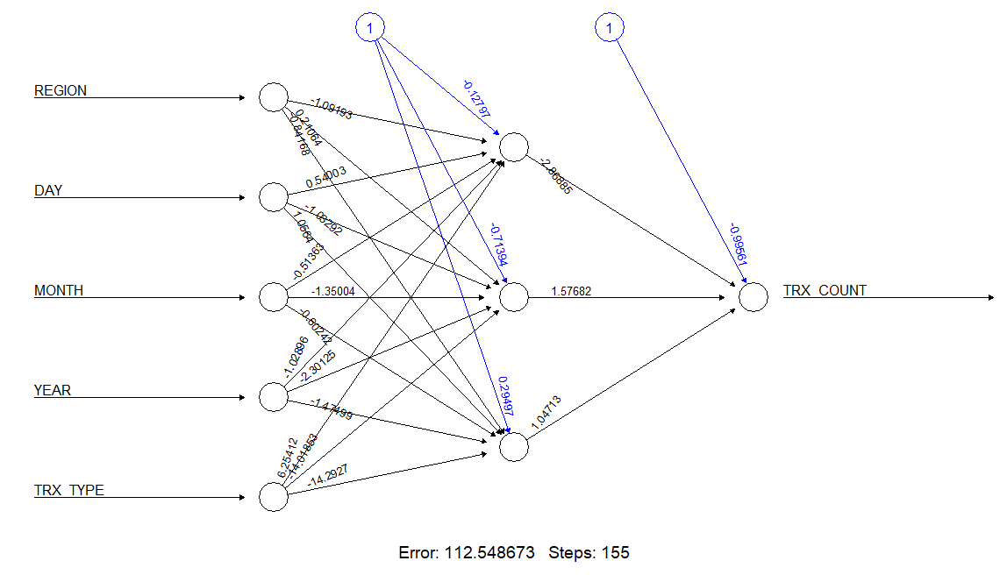

1. Calculator “train_scores” using neural network.
2. Calculator MAE (mean absolute error) value.

("MAE mean absolute error = 14.7629")

1. Calculator RMSE (root mean squared error) value.

("RMSE root mean squared error = 24.0241")

1. Calculator “prediction_scores” using neural network.
2. “prediction_scores” write a file "test_predictions.csv".

Şeyhmus Aydoğdu