

Assignment 01
Git, Gitea, GitHub, Git LFS, and GitHub Pages

Student name | Sehrish Fatima
Registration number | FA24B1-SE-065
Section | A
Course | Cloud Computing
GitHub username | Sehrishfatima018
Ubuntu prompt | Sehrishfatima018@ubuntu:~$
Deadline | 10 October 2026

Task 1: Install Gitea and Push a Repository from the Ubuntu Server

Step 1.1: Install and Run Gitea on the Ubuntu Server
Installed Docker and the Compose plug-in, cloned the instructor's Gitea repository, started Gitea and PostgreSQL, and confirmed Gitea answers on port 3000.
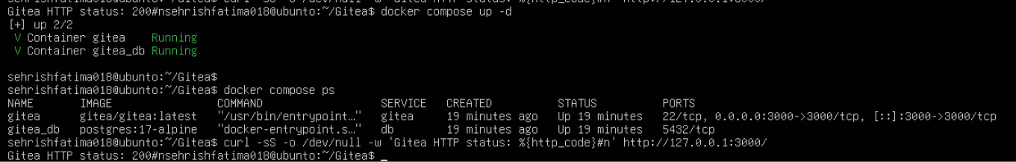
git clone https://github.com/WaqasSaleem97/Gitea.git docker compose up -d docker
compose ps
curl -sS -o /dev/null -w "Gitea HTTP status: %{http_code}\n" http://127.0.0.1:3000/
task1_gitea_running.png: both containers running and Gitea HTTP status 200

Gitea installation page, using the required PostgreSQL database settings (host db:5432, user gitea, database gitea).
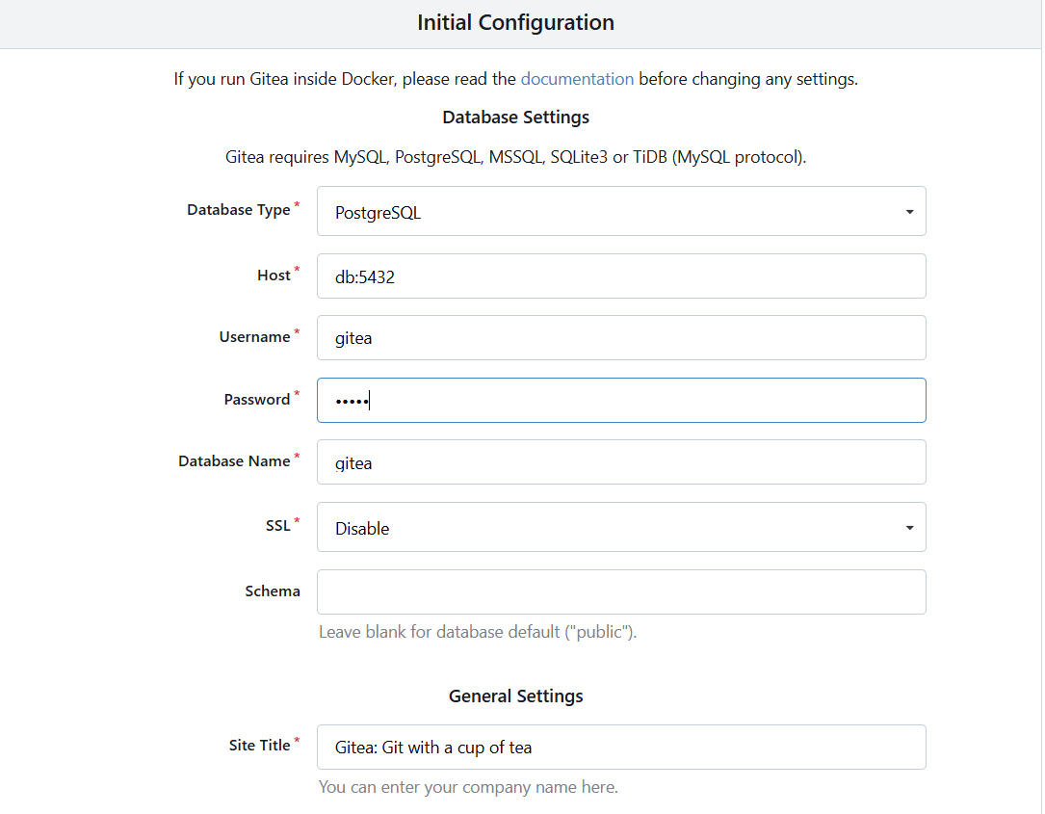
Gitea installation page: database settings
Administrator account created to complete the installation.

Step 1.2: Create and Push the Initial Repository
Created an empty public Gitea repository named Assignment01. On the server, created a separate local repository with a README containing my name and registration number, added the gitea remote without a token in the URL, and pushed with a personal access token entered at the password prompt.
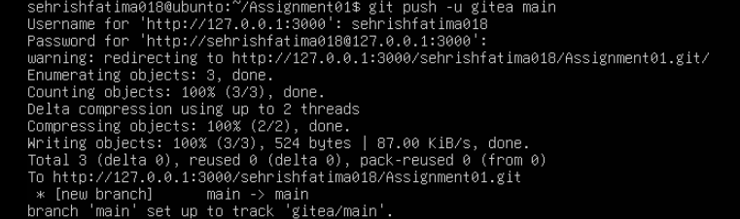
task1_gitea_push.png: gitea remote and successful push to main

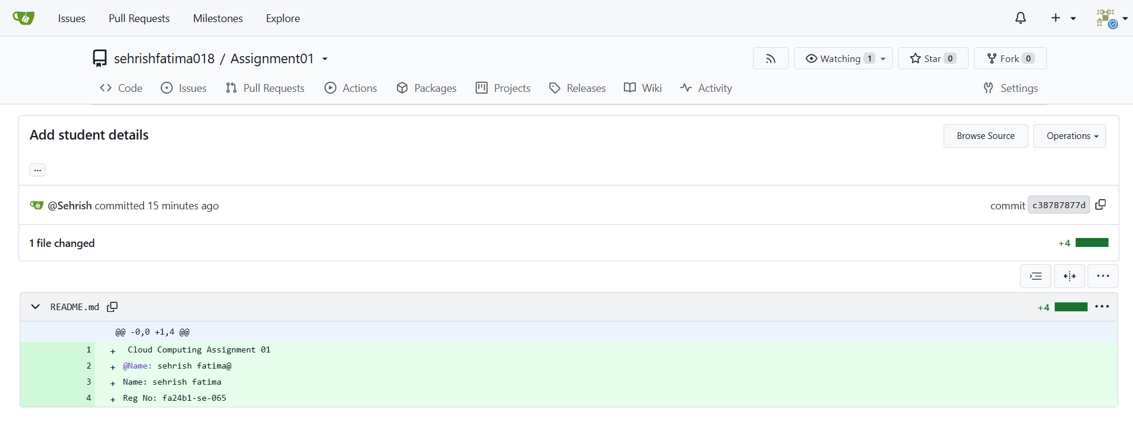
Step 1.3: Verify the Gitea Repository
task1_gitea_repository.png: public repository with rendered README

Task 2: Push the Same Repository to GitHub

Step 2.1: Create the GitHub Repository and Verify Both Remotes
Created an empty public GitHub repository named Assignment01 and added it as the github remote.
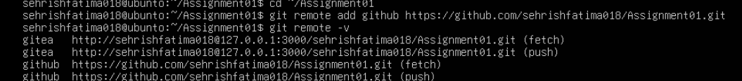
git remote add github https://github.com/ayeshaaafifa/Assignment01.git git remote -v
task2_remotes.png: gitea and github remotes, no token or password in the URLs

Step 2.2: Push to GitHub
git push -u github main
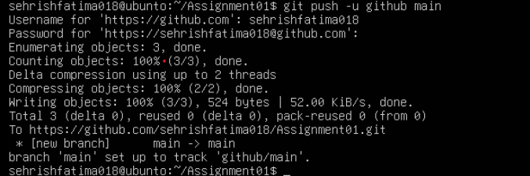task2_github_push.png: successful push of main to GitHub

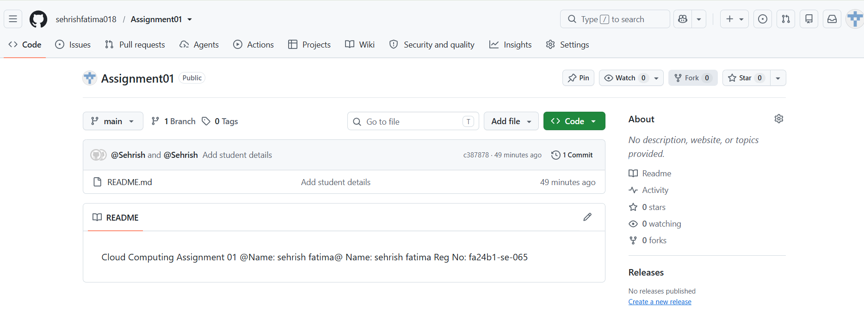
Step 2.3: Verify the GitHub Repository
task2_github_repository.png: public repository with rendered README

Task 3: Track Three Large Files with Git LFS

Step 3.1: Configure Git LFS
git lfs install git lfs version git lfs track "*.bin" cat
.gitattributes

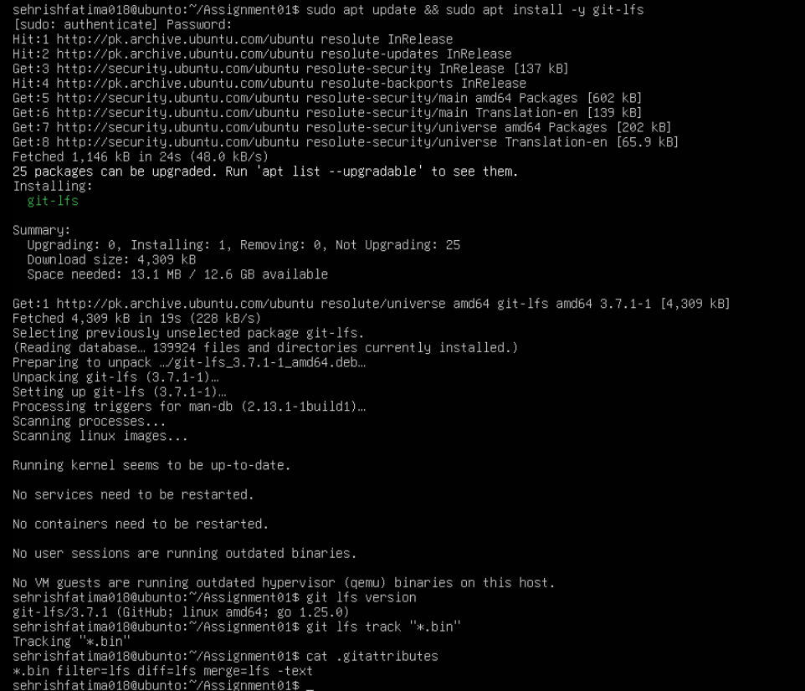
task3_lfs_setup.png: Git LFS initialized, version shown, *.bin rule in .gitattributes

Step 3.2: Create and Verify Three LFS Files
Created three files of 101 MiB, 102 MiB and 103 MiB, staged them, and listed them with Git LFS (shown as 106, 107 and 108 MB).
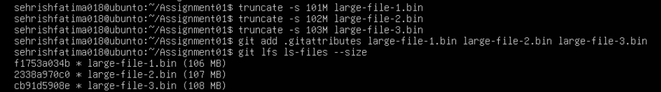
truncate -s 101M large-file-1.bin truncate -s 102M large-file-
2.bin truncate -s 103M large-file-3.bin
git add .gitattributes large-file-1.bin large-file-2.bin large-file-3.bin git lfs ls-files --size
task3_lfs_files.png: three files tracked by Git LFS, each larger than 100 MiB

Step 3.3: Commit and Push the LFS Files
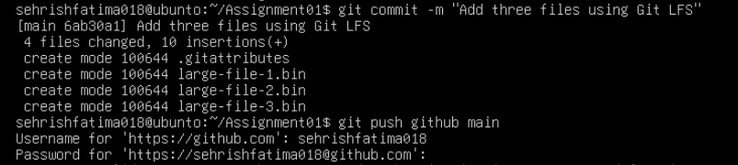
git commit -m "Add three files using Git LFS" git push github main
task3_lfs_push.png: LFS upload 100% (3/3) and successful push to GitHub

