Homework 2 Report ***2D Arrays, Project: Airports***

**Data Structure**

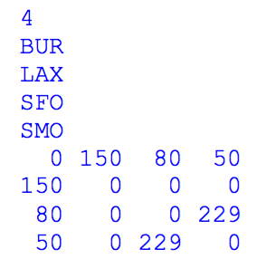 For the sake of demonstration of data organization, we will look at an example input file show on the left. The data structures and variables used in the program are:

int flightMatrix[MAX_AIRPORTS][MAX_AIRPORTS];

int indexOfConnects[MAX_AIRPORTS][MAX_AIRPORTS];

int connectInfo[MAX_AIRPORTS][3];

string airportNames[MAX_AIRPORTS];

int numAirports;

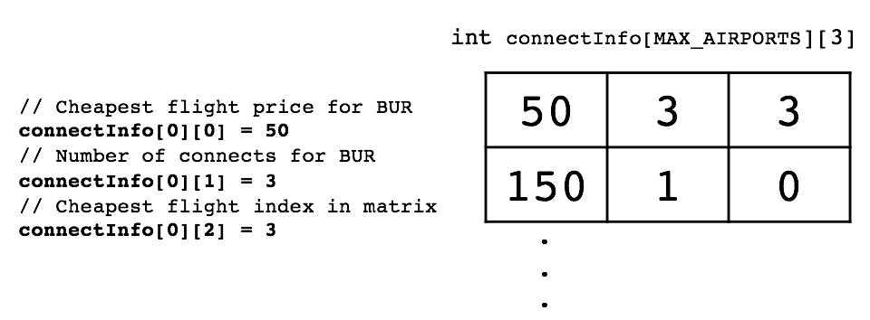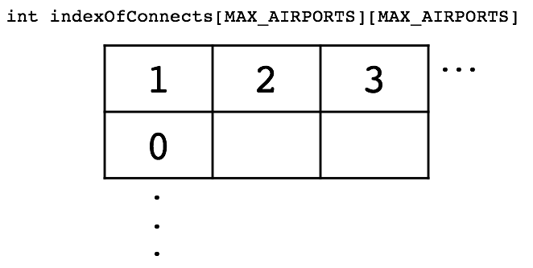

flightMatrix is a 2-dimensional int array (matrix) containing flight prices from each airport to all others. indexOfConnects is a 2-dimensional int array which stores the corresponding index of destination airports of connecting flights for each airport. The example is shown on the right figure which stores 1, 2, and for the airport BUR while for LAX airport it stores only 0 as there exists only one connecting flight to BUR airport of index 0. connectInfo is a 2-dimensional array which stores the cheapest flight, number of connects, and the index for the cheapest flight for each airport. The example first two rows of the connectInfo array in respect to the example input file is shown as above. It will store 50 as the cheapest flight price, 3 as the number of connects, and the 3 as the index of the cheapest flight destination. airportNames stores the airport names in a string array and int numAirports will keep track of how many airports we are dealing with.

**Functions**

int readInAirports(string fName, string names[MAX_AIRPORTS], int matrix[][MAX_AIRPORTS], int detArr[][3], int connectingFlights[][MAX_AIRPORTS]);

void printFormattedTable(int num, int matrix[][MAX_AIRPORTS], string names[]);

void printDestinations(int num, int p_connectInfo[][3], int indexes[][MAX_AIRPORTS], string names[]);

void printGroups(int num, int matrix[][MAX_AIRPORTS], string names[]);

void printCheapest(int num, int p_connectInfo[][3], int indexes[][MAX_AIRPORTS], string names[]);

readInAirports function will read in the first line for numAirports, the number of airports, the next numAirports lines for the names of the airports into string airportNames array, and each row into the int flightMatrix array. The printFormattedTable function will simply print the formatted array with the names of the airports on each side and the flight matrix. The printDestinations function will display a list and number of destinations for each airport. The printGroups function will display pairs airports connected by flights, without duplicates. The printCheapest function will display the cheapest flight price and destination for each airport.