Homework 3 Report: ***Pointers and Dynamic Allocation of Memory***

**Data Organization**

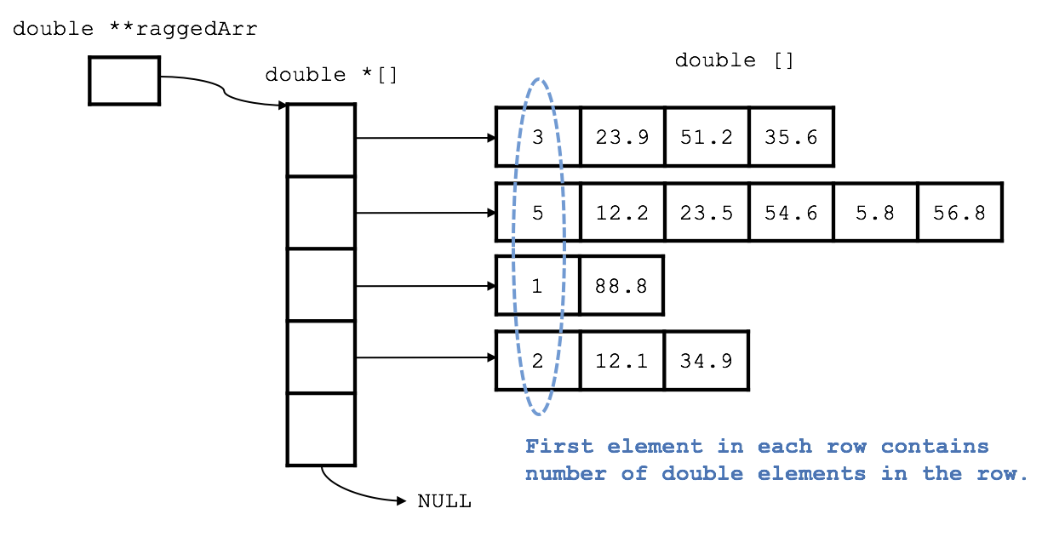

*figure refers to example ragged.txt file for sake of demonstration*

double **raggedArr is a pointer to an array of double pointers. Each double pointer in the double pointer array points to a double array filled with values, except the last pointer which is set to NULL in order to be used as a stop condition in other functions. Each double array is formatted as follows: first element in the array denoting the number of double values, each consequent element being a double value that needs to be sorted.

**Structure & Functions**

void insertionSortRow(double *row);

// Sorts the row in descending order

void insertionSortArray(double **arr);

// Sorts the ragged array from longest length to shortest length

void writeRaggedArray(double **arr);

// Prints ragged array to screen with proper formatting

void freeArray(double **arr);

// Frees all dynamically allocated arrays

// Pseudocode

// Read in first line and store number into int variable num_rows

// Set raggedArr to point to dynamically allocated double pointer array with num_rows+1 elements,

// Read in first element of line and store into int variable num_elems

// Dynamically allocate double array with num_elems+1 elements, store that variable as the first element and store the next num_elem elements

// Call function insertionSortRow on the row

// After num_rows rows have been read in call insertionSortArray on the raggedArr

// Write the output by calling the function writeRaggedArray

// Free dynamically allocated memory by calling the function freeArray