Homework 6 Report: ***Linked List***

**Data Structure**

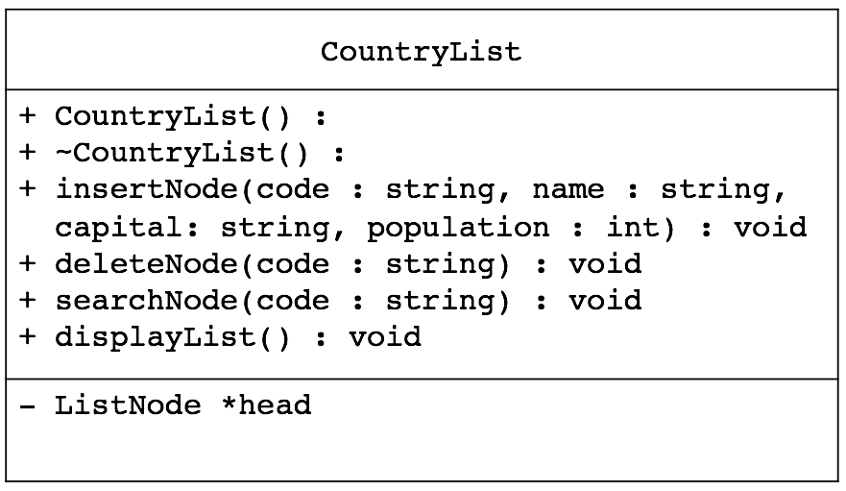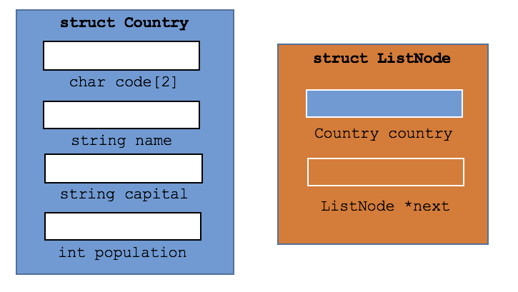

The data structures that are used in the program are a class of CountryList, basically a linked list – the UML diagram shown above, left – and two structs of Country and ListNode, shown above, right. When reading in the input file, each line is read and parsed to four different values to create a country Struct, then a ListNode is created with the country struct object and inserted into the CountryList linked list in alphabetical order. The insertNode function is implemented in a way that when traversing through the linked list, the country code values will always remain sorted in ascending, alphabetical order.

**Functions**

[CountryList member functions]

CountryList() // Creates a CountryList object with the ListNode with NULL

~CountryList(); // Traverses through Country List and deletes all ListNode’s

void insertNode(string, string, string, int);

// Takes in four values of code, country name, capital, and population and creates a

// Country struct and ListNode with that country struct and inserts into the CountryList

void deleteNode(string);

// Finds the ListNode containing country with code of input and deletes the node

void searchNode(string) const;

// Finds the ListNode containing country with code of input and displays country values

void displayList() const;

// Displays the entire linked list as a table

[Auxiliary Functions]

void buildList(CountryList *list, string fileName);

// The buildList function takes a pointer to a CountryList object and a string for the input // filename and builds a linked list of nodes in alphabetic order of country codes.

void deleteCountry(CountryList *list);

// The deleteCountry function takes in a pointer to a CountryList object and prompts the // user for the country code of the country they wish to delete, deletes it, and exits if 'quit' // was entered

void searchCountry(CountryList *list);

// The searchCountry function takes in a pointer to a CountryList object and prompts the // user for the country code of the country they wish to search for, prints values of it, and // exits if 'quit' was entered

bool codeValid(string code);

// The codeValid function validates a string to make sure that it is valid in format so that it can be used to search for the country.