Sei Chain
Snapshot Manager, StoreV2 State Import/Export &
P2P State Sync — Architecture Reference
March 2026

Repositories: sei-cosmos · sei-tendermint · sei-db

Table of Contents

1. System Overview
State sync in Sei is a three-layer system: the Tendermint consensus engine (sei-tendermint) discovers and orchestrates the transfer of snapshot data via P2P; the Cosmos SDK layer (sei-cosmos) owns the snapshot lifecycle, chunk I/O, and the high-level Snapshotter interface; and the custom storage backend (sei-db) actually serialises and deserialises the state trees.
Figure 1 shows how the three repositories fit together and which interfaces connect them.
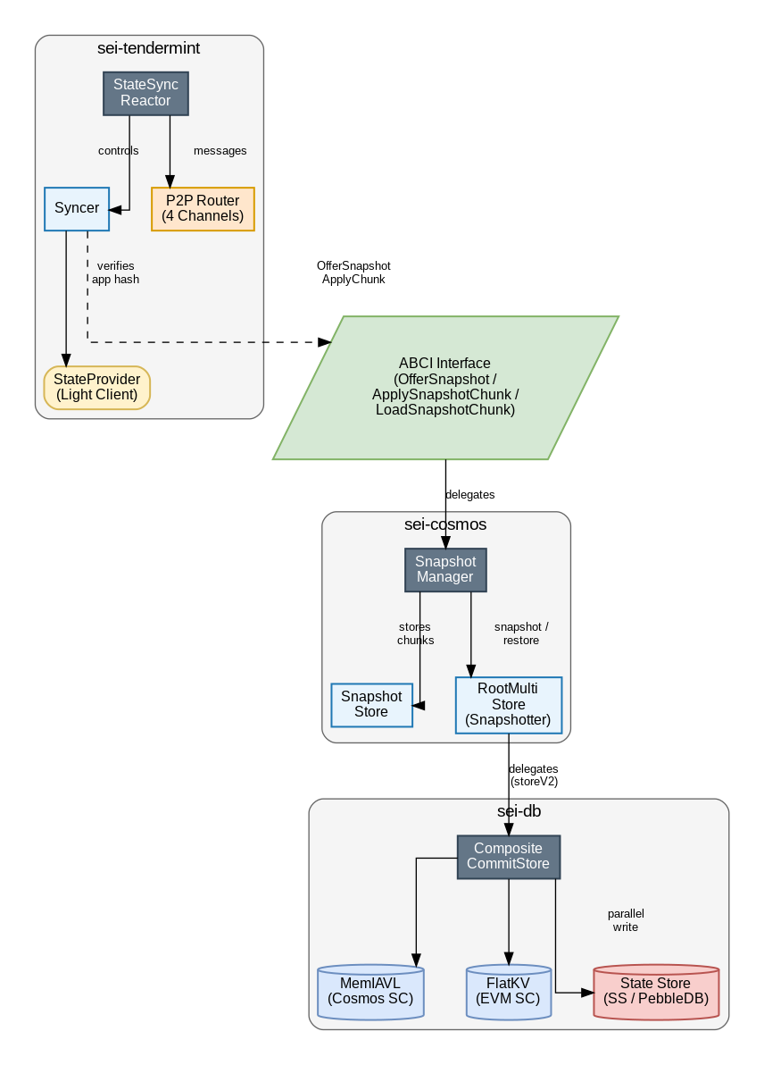
Figure 1 — System overview across sei-tendermint, sei-cosmos, and sei-db
The key integration points are:
- The ABCI interface (OfferSnapshot / ApplySnapshotChunk / LoadSnapshotChunk) is the boundary between Tendermint's state sync reactor and the Cosmos application.
- snapshots.Manager in sei-cosmos is the application-side coordinator; it owns the snapshot store on disk and delegates serialisation to the multistore's Snapshot() / Restore() methods.
- The multistore can be either the legacy rootmulti.Store (IAVL) or the new storeV2 backed by sei-db's composite.CompositeCommitStore, which splits Cosmos state into MemIAVL trees and EVM state into a FlatKV store.

2. Snapshot Manager (sei-cosmos/snapshots/)
The snapshot manager (snapshots.Manager) is the single coordinator for all snapshot-related operations. It enforces that only one operation runs at a time — create, prune, or restore — using a mutex and an operation enum.

2.1 Key Data Structures
Manager holds:
- store (*Store) — the on-disk snapshot store.
- multistore (types.Snapshotter) — the delegate that serialises/deserialises state.
- extensions (map[string]ExtensionSnapshotter) — pluggable snapshotters (e.g., WASM, EVM) appended after the core state.
- chRestore / chRestoreDone — channels used to stream chunks into the async restore goroutine.
Store holds:
- db (tm-db.DB) — key-value database storing snapshot metadata indexed by (height, format).
- dir (string) — root directory; chunks are stored at {dir}/{height}/{format}/{index}.
Snapshot metadata key encoding:
key = 0x01 || BigEndian(uint64 height) || BigEndian(uint32 format) // 13 bytes

2.2 Create Flow
Manager.Create(height) serialises the full application state at a given block height into a set of binary chunk files on disk. It runs the heavy work in a goroutine so the caller is unblocked once the operation starts, but the return value (snapshot metadata) is only available after the goroutine finishes.
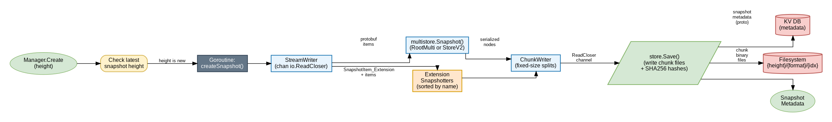
Figure 2 — Snapshot creation flow
Step-by-step:
- 1. begin(opSnapshot) acquires the operation lock.
- 2. A goroutine calls createSnapshot(height, ch) which creates a StreamWriter backed by the chunk channel.
- 3. multistore.Snapshot(height, streamWriter) is called — see Section 3 for how sei-db implements this.
- 4. Each registered extension snapshotter is called in sorted-name order so the stream is deterministic.
- 5. The StreamWriter's underlying ChunkWriter splits the continuous protobuf byte stream into fixed-size chunks (default 10 MB) and sends each as an io.ReadCloser through the channel.
- 6. store.Save() reads from the channel, writes each chunk to a file, computes a per-chunk SHA-256 hash, and accumulates the overall snapshot hash.
- 7. Snapshot metadata (height, format, chunk count, chunk hashes array, total hash) is written to the KV database.
Key constant: chunkBufferSize = 4 (channel buffer — allows up to 4 chunks to be generated ahead of the consumer).

2.3 Restore Flow
Restore is async: Manager.Restore() starts the goroutine and returns immediately. The caller must then feed each chunk via RestoreChunk() until the method returns true (all chunks consumed and state restored).
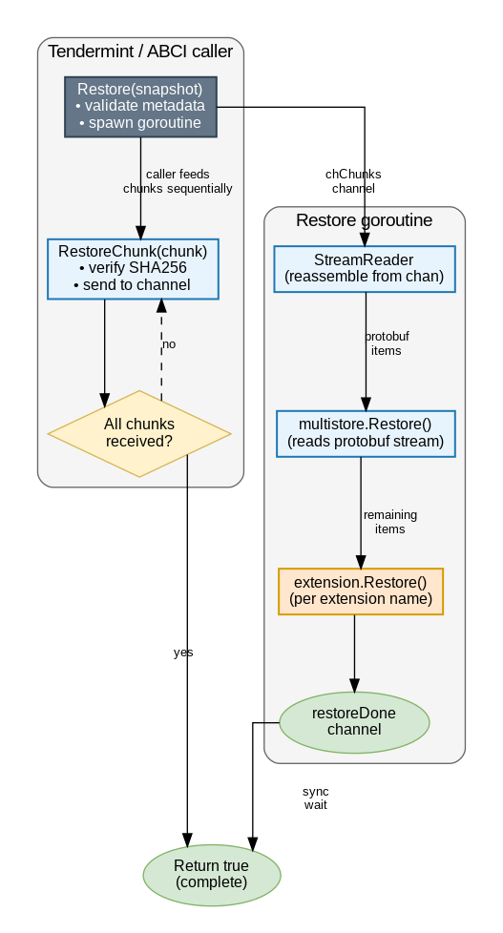
Figure 3 — Snapshot restore flow
Step-by-step:
- 1. Restore(snapshot) validates chunk count, format, and height, then spawns a goroutine running restoreSnapshot().
- 2. The goroutine creates a StreamReader (which reassembles the continuous stream from the chunk channel) and calls multistore.Restore(height, format, streamReader).
- 3. multistore.Restore reads SnapshotItem protobuf messages: SnapshotItem_Store headers signal a new module, SnapshotItem_IAVL nodes carry IAVL tree data.
- 4. When multistore.Restore returns (having read all items it understands), the remaining items are extension items; the goroutine dispatches each to the matching extension snapshotter.
- 5. The caller calls RestoreChunk(chunk) for each chunk in order. Each call: (a) verifies the SHA-256 hash against the stored ChunkHashes, (b) sends the chunk into the channel, (c) checks if the goroutine reported an error.
- 6. When the last chunk is fed, the caller waits on chRestoreDone and returns the final result.
Error handling: SHA-256 mismatch returns ErrChunkHashMismatch immediately. The goroutine can signal an error at any point via the done channel.

2.4 Prune Flow
Manager.Prune(retain) iterates the snapshot KV database in reverse order (newest first) and deletes all snapshots beyond the retain count. It removes both the KV metadata and the chunk files from disk, then removes the height-level directory.

2.5 Storage Layout
On-disk layout inside the snapshot directory:
{snapshotDir}/
{height}/
{format}/
0 ← chunk 0 binary
1 ← chunk 1 binary
...
metadata ← tm-db KV store (snapshot metadata protobuf)

3. StoreV2 State Import / Export (sei-db)
sei-db replaces the legacy IAVL-in-LevelDB backend with a two-tier architecture: State Commit (SC) provides Merkle-hashed state with support for both Cosmos modules and EVM, while State Store (SS) provides plain key-value history for historical queries.

3.1 SC Layer Architecture
The SC layer is handled by the composite.CompositeCommitStore, which coordinates two backends:
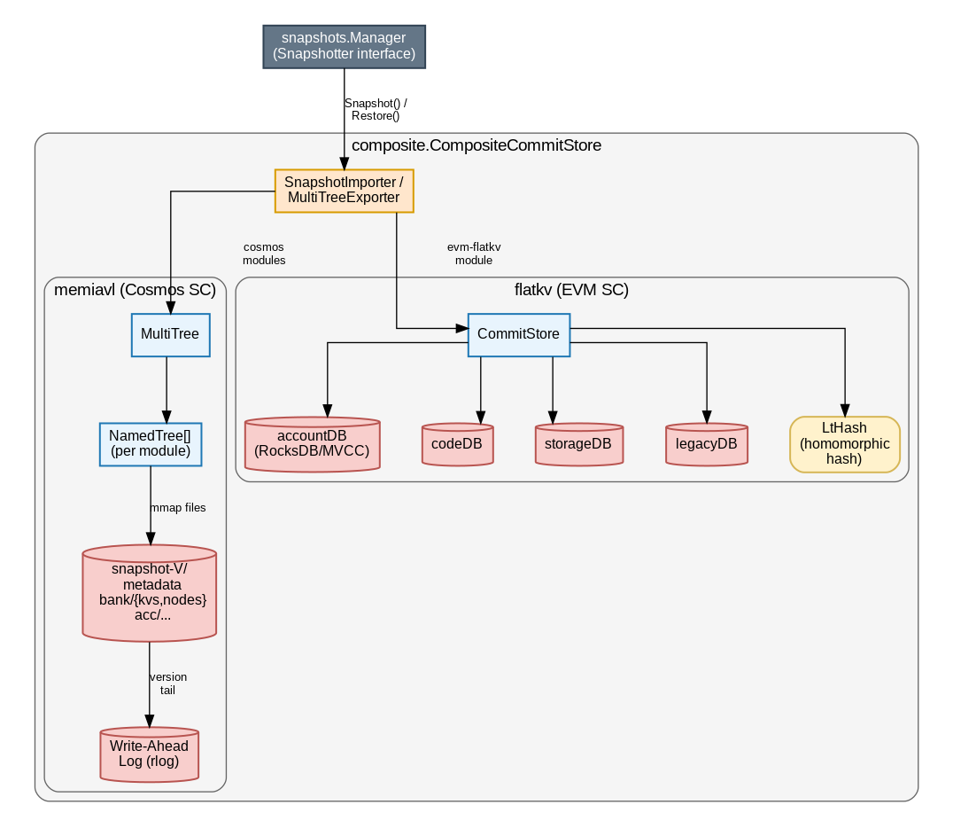
Figure 4 — StoreV2 State Commit (SC) architecture
- MemIAVL (memiavl.CommitStore) — stores all Cosmos module state (bank, staking, gov, wasm, etc.) as IAVL trees. Trees are memory-mapped from snapshot files and an append-only WAL (rlog). A MultiTree manages all named trees and tracks a shared version.
- FlatKV (flatkv.CommitStore) — stores EVM state (accounts, code, storage, legacy) as flat key-value records in RocksDB with MVCC. No Merkle tree; integrity is verified with a homomorphic LtHash that is updated incrementally on each write.
The composite store routes operations by module name: the special module name evm-flatkv directs to FlatKV; everything else goes to MemIAVL.
Write modes: DualWrite (both backends in parallel), SplitWrite (EVM to FlatKV, Cosmos to MemIAVL), and cosmos_only (only MemIAVL, default for nodes without EVM).

3.2 MemIAVL Snapshot Structure
Each MemIAVL snapshot is a directory named snapshot-{version}/ containing:
- A metadata file (__metadata) — protobuf MultiTreeMetadata with CommitInfo (per-module root hashes) and initialVersion.
- One subdirectory per module, each with kvs (sorted leaf data) and nodes (branch nodes) memory-mapped files, plus a module metadata file.
The current symlink always points to the latest snapshot directory, allowing atomic swaps after import.

3.3 Export Pipeline (Snapshot)
When the Snapshotter interface calls Snapshot(), the composite store produces a stream of SnapshotNode items:
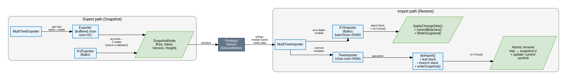
Figure 5 — StoreV2 export/import pipeline
For MemIAVL (MultiTreeExporter):
- Iterates trees in sorted name order. For each tree, emits the tree name (string) then all IAVL nodes via an Exporter.
- Exporter runs a goroutine with a 32-node buffer channel. The goroutine performs an in-order traversal of the IAVL tree, yielding SnapshotNode{Key, Value, Version, Height} items. Height=0 is a leaf, Height>0 is a branch.
For FlatKV (KVExporter):
- Iterates 4 sub-databases in order: accountDB, codeDB, storageDB, legacyDB.
- Account entries are decomposed into 2 SnapshotNodes: one for nonce (EVMKeyNonce prefix) and one for code hash (EVMKeyCodeHash prefix, only if the account has code).
- All emitted nodes carry Height=0 (leaf) — version history is intentionally flattened; only the latest state at the snapshot version is exported.

3.4 Import Pipeline (Restore)
For MemIAVL (MultiTreeImporter):
- Receives items via Add(). A string item triggers AddModule(name) which creates a new TreeImporter for that module in a tmp directory.
- A SnapshotNode item is forwarded to the current TreeImporter's 500,000-node buffered channel.
- TreeImporter runs doImport() in a goroutine, which rebuilds the IAVL tree using a leaf stack and a node stack, writing leaves and branches sequentially via the snapshot writer. Context cancellation is checked every 100,000 nodes or every 5 seconds.
- On Close(): updates the metadata file, then atomically renames the tmp directory to snapshot-{version}/ and updates the current symlink.
For FlatKV (KVImporter):
- Batches SnapshotNodes into groups of 20,000, calls ApplyChangeSets() and commitBatches() per batch. This bypasses the WAL for performance.
- On Close(): writes a snapshot to ensure the imported data survives a store restart (the WAL won't have entries for the imported data).
The composite.SnapshotImporter dispatches by module name: evm-flatkv routes to the KVImporter; all other names route to the MultiTreeImporter.

3.5 Legacy RootMulti Path
When using the legacy IAVL backend (rootmulti.Store), the Snapshot/Restore methods iterate IAVL stores and emit SnapshotItem_Store (module name) and SnapshotItem_IAVL (ExportNode) protobuf messages. An iavl.Importer handles the import side. This path remains active for nodes not using storeV2.

4. P2P State Sync (sei-tendermint)
The Tendermint state sync subsystem allows a new node to bootstrap by downloading and applying an existing snapshot from peers, verified via a light client, rather than replaying all blocks from genesis.

4.1 Components
- Reactor (statesync.Reactor) — the top-level service.Service that owns the p2p channels, the peer list, the snapshot pool, and the syncer. It routes incoming messages and triggers the sync on startup if needsStateSync is set.
- syncer — executes the sync logic: discovers snapshots, offers them to the ABCI app, spawns chunk fetcher goroutines, and verifies the result via the light client.
- snapshotPool — aggregates snapshots announced by peers, with blacklists for rejected peers, formats, and specific snapshots. The Best() method ranks candidates by descending height then peer count.
- StateProvider — an interface (backed by either RPC or P2P light client) that provides trusted AppHash, State, and Commit at a given height. Requires at least two independent RPC endpoints or p2p peers for cross-validation.
- Dispatcher — multiplexes light block requests over multiple p2p peers for the P2P state provider and for reverse block backfill after sync.
- chunkQueue — an ordered, concurrent-safe queue of snapshot chunks. Supports Allocate() (claim a chunk index for fetching) and WaitFor(index) (block until a specific chunk arrives).

4.2 P2P Channels
Four dedicated p2p channels carry all state sync traffic:
ID | Name | Purpose | Max Msg Size
0x60 | SnapshotChannel | Snapshot metadata exchange (SnapshotsRequest / SnapshotsResponse) | 4 MB
0x61 | ChunkChannel | Raw chunk data transfer (ChunkRequest / ChunkResponse) | 16 MB
0x62 | LightBlockChannel | Light block exchange for state provider verification | 10 MB
0x63 | ParamsChannel | Consensus params exchange | 100 KB

4.3 Discovery Flow
When a new node starts with state sync enabled (needsStateSync = true):
- 1. Reactor.OnStart() calls SyncAny() which first broadcasts SnapshotsRequest to all currently-known peers.
- 2. Each connected peer's handler calls ListSnapshots on its ABCI app and sends back up to 10 recent SnapshotsResponse messages.
- 3. AddSnapshot() adds each received snapshot to the snapshotPool, keyed by a hash of (height, format, chunks, hash, metadata).
- 4. After the discovery sleep period (configurable, minimum 5 seconds), SyncAny() calls pool.Best() to select the highest-height snapshot with the broadest peer support.

4.4 Sync Execution
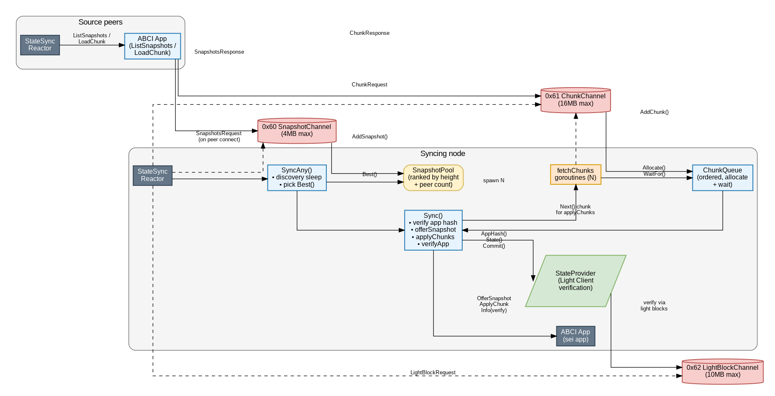
Figure 6 — P2P state sync end-to-end flow
Once a snapshot is selected, Sync() executes:
- 1. AppHash verification — stateProvider.AppHash(height) fetches and verifies a light block at height+1 from at least 2 trusted peers or RPC endpoints, extracting the committed app hash.
- 2. OfferSnapshot — the app is offered the snapshot via ABCI. The app can ACCEPT, REJECT (try next), REJECT_FORMAT (blacklist format), REJECT_SENDER (blacklist peer), or ABORT.
- 3. Chunk fetching — N goroutines (configurable, default 4) each loop: Allocate() a chunk index from the queue → send ChunkRequest on channel 0x61 → wait via queue.WaitFor(index). When a ChunkResponse arrives from the network it is fed into the queue.
- 4. State and commit — concurrently with chunk fetching, stateProvider.State() and stateProvider.Commit() retrieve the Tendermint state and commit record at the snapshot height (also light-client verified).
- 5. applyChunks() — drains the chunk queue, calling ABCI ApplySnapshotChunk() for each chunk in order. The app can request chunk refetches or sender rejections.
- 6. verifyApp() — after all chunks are applied, Info() is called on the ABCI app; LastBlockAppHash and LastBlockHeight are checked against the trusted values. A mismatch triggers errVerifyFailed.
- 7. Bootstrap — the returned (state, commit) are used by the caller to bootstrap the consensus engine.
The local snapshot path (useLocalSnapshot = true) skips p2p chunk fetching and instead calls ABCI LoadSnapshotChunk directly — used when the node is syncing from its own locally-stored snapshot.

4.5 Serving Snapshots
A fully-synced node also serves snapshots to peers:
- On receiving SnapshotsRequest: the reactor calls ABCI ListSnapshots (which delegates to snapshots.Manager.List()) and sends each snapshot as a SnapshotsResponse on channel 0x60.
- On receiving ChunkRequest: the reactor calls ABCI LoadSnapshotChunk (which delegates to snapshots.Manager.LoadChunk()) and sends the raw bytes as a ChunkResponse on channel 0x61.

4.6 Error Handling and Retry Strategy
The SyncAny() loop retries on most failures:
- errRetrySnapshot — reuse the same snapshot, retry all chunks from the queue.
- errRejectSnapshot — remove snapshot from pool, try next best.
- errRejectFormat — blacklist the format, reject all snapshots with that format.
- errRejectSender — blacklist all peers who offered the snapshot, discard their chunks.
- errTimeout — chunk not received within 2 minutes; snapshot is rejected.
- errAbort — hard stop, propagated to caller.

5. End-to-End Data Flow
Putting all three layers together, here is the complete data path for a state-sync restore:
Source node (serving)
- At each snapshot interval, snapshots.Manager.Create(height) fires. The multistore serialises all trees (MemIAVL + FlatKV) through the StreamWriter into chunk files on disk.
- On SnapshotsRequest from a peer: ListSnapshots returns metadata. On ChunkRequest: the chunk file is read from disk and returned.
Syncing node (restoring)
- StateSync Reactor discovers peers → collects SnapshotsResponse → builds snapshotPool.
- Picks Best() snapshot → verifies app hash with light client → sends OfferSnapshot to ABCI.
- ABCI delegates to snapshots.Manager.Restore() which starts the restore goroutine.
- N fetcher goroutines request chunks from source peers via ChunkRequest/ChunkResponse (channel 0x61).
- Received chunks are fed to Manager.RestoreChunk(), which verifies SHA-256, then passes the bytes to the restore goroutine.
- The restore goroutine streams protobuf items through the StreamReader → multistore.Restore() → composite.SnapshotImporter routes to MultiTreeImporter (Cosmos) and KVImporter (EVM FlatKV).
- MultiTreeImporter rebuilds MemIAVL snapshot files in a tmp dir, then atomically renames and updates the current symlink. KVImporter batches writes into FlatKV and writes a snapshot on close.
- verifyApp() checks LastBlockAppHash. On success, the node bootstraps consensus from the restored state and commit.

6. Key Design Choices

6.1 Single-operation mutex in snapshots.Manager
Only one of create / prune / restore can run at a time. This prevents concurrent disk I/O and keeps the logic simple, at the cost of not being able to prune while a snapshot is being served to a peer.

6.2 Streaming with io.Pipe and channels
The snapshot data never lands entirely in memory. The StreamWriter pipes data through the ChunkWriter to chunk files as it is generated, and RestoreChunk() passes each raw chunk byte slice directly into the goroutine. This keeps memory usage bounded to roughly (chunkBufferSize + 1) × chunkSize.

6.3 FlatKV version flattening on export
The KVExporter intentionally emits all nodes with Height=0 (leaf) and the snapshot version, flattening the full edit history. State sync only transfers the latest snapshot state, not historical versions. This makes export fast and keeps the snapshot size proportional to the current state, not the entire history.

6.4 Atomic snapshot directory swap in MemIAVL
doImport() writes into a tmp directory (snapshot-V-tmp) and on Close() renames it to snapshot-V. The current symlink is then updated. This ensures the snapshot directory is never in an inconsistent state visible to readers.

6.5 Light client requirement for state sync
StateProvider requires at least two independent RPC endpoints (or p2p peers) for cross-validation. The light client verifies a block header at height+1 to extract the trusted app hash before any snapshot data is accepted. This prevents a malicious peer from providing a valid-looking but incorrect snapshot.

6.6 Chunk hash verification
Every chunk is SHA-256 hashed on the serving side and stored in the snapshot metadata. The syncing node re-computes the hash before feeding the chunk to the restore goroutine. This catches data corruption or MitM replacement at the chunk level, independent of the higher-level app hash verification.

