1. System design

4.1.1Introduction

This System Design Document has been created to outline the proposed system design for new WSSA. The WSSA is intended to create a user-friendly and powerful tool for customers and employee of WSSA Corp. By designing, testing, and deploying the WSSA, WSSA Corp. will improve its capabilities in maintenance management, tracking, and reporting efficiency in serving customers. This document and the technical specifications listed herein comply with all WSSA Corp. technical standards and infrastructure.

4.1.2Purpose

The purpose of this System Design Document is to provide a description for how the new WSSA will be constructed. The Systems Design Document was created to ensure that the WSSA design meets the requirements specified in the WSSA project requirements documentation. The System Design Document provides a description of the system architecture, software, hardware, database design, and security.

4.1.3Goal

The new WSSA tool will provide the following capabilities:

* Integration of all maintenance data which allows for real-time report generation and simplifies management of all maintenance activities.
* Enhanced and additional user interfaces which provide users with much simpler data entry, updates, queries, and other capabilities.
* Data export capabilities which allow users to export data to various software tools for simplified reporting and presentation capability.
* It will be integrated with latest security methods.
* We will make it as easy as possible by removing all unnecessary things, and it will be straight forward.
* Because of it’s easiness user can start right in.
* Since the application is built directly for the aimed person it will be very flexible.
* Crashes can happen, but it will be recovering fast.

**4.2 Proposed system architecture**

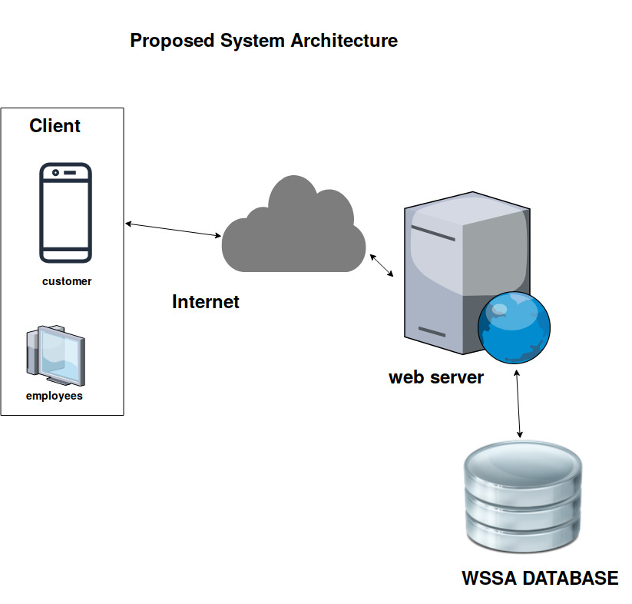

**4.2.1 Hardware**

* Server with minimum specs of.
* **CPU:** Quad core 2GHz+ CPU
* **RAM:** 6GB
* **Minimum database space:** 100GB
* Any type of computer.
* Any version of android phone.

4.2.2 Software

* Latest chrome version.

**Access control**

|  |  |  |  |  |  |  |
| --- | --- | --- | --- | --- | --- | --- |
| **Actors** | **log in** | **Manage account** | **Assign technician** | **Record meter reading** | **Manage customers** | **Approve maintenance** |
| Manager | log_in() | create_user()  update_user()  delete_user() |  |  |  |  |
| Customer | log_in() |  |  |  |  |  |
| Customer service expert | log_in() |  | get_request()  send_request() |  | create_customer()  update_customer()  delete_customer() |  |
| Technician | log_in() |  |  | record_meter() |  | approve() |

Access control matrix table for login, manage account, assign technician, record, record meter reading, manage customers, approve maintenance.

|  |  |  |  |  |  |
| --- | --- | --- | --- | --- | --- |
| **Actors** | **Register meter** | **View report** | **Make payment** | **View history** | **Send request** |
| Manager |  | view_report()  search()  get_consumption()  customer_list()  employee-list()  budget()  history() |  |  |  |
| Customer |  |  | check()  pay()  is_pay() | view_history()  check() | check()  send() |
| Customer service expert |  |  |  |  |  |
| Technician | register() |  |  |  |  |

Access control matrix table for register meter, view report, make payment, send request.