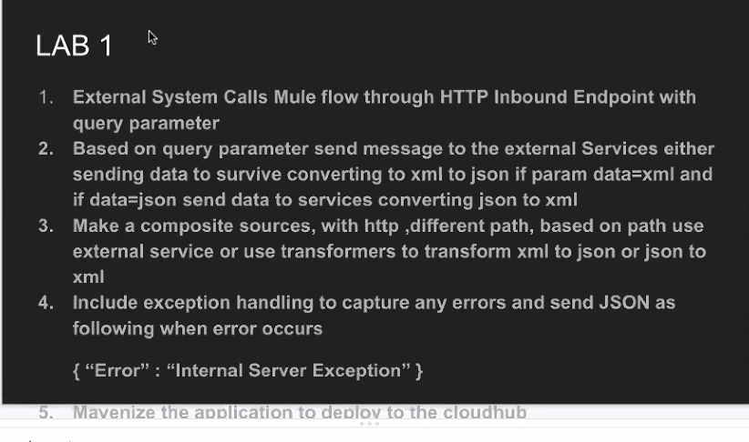

<!-- Deploy to Cloudhub --> <plugin> <groupId>org.mule.tools.maven</groupId> <artifactId>mule-maven-plugin</artifactId> <version>2.0</version> <configuration> <deploymentType>cloudhub</deploymentType> <muleVersion>3.8.7</muleVersion> <username>1234</username> <password>1234</password> <redeploy>true</redeploy> <environment>Sandbox</environment> <workerType>Micro</workerType> </configuration> <executions> <execution> <id>deploy</id> <phase>deploy</phase> <goals> <goal>deploy</goal> </goals> </execution> </executions> </plugin>