# Abstract

As the progression of smart things rises, the field has become an interesting topic to additionally investigate and adapt its concepts among us in daily basis applications. This project is set to further explore the topic of smart home and home automation systems. The project is not only for researching but also for implementing the hardware of the smart home by using a well designed passive architectural concept. The home owner can simply automate and control all of his/her home appliances through IoT and user interface with two-way communication, since all devices are connected to the web. Aside from controlling, monitoring the response and behavior of the systems is also achievable in view of the fact that all systems are connected to a cloud to store their responses.Also aims to reduced the cost of energy consumption by scheduling the home appliances to minimize their load of kwh according to a nonlinear day ahead pricing scheme to set a energy schedule control. This project aims to combine home automation with energy consumption scheduling to form a modern building utilizing modern technology to reduce power consumption.

# Contents

#### AcknowledgmentsV

1. **Introduction****1**
2. **Background****3**
   1. Smart Things 3
   2. Smart Home 3
   3. Demand Response 4
   4. Smart Grids 4
3. Proposed System5
   1. System functions 5
   2. Software required 5
      1. Raspbian 5
      2. Arduino IDE 6
      3. Thingspeak 6
      4. Adafruit 6
      5. Gmail 6
      6. Remote.it 7
      7. Motion 7
      8. OpenCv 7
4. Hardware9
   1. Raspberry Pi 9
   2. Arduino UNO 10

4.3 DHT11 10

4.4 Gas sensor 11

4.5 DS18B20 12

4.6 LDR 12

4.7 ACS712 13

4.8 TP4056 14

* 1. Relay 15
  2. Proximity 16

IX

1. Implementation17
   1. Communication 17
      1. Serial communication 17
      2. UART protocol 17
      3. Connection between Raspberry Pi and Arduino 18
      4. Proxy connection 19
   2. Role of Arduino 20
   3. Role of Raspberry pi 21
      1. Energy management system 21
      2. Energy saving routines 24
      3. Data collection 24
   4. User interface 27
   5. Security system 28
      1. Motioneye 29
      2. Facial recognition 30
   6. Power consumption calculation 31
   7. Model design 33
   8. Battery curve 34
2. Conclusion35
3. Future Work37 Appendix38

A Lists 39

List of Abbreviations 39

**References****40**

X

# Chapter 1

**Introduction**

Accessing energy is a key factor for economic growth and human development but as the world continuing to grow at a rapid pace and more demand for energy now than ever the environmental impacts have been profound on increased pace of global climate change and to meet the global energy targets the way we consume powers in our homes must transit into more automated and energy efficiency driven methods. This is where home automation comes which is the next step in transforming the way of consumption and how we interact with our homes shifting mainly consuming into interaction with our home to monitor and control to become more efficient and low carbon emission of each user. This shift falls on changing the traditionally fixed prices given to customers into a day ahead pricing information that varies based on the energy market prices allowing for smart systems to schedule and plan ahead for different times based on electricity cost.This method encourages users to shift high loads to off peak hours to reduce the monthly electricity cost and involves the user to become more energy efficient but this process is not sustainable if done manually so energy management and automation sys- tems have the ability to simplify and automate this task of optimizing energy usage by creating a schedule for all the loads each day for every hour. In conjunction with that the monitoring and control which is the interconnection of sensors and devices by software.This network connection functions to collect and exchange the data over the sys- tem.The system is mainly connected to the raspberry pi which acts as the brains of the systems and receives its commands form the user from a user interface accessible by any device connected to the internet to control a wide range of home devices such as doors, lights, HVAC, electric windows and surveillance systems. Coupled with energy saving routines this helps in driving energy consumption down and reducing our energy usage to a more sustainable levels. The rest of this paper is organized as follows.The proposed system and the software required to implement the system in Section II. The hardware used in the system is explained individually Section III. In Section IV, the softwares used in building the systems are introduced with their functions explained in Section V, the communication methods that ties the system together explains how the system can com- municate with different hardware in Section VI, the implementation of the system with all the functionality and steps are demonstrated and a conclusion in Section VII.

1

1. *CHAPTER 1. INTRODUCTION*

# Chapter 2

**Background**

This section describes the technology used in this project and their definition in order to have a greater understanding of these topics.

## Smart Things

The evolution of technology forces us to adapt with its techniques and methods. Among those methods are smart things. A thing being smart makes it capable of communicating with other things. This is where the internet of things (IoT) comes in handy. Internet of things works over a network that allows a feasible communication through all devices as mechanical, digital, etc. With the Iot, the flow of the processes goes smoothly and their structure is well defined and organized. The systems could be represented in sensors and actuators which receive signals from each other and act accordingly. A well established system with IoT is the security system. The communication goes through a cloud that is connected to all sensors/devices. Each device uploads its data of signals to the cloud that act as the brain of the overall computations. The purpose of IoT is driven from peoples’ communication as it allows devices to talk with each other and coordinate actions and responses based on a real time data and processes.

## Smart Home

The home automation is nothing but interconnection of physical devices embedded with sensors and software. The network connectivity is used to collect and exchange the data. Home automation refers to the automatic and electronic control of household features, activity and appliances. Various control systems are utilized in this residential extension of building automation. Home automation is also known as domesticsor demoniac. Mod- ern system generally consist of switches and sensors connected to a central “gateway” from which the system is controlled with a user interface that is interacted either with a wall-mounted terminal, mobile phone software, tablet computer or web interface, often but not always via internet cloud services[5].

3

4 *CHAPTER 2. BACKGROUND*

## Demand Response

Various dynamic pricing models have been proposedin literature. Some of the most commonly used ones arereal-time pricing(RTP),day-ahead pricing(DAP),timeof use pric- ing(TOUP),critical peak pricing(CPP), etc.The underlying idea behind all these models is to, firstlyreflect the fluctuations in the actual wholesale prices to thecustomers and sec- ondly, to provide economic incentives topeople for switching loads to off-peak hours. RTP is mostwidely studied pricing model in literature where customerspay electricity prices that are linked to the marginal cost ofgeneration. It has numerous economic advantages includingimprovement in overall system performance and increaseduser participation [1], [2].

## Smart Grids

The European Union has defined a smart grid as “an electricity network that can cost efficiently integrate the behavior and actions of all users connected to it – generators, consumers and those that do both – in order to ensure economically efficient, sustainable power system with low losses and high levels of quality and security of supply and safety”. The US Department of Energy (DOE) have conducted a systems analysis of the electric grid and determined that stakeholders will value a smart grid that makes improvements in the following areas:

* + - reliability: reduced outage frequency and duration, adequate power quality, and improved customer service; *•* security: reduced vulnerability to attack and natural events;

economics: downward pressure on future electricity prices, opportunities, and op- tions for consumers to save on their energy bills;[13]

*•*

efficiency: energy conservation by consumers, reduced system losses and reductions in operations, maintenance, and capital expenditures;

*•*

* + - environmental friendliness: enablement of intermittent renewables;[3]

safety: protection for line workers and the public. When all these features will be implemented, many services will build up on electrical grid; internet and electric grid will converge in a unique global network

*•*

# Chapter 3

**Proposed System**

## System functions

The built system will be capable of monitoring all the home parameters from all the sensors and the status of the devices , with also having the ability to control HVAC

, light , window , devices and receiving any alert on security or abnormal readings while also simultaneously preforming energy based scheduling based on day ahead prices.

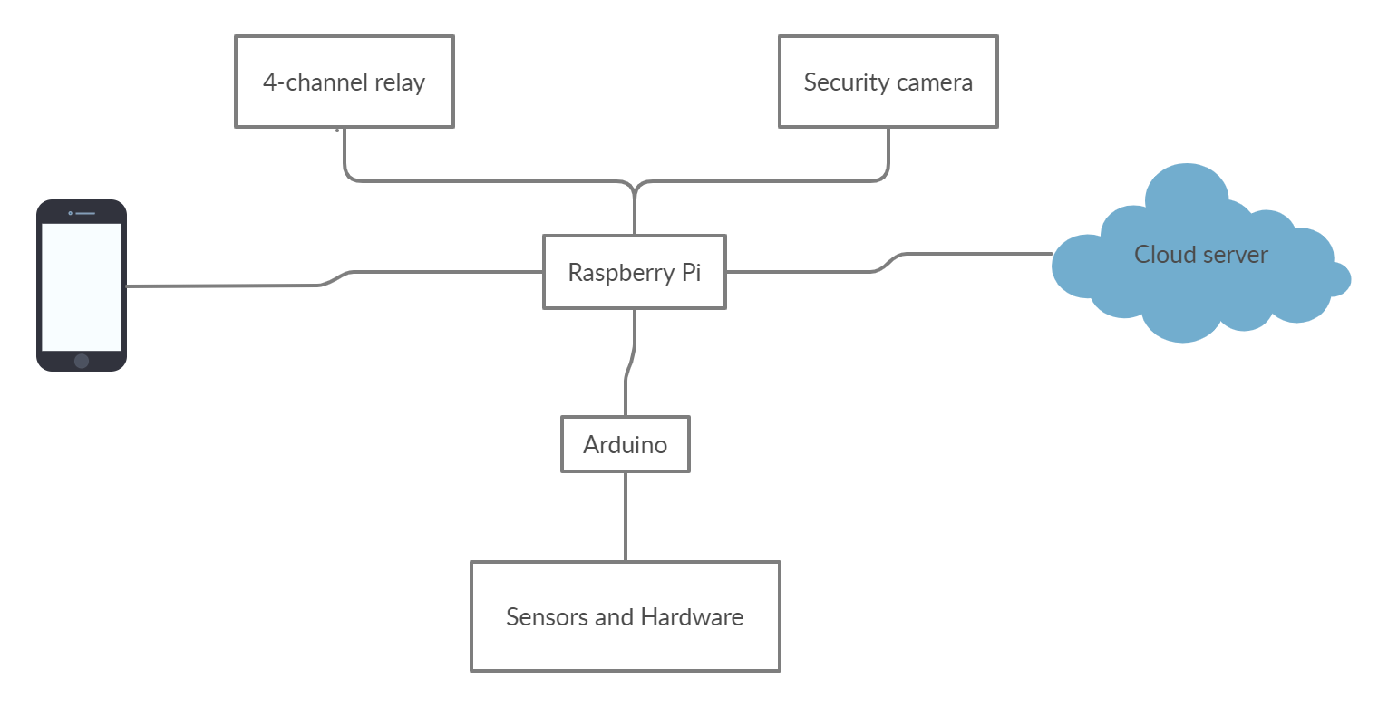

Figure 1:Proposed system diagram

## Software required

### Raspbian

Similar to other computers running on it’s own operating system such as windows the Raspberry Pi runs on Raspbian an operating system based on Debian GNU/Linux but

5

6 *CHAPTER 3. PROPOSED SYSTEM*

made to run on the Pi hardware. Raspbian can be downloaded directly from the Pi website and can be easily installed on the memory card and run on the Pi. The system consists of a desktop environment LXDE which is similar to most operating systems making it more navigable and familiar to first time users.

#### Python

While using Raspbian Python is the programming language used by the raspberry pi to implement all the programs and create the functionality and the integration off all the elements in the system.

### Arduino IDE

For the Arduino to be programmed there exists a program which is the Arduino IDE which stands for “Integrated Development Environment”. This program is download on the Raspberry Pi or computer making it a present on multiple places and easily changing or adding a program to the Arduino.

### Thingspeak

Monitoring the system happens by logging the data pulled from the sensors then displayed for it to analyzed to do this Thingspeak is used, it’s a platform used for IoT applications and suitable for this project. The data collected can be sent and viewed in real-time and displayed either by a graph or a chart indicating the time of data collected and the value itself.

### Adafruit

Monitoring data is not enough without the ability to control and take action based on this data. There are two ways of control by buttons or mainly hardware but this is inconvenient and needs to be present inside , the other way is to control all of these functions remotely on any network eliminating the need all together for hardware.

### Gmail

This software may be familiar to all and that is Gmail, it is used as a mean of sending notifications and urgent alert to quickly notify the user of an occurring event.First an email account is created specifically to be used by the Raspberry Pi.

*3.2. SOFTWARE REQUIRED* 7

### Remote.it

Remote.it is a software used to have access to the raspberry pi remotely it offers a virtual private internet service which is a secure port forward less features and eliminates open communication ports on VPNs this has the huge benefit of keeping every system secure for not having to expose the raspberry pi to external connection or implement any port forwarding to existing router setup which retains the security of the overall system. This software enables remote access to network Attached Storage devices, file servers, other in-office network assets but it is mainly used to remotely view the live feed from the camera stream.

### Motion

Motion is the software used for detecting motion for the security camera it monitors the video signal coming from the camera and detects if there is a large change in pictures.

### OpenCv

OpenCv is an open source library of computer vision , image processing and machine learning.It can process images and videos to detect objects and faces.Mainly it is coupled with the Numpy library to be able to add array operations for analysis to show image patterns and highlight it’s features.

8 *CHAPTER 3. PROPOSED SYSTEM*

# Chapter 4

**Hardware**

## Raspberry Pi

Raspberry Pi can be considered as a small computer which has most of its functionality and performance and features for a significantly lower price, it only requires a monitor

, mouse and keyboard much like a normal computer for visualizing and control and command entering. The Pi chosen for this project is version 3B+ which is sized similar to a card. The other part of Raspbian is power optimization in order to achieves it’s low power consumption it runs four protocols to be run depending on the preformed actions and activity which can make the Pi run on only 5V and 1A.

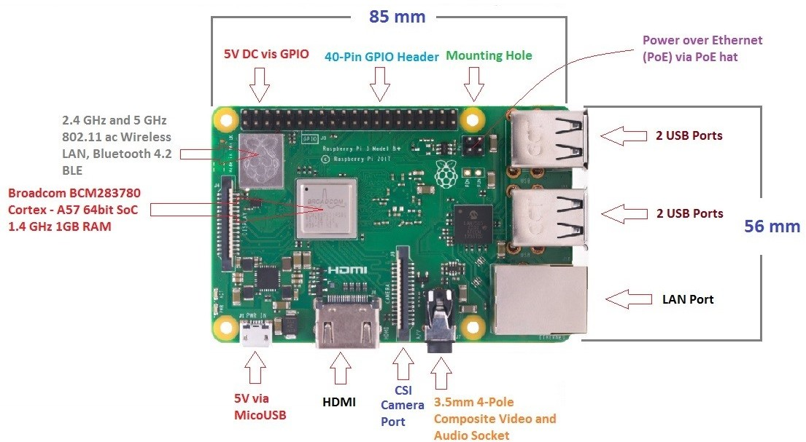

Figure 2: Shows the Raspberry Pi 3b+ used.

9

10 *CHAPTER 4. HARDWARE*

## Arduino UNO

Arduino UNO is the main interface between the hardware and the system is based in 8-bit ATmega328P which acts as it’s controller and is easily accessible only requiring a USB connection supplying 4.5V to 5V with a frequency of 20MHZ to run and upload a code once it’s uploaded and on it interacts with the components connected to it reading values from the analog and digital pins and storing the values and taking actions based on the code to write values to output pins to perform certain actions as it’s programmed.The main limiting of the Arduino UNO is that is has no means of connections such as WIFI or Bluetooth and if any of these functions are needed a shield or an external device must be added and this increases the cost and uses more resources of the Arduino in order to run it’s functionality slowing down the response and reducing performance and also uses more pins lowering the number of hardware that could be attached.

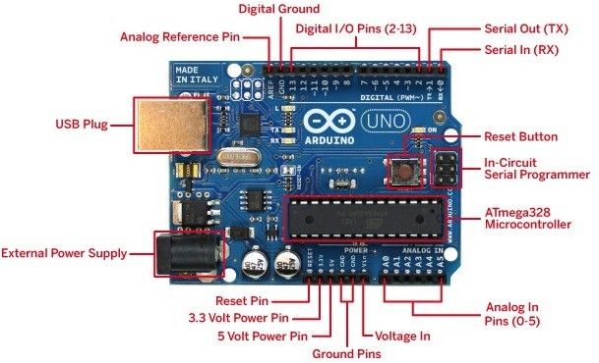

Figure 3: Shows the Arduino Uno used

## DHT11

DHT11 is a humidity and temperature sensor used to measure these parameters in the surrounding area it has a range of 20 to 80 percent with 5 percent accuracy and can measure temperatures ranging from 0 to 50 degrees Celsius with a +-2 degrees accuracy and with a readings sent every one second which translates to a sampling rate of 1Hz, it operates from a supplied voltage of 3V to 5V and a max current of 2.5mA .For the

*4.4. GAS SENSOR* 11

humidity the sensor has a capacitive measuring element which means when the value of the capacitance is changed it changes the resistance which is calibrated to output a humidity value relative As for the temperature a negative temperature coefficient ther- mistor is used which decreases the value of the resistance as the temperature increases which is then translated into a temperature value.

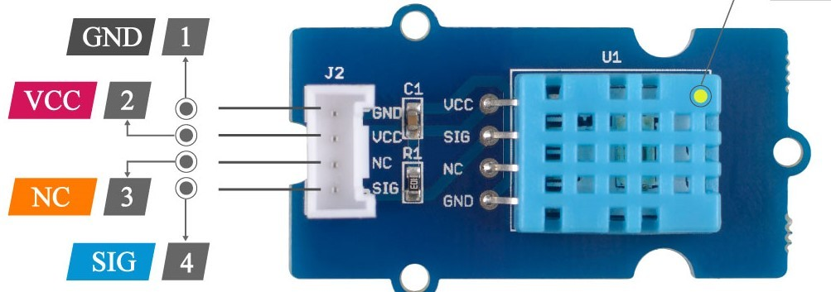

Figure 4: Shows the DHT11 sensor.

## Gas sensor

MQ2 which is Metal Oxide Semiconductor (MOS) type gas Sensor also known as Chemire- sistors.This sensor is able to detect gas leakage. The sensor operates at operating volt- age 5V ,load resistance 20 K ,heater resistance 33 5 percent ,heating consumption

¡800mw,sensing Resistance 10 K – 60 K.The sensor is made using two layers of enclosed stainless-steel mesh called Anti-explosion network.The sensor begins to work when the Tin Dioxide is heated as temperature increases, then oxygen is adsorbed onto the surface. Then the donor electrons of the Tin Dioxide move towards the oxygen which is on the surface. Thus, changing the current flow, so as reducing gases increases the density of oxygen adsorbed decreases as the electrons react with it. Leading to electrons allowing for larger amount of current to flow in the sensor. This give an analog value of the amount of gas concentration present in the air which is shown by the amount of the voltage change as the voltage increases the higher the gas concentration and vice versa.

12 *CHAPTER 4. HARDWARE*

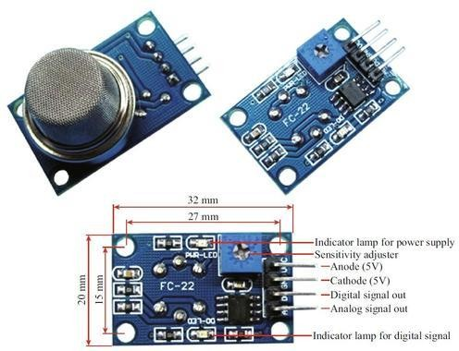

Figure 5: Shows the MQ2 sensor.

## 4.5 DS18B20

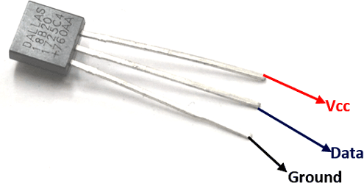DS18B20 is another temperature sensor suited for harsher environment and used to mea- sure outside temperature . The sensor can measure from -55 to +125C with an accuracy of +-5 percent and sends data in 9 to 12 bits.

Figure 6: Shows the DS18B20 sensor.

## LDR

A Light Dependent Resistor also known as a photo-resistor or as it’s more commonly known an LDR is a sensor used to calculate the intensity of light present and display it

*4.7. ACS712* 13

as a digital value. The device resistance varies as the intensity directed towards it. When the sensor is kept in the dark its resistance reaches a level called dark resistance it can reach 1012 ohm and if any light is shined its resistance decreases exponentially the works by providing a constant voltage and current is allowed to vary. This varying in results takes about 8 to 12 ms for the change in resistance to take place, while it takes one or more seconds for the resistance to rise back again to its initial value after removal of light. This is called resistance recovery rate.

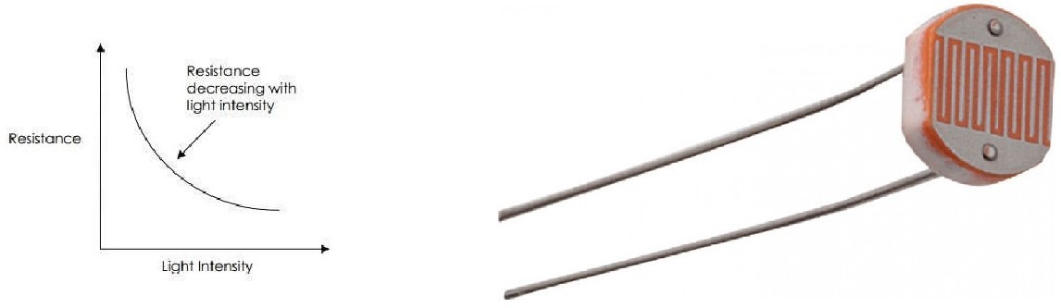

Figure 7: Shows the LDR sensor.

## ACS712

ACS712 is Hall Effect-Based Linear Current Sensor it can measure both AC and DC current and is used in this project as a power meter to monitor energy consumed.The ACS712 sensor works on the principle of Hall-effect. Which means when a conductor with current is near to a magnetic field a voltage is generated perpendicular to the direction of the magnetic field and current..The features of ACS712 include:

1-80kHz bandwidth

2-66 to 185 mV/A output sensitivity 3-Low-noise analog signal path

4-Device bandwidth is set via the new FILTER pin 5-1.2 m internal conductor resistance

6-Total output error of 1.5 percent at TA = 25C 7-Stable output offset voltage.

8-Near zero magnetic hysteresis

14 *CHAPTER 4. HARDWARE*

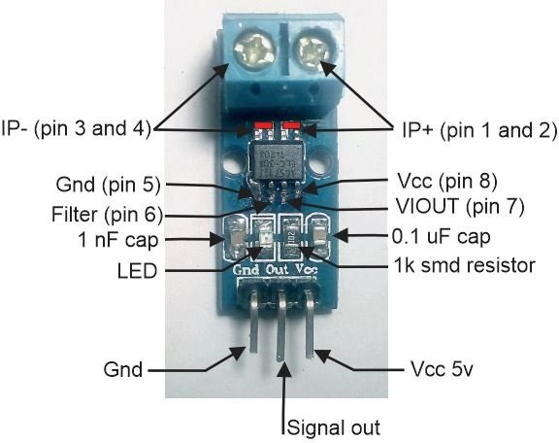

Figure 8: Shows the ACS712 sensor.

## 4.8 TP4056

The TP4056 is used for charging lithium-ion batteries which is used primarily in car batteries or energy storing systems. The main benefit for this module is that it provides constant-current/constant-voltage which for it name provides charges in two stages first by providing constant current from zero voltage to maximum and the second stage voltage is maintained constant from zero to maximum. Even though this method is more complex it is most widely used due to reducing charge time significantly. The module also has a number of features that aid in increasing the safety of charge due to the dangers with charging these types of batteries such as:

1. Over-discharge protection - which maintains a charge above 2.4V which is a healthy minimum and if it dips below it will cut power until it reaches 3V again which then will allow for discharge.
2. Overcharge protection - the module will safely charge your battery to 4.2V
3. Over current and short-circuit protection - the module will cut the output from the battery if the discharge rate exceeds 3A or if a short-circuit condition occurs
4. Soft-start protection limits inrush current
5. Trickle charge (battery reconditioning) - if the voltage level of the connected battery is less than 2.9V, the module will use a trickle charge current of 130mA until the battery voltage reaches 2.9V, at which point the charge current will be linearly increased.

*4.9. RELAY* 15

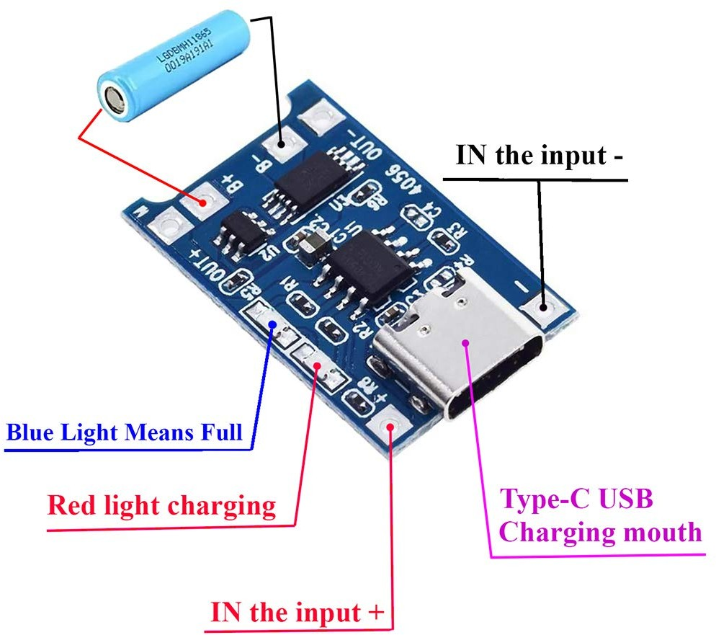

Figure 9: Shows the TP4056 sensor.

## Relay

Relay is simply a switch which operates electrically and , mechanically it consists of contacts and electromagnet which is used for the switching operation. The power is given by the control switch from the contacts of the load. As current starts flowing in the coil the electromagnet is energized and intensifies the magnetic field attracting the upper arm to the lower fixed arm creating a short circuit to power the load.The relay itself has three pins a Normally Open Contact (NO) – NO contact is also called a make contact. It closes the circuit when the relay is activated. It disconnects the circuit when the relay is inactive. Normally Closed Contact (NC) – NC contact is also known as break contact. This is opposite to the NO contact. When the relay is activated, the circuit disconnects. When the relay is deactivated, the circuit connects and a common in the middle which carries the voltage form the NO or the NC.The basic of the relay is applied to the same four channel relay used this board contains four relays connected on one PCB with four control pins connected to the board which controls each relay depending on the signal given.

16 *CHAPTER 4. HARDWARE*

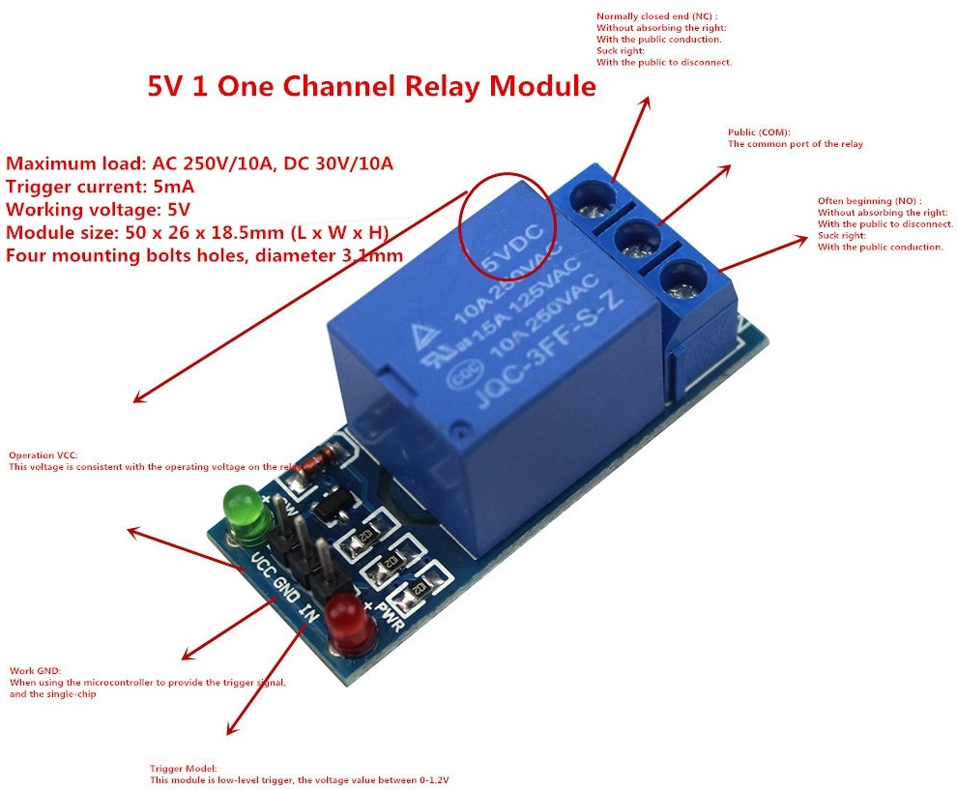

Figure 10: Shows a single relay module.

## Proximity

Infrared sensors of active types is used as proximity sensors they consist of consists of an IR photo-transistor, a diode, a MOSFET, a potentiometer and infrared source and infrared detector.The energy generated by the infrared source is reflected by an object and is received by the infrared detector when this happens a current is generated to the MOSFET to turn on the indicator LED to signal that serves as a visual confirmation that an object is detected.

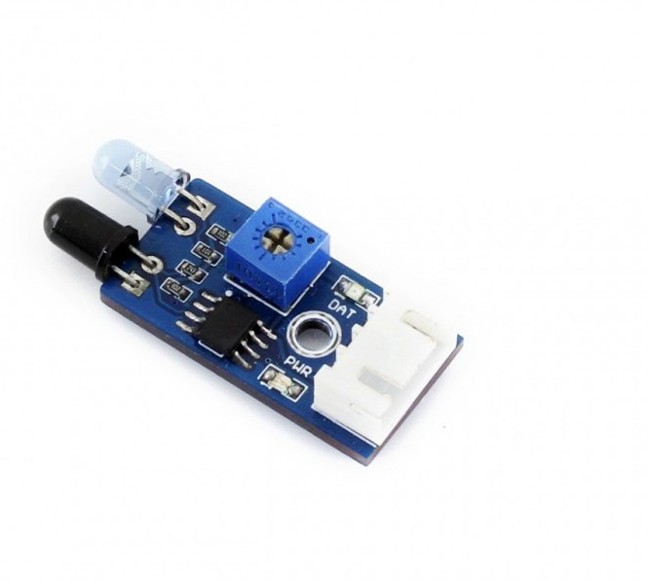

Figure 11: Shows the proximity sensor.

# Chapter 5

**Implementation**

The proposed system in this project uses the hardware and software mentioned above to create a energy management system for the home which can display all the sensors parameters and have the ability to control the hardware remotely based on these readings.

## Communication

### Serial communication

Serial communication is one of the most used method in transferring information between data processing devices it sends and receives data one bit at a time.Serial communication requires a low amount of communication lines due to sending one bit at a time thus reducing complexity and chances of cross-talk and also occupying a smaller footprint. IN order to setup the serial communication correctly a set of rules must be followed to transmit the data correctly which are Data bits, Synchronization bits, Parity bits, and Baud rate. These rules must be set to the same protocols starting with the baud rate. The baud rate must be set to the same number in both devices so the Arduino and Raspberry Pi are both set to 9600 bps. The baud rate is the speed of the data being transferring over the serial line and shows the amount of time the transmitter holds the serial line high/low. It’s the amount of time of a bit takes to be transmitted and is expressed in bits-per-second unit.

### UART protocol

UART (Universal Asynchronous Transmitter Receiver) communication methods trans- mits parallel data from a device into serial form, transmits it in serial to the receiving UART, which then converts the serial data back into parallel data for the receiving de- vice and this done by only one wire which is the USB cable. UART transmit data

17

18 *CHAPTER 5. IMPLEMENTATION*

asynchronously. Thus transmitting UART adds start and stop bits to the data packet being transferred. These bits define the beginning and end of the data packet so the re- ceiving UART knows when to start reading the bits. When the receiving UART detects a start bit, it starts to read the incoming bits at a specific frequency known as the baud rate. Baud rate is a measure of the speed of data transfer, expressed in bits per second (bps).

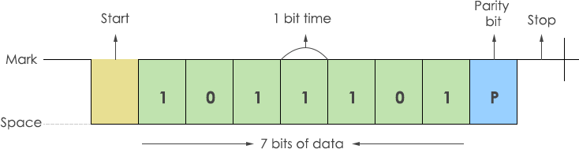

Figure 12: Shows how data is transmitted.

### Connection between Raspberry Pi and Arduino

With our project which involves several functionalities at the same time, requires easy access to the Internet and also needs media accessibility, and requires easy reads from easier to connect to analog sensors and expecting to do only a few outputs based on the sensor data, communicates easily with other machine parts. The problem is the Pi has a lot of high-end capability, but interfacing with hardware can be very tricky with Linux. It’s not a real-time operating system, and getting Linux programs to work with new hardware is tricky. On the other hand Arduino has no operating system, and can work at the hardware level with no restrictions. The Arduino will act as a buffer between the Pi and the custom hardware. The Pi will be used handle things like accessing to the internet. It would communicate with two Arduinos which would hide the hardware details. At the Pi level we don’t need to worry about how the Arduino does it. The data is sent and shows it up on the display a task that’s pretty easy with Linux. At the Arduino level, we don’t need to worry about what to do with the data. The hardware is connected and reads then store the data. When a command comes in, you just send the data off using serial communication thus using the best of the two devices to build the system.

The data sending between Raspberry Pi and Arduino uses UART serial communica- tion they are connected using the USB ports in the micro-controller as the Pi has four inputs this is done over connection with pins to reduce amount of wiring and due to both boards running on different voltages and can cause significant damage if not connected correctly. Each Arduino once connected to the Pi is develops a unique address which can be any number ranging from /dev/ttyACM0 to /dev/ttyACM4 and this address is added to the code to correctly sends a signal to the correct board. This address can be identified through the terminal using ls /dev/tty* code which shows all devices connected

*5.1. COMMUNICATION* 19

and their specific address. For the Ardunio it’s much simpler as only a command from writing and receiving from the serial with no need to setup any additional codes or ad- dress.The data in each code follows the same process weather its on the raspberry pi or the Arduino firstly all the variables are read from their respective sources then collected in an array with a specific order then data is encoded into ”UTF-8” for the data to be readable between the two devices then after receiving the array a loop is done over it to extract each variable depending on it’s position.Thus method of array is implemented for two reason firstly for easily adding new variable to the system as it will be easily added to the end of the list and change the number of the list for the receiver, the other reason is for reducing data loss as much as possible as serial communication can skip a reading if there is a lot of data transmitted in the same time so a list sends all the data collected in one message and then stored inside the program.

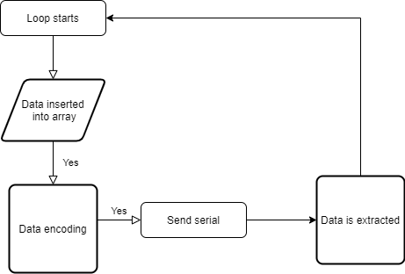

Figure 13: Shows flow of data between Arduino and the Pi.

### Proxy connection

A proxy server is a basic three-way connection between two devices and a hub through which requests are revived and processed by sending a request through the first computer to the server then returns the needed data from the other computer. This serves as a middle man between the raspberry pi and any other computer wishing to connect remotely and with any network not only the local network. This is used to connect the camera feed and generate a link which is saved with the user to be able to monitor the camera remotely without the need to be on the same network.

20 *CHAPTER 5. IMPLEMENTATION*

## Role of Arduino

The system has two Arduinos connected to the USB ports of the raspberry pi and each serves a different function. The first Arduino which can be considered a collector it has all the sensors and hardware that reads a parameter or receives an input from the user, the Arduino is used for collecting data for the versatility of the board to read both digital and analog input which is an edge over the pi and opening up the range of sensors chosen.The other Arduino is the receiver and gives the signal for the devices connected to the system to be turned on or off or based on the functionality of the components it receives the commands coming from the raspberry pi then takes action based upon it, all of the devices in system are represented by a LED to indicate the status other than that two servo motors are attached for the doors and the window. The other important factor in the use of Arduino in this project is done due to it having analog reading capabilities which is crucial in reading voltage and current which is done through the analog pins this happens by connecting using the multichannel 10-bit analog to digital converter which can read voltages from 0V to 5V and converts the to a integer value between 0 and 1024 which then can be translated into voltage by using this value and applying a simple cross multiplication this is used in two applications and will be further discussed below, the other reason is the ease of uploading and interfacing with sensors and hardware and the extensive libraries this makes the connecting to hardware easier and more efficient compared to only connecting to raspberry pi directly freeing up the processing power for managing the server.

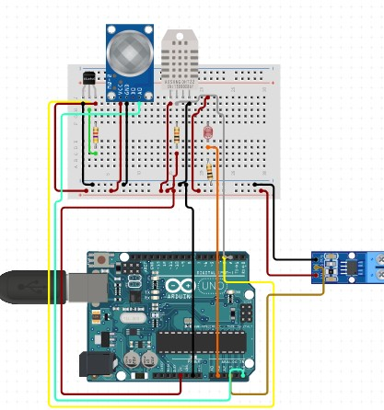

*5.3. ROLE OF RASPBERRY PI* 21

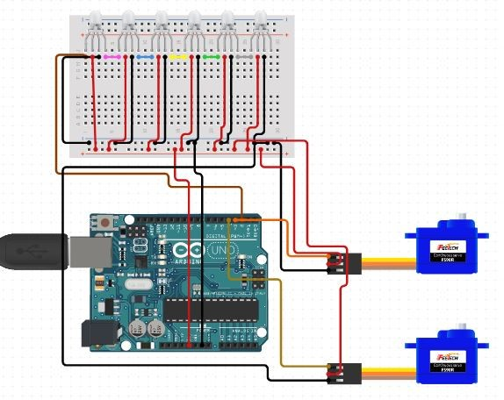

Figure 14 and 15: Shows the collector and receiver Arduinos.

## Role of Raspberry pi

The raspberry pi has the most impact on the system it has several roles which will be divided and explained in the next subsections and these roles consist of the energy scheduling algorithm and control of relays, the setup and connection to thingspeak , receiving and sending data to adafruit ,energy saving routines , emergency routines , communicating with user and controlling and feeding the live camera feed.

### Energy management system

Energy management system works by a basic concept which is to get the day ahead prices for electricity which can be accessed online the raspberry pi does with web scrapping a table which shows the day ahead prices. Web scrapping is a technique in which a code is given a certain web-page which it can automatically access and retrieve large amounts of data that could be used further in the code.This is done mainly by allowing the pi to

22 *CHAPTER 5. IMPLEMENTATION*

access the given website and searching in the source code for the table which is defined by tags ¡tr¿ which is the start of the table once this is found the ¡td¿ which is the table data is extracted and since we are dealing with a constant 24 variable the are inserted in a one dimensional list which in each position represents a different hour of the day, the one dimensional list is done solely for the the ease of looping over the variables as it is much faster and simpler over looping over two dimensional arrays. When the prices are acquired the system forms a scheduling algorithm based on some key parameters in which they are the number of devices present inside the house, how long each device is allowed to be operational during the day, the minimum and maximum amount of power used per device each hour and the maximum energy allowed for the day.With these variables the below equation is used and is limited by four constraints.

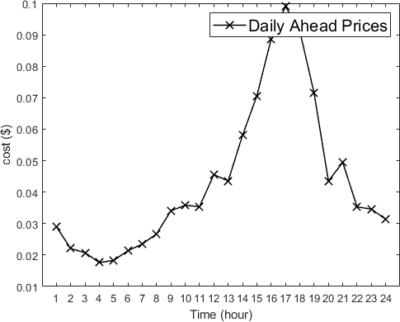

Figure 16: Shows the price fluctuation during the day.

minΣ24 *P* Σ *xh*

Σ*ββ*

1 *a*

*xh* = *E*

*h*=*αα*

*a*

*a*

*γmin ≥ xh ≥ γmax, hs*[*αa, βa*]

*a*

*a*

*a*

x*h* = 0*, hφ*[*αa, βa*]

Σ*asA x ≤ E , Hs*[1*, ..., H*]

*a*

*h max*

*a*

These equation works as follow the first equation which is the optimization problem states that the sum of the 24 hours of the day multiplied by the sum of energy consumma- tion of each device for each hour must be at a minimum value subject to firstly the sum

*5.3. ROLE OF RASPBERRY PI* 23

of all devices through out the day must not exceed the maximum energy consumption limit ,secondly each device for every hour it’s allowed to operate it must be between it’s maximum and minimum power consumption limit and a addition to this constraint out- side it’s working hours the consumption must be zero and the fourth and final constraint sums all devices consumption for each hour and limits them below or equal an hourly load. The raspberry pi is given all for all of these devices and calculates the optimal schedule for the day then it’s sent to a processing code which takes this schedule that is in a 4x24 matrix each row represents the device hourly consumption the algorithm filters them and controls the relays connected to each device if the consumption is above the device threshold thus forming an energy scheduling algorithm.

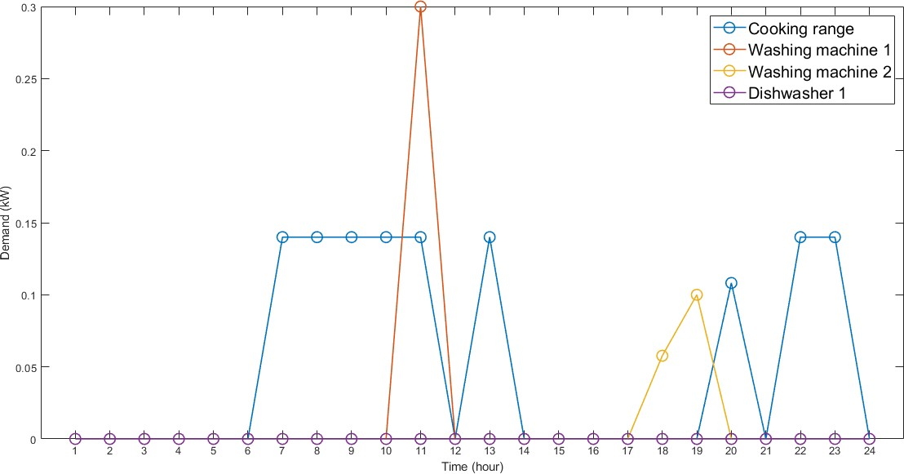

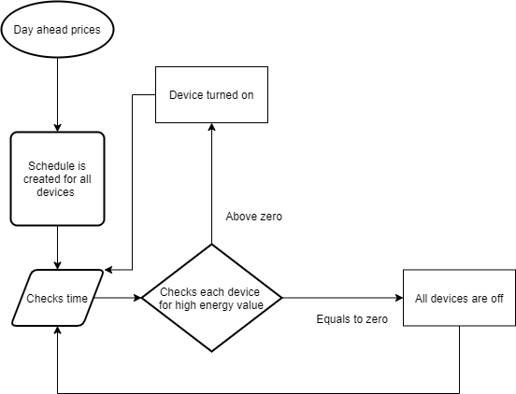

24 *CHAPTER 5. IMPLEMENTATION*

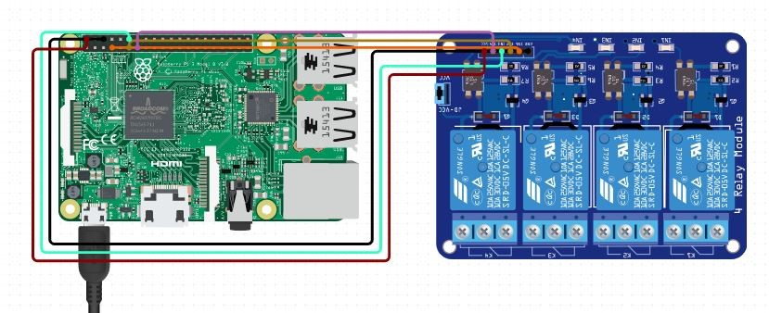

Figure 17 ,18 and 19: Shows the schedule produced and the flow of the algorithm and the connection of the hardware.

### Energy saving routines

The system also supports a couple of features to aid in energy saving firstly is the light control depending on the time of day , the feature works by inputting the coordinates of the house and this generates two variables the sunrise and dawn time of the day this coupled with the outside temperature and window input of the user runs an algorithm to control the shades if temperature is too high shades open at a low angle to preserve the coolness inside the house and the opposite happens if temperature is moderate it opens at a higher angle to help in regulating the temperature in both cases this shuts down the lights automatically and uses natural sunlight. The window angle could also be overridden by the user if a larger angle is required. The second feature is the ”Away Mode” which can be turned on when leaving the house this mode controls all the lights and devices except the devices connected to the ESC and automatically shuts them off

, this is done to quickly and to confirm all devices are off during times which there is

no presence inside the house to save on energy consumption. The last one is motion detection to control inactive spaces, this is done by monitoring a presence inside the room continuously if the sensor is detecting someone in the room the devices and lights are turned off but once the room is left the a timer begins for a set amount of time if the sensors doesn’t read anyone in the room the devices automatically shuts down saving on energy consumption by reducing amount of unused devices.

### Data collection

Data collection is done through the collection of all sensors data and forming a server which all of this data is stored through out the day and can be accessed and downloaded to be further processed and determining an overall behaviour. This process starts from the Arduino collecting all the data in a list which consist of temperature inside the house and outside, humidity inside the house, light intensity outside , energy consumption

,battery charge level for electric vehicle and the gas level then sending through the serial communication to the raspberry pi which then extracts each value from the list and assigns it to a specific parameter.

* 1. *ROLE OF RASPBERRY PI* 25

#### Thingspeak

Thingspeak using a system of channels where as each channel can store up to eight parameters which are the number of data needed to be uploaded. Then each parameter of the channel is given a unique id which is then copied onto the pi to be assigned to it’s specific sensor value and a authentication code for extra security can store each value to it’s specific place forming a server for the system.Once all is setup all data is presented in a graphical presentation which shows each individual value uploaded with its timestamp these data is stored continuously and can be downloaded once again in a CSV file format.

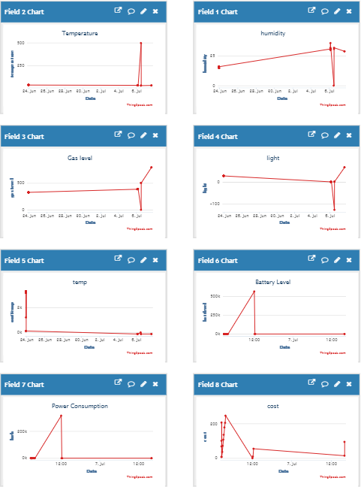

Figure 20: Shows sample data that was collected from the system.

26 *CHAPTER 5. IMPLEMENTATION*

#### Google cloud

Prior to thingspeak google cloud was used,this was done due to the functionality and features that google cloud provides such as data studio and machine learning algorithms and many other that aids in processing and manipulating data with ease. The raspberry pi google’s account was used as each account has a credit of 300 dollars on google cloud once signed up.The setup process was first started by setting up google cloud then a project will be created which can be considered as the file to store data and be used for any functionality in the cloud service, then we add three APIs which is basically a interface which dictates the interaction between the softwares and guidelines for requests and data formats to enable to build the servers. These are Data-flow which manages google cloud data-flow projects,Cloud Pub/Sub API which handles sending and receiving messages among applications and services and the last one which is Cloud IoT API which registers and manages IoT devices that connect to google cloud.After all APIs have been added we now use google IoT core service to create a registry which will connect to the raspberry pi and receive data incoming, then all data will be stored in google Big-Query which will contain a table with each field representing a sensor but the data in this form might not be easily understood and needs preexisting knowledge of system setup thus to ease the process all of the data is then used in google’s data studio which then each data is represented in a graph for a more easier representation. But it must be noted that thingspeak was ultimately used due to preserving the credit that was given before.

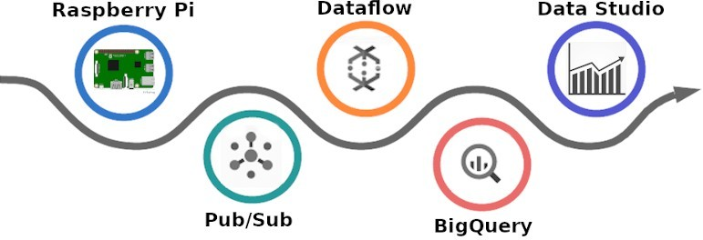

Figure 21: Shows the flow of the data from the Pi to the cloud.

* 1. *USER INTERFACE* 27

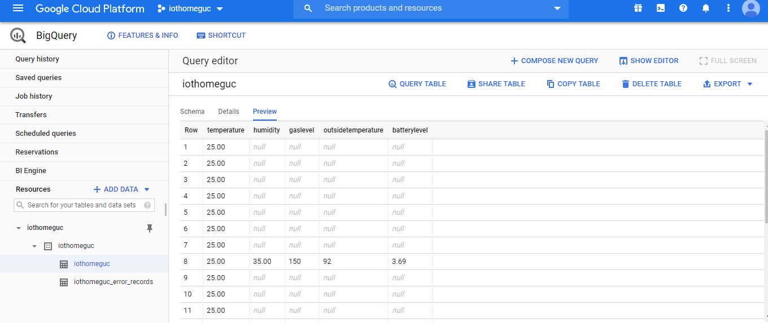

Figure 22: Shows actual sample data uploaded by the Pi.

## User interface

For the system to become more user friendly a user interface was implemented it is divided into two parts monitor and control.The monitor parts has all the parameters taken from the server and displays the last submitted value with an icon and a title to describe what does the value represent other than that for each critical parameter such as the gas level an light indicator is present below to signify if there is a problem.The other part in the monitoring is the state for each of the four devices controlled by the energy management system, these state are represented by a toggle for each device which switches every time a signal is given form the schedule to turn the device.The other part of the user interface is the control part which consists of controlling eight devices through the system six off them are on and off devices which can be toggled any time by the user and the other two are a slider for window position control and a control for the HVAC temperature all are updated regularly to monitor the state as some operate automatically based on predefined functions and all of this can be accessed and controlled remotely with no need to be connected on the same network.

28 *CHAPTER 5. IMPLEMENTATION*

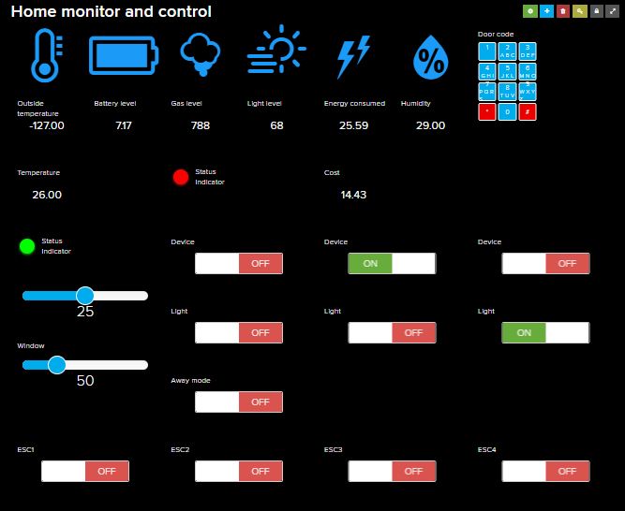

Figure 23:Shows the final layout of the user interface.

## Security system

The security system constantly monitors the perimeter using visual and motion sensing. The visual part is done by using a simple camera connected to the raspberry pi, this camera is setup to be connected with motion software installed on the raspberry pi this enables the camera to have motion detection abilities which triggers the camera to take photos every time motion detected and if there is no motion a continues video is being recorded and uploaded to the google drive account of the raspberry pi and can be accessed and downloaded if needed, the use of google drive is done to save up storage space of the raspberry pi an hard drive extension could be added but this option enables remote and convenient access from anywhere.The monitoring system feed can also be accessible remotely to be able to view the footage of the camera.The configuration for the camera was done in two processes first to configure the motion software this was done by changing the following parameters setting ’daemon’ to ON which automatically starts motion as to eliminate the need to manually starting every time the system restarts, then changing web control local host’ to OFF to allow external devices from other networks to access the feed and ’Stream port’ to 8081.The other factors was done based on a trail of mixing the

* 1. *SECURITY SYSTEM* 29

best quality while maintaining the response speed due to connection speed setting frame rate to 1500,’Stream quality’ to 100, ’quality’ to 100 ,’width’ and ’height’ to 640 and 480 and finally the ’post capture’ to 5 which specify the number of frames to be captured after motion has been detected.The other part of the security system is the placement of motion detection sensors they are placed on each corner of the model each covers a side and they are connected to the raspberry pi directly then if a motion is detected it automatically sends an email to the user to notify that there is a security alert and then can show the drive for all the footage needed.

### Motioneye

To keep with the ease of interfacing with the system, motion alone was insufficient in the security system as any modification requires to change the variable in the configuration file which for any end user is not acceptable, so motioneye was used which is simply a web-based front-end for motion which takes all the functionality of the software and implements a friendly user interface showing the live feed and all the options the users prefers to setup such as controlling the resolution to save storage and the frame-rate

,setting an upper and lower detection threshold for the integrated motion detection. having MotionEye draw a box around the change it detects inside the frame ,changing the format of recording feed, choosing between a continuous recording and a recording triggered by motion detection,selects where top-load the videos to an FTP or SFTP Server or to Google Drive , re-streaming all the camera’s video streams and taking a quick snapshot.Thus allowing for an easy interface between the user and the adjustment of the camera settings.

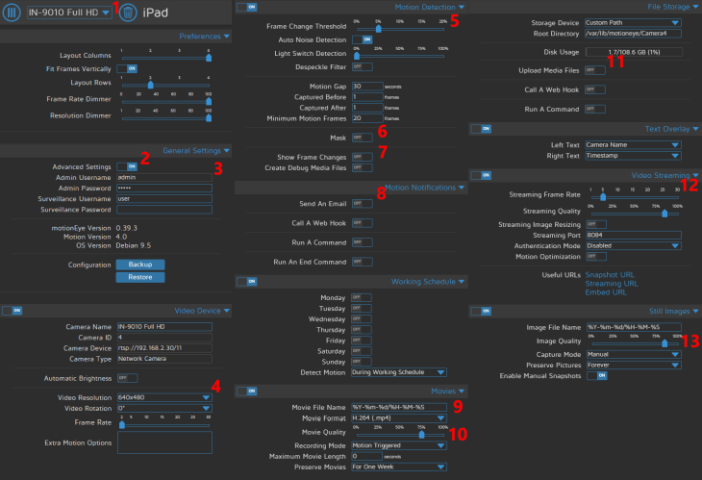

Figure 24: Shows all the configuration settings available.

30 *CHAPTER 5. IMPLEMENTATION*

### Facial recognition

The facial recognition is the final part of the security system it is divided into three main parts acquiring the feed and detection of faces, face recognition by checking each face with the known data present in the system and finally the action part based on the result of the facial recognition. First of all a webcam is used again in order to input the feed to the system this is done by using openCV software and by using the videocapture method which capture all the frames coming from the webcam and can be used to get each frame indivisually by using the read function which grabs from the video each single frame which then could be then used further in the program.It’s well known that openCV can be used for facial recognition and has many algorithms and functions that supports this feature but for this implementation face-recognition library was used for it’s simplicity of implementation and a slightly faster performance which saves up from the limited resources of the pi. This library works by using the dlib for python which basiclly includes many machine learning tools enabling us to extract detects faces and identify them. This works by firstly providing images a reference this worked on by firstly using Histogram of Oriented Gradients (HOG) to detect faces this simply works by converting each pixel and calulate the darkness of the pixel and showing an arrow for which the image it getting darker this is repeated for each pixel and ends up by replacing them with arrows flowing form light to dark colours then after taht the image will be broken up to 16x16 squares and take the strongest direction in each this will result in capturing the basic structure of a face.Then this is pased to an another algorithim called face landmark estimation which will come up with 68 specific points refered to as landmarks which are defining features on faves such as the top of the chin, the outside edge of each eye, the inner edge of each eyebrow and this will mark and produce an output image which will be perfectly centered for using it in defing different faces.After this is done the images are passed to a pre-tranied neural network which generates 128 mesaurments for each face and compares them togther which done using the enconding feature and output the result and since this neural network is trained it is just needs two images and will output it’s result with high accuracy.

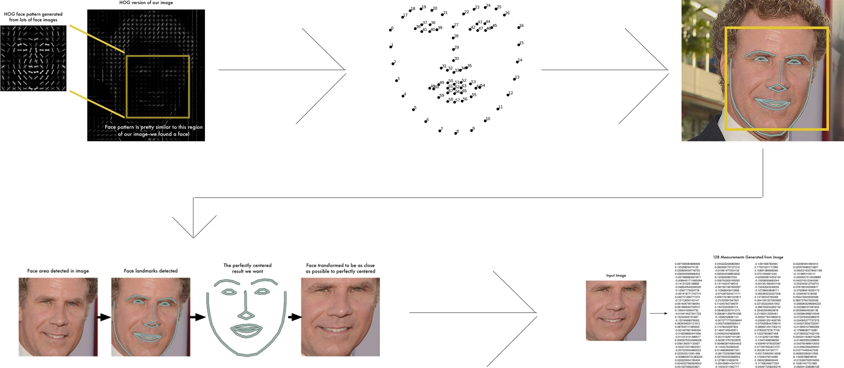

Figure 25:Shows the steps taken in processing each image.

* 1. *POWER CONSUMPTION CALCULATION* 31

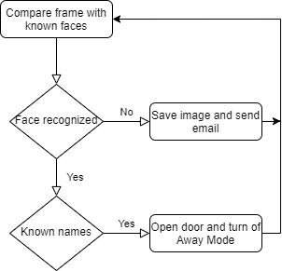Since the workings of the libary is clear the workings of the code is as follows a file was created with all the known faces images of myself was added with the ability to add any number of other persons as we would like, then for my set of images I define an name which will be shown on the feed when the algortihm recognizes my face once all of this is done the code runs and captures each frames and compares it with known images if a match isn’t found it’s marked as unknown and the image is saved on the pi then is sent usning the pi email with the date and time and the image attached to be permanitly saved and immeditly notifies the occupants.The other option is for the image to be recoginized for one of the predefined persons for this option there are two actions taken first the ’Away Mode’ is turned off as this signals that someone is entering the home and the other thing the automatic openning of the main enternace.

Figure 26:Shows a flowchart of how the code runs.

## Power consumption calculation

The power supply for the entire system comes from a wall outlet so every component is connected to the same source thus power consumed can be calculated by knowing voltage and current and since voltage is known to be a constant 240V the remaining factor is the current so the current sensor is used and calculates the power using the following equations:

VoltageRead = ((maxValue - minValue) * 5.0)/1024.0

32 *CHAPTER 5. IMPLEMENTATION*

VRMS = VoltageRead *0.707;

Amps = (VRMS * 1000)/mVperAmp Watt =Amps*240

Wh = Watt * (time / 3600000.0); Kwh=Kwh+(Wh/1000);

These equations are used to calculate the power consumption of the entire house.The first equation is to obtain the output of the sensor which is in voltage analogous to the current passing through firstly the Arduino reads voltage from 0 to 5V into integer values from 0 to 2*10-1 i.e. equal to 1024 so we multiply the value with 5 and divide by the maximum number which is 1024 to get the value then is compared with predefined values to obtain the maxValue and minValue part of the equation is to find the absolute peak and then this is multiplied by 0.707 which is root two to get the voltage RMS,the second equation is to calculate the current after we read the output from the sensor it is then converted to mV so we can multiply by the sensor sensitivity which is 66 mVperAmp to get an accurate value.Then the current value is the multiplied by the constant voltage number which is 240 to get the power in watt.Then the time since the program started to run which is in millisecond is converted to hours and multiplied to the watt to obtain the watt hours then is divided by 1000 to add to the cumulative kilowatt hours used by the system .

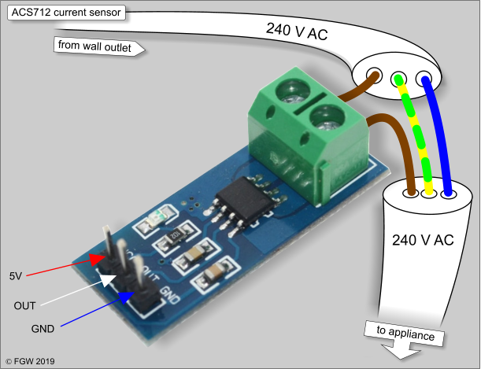

Figure 27:Shows the connection of the sensor with power source.

* 1. *MODEL DESIGN* 33

## Model design

The housing project is meant for a family of 3.The plot is surrounded by neighboring buildings from 3 sides and a main street from the 4th side. The house within the plot is positioned in a semi-central manner, allowing for an open small garden view from 3 sides of the house. The main door on the street welcomes you into the ground floor through an interior double-height lounge. This double-highted spaces plays a critical role in ventilating and cooling down the upper floor. It also offers a tranquil natural space within the walls of the house. From the lounge, you access the main reception area where the circulation stairs instantly reveal themselves. The lounge and reception area are elevated by two steps, creating a psychological division of the spaces in this vast open plan of the ground floor. On the lower level of the steps, the dinning area, a secondary seating space, and service areas (toilet and kitchen) are situated. The dinning area also hosts a door to the backyard of the house, pushing air and sunlight through the spaces of the floor. The kitchen takes in the sun and the garden view as well. Taking the stairs up, a big retractable window opens up to the double-highted lounge downstairs; connecting the view to its greenery. The whole of the upper floor is a strictly private space for the family. It consists of two bedrooms, a bathroom as well as central living space where the family can gather.

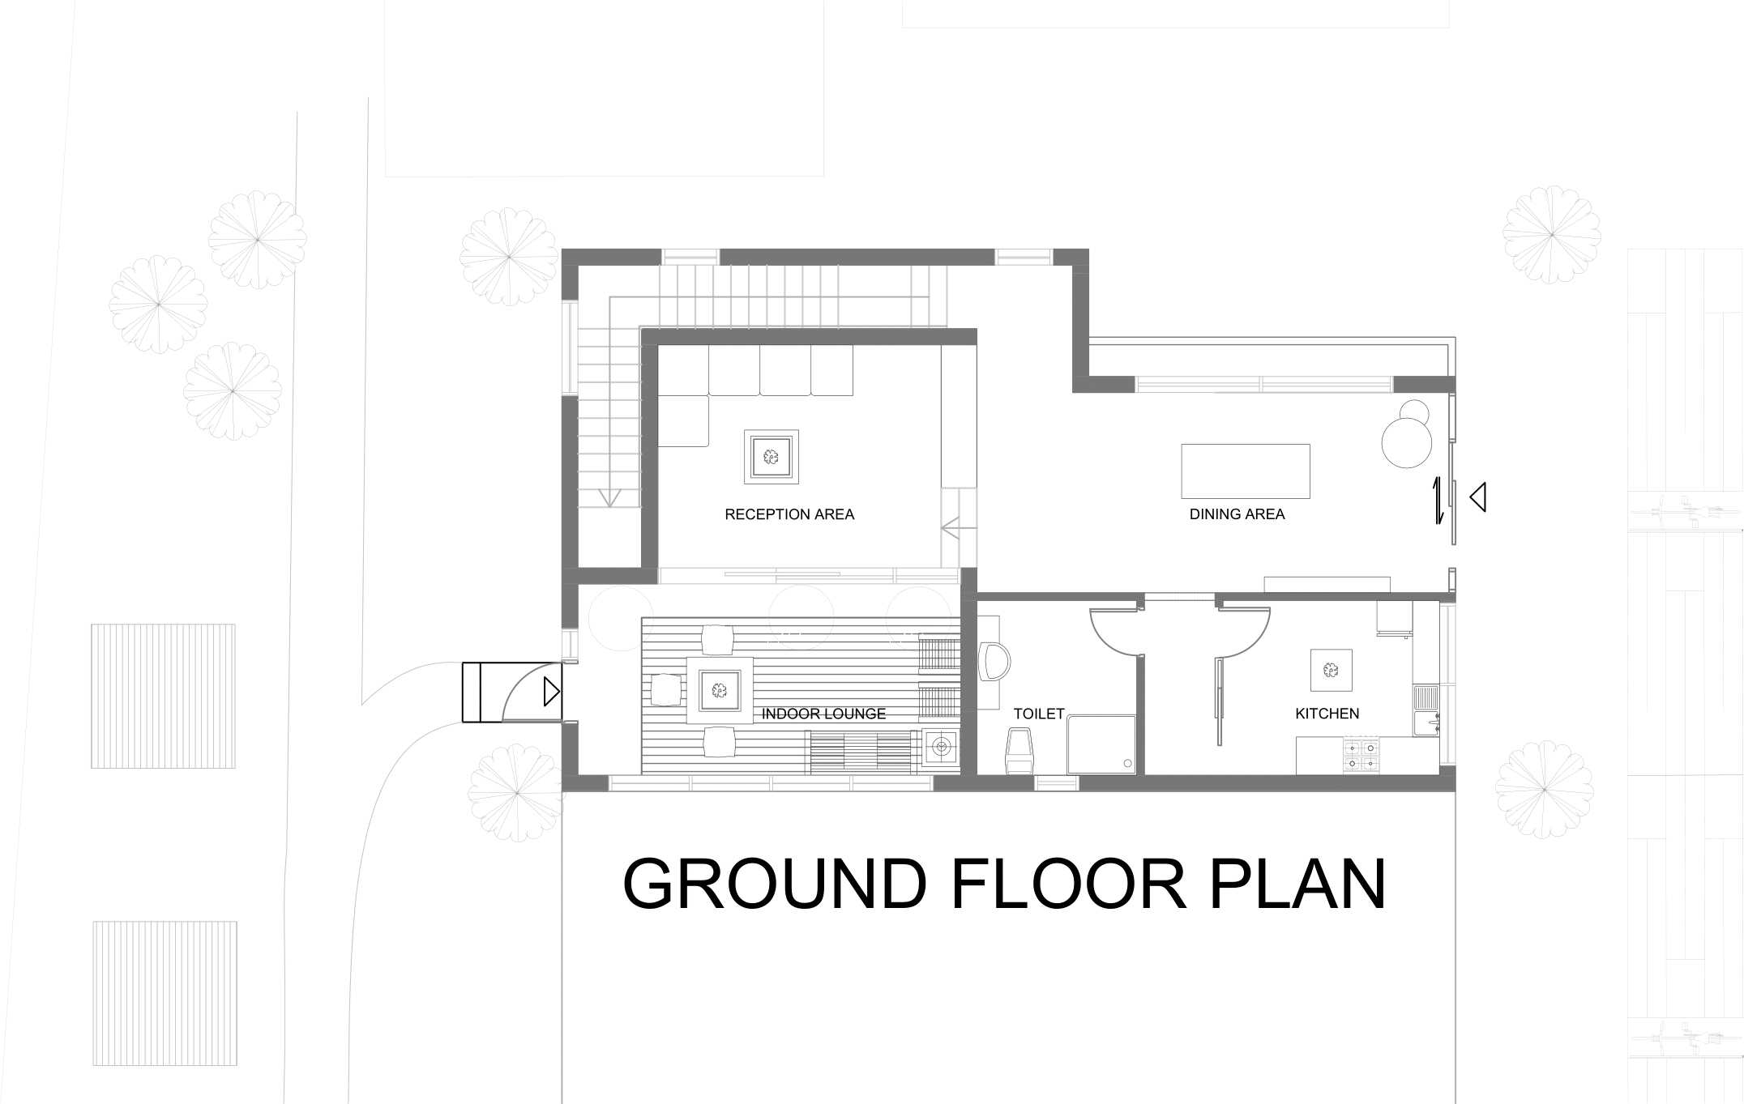

34 *CHAPTER 5. IMPLEMENTATION*

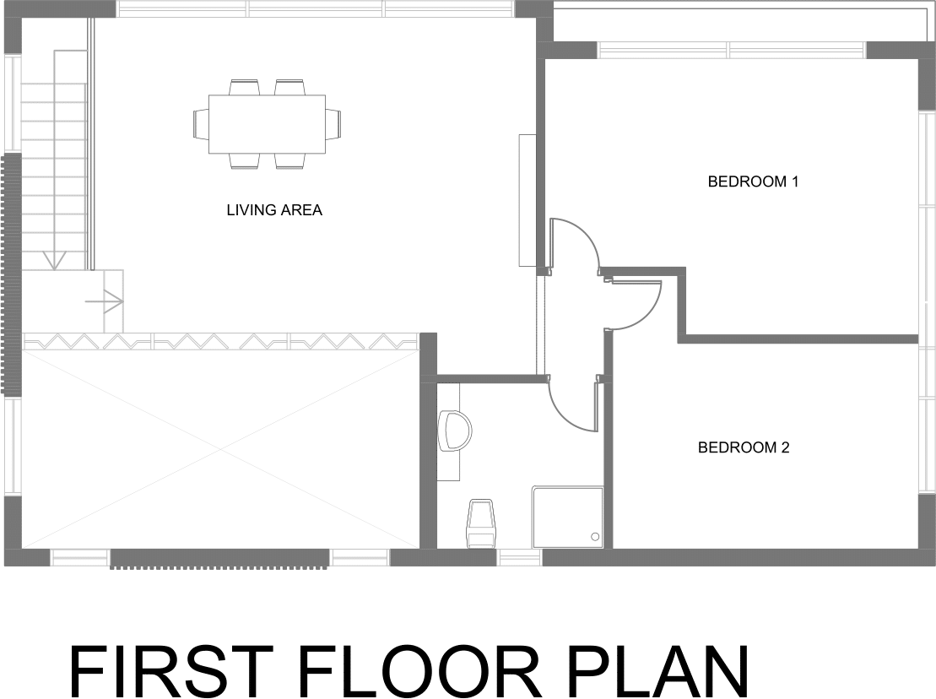

Figure 28 and 29:Shows the plan for the design of the house.

## Battery curve

In order to have an accurate estimation for the charge level of the battery and remaining charge time as we use a single lithium ion battery to represent an electric car charging.The battery is tested in two ways full charge time and full discharge time , firstly we charge the battery using the TP4056 sensor until a max voltage is read and is stable for an amount of time which as tested is 4.10V which will be considered full charge.Then a simple circuit is implemented where it involves a battery as a supply in parallel with load with known resistance and all connected to the Arduino.By following these equations bellow:

voltage=value/1024*5.0; current = voltage/resistance;

capacity=capacity+current/3600;

The first part is measuring the voltage of the circuit by using the same equation used to measure voltage by the analog pins of the Arduino.The second part is using the known voltage divided by the resistance gives the current flowing then this current is divided by 3600 to convert to Ah (Amp per Hour) then added for each loop until the battery is fully discharged then the capacity and discharge time is obtained.

# Chapter 6

**Conclusion**

This paper introduces a combination of home automation and control technology with a energy scheduling control. By this system the users will have the ability to transition form just an end user to an efficient home which will lower energy consumption by choosing lower price periods for devices and by automatic energy saving routines coupled with direct control over all devices.This was done by formulating the optimization problem based on devices present inside the system and retrieving their specification and using for cost minimizing based on the energy market prices and by doing this it will help reduce energy loads on the grid in peak times.This also with the remote user interface for the system which will monitor all aspects making the task of reducing energy less time consuming and even encouraged.This model helps in proving that the IoT will be growing and become the next norm in our life in our home products to increase family safety, specifically related to fire protection and carbon monoxide monitoring. At the present time a few devices at home are connected but in the future IoT will connect all devices.

35

36 *CHAPTER 6. CONCLUSION*

# Chapter 7 Future Work

Future work may include several improvement in these key areas.Firstly the system could add renewable energy sources which can be used to supply energy independent from the grid to drive energy consumption even more and could even potentially be connected back to the grid to sell off excess energy.The second part is to utilize machine learning by collecting enough data on the usage of the user inside the house a profile could be made to predict future behaviour and optimize the system and automate some of the manual decision taken.The last part is to improve on the software used by making the Pi run a dedicated home automation software and transforms the Pi from running Raspbain into having the sole purpose of monitoring and controlling the system.

37

# Appendix

38

# Appendix A

**Lists**

List of Abbreviations

|  |  |
| --- | --- |
| HVAC | Heating, ventilation, and air conditioning |
| LDR | Light Dependent Resistor |
| UART | Universal Asynchronous Transmitter Receiver |
| Pi | Raspberry pi |
| UTF | Unicode Transformation Format |
| ESC | Energy Consumption Schedule |
| API | Application Programming Interface |
| IoT | Internet of things |
| SFTP | Secure File Transfer Protocol |
| FTP | File Transfer Protocol |
| VPN | Virtual private network |
| IDE | Integrated Development Environment |
| CSV | Comma-separated values |

39

# Bibliography

1-W.Burke and D. Auslander, “Residential electricity auction withuniform pricing and cost constraints,”presented at the North Amer.Power Symp., Oct. 2009.

2-P.Centolella, “The integration of price responsive demand into re-gional transmis- sion organization wholesale power markets and systemoperations,”Energy, vol. 35, no. 4, pp. 1568–1574, 2010.

(PDF) Implementation of home energy management system with optimal load schedul-

ing based on real-time electricity pricing models. Available from: h[ttps://www.researchgate.net/publica](http://www.researchgate.net/publica)

*timeelectricitypricingmodels*[*accessedJul*292020]*.*

1. Jiang, J., Kou, Y., Bie, Z. and Li, G., 2019. Optimal Real-Time Pricing of Electricity Based on Demand Response. Energy Procedia, 159, pp.304-308..
2. International Journal of Recent Trends in Engineering and Research, 2018. Wi-Fi Based Smart Home Automation Using Raspberry Pi. pp.89-93.

4-J.Jeyapadmini, K.R.Kashwan, “Effective Power Utilization and conservation in Smart Homes Using IoT”, 2015 International Conference on computation of power ,Information and Communication, 2015.

(PDF) IoT Based Home Automation Using Raspberry Pi. Available from: https://www.researc 5-Hwang, S., 2017. Monitoring and Controlling System for an IoT Based Smart Home.

International Journal of Control and Automation, 10(2), pp.339-348.

1. International Journal of Recent Trends in Engineering and Research, 2018. Struc- turing and Design of Home Automation System using IOT. 4(5), pp.200-206.
2. Amit Kumar Dwivedi and Shimi S. L., 2015. Home Automation and Energy Man- agement using Android App. International Journal of Engineering Research and, V4(12).
3. Al-Ali, A., Zualkernan, I., Rashid, M., Gupta, R. and Alikarar, M., 2017. A smart home energy management system using IoT and big data analytics approach. IEEE Transactions on Consumer Electronics, 63(4), pp.426-434.
4. Ahmed ElGuindy ,S 2020,Lecture 9 :Demand Response,lecture notes,Smart Grid Systems,German University in Cairo,delivered April 18, 2020

40

*BIBLIOGRAPHY* 41

1. Ahmed ElGuindy ,S 2020,Lecture 4 :Optimal Power flow,lecture notes,Smart Grid Systems,German University in Cairo,delivered February 29, 2020
2. Journal of Xidian University, 2020. Design and Implementation of IoT based Smart System for Controlling Electrical and Electronics Home Appliances using low cost IoT Device and Existing Cloud Platform. 14(5).
3. International Journal of Recent Trends in Engineering and Research, 2018. IOT Based Energy Monitoring and Management System for Smart Homes. 4(1), pp.287-295.
4. International Conference on Environment and Electrical Engineering,2013.Technologies for Smart Grids: a brief review.