
EGYPT TOP LIGHT TRAVEL

20 B. El shams Buildings ,behind LE MERIDIEN PYRAMIDS hotel Haram Street ,Giza Egypt
Tel : +20233778015, Fax : +20233778016
E-Mail : Roqya@egypttoplight.net Website : www.egypttoplight.net
HOTEL VOUCHER

Hotel Logo:
Hotel Name: {hotel_name}
Hotel Address: {hotel_address}
Tel: {hotel_tel}
Fax: {hotel_fax}
GUEST OR GROUP NAMES: {group_name}
NATIONALITY: {nationality}

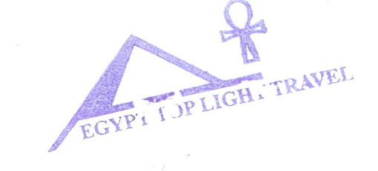
From Date | To Date | Night(s) | SGL(s) | TWIN(s) | TPL (s) | Total rooms
{from_date} | {to_date} | {nights} | {sgl} | {dbl_twin} | {tpl} | {total_rooms}
Room No 1 : TWIN Room Based on soft all inclusive.

Room Number | Name of Guests in Room | Room Type
{#rooms}{room_no} | {names} | {type}{/rooms}

