COMPUTER VISION PROJECT REPORT
Bowling Detection
Using YOLOv8 Object Detection & BowlVision Web Application
Team Members

Seif Ahmed  ID: 202202307 | Amel Emad  ID: 202201991

Course  Computer Vision | Model  YOLOv8 (Ultralytics) | Date  May 2026

BowlVision — Automated Bowling Video Analysis using Deep Learning

1. Project Overview
BowlVision is a computer vision project developed to automatically detect bowling-related objects in video footage using the YOLOv8 deep learning architecture. The system captures frames from bowling match videos, trains a custom object detection model, and provides a polished web-based interface for real-time inference on new videos.

1.1 Objectives
- Extract frames from bowling match videos for dataset construction.
- Train a YOLOv8n model on a labeled bowling dataset (BowlingData).
- Run inference on new bowling videos to detect bowling objects.
- Expose a browser-based UI (BowlVision) for end-users to upload videos and review annotated results.
- Compute real-time bowling scores from detected pin counts using an interactive 10-frame scorecard with strike, spare, and open-frame tracking.

1.2 Technologies Used
Deep Learning Framework | Ultralytics YOLOv8 (yolov8n.pt)
Programming Language | Python 3
Computer Vision Library | OpenCV (cv2)
Web Framework | Flask
Tunneling / Deployment | pyngrok (ngrok)
Training Environment | Google Colaboratory (GPU)
Storage | Google Drive
Video Re-encoding | FFmpeg (H.264 / libx264)

2. System Architecture & Pipeline
The project is structured in three distinct phases: data preparation, model training, and deployment/inference. Each phase is implemented as a series of steps in a Google Colab notebook.

2.1 Phase 1 — Frame Extraction
The first phase reads all .mp4 video files from a /content/videos folder and extracts every individual frame as a .jpg image. Each video receives its own sub-folder under a frames/ output directory to maintain organization.

Key Implementation Details
- Uses OpenCV VideoCapture to iterate frames sequentially.
- Frames are zero-padded (e.g., frame_00001.jpg) to ensure correct lexicographic ordering.
- After extraction, frames are zipped and uploaded to Google Drive for persistent storage.

Relevant code excerpt:
cap = cv2.VideoCapture(video_path)
while True:
ret, frame = cap.read()
if not ret: break
cv2.imwrite(frame_path, frame)

2.2 Phase 2 — Model Training
The second phase trains a YOLOv8 nano model on the custom BowlingData dataset. The dataset is distributed as a zip archive (BowlingData.zip) containing images, labels, and a data.yaml configuration file.

Training Configuration
Base Model | yolov8n.pt (YOLOv8 Nano)
Epochs | 50
Image Size | 640 x 640 pixels
Batch Size | 16
Early Stopping Patience | 10 epochs
Dataset Config | data.yaml (classes, paths)
Best Weights Output | runs/detect/train*/weights/best.pt

The trained best.pt weights file is automatically saved to Google Drive after training completes, ensuring persistence between sessions.

model = YOLO('yolov8n.pt')
model.train(data='/content/BowlingData/data.yaml',
epochs=50, imgsz=640, batch=16, patience=10)

2.3 Phase 3 — Inference
After training, the model is used to run inference on two test videos captured during bowling sessions. The model predicts bounding boxes and class labels on each frame with a confidence threshold of 0.25.

- Video 1: VID_20260504_143244.mp4
- Video 2: WhatsApp Video 2026-05-07 at 4.09.26 PM.mp4

results = model.predict(source=video_path, conf=0.25, save=True)

3. BowlVision — Web Application
BowlVision is a full-stack, browser-accessible interface that allows any user to upload a bowling video, configure the pin setup for the current frame, optionally supply a custom .pt model, and receive a fully annotated output video complete with pin-count detection, real-time scoring, and a 10-frame bowling scorecard. It is powered by Flask on the backend and a modern dark-themed HTML/CSS/JS frontend.

3.1 Backend Architecture
The Flask server exposes four REST endpoints, and video processing runs on a background thread to avoid blocking the HTTP response loop.

Method | Route | Description
GET | / | Serves the full BowlVision single-page HTML application.
POST | /upload | Accepts video + optional model + confidence; starts background job; returns job_id.
GET | /status/<jid> | Returns JSON with status, progress %, message, and detection results.
GET | /download/<fname> | Streams the processed output video for playback or download.

3.2 Video Processing Pipeline (Backend)
When a job is received, the process_video() function executes the following steps on a daemon thread:

- Step 1 — Load Model: Instantiate a YOLO model from the provided weights file (default: yolov8n.pt) or a user-uploaded .pt file.
- Step 2 — Open Video: Read video metadata (frame count, FPS, dimensions) using OpenCV.
- Step 3 — Inference, Pin Counting & Annotation: Stream frames through YOLO predict(), classify each detection as a fallen pin (keywords: fall, fallen, down, knocked, toppled) or standing pin (pin, standing, upright) using name-based keyword matching. Compute knocked-pin count per frame (fallen_count, or pins_standing − standing_count as fallback). Track max_knocked and its frame index across all frames. Overlay “Pins Down” and “Best” counters directly on each frame with cv2.putText(), render bounding boxes with result.plot(), and write annotated frames to the raw mp4v output. Per-class detection counts are accumulated throughout.
- Step 4 — Re-encoding: Convert the raw output to H.264 (yuv420p) via FFmpeg so the browser <video> element can play it natively.
- Step 5 — Job Done: Update the jobs dictionary with status=‘done’, statistics, output filename, and the new scoring fields: knocked_pins (maximum pins detected down in any single frame), pins_standing (user-configured value sent from the frontend), and best_frame (the frame index where the peak knock-down occurred).

3.3 Frontend Design
The frontend is a single-page application served entirely from Flask's / route as an embedded HTML string. It is designed with a dark, professional aesthetic suitable for sports analytics tools.

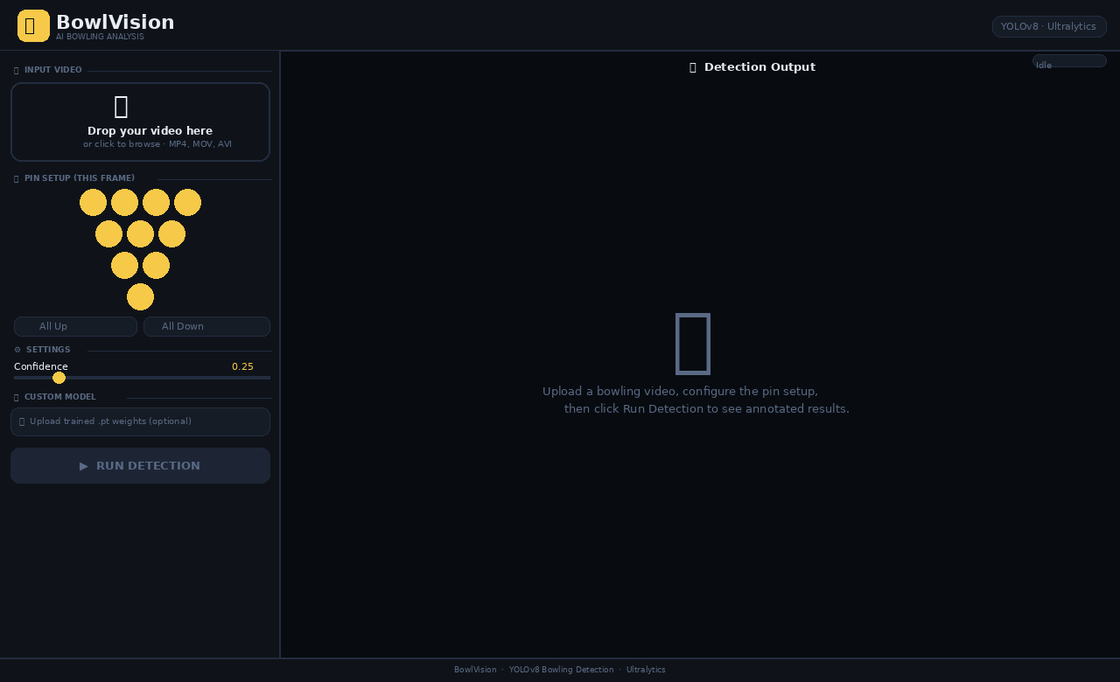
Figure 1 — BowlVision idle state: interactive pin setup diagram, confidence slider, and model uploader in the left panel.
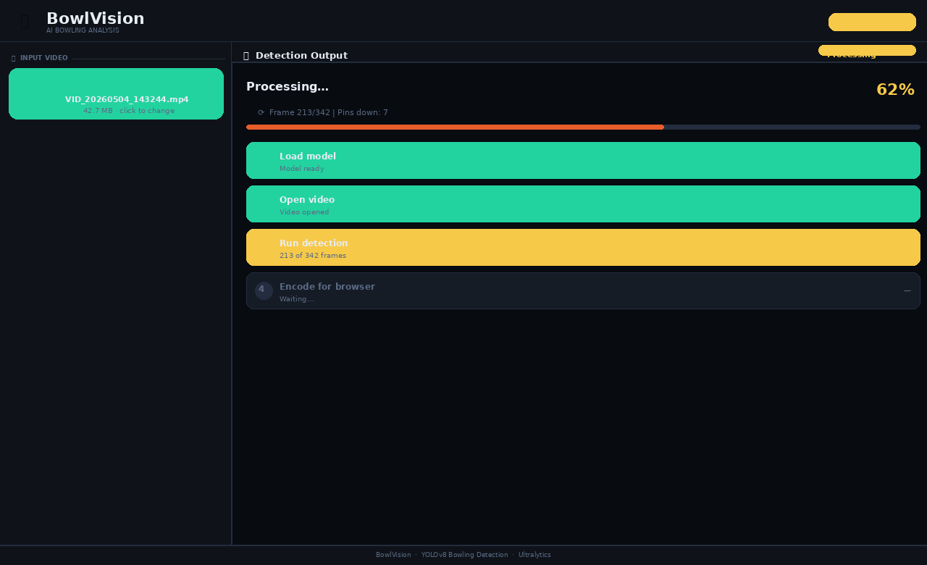
Figure 2 — BowlVision processing state: 4-step progress tracker with active spinner on Step 3 (Run Detection) and live frame counter.
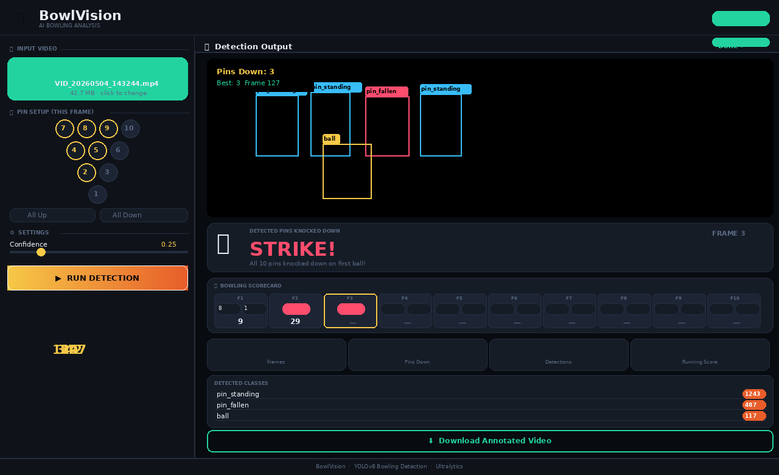
Figure 3 — BowlVision results state: annotated video with pin-count overlay, Strike score banner, 10-frame bowling scorecard, and 4-column statistics grid.

Layout Structure
- Top Bar: Application logo (BowlVision), subtitle, and a live status badge that transitions between Idle, Processing, Done, and Error states.
- Left Panel (320px): Contains the video drop-zone, an interactive Pin Setup diagram (all 10 bowling pins arranged in their standard triangle layout with individual toggle buttons and All Up / All Down controls), a confidence threshold slider, and optional model uploader. The currently standing pin count is sent with each job request so the backend can compute knocked pins when no fallen-pin class is detected. A prominent Run Detection button initiates a job.
- Right Panel (flex): Displays either an idle placeholder, the live progress tracker, or the annotated output video with statistics.

Progress Tracker
During processing, the right panel shows a four-step progress tracker with real-time updates polled every 900ms via /status/<jid>:

Step 1 | Load Model — weights loaded and ready
Step 2 | Open Video — metadata read
Step 3 | Run Detection — frame-by-frame progress counter
Step 4 | Encode Output — H.264 re-encoding

Results Display
Upon completion, the annotated output video is embedded directly in the browser using a <video> element. Below it, the full scoring dashboard is revealed: a Score Banner displays the result of the throw (“STRIKE!”, “SPARE!”, or “N pins”) in large color-coded type; a 10-frame Bowling Scorecard renders each frame’s rolls with X / / or numeric symbols and running cumulative totals; a four-column statistics grid shows total frames processed, pins knocked down, total detection events, and running score; and a scrollable detection breakdown lists each detected class with its count.

UI/UX Design Highlights
- Dark theme using CSS custom properties (--bg, --surface, --accent, --green) for consistent theming.
- Drag-and-drop video upload with visual feedback (dashed border turns orange on hover, green on selection).
- Google Fonts: Bebas Neue for headers, Syne (wght 400–800) for body text.
- Step indicators animate between pending (faded), active (spinner), and done (green checkmark) states.
- Animated gradient progress bar synced to per-frame inference progress.
- Download button to save the processed video locally.

3.4 Scoring Engine
The scoring engine is implemented entirely in the browser as a JavaScript module. It maintains a 10-element scorecardFrames array, a currentFrame pointer, and four coordinated functions:
- processThrow(knocked) — Records the number of knocked-down pins returned by the backend. Detects strikes (first ball, 10 pins), spares (second ball, cumulative 10), and open frames. Advances the frame pointer and resets the pin diagram to “All Up” after a strike or spare is confirmed (frames 1–9).
- computeCumulatives() — Iterates through all frames and computes cumulative running totals. Frames with no rolls yet are marked null and displayed as “—” on the scorecard.
- renderScorecard() — Renders the 10-frame scorecard. Each frame shows its ball symbols (X for strike in red, / for spare in blue, numeric pins otherwise) and its cumulative total. The current frame is highlighted with a gold border.
- updateScoreBanner(knocked, resultType, frameNum) — Updates the prominent Score Banner above the scorecard with the throw result icon, color-coded score text (STRIKE! in red, SPARE! in blue, “N pins” in grey), a contextual subtitle, and the current frame number.

The backend contributes to scoring by accepting a pins_standing field in the /upload POST request (the count of pins toggled as active in the left-panel pin diagram). Inside process_video(), each frame’s detection set is scanned with keyword helpers is_fallen() and is_standing() to classify detections. The per-frame knocked count, the overall maximum (max_knocked), and the frame index of the best throw (best_frame) are returned to the frontend as part of the job result JSON.

4. Code Structure & Notebook Organization
The entire project is contained within a single Google Colab notebook organized into clearly labeled sections:

Notebook Section | Contents
Imports & Setup | Install ultralytics, pyngrok; import cv2, os, YOLO, Flask, threading
Frame Extraction | VideoCapture loop, per-video sub-folders, frame counting, zip & Drive upload
Model Section | Dataset extraction, YOLO training, model save, Drive backup
Inference Cells | Predict on two test videos with conf=0.25
UI Section | Full Flask app: HTML string, 4 routes, process_video() with pin-counting logic, scoring engine (processThrow, computeCumulatives, renderScorecard, updateScoreBanner), ngrok tunnel

5. Results & Output

5.1 Training Output
The training process runs for up to 50 epochs with early stopping (patience=10). The best-performing weights are saved as best.pt and uploaded to Google Drive for reuse. Training artifacts (loss curves, confusion matrices, PR curves) are stored under runs/detect/train*/ in the Colab runtime.

5.2 Inference Output
The YOLO predict() call with conf=0.25 draws bounding boxes and class labels on every detected object in every frame. The output is saved as an annotated video. When using BowlVision, the output is additionally re-encoded to H.264 for browser compatibility and streamed directly to the user.

5.3 Detection Statistics
The BowlVision backend accumulates per-class detection counts across all frames and reports them in the UI. The scoring dashboard shows:

- Total frames processed in the video.
- Maximum pins knocked down in any single frame (knocked_pins), used as the throw result for scoring.
- Total detection events (sum across all classes and frames).
- Running cumulative bowling score, updated by the browser’s scoring engine after each throw.

6. Deployment
The application is deployed using a combination of Flask as the HTTP server and ngrok as a secure tunneling service. This allows the Colab-hosted server to be accessed from any browser via a public HTTPS URL, without requiring any port forwarding or cloud deployment.

ngrok.set_auth_token('...')
public_url = ngrok.connect(5000).public_url
print(f'BowlVision is LIVE! Open: {public_url}')

A background daemon thread runs the Flask server so the Colab notebook cell can complete without blocking. The ngrok tunnel persists as long as the Colab runtime remains active.

6.1 Deployment Architecture
Server | Flask (host=0.0.0.0, port=5000, debug=False)
Threading | Daemon thread per Flask server; separate thread per video job
Tunnel | pyngrok ngrok secure HTTPS tunnel
Upload Storage | /tmp/bv_uploads (ephemeral, Colab RAM disk)
Output Storage | /tmp/bv_outputs (ephemeral, cleared on session end)
Model Storage | /tmp/bv_models (accepts user-uploaded .pt files)

7. Conclusion
The BowlVision project demonstrates a complete, end-to-end computer vision pipeline from raw video data to a user-friendly web application. By leveraging YOLOv8’s efficient nano architecture and the Ultralytics training framework, the team produced a model capable of detecting bowling objects in real-time video. The Flask + ngrok deployment pattern makes the system accessible to any user with a browser, without requiring complex infrastructure.

The BowlVision UI showcases strong software engineering practices: asynchronous job processing, live progress polling, drag-and-drop file handling, and a professional dark-themed design. The combination of a trained computer vision model with a polished interface makes this project suitable for practical deployment in bowling analytics scenarios.

7.1 Key Achievements
- Fully automated frame extraction pipeline for dataset construction.
- Trained YOLOv8n model on custom bowling dataset with 50 epochs.
- End-to-end web application with live inference progress tracking.
- H.264 video re-encoding for universal browser compatibility.
- Polished, responsive UI with drag-and-drop, progress steps, and statistics.
- Interactive pin setup diagram with real-time scoring engine: strike/spare/open detection, 10-frame scorecard, and live running score.

7.2 Potential Future Improvements
- Implement frame sampling (e.g., every Nth frame) to accelerate processing for long videos.
- Improve pin-count accuracy with segmentation-based models to distinguish individual standing pins more precisely (current implementation uses keyword-based class-name matching).
- Extend the 10th-frame scoring logic to support the standard bonus throws (two extra balls after a strike, one after a spare in frame 10).
- Deploy on a persistent cloud platform (e.g., Google Cloud Run, AWS) for 24/7 availability.
- Add user authentication and video history storage in a database.

