

Seif Ahmed 23/08433
Jana Hassan 23/03055

Software Requirements Specification (SRS) for Eventify
- Preface
1.1 Purpose:
The purpose of this Software Requirements Specification (SRS) document is to define the functional and non-functional requirements for Eventify, an e-commerce web application designed for event ticketing. This document provides a detailed description of the system’s objectives, scope, and features, and serves as a reference for developers, testers, and stakeholders involved in the system’s design, implementation, and validation [7][8].
1.2 Scope:
Eventify is a web-based platform that enables users to discover, purchase, and manage tickets for various events. Users can browse events by category (music, sports, theatre, etc.), apply filters and search criteria, purchase tickets securely online, receive e-tickets via email, and manage their bookings through a personal account.
Administrators can manage event listings (create, update, delete), monitor ticket sales and user activity, and generate reports for performance tracking [1][5][9].
1.3 Motivation:
The development of Eventify was initiated to address the challenges users face in finding and purchasing event tickets through multiple sources. Many existing ticketing systems lack centralized management and seamless user experiences. Eventify aims to simplify event discovery and ticket management by offering an integrated, user-friendly, and secure platform for both customers and administrators [3][4][6].

2. Introduction
This section provides an overview of the Eventify system, outlining its objectives, scope, stakeholders, and research foundations that guided its development [7][8].
2.1 System Overview (Product Description)
Eventify is a modern e-commerce web application specifically designed to streamline and simplify the process of event ticket sales. It offers a user-friendly interface for discovering events, combined with secure payment processing and real-time ticket availability management [9][19].
The system provides role-based access for customers and administrative staff, ensuring efficiency, transparency, and data integrity across all transactions [3][4][6].
It integrates with an external payment gateway for secure transactions and uses automated email delivery to send e-tickets upon purchase completion.
2.2 Objectives
The primary objectives of the Eventify system are to:
- Enable seamless browsing and searching of events through a responsive and intuitive user interface [1][5].
- Offer robust administrative functionality for managing events, monitoring sales, and administering user accounts [3][4][6].
- Provide secure online transactions by integrating certified payment gateways and adhering to recognized industry security standards [9][19].
- Ensure real-time ticket availability updates to prevent overselling and maintain accurate inventory visibility [18][20].

In Scope | Out of Scope
Event Exploration: Browsing, searching, and filtering events by category, date, or location. | Event Logistics: Managing physical venue setup, seating arrangements beyond ticket allocation, or staff scheduling.
Secure E-commerce: Cart management, ticket selection, checkout, and payment processing. | Financial Accounting: Complex ledger integration — Eventify provides reports but is not a full accounting system.
User Authentication: Registration, login, password management, and order history tracking. | Customer Service Tools: Live chat or helpdesk systems (handled externally).
Real-Time Inventory: Dynamic ticket stock tracking and concurrency management. | Physical Ticket Printing: Only supports e-tickets and QR codes.
Admin Dashboard: CRUD operations for events and user management. | —

Stakeholders | Role/ Privileges | Responsibilities / Interactions with System
Unregistered User (Guest) | Visitor without an account | - Browse and search for events  - View event details  - Register or log in to make a purchase
User (Customer) | Regular user of the platform | - Browse events by category or search keywords  - View event details  - Select tickets and add to cart  - Complete ticket purchase via secure payment  - Receive e-ticket via email  - Manage account and view booking history  - event attendees
Admin | System Administrator | - Add, update, or delete events  - Monitor ticket sales  - Manage user accounts  - View system reports and logs  - Handle platform issues or support requests
Event organizer | Event contributor | - Submit event details (title, date, venue, category)  - Monitor ticket sales for their own events  - Receive reports or feedback from the admin
Payment Gateway provider [1][14] | handling and securing financial transactions | - Process simulated or real payment requests initiated by users during checkout  - Validate payment details (card number, expiry date, CVV) securely  - Confirm transaction success or failure and return status to Eventify  - Ensure compliance with financial regulations (e.g. PCI-DSS)  - Provide encryption and fraud detection mechanisms  - Log transaction metadata for auditing and reporting
2.3 Stakeholders
3. Similar Systems
System Name | Features | Limitations
Eventbrite [18] | Online event listing, ticket purchase, event promotion, QR code tickets
  High service fees for organizers, mostly geared toward medium to large events
Ticketmaster [19] | Extensive event coverage, mobile ticketing, seat selection, secure payments | Complex for small or local events, higher fees
Tazkarti [20] | Popular for local ticketing (e.g., concerts, sports in certain regions), online booking, seat selection | Limited international coverage, smaller UI/UX features

Eventify Differentiator:
- Low fees for users
- Simple and intuitive UX
- Flexible event categorization and filtering
- Full admin control over events and users
- Designed for local academic or small-scale events
4.Glossary
Term | Definition
Event | A concert, show, or activity with tickets sold online
E-Ticket | Digital access for a specific event
User | Customer purchasing tickets
Admin | System operator managing events and users
Cart | Collection of items selected before purchase
Checkout | Process of finalizing ticket purchase

5. Functional User Requirements (Natural Language)
Title: The Eventify system shall allow registered users to browse upcoming events by category, date, and location using a responsive web interface.
Description: an e-commerce web application designed for event ticketing.

6. Functional System Requirements
These requirements describe the core system functionalities that support user and admin interactions [3][4][6].
6.2 Event Management
- The system shall allow admins to create, update, and delete events [4].
- Each event shall include a title, description, date, time, venue, ticket price, and category [4].
- The system shall display upcoming events to users with search and filter options [12]
6.3 Ticket Booking
- The system shall allow users to book tickets for available events [3].
- Each ticket shall be linked to a user and an event, including seat number, price, and entry code [6].
- The system shall prevent overbooking beyond event capacity [9][11].
6.4 Payment Processing
- The system shall record payments made by users for ticket purchases [1].
- Each payment shall include amount, method, date, and status [5].
- The system shall confirm successful transactions and generate downloadable tickets [14].
6.5 QR Code and Ticket Access
- The system shall generate a unique QR code for each ticket [6].
- The system shall allow users to view and download their tickets containing event details and entry codes [12].

7. Non-Functional Requirements
7.1 Performance
- The system shall support at least 500 concurrent users without noticeable degradation in response time [9].
- Ticket availability shall be updated in real-time to prevent double booking [9].
- All pages shall load within 3 seconds under normal network conditions [11].
- Ticket booking, registration, and login transactions shall be completed within 5 seconds of confirmation [11].
- The system shall ensure session creation and user authentication occur instantly without delay [11].

7.2 Security
- The system shall use HTTPS/TLS encryption for all data transmissions [1].
- User registration shall include email verification to confirm account ownership [1].
- The system shall log out inactive sessions after 15 minutes of inactivity [1].
- Passwords shall be hashed using a secure one-way algorithm (e.g., bcrypt or SHA-256) [5].
- The login process shall use secure authentication mechanisms to prevent unauthorized access [5].
- The system shall validate all user inputs to prevent SQL injection, XSS, and CSRF attacks [5].
- Role-Based Access Control (RBAC) shall separate customer and admin privileges [14].
- The system shall lock user accounts after 5 consecutive failed login attempts to prevent brute-force attacks [14].
7.3 Usability
- Registration and login forms shall be simple, user-friendly, and accessible, requiring no more than two steps to complete [6].
- Error messages shall be descriptive and provide corrective guidance for issues like invalid login or registration input [6].
- The system shall have a responsive design for desktops, tablets, and mobile devices [10].
- The system shall provide a consistent and intuitive navigation structure [10].
- Users shall be able to complete a ticket purchase in no more than five steps [10].
- The interface shall support auto-focus, input validation, and clear feedback for registration and login forms [10].
7.4 Reliability and Availability
- All ticket, registration, and login transactions shall be processed atomically (no duplicates or missing records) [11].
- The system shall recover from minor restarts without data loss [11].
- The system shall maintain at least 95% uptime during normal operation [13].
- The database shall be backed up daily to prevent data loss [13].
- In case of system failure, a user-friendly error message shall appear, and the issue shall be logged [13].
- The system shall notify administrators via dashboard alerts or email when downtime or errors occur [13].
7.5 Maintainability
- The system shall be developed using modular architecture for easier updates and feature extensions [4].
- Maintenance and updates shall be deployable with minimal downtime [4].
- Authentication and user management modules shall be separated for independent maintenance [12].
- The system’s codebase shall be well-documented to support future developers in managing registration and login logic [12].
8.Prototype of Forms/Pages
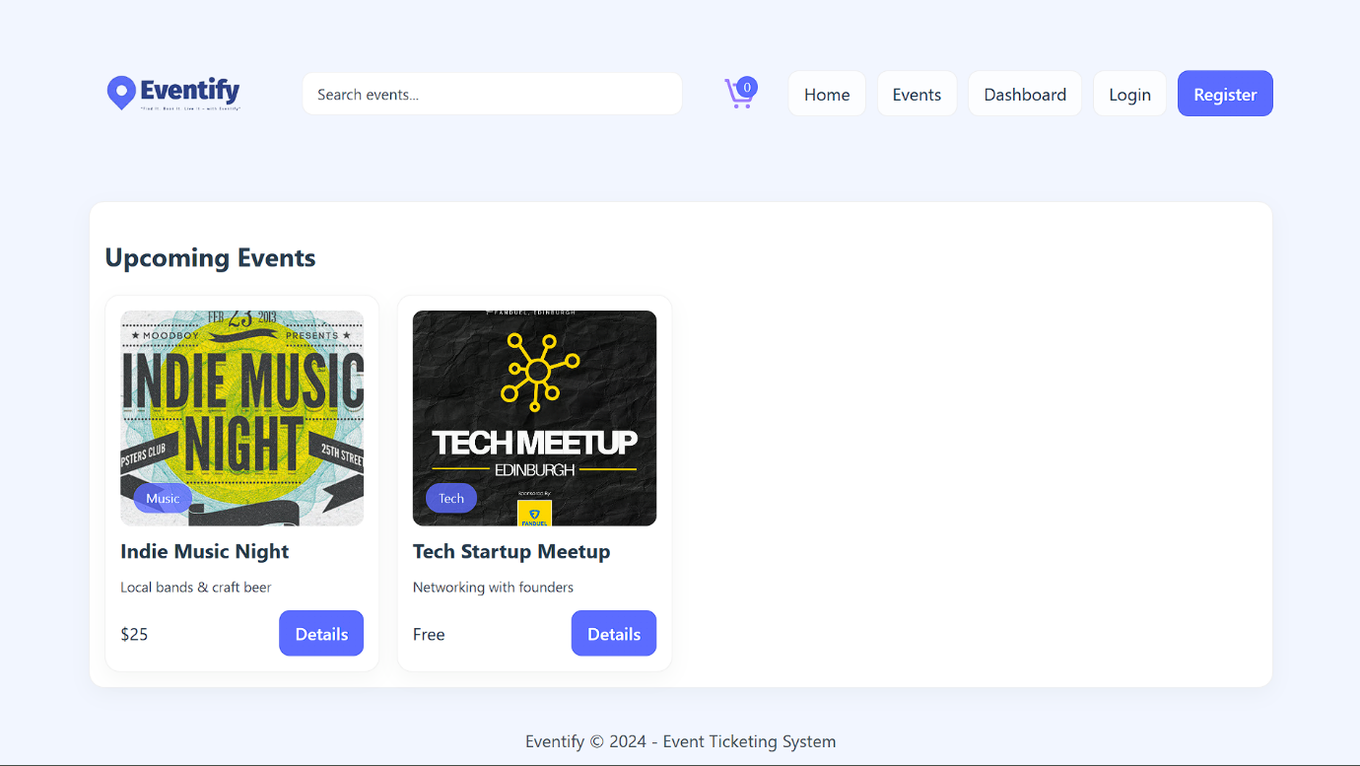
Home page
Register
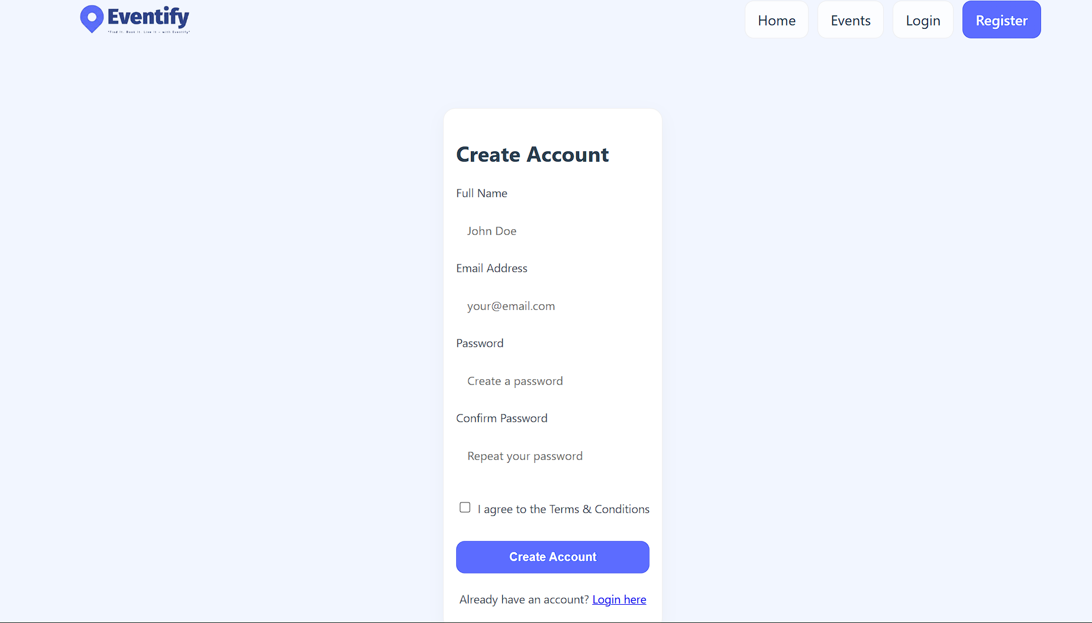

Login
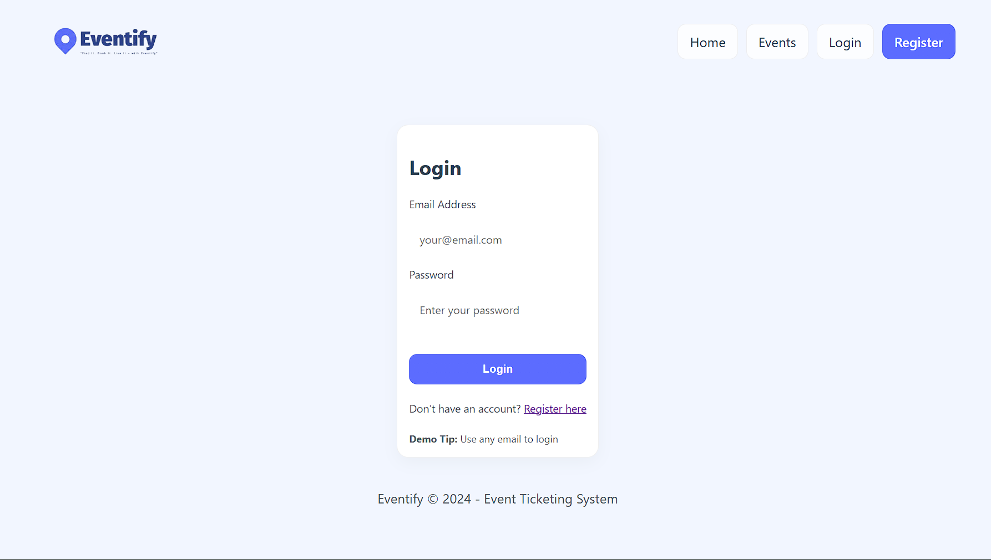

Events
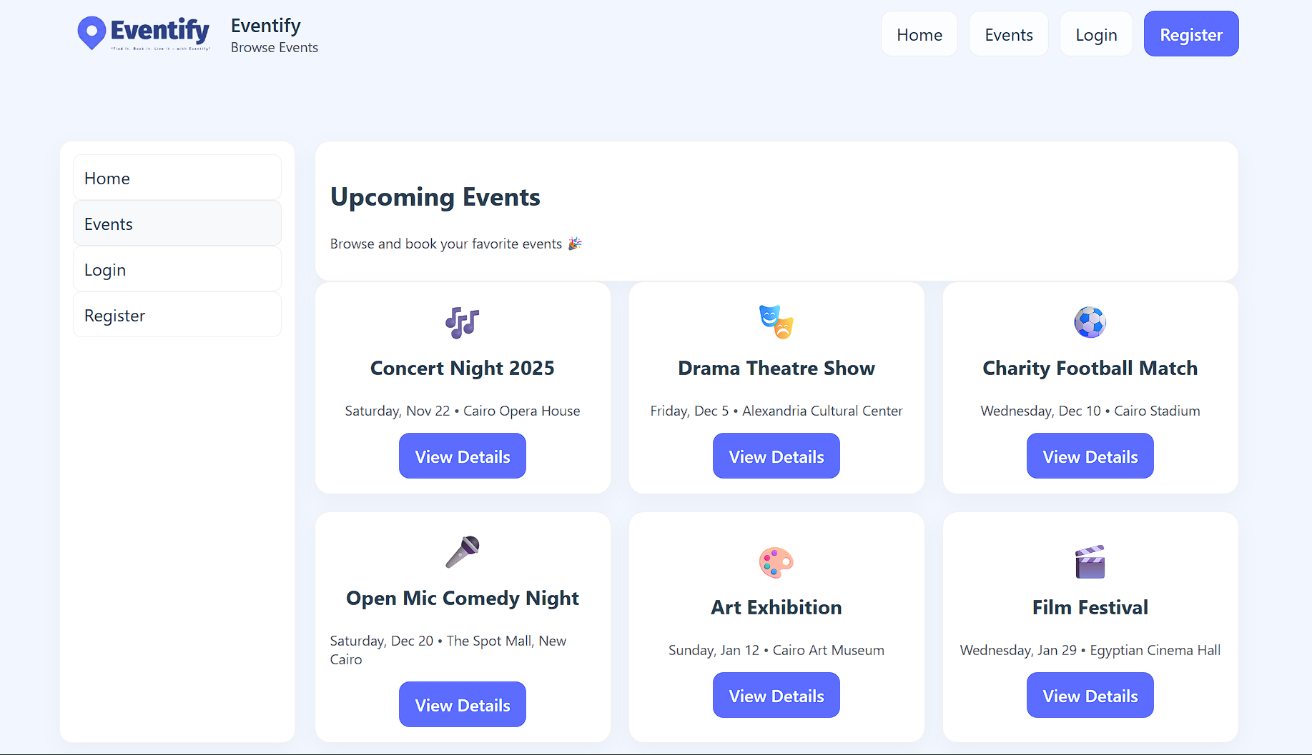

Admin dashboard
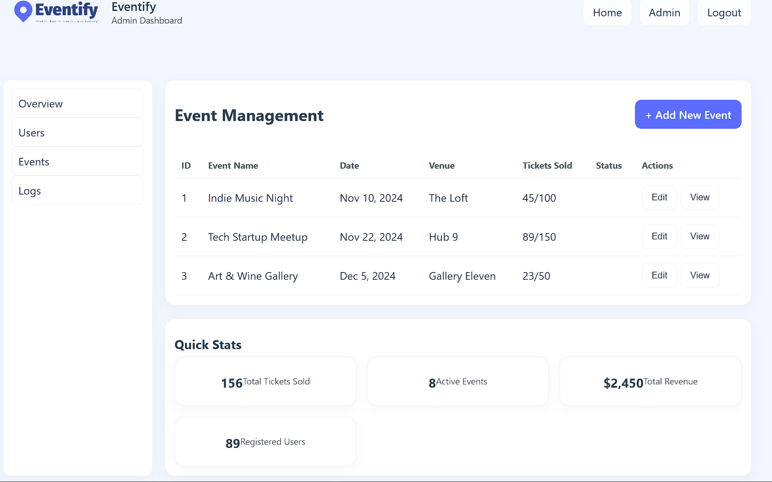

Manage users (Admin)
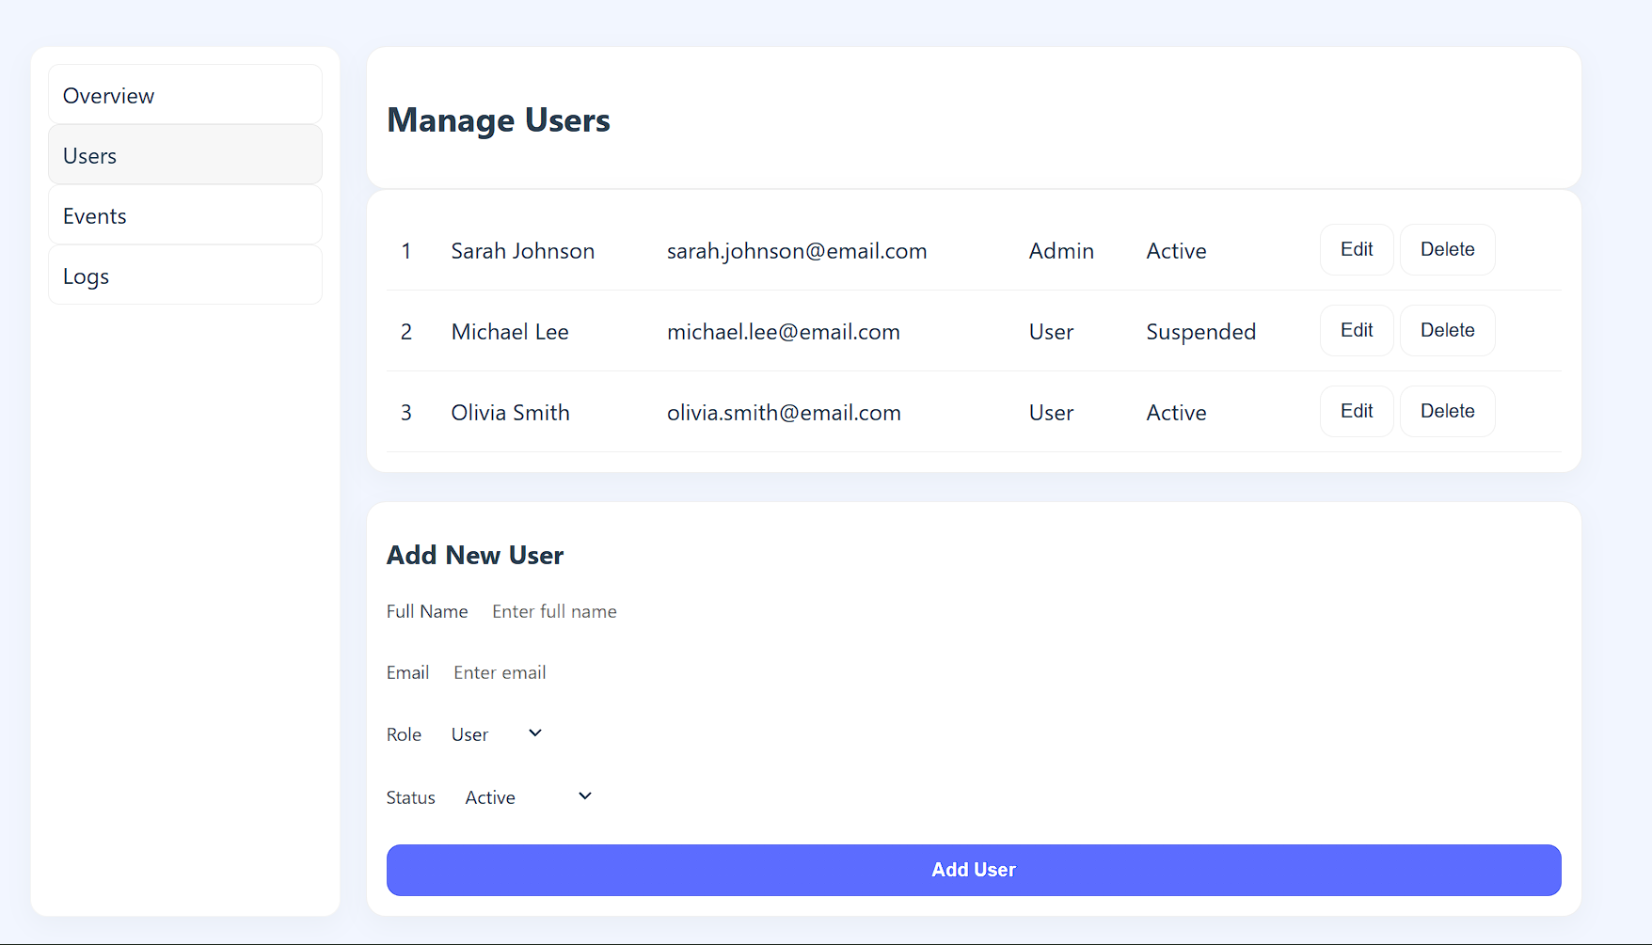

Manage events (Admin)
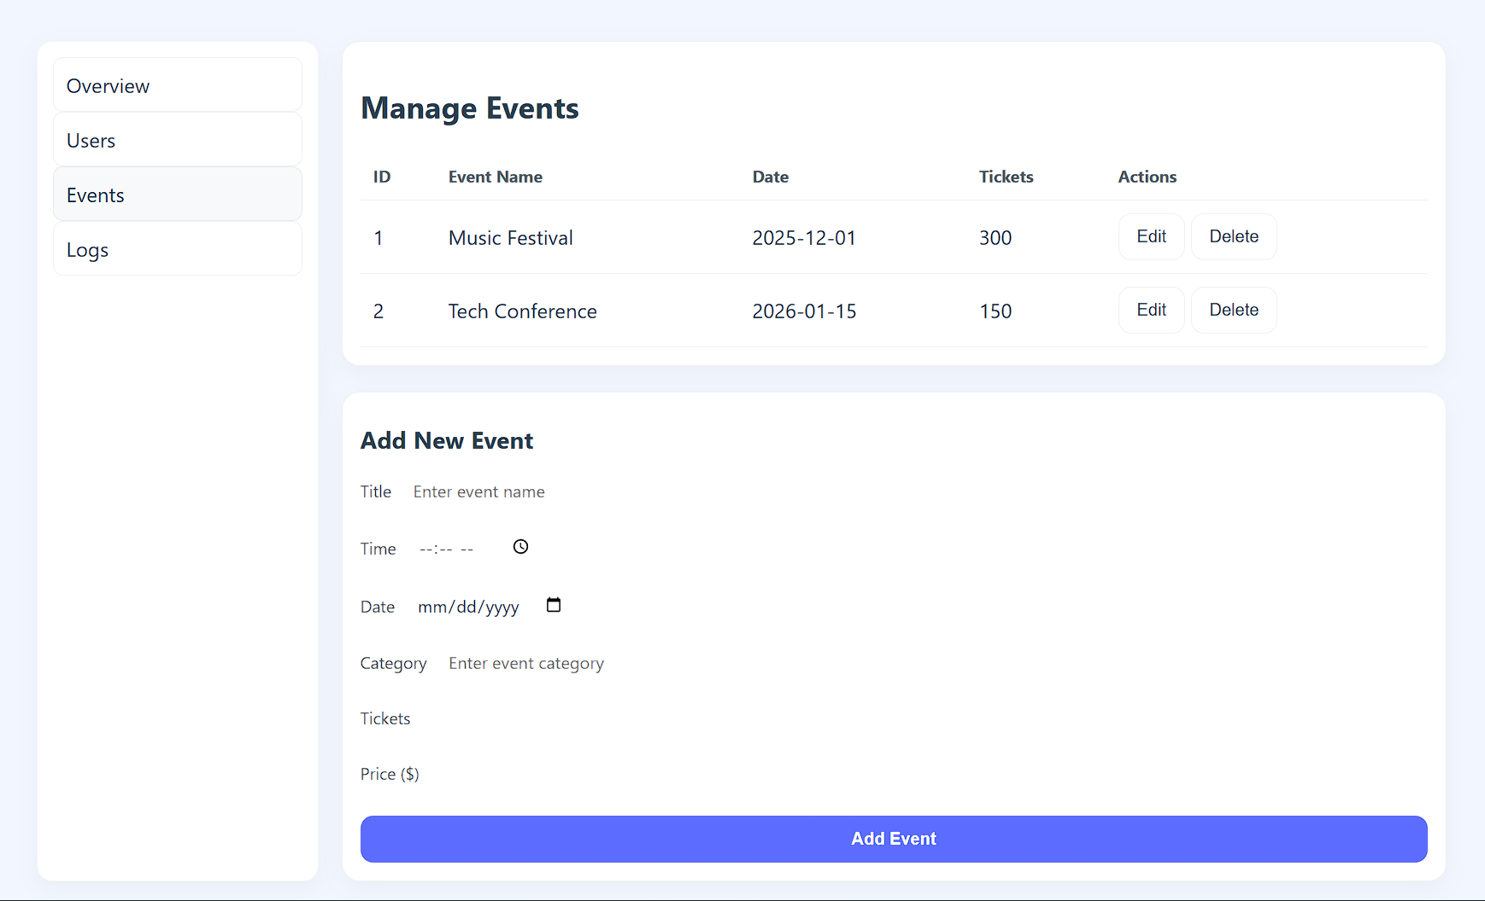

System logs (Admin)
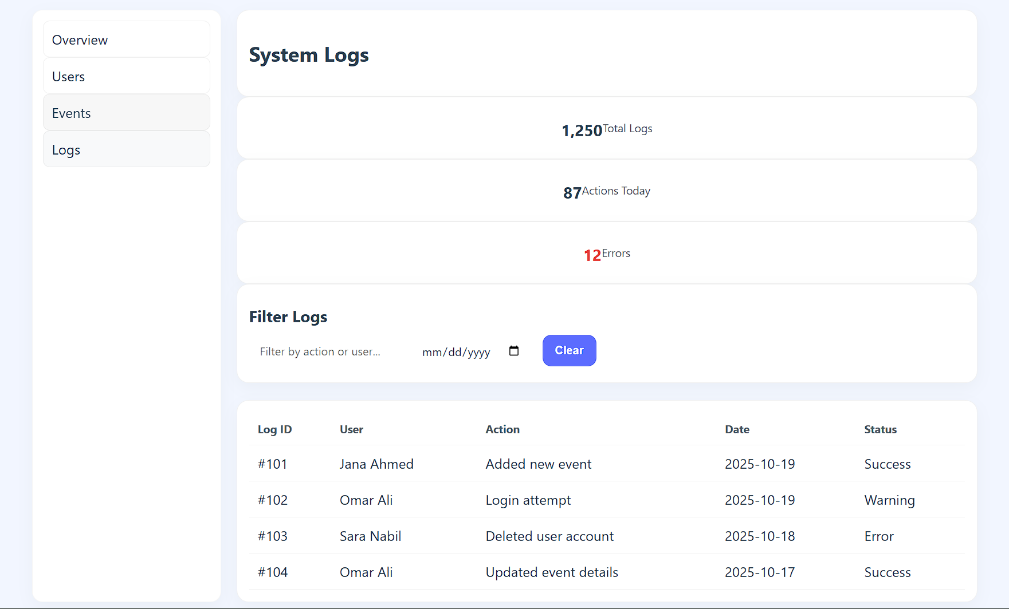

Checkout
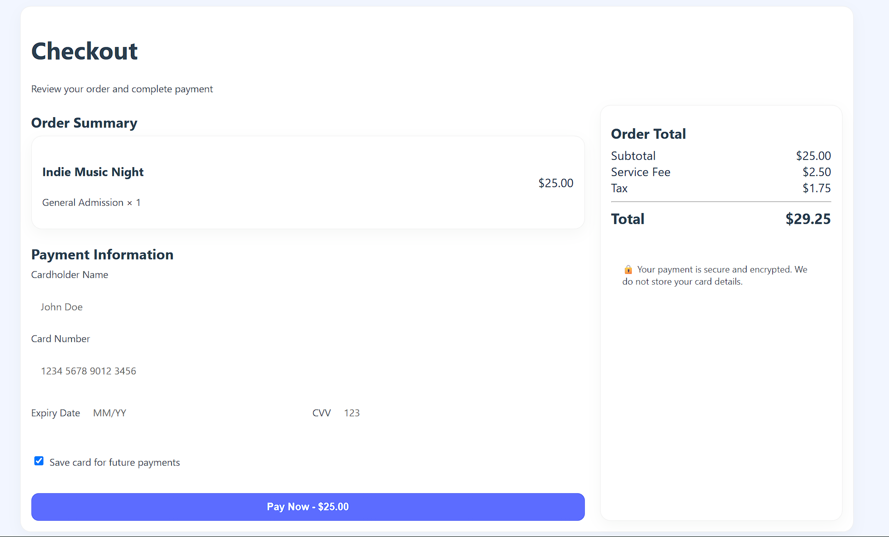

User dashboard
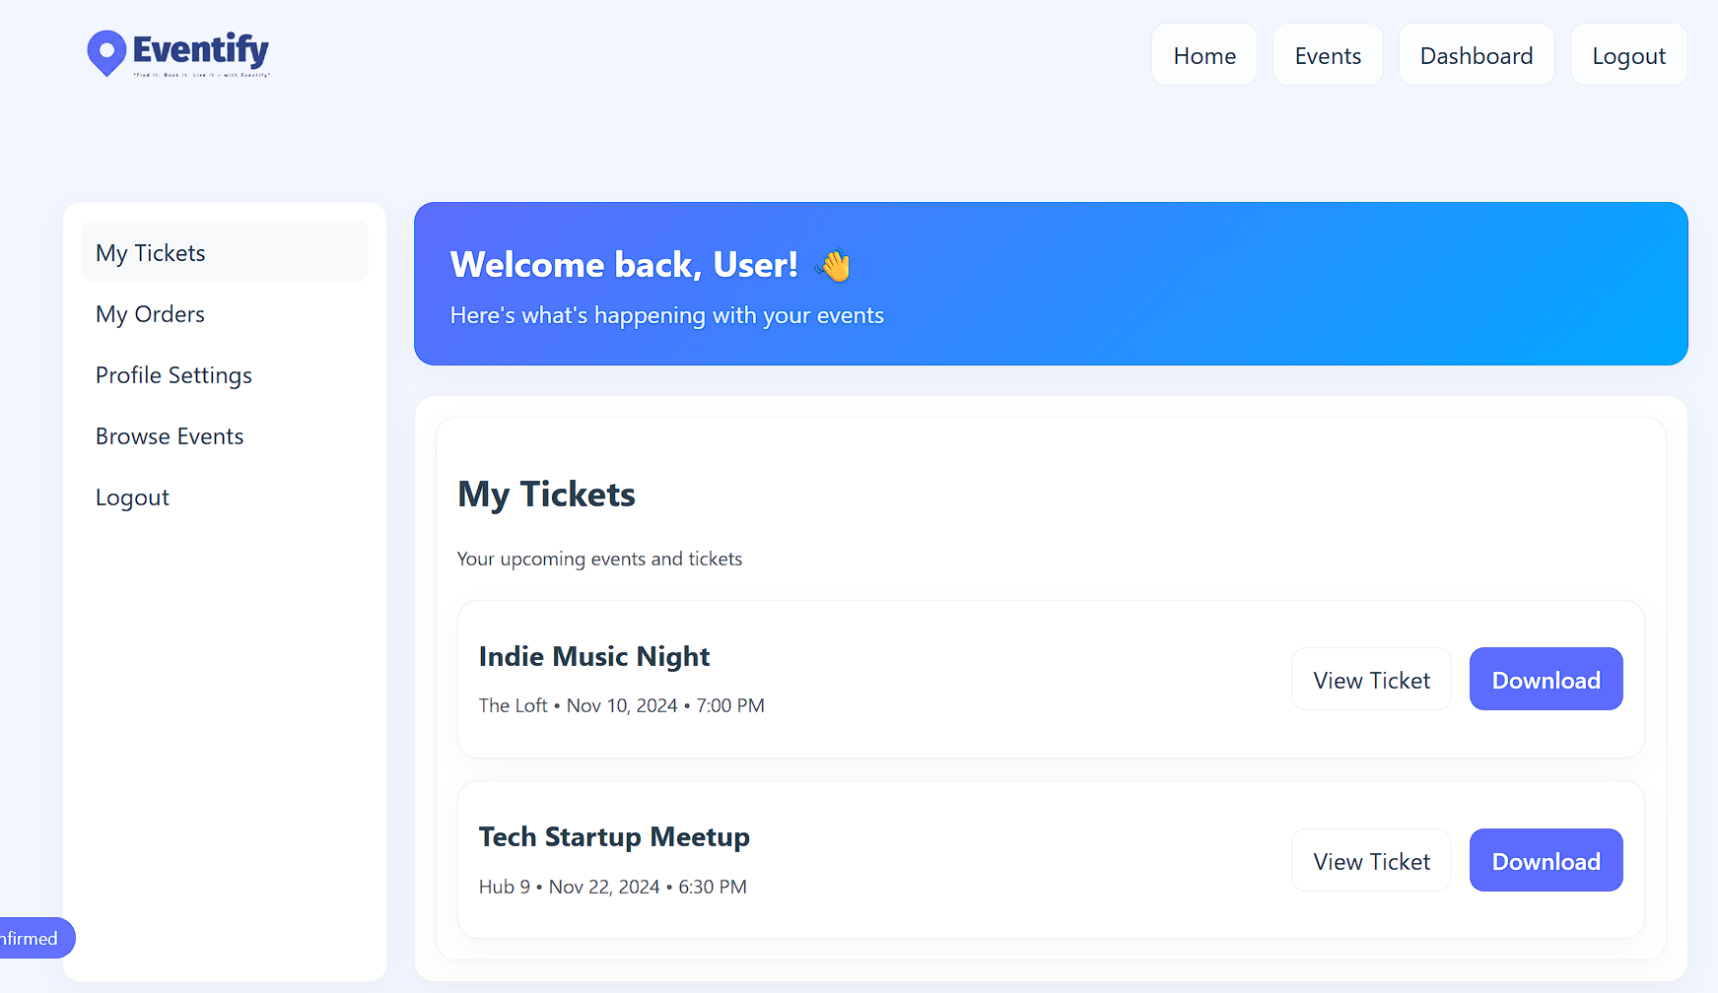

Event details
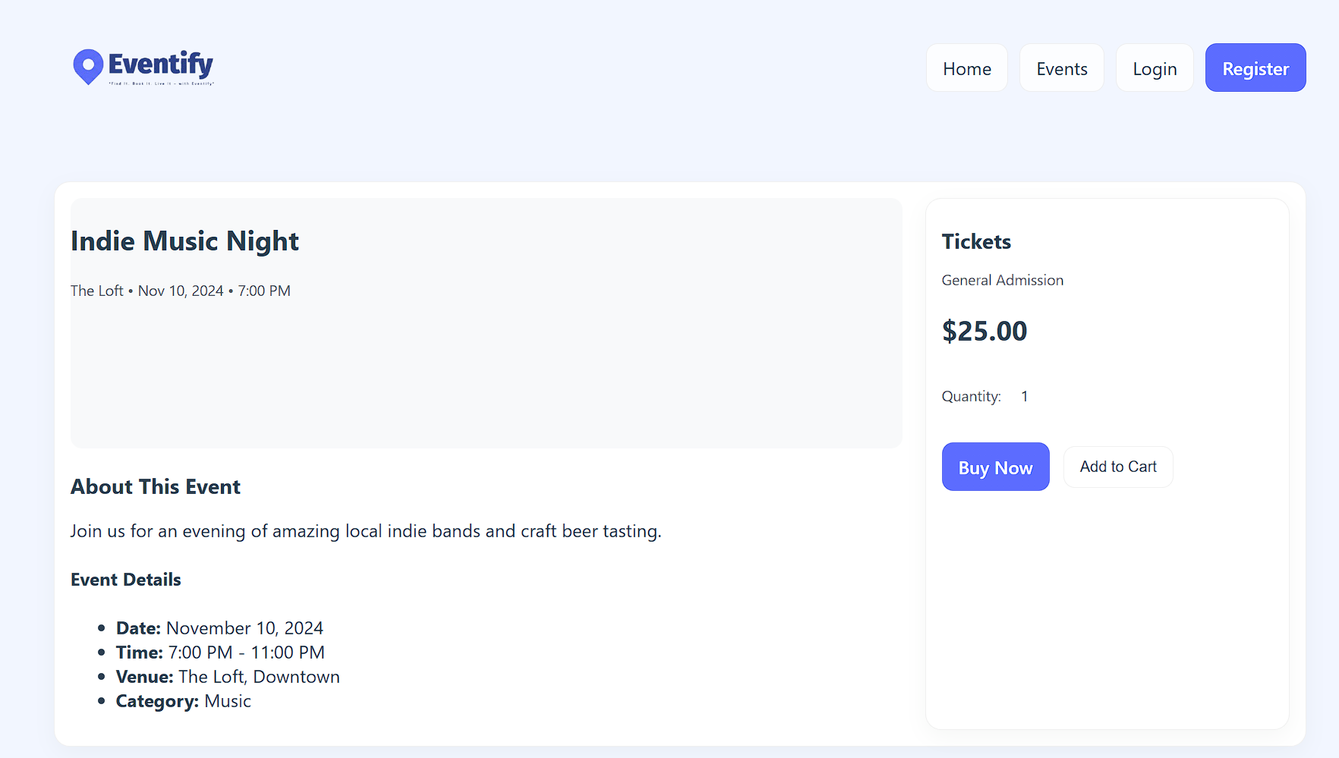

Payment confirmation
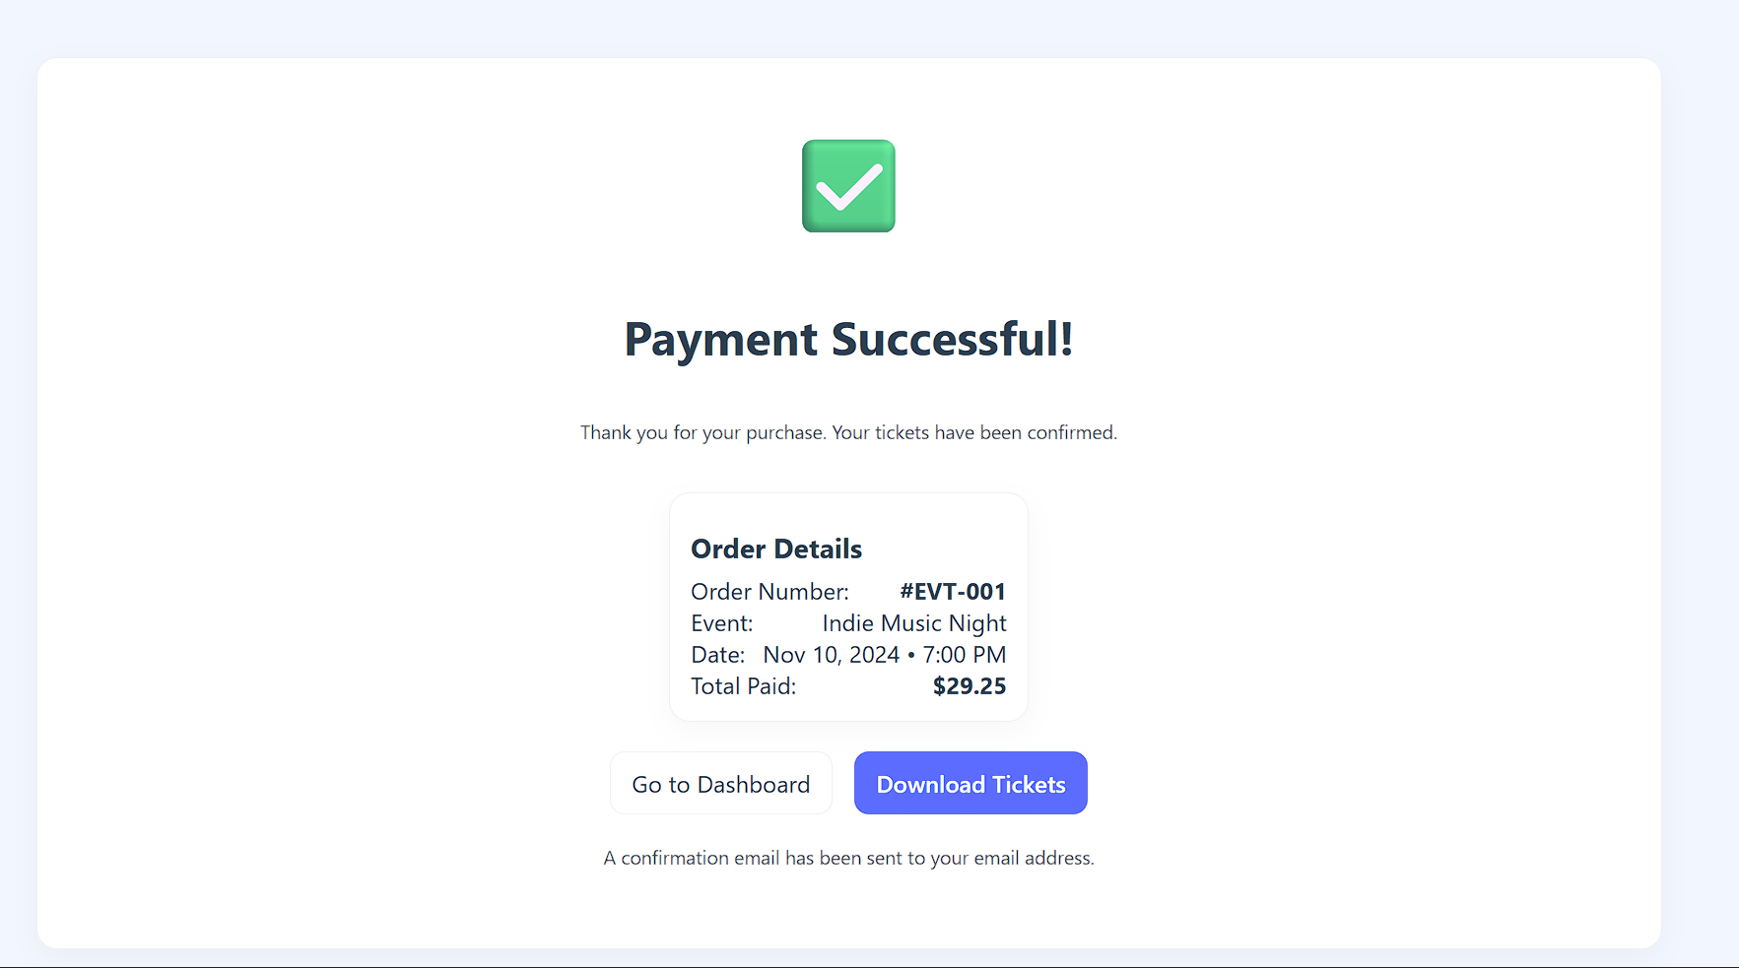

Ticket
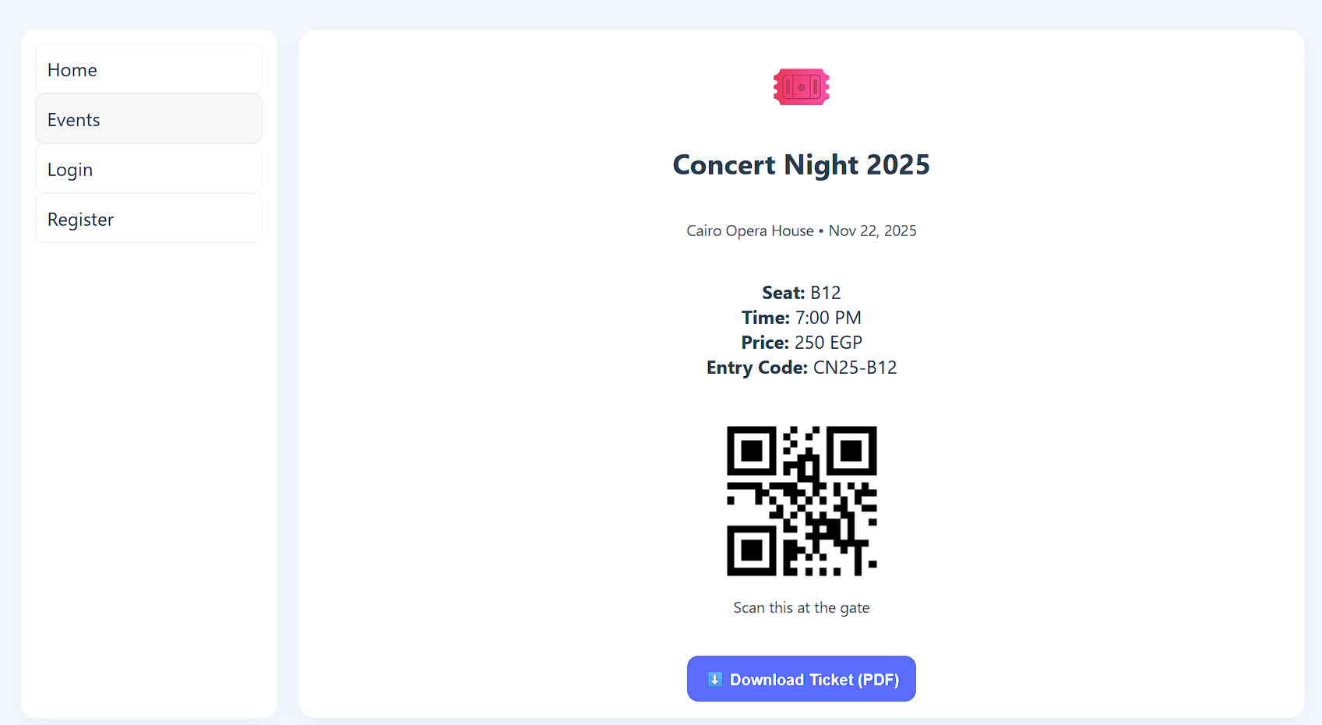

9.Scenarios
Scenario 1: University Student Books a Ticket for a Local Tech Meetup [3][6]
Actor: Registered User
Goal: Browse, select, and purchase a ticket using the system’s forms
- Login Form
  - Student enters Email and Password
  - System validates credentials and redirects to dashboard
- Event Browsing
  - Student navigates to Events Page
  - Filters events by Category = Tech
  - Clicks on the selected event to view details
- Ticket Booking Form
  - System displays Event Title, Date, Time, Venue, Category, Price
  - Student selects Number of Tickets
  - Optionally selects Seat if applicable
- Payment Form (Simulated)
  - Student enters:
    - Cardholder Name
    - Card Number
    - Expiry Date
    - CVV
  - System validates inputs and confirms Payment Successful
- Ticket Download Interface
- Student clicks Download Ticket
- System generates PDF with:
- Event Details
- Seat Number
- Entry Code
- QR Code

Scenario 2: Admin Updates Venue Details for an Upcoming Concert [6][12]
Actor: Admin
Goal: Modify event information using admin forms
- Login Form
  - Admin enters Email and Password
  - System validates credentials and redirects to Admin Dashboard
- Event Creation Form (Edit Mode)
  - Admin navigates to Events Section
  - Selects the concert event to edit
  - Updates:
    - Venue Name
    - Location
    - Capacity
    - Date/Time if needed
System validates:
- Date must be in future
- Time format must be valid
- Capacity must be a positive number
Confirmation
- Admin clicks Save Changes
- System updates event listing and confirms success

Scenario 3: User Enters Invalid Password During Login [6][14]
Actor: Registered User
Goal: Attempt to log in with incorrect credentials and receive error feedback
- User opens the Login Page
  - From fields:
  - Email (type: Email, validation: valid format)
  - Password (type: Password, validation: min 8 characters)
- User enters:
  - Email: student@example.com ✅ (valid format)
  - Password: 12345 ❌ (fails validation: too short, lacks uppercase)
- System performs validation
  - Checks password length and format
  - Detects that password do not meet criteria
- System response
  - Displays error message:
“Password must be at least 8 characters and include one uppercase letter.”
  - Prevents login and keeps user on the login page
- User corrects input
- Enters: SecurePass123 ✅
- System validates and logs in successfully

10.Use Cases [3][4][6][12]
UC-01: Browse Events as Guest
Actor: Unregistered user (Guest)
Description: Allows a visitor to view events without logging in.
Precondition: User is on the website.
Postcondition: User sees the list of events and can click event details.
Steps:
- Guest opens Eventify homepage.
- System displays a list of upcoming events.
- Guest clicks an event to view details.
- Guest is prompted to register or log in if they want to purchase tickets.
UC-02: User Registration
- Actor: User
- Description: Allows a new user to create an account.
- Precondition: Visitor is on the registration page.
- Postcondition: User account is created; user can log in.
- Steps:
  - User clicks Register.
  - User enters name, email, and password.
  - System validates input (required fields, email format).
  - System confirms successful registration and redirects to login/dashboard.
UC-03: User Login
- Actor: User
- Description: Allows existing users to access their dashboard.
- Precondition: User account exists.
- Postcondition: User is logged in and dashboard is displayed.
- Steps:
  - User enters email and password.
  - System validates credentials.
  - On success, system redirects to dashboard.
  - On Failure, System displays an error
UC-04: Browse Events
- Actor: User
- Description: Allows user to view available events.
- Precondition: User is logged in.
- Postcondition: Event list is displayed.
- Steps:
  - User navigates to the Home or Events page.
  - System displays event cards with basic info (name, date, category).
  - User can click an event for details.
UC-05: Add Tickets to Cart
- Actor: User
- Description: Allows user to select tickets for an event.
- Precondition: Event exists, and user is logged in.
- Postcondition: Tickets are added to the user’s cart.
- Steps:
  - User selects event.
  - User chooses number of tickets.
  - User clicks Add to Cart.
  - System confirms tickets added to cart.
UC-06: Checkout & Simulate Payment
- Actor: User
- Description: User completes the purchase of selected tickets.
- Precondition: User has tickets in the cart.
- Postcondition: Payment confirmed (simulated) and tickets available for download.
- Steps:
  - User clicks Checkout.
  - User enters payment details (simulated).
  - System validates inputs.
  - System confirms “Payment Successful.”
  - User is provided with e-ticket download option.
UC-07: Download Ticket
- Actor: User
- Description: User downloads e-ticket after purchase.
- Precondition: Payment completed.
- Postcondition: User downloads the ticket successfully.
- Steps:
  - User clicks Download Ticket.
  - System generates ticket PDF or downloadable file.
  - User saves the ticket.
UC-08: Admin - Manage Events
- Actor: Admin
- Description: Admin can create, update, or delete events.
- Precondition: Admin is logged in.
- Postcondition: Events updated in the system.
- Steps:
  - Admin navigates to Admin Dashboard → Events.
  - Admin clicks Add/Edit/Delete Event.
  - Admin enters or updates event details.
  - System confirms changes and updates public listing.
UC-09: Admin - View Users & Reports
- Actor: Admin
- Description: Admin monitors user activity and ticket sales.
- Precondition: Admin is logged in.
- Postcondition: Admin sees user list and reports.
- Steps:
  - Admin navigates to Dashboard → Users/Reports.
  - System displays user data, sales data, and logs.
  - Admin can export or review reports.

-Use case diagram
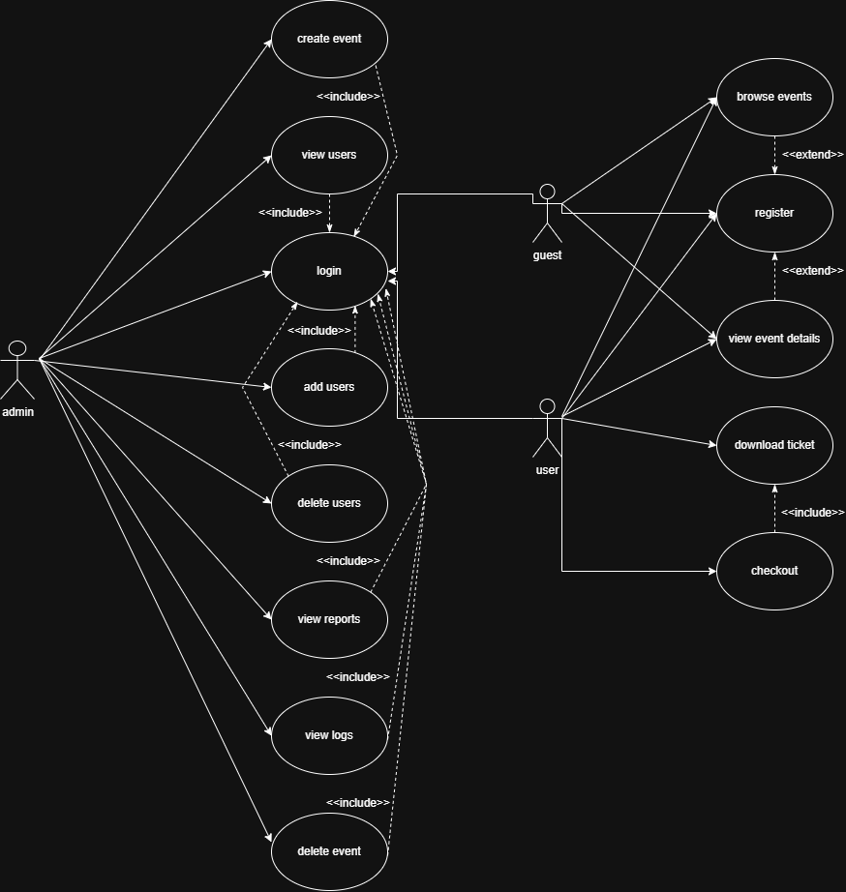
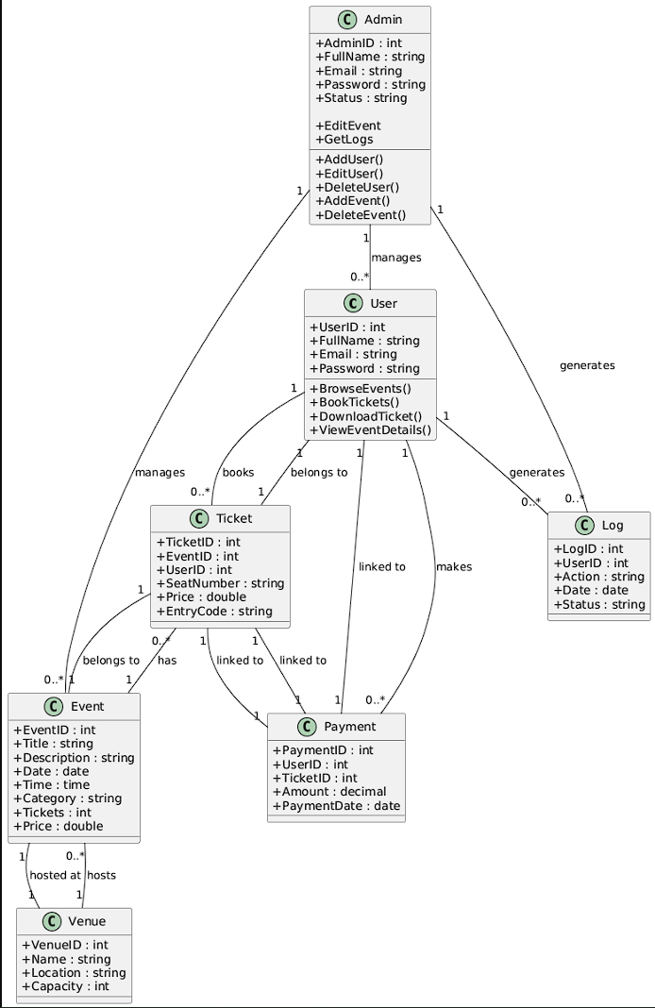
11.Form-Based Specification [3][4][6][12]

- Registration Form

element | description
Function | Create new user account
Inputs | Full name, email, password, confirm password
Outputs | Success → Account created  Failure → Validation errors
Requires | Unique email, valid password format
Action | Validate fields → Store user → Redirect to login
Precondition | Visitor is on registration page
Postcondition | User account is created
Side effects | none

- Login form

element | description
Function | Authenticate user and grant access to dashboard
Inputs | Email, password
Outputs | Success → Dashboard view  Failure → Error message
Requires | Valid user credentials stored in database
Action | Validate input → Check credentials → Redirect or show error
Precondition | User account exists
Postcondition | User is logged in or receives error
Side effects | Logs login attempt (success/failure)

- Event creation form (Admin)
element | description
Function | Add or update event listing
Inputs | Title, Date, Time, Category, Tickets, Price
Outputs | Event saved and listed publicly
Requires | Admin privileges, valid input formats
Action | Validate → Save to database → Update event list
Precondition | Admin is logged in
Postcondition | Event appears in public listing
Side effects | none

- Ticket booking form
element | description
Function | Reserve tickets for selected event
Inputs | Event ID, Number of Tickets, Seat Selection (optional)
Outputs | Tickets added to cart
Requires | Valid event, available capacity
Action | Validate → Reserve seats → Update cart
Precondition | User is logged in, and event exists
Postcondition | Tickets reserved in cart
Side effects | Reduces available ticket count temporarily

- Payment form (simulated)
element | description
Function | Simulate payment and confirm ticket purchase
Inputs | Cardholder Name, Card Number, Expiry Date, CVV
Outputs | Payment status (Success/Failure)
Requires | Valid simulated card input
Action | Validate → Simulate transaction → Confirm or reject
Precondition | Tickets exist in cart
Postcondition | Payment confirmed and ticket generated
Side effects | Logs transaction, triggers ticket generation

- Ticket download interface

element | description
Function | Allow user to download purchased ticket
Inputs | Ticket ID, Format (PDF/PNG)
Outputs | Downloadable ticket file
Requires | Completed payment and valid ticket ID
Action | Generate file → Provide download link
Precondition | Ticket is paid and available
Postcondition | Ticket saved by user
Side effects | Logs download action make the rest of

7.Eventify System
element | description
Function | Event Management and Ticket Booking System
Inputs | - Event date  - Event category  - Location  - User registration details (name, email, password)  - Login credentials (email, password)  - Ticket quantity  - Payment details
Outputs | Downloadable ticket file
Requires | - List of available events  - Confirmation message for successful registration, login, or booking  - Electronic ticket (e-ticket)  - Payment confirmation  - Notifications (email or on-screen)
Action | - Validate inputs  - Authenticate users  - Process ticket bookings and payments  - Update event availability in real-time  - Store and retrieve data from the database
Precondition | - User must have an active account (for booking)  - Events must be available in the database  - Internet connection must be active
Postcondition | - Booking record is stored successfully  - User receives confirmation and ticket  - Event availability is updated
Side effects | - Invalid input data (e.g., wrong date format, missing fields)  - Payment failure  - Event sold out  - Server or database downtime

12 .Tabular Specification [3][4][6][12]
Registration
condition | action
Email format is valid and already registered | Create account and redirect to login
Email format is invalid | Show error: “Please enter a valid email address”
Password and Confirm Password match and meet criteria | Proceed with registration
Passwords do not match | Show error: “Passwords do not match”
Password too weak (e.g. < 8 characters or no uppercase) | Show error: “Password must be at least 8 characters and include one uppercase letter”
Login
condition | action
Email and password are valid and match a registered account | Log in the user and redirect to dashboard
Email format is invalid | Show error: “Please enter a valid email address”
Email not found in database | Show error: “No account found with this email”
Password does not match the email | Show error: “Incorrect password”
User account is suspended | Show error: “Your account has been suspended. Contact support.”
Admin logs in successfully | Redirect to admin dashboard
Event Creation (Admin)
condition | action
All fields valid and date is in the future | Save event and update public listing
Title too short (< 5 characters) | Show error: “Event title must be at least 5 characters”
Date is in the past | Show error: “Event date must be in the future”
Price or ticket count is negative | Show error: “Price and ticket count must be positive values”
Admin not logged in | Redirect to login page

Ticket booking
condition | action
Event exists and tickets available | Allow booking and add to cart
Event exists but sold out | Show “Sold Out” message
Invalid event ID | Show error: “Event not found”
User not logged in | Redirect to login page
Booking exceeds capacity | Show error: “Not enough tickets available”
Payment Processing
condition | action
Card number is 16 digits and CVV is 3 digits | Simulate payment and confirm success
Card number invalid | Show error: “Invalid card number”
CVV invalid | Show error: “Invalid CVV”
Expiry date invalid | Show error: “invalid Card expiry date”
Payment successful | Generate ticket and enable download
Payment failed | Show error: “Transaction failed. Please try again.”
Ticket Download
Condition | Action
Ticket ID exists and payment is confirmed | Generate ticket file (PDF/PNG)
Ticket ID not found | Show error: “Ticket not found”
Payment not completed | Show error: “You must complete payment before downloading”
Format not selected | Show error: “Please choose a download format”

Reference & Citations
[1] Ahmad, A. M., & Khan, M. F. (2021). Security Protocols and Best Practices for Payment Gateway Integration in Online Platforms. Journal of Network and Computer Applications, 192, 103180.
[2] Alshomrani, S., & Qureshi, M. A. (2019). Functional and Non-Functional Requirements for a Secure E-commerce Website. International Journal of Computer Applications, 178(3), 15–20.
[3] Chopade, P. S., & Ponde, S. (2014). Software Requirements Specification for Online Ticket Booking System. International Journal of Advanced Research in Computer Science and Software Engineering, 4(12), 65–71.
[4] Chopra, R., & Kumar, M. V. (2018). Developing an Online Event Management and Ticketing System with Advanced Features. International Journal of Scientific Research in Computer Science, Engineering and Information Technology, 4(2), 110–117.
[5] Gupta, S., & Singh, J. (2016). A Comparative Study of Security Issues in Online Payment Systems. Procedia Computer Science, 85, 307–314.
[6] Hossain, S., & Islam, R. (2020). A Formal Approach for Specifying Requirements of E-Ticketing System using UML. Journal of King Saud University - Computer and Information Sciences, 32(5), 577–586.
[7] IEEE Computer Society. (1998). IEEE Std 830-1998: Recommended Practice for Software Requirements Specifications.
[8] ISO/IEC/IEEE. (2018). ISO/IEC/IEEE 29148: Systems and Software Engineering — Life Cycle Processes — Requirements Engineering.
[9] Kim, J., & Park, K. (2022). An Efficient Real-Time Inventory Management System based on Cloud Computing for E-commerce. Journal of Retailing and Consumer Services, 68, 103038.
[10] Ma, S., & Wu, X. (2018). User Interface Design Principles for Effective E-Commerce Experience. Journal of Electronic Commerce Research, 19(4), 263–278.
[11] Srivastava, M., & Singh, R. (2019). Scalable Architecture for Real-Time Data Processing in Web Applications. IEEE Transactions on Software Engineering, 45(11), 1083–1100.
[12] Wang, H., & Chen, J. (2023). Design and Implementation of an Event Management System with Administrator Control Module. International Journal of Software Engineering and Knowledge Engineering, 33(1), 1–20.
[13] Wong, B., & Lee, D. (2017). Performance and Scalability Analysis of High-Concurrency E-Commerce Systems. International Journal of Computer Networks & Communications, 9(3), 13–28.
[14] Yadav, S., & Sharma, M. (2015). Role-Based Access Control (RBAC) in Web Application Security: A Case Study in E-commerce. International Journal of Computer Science and Network Security, 15(7), 90–96.
[15] Zhu, Y., & Li, Q. (2020). Audit Logging and Reporting Requirements for Compliance in Online Transaction Systems. Computers & Security, 99, 102061.nce
[16] Unimate: A Student Information System. IEEE Xplore. Retrieved from: https://ieeexplore.ieee.org/document/6637357/
[17] Web Based Student Information Management System. Academia.edu. Retrieved from: https://www.academia.edu/36308712/Web_Based_Student_Information_Management_System
[18] Eventbrite – Discover Great Events or Create Your Own & Sell Tickets. Retrieved October 20, 2025, from https://www.eventbrite.com
[19] Ticketmaster – Buy Tickets for Concerts, Sports, Theatre, and More. Retrieved October 20, 2025, from https://www.ticketmaster.com
[20] Tazkarti – Online Ticketing Platform. Retrieved October 20, 2025, from https://www.tazkarti.com

