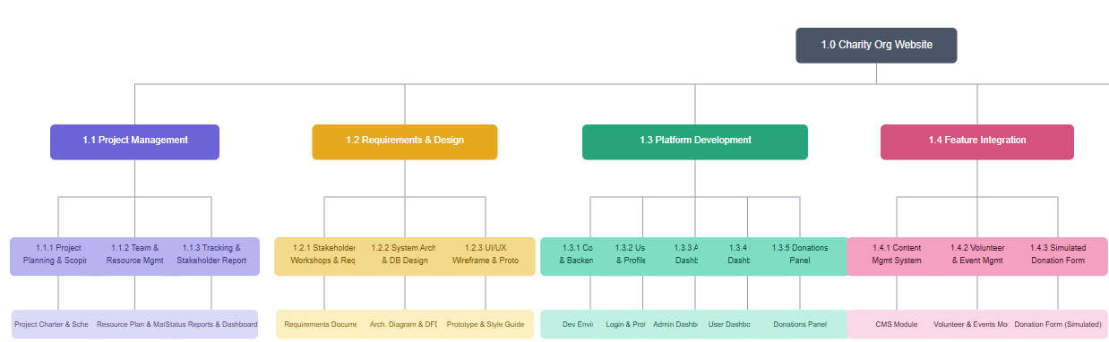
Charity Organization Website
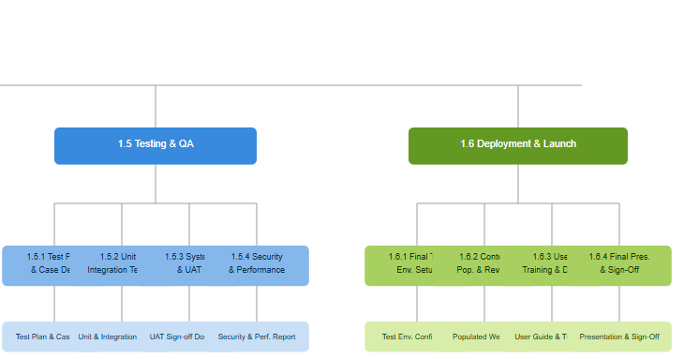

Responsibility Assignment Matrix (RAM)

OBS Units ↓ / WBS Activities → | 1.1 Project management | 1.2 Requirement & Design | 1.3 Platform Developments | 1.4 Feature integration | 1.5 Testing & QA | 1.6 Deploy & Launch
Project Management | RP | R | R | R | R | RP
Design & UX Team |  | RP | P | P
Front-End Dev |  | P | P | P | P | P
Back-End Dev |  | P | RP | RP | P | P
Quality Assurance |  |  | P | P | RP | P
Sponsor (UNICEF) | R | P |  |  | P | R

RACI Chart
 | Project Manager (Jana / Seif) | Design & UX | Front-End Dev | Back-End Dev | QA Engineer | Sponsor (UNICEF)
1.1.1 Project Planning & Scoping | A | I | I | I | I | C
1.1.2 Team & Resource Management | A | R | R | R | R | I
1.1.3 Project Tracking & Stakeholder Rep. | R | I | I | I | I | A
1.2.1 Stakeholder Workshops & Req. Gathering | A | R | C | C | I | R
1.2.2 System Architecture & Database Design | A | C | C | R | I | I
1.2.3 UI/UX Wireframing & Prototyping | A | R | C | I | I | C
1.3.1 Core Infrastructure & Backend Setup | A | I | C | R | I | I
1.3.2 User Authentication & Profile Mgmt | A | I | R | R | C | I
1.3.3 Main Dashboard — Admin View | A | C | R | R | C | I
1.3.4 User Dashboard — User View | A | C | R | R | C | I
1.3.5 Donations Panel | A | I | R | R | C | I
1.4.1 Content Management System | A | C | R | R | C | I
1.4.2 Volunteer & Event Management Module | A | C | R | R | C | I
1.4.3 Simulated Donation Form | A | R | R | C | C | I
1.5.1 Test Planning & Case Development | A | I | C | C | R | I
1.5.2 Unit & Integration Testing | A | I | R | R | R | I
1.5.3 System & (UAT) | A | I | C | C | R | R
1.5.4 Security & Performance Testing | A | I | C | C | R | I
1.6.1 Final Testing Environment Setup | A | I | R | R | C | I
1.6.2 Content Population & Final Review | A | R | R | C | C | C
1.6.3 User Training & Documentation | R | I | I | I | I | A
1.6.4 Final Presentation & Sponsor Sign-Off | R | I | I | I | I | A

