🏥
Smart Clinic Management System
Technical Documentation
Odoo Module: smart_clinic

Version 1.0 | June 2026
Industry: Healthcare | Team A

1. System Overview
Smart Clinic Management System is a comprehensive Odoo module designed for private multi-specialty clinics. It covers all daily operations from patient registration and doctor scheduling to billing and online booking.

1.1 Main Menu
The system is accessible from the Odoo top navigation bar with the following main sections:
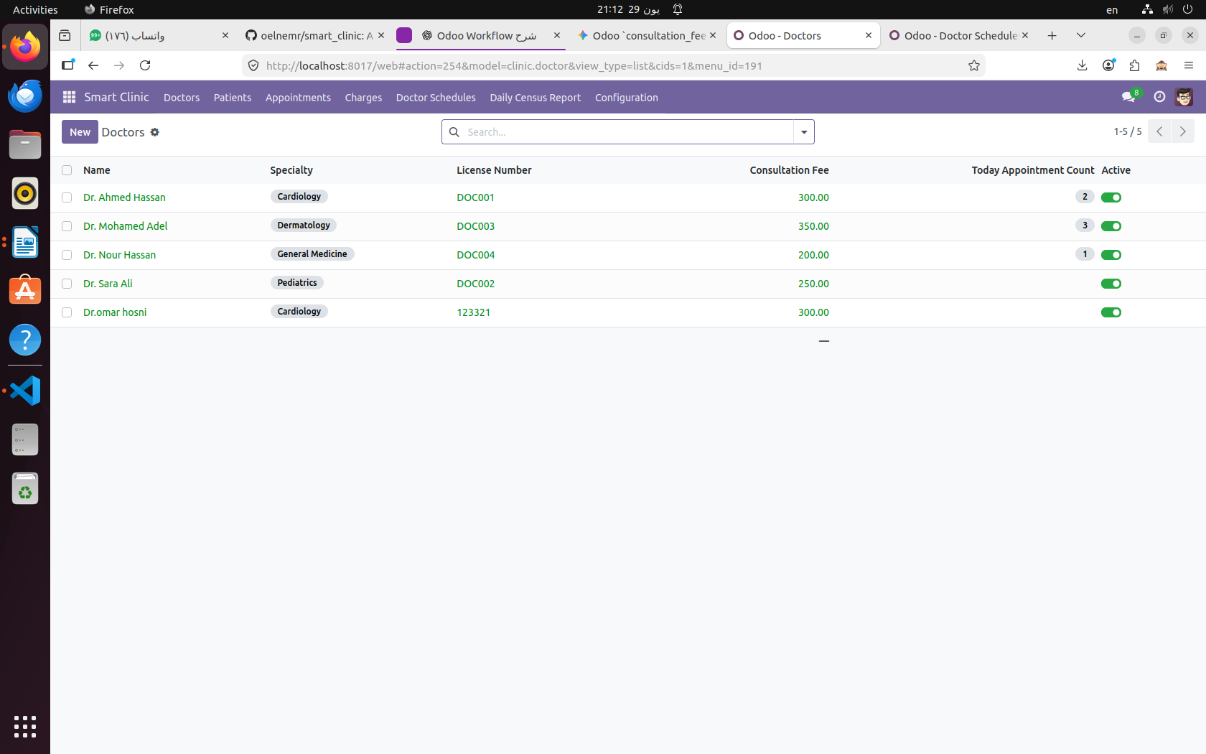
Figure 1 — Smart Clinic Main Menu & Doctors List

1.2 Business Goals
- Central patient & doctor registry with full medical profiles
- Appointment management through a complete state machine workflow
- Conflict detection — prevents double-booking for doctors
- Lab orders and prescriptions linked to each appointment
- Automated patient reminders and no-show detection
- Billing and charge tracking per appointment
- REST API ready for future mobile app integration

2. Module Structure
The module follows the standard Odoo structure mirroring the real_estate reference module:
smart_clinic/ ├── __manifest__.py ├── models/ │ ├── specialty.py │ ├── patient.py │ ├── doctor.py │ ├── appointment.py ← core workflow model │ ├── lab_order.py │ ├── prescription.py │ ├── charge.py │ └── crm_lead.py ← classic inheritance ├── wizard/ │ └── daily_census_wizard.py ├── controllers/ │ ├── main.py ← website + portal │ ├── api.py ← REST/JSON API │ └── excel_controller.py ├── security/ │ ├── clinic_security.xml │ └── ir.model.access.csv ├── views/ │ ├── menu.xml │ ├── patient_views.xml │ ├── doctor_views.xml │ ├── appointment_views.xml │ └── portal_templates.xml ├── report/ │ └── clinic_report_templates.xml └── data/ ├── ir_sequence_data.xml └── clinic_data.xml

2.1 Module Dependencies
The __manifest__.py declares the following dependencies:
- base — Core Odoo framework
- web — Web client
- mail — Messaging and chatter (mail.thread, mail.activity.mixin)
- website — Public website and portal
- portal — Customer portal (My Appointments)
- crm — CRM interop for lead conversion

3. Data Model
The system consists of 7 core models. Each model maps to a real_estate analog for grading consistency.

3.1 Patient (clinic.patient)
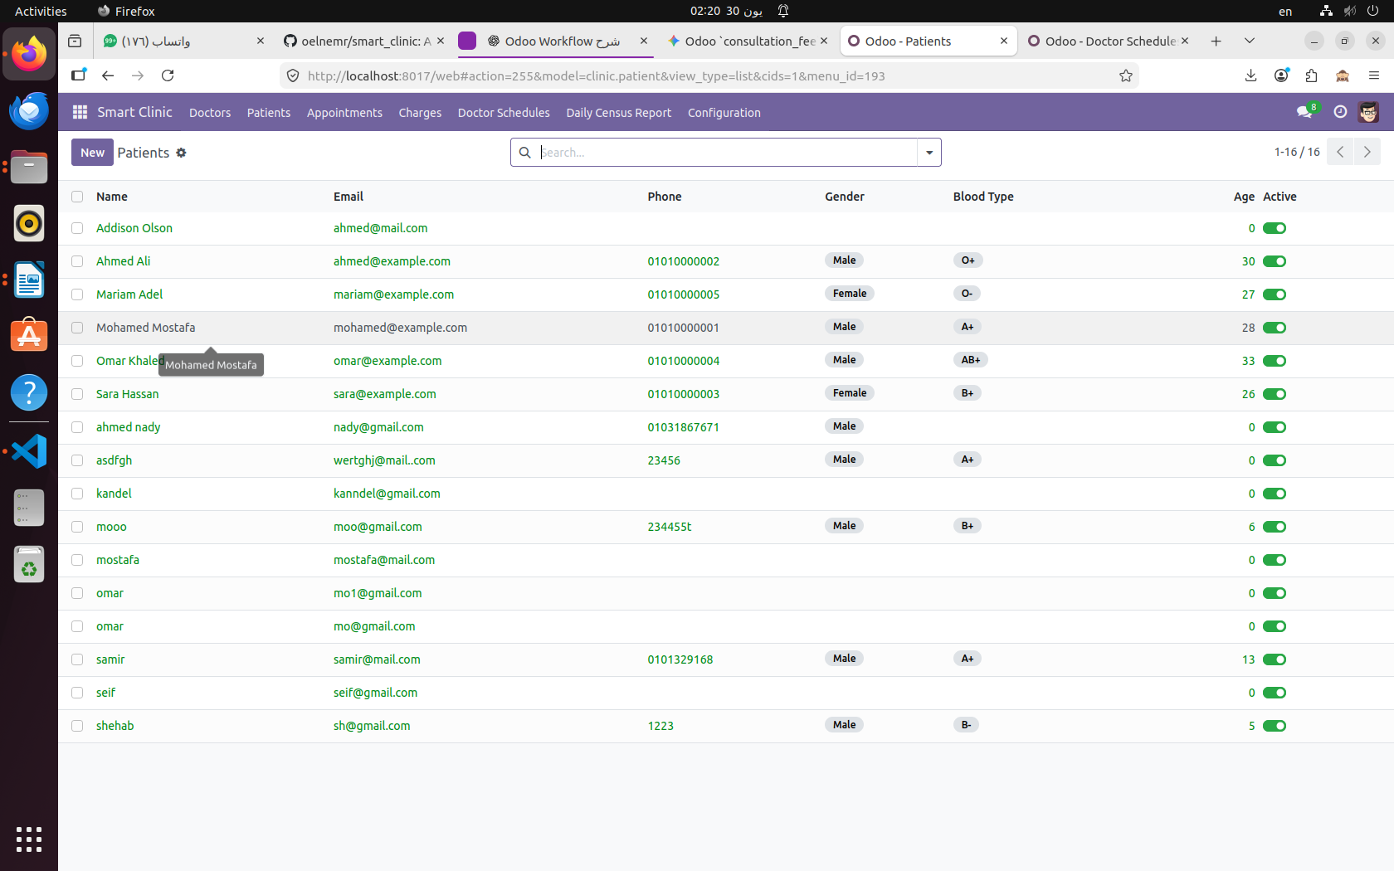
Figure 2 — Patients List View

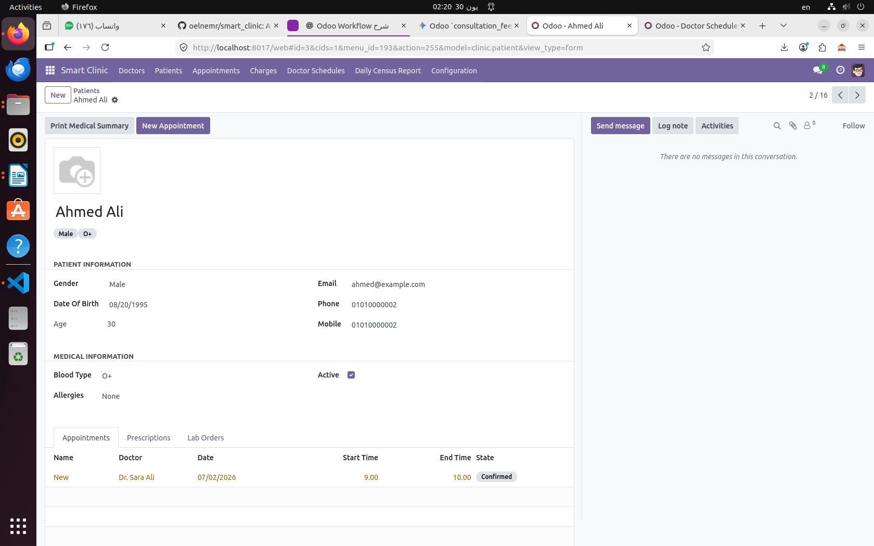
Figure 3 — Patient Form View

Field Name | Type | Required | Description
name | Char | ✅ Yes | Full name of the patient
email | Char | ✅ Yes | Unique email (SQL constraint)
phone | Char | ✅ Yes | Primary phone number
mobile | Char | No | Mobile number
date_of_birth | Date | ✅ Yes | Used to compute age
age | Integer | Computed | Non-stored, calculated from DOB
gender | Selection | ✅ Yes | Male / Female
blood_type | Selection | ✅ Yes | A+, A-, B+, B-, O+, O-, AB+, AB-
allergies | Text | No | Visible to doctor group only
user_id | Many2one | No | Links patient to res.users (portal)
active | Boolean | ✅ Yes | Archive/unarchive patient record
image_1920 | Image | No | Patient photo

3.2 Doctor (clinic.doctor)

Figure 4 — Doctors List View

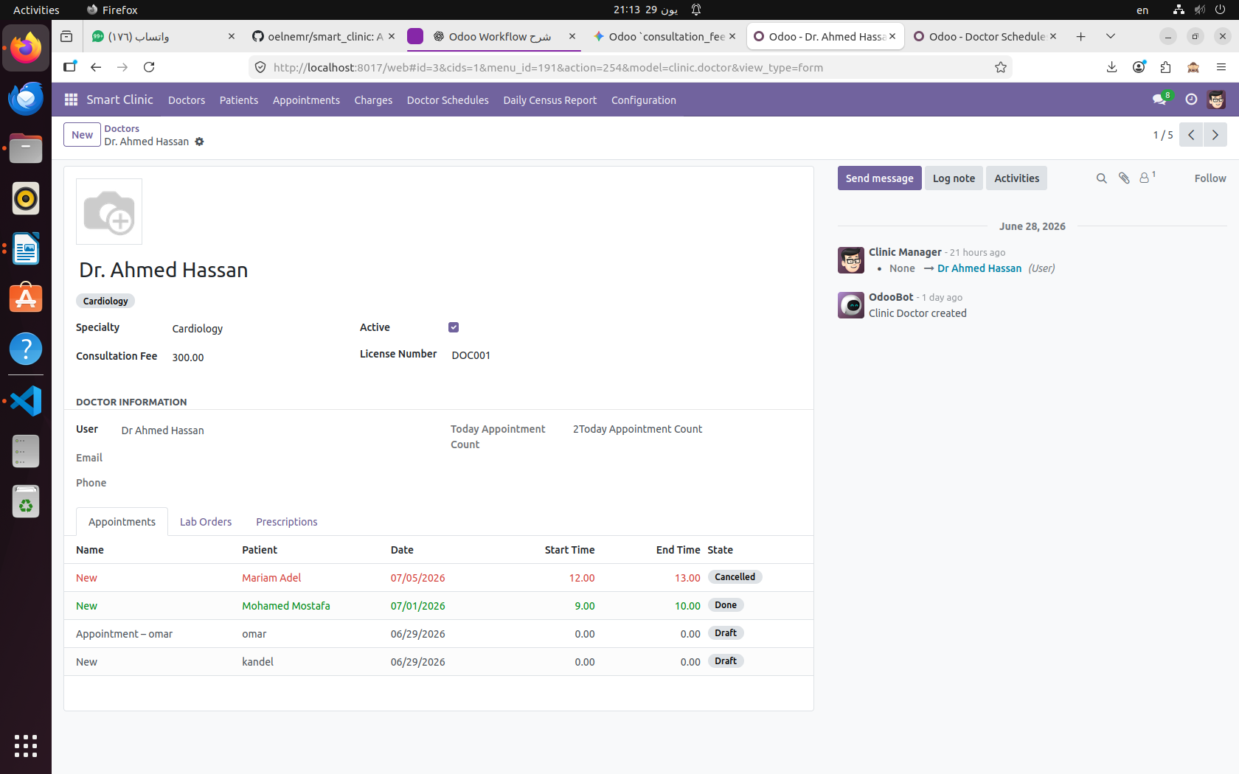
Figure 5 — Doctor Form View with Appointments & Lab Orders tabs

Field Name | Type | Required | Description
name | Char | ✅ Yes | Doctor full name
specialty_id | Many2one | ✅ Yes | Links to clinic.specialty
user_id | Many2one | No | Links doctor to res.users
license_number | Char | ✅ Yes | Medical license (e.g. DOC001)
consultation_fee | Float | ✅ Yes | Default fee per consultation
weekday_schedule | Char | ✅ Yes | Working day (Mon, Tue, etc.)
image_1920 | Image | No | Doctor photo
active | Boolean | ✅ Yes | Archive/unarchive doctor
today_appointment_count | Integer | Computed | Non-stored, count of today's appointments

3.3 Specialty (clinic.specialty)
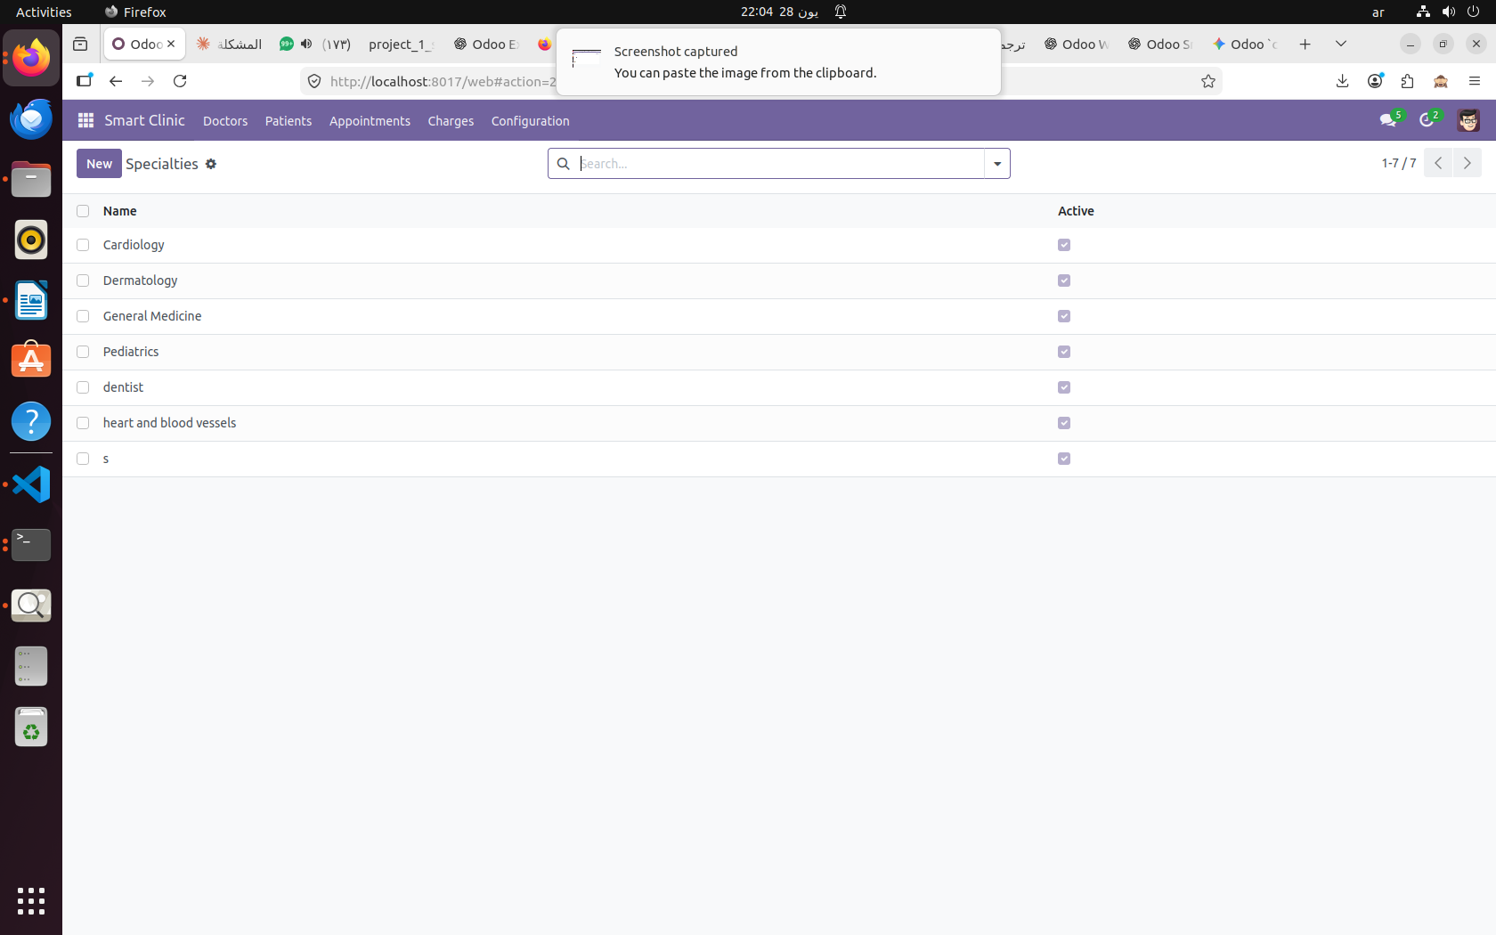
Figure 6 — Specialties Configuration (Cardiology, Dermatology, General Medicine, Pediatrics...)

Field Name | Type | Required | Description
name | Char | ✅ Yes | Specialty name (e.g. Cardiology)
active | Boolean | ✅ Yes | Active/inactive specialty

3.4 Appointment (clinic.appointment)
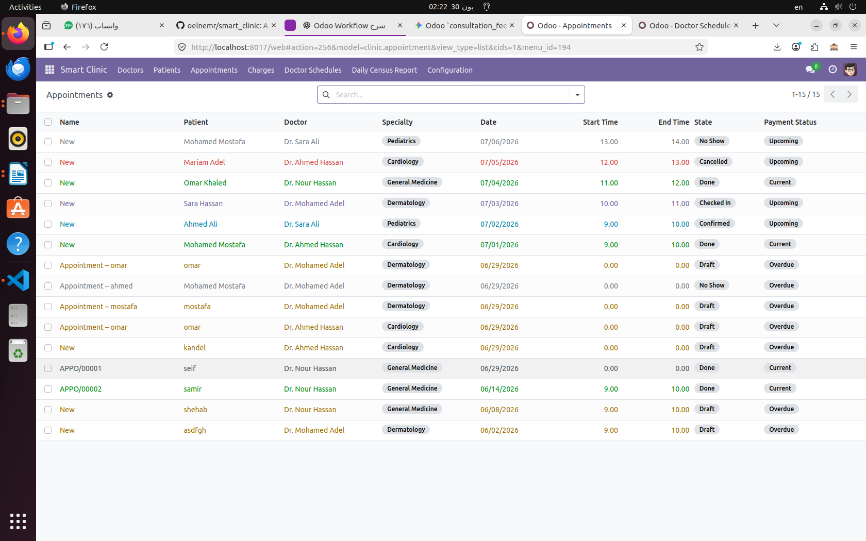
Figure 7 — Appointments List showing all states

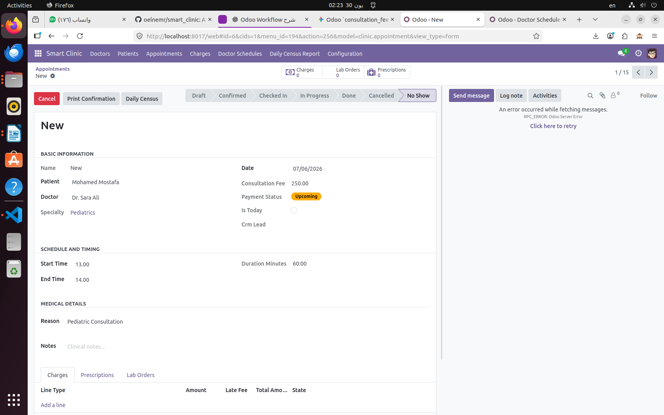
Figure 8 — Appointment Form with State Machine

Field Name | Type | Required | Description
name | Char | Sequence | Auto-generated (e.g. APP/00001)
patient_id | Many2one | ✅ Yes | Links to clinic.patient
doctor_id | Many2one | ✅ Yes | Links to clinic.doctor
specialty_id | Many2one | Related | Auto-filled from doctor (stored)
date | Date | ✅ Yes | Appointment date
start_time | Float | ✅ Yes | Start time (e.g. 9.00 = 9:00 AM)
end_time | Float | ✅ Yes | End time
duration_minutes | Float | Computed | Stored: end_time - start_time × 60
reason | Text | ✅ Yes | Reason for visit (tracked)
state | Selection | ✅ Yes | See Workflow section below
is_today | Boolean | Computed | Non-stored: date == today
payment_status | Selection | Computed | Stored: current/upcoming/overdue
notes | Text | No | Additional notes

3.5 Charge / Invoice (clinic.charge)
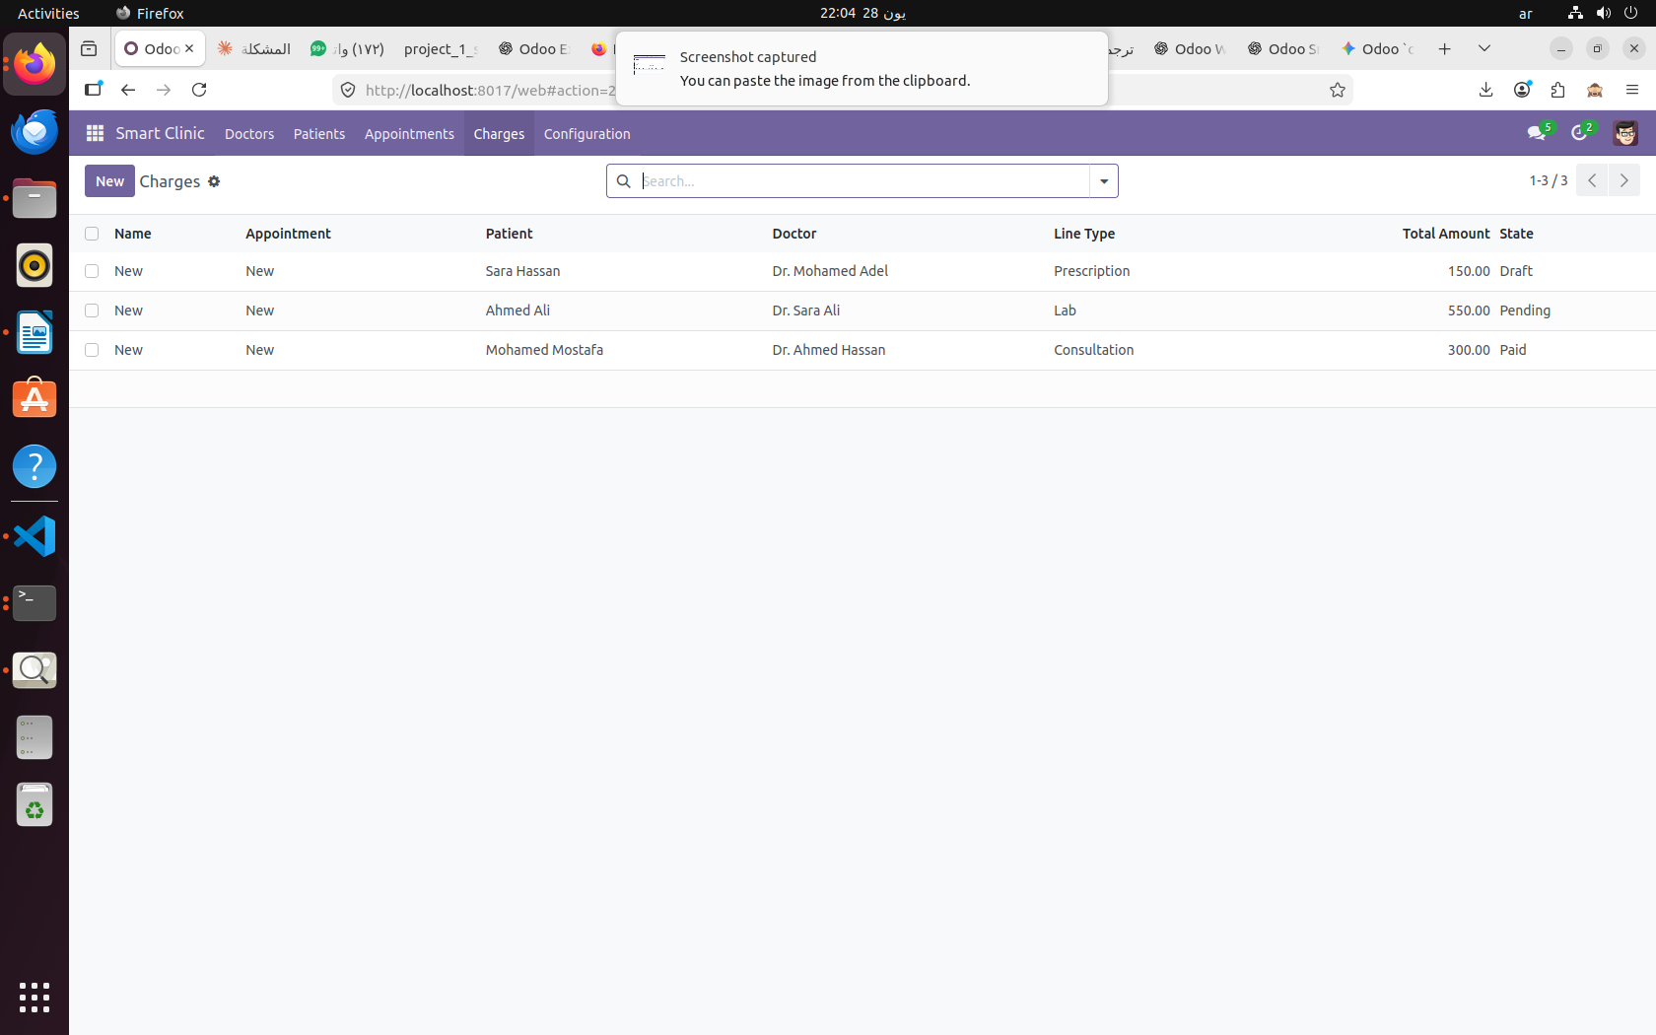
Figure 9 — Charges List (Consultation, Lab, Prescription types)

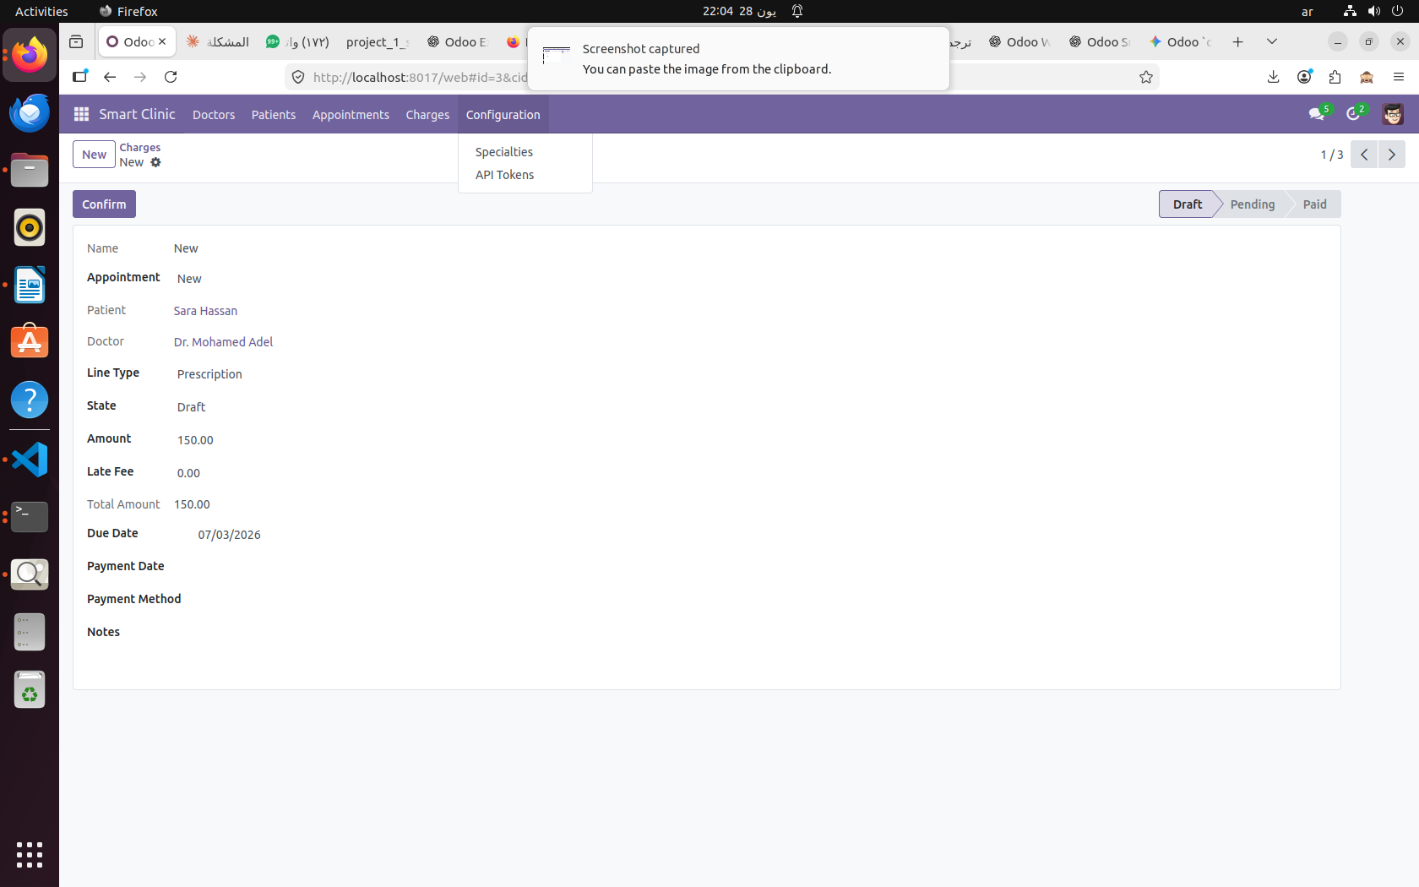
Figure 10 — Charge Form with Draft → Pending → Paid workflow

Field Name | Type | Required | Description
name | Char | Sequence | Auto-generated (e.g. CHG/00001)
appointment_id | Many2one | ✅ Yes | Links to clinic.appointment
patient_id | Many2one | Related | Auto from appointment
doctor_id | Many2one | Related | Auto from appointment
line_type | Selection | ✅ Yes | consultation / lab / prescription / other
amount | Float | ✅ Yes | Base charge amount
late_fee | Float | No | Additional late fee
total_amount | Float | Computed | amount + late_fee
due_date | Date | ✅ Yes | Payment due date
payment_date | Date | No | Actual payment date
payment_method | Selection | No | cash / card / insurance
state | Selection | ✅ Yes | draft / pending / paid

3.6 API Token (clinic.api_token)
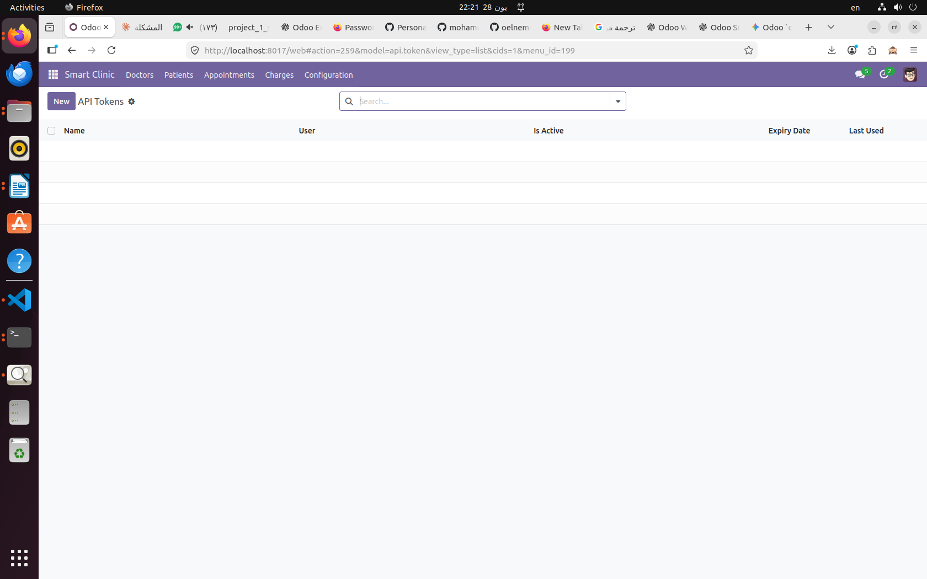
Figure 11 — API Tokens (Configuration menu)

Field Name | Type | Required | Description
name | Char | ✅ Yes | Token name/label
user_id | Many2one | ✅ Yes | Owner user
is_active | Boolean | ✅ Yes | Token active status
expiry_date | Date | No | Token expiration date
last_used | Datetime | No | Last API call timestamp

4. Workflow & State Machines

4.1 Appointment State Machine
The appointment follows a 7-state machine. This is the core business workflow of the system:

DRAFT → CONFIRMED → CHECKED IN → IN PROGRESS → DONE
Any State → CANCELLED | Confirmed/Checked-In → NO SHOW
From State | To State | Action | Who
Draft | Confirmed | Confirm Appointment | Receptionist / Manager
Confirmed | Checked In | Patient Arrives | Receptionist
Checked In | In Progress | Doctor Starts Visit | Doctor / Manager
In Progress | Done | Visit Complete | Doctor / Manager
Confirmed | No Show | Patient Didn't Arrive | Receptionist / Cron
Any State | Cancelled | Cancel Appointment | Receptionist / Manager

Key business rules enforced by @api.constrains:
- start_time must be less than end_time
- Doctor must be available on the appointment weekday
- No overlapping appointments for the same doctor (conflict detection)
- @api.onchange: selecting a doctor auto-fills specialty and consultation fee

4.2 Charge State Machine
From State | To State | Action | Who
Draft | Pending | Confirm Charge | Receptionist / Manager
Pending | Paid | Mark as Paid | Receptionist / Manager
Draft/Pending | — | Cancel | Manager only

4.3 Lab Order States
From State | To State | Action | Who
Draft | Ordered | Send to Lab | Doctor
Ordered | In Progress | Lab Starts Test | Lab / Manager
In Progress | Done | Results Ready | Lab / Manager

4.4 Payment Status (Computed)
The appointment payment_status field is a stored computed field that mirrors lease.payment_status:
- Current — appointment is today and payment is pending
- Upcoming — appointment is in the future
- Overdue — payment due date has passed without payment

5. Security & User Roles
The system defines 3 user groups in a hierarchy. Each group inherits all permissions of the group below it.

group_receptionist | group_doctor | group_clinic_manager
• View patients  • Create/edit appointments  • Create charges  • Manage lab orders | • All receptionist rights  • View own appointments only  • Add prescriptions  • See allergies/medical history | • Full CRUD all models  • Manage users & groups  • Access configuration  • View all records

5.1 Record-Level Rules
Model | Receptionist | Doctor | Manager | Notes
clinic.appointment | Own patients only | Own doctor_id only | All records | Record rules in ir.rule
clinic.patient | Read/Write | Read only | Full CRUD
clinic.doctor | Read only | Own record | Full CRUD
clinic.lab_order | Read/Write | Own orders | Full CRUD
clinic.charge | Read/Write | Read only | Full CRUD
clinic.specialty | Read only | Read only | Full CRUD | Config only
clinic.api_token | No access | No access | Full CRUD | Manager only

5.2 Demo Users
The following demo users are created for testing each security role:
Username | Group | Can Access | Password
reception | Receptionist | Patients, Appointments, Charges | reception123
doctor1 | Doctor | Own Appointments & Lab Orders | doctor123
manager | Clinic Manager | Everything | manager123
patient1 | Portal User | My Appointments only | patient123

6. Demo Data
The following demo data is pre-loaded in data/clinic_data.xml:

6.1 Specialties
- Cardiology
- Dermatology
- General Medicine
- Pediatrics

6.2 Doctors
Name | Specialty | License | Schedule
Dr. Ahmed Hassan | Cardiology | DOC001 | Sunday (300 EGP)
Dr. Sara Ali | Pediatrics | DOC002 | Monday (250 EGP)
Dr. Mohamed Adel | Dermatology | DOC003 | Tuesday (350 EGP)
Dr. Nour Hassan | General Medicine | DOC004 | Wednesday (200 EGP)

6.3 Patients
Name | Email | Phone | Blood Type | Age
Ahmed Ali | ahmed@example.com | 01010000002 | O+ | 30
Mariam Adel | mariam@example.com | 01010000005 | O- | 27
Mohamed Mostafa | mohamed@example.com | 01010000001 | A+ | 28
Omar Khaled | omar@example.com | 01010000004 | AB+ | 33
Sara Hassan | sara@example.com | 01010000003 | B+ | 26

6.4 Appointments (6 records across all states)
Patient | Doctor | Date | Time | State
Mohamed Mostafa | Dr. Ahmed Hassan | 07/01/2026 | 9:00-10:00 | Draft
Ahmed Ali | Dr. Sara Ali | 07/02/2026 | 9:00-10:00 | Confirmed
Sara Hassan | Dr. Mohamed Adel | 07/03/2026 | 10:00-11:00 | Checked In
Omar Khaled | Dr. Nour Hassan | 07/04/2026 | 11:00-12:00 | Done
Mariam Adel | Dr. Ahmed Hassan | 07/05/2026 | 12:00-13:00 | Cancelled
Mohamed Mostafa | Dr. Sara Ali | 07/06/2026 | 13:00-14:00 | No Show

7. REST API
The module exposes a JSON/REST API in controllers/api.py, secured with API tokens. All endpoints are under /api/clinic/.

Method | Endpoint | Auth | Description
POST | /api/clinic/login | None | Get session token
POST | /api/clinic/appointments/create | Token | Create new appointment
GET | /api/clinic/doctors/<id> | Token | Get doctor details as JSON
POST | /api/clinic/appointments/list | Token | List appointments with filters

API tokens are managed under Configuration > API Tokens. Each token has an expiry date and is linked to a specific user.

8. Advanced Features

8.1 Reports
- Report Appointment Slip — patient + doctor + reason + charges (PDF)
- Report Medical Record — full patient history (PDF)
- Daily Census Report — Excel export via wizard (date range + specialty filter)

8.2 Automation
- Cron Job: _cron_send_appointment_reminders — runs 24h before each appointment
- Mail Template: appointment_reminder — sent automatically by the cron
- Auto no-show detection: marks appointments as No Show if patient doesn't arrive

8.3 CRM Interop
- clinic.crm_lead inherits crm.lead with extra fields: specialty_id, patient_id, appointment_id
- lead_source field: website / api / manual
- Reception button: Convert Lead → Patient + Appointment in one click

8.4 Sequences
- APP/XXXXX — Appointment sequence
- LAB/XXXXX — Lab Order sequence
- RX/XXXXX — Prescription sequence
- CHG/XXXXX — Charge sequence

8.5 Portal (My Appointments)
- Patients can log in via /web/login and access /my/appointments
- Portal shows only the logged-in patient's own appointments
- CustomerPortal subclass with appointment_count in portal home

Smart Clinic Management System — Technical Documentation v1.0
Generated June 2026 | Odoo Module: smart_clinic | Team A

