***Title: Augmented Reality Car Showcase and* Prefab House View on Image Recognition:**

*Project Synopsis:*

The Augmented Reality Car Showcase is a visionary project that seamlessly amalgamates Google's AR Core with Unity's cutting-edge visual scripting tools to create an immersive and interactive platform for exploring an exquisite collection of 3D car models. This endeavor goes beyond the ordinary, redefining how users engage with automotive designs through a virtual lens.

*Technological Foundations:*

*AR Core Integration:*

Our project harnesses the capabilities of AR Core, Google's augmented reality platform for Android devices. This integration allows for robust motion tracking, environmental understanding, and light estimation, enhancing the realism of the AR experience.

*Unity Visual Scripting:*

The project's backbone is Unity's visual scripting interface, a powerful toolset that empowers developers with a no-code/low-code environment.

Screenshots from Unity's visual scripting canvas showcase the intricacies of crafting interactive AR experiences without delving extensively into traditional coding paradigms.

*On Button Click:*

**Action:** Use an "Event Unit" to capture button clicks.

**Explanation:** When the button is clicked, connect this event to trigger desired actions.

*Get Variable:*

**Action:** Utilize a "Variable Unit" to retrieve the value of a variable.

**Explanation:** Retrieve the current value of a specified variable for use in scripts or actions.

*Transform Rotate:*

**Action:** Use a "Transform Unit" with the rotation function to rotate an object.

**Explanation:** Change the rotation of a Game Object in 3D space, useful for dynamic transformations.

*Transform Position:*

**Action:** Apply a "Transform Unit" with the position function to move an object.

**Explanation:** Alter the position of a Game Object in 3D space, enabling dynamic movement.

*General Tips:*

**Event Flow:** Connect events to actions for a sequence of operations.

Parameter Configuration: Configure parameters for each action based on specific needs.

**Debugging:** Utilize debugging features provided by visual scripting tools to troubleshoot and inspect variables.

These actions empower you to create interactive experiences, especially useful for moving and rotating 3D models in response to user interactions in your AR project.

*General UI Overview:*

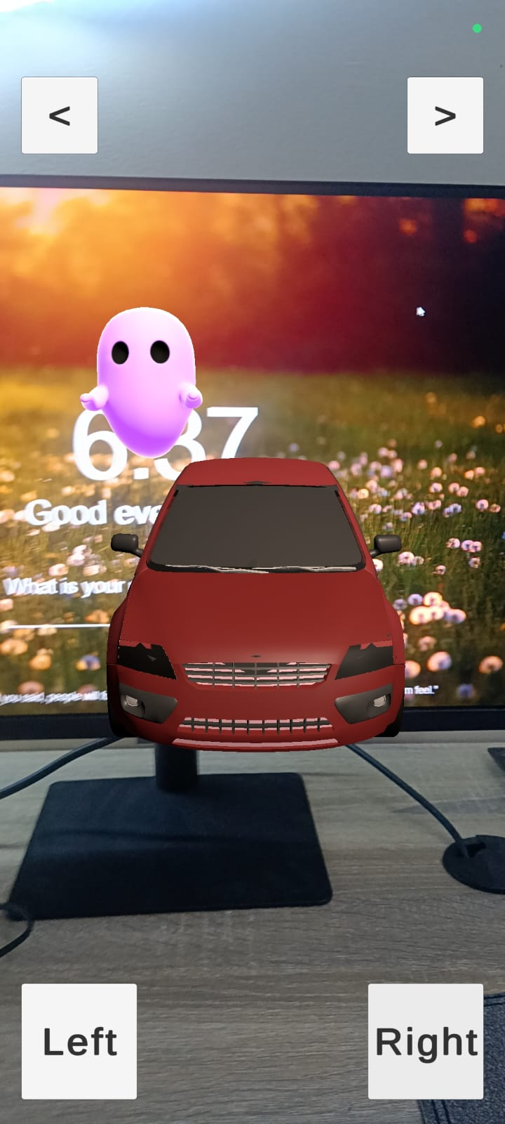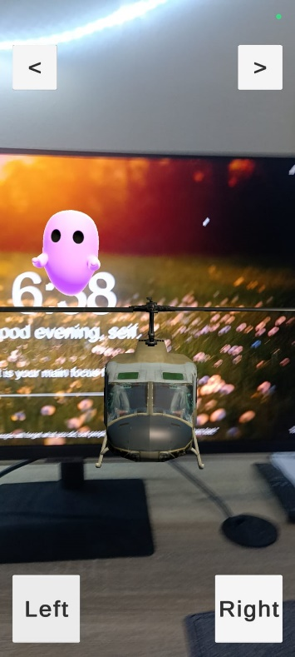

*3D Car Models:*

A meticulous curation of 3D car models forms the heart of our showcase. Each model is a testament to detailed craftsmanship, featuring realistic textures, intricate designs, and lifelike proportions. These models are seamlessly integrated into the AR environment, dynamically adjusting their scale and placement to provide users with an authentic sense of each vehicle.

*User Interaction and Navigation:*

The user interface is designed with simplicity and interactivity in mind. Users navigate through the virtual showroom using intuitive swipe gestures, allowing for a fluid and engaging experience. Each swipe triggers a smooth transition between car models, giving users the freedom to explore the entire collection effortlessly.

*Realism through Dynamic Placement:*

Car models dynamically adapt to the real-world environment, leveraging AR Core’s environmental understanding. This ensures that each vehicle appears realistically placed within the user's physical space, enhancing the overall immersion, and providing a true-to-life showcase experience.

Educational and Marketing Opportunities:

Beyond its entertainment value, the Augmented Reality Car Showcase project opens doors to educational and marketing avenues. It serves as a virtual showroom, enabling users to explore and learn about different car designs. Additionally, businesses can utilize the platform for interactive marketing campaigns, allowing potential buyers to virtually experience their products.

*Future Vision and Enhancements:*

The project is a living canvas with a roadmap for future enhancements. Considerations include user customization options, real-time lighting effects to enhance visual fidelity, and integration with AR glasses for an even more immersive exploration of the automotive world.

*Conclusion:*

The Augmented Reality Car Showcase is not just a demonstration of technology; it's an immersive journey into the future of automotive exploration. Through the marriage of AR Core and Unity's visual scripting, we've crafted an experience that goes beyond the screen, bringing automotive designs into the hands of users in an unprecedented and captivating minareted Reality Car Showcase: A Unity AR Core Endeavor

**Project Synopsis:** The Augmented Reality Car Showcase is a visionary project that seamlessly amalgamates Google's AR Core with Unity's cutting-edge visual scripting tools to create an immersive and interactive platform for exploring an exquisite collection of 3D car models. This endeavor goes beyond the ordinary, redefining how users engage with automotive designs through a virtual lens.

*Image Recognition Integration:*

**Implementation:** Utilizing AR Core’s image recognition capabilities or a similar technology, the app detects a specific picture as a trigger for additional content.

*1. Home Prefab View:*

the moment when the AR app recognizes the specific picture, triggering the

display of the home prefab.

**Description:** Highlight the seamless integration of image recognition technology, demonstrating how the app dynamically overlays the prefab house view upon detecting the target image.

*Enhancing Realism:*

**Explanation:** Discuss how the inclusion of a home prefab view enhances the realism of the AR experience, allowing users to virtually place a house in their physical environment.

*Potential Applications:*

**Description:** Explore potential applications such as virtual home tours, architectural visualization, or interactive real estate presentations enabled by the home prefab feature triggered by image recognition.

*User Guidance:*

**Screenshot or Mockup:** Include an illustration demonstrating any guidance or UI elements that instruct users on the image to scan for activating the prefab house view.

**Description:** Ensure users have a clear understanding of the image recognition process and how they can activate the home prefab view.