Project Title: **Watchify**

Student Names:

Seif El-Deen Raafat 247563

Bashar Zain 249625

Malek al Hariri 244902

Karim Hisham 249581

Abdallah Waleed 247130

Daniella Amgad 240239

Emails:

[seifeldeen247563@bue.edu.eg](mailto:seifeldeen247563@bue.edu.eg)

[bashar249625@bue.edu.eg](mailto:bashar249625@bue.edu.eg)

[malek244902@bue.edu.eg](mailto:malek244902@bue.edu.eg)

[karim249581@bue.edu.eg](mailto:karim249581@bue.edu.eg)

[abdallah247130@bue.edu.eg](mailto:abdallah247130@bue.edu.eg)

daniella240239@bue.edu.eg

SITE MAP

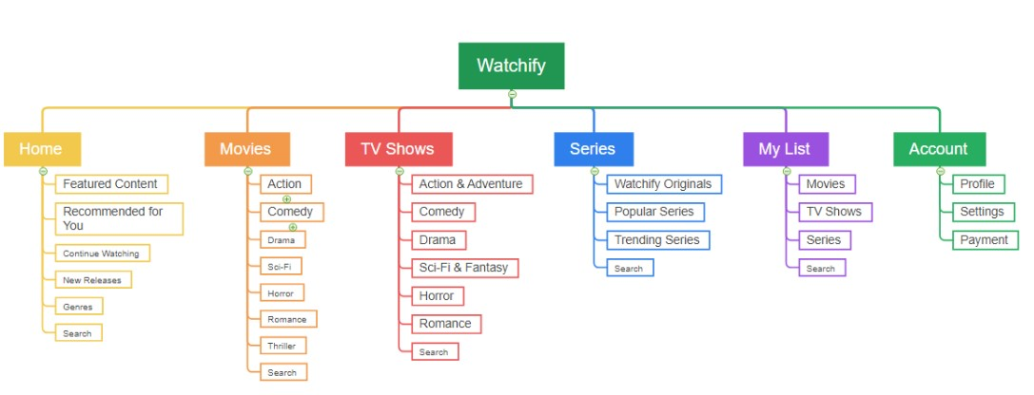

Wireframes

|  |  |
| --- | --- |
| Home,Sign In/Up,Profile – SiteMap – WireFrames Javascript File | Seif El-Deen |
| Settings, Tv Show | Bashar Zain |
| Movie,Serie | Karem hesham |
| Payment,Subscribe | Malek al Hariri |
| Account,mylist | Daniella Amgad |
| Movies,Series | Abdallah Waleed |

**Contribution Table :**