

Name: Seif eldin ahmed

I.D: 2018/02862

Course Name: Operating System 1

Course Code: CSC250

Project 3

Contents

How the project works? 3

Main menu: 3

First fit: 4

Getting from file: 5

Best Fit algorithm: 6

Before filling: 6

After filling: 6

Getting from file: 7

Worst Fit algorithm: 8

Before filling: 8

After filling: 9

Getting from file: 10

First Fit Flow Chart: 11

Best Fit Flow Chart 12

Worst Case Flow Chart: 14

# How the project works?

When the application runs the user choses the algorithm that they want to calculate. Then the program takes the user after choosing to enter the values they want or to retrieve the data from the file. When the user start to fill the text fields of the values, they have to fill all the fields then press done to be stored in the array and then the same goes for the memory blocks then show values to be sure of the numbers the user entered, then press calculate.

# Main menu:

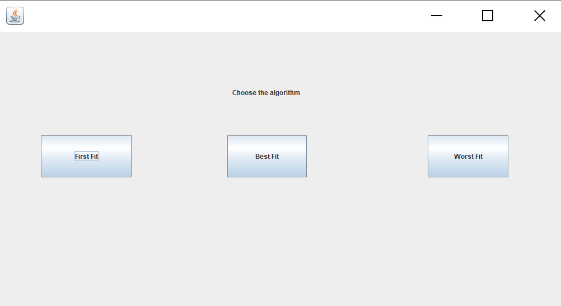

# First fit:

Before filling:

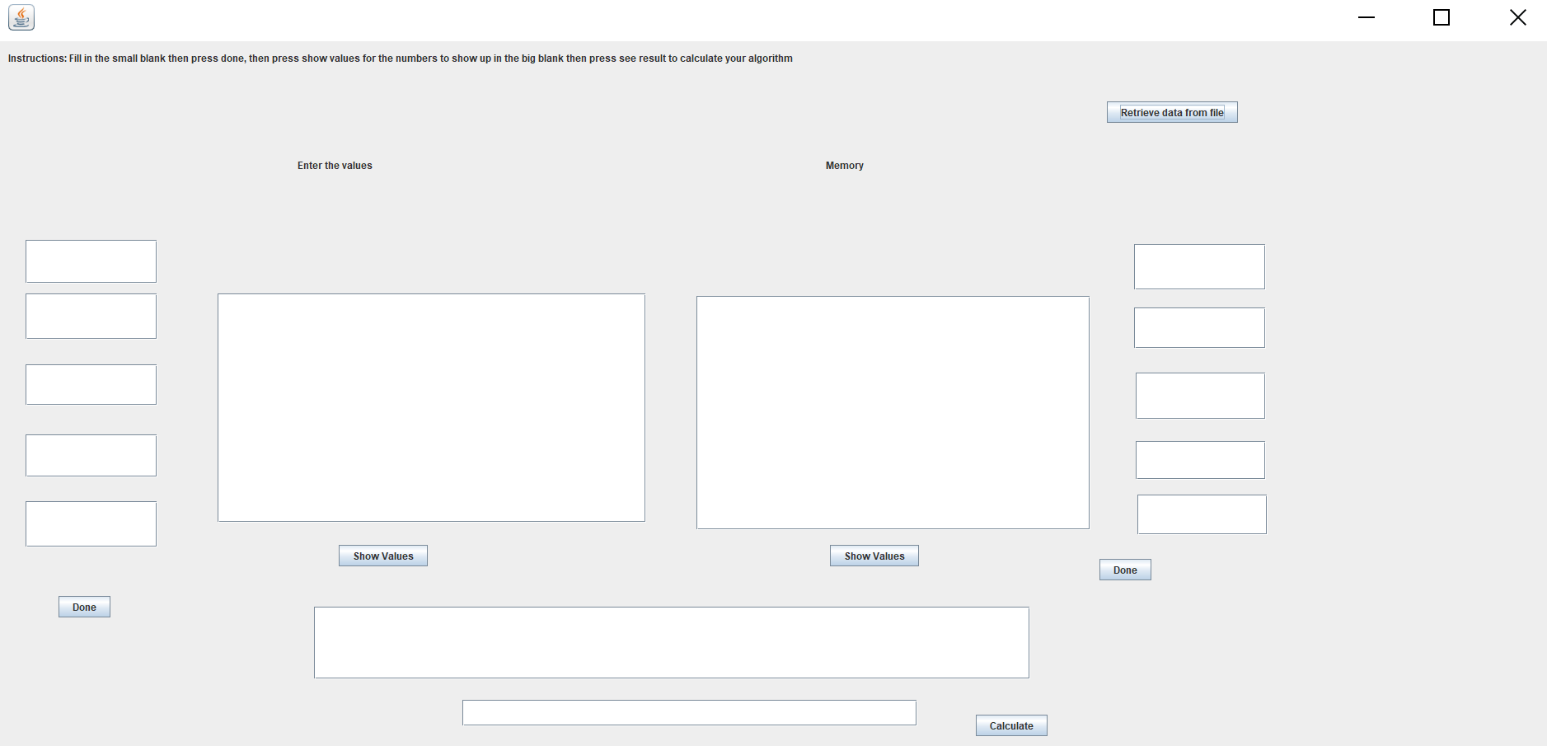

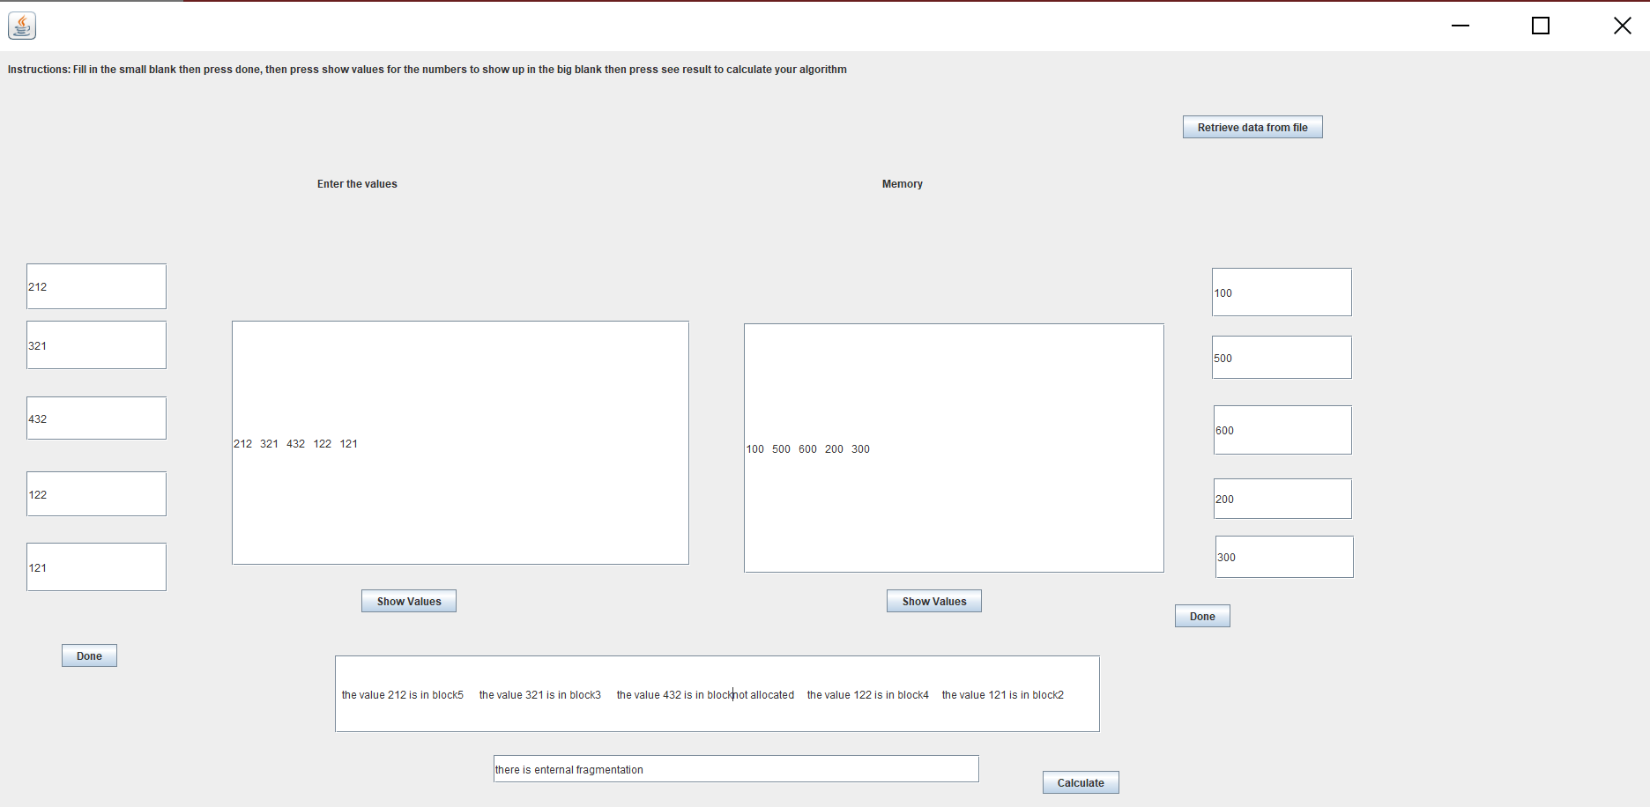After filling and calculated the algorithm and the fragmentation:

# Getting from file:

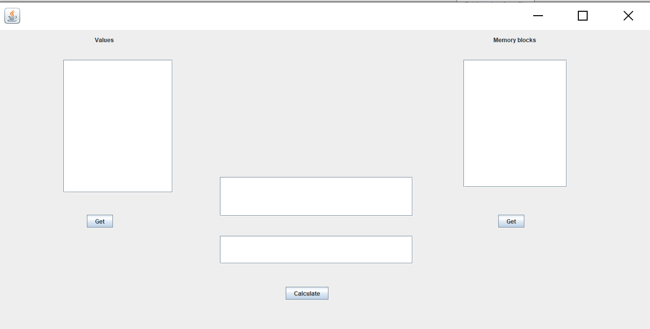

# Best Fit algorithm:

# Before filling:

# 

# After filling:

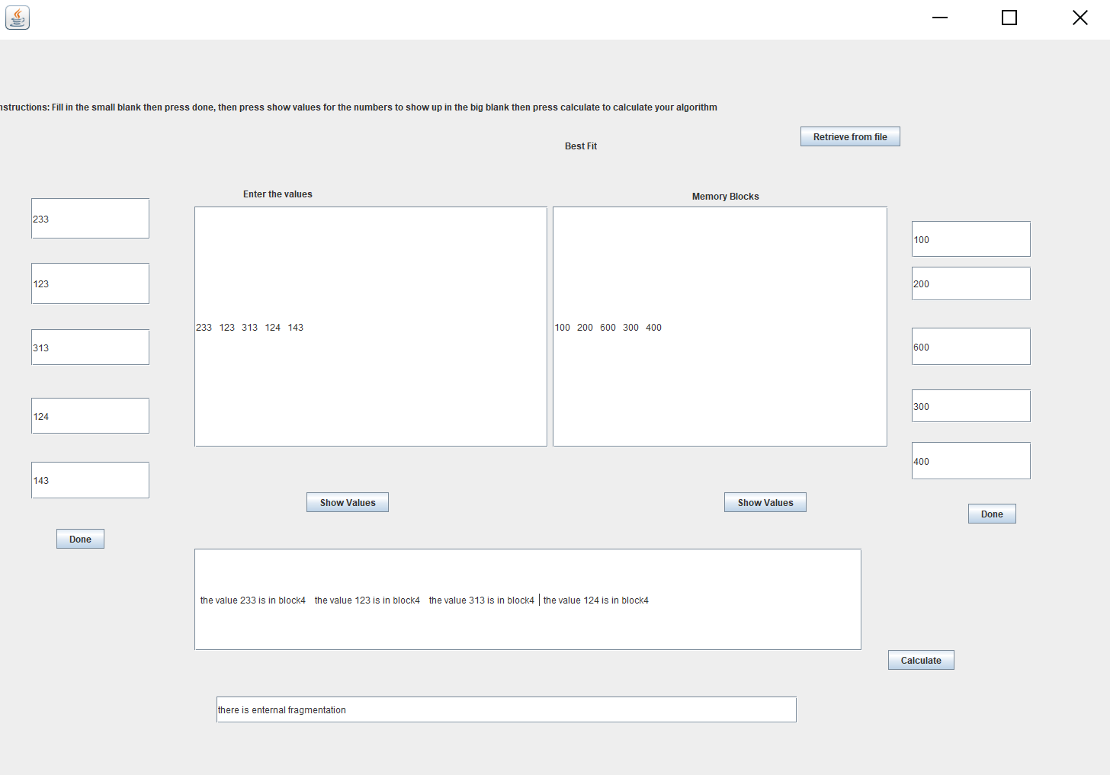

# Getting from file:



# Worst Fit algorithm:

# Before filling:

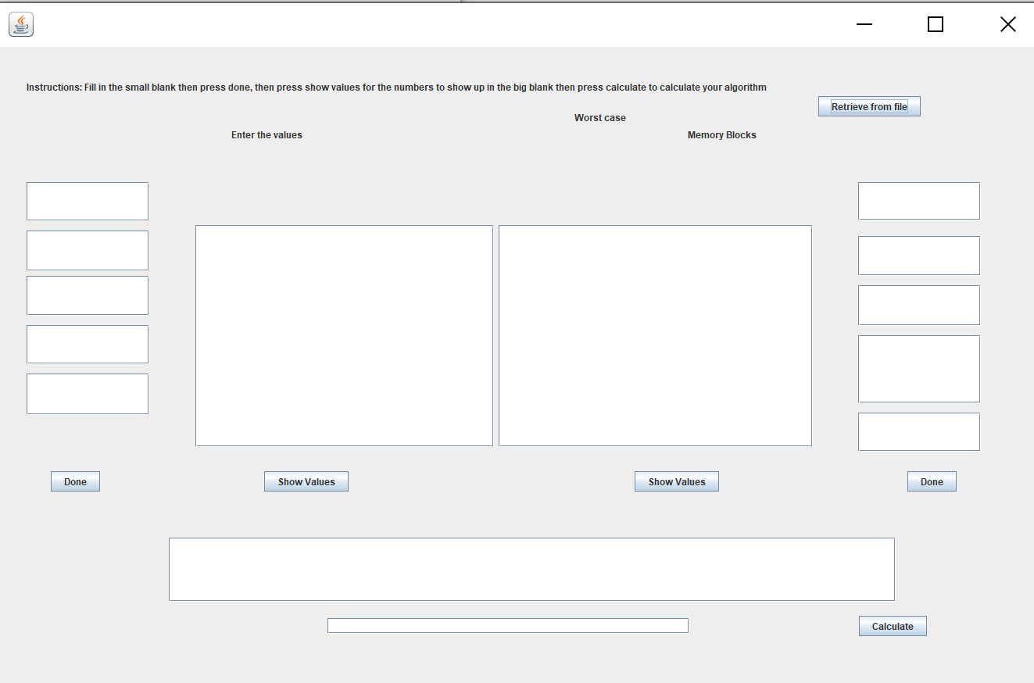

# After filling:

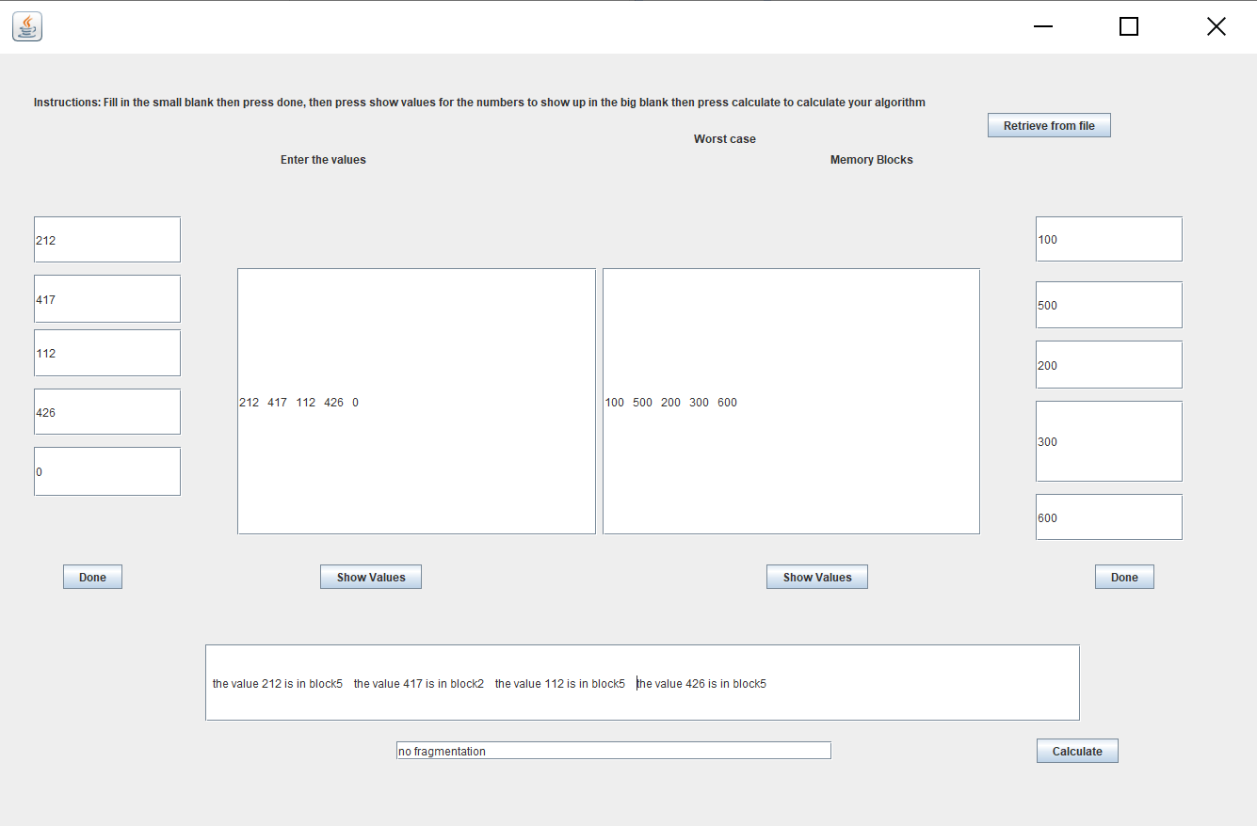

# Getting from file:



# First Fit Flow Chart:

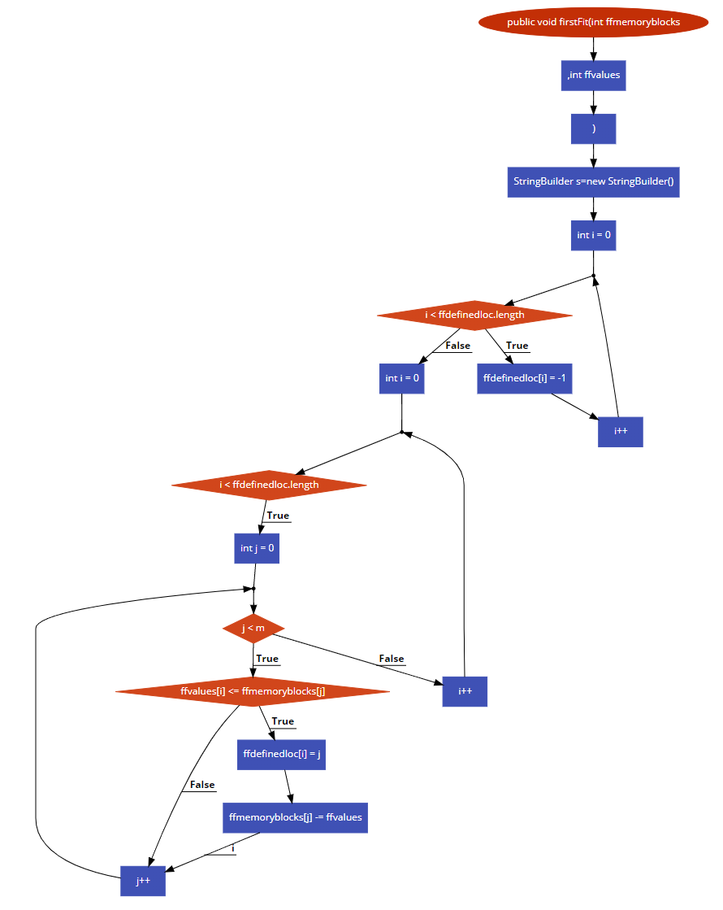

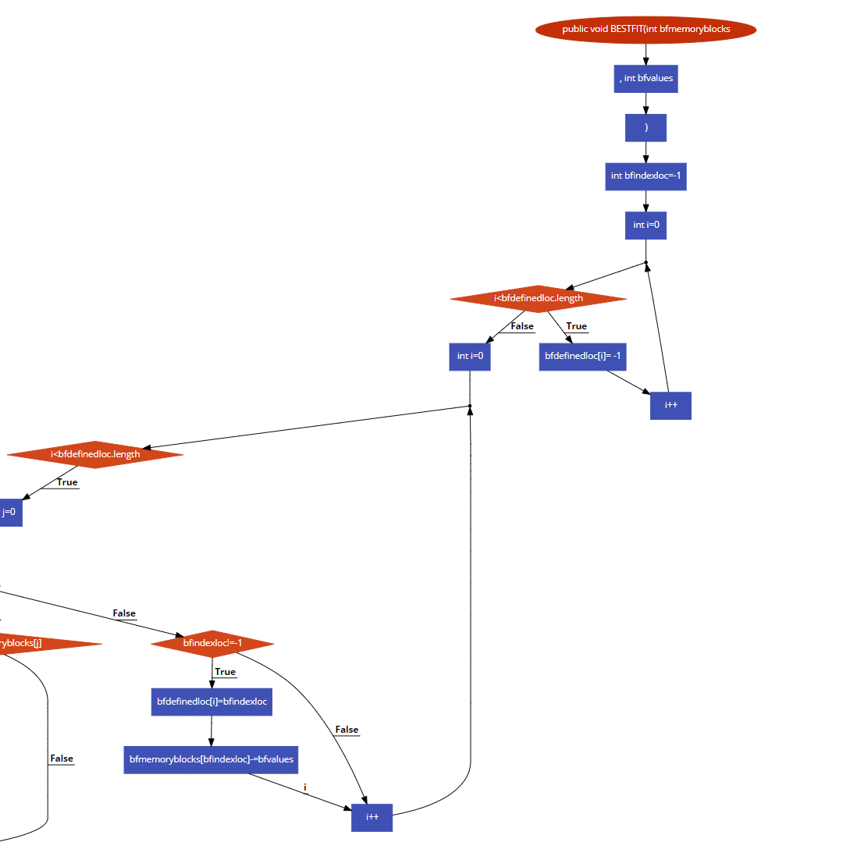Best Fit Flow Chart**:**

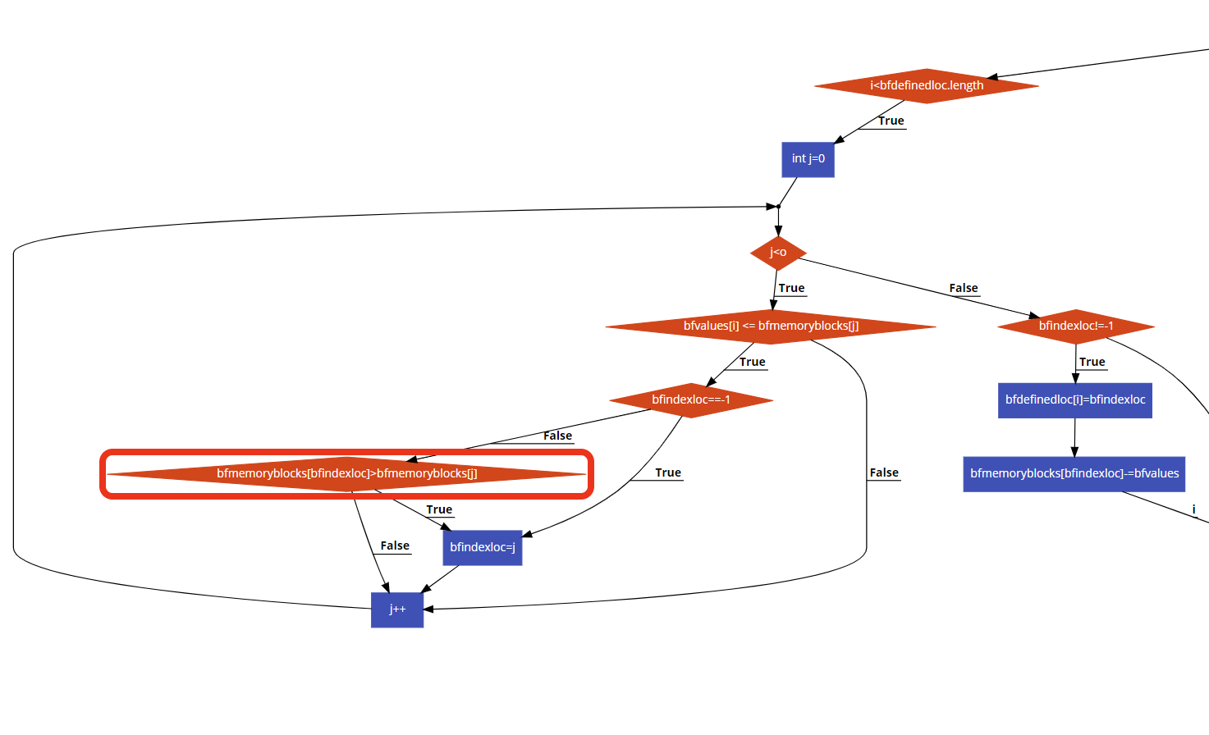

# Worst Case Flow Chart:

