

Walmart Data Analytics Documentation

Data Management

Team 1

|  |
| --- |
| **Seif El Din Mohamed** |
| **Ahmed Mustafa Otifi** |
| **Eslam Ahmed** |
| **Hassan Marzouk** |
| **Mariam Eid** |

**Optimizing Sales through Data-Driven Insights**

**Executive Summary**

This report identifies key opportunities to optimize Walmart’s sales based on purchasing patterns, customer demographics, and product pair analysis. By leveraging data-driven strategies, Walmart can enhance inventory management, streamline promotions, and improve customer satisfaction, ultimately driving profitability.

**Key Findings**

1. **Top-Selling Products**
   * *Highest Revenue Generators*:
     + Samsung Galaxy S22 ($7,919.90, Electronics).
     + Treadmill ($6,239.88, Sports & Outdoors).
   * **Action**: Prioritize these products in marketing and stock planning.

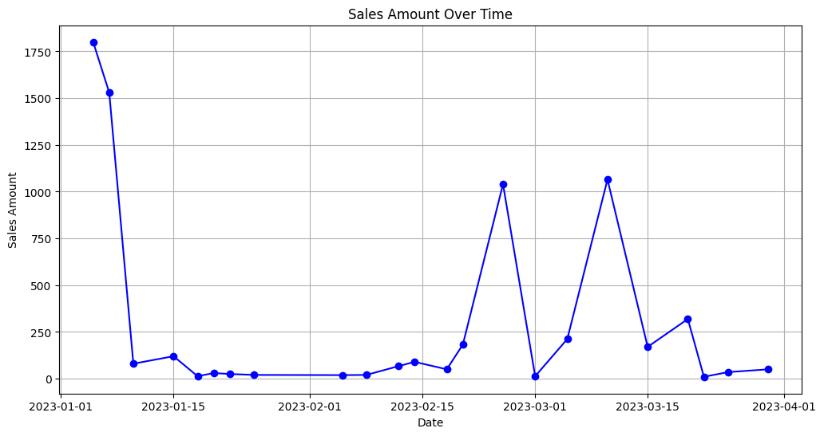

1. **Customer Behavior**
   * *Key Demographic*: Married males (30s) with children drive the highest sales.
   * *Time-Based Trends*: Weekends show the highest sales spikes.
   * **Action**: Implement weekend-centric promotions and personalized campaigns for this demographic.

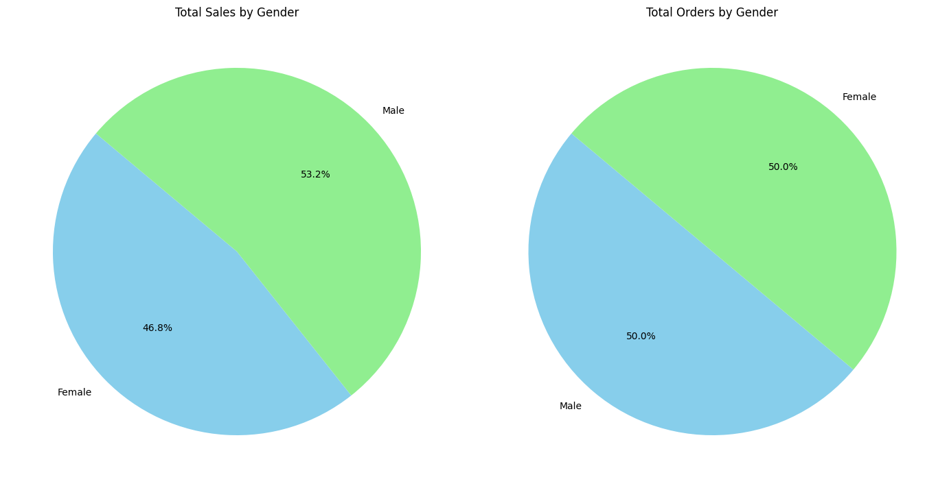

1. **Promotion Effectiveness**
   * High-value items like electronics and cookware benefit most from promotions.
   * **Action**: Focus on bundling and cross-category promotional offers.

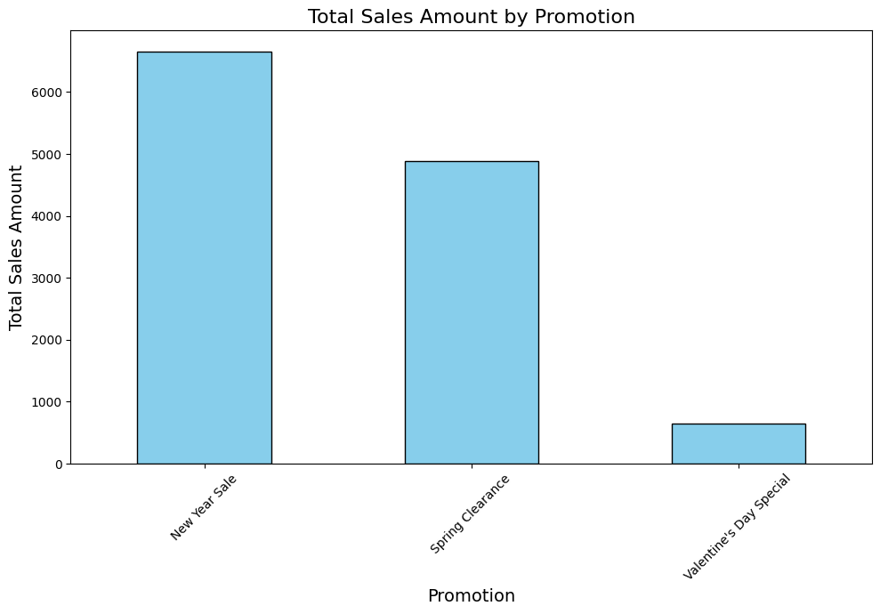

1. **Frequently Bought-Together Products**
   * Top pairs include:
     + Men’s T-Shirt and Jeans.
     + Women’s Dress and Jacket.
   * **Action**: Reorganize store layouts to group related items and offer bundle discounts.

**Recommendations**

1. Top-Selling Products by Category

* Promote high-value items (e.g., Samsung Galaxy S22, Treadmill) via targeted campaigns.

1. Customer Purchase Behavior

* Launch weekend-specific promotions and loyalty programs for married males in their 30s with children.

1. Daily Sales Trends

* Plan inventory and staffing to meet weekend and holiday demand.

1. Promotion Performance

* Bundle high-value items with complementary products to maximize sales.

1. Frequently Bought-Together Products
   * Optimize store layouts to position related products together (e.g., Men’s T-Shirt near Men’s Jeans).
   * Offer bundle discounts for frequently purchased pairs.

**Next Steps**

* Conduct a 3-month pilot in select stores.
* Monitor key metrics: sales growth, customer feedback, and inventory turnover.
* Refine strategies and expand implementation based on pilot results.