

Assignment 1

Name(ID) :

Ans Gomaa Elnagar (18010421)

Seif Mohamed Gneedy (18010834)

Problem statement:

It is required to implement a program that can do union, intersection and complement of sets.

Used data structures:

- ArrayList (It is a dynamic array).

- Our implementation of Set Class.

Algorithms used:

\* Adding element to the set

Add method: looks if the element is existed in the set before and if not then adds it.

method add(argument arg){

if argument arg doesn’t exist in the set values then :

add arg to the set values

end if

end

}

\* Union of 2 sets

Union method: returns all the elements in the 2 sets without repitition.

method union(Set first,Set second){

creating an arrayList to store the results to return it.

then , adding all the elements of the first set to result and then adding the elements in the second set (that doesn’t exist in the first one) to result .

return result;

end

}

\* Intersection of 2 sets :

Intersection method:returns the elements that exists in both sets.

method intersection(Set first,Set second){

creating an arrayList to store the results to return it.

taking every element in the first set and check if it exists in the second and if so then add it to result

return result

end

}

\* Complement of a set :

Complement method : returns all the elements in the universe that doesn’t exist in the set.

method complement(Set universe){

creating an arrayList to store the results to return it.

iterate over every element in the universe set :

if this element doesn’t exist in the set then

add it to result

return result

end

}

Code snippets:

Main class

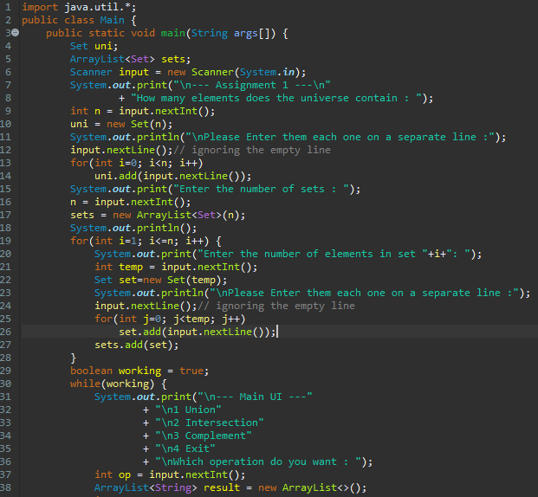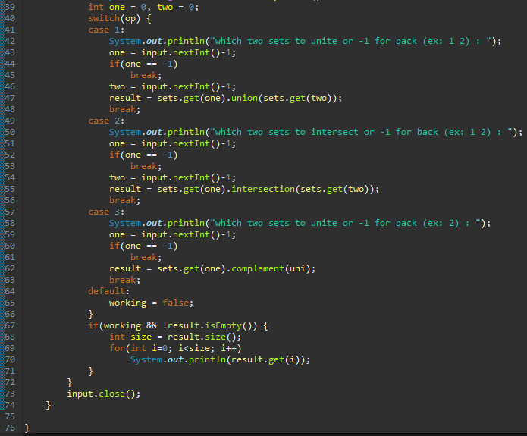

Set Class

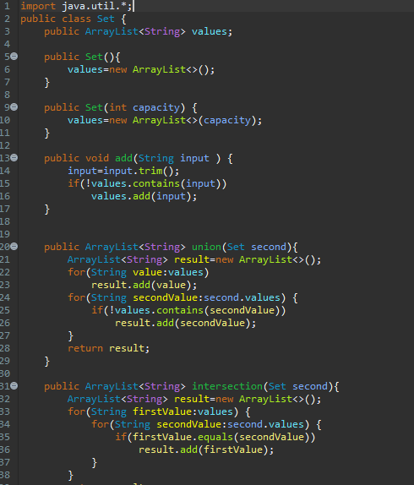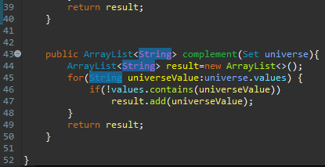

Sample runs:

\* input UI :

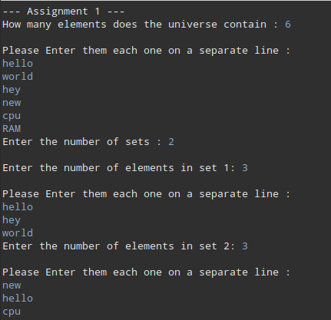

\* Union :

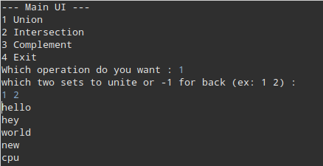

\* Intersection :

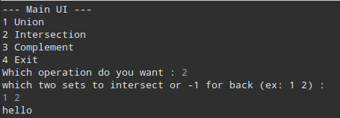

\* Complement :

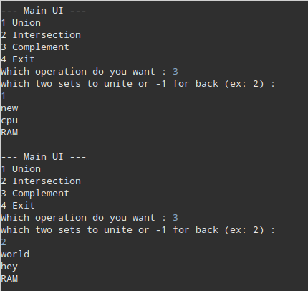

Assumptions:

The input of universe and sets must be in the form

numberOfElementsInUniverse

element1

element2

.

.

Element

numberOfSets

numberOfElementsInSet1

element1

element2

.

.

Elementn

numberOfElementsInSet2

.

.

And So on.