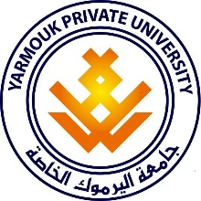

Yarmouk Private University Faculty of Informatics and Communication Engineering Department of Software Engineering Major

**Education Assessment System**

A project to gain the Bachelor degree in software engineering

**Developed By**

Seif Al-Deen Al-Kowatli Saleem Jammoul

**Supervised By**

Dr. Eng. Tala Shehbi

D.Eng. Wassim Juneidi

Semester

2017-2