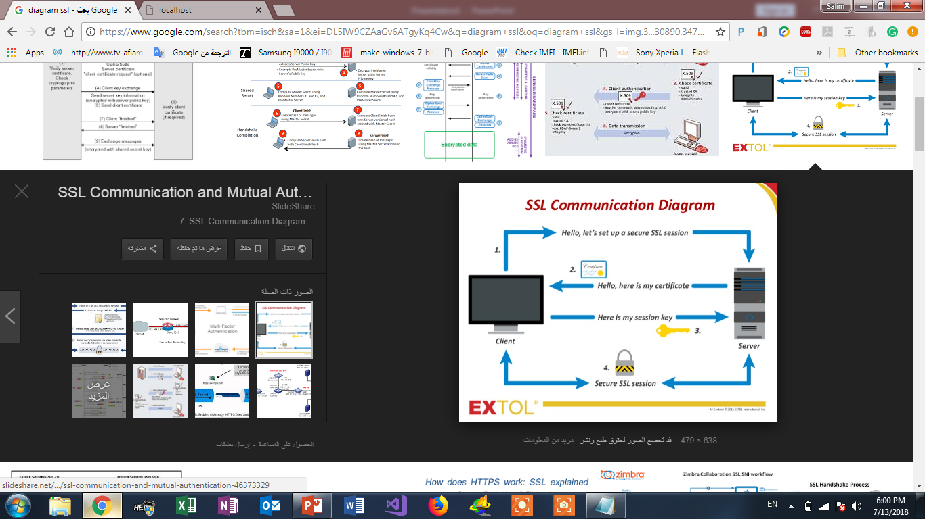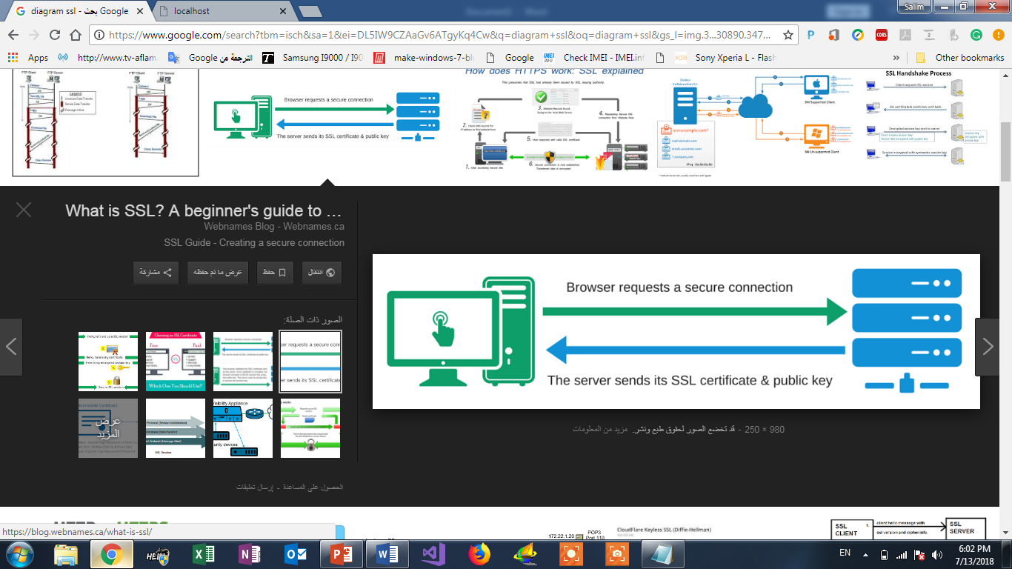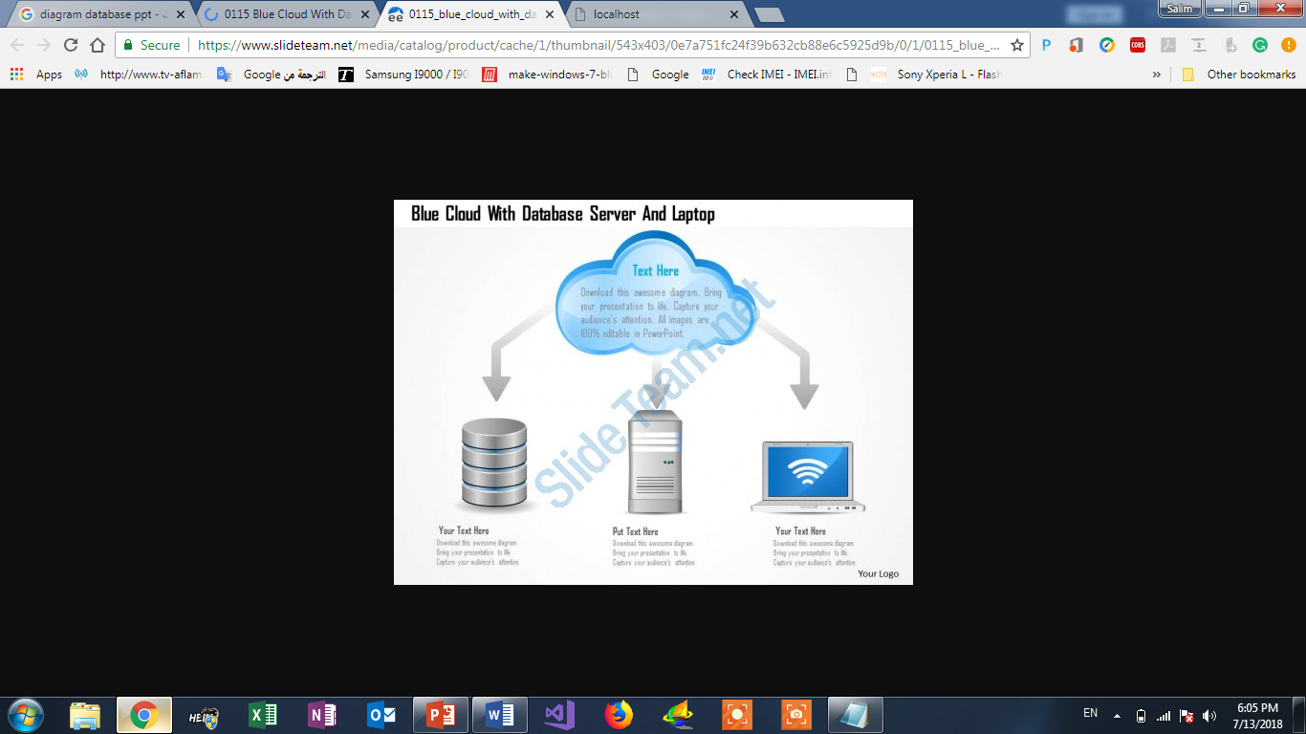

Database



Browser requests a secure connection

The server sends its SSL certification & public key

Encryption use DES & RSA

Decryption