- Task A1 - Start an interactive container
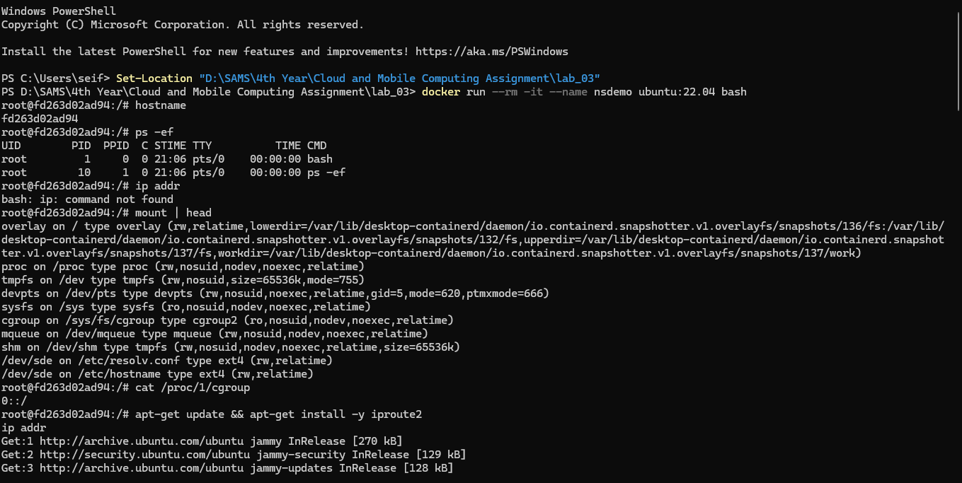

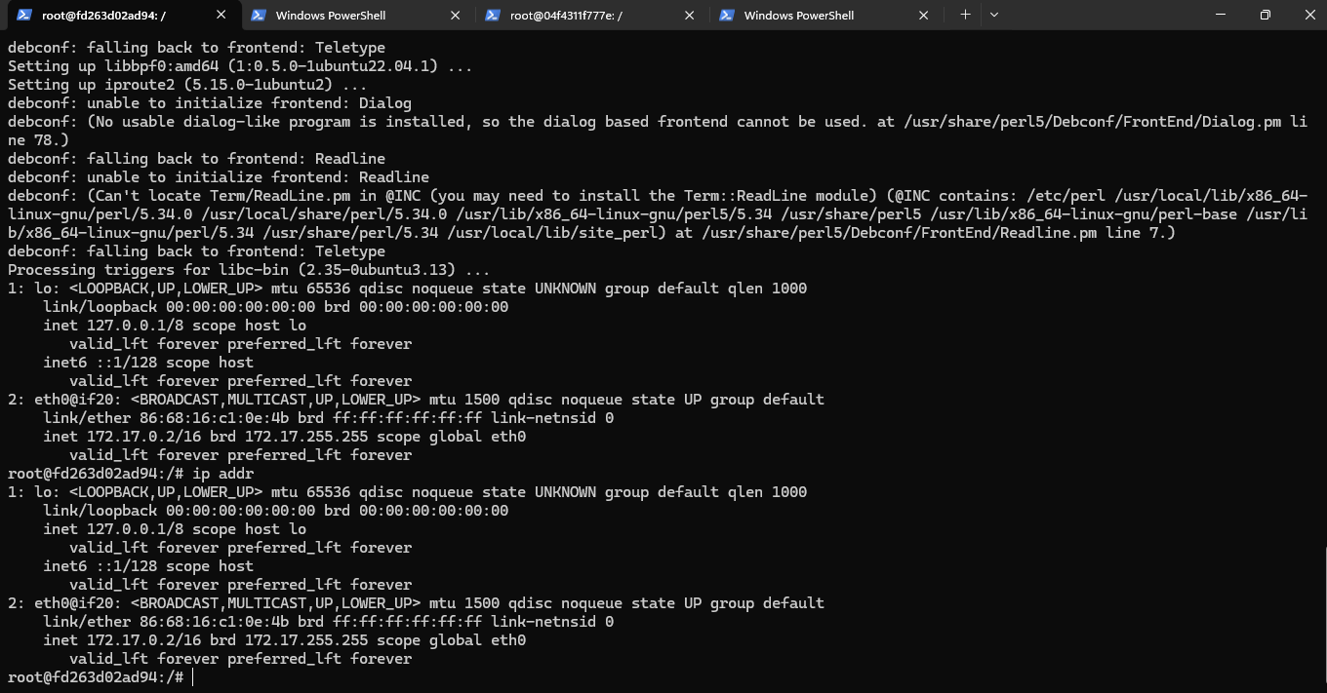

- Task A2 - Compare host and container process views
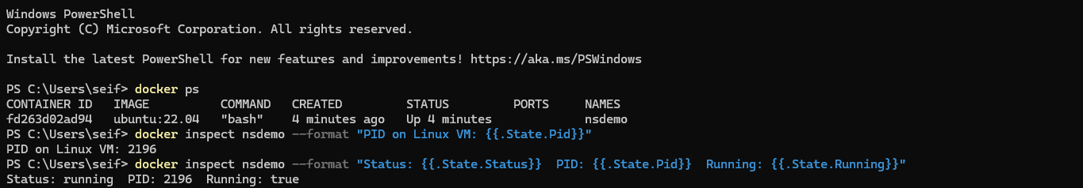

- Task A3 - Apply resource limits with cgroups
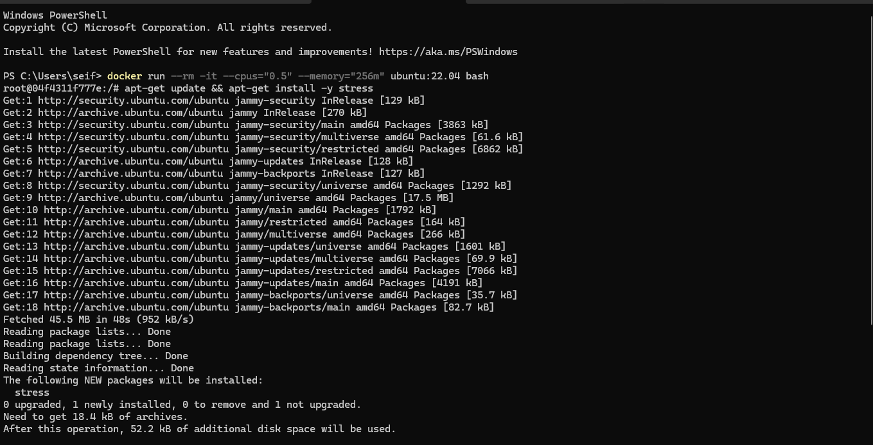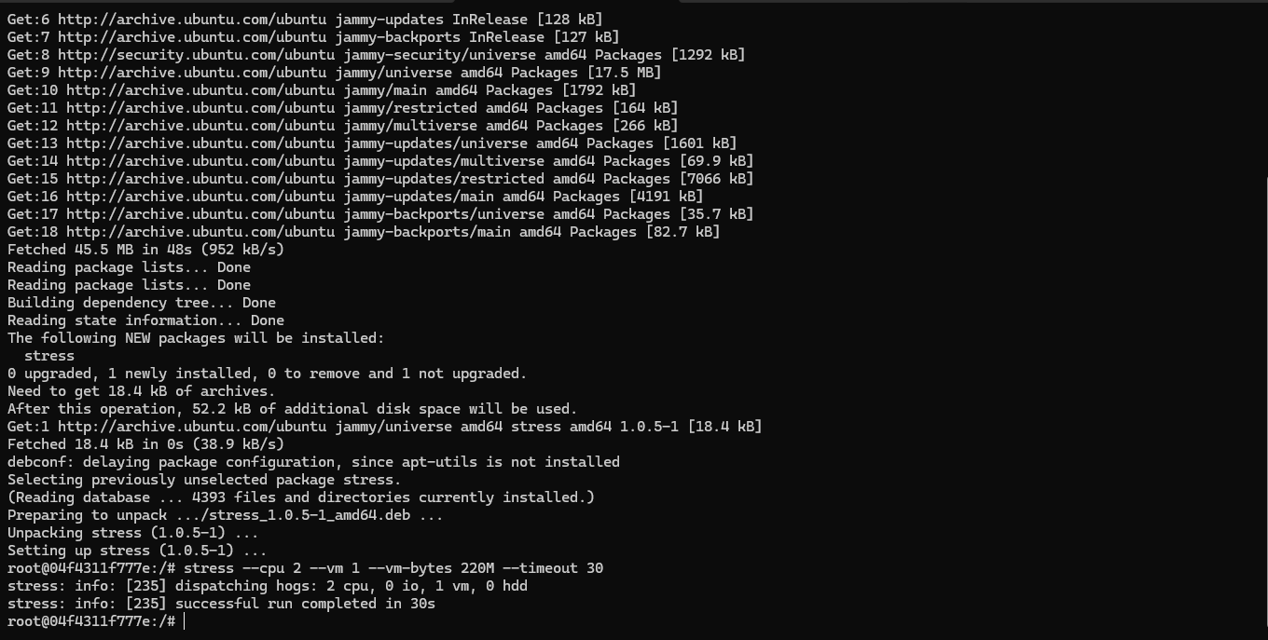

- Task B1 - Create application files
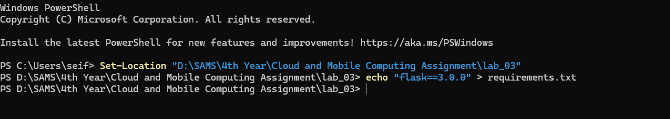

- Task B2 - Build a basic image
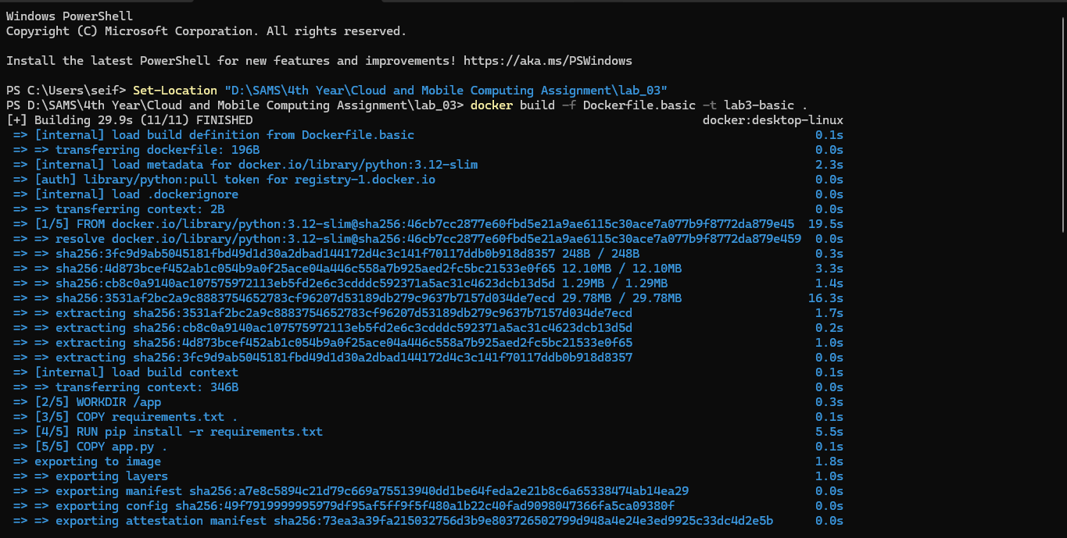
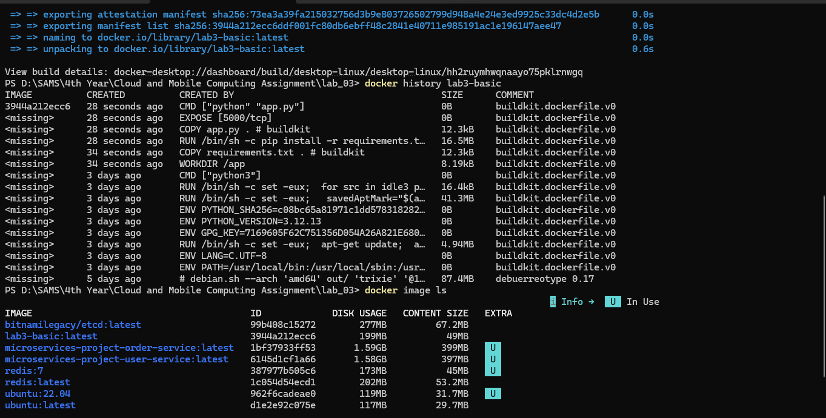

- Task B3 - Build a multi-stage image
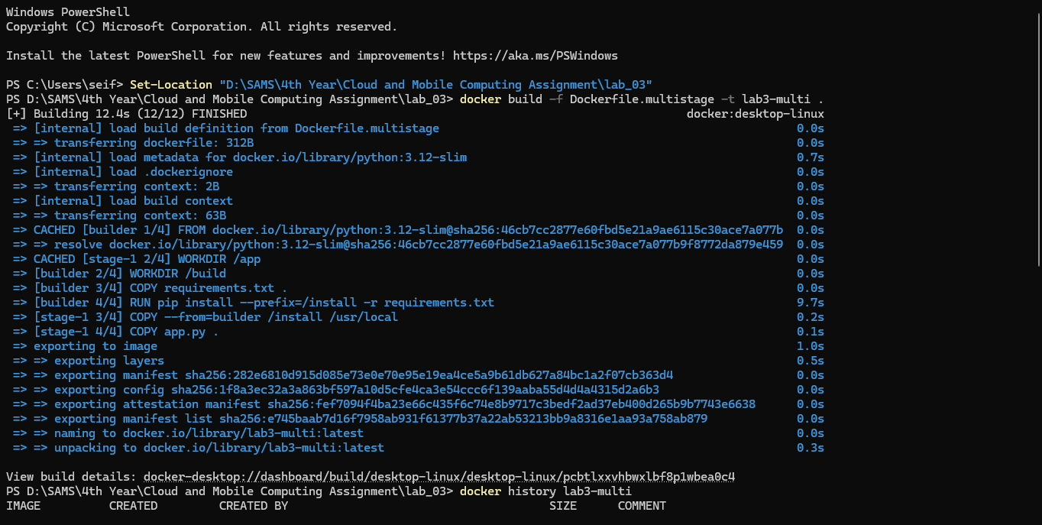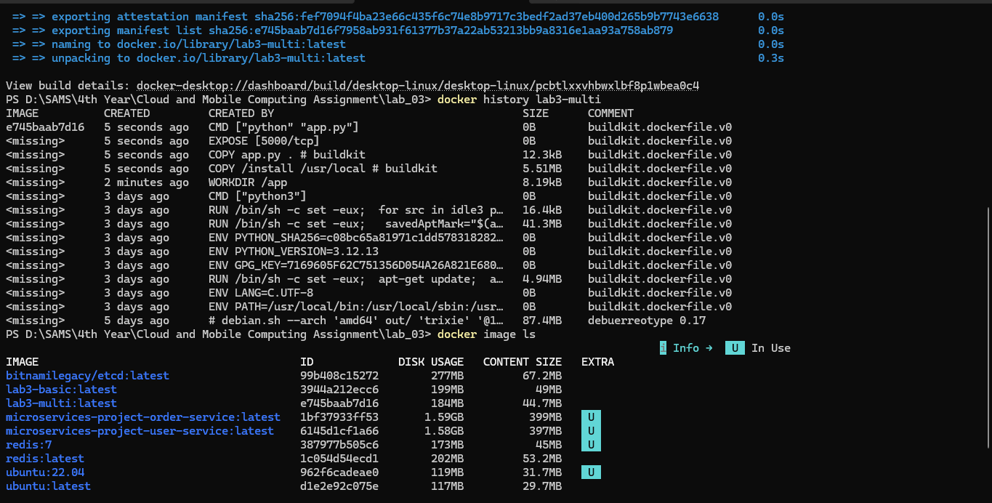

B.1 Overview
Docker images are constructed as a series of read-only layers, each representing an incremental change to the filesystem produced by a single instruction in the Dockerfile. This layered architecture has direct implications for build performance, storage efficiency, and security. This section compares two build strategies — a single-stage build and a multi-stage build — and analyses the practical differences observed during the experiment.

B.2 Image Size Comparison
Upon completing both builds, the following image sizes were recorded using docker image ls:
Image | Size
lab3-basic | 199 MB
lab3-multi | 184 MB
The multi-stage image (lab3-multi) is approximately 15 MB smaller than its single-stage counterpart. This reduction is attributed to the architectural separation enforced by multi-stage builds. In the single-stage approach, all intermediate artefacts produced during the dependency installation phase — including pip's internal cache, temporary build metadata, and any compiler tooling — are retained in the final image layers. In the multi-stage approach, a dedicated builder stage performs the installation in isolation, and only the resulting installed packages are transferred to the final runtime image via the COPY --from=builder directive. Consequently, the final image contains exclusively what is required for execution, producing a leaner and more secure output.

B.3 Layer Caching Behaviour When app.py Changes
A fundamental property of the Docker build cache is that it operates sequentially: once a layer is invalidated due to a change in its corresponding instruction or its input files, all subsequent layers must be rebuilt regardless of whether they themselves have changed. This behaviour was directly observable in the recorded build outputs.
When only app.py is modified, the cache behaviour for each build strategy is as follows:
Layer / Instruction | lab3-basic | lab3-multi
FROM python:3.12-slim | Cache hit | Cache hit
WORKDIR | Cache hit | Cache hit
COPY requirements.txt | Cache hit | Cache hit
RUN pip install | Cache hit (16.5 MB, ~5.5s saved) | Cache hit (5.51 MB)
COPY app.py | Rebuilt | Rebuilt
CMD | Rebuilt | Rebuilt
In both strategies, the pip install step — which constitutes the most time-consuming and computationally expensive operation — remains cached when only app.py is modified. This is possible because requirements.txt is copied prior to app.py in both Dockerfiles, ensuring that the dependency installation layer is not invalidated by changes to the application code.

B.4 Why Layer Order Matters
Layer ordering is a critical design consideration in Dockerfile authorship. Because Docker's cache invalidation propagates downward — that is, a change at any layer invalidates all layers beneath it — instructions that are likely to change frequently must be placed as late in the Dockerfile as possible.
In the context of this experiment, this principle is demonstrated by the deliberate placement of COPY requirements.txt before COPY app.py. Since application dependencies declared in requirements.txt are modified far less frequently than the application source code itself, placing the dependency copy and installation steps earlier in the build sequence ensures that these expensive operations benefit from caching during routine development iterations.
To illustrate the consequence of incorrect ordering, consider the following contrast:
Optimal order (used in this lab):
dockerfile
COPY requirements.txt . # Rarely changes → cached
RUN pip install ... # Expensive → remains cached
COPY app.py . # Changes frequently → only this layer rebuilds
Suboptimal order:
dockerfile
COPY app.py . # Changes frequently → cache invalidated here
COPY requirements.txt . # Forced to re-run despite no change
RUN pip install ... # Expensive step re-executes on every build
In a large-scale orchestration environment where dozens of services are built and deployed continuously, such ordering decisions have compounding effects on pipeline duration, bandwidth consumption, and infrastructure cost. Correct layer ordering is therefore not merely a performance optimisation but a fundamental engineering discipline in containerised software deliver
- Create a local cluster
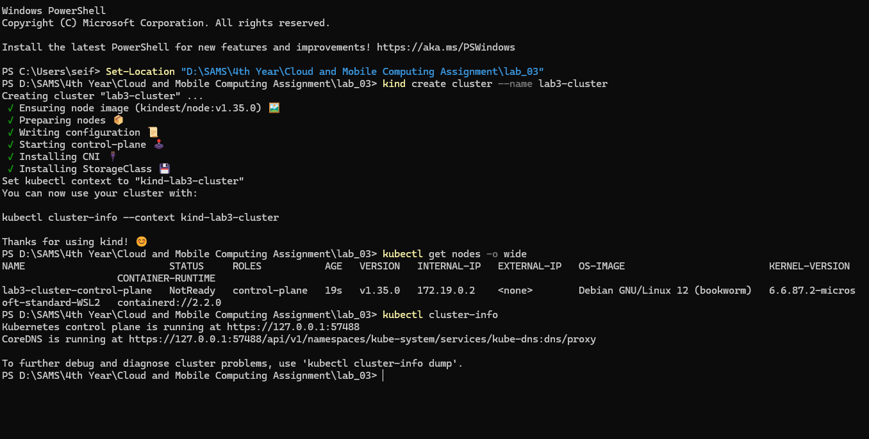

- Task C2 - Load your image into kind
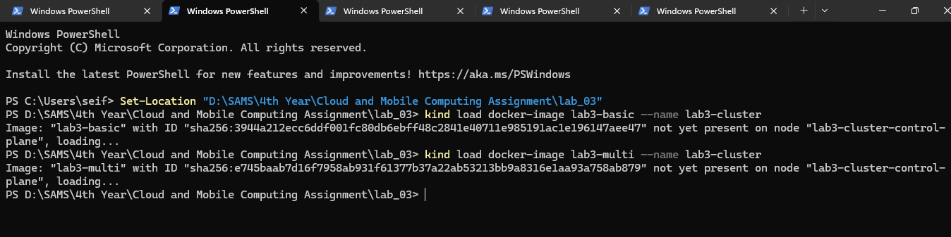

- Task C3 - Deploy a replicated application
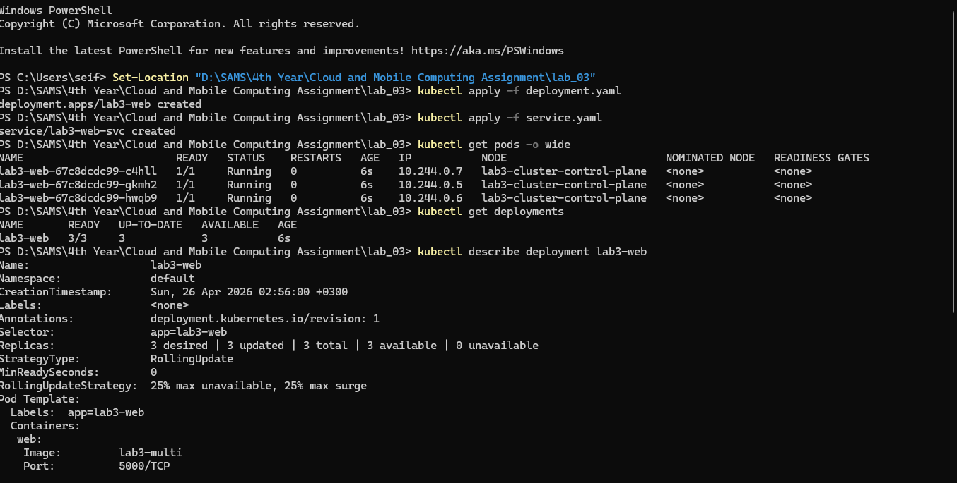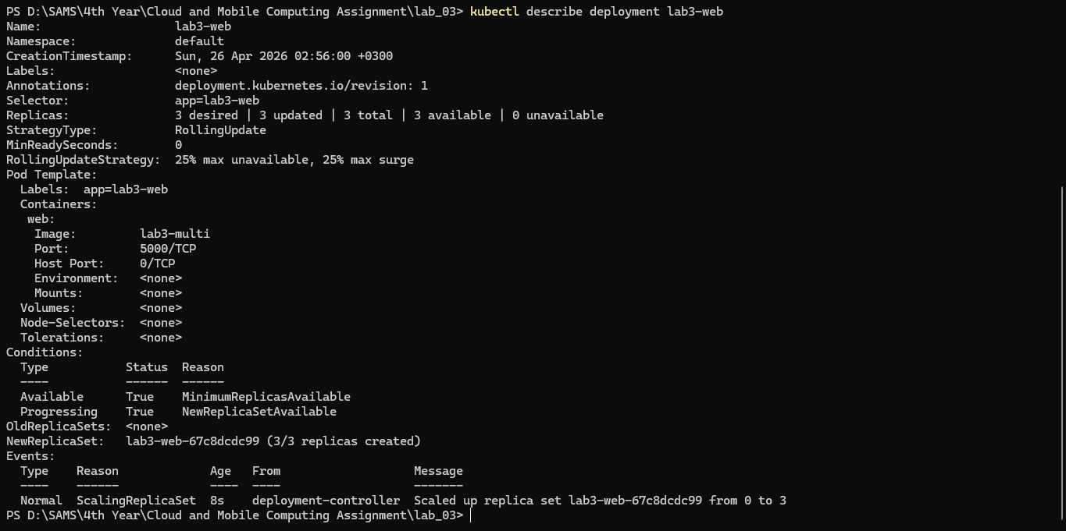

- Task C4 - Access the service
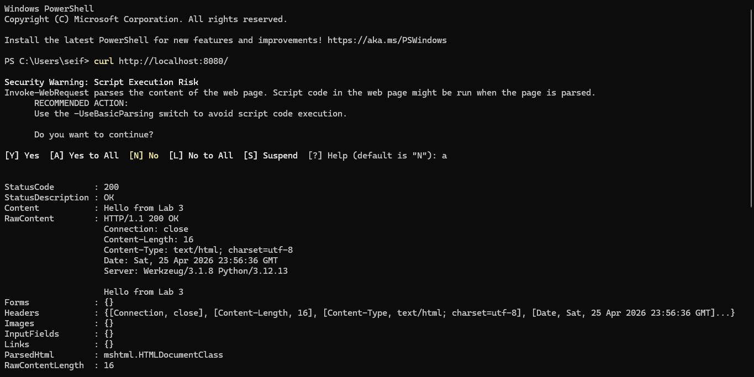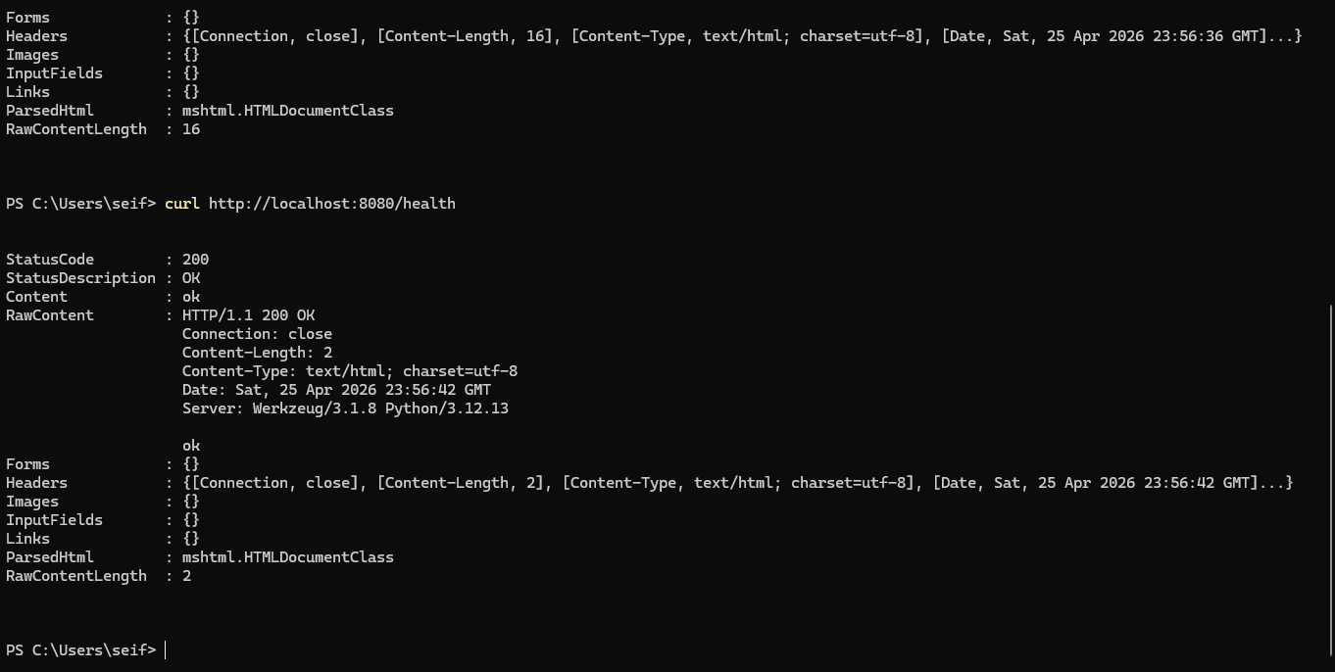

- Task D1 - Label the node
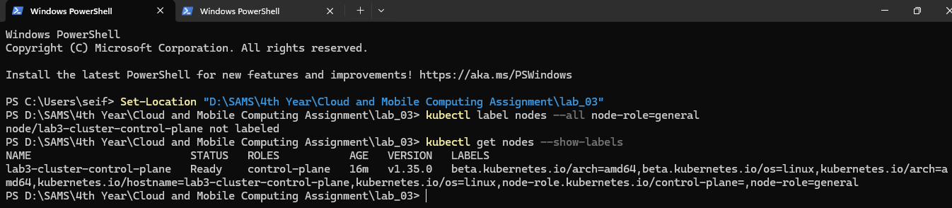

- Task D2 - Force placement with a node selector
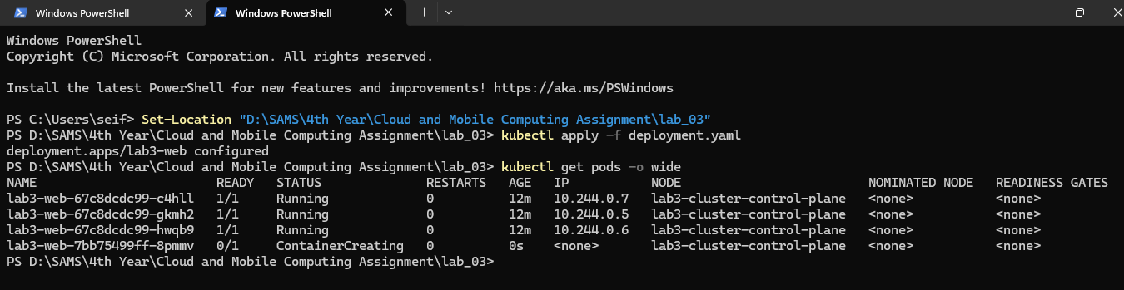

- Task E1 — Trigger Self-Healing
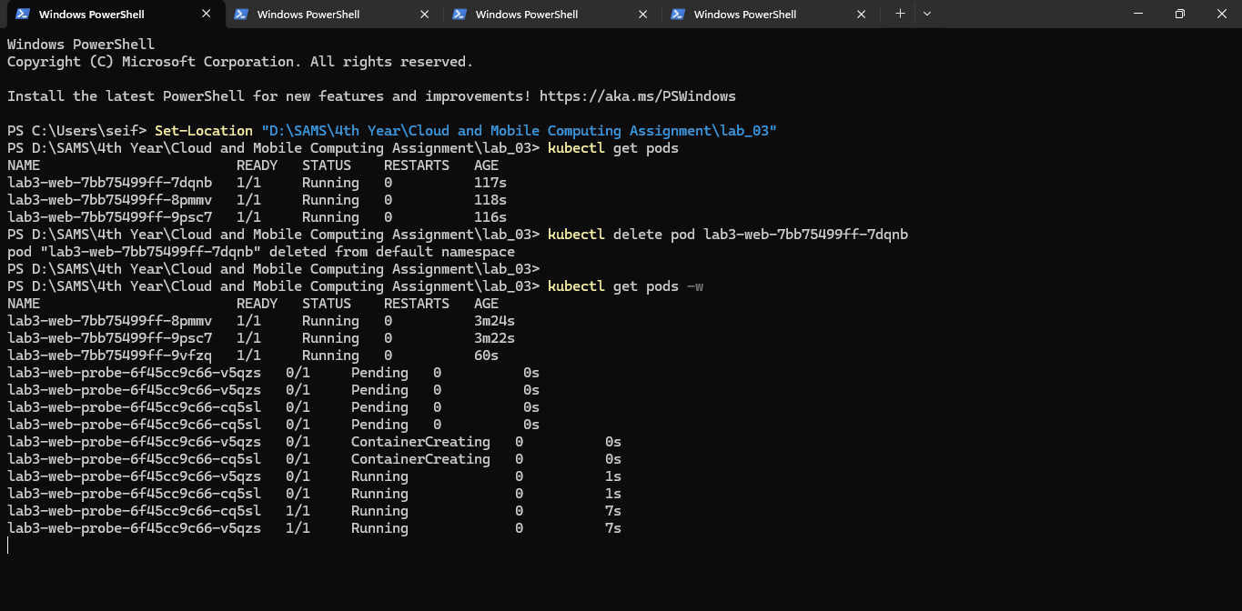

- Task E2 - Add readiness and liveness probes
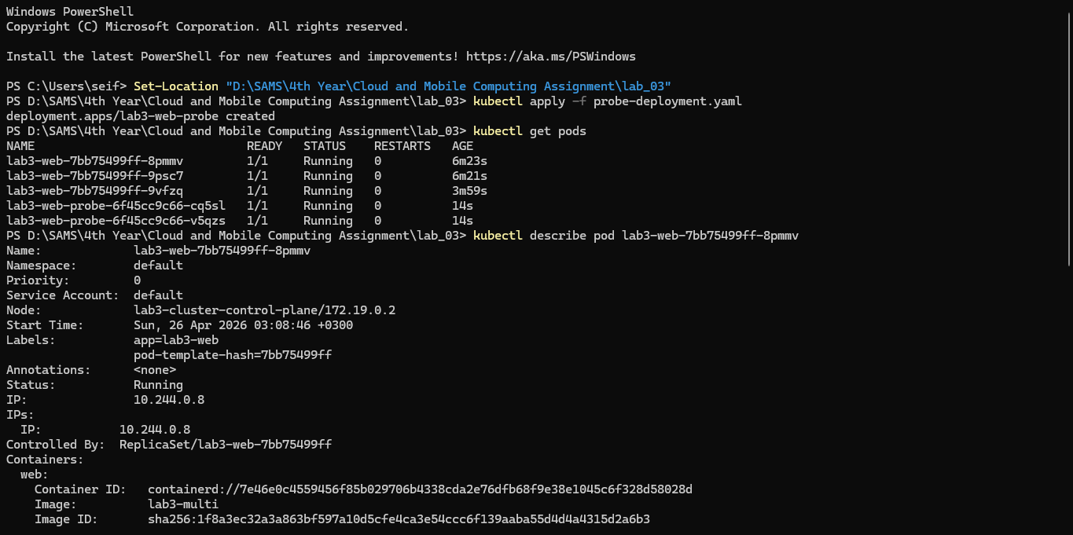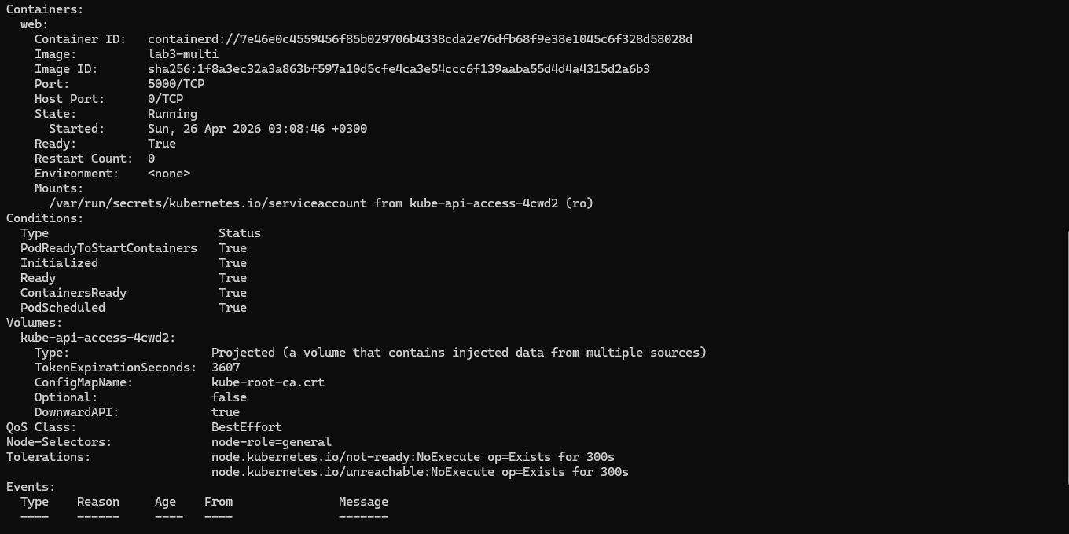
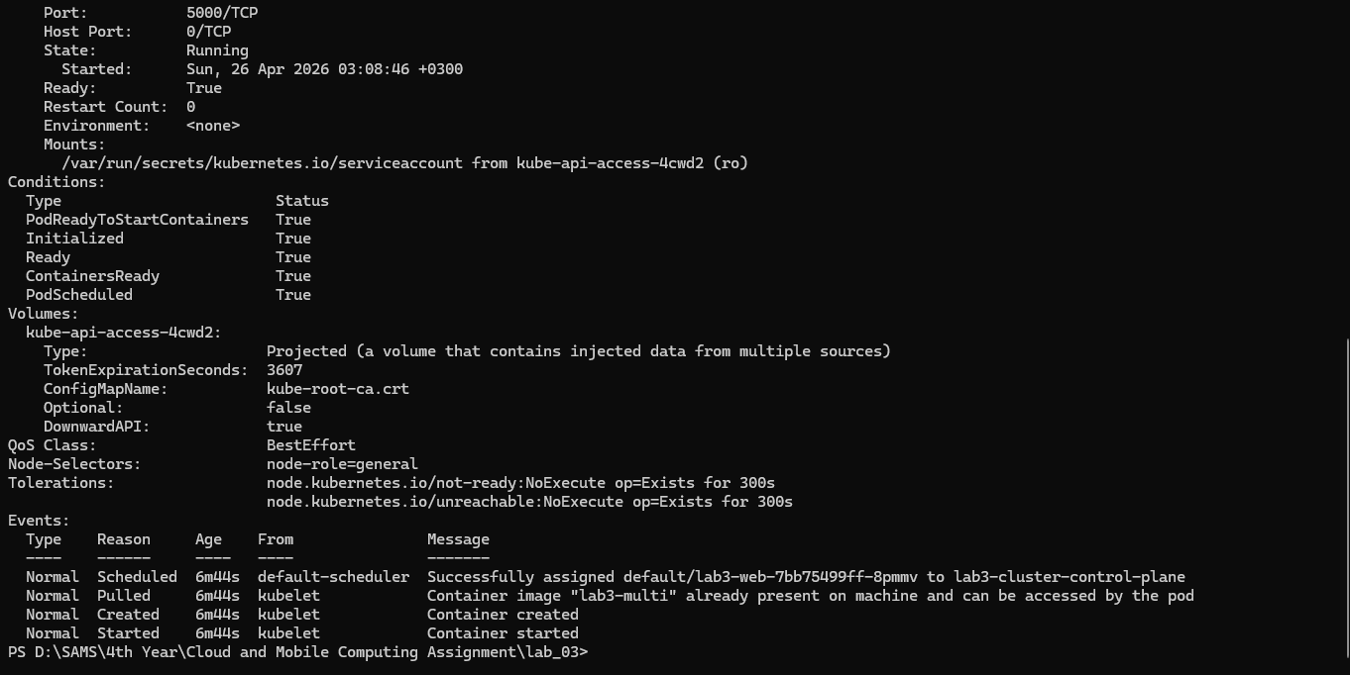
- Task E3 - Observe what happens if the container process dies
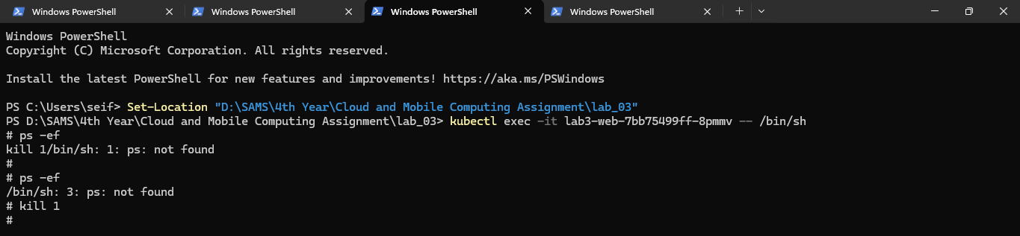
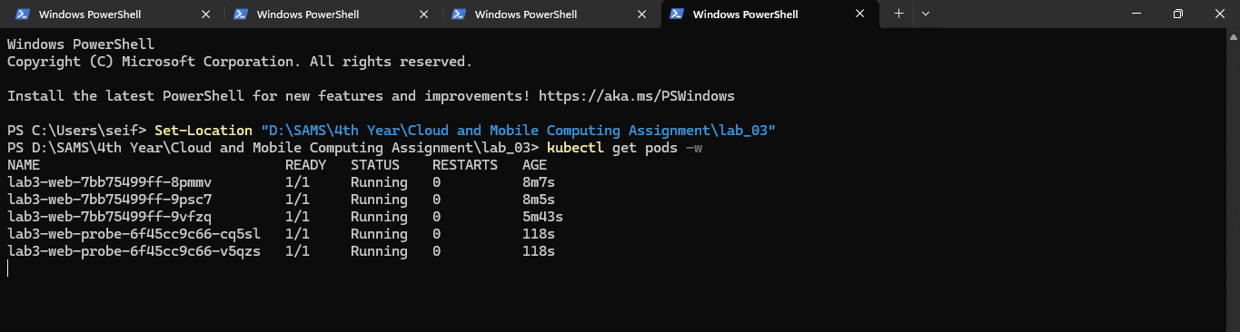
1. Why do namespaces alone not guarantee fair resource use?
Namespaces provide isolation by controlling what a process can see — they restrict visibility of other processes, network interfaces, and filesystem mounts. However, they impose no limits on how much of a shared resource a process may consume. A process running inside a namespace can still exhaust the host's CPU or memory, starving other containers of the resources they require. Fair resource allocation requires a separate enforcement mechanism entirely.

2. How do cgroups improve cluster stability?
Control groups (cgroups) allow the kernel to enforce hard limits on the amount of CPU, memory, and I/O that any given process or container may consume. In a multi-tenant cluster environment, this prevents a single misbehaving or heavily loaded container — often referred to as a "noisy neighbour" — from monopolising shared resources and degrading the performance of co-located workloads. By guaranteeing each container a bounded resource envelope, cgroups make overall cluster behaviour predictable and stable.

3. Why is Docker image layering important for large-scale orchestration?
In large-scale orchestration environments, the same base layers are shared across many images. Because Docker only stores and transfers each unique layer once, this dramatically reduces storage consumption on both registries and nodes. When a new image is pulled onto a node that already possesses its base layers, only the changed layers are downloaded, accelerating deployment times. In CI/CD pipelines where images are rebuilt frequently, effective layer caching also reduces build duration and infrastructure cost significantly.

4. What does Kubernetes mean by desired state?
Desired state refers to the declarative specification submitted by an operator describing how the system should look — for example, that a Deployment should maintain three running replicas of a given container image. Kubernetes does not execute this as a one-time instruction. Instead, its control plane continuously monitors the actual state of the cluster and takes corrective action whenever a divergence from the desired state is detected, regardless of what caused the discrepancy.

5. How is self-healing different from traditional manual operations?
In traditional operational models, detecting and recovering from failure depends on human intervention — an operator must notice the failure, diagnose it, and manually restart or replace the affected component. Kubernetes self-healing is entirely automated and continuous. The Deployment controller perpetually reconciles actual state against desired state, replacing failed Pods without any human involvement. This reduces mean time to recovery, eliminates human error from the recovery process, and allows systems to operate reliably at a scale that manual intervention could not support.

6. Why are readiness probes and liveness probes not interchangeable?
Although both probe types interrogate the health of a container, they serve fundamentally different purposes and trigger different responses. A liveness probe determines whether a container is still alive and functioning; a failure causes Kubernetes to restart the container. A readiness probe determines whether a container is prepared to serve traffic; a failure causes Kubernetes to remove the Pod from the Service's load balancing pool without restarting it. A container that is still initialising, for instance, should fail its readiness probe to avoid receiving premature traffic, but it should not fail its liveness probe and be unnecessarily restarted. Conflating the two would result in either premature traffic routing or unnecessary container restarts.

7. What is one limitation of observing scheduling in a single-node kind cluster compared with a real multi-node cluster?
In a single-node kind cluster, all Pods are necessarily scheduled onto the same node regardless of any placement policies defined, because there is no alternative node available. This makes it impossible to observe meaningful scheduling decisions such as workload distribution across nodes, the effect of resource pressure on placement, or the behaviour of anti-affinity rules that are designed to spread replicas across distinct physical or logical failure domains. A real multi-node cluster is required to meaningfully evaluate and demonstrate these scheduling properties.

